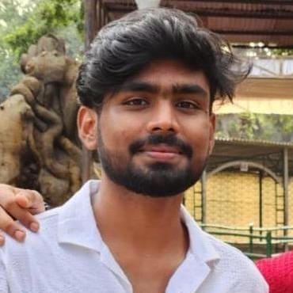 | ADWAITH P |  |  |  |  | 
 |  | adwaithaadhi12@gmail.com |  | 7025524065
 |  | (17) ADWAITH P | LinkedIn
 |  | Github: Manu10077 (ADWAITH P)

PERSONAL PROFILE
Final-year B.Tech student in Electrical and computer Engineering with strong project experience in IOT,machine learning , and full-stack web development . Skilled in Python,C/C++,JavaScript,RSP32,and MySQL,with a passion for integrating sensors,AI,and cloud platforms like Blynk .Developed multiple smart systems and websites,demonstrating creativity,problem-solving ,and technical . Eager to contribute to innovate tech-driven environments.
ACADEMIC CREDENTIALS
TKM College of Engineering, Kollam
Bachelor of Technology, Electrical and Computer Engineering, Kollam,2022-26
Jawahar Navodaya Vidyalaya,CBSE
Higher Secondary Certificate(Class XII), CBSE Bord-Science,Kozhikode
TECHNICAL AREAS OF INTEREST
- Technical Skills:Python| C/C++ | Java | JavaScript | MySQL | HTML | CSS | Arduino IDE | Blynk | Git | ESP32
- Others: Visual Stdio Code | GitHub | MS Office
CERTIFICATIONS AND VALUE-ADDED COURSES
- NPTL ONLINE CERTIFICATION - The Joy of Computing Using Python (77%)
- Workshop on AI in Electric Transport
- Workshop on Basics of AutoCAD & SketchUP
- Workshop on Self Driving Electric Vehicle
INTERNSHIP EXPERIENCE
Kerela State Electronics Development Corporation Ltd.(KELTRON)
Data Science and Analytics , Calicut, Kerala
1 week
ACADEMIC PROJECTS
Student-Teacher Exam App (DBMS mini project) - Using python and MySQL
Wireless Human Motion Detection System (IOT lab project) - Using Ai-Thinker Rd-03E,ESP32,NRF module,Blynk
PERSONAL TRAITS
- Hard working
- Problem solving
- Time management
- Team work
CO-CURRICULAR AND EXTRA CURRICULAR ACTIVITIES
- Student member of IEI College chapters
HOBBIES AND INTERESTS
- Community involvement
- Travelling
- Professional development
- Playing game
- fooding
LANGUAGES
- English
- Hindi
- Malayalam

