Datastraw CX Platform — Architecture at Scale
500 brands · 5,000 CX agents · millions of customer messages

1. Architecture overview
The diagram below shows the full pipeline at scale.
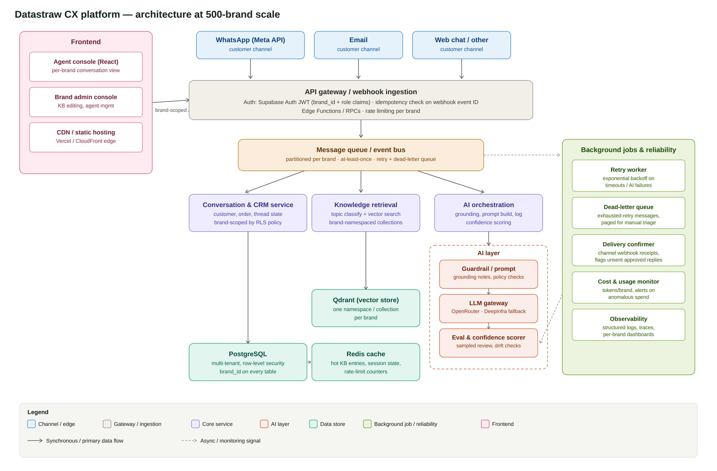
The system is a message pipeline with four stages — ingest, understand, generate, deliver — wrapped by a frontend agents use to supervise it and a reliability layer that keeps it correct under failure.

Frontend
A single React app serves two roles behind the same auth: an agent console (conversation view, generate/edit/approve, per the Part 1 build) and a brand admin console (knowledge base editing, agent management). Both are static-hosted on a CDN edge and talk to the backend only through the API gateway — no direct database access from the browser. Every request carries a JWT with a brand_id claim, so the frontend never has to be trusted to filter data correctly; it just renders what the backend returns.

APIs / backend
A thin API gateway layer (Edge Functions / RPCs) fronts everything: inbound channel webhooks (WhatsApp, email, web chat) land here, as do the agent console's requests. Two responsibilities live specifically at this layer: auth (validate the JWT, resolve brand_id) and idempotency (webhook event IDs are checked against a short-lived dedup table before anything is queued — see Reliability). The gateway does not do business logic; it authenticates, deduplicates, and hands off to a queue.

Database
PostgreSQL remains the system of record for conversations, messages, customers, orders, and AI reply logs — the same schema as Part 1, unchanged in shape, just partitioned and indexed for scale (see Scalability). Redis sits in front of it for hot reads: KB entries per brand, session state, and rate-limit counters.

Authentication
Supabase Auth issues JWTs for agents and, for server-to-server integrations, brand-admin API keys. Every JWT carries brand_id and role. This claim is the single source of truth the rest of the system trusts — see Multi-Brand Data below.

External integrations
Meta WhatsApp API, email (inbound parse + outbound send), and any future channel connect as webhook producers into the gateway and as delivery targets from the Delivery Confirmer (background jobs). Each integration is isolated behind an adapter so a channel-specific API change doesn't ripple into the core pipeline.

AI layer
Three components, deliberately separated: a guardrail/prompt builder (assembles retrieved context and computed grounding facts, exactly as in Part 1, now brand-aware at the retrieval step), an LLM gateway (OpenRouter as primary, DeepInfra as a fallback route — model choice is per-brand config, not hardcoded), and an eval/confidence scorer that samples generated replies for human review and tracks drift over time. Covered in depth in section 3.

Knowledge retrieval
At one brand, Part 1's keyword matching is sufficient. At 500 brands with real documents, retrieval becomes: classify the incoming message's topic, vector search a brand-namespaced Qdrant collection, return top-k chunks above a similarity threshold. Namespacing by brand is the same isolation mechanism as Postgres row-level security, applied to the vector store (see below).

Background jobs / queues
A message queue, partitioned by brand_id for ordering and noisy-neighbor isolation, decouples ingestion from processing. Four workers consume from it: a retry worker (exponential backoff on transient failures), a dead-letter queue for exhausted retries (paged for manual triage), a delivery confirmer (matches outbound sends to channel delivery receipts and flags any approved reply that never went out), and cost/usage monitoring (per-brand token spend, alerting on anomalies — ties directly into the Part 3 scenario).

2. Multi-brand data isolation
Brand A's data must never be reachable from Brand B's context, at three independent layers so a bug in any one doesn't become a breach:
- Application layer — every API call resolves brand_id from the JWT, never from a request parameter the client controls. A URL like /conversations/123 is scoped server-side to WHERE brand_id = :jwt_brand_id, not just WHERE id = 123.
- Database layer (the real enforcement point) — Postgres Row-Level Security policies on every brand-owned table (conversations, messages, orders, knowledge_base, ai_reply_logs), keyed to the session's brand_id. Even a query with a bug in its WHERE clause cannot return another brand's rows, because the database itself refuses. This is the layer I'd actually trust — application-layer filtering is defense in depth, not the guarantee.
- Vector store — Qdrant collections are namespaced per brand (or a brand_id payload filter enforced on every query, never optional). Retrieval code cannot construct a cross-brand query even by mistake, because the brand-scoped client only knows about its own collection.
Same pattern at all three layers: never trust an ID passed in; always derive scope from the authenticated session, and enforce it as close to the data as possible.

3. Making the AI system reliable
- Knowledge retrieval — vector search returns top-k results above a minimum similarity threshold; below threshold, the system falls back to “no confident match” rather than forcing in a low-relevance chunk (the same principle as Part 1's keyword fallback, generalized).
- Hallucinations — the system prompt hard-constrains the model to only state facts present in retrieved context, and — the more important lever — grounding notes are computed deterministically outside the model (date arithmetic vs. policy windows, order status) rather than left to the model's own reasoning. This is the single biggest reliability win in Part 1's implementation: don't ask the model to compute what code can compute correctly.
- Context provided to the model — bounded and structured: brand tone, order facts, retrieved KB chunks, computed grounding notes, conversation history. No open-ended “here's everything, figure it out.”
- Confidence / fallback — a confidence signal independent of the model's own claimed certainty: did retrieval clear its similarity threshold, did a grounding check land inside or outside a policy window. Low confidence surfaces as a visible warning to the agent (Part 1's implementation) rather than being silently absorbed.
- Evaluation — a sample of generated replies, weighted toward low-confidence ones, goes to human review continuously, not as a one-time launch gate. Two cheap proxy metrics tracked per brand over time: escalation rate (how often the AI correctly declined vs. incorrectly answered) and edit rate (how much agents change the draft before sending) — both signal retrieval or prompt drift without needing a full labeled eval set for every brand.

4. Scalability: 20 brands → 500 brands
What breaks first: keyword-based retrieval breaks almost immediately — it doesn't survive past a handful of brands with real (non-mocked) knowledge bases, which is why Part 1 already frames it as a placeholder. Past that, in order:
- 1. A single Postgres instance's connection count and hot-table contention — messages and ai_reply_logs grow fastest; I'd introduce read replicas for the agent console's read-heavy queries and consider partitioning ai_reply_logs by month before it partitions by brand.
- 2. Unpartitioned queues — a busy brand's message volume can starve a quiet brand's messages if they share one queue without per-brand partitioning; this is why the queue is partitioned by brand_id from day one in the design above, not retrofitted later.
- 3. Prompt/KB management — 500 brands means 500 sets of policies someone has to keep current; the brand admin console and a lightweight versioning/audit trail on KB edits (who changed what, when) becomes a real product surface, not a nice-to-have.
- 4. AI spend — see Part 3. Per-brand usage monitoring has to exist before this is a fire to put out, not after.

5. Reliability
- Webhook received twice — the idempotency check at the gateway (dedup on the channel's own event ID, short-lived key store) drops the duplicate before it reaches the queue. Message processing itself is also written to be idempotent (upsert on a natural key) as a second line of defense, since “exactly-once delivery” isn't a guarantee any real queue gives you.
- External API timed out — retried with exponential backoff by the retry worker, capped at a small number of attempts, then routed to the dead-letter queue for manual triage rather than silently dropped or retried forever.
- AI request failed — same retry path; if OpenRouter fails, the LLM gateway fails over to DeepInfra rather than surfacing an error to the agent immediately. If both fail, the conversation is flagged for manual reply rather than left silent.
- Message processed but response wasn't sent — this is exactly what the delivery confirmer exists for: it reconciles “approved” rows in ai_reply_logs against channel delivery receipts and raises an alert (and re-queues the send) for anything approved-but-unconfirmed past a short window. Silent drops here are the failure mode most damaging to trust, so it gets dedicated coverage rather than relying on the general retry path.

