Abstract — The aim of this thesis is to make a smart umbrella which can reduce human effort due to its functionality and can target the market due to its unique design, is really important in modern society at risk of rainfall and wind without coverage in place. The purpose of this project is to make such an umbrella that is really sensitive in the incidences of rain and sunlight at domestic and market level. This umbrella operates with the help of sensor like water sensors and servo motor.

The opening and closing of umbrella are being controlled through a motor. Motor can give a quick and instant response to the shaft so that shaft can play a major role of power transmission for opening and closing of umbrella.

Then Arduino sends signal further to the motor so that motor may activate and deliver required rpm to the coupling shaft. This project is a cost-effective way of providing automated controlled shade from high intensity rain. So, the problems of open and vast areas can be solved by using such types of automated umbrellas.

Keywords—Water Sensors, Servo motor, Arduino.

I. INTRODUCTION

An umbrella is a folding canopy (overhead roof) supported by Plastic ribs that is usually mounted on a plastic pole. It is designed to protect a person against rain. Umbrellas and parasols are primarily handheld portable devices sized for personal use. The largest hand portable umbrellas are golf umbrellas. Umbrellas can be divided into two categories: fully collapsible umbrellas, in which the metal pole supporting the canopy retracts, making small enough to fit in a handbag, and non-collapsible umbrellas, in which the support pole cannot retract and only the canopy can be collapsed.

The vision is to make a optimize structure which is of low cost that fulfills the need of the people working in open areas. The main function of an automated umbrella is protection from rain. This umbrella meets these needs by using sensor and a set of DC motors to automatically track the falling rain to maximize shading where it is being used. DC motor is used for direct and Instant response of a current having single phase. The selection of DC motor depends upon torque. It operates whenever sensors detect rain and activate the motors of umbrella which further drives the shaft to open and close the umbrella.

Generally, sun shading big umbrellas are used at beaches, swimming pools Orin courtyards, a lot of coffee shops or restaurants also use sun-shading big umbrellas on tables and rain-shielding but also for providing a good mood of being in the surrounding. Therefore, the big umbrellas are quite practical. For such types of purposes, an automated umbrella is required which is equipped with modern technology.

The purpose of doing this is to feel comfortable while working in open areas and to make a design which is really reliable for domestic and industrial purposes.

The vision is to make a optimize structure which is of low cost that fulfils the need of the people working in open areas. This umbrella meets these needs by using multiple sensors and a set of DC motors to automatically sense the rain to maximize shading where it is being used. DC motor is used for direct and Instant response of a current having single phase. The selection of DC motor depends upon torque. It operateswhenever it detects the rain and activate the motors of umbrella which further drives the shaft to open and close the umbrella

II. COMPONENTS

1. Servo Motor

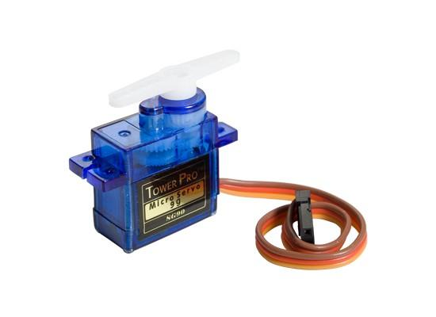

Servo motor is a type of motor that can rotate with great precision. Normally this type of motor consists of a control circuit that provides feedback on the current position of the motor shaft, this feedback allows the servo motors to rotate with great precision. If you want to rotate an object at some specific angles or distance, then you use a servo motor.

In our project, servo motor is used to provide the necessary rotational motion to the shaft because they have higher starting torque, quick starting and stopping, reversing, variable speeds with easier and cheaper voltage control. Three types of motors generally used are direct current motors, servos and stepper. Servo motors are fast, high torque and rotate accurately within a limited angle designed for robotic arms / legs or cycle control etc.

1. Water-Sensor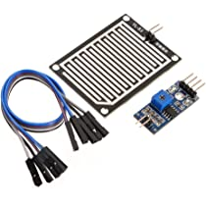

Fig 2 - Water sensor

Water sensor brick is designed for water detection, which can be widely used in sensing rainfall, water level, and even liquid leakage.

A water detector is an electronic device designed to detect the presence of water for purposes such as providing timely awareness to allow for water leakage prevention.

To detect rain, we used a water drop recognition module. It contains a series of similar cables. When water droplets come in contact with these wires, the rotation terminates and provides a signal to the microcontroller chip (Arduino) to control the flow of motion.

1. Arduino uno

Arduino is an open-source electronic source software based on easy-to-use hardware and software. Arduino boards can read input - light sensor, fingerprint, or a message - and then take it out - activate the system, turn on the LED, and publish something online.

It can control the main circuit board what to do by sending a set of instructions to the microcontroller on board.

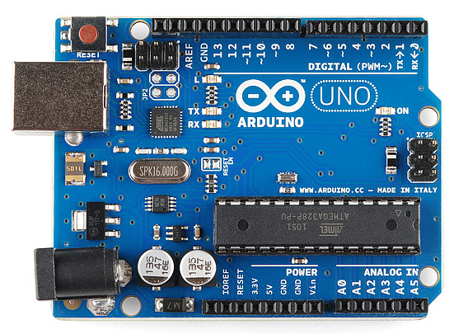

Fig3- Arduino

To do so we use Arduino programming language and Arduino Software (IDE), based on Analysing. Over the years Arduino has been the central unit of thousands the electronics and robotics projects, from everyday objects to sophisticated scientific tools. A global community of practitioners - students, programmers, and professionals – have gathered in this open-source forum over the last few years.

It provides incredible amount of information and a great help for professional automated projects.

1. Buzzer

An audio signalling device like a beeper or buzzer may be electromechanical or mechanical type. The main function of this is to convert the signal from audio to sound. Generally, it is powered through DC voltage and used in timers, alarm devices, printers, alarms, computers, etc. Based on the various designs, it can generate different sounds like alarm, music, bell & siren.

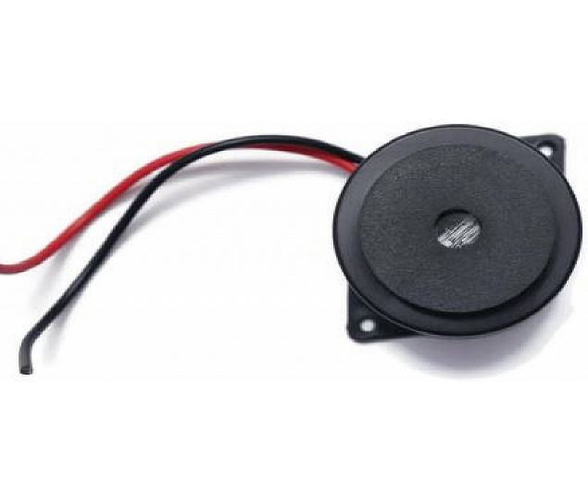

Fig-4 Buzzer

Whenever we open or close the umbrella it will give a alert to the user that the umbrella will be going to open or close.

1. Bread board

The breadboard is a white rectangular board with small embedded holes to insert electronic components. It is commonly used in electronics projects. We can also say that breadboard is a prototype that acts as a construction base of electronics.

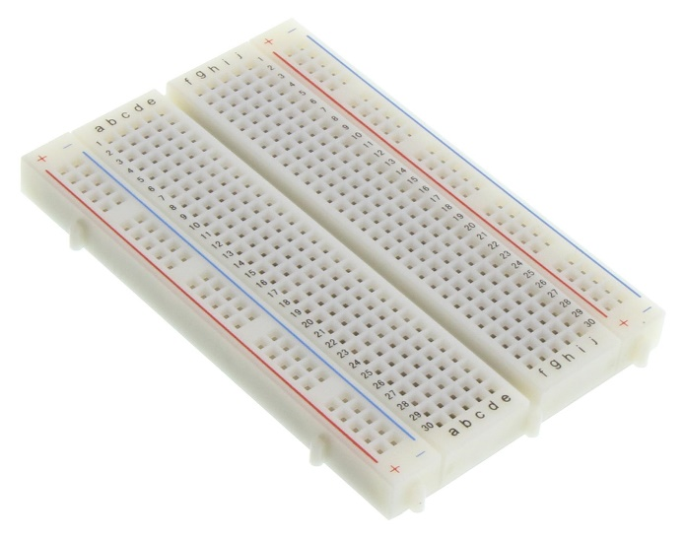

It is also categorized as a Solderless board. It means that the component does not require any soldering to fit into the board. Thus, we can say that breadboard can be reused.

We can easily fit the components by plugging their end terminal into the board. Hence, a breadboard is often called a plugboard.

III. Circuit Diagram

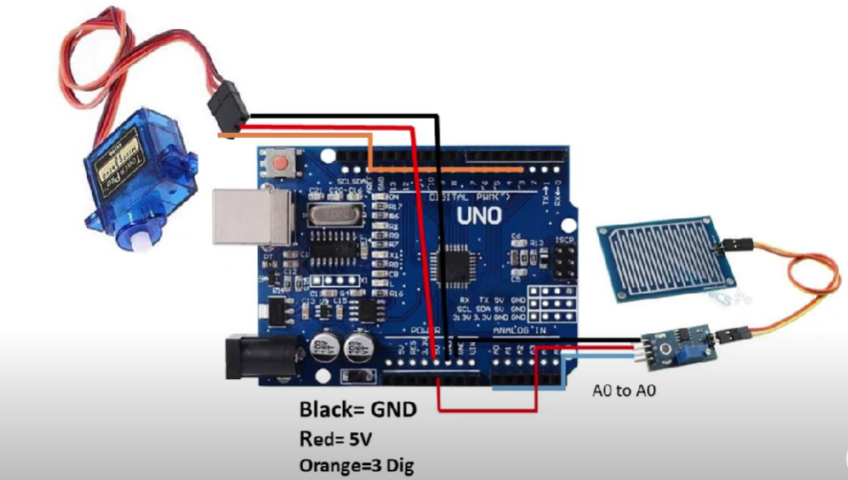

Fig 5 - Circuit Diagram

IV. WORKING PRINCIPLE

A Rain sensor based automatic rain sensing umbrella works on the principle If rainfall is detected in the sensor, the sensor sends trigger to the arduino controller. The arduino now operates the motors to open the small umbrella shed to protect user from rain.

It is the main object of the present invention to provide an automatic umbrella control mechanism, which enables the user to open and close the umbrella automatically by switching on a button.

The opening and closing of umbrella are being controlled through a motor. Motor can give a quick and instant response to the shaft so that shaft can play a major role of power transmission for opening and closing of umbrella. Motor provides required rpm to the shaft. Whenever the sensor senses the rain.

Then Arduino sends signal further to the motor so that motor may activate and deliver required rpm to the coupling shaft.

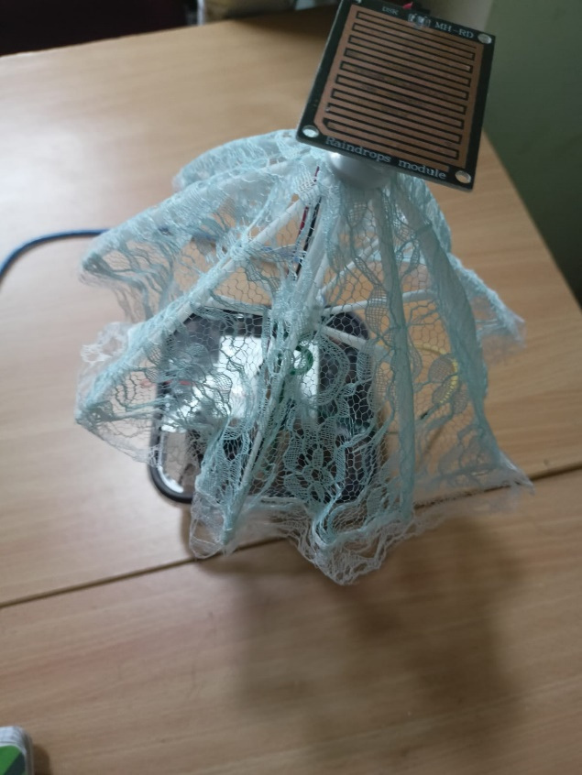

Fig 6 – top view of our prototype

If rainfall is detected in the sensor, the sensor sends trigger to the Arduino controller.

This project is a cost-effective way of providing automated controlled shade from rain. So, the problems of open and vast areas can be solved by using such types of automated umbrella.

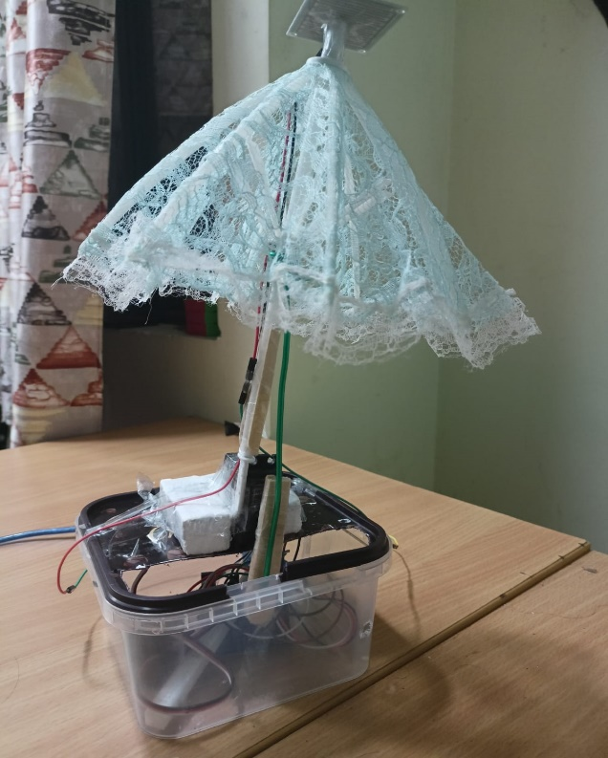

Fig 7 – side view of our prototype

V. CONCLUSION:

After completing our project successfully, we have concluded that our project is a cost-effective way of providing automated shade and shelter from rain. This type of automated umbrella could be widely used. It could be installed in large open spaces where shade and shelter are required. Further modifications can be made to get better result. If we use a powerful motor having larger torque with larger umbrella, i.e., cafe size umbrella, it may be an effective way of proving shelter on wide open spaces.

VI. ACKNOLEDGEMENT

We would like to take this opportunity to express my heartfelt gratitude to Professor Bipin Mandi for his invaluable guidance and support during our academic journey. Professor Mandi's vast knowledge, expertise, and dedication have been instrumental in shaping our understanding of the subject matter and preparing me for the challenges that lie ahead.

His commitment to excellence, coupled with his ability to inspire and motivate students, has had a profound impact on our personal and professional development. The insights and wisdom that we have gained from Professor Mandi will continue to serve us well in all our future endeavours.

We are honoured to have had the opportunity to learn from such an exceptional educator and mentor, and we are truly grateful for his unwavering support and guidance. Thank you, Professor Mandi, for everything you have done for us.

VII. References

1. Nevonprojects- <https://nevonprojects.com/automatic-rain-water-sensing-umbrella/>
2. ResearchGate–<https://www.researchgate.net/publication/347331030_Design_of_an_Automatic_Umbrella_Actuated_through_Water_and_Temperature_Sensors>
3. TechsScience- <https://youtu.be/SVRvx1OQhQg>
4. Arduino- <https://www.arduino.cc/>