MAMC BioStat
Quick-Start Guide for UG & PG students
Free, open-source biostatistics software built on R - Maulana Azad Medical College, New Delhi - Version 1.1.0

1. Installing and starting
- Windows 10/11: double-click MAMC_BioStat_Setup_..._Windows10-11.exe, then Next and Install. R and everything else is included - no admin rights and no internet needed. Start it from the desktop icon.
- Windows 7/8.1: use the ..._Windows7-8.exe installer (needs Windows 7 SP1 with updates and Chrome or Edge 109).
- Mac: open the .dmg (Apple chip or Intel version), drag MAMC BioStat to Applications, and the first time right-click it and choose Open. If R is not yet on the Mac, the app installs it for you (included).
- College PC without install rights: extract the portable .zip (e.g. to a USB stick) and double-click “MAMC BioStat.vbs”.
- MAMC BioStat opens in its own window and runs only on your computer - your data never leave it. Close the window to quit.
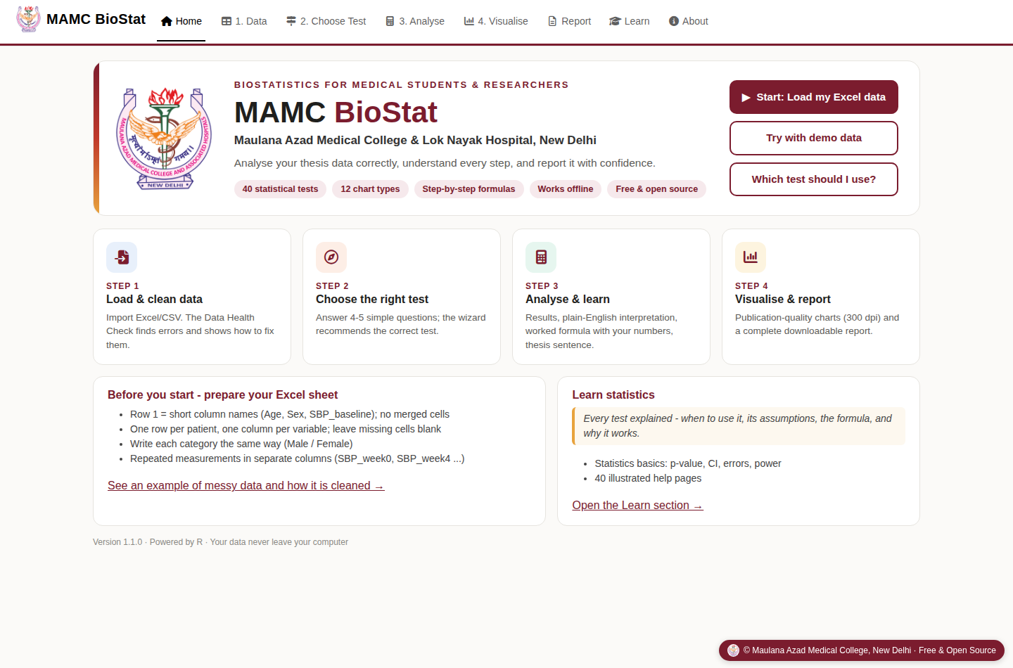
Figure 1. Home screen - four steps: Data, Choose Test, Analyse, Visualise & Report

2. Prepare and import your Excel sheet
- Row 1 holds short column names (Age, Sex, SBP_baseline). Do not use merged cells or a title row.
- Use one row per patient and one column per variable. Remove names, phone numbers and CR numbers.
- Put only numbers in numeric columns: no units ('120 mg') and no '<5'. Leave missing cells blank.
- Spell each category the same way every time (Male / Female, not M, male, MALE).
- Before-after or repeated values go in separate columns (SBP_week0, SBP_week4, SBP_week8).
Open the 1. Data tab and click Browse. The Data Health Check runs straight away and lists each problem with what to do about it. Tick the automatic fixes you want and click Apply selected fixes. Your original file is never changed, and you can download the cleaned copy. If a numeric code such as 0/1 means a category, use Treat as categorical.
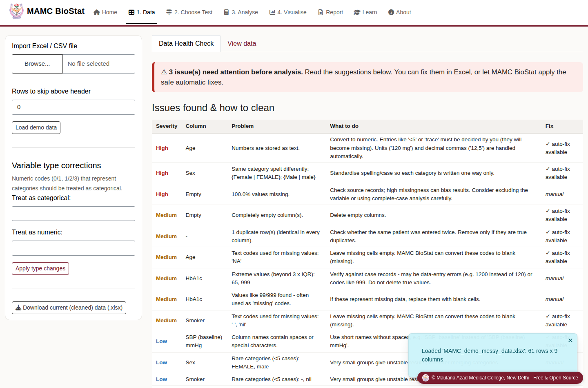
Figure 2. Data Health Check on the messy demo file - problems found, suggestions and one-click fixes

3. Choose the right test
Open 2. Choose Test and answer the questions: your aim, the outcome type, the number of groups, independent or paired, and whether the data are normal. If you do not know whether the data are normal, choose “I don't know - check it for me”. The recommended test appears on the right, and Open this test takes you straight to it.
Your aim | Normal numeric data | Skewed / ordinal data | Categorical outcome
1 group vs known value | One-sample t-test | Wilcoxon signed-rank (one sample) | One-sample proportion / chi-square GOF
2 independent groups | Independent t-test (Welch) | Mann-Whitney U | Chi-square / Fisher's exact
2 paired measurements | Paired t-test | Wilcoxon signed-rank (paired) | McNemar
3+ independent groups | One-way ANOVA + Tukey | Kruskal-Wallis + Dunn | Chi-square (R x C)
3+ repeated measurements | Repeated-measures ANOVA | Friedman | -
Association of two variables | Pearson r | Spearman rho | Chi-square, OR / RR
Predict outcome, adjust confounders | Linear regression | - | Logistic regression
Time to event | Kaplan-Meier + log-rank; Cox regression
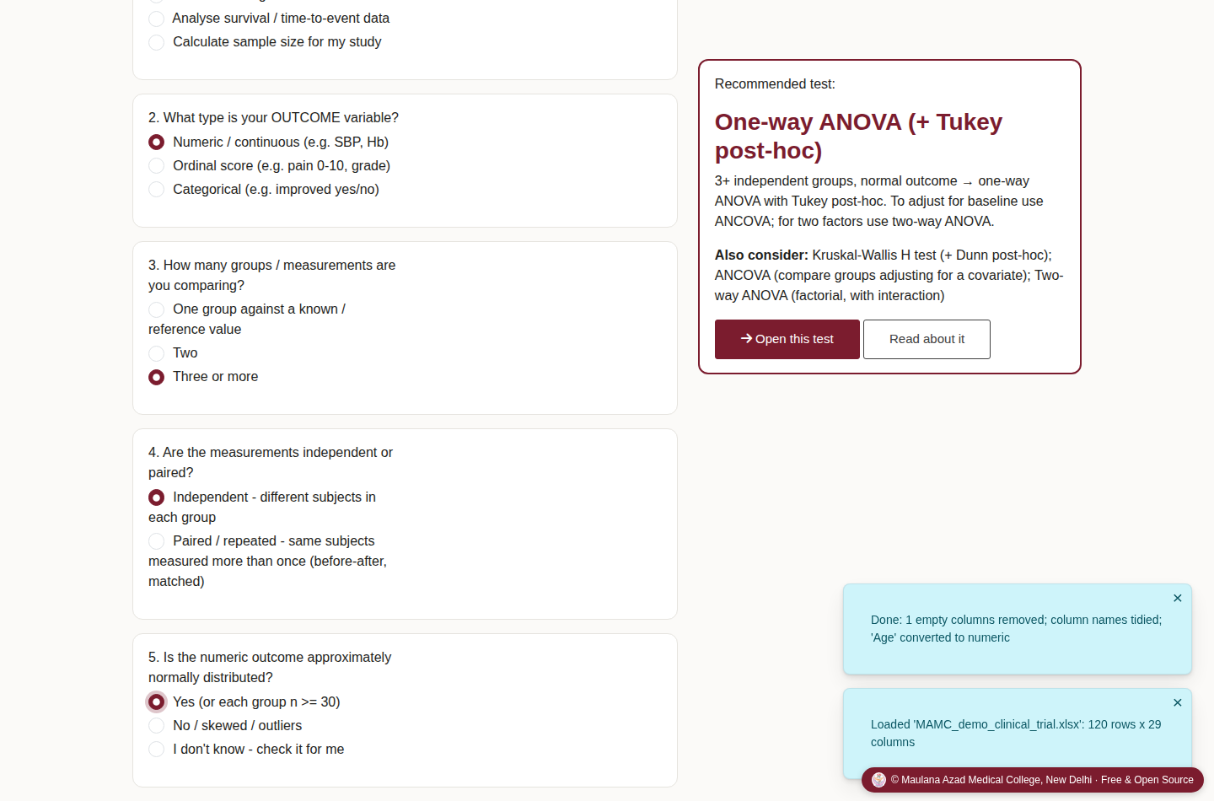
Figure 3. The test-chooser wizard recommending one-way ANOVA

4. Run the analysis
In 3. Analyse, the software asks only for what that test needs, such as an outcome variable, a grouping variable or a reference value. Select them and click Run analysis. You get four tabs:
- Results - tables, plain-English interpretation, the H0 decision, assumption checks (normality, equal variances, expected counts) with warnings, effect size with 95% CI, and a ready-made thesis sentence.
- Plot - a graph for the test, downloadable at 300 dpi.
- Step-by-step calculation - the formula worked out with your own numbers, step by step.
- Help - when to use the test, its hypotheses and assumptions, the formula, background (why and how it works) and what to do if assumptions fail.
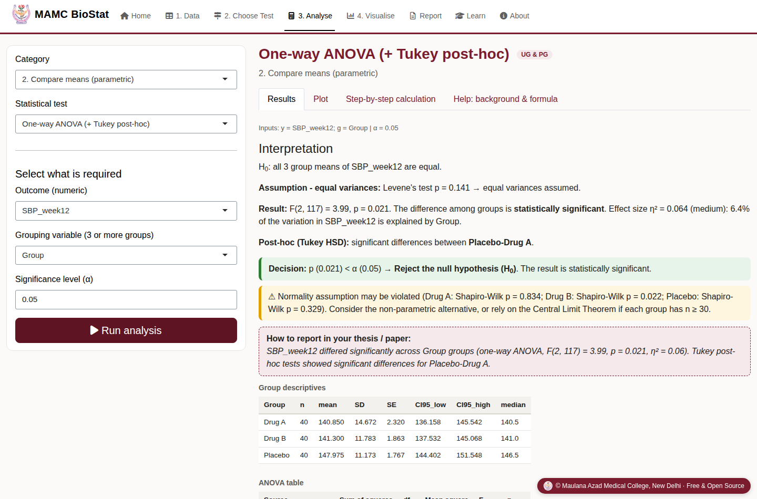
Figure 4. One-way ANOVA results with interpretation, decision and thesis sentence
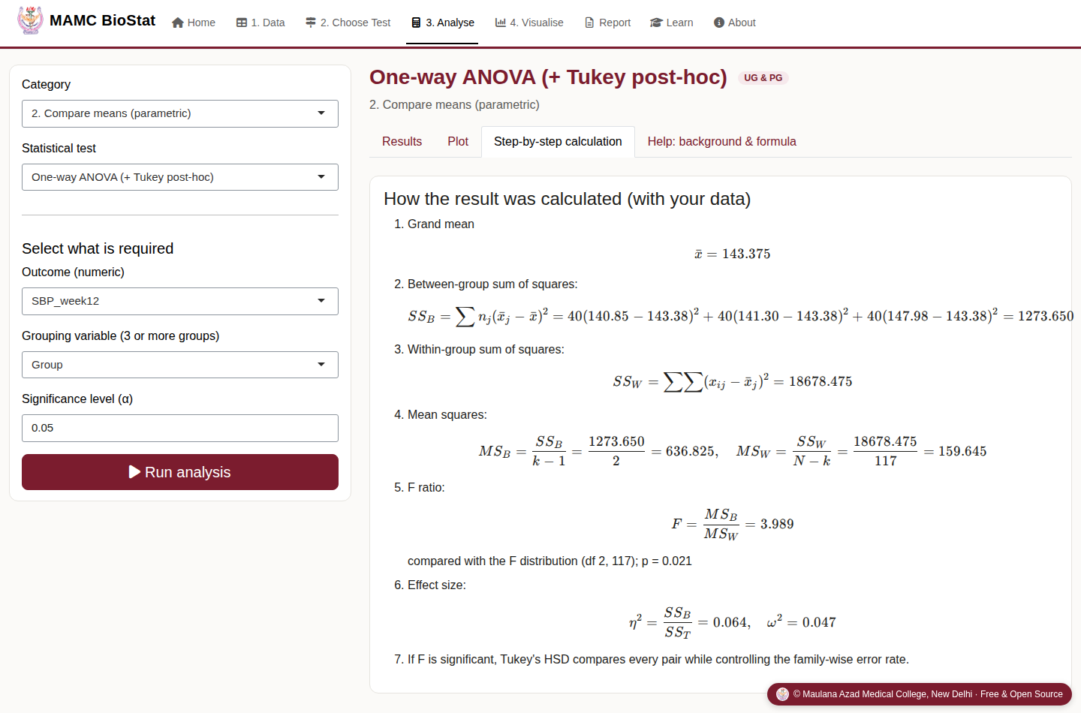
Figure 5. Worked calculation showing every step of the F test

5. Make charts (with Python code)
The 4. Visualise tab draws 12 chart types: histogram, density, box, violin, mean ± error bars, bar (grouped / stacked / 100%), pie / donut, scatter with regression line, line chart over time, correlation heat map, Q-Q plot and forest plot. Choose variables, a colour palette (the default is colour-blind safe), value labels, titles and font size. Export as PNG (300 dpi), PDF or TIFF for journals.
The Python code for this chart tab gives the same chart in pandas + seaborn + matplotlib. Download the .py file, change the file name in the read_excel line, and run it in Jupyter or Spyder.
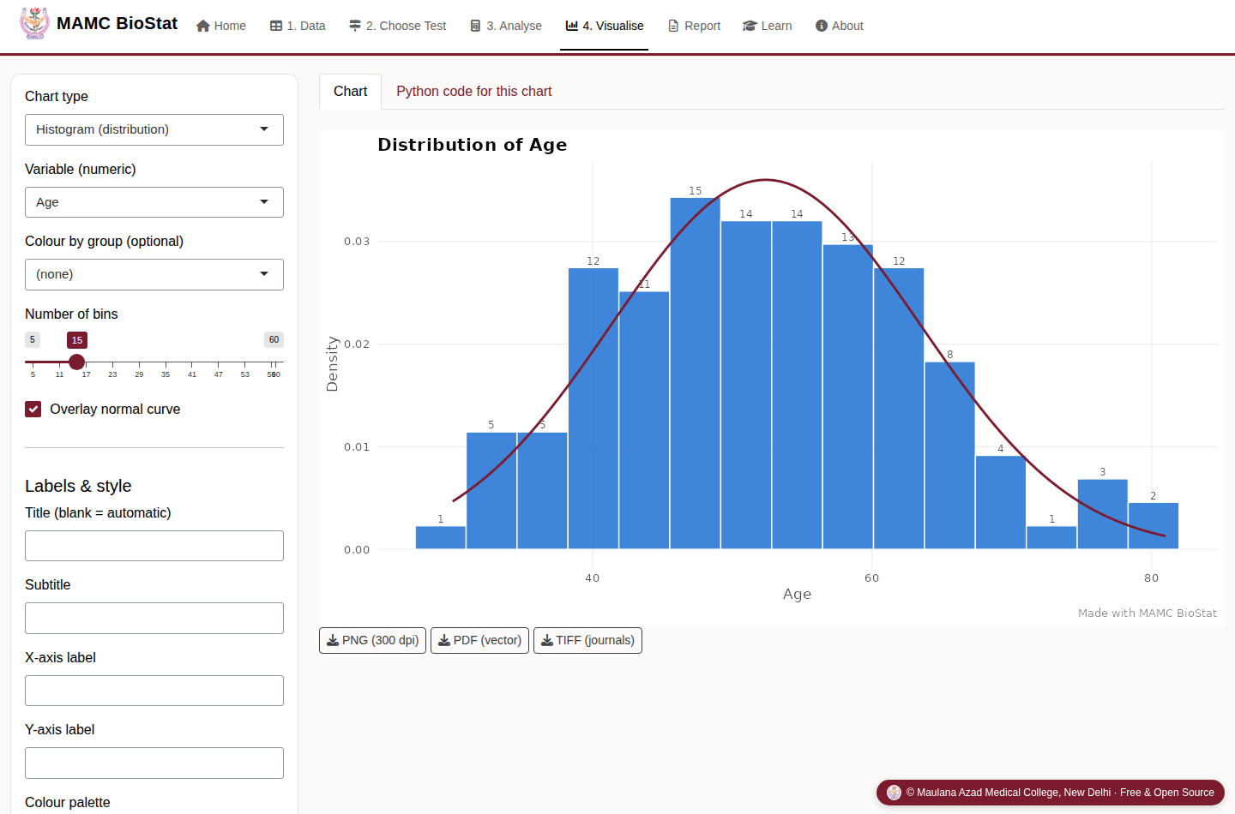
Figure 6. Chart studio - labelled histogram with normal curve
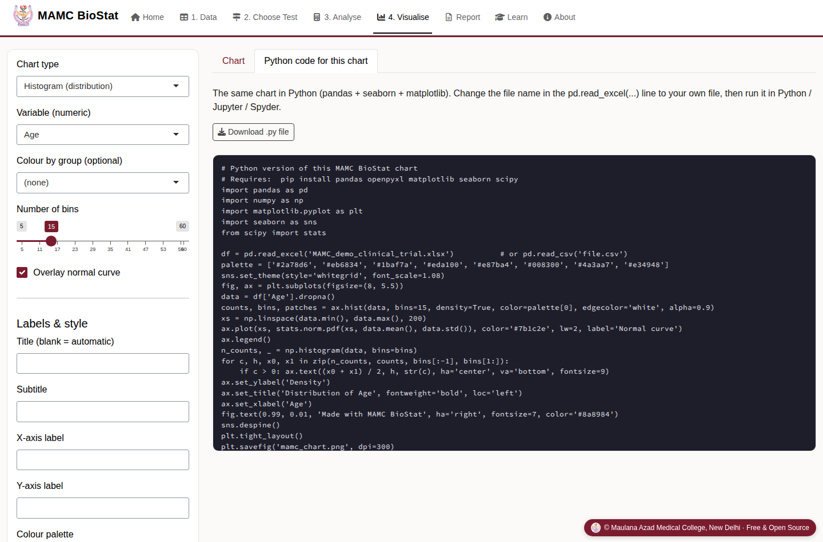
Figure 7. Matching Python code generated for the chart

6. Report, learning and help
- Report - every analysis you run is collected here. Download it as an HTML report (it opens in any browser and can be copied into Word) or download all result tables as one Excel file.
- Learn - a statistics primer (p-value, CI, type I/II error, parametric vs non-parametric, multiple comparisons) and a page for each of the 40 methods.
- Significance level - the default is α = 0.05. You can change it in the Analyse tab.

Methods available (40)
Descriptive statistics, frequency tables, normality; one-sample, independent (Student/Welch) and paired t-tests; one-way, two-way and repeated-measures ANOVA, ANCOVA; Wilcoxon (one-sample and paired), Mann-Whitney, Kruskal-Wallis + Dunn, Friedman; chi-square (association and goodness-of-fit), Fisher's exact, McNemar, OR/RR/NNT, one- and two-proportion tests; Pearson, Spearman/Kendall, correlation matrix; linear and logistic regression; Cohen's kappa, Bland-Altman, ICC, diagnostic accuracy, ROC/AUC, Cronbach's alpha; Kaplan-Meier + log-rank, Cox regression; sample size for means, proportions, prevalence, correlation and ANOVA.

Citing the software
MAMC BioStat (Version 1.1.0) [Computer software]. Maulana Azad Medical College, New Delhi; 2026. Available from: https://github.com/ManuHCI/mamc-biostat
Interpretations are generated automatically to help you learn. You remain responsible for the choice of method, so consult a biostatistician for complex designs.

