
MAMC ML Studio
User Guide
Machine learning for medical students and researchers - no coding needed
Version 1.0.0 | October 2026

Developed by Faculties of Maulana Azad Medical College & Govind Ballabh Pant Hospital, University of Delhi, New Delhi.
Contributed by
Dr. Pradeep Kr. Dabla, Director Professor, Department of Biochemistry, GB Pant Hospital
Dr. Manu Kumar Shetty, Professor, Department of Pharmacology
Medical Innovation Centre, Maulana Azad Medical College, New Delhi
Free and open-source software (GNU GPL-3.0). For learning and research - not for clinical decisions on individual patients.

Contents
1 What MAMC ML Studio does
2 Installing and starting
3 A 15-minute guided tour
4 The screens, one by one
5 The demo datasets
6 Which algorithm? Quick reference
7 Reading the results - cheat sheet
8 Good practice for a thesis or paper
9 Frequently asked questions and troubleshooting
10 For teachers and developers
References

1. What MAMC ML Studio does
MAMC ML Studio lets you build, test and understand machine-learning (ML) prediction models from your own Excel data by pointing and clicking. It is the companion of MAMC BioStat: BioStat answers 'is there a difference / an association?', ML Studio answers 'can we predict the outcome for a new patient, and how well?'.
Every step is explained in simple words, with medical analogies, and every result is shown in the language doctors already know - sensitivity, specificity, predictive values, ROC curves and confidence intervals.
Area | What you get
Import & clean | Excel or CSV import. The Data Health Check finds the usual mistakes (numbers typed as text, 'NA' and '999' codes, 'male / M / MALE', duplicates, impossible values, ID columns, data leakage) and fixes them with one click. Every change is logged.
Choose | Detects whether you need classification or regression, and the model advisor ranks 8-9 algorithms for *your* data and explains why.
See inside | A live picture shows how each algorithm divides *your* patients, and how its settings change that.
Train & tune | Train/test split, cross-validation and automatic setting search (grid / random search) - each shown as a diagram.
Results | Comparison with 95% confidence intervals, ROC and calibration curves, a cut-off slider, the 2x2 table, over/under-fitting verdict, important factors, odds ratios, partial dependence, learning curves.
Use & report | Predict for a new patient with reasons; a Word report with a ready-to-adapt methods paragraph; the same analysis as a Python script; trained models.
Learn | A built-in illustrated textbook, a sample-size calculator (Riley method) and patient clustering.

Privacy
Everything runs on your own computer. Your data are never uploaded to the internet.

2. Installing and starting
MAMC ML Studio comes as a normal installer. Python and every library it needs are inside the download, so nothing else has to be installed and no internet is needed after downloading. Download the file for your computer from https://github.com/ManuHCI/mamc-ml-studio/releases/latest (scroll down to Assets).
Your computer | Download this file
Windows 10 / 11 (64-bit) | MAMC_ML_Studio_Setup_1.0.0_Windows10-11.exe
Windows PC where you cannot install (college PC) | MAMC_ML_Studio_1.0.0_Windows_portable.zip
Mac with Apple chip (M1, M2, M3, M4) | MAMC_ML_Studio_1.0.0_macOS-AppleSilicon.dmg
Mac with Intel processor | MAMC_ML_Studio_1.0.0_macOS-Intel.dmg

Needs Windows 10 or 11 (64-bit) or macOS 12 Monterey or newer, about 1.5 GB of free disk space and 4 GB RAM. Not sure which Mac you have? Apple menu > About This Mac: 'Chip: Apple M...' means Apple chip, 'Processor: Intel...' means Intel.

2.1 Windows 10 / 11
1. Double-click the downloaded MAMC_ML_Studio_Setup_...exe.
2. A blue box 'Windows protected your PC' appears (the software is safe, but new and not signed with a paid certificate). Click the small words More info, then Run anyway. Do not click 'Don't run'.
3. Click Next > I Agree > Install > Finish. No administrator password is needed.
4. Start the software from the MAMC ML Studio icon on your Desktop (or the Start menu).
5. A small 'Starting...' window appears and after a few seconds the software opens in its own window.
6. To quit, simply close the window. The software stops by itself after half a minute.
Download warning
If Edge or Chrome says the file 'isn't commonly downloaded', click the three dots next to the download, then Keep and Keep anyway. To remove the software later: Settings > Apps > MAMC ML Studio > Uninstall.

2.2 Windows - portable version (no installation)
1. Right-click the downloaded ..._Windows_portable.zip and choose Extract All.
2. Open the extracted folder MAMC_ML_Studio and double-click MAMC ML Studio.exe (if Windows warns: More info > Run anyway).
3. Keep the whole folder together; it can also be copied to a pen drive.

2.3 Mac
1. Open the downloaded .dmg file and drag MAMC ML Studio onto the Applications folder.
2. Open Applications, right-click (or Control-click) MAMC ML Studio and choose Open, then Open again. This is needed only the first time, because the app is not from the App Store.
3. On macOS 15 or newer, if there is no Open button: click Done, open System Settings > Privacy & Security, scroll down and click Open Anyway.
4. The software opens in its own window (Chrome or Edge if installed, otherwise Safari). Close the window to quit.

2.4 Running from the source code (for developers)
The source code edition needs Python 3.10 or newer. Windows: double-click START_MAMC_ML_Studio_Windows.bat; Mac: START_MAMC_ML_Studio_Mac.command; Linux: bash start_mamc_ml_studio_linux.sh. The first start creates a private Python environment in the folder .venv and downloads the components (internet needed, 5-10 minutes). Experienced users can also run pip install -r requirements.txt and then streamlit run app.py.

2.5 The screen layout
The menu on the left lists the eight steps of building a prediction model, followed by 'Learn & other tools'. Below the menu, Your progress ticks off what you have done. Every chart has a small camera button (top-right when you point at it) that saves a high-resolution PNG for your slides or thesis.

Figure 1. The home page. 'Guided demo' walks you through every step with a ready-made dataset.

3. A 15-minute guided tour
Click Guided demo on the home page. The software loads a study of 328 adults followed for 5 years (did they develop type 2 diabetes?), typed into Excel with the usual mistakes. A blue 'Guided demo' box on every page tells you what to do and what to notice.
Step | What to do
1. Load data | Look at 'What the software sees in each column': types, blanks, examples.
2. Check & clean | Read a few problems. Notice On_metformin - it is only known after diabetes is diagnosed, so it would let the model cheat (leakage). Click Apply all recommended fixes.
3. Explore | 'Outcome vs predictors' -> Fasting_glucose: patients who developed diabetes had higher values.
4. Choose | Read the advisor's reasons. At the bottom, choose Fasting_glucose and BMI and compare Logistic Regression (a straight line), Decision Tree (boxes) and K-Nearest Neighbours (wiggly).
5. Train & tune | Keep 80:20 and 5-fold cross-validation. For Random Forest choose 'grid search'. Press Train.
6. Results | Compare models; move the cut-off slider and watch sensitivity and specificity trade off.
7. Predict | Change a test patient's glucose or BMI; see the probability and the reasons.
8. Report | Download the Word report and the Python script.

4. The screens, one by one

4.1 Load data
Upload an Excel (.xlsx, .xls) or CSV file, or pick one of the six demo datasets. If your Excel file has several sheets you choose the sheet; if the column names are not in row 1 you can say which row they are in. The table What the software sees in each column shows how each column was understood (number, categories, two groups, ID, free text, date, empty) and how many cells are blank. The tab What data do I need? lists the rules for a good sheet.
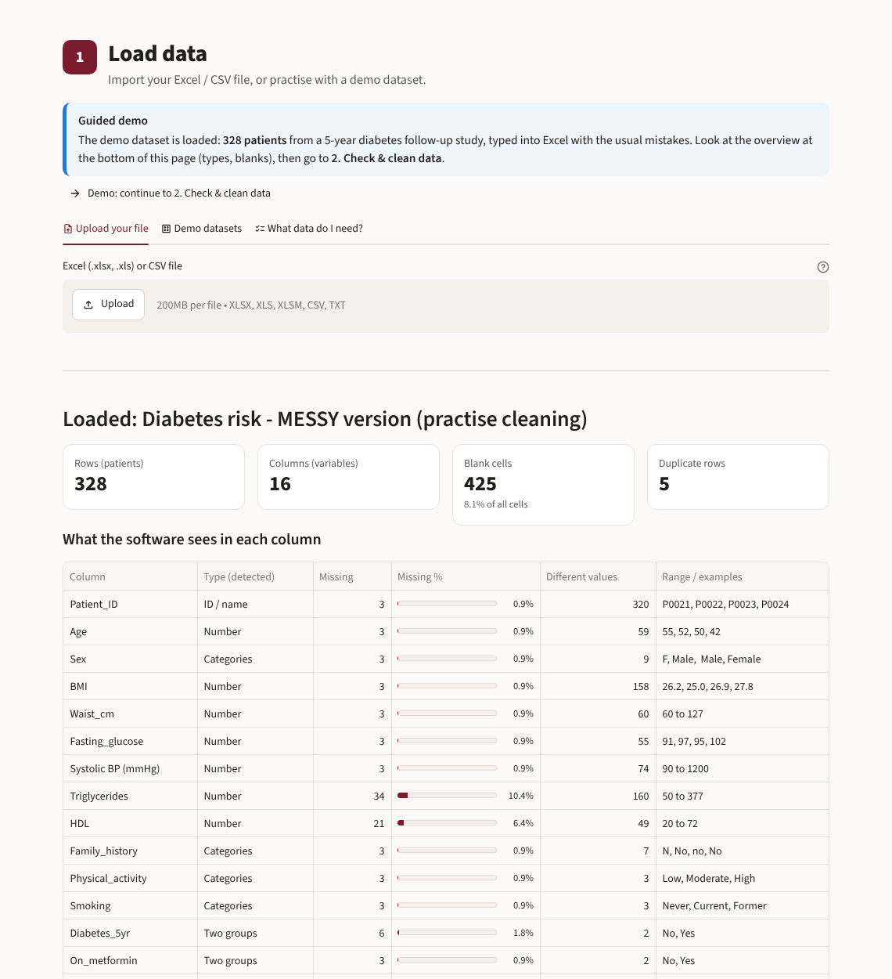
Figure 2. Load data: the demo sheet is loaded and every column is described.
A good Excel sheet in one sentence
One row per patient and one column per variable. Short column names in row 1, units in the name (Hb_g_dL), never in the cells. Leave missing cells blank. Write each category the same way. Use only predictors known before the outcome. Remove names, phone numbers and hospital IDs.

4.2 Check & clean data (the Data Health Check)
Choose the outcome column at the top (this enables extra checks such as leakage and events per variable). Problems are grouped as Must fix, Should fix, Worth checking and For information. Each card says what was found, why it matters for ML, and offers fixes with the recommended one pre-selected. You can apply fixes one by one or all at once, and undo everything. The cleaning log records every change, also as Python (pandas) code, and you can download the cleaned data.
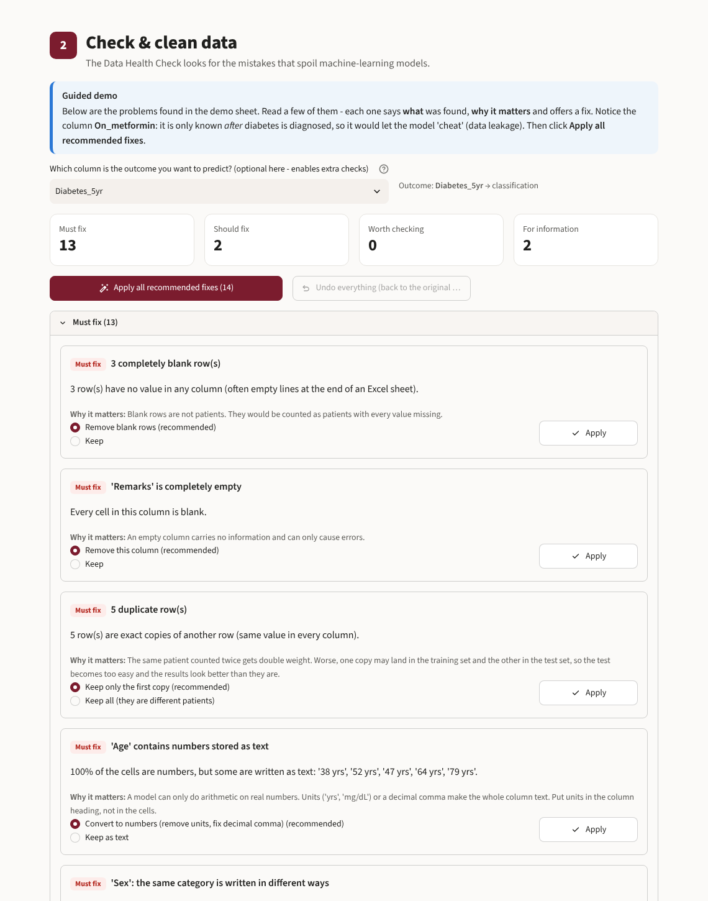
Figure 3. The Data Health Check on the messy demo sheet.
Problem | Recommended action
Blank rows / empty or constant columns | Remove
Duplicate rows | Keep the first copy (duplicates can leak into the test set)
Numbers stored as text ('45 yrs', '27,5') | Convert to numbers
Missing values typed as NA, -, nil, 999 | Convert to blank
Male / male / M / MALE | Merge the spellings
Impossible values (age 250, BMI 0, SBP 1200) | Treat as missing (after checking the case record)
Extreme but possible values | Keep (tree models are not affected)
ID, name, free text, date columns | Remove from the analysis
A column that predicts the outcome almost perfectly | Possible leakage - remove unless truly measured before the outcome
Few events per predictor, unbalanced outcome | Information - use fewer predictors / balance the groups
Blank cells (<50%) | Leave them - the model fills them in from the training patients (imputation)

4.3 Explore data
Five tabs: One variable (histogram with mean, SD, median, IQR), Two variables (scatter, box plot or grouped bars, with optional colour), Outcome vs predictors (how each predictor differs between outcome groups), Correlations (heat-map) and Blank cells (where the missing values are).
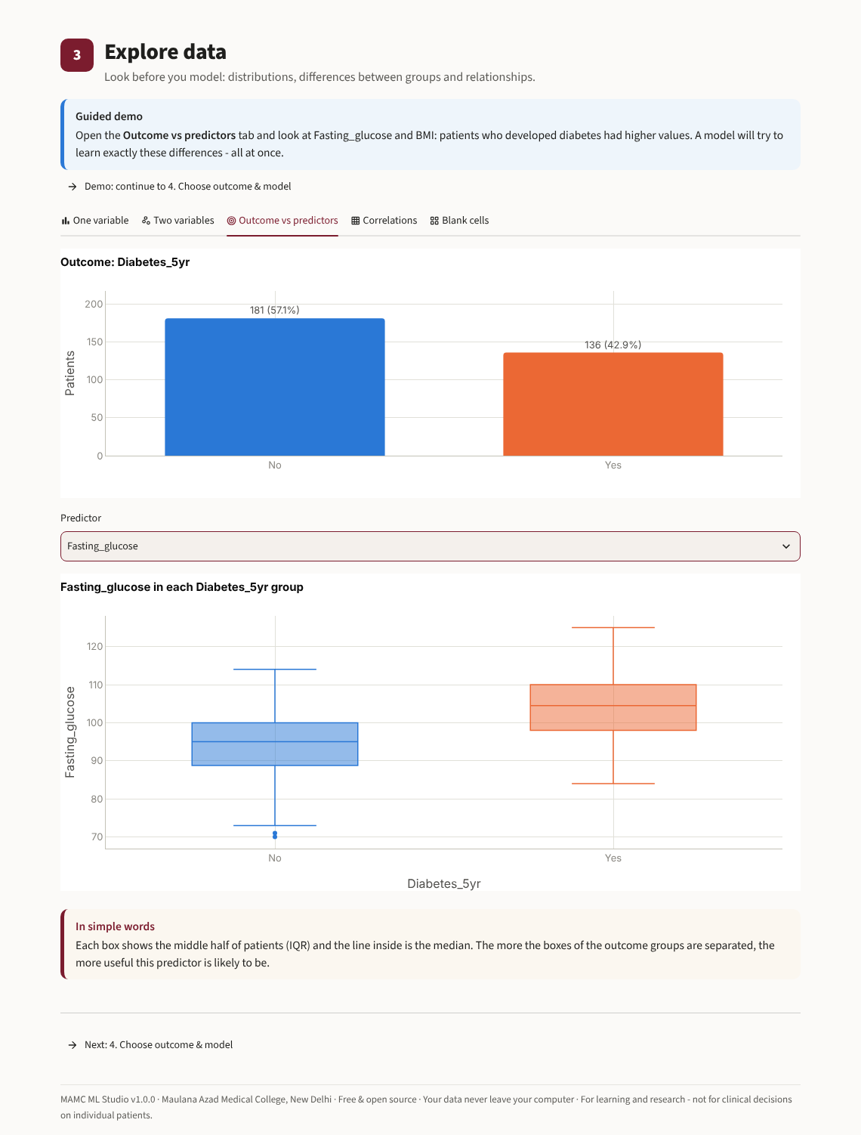
Figure 4. Outcome vs predictors: fasting glucose in patients with and without diabetes after 5 years.

4.4 Choose outcome & model
A. Pick the outcome. The software says whether this is classification (predict a group) or regression (predict a number) and, for two groups, asks which value is 'positive' (the disease you want to catch). B. Pick the predictors; columns that cannot be used are listed with the reason. C. The model advisor summarises your data (patients, predictors, events per variable, imbalance, blanks), asks what matters most to you (balance, explainability, accuracy) and ranks the algorithms with stars, reasons and cautions. Tick the models you want to train - comparing a simple model with one or two flexible ones is good practice.
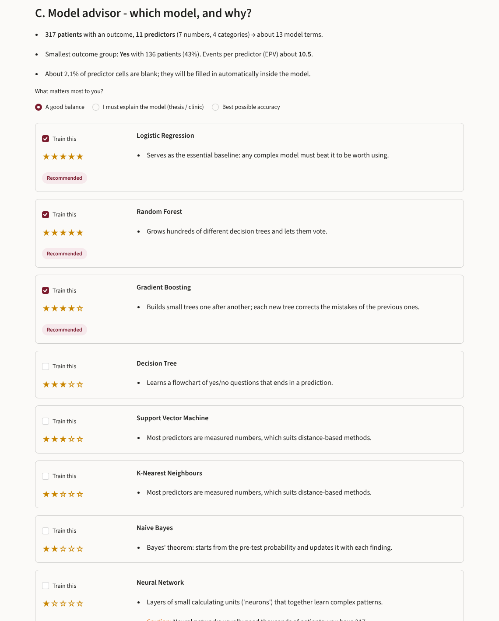
Figure 5. The model advisor explains why each model suits (or does not suit) this dataset.
D. An explainer card for every algorithm: one-line summary, an analogy, how it learns step by step, what it does to your data, strengths, weaknesses, when to use it, and its settings. E. The algorithm is trained on two of your predictors and the picture shows how it divides your patients. Change its settings and watch the boundary become simpler or more wiggly.
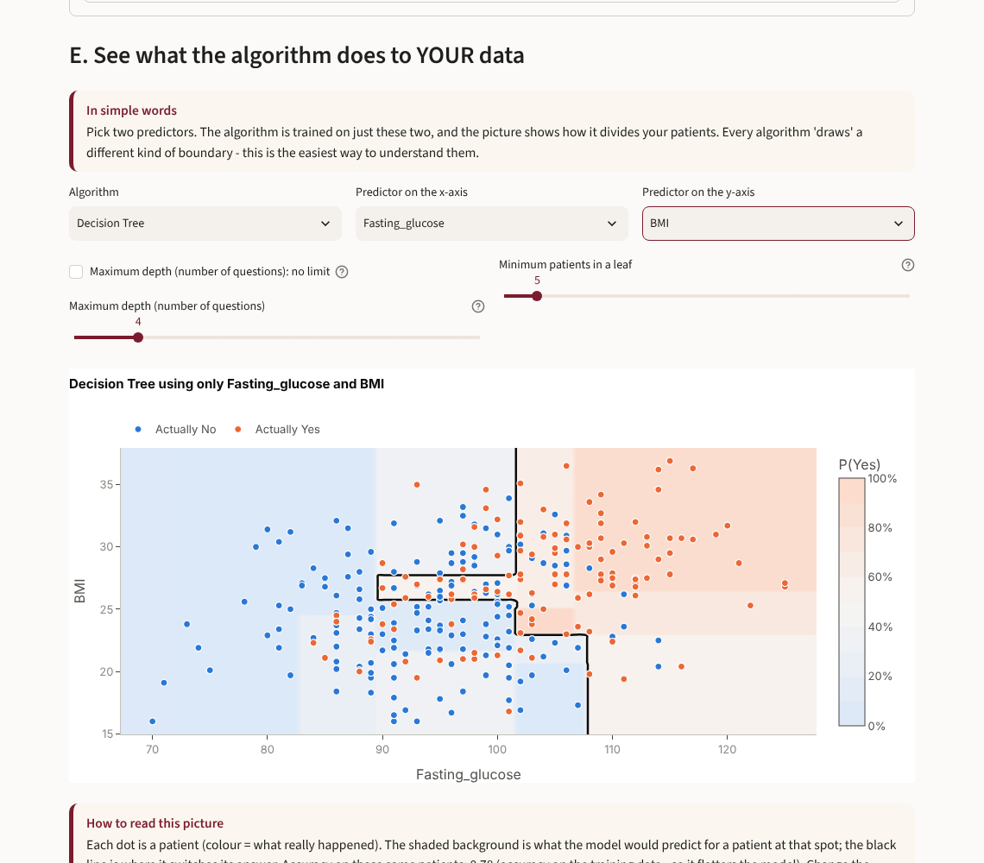
Figure 6. What a decision tree does to the data: it cuts the patients into boxes.

4.5 Train & tune
Step 1 - split: choose the percentage of patients locked away for the final test (20% is usual), the random seed (the same seed always gives the same split) and stratification. Step 2 - the pipeline: blanks are filled, numbers scaled and categories turned into 0/1 - all learned from the training patients only. Step 3 - cross-validation: k practice tests inside the training set, shown as a diagram, and the score used to judge the models (AUC, balanced accuracy, R2, MAE ...).
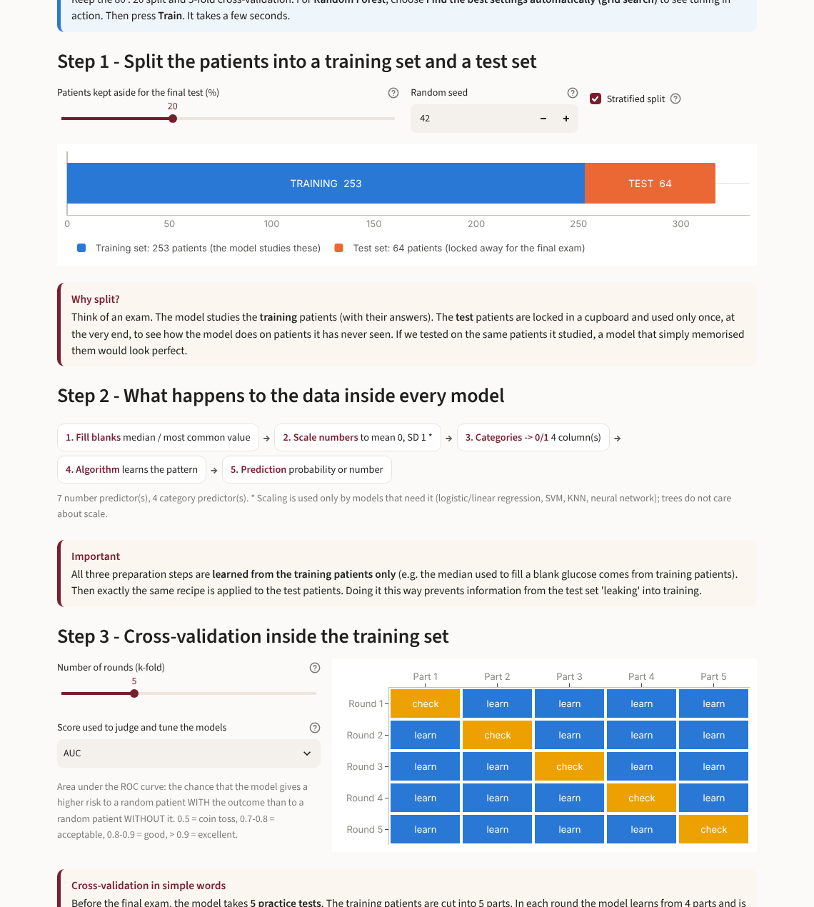
Figure 7. Training set vs test set, and the k-fold cross-validation diagram.
Step 4 - settings (hyperparameters): for each model choose 'recommended starting values', 'set them myself' (sliders with explanations of what low and high values do), grid search (every combination from a list) or random search (random combinations from wide ranges). The software tells you how many model fits this means. 'Balance the outcome groups' gives extra weight to the smaller group. Step 5 - Train: a live log explains what is happening. The summary table compares the training, cross-validation and test scores, and the tuning chart shows how each setting affects the score on training vs unseen patients - the clearest picture of overfitting.
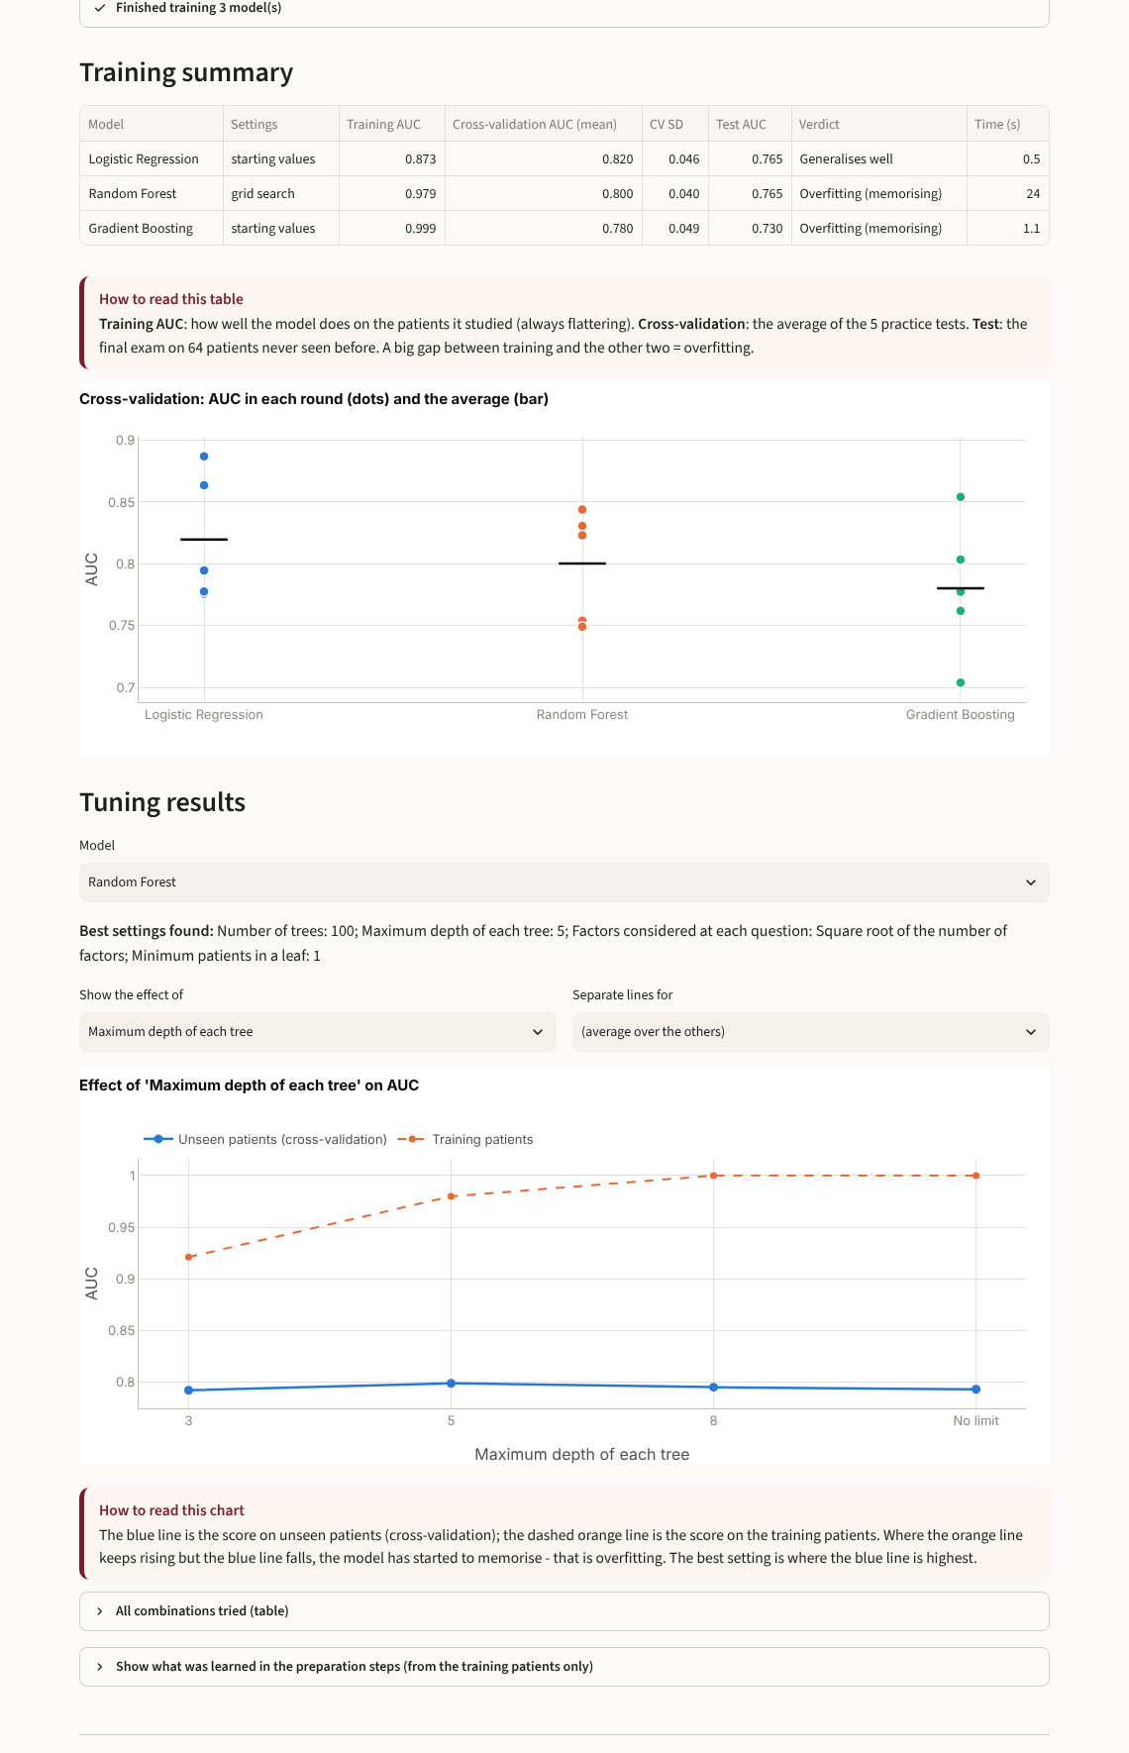
Figure 8. After training: summary table, cross-validation rounds and the tuning curve.

4.6 Results
The comparison table shows each model's test-set performance; the bar chart adds 95% bootstrap confidence intervals, and a box tells you whether the 'best' model is really better or only better by chance. ROC and calibration curves follow. Under One model in detail you get a plain-language verdict (generalises well / overfitting / weak), and four tabs:
- Performance - a cut-off slider (with 'Best balance (Youden)'), tiles for sensitivity, specificity, PPV, NPV, AUC and accuracy with 95% CI and a sentence such as 'Of 100 patients who truly are Yes, the model catches 74', the confusion matrix drawn as the familiar 2x2 table, ROC with the current cut-off, and how the cut-off changes every measure. For regression: R2, MAE, RMSE, predicted-vs-actual and error plots.
- Which factors matter - permutation importance (works for every model), odds ratios for logistic regression, coefficients for linear models, and partial-dependence curves ('how does the predicted risk change with glucose?').
- Over/under-fitting - training vs cross-validation vs test score, and the learning curve ('would more patients help?').
- Inside the model - the decision tree diagram and its rules, the tree-by-tree improvement of boosting, the learning curve of a neural network, and short descriptions for the other models.
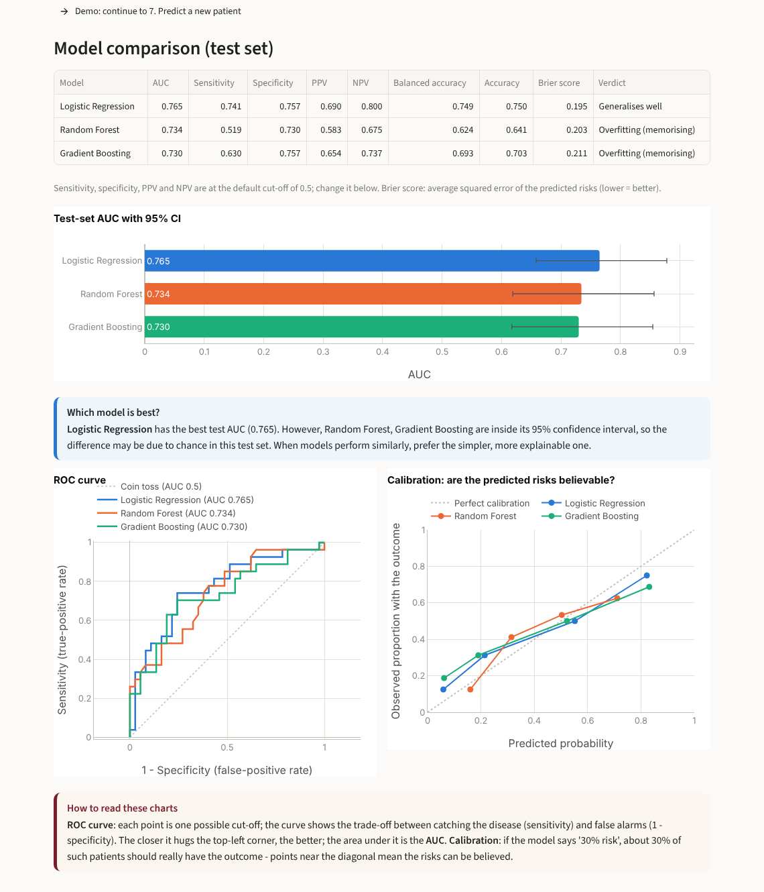
Figure 9. Model comparison with 95% confidence intervals, ROC and calibration curves.
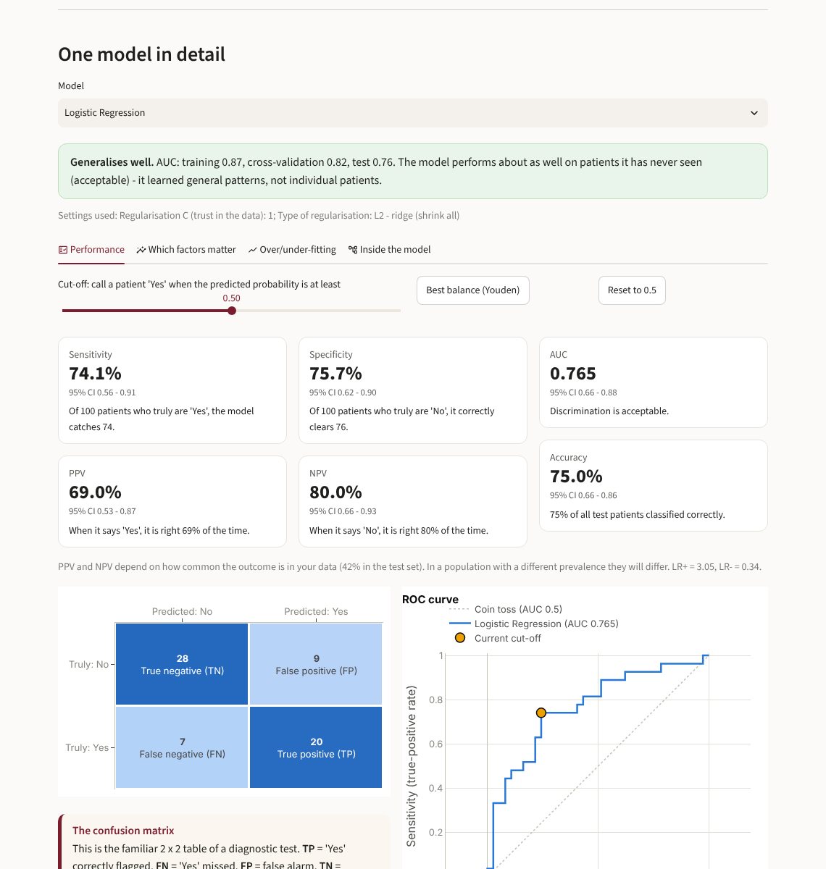
Figure 10. One model in detail: clinical metrics with 95% CI, the 2x2 table and the cut-off.
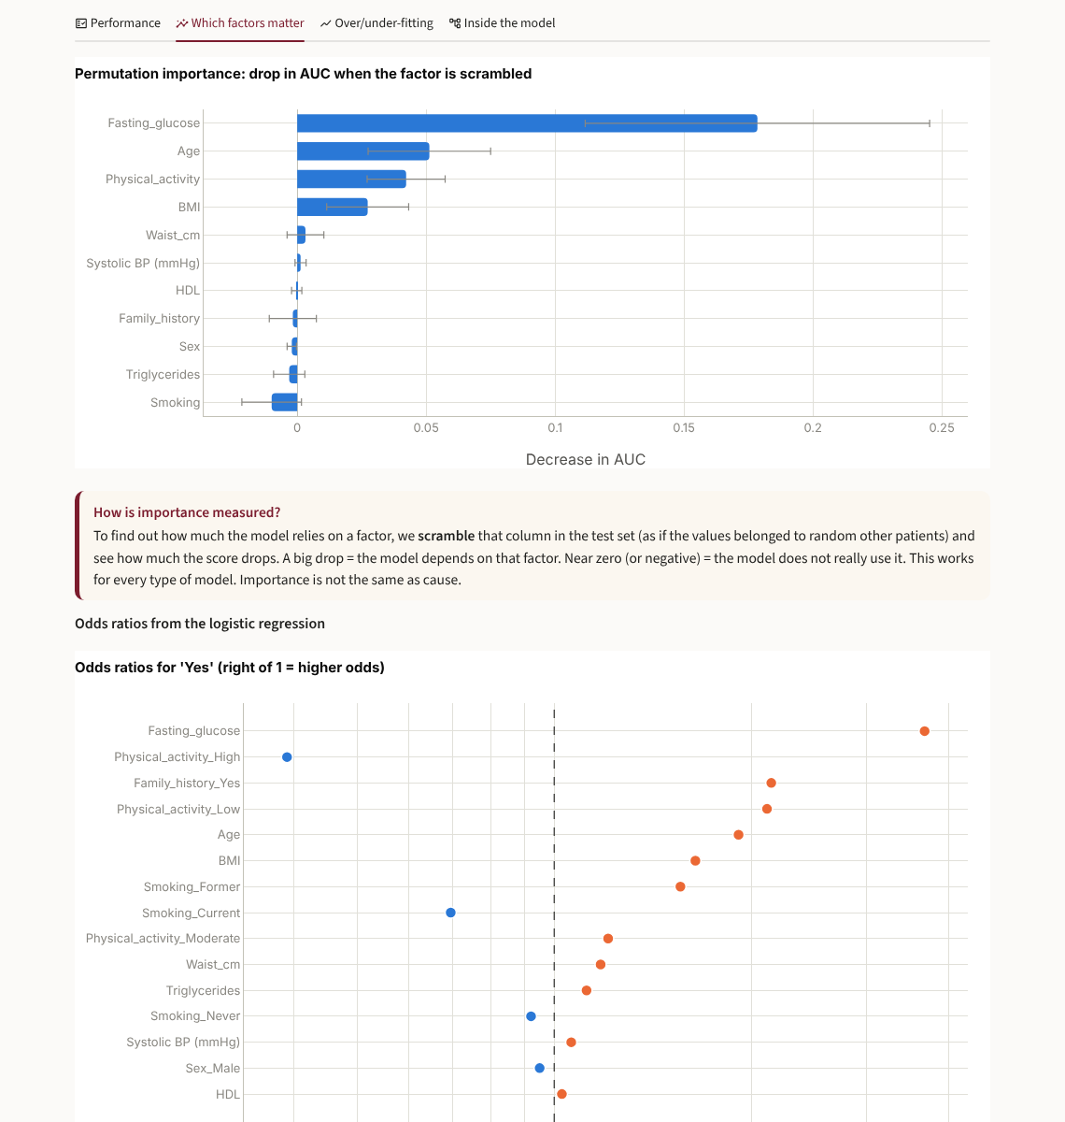
Figure 11. Which factors matter: permutation importance and odds ratios.

4.7 Predict a new patient
Start from a test patient or a 'typical' patient, change any value and press Predict. You see the probability (or the predicted number) and a chart of which of this patient's values pushed the prediction up (red) or down (blue). A warning appears when a value lies outside the range of the training patients. The second tab predicts for many patients from an Excel file (an empty template is provided).
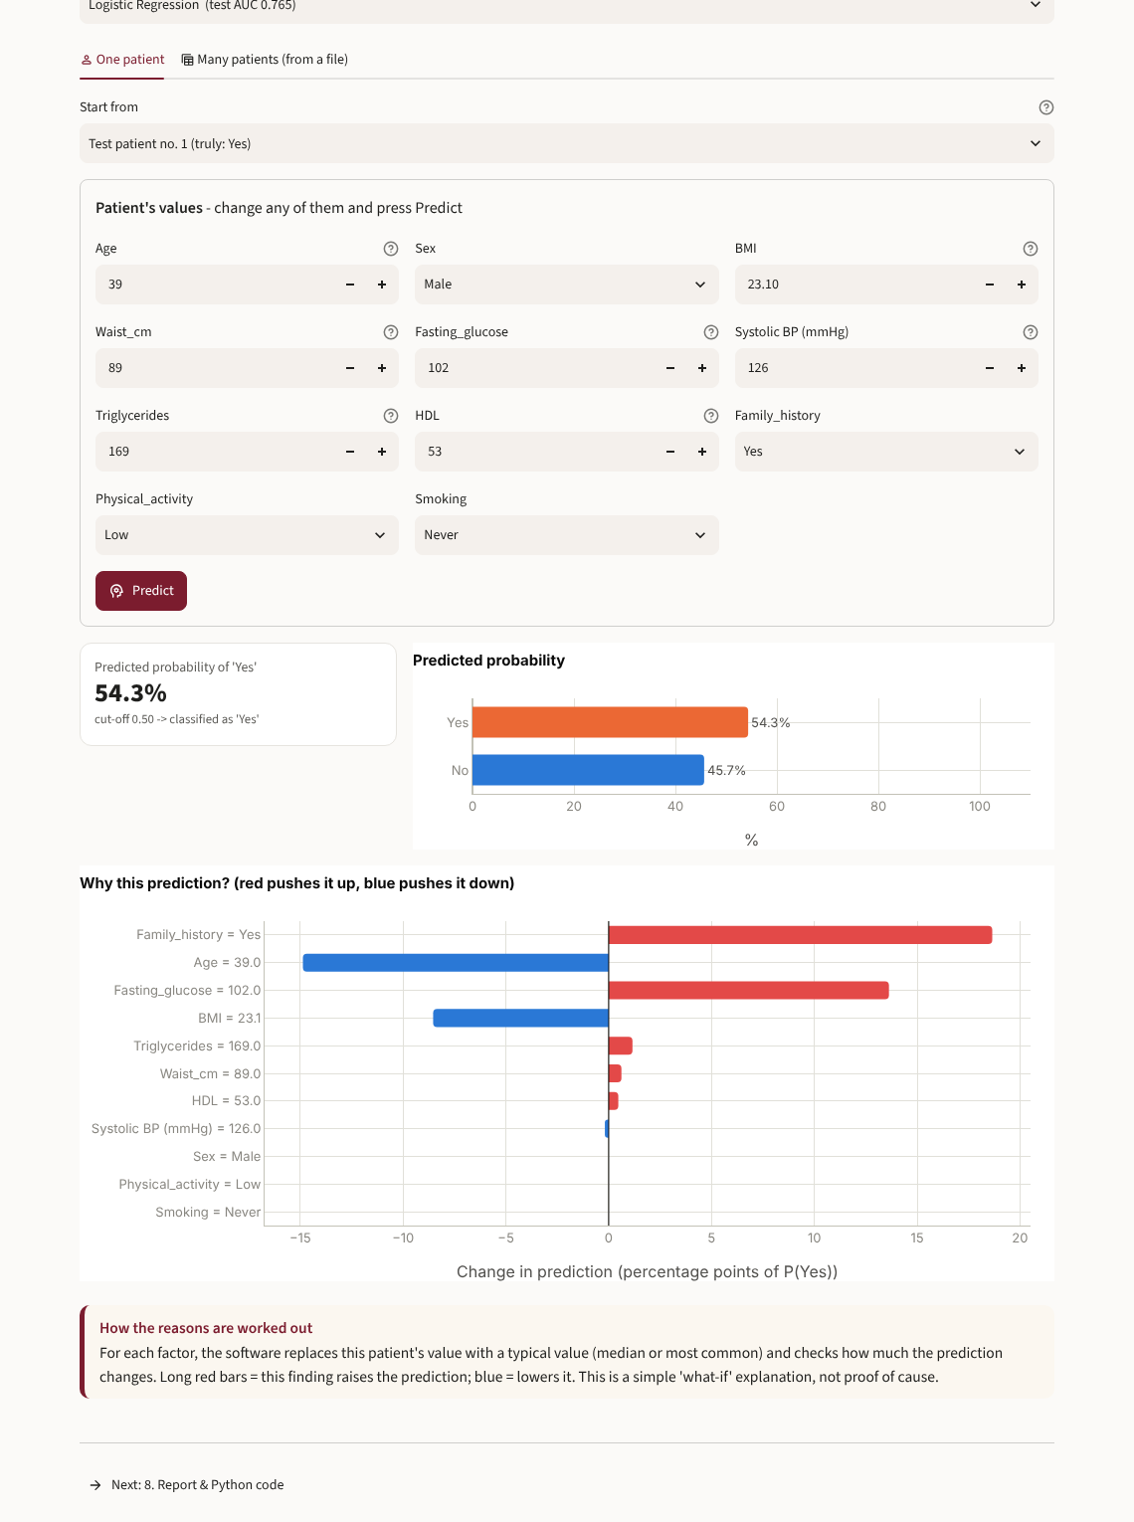
Figure 12. Predicting for one patient, with the reasons for the prediction.

4.8 Report & Python code
Prepare the Word report creates a .docx with the data description, cleaning log, a methods paragraph you can adapt for your thesis, the settings of each model, the results table with 95% CIs, ROC / calibration / confusion matrix, important predictors, fit verdicts, limitations and references. The methods and main-result text can also be copied directly. The analysis package (.zip) contains a Python script that repeats the whole analysis (split, pipeline, settings / tuning, evaluation, charts) together with your original and cleaned data - the natural next step for students who want to learn coding. You can also download the test-set predictions and the trained models.
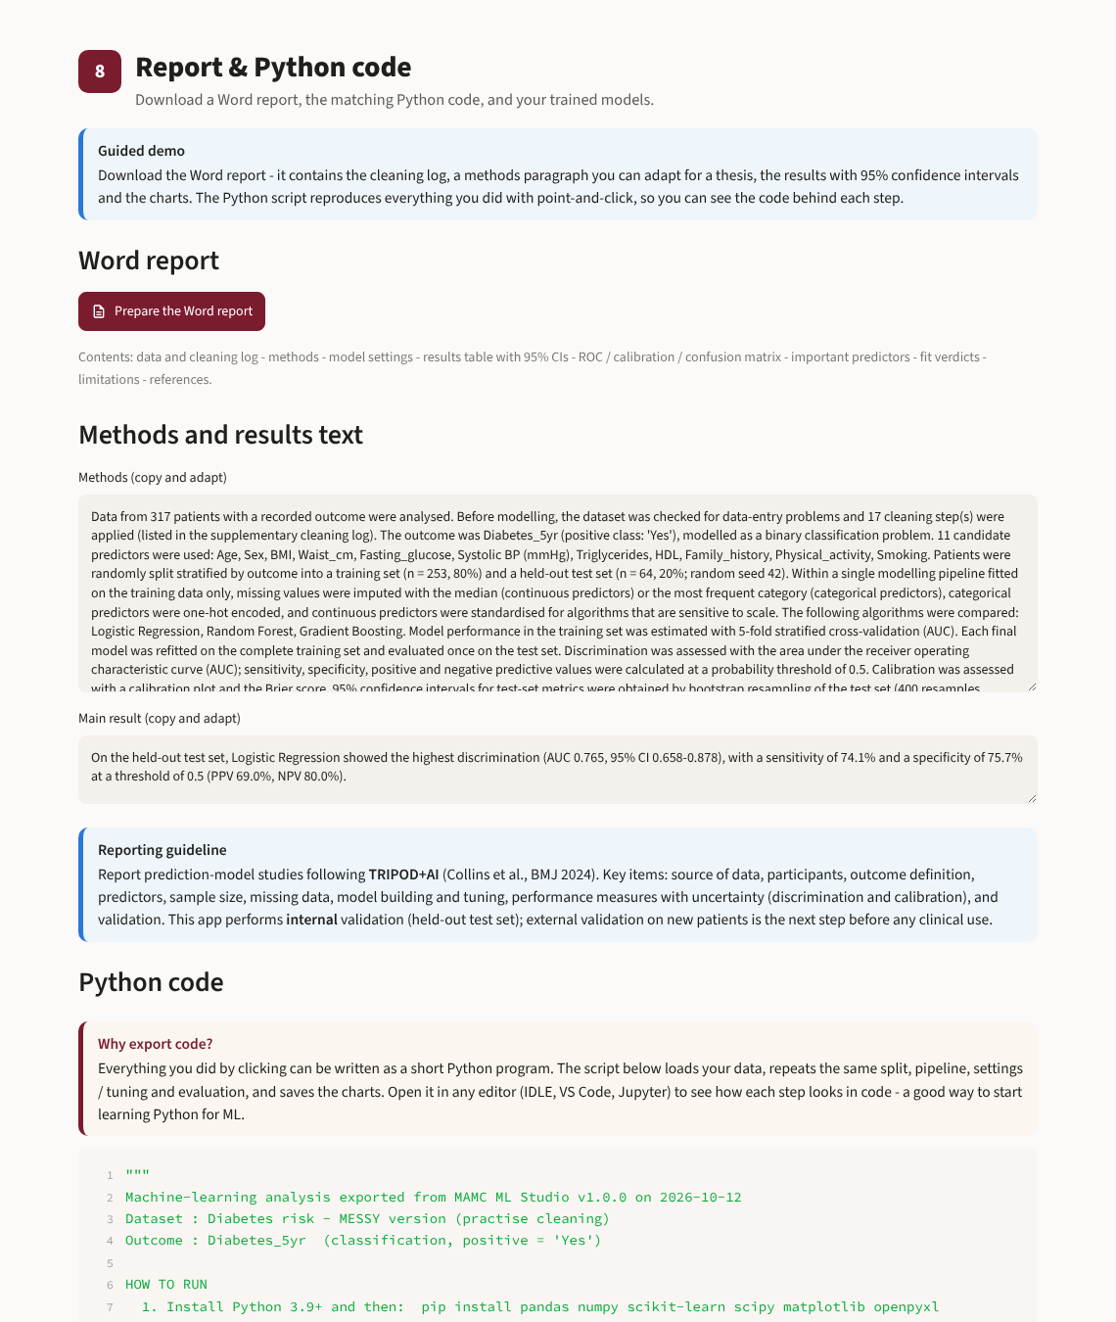
Figure 13. Report & Python code.

4.9 Learn machine learning
Nine short chapters with interactive pictures: what ML is (with an ML-to-medicine dictionary), kinds of ML, data for ML (including leakage), training & testing, overfitting (drag a slider and watch a curve memorise its training patients), settings & tuning (the dose-finding analogy), judging a model (move the cut-off, separation and prevalence and watch the 2x2 table change), every algorithm with a live demo, pitfalls & ethics, and a glossary.
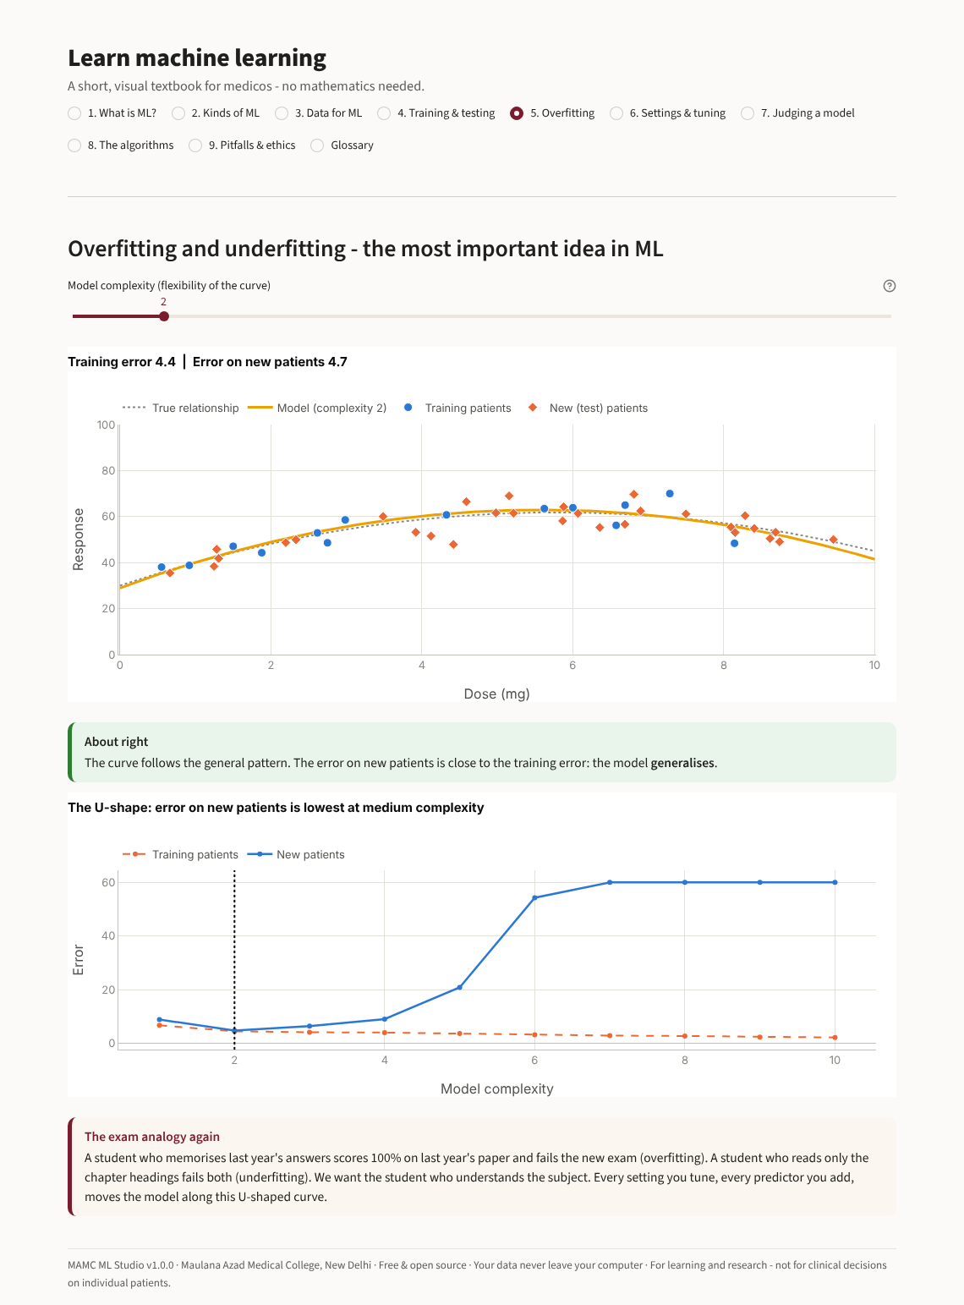
Figure 14. Learn: overfitting and underfitting with an interactive curve.

4.10 Find patient groups (clustering)
For data without an outcome. Choose the variables and a method (K-means, hierarchical, DBSCAN). The silhouette and elbow plots help choose the number of groups; a PCA map shows the patients in two dimensions, coloured by group; a heat-map and sentences describe each group ('higher BMI, waist and triglycerides'). If an outcome exists it is compared between the groups. The group can be added as a new column.
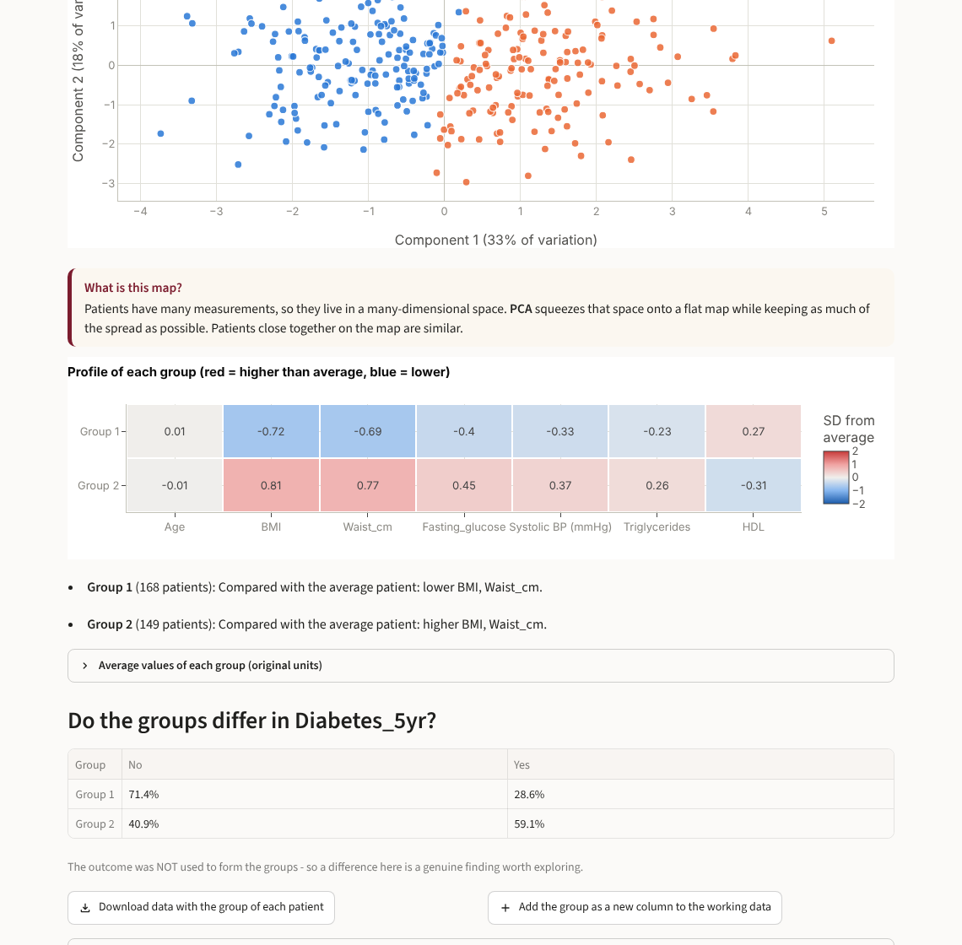
Figure 15. Finding natural groups of patients.

4.11 Sample size calculator
For a binary outcome, the calculator applies the three criteria of Riley et al. (BMJ 2020) - little overfitting, small optimism and a precise overall risk - from the expected prevalence, the number of predictor parameters and the expected model performance (AUC, Nagelkerke R2 or Cox-Snell R2). It also shows the 10 and 20 events-per-variable rules. Remember that flexible ML models usually need several times more patients than logistic regression.

5. The demo datasets
All are synthetic (computer-generated) patients with a fixed random seed, except the breast-cancer data, which are real and public. They are also in the folder sample_data as Excel files, so students can practise the import step.
Dataset | Patients | Task | Variables
Diabetes risk in 5 years | 500 | Classification (Yes/No) | Age, sex, BMI, waist, fasting glucose, BP, lipids, family history, activity, smoking
Diabetes - MESSY version | 328 | Classification + cleaning | The same study with typical data-entry mistakes and a leaky column
Type of anaemia | 400 | Classification (4 groups) | Hb, MCV, MCH, RDW, RBC, ferritin -> normal / iron deficiency / thalassaemia trait / B12-folate deficiency
Length of hospital stay | 400 | Regression (days) | Age, sex, admission type, surgery, comorbidities, CRP, albumin, Hb, diabetes
Patient groups | 300 | Clustering (no outcome) | Metabolic profiles with three hidden groups
Breast cancer (Wisconsin) | 569 | Classification (malignant/benign) | Real public data: 10 cell-nucleus measurements

6. Which algorithm? Quick reference
Algorithm | Think of it as | Good for | Watch out
Logistic / linear regression | A clinical risk score: weights x values | Small data, explanation, the baseline | Misses curves and interactions
Ridge / lasso | Regression with a brake on the weights | Many or correlated predictors; lasso selects variables | Still straight-line
Decision tree | A triage flowchart of yes/no questions | Printable rules, teaching | Overfits when deep; unstable
Random forest | A board of doctors voting | Accurate default for a few hundred patients or more | Black box
Gradient boosting | A relay of residents correcting each other (XGBoost-like) | Often the most accurate on tables | Needs tuning; overfits small data
Support vector machine | The widest street between two groups | Many numeric predictors, medium size | Slow on big data; black box
K-nearest neighbours | 'This patient reminds me of 7 similar ones' | Few meaningful numeric predictors | Needs scaling; weak with many predictors
Naive Bayes | Pre-test probability x likelihood ratios | Tiny data, Bayesian teaching | Assumes independent tests
Neural network | Layers of artificial neurons | Thousands of patients | Data-hungry; black box
K-means / hierarchical / DBSCAN | OPD counters / family tree / outbreak map | Finding patient groups | Groups must be checked clinically

7. Reading the results - cheat sheet
Measure | Meaning | Rule of thumb
AUC (C-statistic) | Chance that a random patient with the outcome gets a higher risk than one without | 0.7-0.8 acceptable, 0.8-0.9 good, >0.9 excellent
Sensitivity | Share of true positives that the model catches | Higher for screening
Specificity | Share of true negatives correctly cleared | Higher for confirmation
PPV / NPV | When the model says yes / no, how often it is right | Depend on prevalence
Balanced accuracy | Average of sensitivity and specificity | Use instead of accuracy for unbalanced outcomes
Brier score | Average squared error of predicted risks | Lower is better
Calibration plot | Do predicted risks match observed rates? | Points near the diagonal
R2 | Share of variation explained (regression) | Closer to 1 is better
MAE / RMSE | Typical size of the error, in outcome units | Smaller is better
Training vs CV vs test | Big gap = overfitting; all low = underfitting | Similar values = generalises
95% CI | How much the result could change with other test patients | Narrow = precise; overlapping CIs = no clear winner

8. Good practice for a thesis or paper
- Define the outcome, the prediction time point and the predictors before looking at the data.
- Check the sample size (Sample size calculator) and report events per predictor.
- Remove leaky predictors - anything recorded after the outcome.
- Report how missing data were handled (here: imputation inside the pipeline, learned from training data).
- Always include a simple baseline (logistic or linear regression). Prefer the simpler model when performance is similar.
- Report discrimination (AUC with 95% CI) and calibration, plus sensitivity/specificity at a stated cut-off.
- State that validation was internal (held-out test set); external validation is needed before clinical use.
- Follow the TRIPOD+AI reporting guideline (BMJ 2024).
- For p-values and adjusted odds ratios with confidence intervals (inference rather than prediction), use classical regression, e.g. in MAMC BioStat.

9. Frequently asked questions and troubleshooting
Windows says 'Windows protected your PC'.
Click More info, then Run anyway. This appears because the software is new and not signed with a paid certificate.
Windows says 'Smart App Control has blocked part of this app', or nothing opens.
New Windows 11 laptops have Smart App Control switched on. It blocks programs that are not signed with a paid certificate, including the libraries inside MAMC ML Studio. Open Windows Security > App & browser control > Smart App Control settings and choose Off, then start MAMC ML Studio again. Microsoft Defender antivirus keeps protecting the laptop. With Windows updates from April 2026 onwards, Smart App Control can be switched on again later (MAMC ML Studio will then be blocked again).
The Mac says the app cannot be opened.
Right-click the app in Applications > Open > Open. On macOS 15 or newer: System Settings > Privacy & Security > Open Anyway. Only if it says the app 'is damaged': open Terminal, paste xattr -cr "/Applications/MAMC ML Studio.app", press Enter and open the app again.
The Mac says 'This copy is for Macs with an Apple chip'.
Download the Intel edition (file ending in macOS-Intel.dmg).
Nothing happens or a message says the software could not start.
Wait a minute - the very first start after installation is slower. If it still fails, the details are in the file last_run.log: on Windows in %LOCALAPPDATA%\MAMC ML Studio, on a Mac in ~/Library/Application Support/MAMC ML Studio. Send this file to the developers.
The window closed but I want to continue.
Open MAMC ML Studio again from its icon. Your data are not kept between sessions, so download the cleaned data and the report before closing.
(Source code edition) Python was not found / the first start fails.
Install Python 3.10 or newer from python.org (tick 'Add python.exe to PATH'); the first start needs internet. Or use the installer instead - it needs neither.
Training takes long.
Grid search on random forests or boosting multiplies the work. Tune fewer settings, use fewer cross-validation rounds or random search with fewer tries.
Why are my results different from my friend's?
Use the same random seed, the same test percentage and the same cleaning steps. With small datasets, different splits give noticeably different results - that is what the confidence intervals show.
The model is 'overfitting'. Is it wrong?
Flexible models always score higher on their training patients. Judge them by the cross-validation and test scores; if a simpler model does as well, prefer it.
Can I use the prediction for my patients?
No. A model needs external validation, calibration checks and approval before clinical use. This software is for learning and research.
Is my data safe?
Yes. The software runs on your computer only; nothing is sent over the internet.

10. For teachers and developers
The software is written entirely in Python (Streamlit for the screens, scikit-learn for the models, pandas, Plotly and matplotlib for charts, python-docx for reports).
File | Purpose
app.py | Start page and menu
desktop_launcher.py | Installed edition: starts the bundled Python, opens the program window, stops when it is closed
launcher.py | Source edition: creates the private environment, installs the components, starts the app
build_tools/ | Builds the Windows installer and portable zip (build_windows.py) and the Mac .dmg (build_mac.py)
app_pages/ | One file per screen
mlstudio/data_check.py | File reading, Data Health Check and fixes
mlstudio/advisor.py | Problem-type detection and model recommendations
mlstudio/models.py | Algorithm catalogue: explanations, settings, estimators
mlstudio/trainer.py | Pipeline, split, cross-validation, tuning, metrics, importance, verdicts
mlstudio/plots.py | All charts
mlstudio/report.py / codegen.py | Word report / exported Python script
mlstudio/clustering.py, sample_size.py | Clustering; Riley sample-size criteria
tests/ | Engine tests (all models, report, exported code) and a click-through test of every screen

Change the version number in mlstudio/__init__.py (APP_VERSION). Run python tests/run_engine_tests.py after changes. The installers are built and tested automatically on GitHub (Actions tab). To publish a new version, open Releases > Draft a new release on GitHub, type a new tag such as v1.0.1 and click Publish release; the four downloads are attached automatically about 40 minutes later. Teaching texts for each algorithm are in mlstudio/models.py and can be edited without touching the logic.

References
1. Collins GS, Moons KGM, Dhiman P, et al. TRIPOD+AI statement: updated guidance for reporting clinical prediction models that use regression or machine learning methods. BMJ. 2024;385:e078378.
2. Riley RD, Ensor J, Snell KIE, et al. Calculating the sample size required for developing a clinical prediction model. BMJ. 2020;368:m441.
3. Riley RD, Snell KIE, Ensor J, et al. Minimum sample size for developing a multivariable prediction model: Part I - continuous outcomes. Stat Med. 2019;38(7):1262-75.
4. Riley RD, Van Calster B, Collins GS. A note on estimating the Cox-Snell R2 from a reported C statistic (AUROC) to inform sample size calculations for developing a prediction model with a binary outcome. Stat Med. 2021;40(4):859-64.
5. van der Ploeg T, Austin PC, Steyerberg EW. Modern modelling techniques are data hungry: a simulation study for predicting dichotomous endpoints. BMC Med Res Methodol. 2014;14:137.
6. Pedregosa F, Varoquaux G, Gramfort A, et al. Scikit-learn: machine learning in Python. J Mach Learn Res. 2011;12:2825-30.

