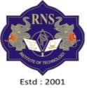**RNS INSTITUTE OF TECHNOLOGY**

Affiliated to VTU, Recognized by GOK, Approved by AICTE, New Delhi

(NAAC ‘A+ Grade’ Accredited, NBA Accredited (UG - CSE, ECE, ISE, EIE and EEE) Channasandra, Dr. Vishnuvardhan Road, Bengaluru - 560 098

Ph: (080) 28611880, 28611881 URL: [www.rnsit.ac.in](http://www.rnsit.ac.in/)

Department of Computer Science and Engineering (Data Science)

Course Name: Database Management Systems Lab with Mini-Project Course Code: 21CSL55

Semester and Section: 5th DS

# Mini Project Synopsis

|  |  |
| --- | --- |
| Title of the Project | College Event Management System |
| Students Name with USN | Vikas U S 1RN21CD058 |
| Manu kumar N 1RN21CD025 |

1. Introduction

The College Event Management System aims to address the need for an efficient and organized platform to manage various events within a college environment. With the increasing number and complexity of events, there is a growing necessity for a robust database management system to streamline the process of planning, organizing, and executing these events. The system will provide a centralized platform for managing event details, participant information, and resource allocation.

1. Objectives:

The primary objectives of the project are to:

1. Develop a user-friendly database management system to facilitate the planning and coordination of college events.

2. Streamline the process of event scheduling, participant registration, and resource allocation.

3. Enhance communication and collaboration among event organizers, participants, and stakeholders.

1. Scope:

The College Event Management System will encompass the following functionalities and features:

1. Event creation and management

2. Participant registration

4. Budget management and expense tracking

5. Communication and collaboration tools for event organizers

1. Hardware Requirements:

None

1. Software Requirements:

HTML, CSS and JAVASCRIPT for Frontend .

NODE JS (EXPRESS JS) for Backend.

MySQL as RDBMS (Relational Data Base Management System) .

1. Database Design
   1. ER Diagram

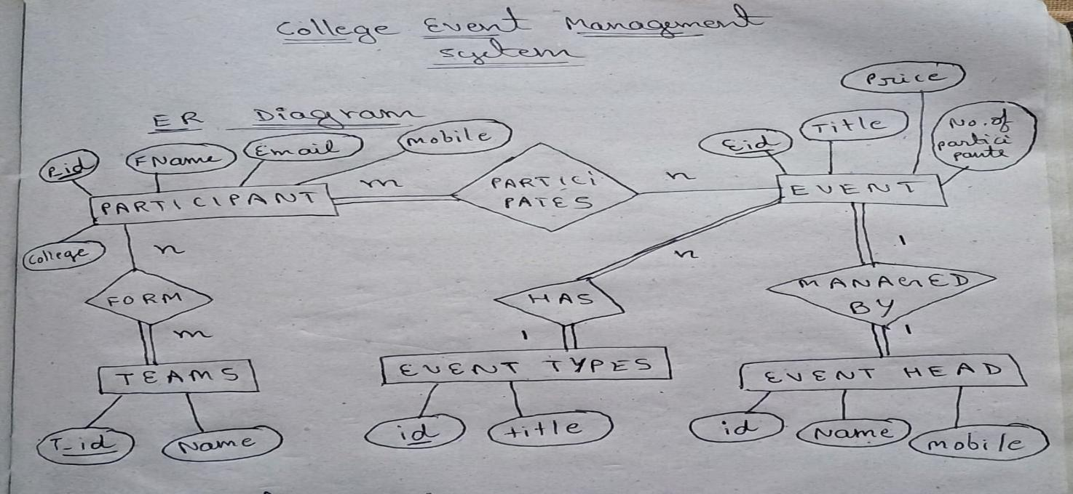

* 1. Schema Diagram

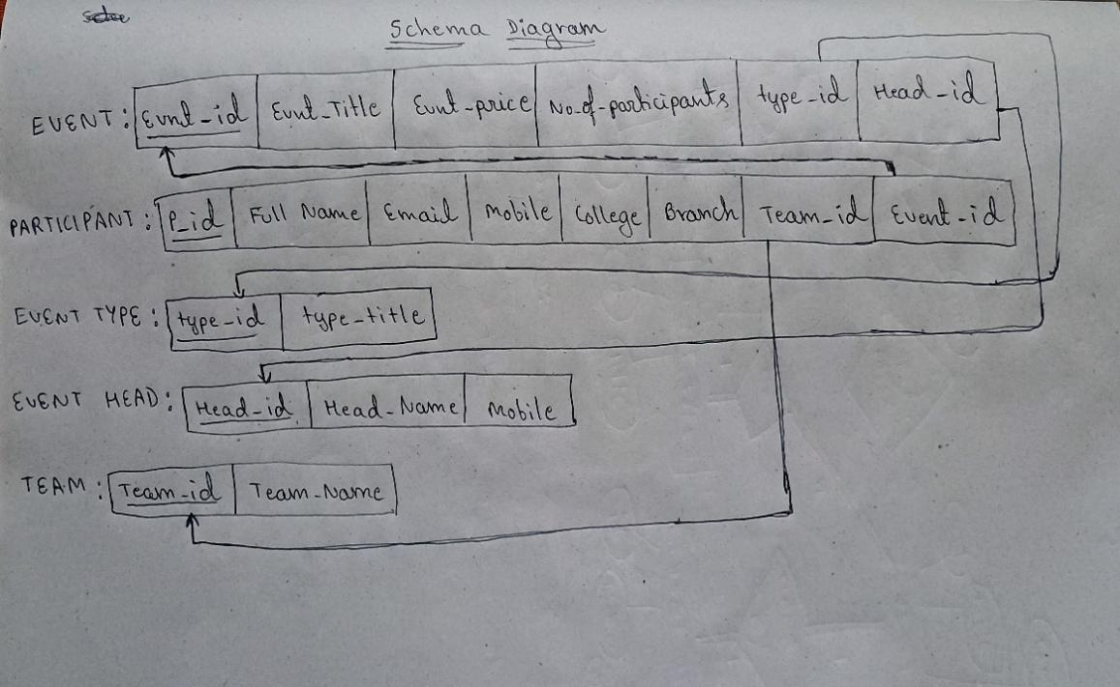

Signature of Students

Signature of faculty