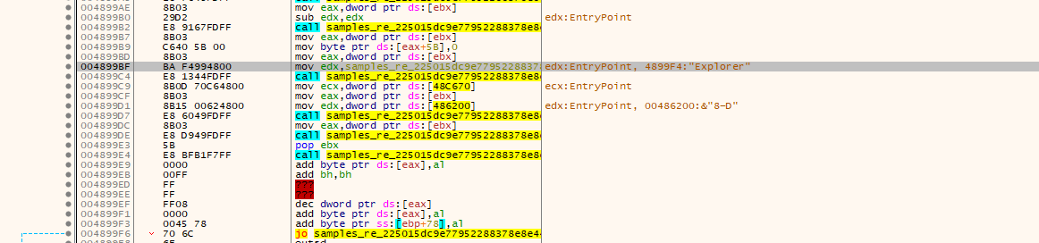
I could observe that the file is opening the explorer and decreasing its opacity so that the user wouldn’t be able to identify that there is a browser running.

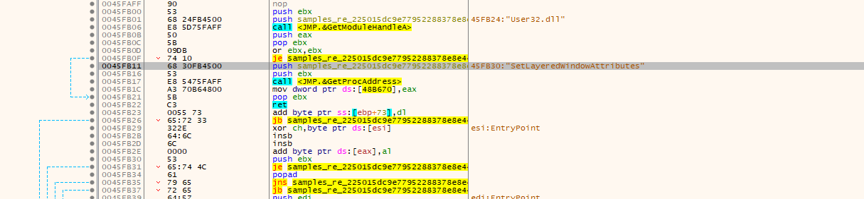
The setLayerWindowAttribute controls the opacity.

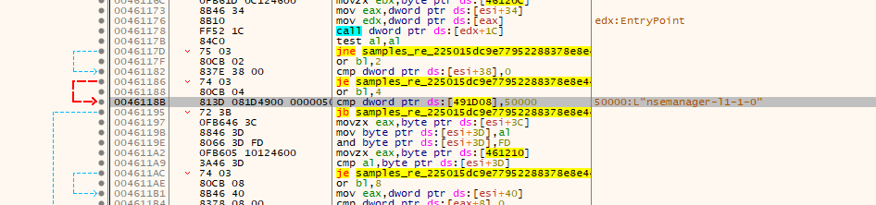
An unkown manager running, according to Rapid7 they had identified it as a malware category. The current file is still suspicious even more.

Shell is being executed.
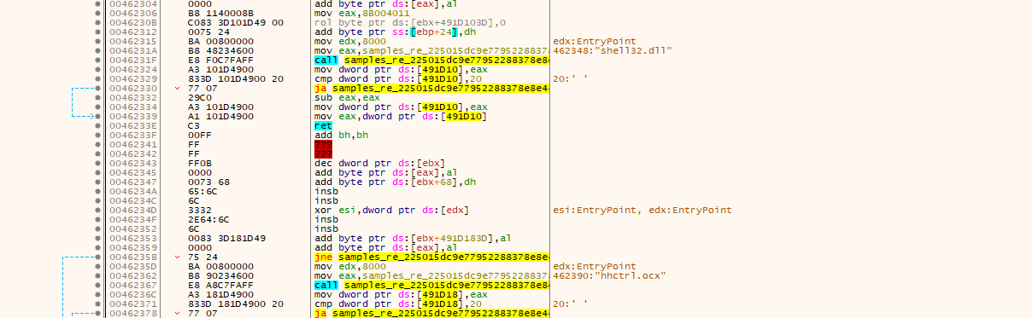
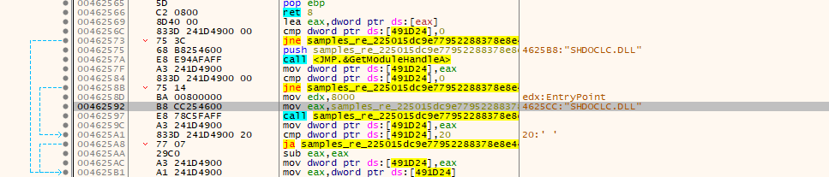
An unknown dll file is being run, could be a user written dll. The file seems even more suspicious than before. DLL file name: SHDOCLC.DLL

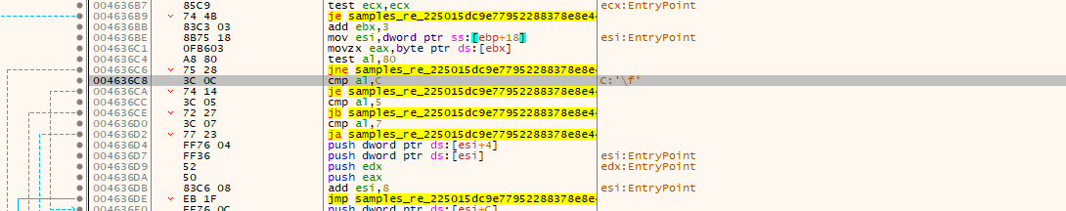
It is locating my f drive, I do not have an F drive.

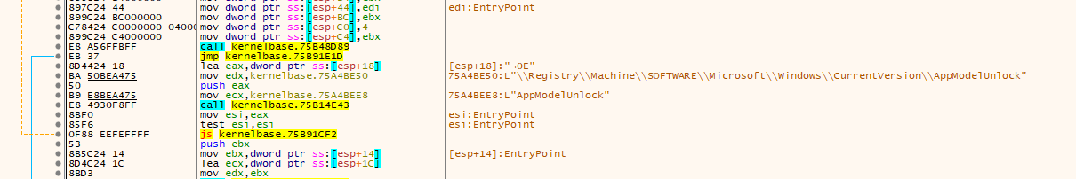
It enables the developer mode to get root access

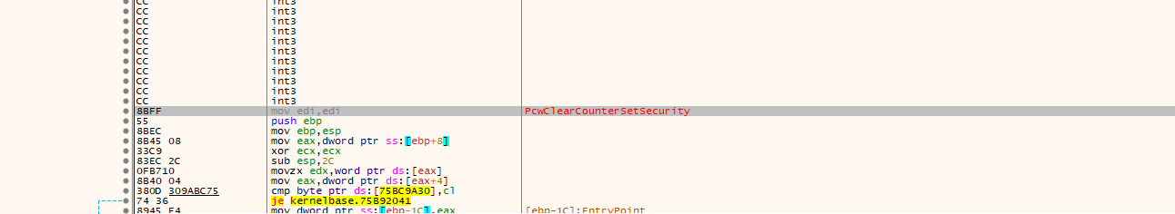
It also clears the security feature from the pcwum.dll which is not a system dll file

Verdict: Malware

