# Materials and Methods

# Basic methods and animal husbandry

* + 1. Drosophila stocks

All the experiments were performed on wild type isogenic Oregon-R. The stocks were maintained at 25°C on 12 hour light: 12 hour dark cycle in temperature-controlled room. Cornmeal, sucrose and yeast medium (Section 2.2.1) was used for stock maintenance. Adult flies (30-50 flies per bottle) were kept on 8-10 media bottles for 4 days to lay eggs and then discarded to avoid overcrowding. After 3-4 days of eclosion, newly emerged flies were transferred to fresh media bottles. Therefore, at every batch, flies were inter-generationally crossed.

* + 1. Virgin collection

All the experiments were performed on unmated female and male flies since media liquefaction due to larval action may interfere with the feeding behavior in diet experiments. Also, for setting up F1 and F2 crosses, unmated female flies were collected. At 25°C, as female flies do not respond to copulating males during first 12 hours after eclosion; the flies were collected within 4 hours after clearing the bottles of adults (Manning, 1967). Flies were separated into male and females under CO2 anesthesia using a fine paint brush. Collected flies were kept in media vials for 2 days to observe the larval activity. In case of experimental flies, vials having larval activity were discarded. For F1 and F2 generation, all the crosses was setup using 2-weeks old virgin females and unmated males.

# Drosophila food media

* + 1. Cornmeal, sucrose and yeast medium

The media components are listed in the table

|  |  |
| --- | --- |
| **Ingredients** (1 liter media) |  |
| Cornmeal powder (generic) | 51 grams |
| Sucrose (Himedia #MB025) | 51.3 grams |
| Yeast powder (generic) | 8 grams |
| Agar (Himedia #CR301) | 8 grams |
| Methyl 4-hydroxybenzoate (Merck #106757) | 2.5 grams dissolved in 10 ml of ethanol |
| Propionic acid (Himedia #GRM3658) | 6 ml |

Agar added to 500 ml of distilled water; boiled it till agar dissolves then sucrose is added to agar/water mix. Meanwhile yeast powder and cornmeal powder were dissolved bit by bit, continuously stirring (to avoid lumps) in 400 ml of distilled water and boiled it. Both the mixtures were added together, brought to boil made the total volume up to one liter by adding water. Allowed to cool below 60°C and then Methyl 4-hydroxybenzoate solution and propionic acid were added. Media was poured in the bottles (25ml each) or in the vials (5ml each). Kept it at room temperature overnight, plugged it and then stored at 4°C for long term storage.

* + 1. Semi-defined medium

In order to decrease batch-to-batch variation we used semi-defined media for all the experiments. Since its components are chemically more defined as compare to cornmeal, sucrose and yeast medium.

|  |  |
| --- | --- |
| **Ingredients** (1 liter media) |  |
| Sucrose (Himedia #MB025) |  |
| Control diet | 51.3 grams |
| High-sugar diet | 342 grams |
| Yeast powder (generic) | 80 grams |
| Yeast extract (Himedia #RM027) | 20 grams |
| Peptone (Himedia #RM001) | 20 grams |
| Magnesium sulphate heptahydrate (Himedia #RM684) | 0.5 grams |
| Calcium chloride dehydrate (Himedia #MB034) | 0.5 grams |
| Agar (Himedia #CR301) | 10 grams |
| Methyl 4-hydroxybenzoate (Merck #106757) | 2.5 grams dissolved in 10 ml of ethanol |
| Propionic acid (Himedia #GRM3658) | 6 ml |

Agar and sucrose were dissolved in 500 ml of distilled water as described in section 2.2.1. All remaining components (except Methyl 4-hydroxybenzoate and propionic acid) were added to remaining water and boiled it. Both the half were mixed together and boiled. Total volume was made up to 1 liter by adding boiling distilled water. Methyl 4-hydroxybenzoate and propionic acid were added when media temperature was below 60°C and then poured in bottles/vials. For long term storage media bottles/vials were kept at 4°C in double plastic bags to prevent moisture evaporation.

# Transgenerational experiments (Decide whether to keep it here or in next two chapter separately)

* + 1. High-sugar diet treatment (schematic for high-sugar experiment)

Three to four days old unmated male and virgin female flies were either continued on control diet (control group) or fed high-sugar diet (treatment group) for two weeks. Each media vial had 30 flies and transferred to respective fresh media after one week without anesthesia. In case if there is any larval action observed in the vials, then discarded.

After two weeks of diet treatment, flies were either used for metabolite measurements, RNA extraction or for setting up crosses to generate subsequent generations.

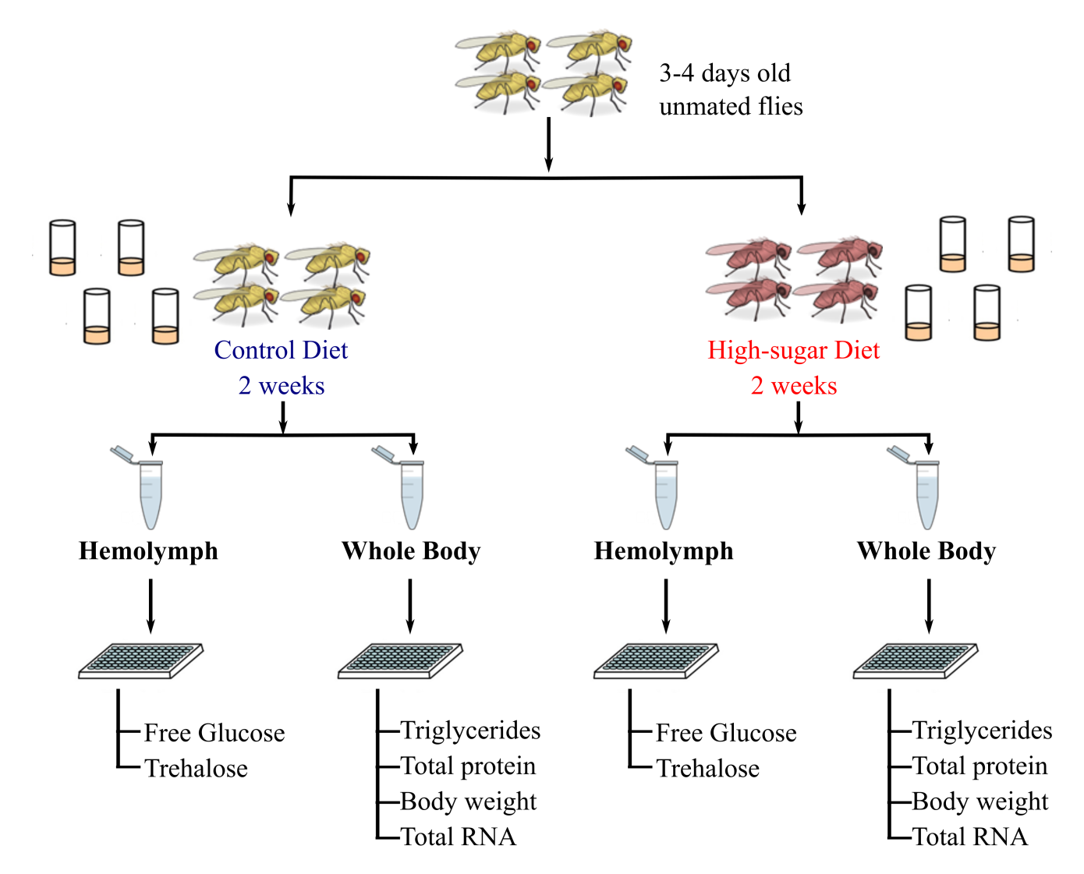

**Fig.xx High sugar diet experimental workflow**

* + 1. F1 generation experiments (schematic for F1 experiment)

Two-weeks old female flies raised on control diet were crossed either with 2-weeks old high-sugar fed males or normal diet fed males. All the crosses were set-up on control diet. The unmated male and virgin female flies were collected from control and treatment group as described in the section 2.1.2. The adult flies then were treated with either control diet or high-sugar diet for 2-weeks. At the end of the experiment we measured metabolites, extracted RNA from the flies.

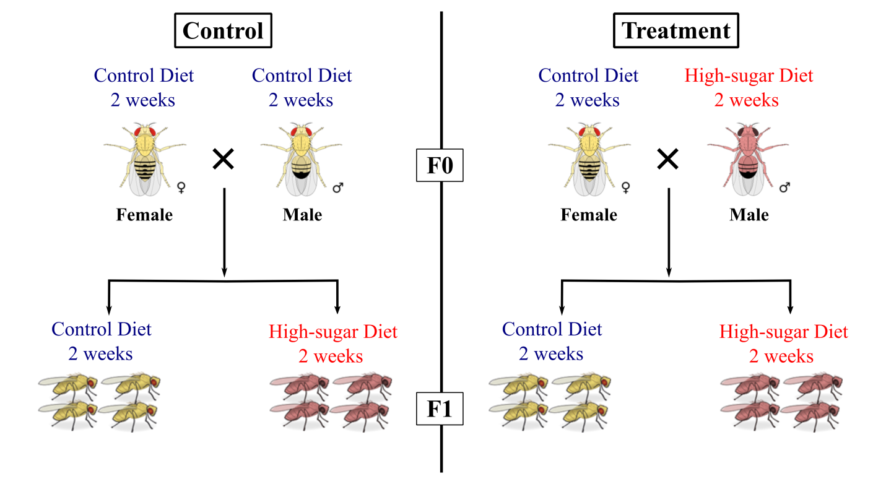

* + 1. F2 generation experiments (schematic for F2 experiment)

For generating F2 flies, we crossed 2-weeks old F0 high-sugar fed male flies with 2-weeks old control diet fed female flies and F1 flies raised on the control diet. Both the F1 parents were fed control diet for 2-weeks and then mated to obtain F2 flies for the transgenerational experiment. In control group, same pattern were followed with 2-weeks old control diet fed F0 males to generate F2 flies. At the end of the experiment we measured metabolites, extracted RNA from the flies.

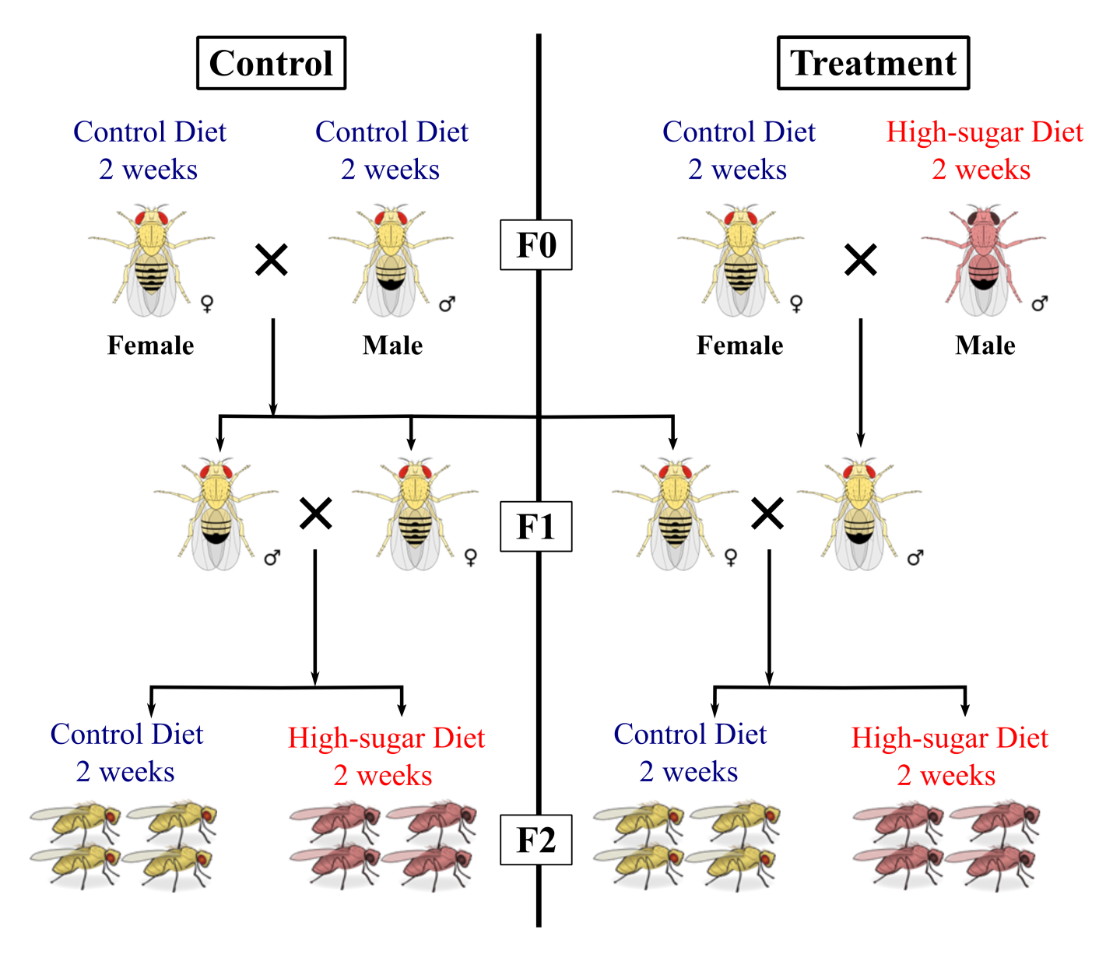

# Metabolic measurements

* + 1. Hemolymph free-glucose and trehalose

For a collection of hemolymph from flies, an assembly was made using 0.5ml microcentrifuge tube (punctured at the bottom) and placed into 1.5ml of microcentrifuge tube (collection tube). 30 decapitated flies were placed in assembly and centrifuged at 5000 rpm, 4°C for 15 min. Hemolymph was collected and diluted 1:10 times in distilled dH2O. Diluted hemolymph was stored at 20°C for measurement of free glucose levels. To measure the levels of trehalose, diluted hemolymph was incubated at 37°C for overnight such that trehalose gets broken down into glucose. Free glucose and trehalose levels were measured using Glucose HK assay kit GAHK20 (Sigma) at 340nm.

* + 1. Triglyceride measurement

Triglyceride levels in Drosophila were measured using Stanbio LiquiColor® ­­Procedure no. 2100. 12 male or 10 female flies were homogenized in 150 μl of distilled dH2O. Zirconia beads (0.7mm diameter) were used for homogenization purpose. Homogenate denatured at 95 °C for 10 minutes and filtered. 10 μl of the filtrate was assayed using 90 μl of triglyceride reagent and absorbance measured at 500nm using TECAN infinite pro 200. Triglyceride levels were normalized using protein level. Protein levels of the sample assayed spectrophotometrically at 562nm using Pierce™ BCA protein assay kit (Thermo Scientific).

# RNA extraction and Microarray

Total RNA was extracted using RNeasy Microarray tissue kit (Qiagen). 60-80 flies per group were homogenized in trizol for RNA isolation. RNA was eluted in nuclease free water and stored at -80°C. 200ng of total RNA was amplified using 3 ′IVT Express kit (Ambion). The GeneChip™ Drosophila Genome 2.0 Array (Affymetrix) was used for gene expression profiling. The array was hybridized and scanned according to manufactures instructions. Raw .cel files were exported and analyzed using Bioconductor packages of R statistical software.

# Bioinformatics

#ask sir for particular details