**Library Management System UML Diagrams**

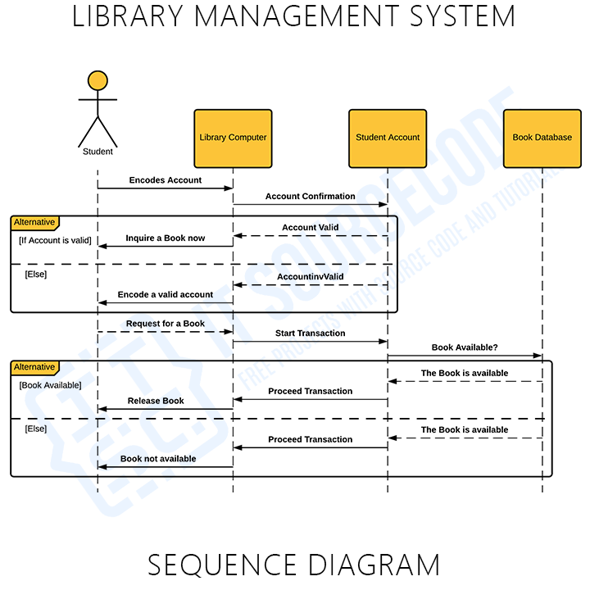

.

[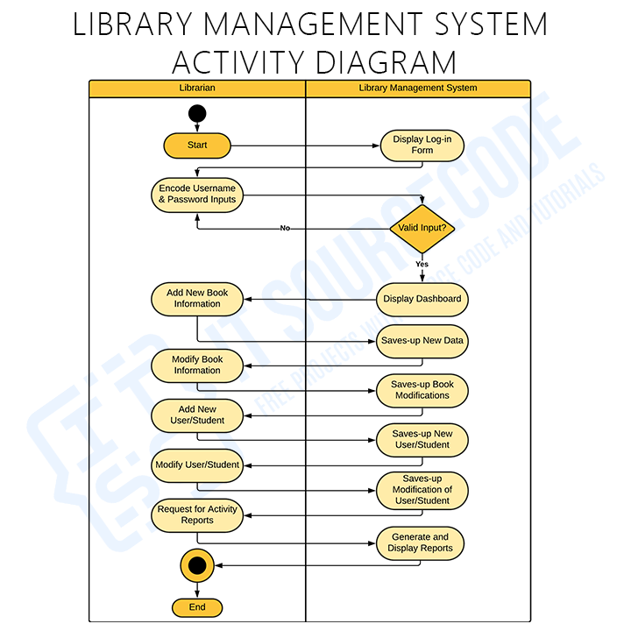](https://itsourcecode.com/wp-content/uploads/2021/09/Activity-Diagram-for-Library-Management-System.png)

[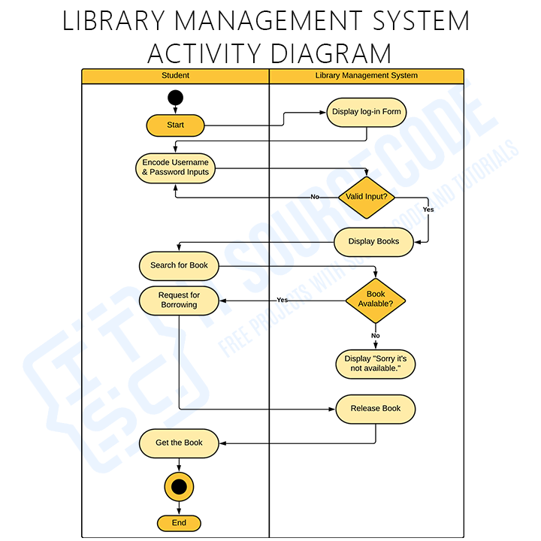](https://itsourcecode.com/wp-content/uploads/2021/09/Activity-Diagram-of-Library-Management-System.png)

[**Class Diagram for Library Management System**](https://itsourcecode.com/uml/library-management-system-class-diagram-uml/)

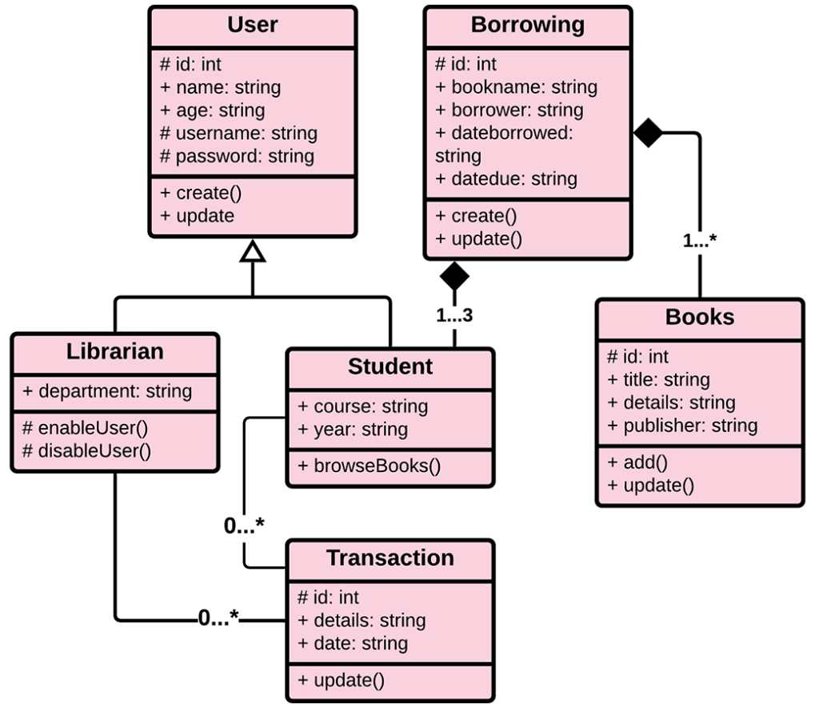

[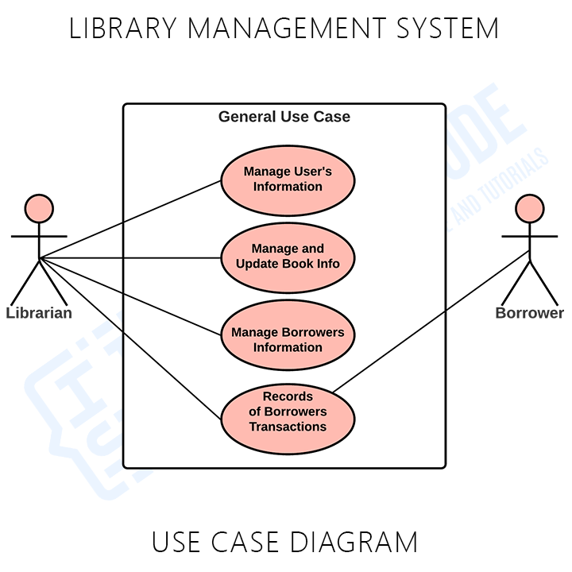](https://itsourcecode.com/wp-content/uploads/2021/05/Library-Management-System-General-Use-Case.png)

[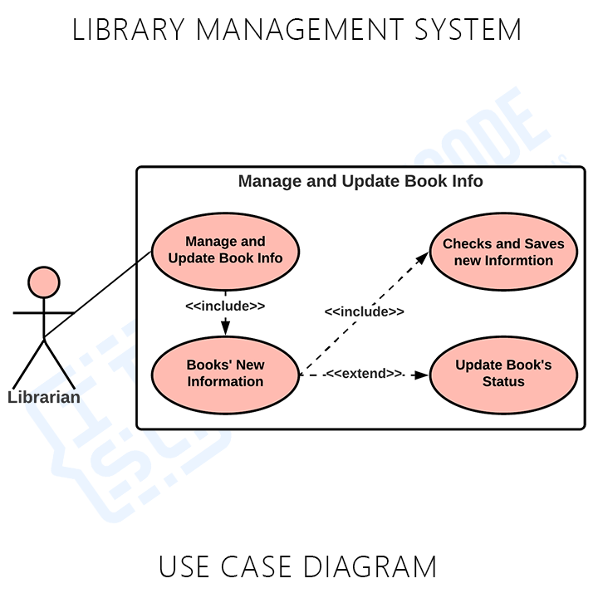](https://itsourcecode.com/wp-content/uploads/2021/05/Library-Management-System-Use-Case-Diagram-Book-Info-.png)

[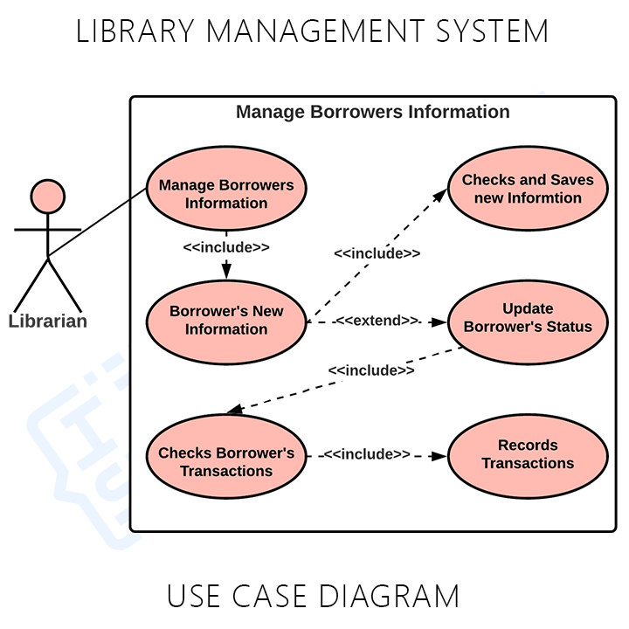](https://itsourcecode.com/wp-content/uploads/2021/05/Library-Management-System-Use-Case-Diagram-Borrowers-Info.png)

[**ER Diagram for Library Management System**](https://itsourcecode.com/uml/college-library-management-system-er-diagram/)

