Write a program to demonstrate the structure of HTML program.

<!DOCTYPE html>

<html>

    <head>

        <title> This is example program</title>

    </head>

    <body>

        <p> This is first program</p>

    </body>

</html>

**Output:**

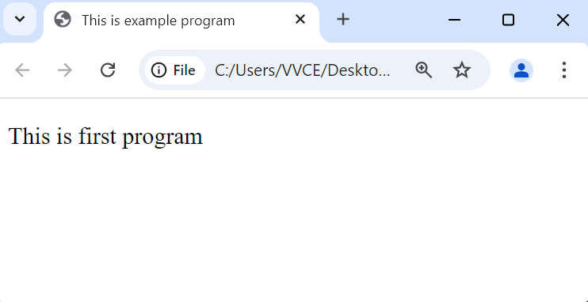

1. **Develop a HTML program to display the working of following elements: Page title, page heading, paragraph, line break, horizontal line, heading tags, body, bold, italic, small element, subscript and super script element, strong element, and mark tag**.

<!DOCTYPE html>

<html>

    <head>

        <title>

            Lab Program 1

        </title>

    </head>

    <body>

            <h1> Heading 1</h1>

            <h2> Heading 2</h2>

            <h3> Heading 3</h3>

            <h4> Heading 4</h4>

            <h5> Heading 5</h5>

            <h6> Heading 6</h6>

            <p>This is paragraph tag<br>

            This is the second line of the paragraph</p>

         <hr>

<b> This is bold tag</b><br>

<i> This is italic tag</i><br>

<small> this small element</small>

<p>x<sup>2</sup></p>

<p>H<sub>2</sub>O</p>

<strong> Strong Tag</strong><br>

<mark>Mark Tag</mark>

    </body>

</html>

**Output:**

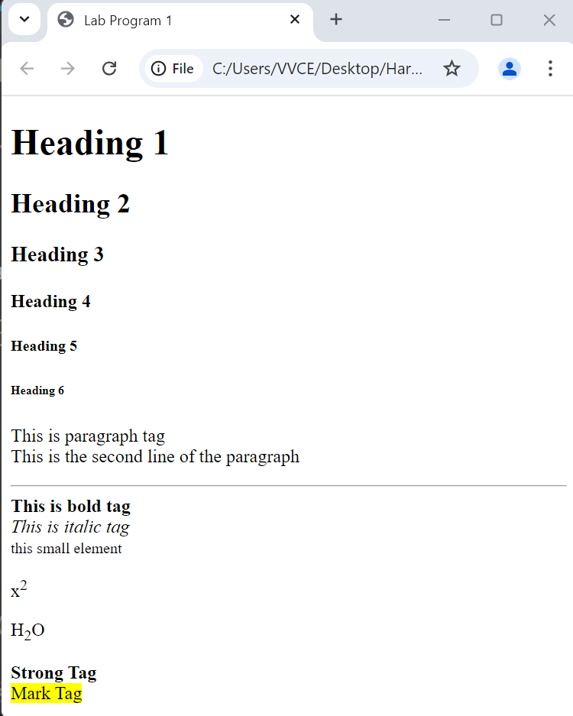

1. **Develop a HTML program to display:**

**a) Table (shown below) b) use of image tag**

<!DOCTYPE html>

<html>

    <head>

        <title> Lab Program2</title>

    </head>

    <body>

        <table border="2">

            <caption> Employee Details</caption>

                <tr>

                    <th>EID</th>

                    <th>ENAME</th>

                    <th>AGE</th>

                </tr>

                <tr>

                    <td> 101</td>

                    <td>Madhu</td>

                    <td>32</td>

                </tr>

                    <tr>

                        <td> 102</td>

                        <td>Naveen</td>

                        <td>33</td>

                    </tr>

                </table>

                <br> <br>

        <img src="flower2.jpg" height="300" width="300" alt="image not found">

    </body>

</html>

**Output:**

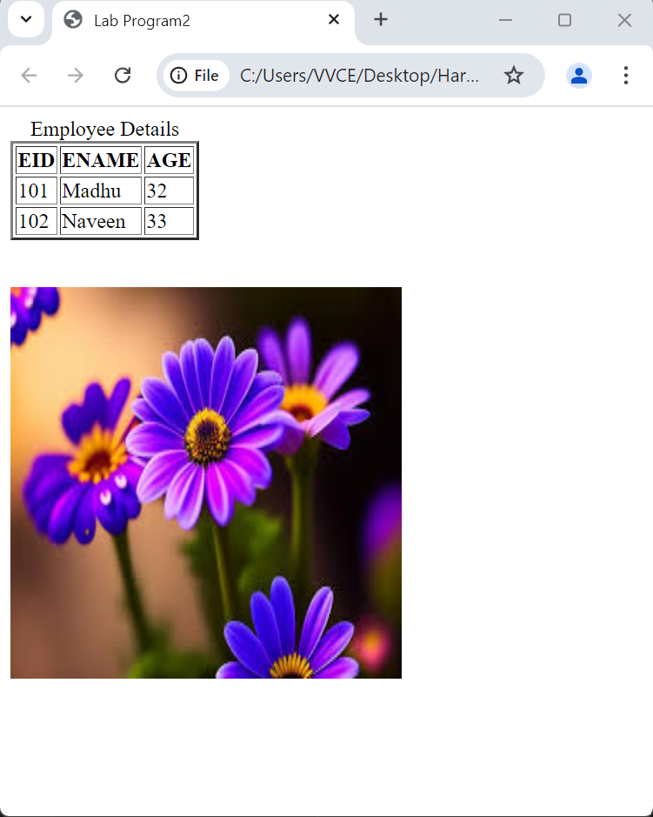

1. **Write an HTML page that contains a simple user sign up form with following fields: First name, Last name, Date of Birth, Place of Birth, Current Address, Gender and a submit button.**

<!DOCTYPE html>

<html>

<head>

<title>

Create a Login form

</title>

</head>

<body>

<br>

<fieldset>

The following tags are used in this Html code for creating the Login form:

<form> <br>

<label> Firstname:</label>

<input id="fname" type="text" size="15"/> <br> <br>

<label>Lastname:</label>

<input id="lname" type="text" size="15"/> <br> <br>

<label>Date of Birth:</label>

<input type="date" > <br> <br>

<label>Place of Birth: </label>

<input id="pob" type="text" size="15" /> <br> <br>

<label>Gender:</label><br>

<input type="radio" name="gender"/> Male <br>

<input type="radio" name="gender"/> Female <br>

<input type="radio" name="gender"/> Other <br> <br>

<label>Address:</label>

<br>

<textarea cols="80" rows="5" value="address">

</textarea>

<br> <br>

<input type="submit" value="submit">

</fieldset></form>

</body>

</html>

**Output:**

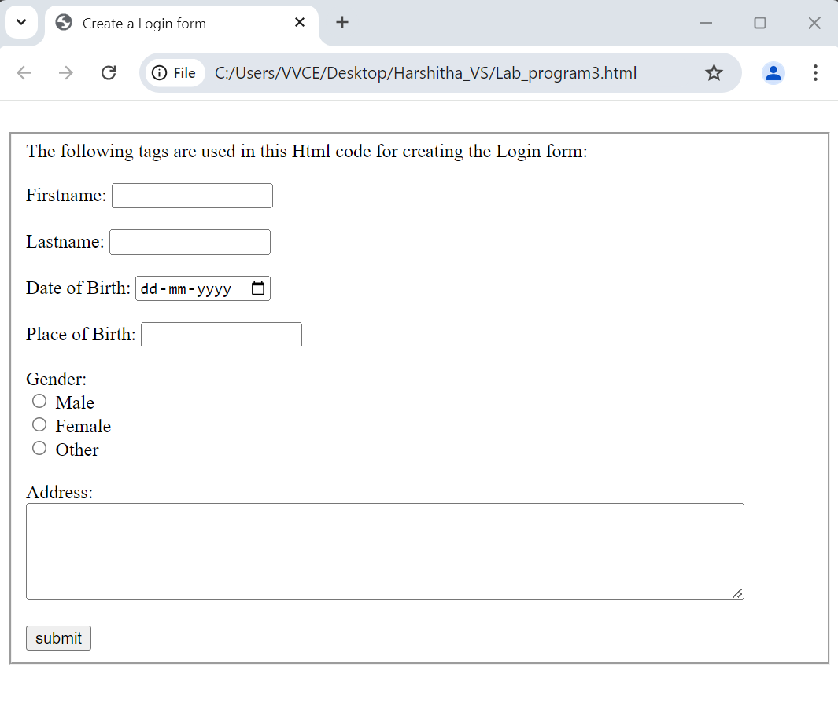

1. **Create a HTML webpage with the following CSS specifications:**

**Set background color of the page as Blue, Text color as White, set different borders on each side, and an image floating to the right in a text.**

<!DOCTYPE html>

<html>

  <head>

    <title>program 4</title>

<style>

    body{

        background-color: lightblue;

        }

    img {

        float: right;

        }

    p{

        color: white;

        border-width: 10px;

        border-top-style: dotted;

        border-right-style: solid;

        border-bottom-style: double;

        border-left-style: dashed;

    }

</style>

  </head>

<body>

    <p> <img src="flower1.jpg" width=180 height=100 >

this is the example for css specifications such as background color , text color and

<br><br>different borders for each side of the paragraph <br> <br>

and an floating image to the right<br> <br>

</p>

  </body>

</html>

**Output:**

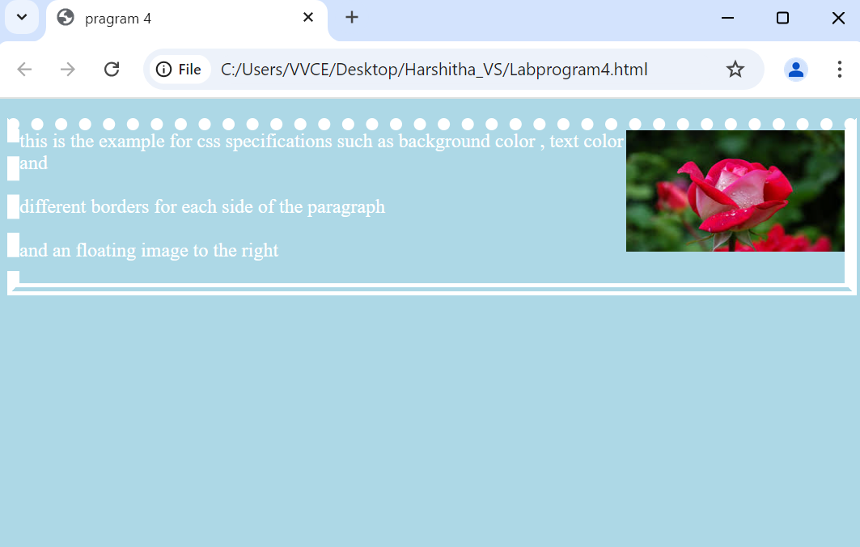

1. **Design HTML webpage with following CSS specifications: Show any two-font family through text, decorated the text through plain, underline, overline and line through, display the head text with shadow in red color. (Structured Inquiry)**

<!DOCTYPE html>

<html>

<head>

<title>CSS Font</title>

<style>

h1{ text-shadow: 2px 12px 10px red;}

</style>

</head>

<body>

<h1> head with text shadow</h1>

<p style="font-family:cursive"> different font family</p>

<p style="font-family:monospace"> different font family</p>

<p style="text-decoration:none">working of defferent text decoration property</p>

<p style="text-decoration:underline">working of defferent text decoration property</p>

<p style="text-decoration:overline">working of defferent text decoration property</p>

<p style="text-decoration:line-through">working of defferent text decoration property</p>

</body>

</html>

**OUTPUT:**

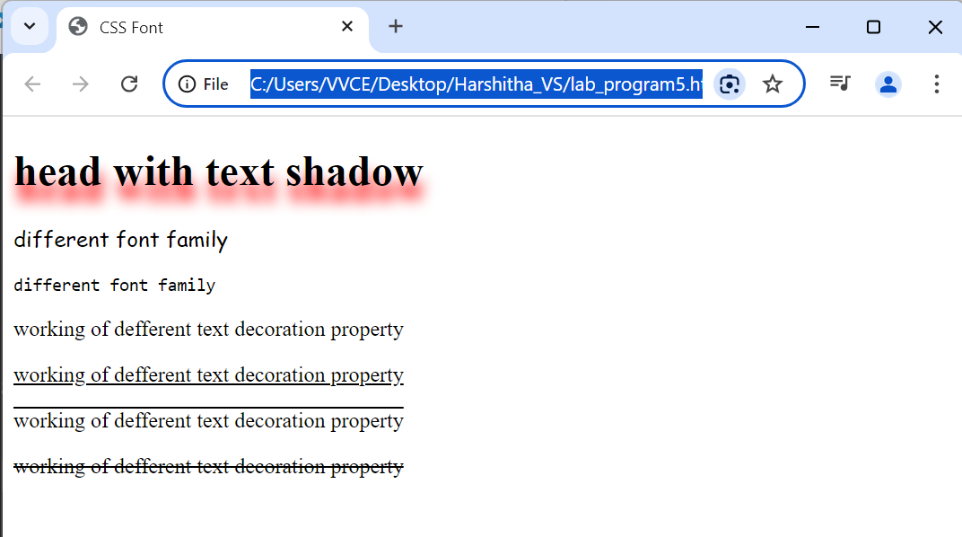

1. **Design and develop HTML program to display VIBGYOR.**

<!DOCTYPE html>

<html>

<head>

    <title>VIBGYOR</title>

</head>

<body>

    <div style="background-color: violet;"><p> violet</p></div>

    <div style="background-color: indigo;"><p> indigo</p></div>

    <div style="background-color: Blue;"><p> Blue</p></div>

    <div style="background-color: green;"><p> Green</p></div>

    <div style="background-color: yellow;"><p> yellow</p></div>

    <div style="background-color:orange;"><p> orange</p></div>

    <div style="background-color: red;"><p> red</p></div>

</body>

</html>

OUTPUT:

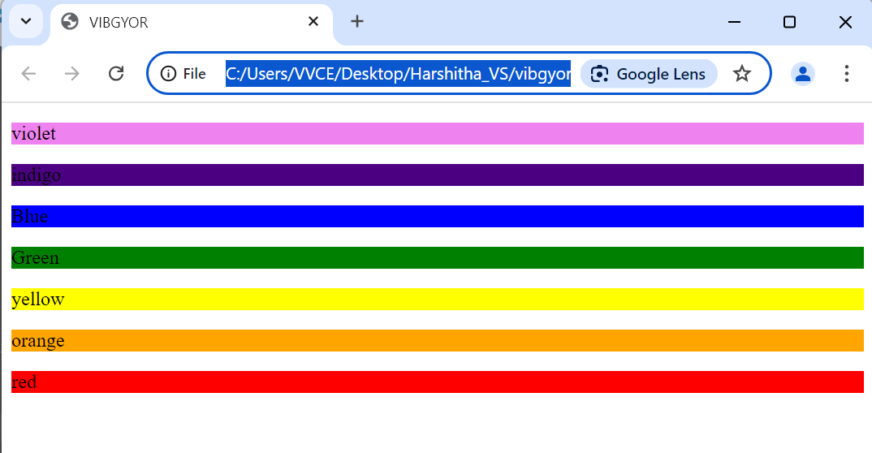

1. **Design and develop HTML program to display Chess Board.**

<!DOCTYPE html>

<html>

    <head>

        <title>chess </title>

                <style>

            .chess-board { border-spacing: 0; border-collapse: collapse; }

                     td { border: 1px solid; width: 2em; height: 2em; }

           .light { background:white; }

             .dark { background: black; }

        </style>

    </head>

    <body>

        <table class="chess-board">

                <tr>

                    <th></th>

                    <th>a</th>

                    <th>b</th>

                    <th>c</th>

                    <th>d</th>

                    <th>e</th>

                    <th>f</th>

                    <th>g</th>

                    <th>h</th>

                </tr>

                <tr>

                    <th>8</th>

                    <td class="light"></td>

                    <td class="dark"></td>

                    <td class="light"></td>

                    <td class="dark"></td>

                    <td class="light"></td>

                    <td class="dark"></td>

                    <td class="light"></td>

                    <td class="dark"></td>

                </tr>

                <tr>

                    <th>7</th>

                    <td class="dark"></td>

                    <td class="light"></td>

                    <td class="dark"></td>

                    <td class="light"></td>

                    <td class="dark"></td>

                    <td class="light"></td>

                    <td class="dark"></td>

                    <td class="light"></td>

                </tr>

                <tr>

                    <th>6</th>

                    <td class="light"></td>

                    <td class="dark"></td>

                    <td class="light"></td>

                    <td class="dark"></td>

                    <td class="light"></td>

                    <td class="dark"></td>

                    <td class="light"></td>

                    <td class="dark"></td>

                </tr>

                <tr>

                    <th>5</th>

                    <td class="dark"></td>

                    <td class="light"></td>

                    <td class="dark"></td>

                    <td class="light"></td>

                    <td class="dark"></td>

                    <td class="light"></td>

                    <td class="dark"></td>

                    <td class="light"></td>

                </tr>

                <tr>

                    <th>4</th>

                    <td class="light"></td>

                    <td class="dark"></td>

                    <td class="light"></td>

                    <td class="dark"></td>

                    <td class="light"></td>

                    <td class="dark"></td>

                    <td class="light"></td>

                    <td class="dark"></td>

                </tr>

                <tr>

                    <th>3</th>

                    <td class="dark"></td>

                    <td class="light"></td>

                    <td class="dark"></td>

                    <td class="light"></td>

                    <td class="dark"></td>

                    <td class="light"></td>

                    <td class="dark"></td>

                    <td class="light"></td>

                </tr>

                <tr>

                    <th>2</th>

                    <td class="light"></td>

                    <td class="dark"></td>

                    <td class="light"></td>

                    <td class="dark"></td>

                    <td class="light"></td>

                    <td class="dark"></td>

                    <td class="light"></td>

                    <td class="dark"></td>

                </tr>

                <tr>

                    <th>1</th>

                    <td class="dark"></td>

                    <td class="light"></td>

                    <td class="dark"></td>

                    <td class="light"></td>

                    <td class="dark"></td>

                    <td class="light"></td>

                    <td class="dark"></td>

                    <td class="light"></td>

                </tr>

        </table>

    </body>

</html>

**OUTPUT**

1. **Write a JavaScript function to count the number of vowels in each string. (Demonstrate)**

<html>

<head>

<title>

get a number of vowels in a string in JavaScript

</title>

</head>

<body>

<h1>

vowel in a string

</h1>

<script>

function getVowels(string) {

var Vowels = 'aAeEiIoOuU';

var vowelsCount = 0;

for(var i = 0; i < string.length ; i++) {

if (Vowels.indexOf(string[i]) !== -1) {

vowelsCount += 1;

}

}

return vowelsCount;

}

document.write("The Number of vowels in -"+" Computer Science "+ getVowels("Computer Science "));

</script>

</body>

</html>

OUTPUT:

1. **Write a JavaScript to design a simple calculator to perform the following operations: sum, product, difference, and quotient. (Exercise)**

<html>

<head>

<title> Simple Calculator </title>

<style>

input {

background-color:darkmagenta;

border: none;

color: white;

width: 100%;

padding: 15px 32px;

text-align: center;

text-decoration: none;

display: inline-block;

font-size: 16px;

}

</style>

</head>

<body>

<center>

<form name="calculator">

<table>

<tr>

<td colspan="4">

<input type="text" name="display">

</td>

</tr>

<tr>

<td><input type="button" value="1" onclick="calculator.display.value += '1'"></td>

<td><input type="button" value="2" onclick="calculator.display.value += '2'"></td>

<td><input type="button" value="3" onclick="calculator.display.value += '3'"></td>

<td><input type="button" value="+" onclick="calculator.display.value += '+'"></td>

</tr>

<tr>

<td><input type="button" value="4" onclick="calculator.display.value += '4'"></td>

<td><input type="button" value="5" onclick="calculator.display.value += '5'"></td>

<td><input type="button" value="6" onclick="calculator.display.value += '6'"></td>

<td><input type="button" value="-" onclick="calculator.display.value += '-'"></td>

</tr>

<tr>

<td><input type="button" value="7" onclick="calculator.display.value += '7'"></td>

<td><input type="button" value="8" onclick="calculator.display.value += '8'"></td>

<td><input type="button" value="9" onclick="calculator.display.value += '9'"></td>

<td><input type="button" value="x" onclick="calculator.display.value += '*'"></td>

</tr>

<tr>

<td><input type="button" value="c" onclick="calculator.display.value = ''"></td>

<td><input type="button" value="0" onclick="calculator.display.value += '0'"></td>

<td><input type="button"value="="onclick="calculator.display.value = eval(calculator.display.value)"></td>

<td><input type="button" value="/" onclick="calculator.display.value += '/'"></td>

</tr>

</table>

</form>

</center>

</body>

</html>

OUTPUT

1. **Design and develop a program to create a countdown timer with JavaScript. (Exercise)**

<!DOCTYPE HTML>

<html>

<head>

<style>

p { text-align: center; font-size: 60px; }

</style>

</head>

<body>

<p id="demo"></p>

<script>

var deadline = new Date("march 7, 2025 10:00:25").getTime();

var x = setInterval(function() {

var t = deadline - new Date().getTime();

if (t < 0) {

clearInterval(x);

document.getElementById("demo").innerHTML = "EXPIRED";

} else {

document.getElementById("demo").innerHTML = Math.floor(t / (1000 * 60 * 60 * 24)) + "d " +

Math.floor((t % (1000 * 60 * 60 * 24)) / (1000 * 60 * 60)) + "h " +

Math.floor((t % (1000 * 60 * 60)) / (1000 * 60)) + "m " +

Math.floor((t % (1000 * 60)) / 1000) + "s ";

}

}, 1000);

</script>

</body>

</html>

OUTPUT

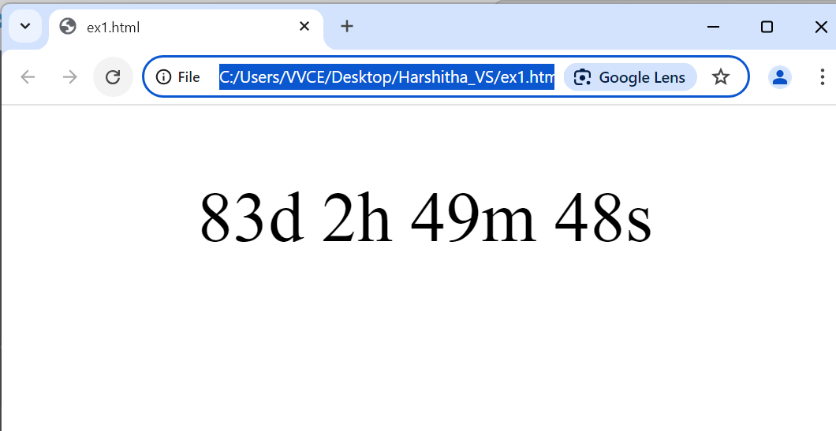

**VIVA QUESTIONS**

1. What is HTML?

2. What is the current version of HTML?

3. What is !DOCTYPE?

4. How Container tag is different from the Empty tag in HTML?

5. What are logical and physical tags in HTML?

6. What are the various heading tags and their importance?

7. Are <b> and <strong> tag same? If not, then why?

8. Types of HTML Comments? How are comments added in HTML?

9. What are the different formats in which colors in HTML can be declared?

10. How to create a link in HTML?

11. What is the use of the target attribute in the <link> tag?

12. What is the use of alt attribute in images?

13. What are the HTML tags used to display a table?

14. Use of DIV and SPAN element

15. In how many ways you can apply CSS to your HTML file?

16. How can you apply JS in your HTML?

17. What are the elements used to create a form

18. Elements used to create a table

19. Use of br and hr tag