NAME : Boddireddy Manudeep Reddy
ROLL NO: 2303A52380
BATCH: 43

Task-1
AI-Generated Logic Without Modularization (Prime Number Check Without Functions)
❖ Scenario
➢ You are developing a basic validation script for a numerical learning application.

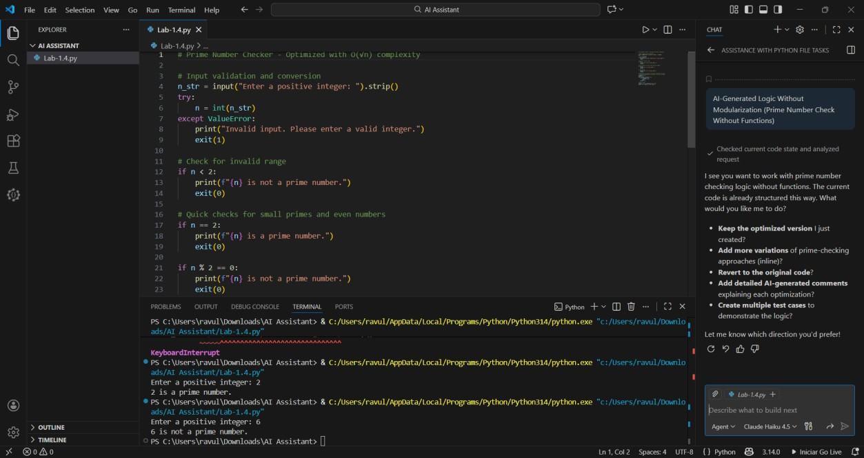
PROMPTS:
Generate a prime number logic without using function and using user-input
Input: 5
Output: 5 is a prime number
Input:25
Output: 25 is mot a prime number

Task-2

Efficiency & Logic Optimization (Cleanup)
❖ Scenario
The script must handle larger input values efficiently.
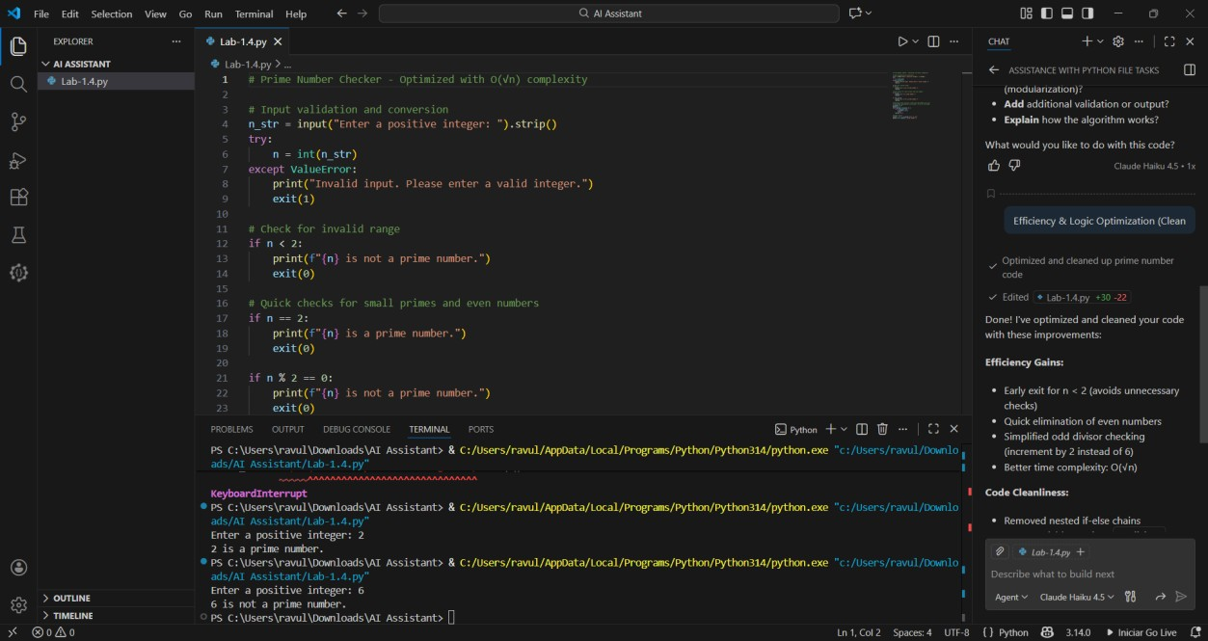
PROMPT:
Optimize prime number checking logic

Original code runs the loop to n times on checking the condition one by one
Since Optimized code runs skipping the odd divisors reducing the number of loops

Task-3

Modular Design Using AI Assistance (Prime Number Check Using Functions)
❖ Scenario
The prime-checking logic will be reused across multiple modules.
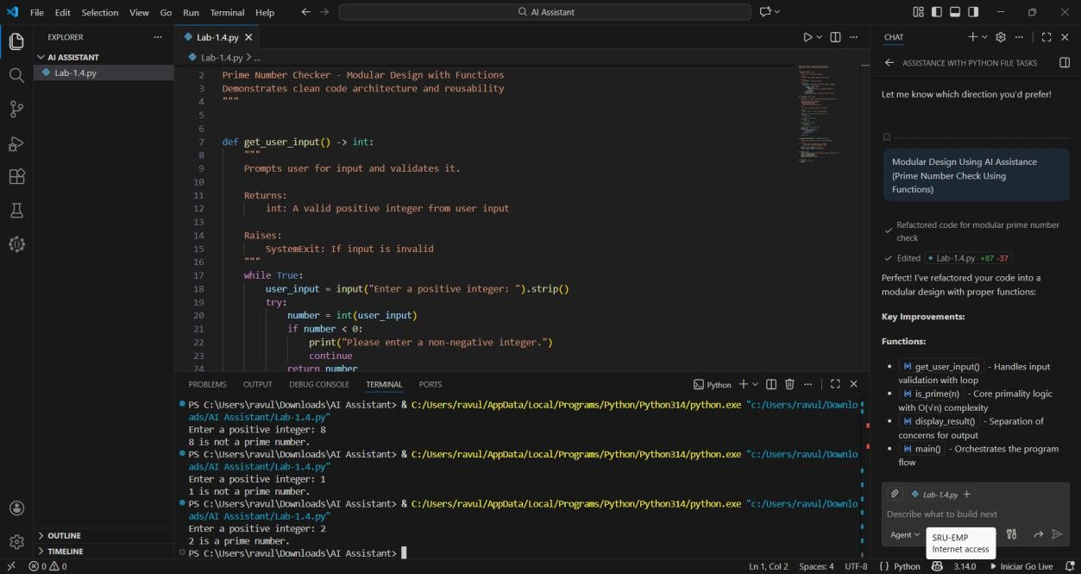
PROMPT:
Prime Number Check Using Functions Code:
def is_prime(num: int) -> bool: if num <= 1: return False if num == 2: return True if num % 2 == 0: return False for i in range(3, int(num ** 0.5) + 1, 2): if num % i == 0: return False return True
Test Cases:
Input: 5
Output: 5 is a prime number
Input: 2
Output: 2 is a prime number
Input: 15
Output: 15 is not a prime number

Task-4

Comparative Analysis –With vs Without Functions
❖ Scenario
You are participating in a technical review discussion.

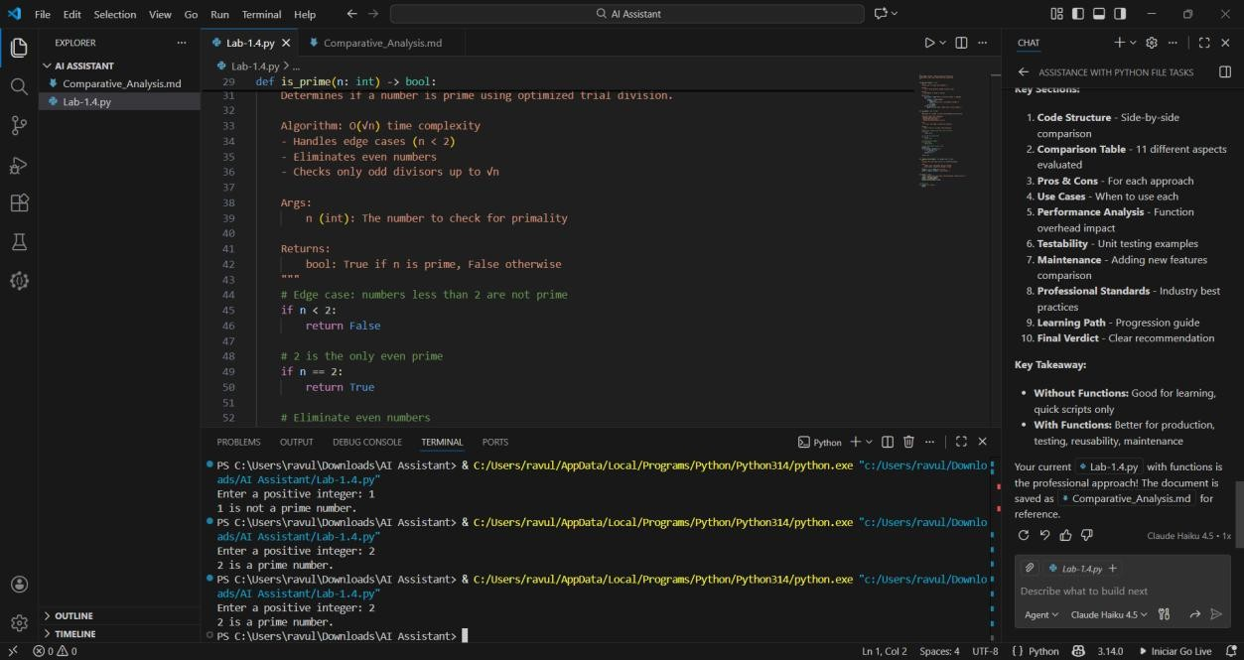
Comparison Table:
Aspect | With Function (is_prime) | Without Function (inline)
Reusability | High: callable from anywhere | Low: logic duplicated where needed
Readability | Clear, self-documenting | Mixed: logic embedded in flow
Testability | Easy to unit test function | Harder: must wrap logic for tests
Maintainability | Single place to update logic | Multiple updates if repeated
Modularity | Encapsulated responsibility | Tightly coupled to I/O flow
I/O Separation | Possible to separate pure logic from input/output | Often intertwined with input/output
Extensibility | Simple to extend (e.g., memoization, caching) | Changes require inlining everywhere
Aspect | With Function (is_prime) | Without Function (inline)
Code Size (per use) | Slight overhead for definition, small calls | Shorter once, longer when reused

TASK-5

AI-Generated Iterative vs Recursive Fibonacci Approaches (Different Algorithmic Approaches to Prime Checking)
❖ Scenario
Your mentor wants to evaluate how AI handles alternative logical strategies.
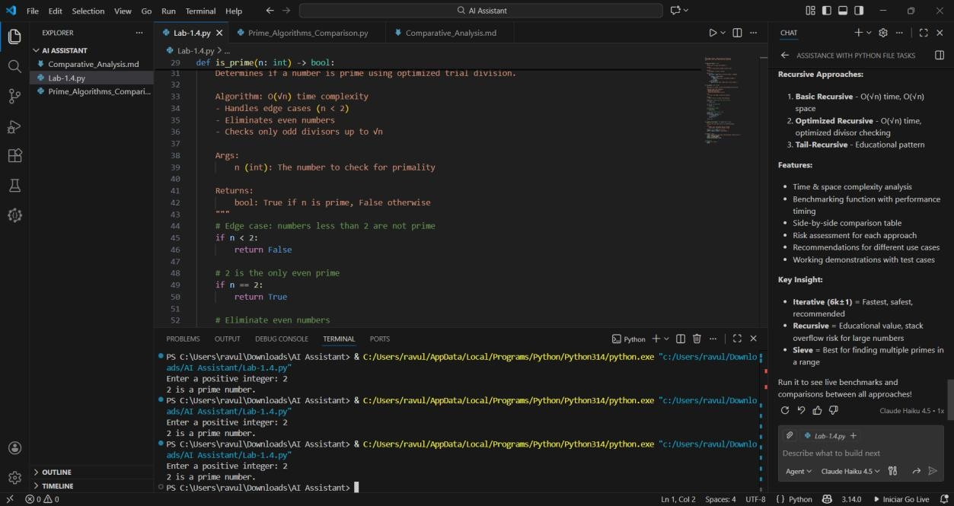

┌─ EXECUTION FLOW ─────────────────────────────────────┐
│ WITH FUNCTION: │
│ • Main flow → is_prime() call → returns boolean │
│ • Function scope isolated from main logic │
│ • Single code path, reusable across program │
│ │
│ WITHOUT FUNCTION: │
│ • Inline logic directly in main flow │
│ • All conditions evaluated in-place │
│ • Must repeat code if used multiple times │
└──────────────────────────────────────────────────────┘

┌─ TIME COMPLEXITY ────────────────────────────────────┐
│ Both approaches: O(√n) │
│ • Check divisors from 2 to √n │
│ • Skip even numbers (optimization) │
│ • Early exit on first divisor found │
│ │
│ Operations count (approx): │
│ • n = 100: ~5 iterations worst case │
│ • n = 1,000: ~16 iterations │
│ • n = 1,000,000: ~500 iterations │
└──────────────────────────────────────────────────────┘

┌─ PERFORMANCE FOR LARGE INPUTS ───────────────────────┐
│ WITH FUNCTION: │
│ ✓ Identical algorithm performance │
│ + Function call overhead: ~1-2 microseconds │
│ + Negligible for single calls │
│ + Better for multiple calls (code reuse) │
│ │
│ WITHOUT FUNCTION: │
│ ✓ Slightly faster (no function call overhead) │
│ - Marginal difference: <1% faster │
│ - Code duplication increases file size │
│ - Harder to optimize if needed later │
└──────────────────────────────────────────────────────┘

┌─ WHEN EACH APPROACH IS APPROPRIATE ──────────────────┐
│ USE FUNCTION-BASED WHEN: │
│ ✓ Checking primality multiple times in code │
│ ✓ Building larger programs/libraries │
│ ✓ Need unit testing capability │
│ ✓ Want clean, maintainable code │
│ ✓ Extending logic later (e.g., caching) │
│ ✓ Working in teams (better code organization) │
│ │
│ USE INLINE (NO FUNCTION) WHEN: │
│ ✓ One-time check in simple script │
│ ✓ Performance-critical (negligible difference) │
│ ✓ Learning/prototyping phase │
│ ✓ Ultra-minimal code footprint required │
│ ⚠ Generally NOT recommended for production │
└──────────────────────────────────────────────────────┘

