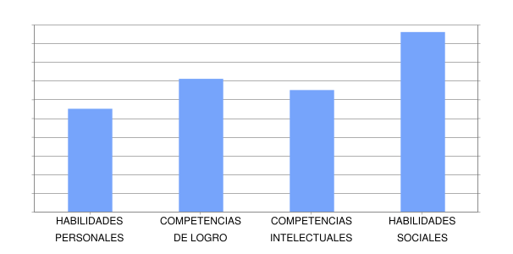

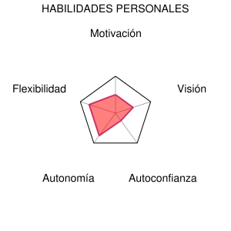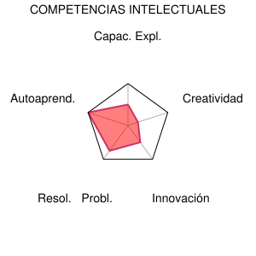

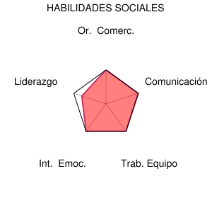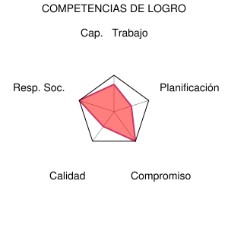

As the graphics says I’m a really social person and have a good capacity in teamwork and comunication, but not too good for example in leadership, i totally agree with it in that but I don’t really concur with the creativity part, I consider myself a creative person but maybe this creativity is useless in the business world.

Finally the self confidence is not exactly like it’s shown in my opinion because in my experience I prefer ask to others if i have a doub and that’s can make me look like a weak person or maybe inferior but i have a good confidence in my own persona.