Altium Guide

Create new project and add new documents
- File New Project save Local/ in Workspace
- Right click on project Add new to project Schematic/ Layout etc.

Start with schematic/ Manufacturer Part Search
- Panels Manufacturer Part Search
  - Usefull to search existing parts
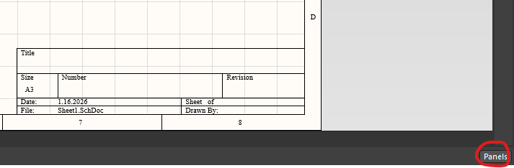
  - If you know the name of the part
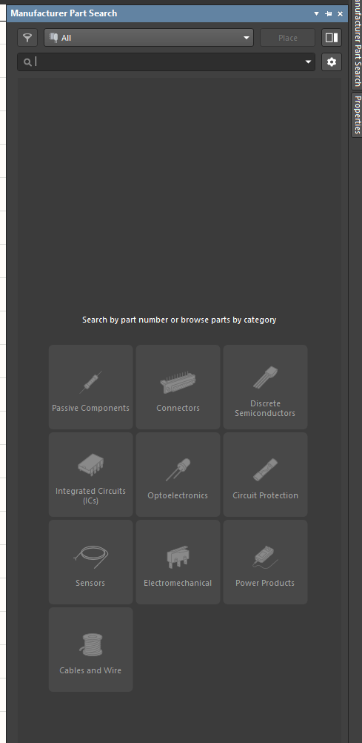
  - Type in this exact name or number
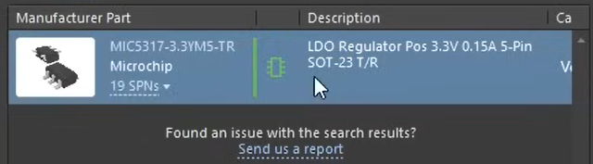
  - Green IC symbol means: schematic symbol and a footprint

Part placement and properties
- Double left click to get to properties of the part
- While placing a part: click tab to get to properties
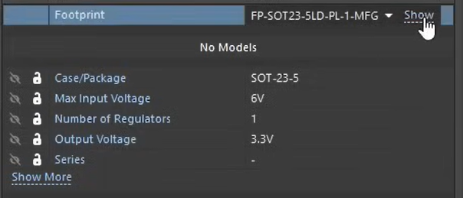
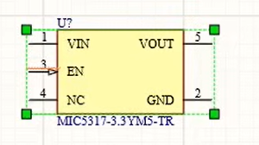
  - Then you see the parameters
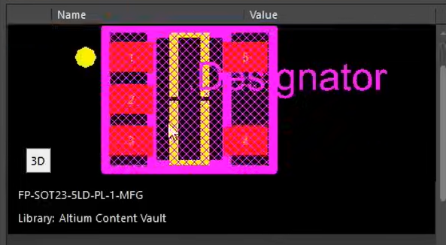
  - Footprint Show
  - Switch between 3D - model and footprint
- In Partsearch, you can also type in keywords.
  - E. g for a capacitor: Capacity, form factor, max voltage etc.
  - Or you can search for packages if you use IC’ s
- Right click Place
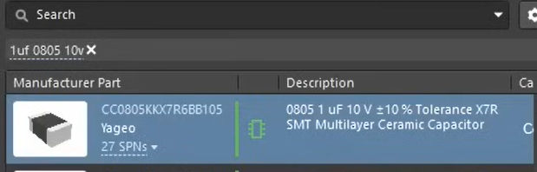
  - First it needs to download the information about the part
  - Place with left click
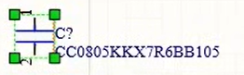
- Change comment to e. g 10u. Part number is usually in the comment, if you delete the number from the comment, it is still stored in the properties of the part.
- Flip components with x and y while pressing the left mouse button
- Space to rotate
- For unconnected pins: crosses, else there would be an ERC error
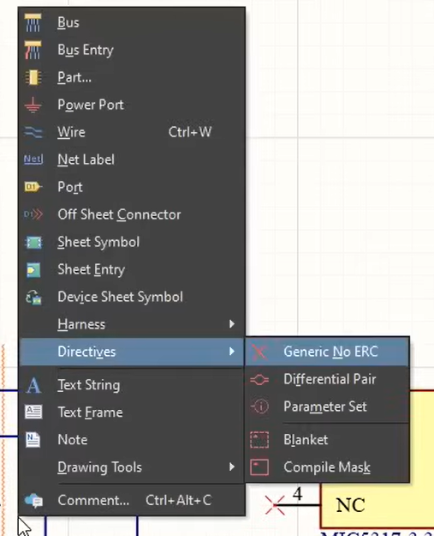

Wiring
- Click Ctrl + W
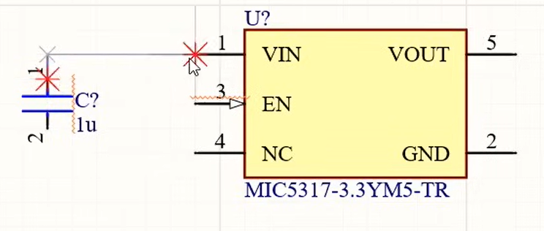
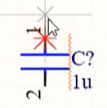
  - To change angle/ direction of wire: Left click
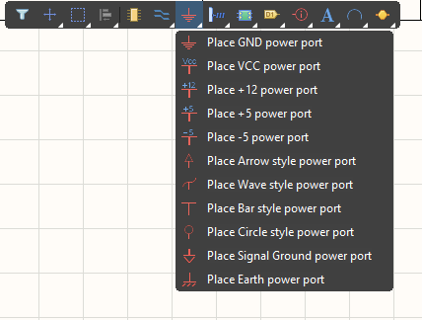
- Powerflags: GND, VCC etc.

Annotation/ numeration of parts
- Tools Annotation Annotate Schematics
- Select the order etc.
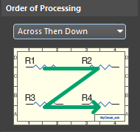
- Accept Changes (Create ECO)

Electrical Rule Check
- Go to project, right click, Validate PCB Project
- If there is an error: Panels Messages

Shortcuts
- Repour All: T, G, A
- Place polygon in polygon (Solid Region): P, R
- Show whole connection/ conductor track: Hover over it + Tab
- Toggle bottom and top layer: * (Numpad)
- Change between all layers: Ctrl + Shift + Mouse wheel
- Place Vias: P, V
- Change to properties from object while placing: Tab
  - Altium is like “paused”
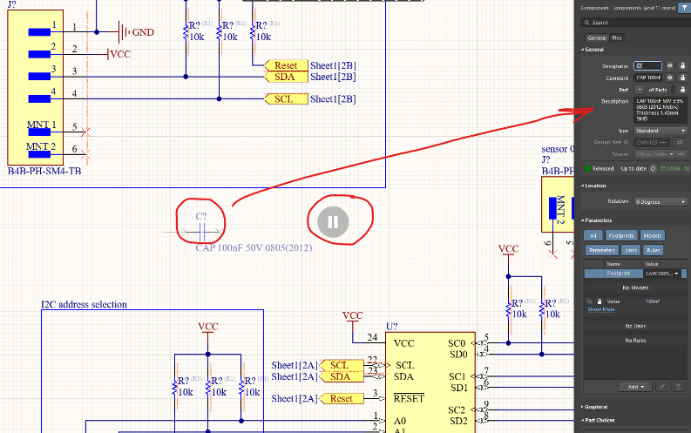
  - Not only for placing components but for almost everything (e. g tracks).
- View configuration panel: L (in layout 3D - window)
  - Under “View options”: “Show 3D Bodies” (On/ Off to show or hide 3D models). Also possible with: Shift + Z.
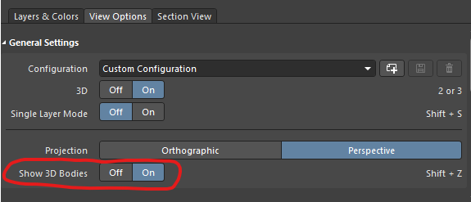
  - Other settings are possible, e. g transparency of the layers and more.
- Annotate schematics: T, A, A
  - Then: Update Changes List, Accept Changes (Create ECO)
- Update PCB with components from schematics: D + U (in schematics window)
- Lock components together: Select them, right click, U (Unions)
- Polygon Pour with round corners: P, G to place Polygon, Shift + Spacebar to toggle the corner modes.
  - Space: Mirror the corner to 180°
- Select whole shape if one line is clicked: Tab (e. g for rectangles in the PCB Editor)
- Board shape from object: Mark object, D, S, D
- Align Component Text: Mark component, A, P
- Design Rules (e. g change track width): D, R
- Change Units: V, U
- Place net label: P, N
- Align two pads (so that they are at the same height): Select both pads, A, V
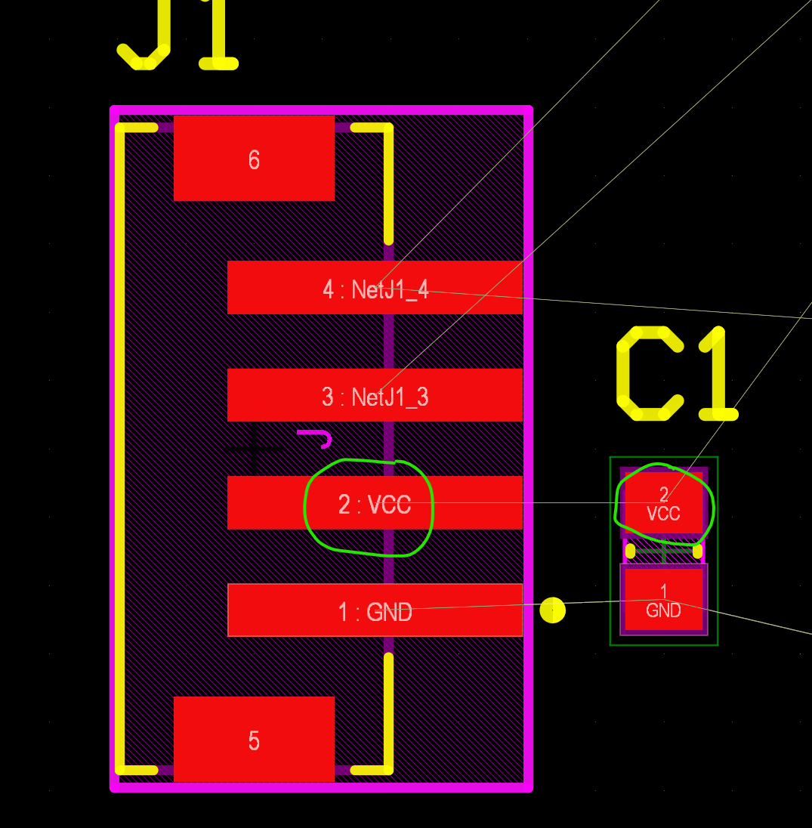
  - Important: After pressing A, V, a green cursor appears. Now you can decide, which part/ pad should be moved and which should stay at the same position.
- Flip the PCB in the 3D – Viewer: V, B
- Layer View: L
- Toggle Units PCB – Designer: Q
- Arrange Within Rectangle (Components): T, O, L
- Design Rule Check: T, D
- Reset Error Markers: T, M

Settings
- Cross Select Mode: Shift + Ctrl + X
  - Marked components in the schematic or the layout are also marked in the other window.
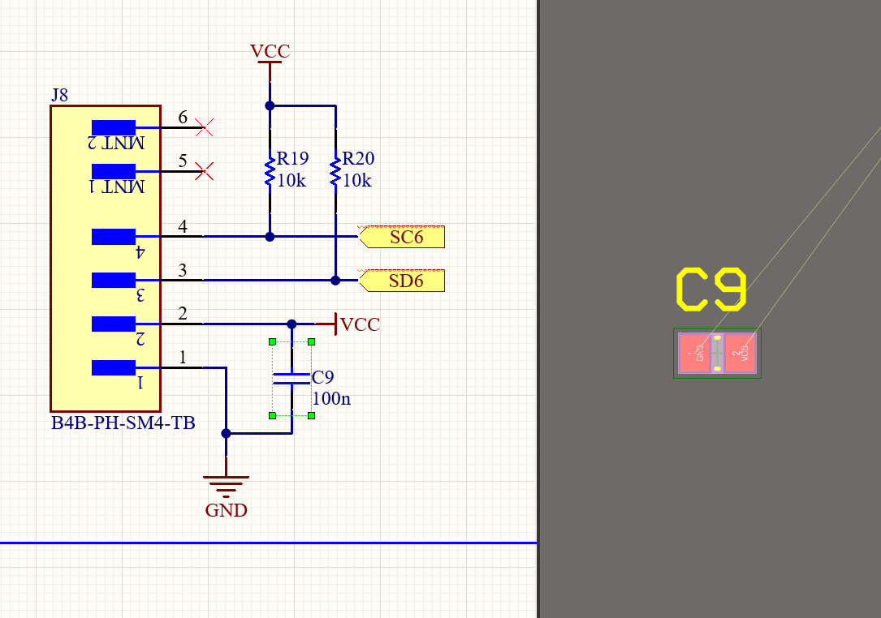
  - Like in KiCad
- Drag Panels to Projects Panel, then it is permanently available.
- Repour polygon automatically: Preferences, PCB Editor, General, Polygon Rebuild, Repour Polygons After Modification

PCB Layout Replication
- Mark the layout to replicate, press T, PCB Layout Replication
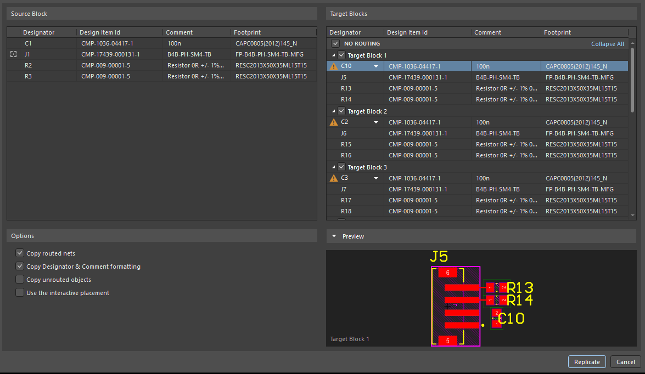
- Then this window appears:

Create schematic/ layout library and new symbols/ footprints
- Create new Library: F, N, L
  - Library Type: File (Locally)
  - Select Schematic or PCB Library, Create
  - Create both Libraries and save them at the same location
- New symbol from scratch: open library, add
  - Start drawing the symbol
- New symbol from existing symbol:
  - Download the existing one (from manufacturer part search or supplier)
  - Open it
  - Select it
  - Copy, paste
  - Start drawing the symbol
  - Make sure the Grid is the same
- New footprint from scratch: open library, add
  - Start placing pads and more.
- New footprint from existing footprint
  - Download the existing one (from manufacturer part search or supplier)
  - Open it
  - Select it
  - Copy, paste
  - Start placing pads and more
  - Make sure the Grid is the same

Link library to component panel
- Open component panel
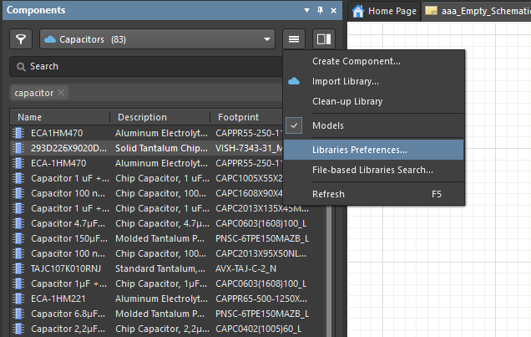
- Go to:
- Add library

Sheet symbols
- Generate sheet symbol: D, Y
- Select the schematic from which you want the sheet symbol
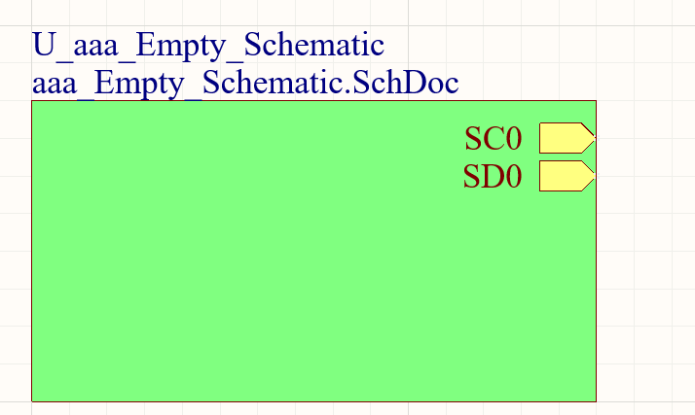
- Use ports to have connections across different sheets.

OutputJob
- Right click on project, Add New To Project, Output Job File

Fabrication Outputs
- Generate Fabrication Outputs: F, F, Gerber X2 Files
  - View different Layers of Layout
  - Panels, CAMtastic

Schematic Template
- Open a project or file
- Right click, Preferences, Data management, Templates
- Add

Special Strings
- There are special strings which adjust their shown value automatically
  - E. g ProjectName
- Own special strings: Right click, project options, parameters

Assembly Drawing
- Go to the layout of the PCB
- File, New, Draftsman Document
- Export to PDF

Bill of Materials
- Open BomDoc
- Reports, Bill of Materials
- Export

