A protected-area boundary separates tree-cover loss but not fire across changing territorial control

Abstract
Protected areas in conflict-affected landscapes may retain legal boundaries while practical authority shifts among conservation institutions, state forces, customary authorities, communities, and armed groups. We combined annual satellite observations from 2001–2022 with a historically reconstructed chronology of territorial control in Upemba National Park, Democratic Republic of the Congo. Within environmentally structured landscape comparison groups, we estimated inside–outside contrasts in recurrent fire, first tree-cover loss, and first agricultural expansion under fragmented, militia-centred, and park-centred control. We then compared estimates at the legal boundary with spatially offset pseudo-boundaries to determine whether comparable contrasts recurred elsewhere in the landscape.
Tree-cover loss was consistently lower inside the park under fragmented, militia-centred, and park-centred control, with inside-minus-outside log-odds contrasts of −0.846, −0.898, and −1.430, respectively. Under all three profiles, the legal-boundary estimates were more negative than those observed at the evaluated outer pseudo-boundaries. Fire showed a different pattern: contrasts were positive under fragmented control (0.170) and park-centred control (0.068) but near zero under militia-centred control (0.011). Comparable or larger fire contrasts recurred at outer pseudo-boundaries, indicating that the legal boundary did not uniquely organize burning. Agricultural expansion was lower inside only under park-centred control (−0.347), but sparse events and sensitivity to analytical choices made this result inconclusive.
Upemba’s legal boundary therefore retained a selective spatial signature under changing territorial control, consistently differentiating site-specific tree-cover loss but not recurrent fire. Evaluations of governance-fragile protected areas should distinguish among disturbance processes and test whether apparent inside–outside contrasts are exceptional at the legal boundary rather than components of broader spatial gradients.

Keywords
armed conflict; protected-area effectiveness; remote sensing; territorial control; tree-cover loss; fire; Democratic Republic of the Congo

1. Introduction
Protected areas remain a central instrument of biodiversity conservation, but legal designation does not guarantee ecological effectiveness. Global and regional studies often report lower habitat loss, reduced anthropogenic pressure, or higher local biodiversity within protected areas than in surrounding or otherwise comparable unprotected landscapes (Andam et al., 2008; Geldmann et al., 2013, 2019; Gray et al., 2016; McNicol et al., 2023). Yet effectiveness varies widely among locations, disturbance processes, and management contexts, and substantial human pressure persists within many protected areas (Jones et al., 2018). Evaluations commonly estimate effectiveness by comparing ecological conditions inside legal boundaries with those outside them. Such comparisons can provide valuable evidence, but their interpretation often assumes that management institutions exercise reasonably stable authority, that the boundary marks a meaningful change in land-use regulation, and that surrounding areas provide an interpretable comparison. These assumptions become especially problematic where state authority, conservation management, and access to land are unstable.
Conflict-affected protected areas frequently lack stable or exclusive territorial authority. Armed groups, state forces, customary authorities, conservation organisations, local administrations, and communities may exercise overlapping and spatially uneven control, while insecurity, displacement, military operations, and changing access reshape resource use on both sides of protected-area boundaries (de Merode et al., 2007; Gaynor et al., 2016; Daskin and Pringle, 2018). Conflict often weakens conservation institutions and contributes to wildlife decline, but its environmental consequences are not uniform: violence may intensify extraction, alter livelihoods and settlement, displace pressure, or restrict access to particular areas. Conservation responses may themselves rely on coercive or militarised forms of territorial control whose social legitimacy and ecological consequences cannot be inferred from reduced disturbance alone (Lunstrum, 2014; Marijnen and Verweijen, 2016; Duffy et al., 2019). Under these conditions, legal protection, practical authority, conservation intent, and institutional legitimacy may diverge. A boundary may retain material consequences even when park institutions do not control the territory continuously, while lower disturbance may reflect enforcement, customary regulation, insecurity, displacement, inaccessibility, or coercive exclusion rather than legitimate conservation success. Here, territorial control refers to the practical capacity of actors to shape who can enter, extract, cultivate, settle, or burn within a landscape. It is analytically distinct from legal jurisdiction, conservation intent, institutional legitimacy, and exclusive sovereignty.
These settings are also difficult to evaluate empirically. Insecurity restricts field access, interrupts ecological monitoring, destroys records, and increases dependence on retrospective accounts and institutionally produced reports. Existing protected-area management-effectiveness datasets remain incomplete and rely heavily on self-assessment, particularly in regions where monitoring capacity is weakest (Leverington et al., 2010; Coad et al., 2015; Fromont et al., 2024). Satellite observations provide an important complementary source of evidence because they measure land-surface change consistently across inaccessible landscapes and long periods. Global products now permit annual observation of fire, tree-cover loss, and agricultural expansion at spatial resolutions relevant to protected-area evaluation (Hansen et al., 2013; Chuvieco et al., 2018; Lou et al., 2025). Remote sensing has consequently become central to assessments of protected-area outcomes and anthropogenic pressure (Blankespoor et al., 2017; Gohr et al., 2022; McNicol et al., 2023). Satellite measurements are not, however, direct measures of governance. They identify land-surface outcomes but cannot determine who produced them, why they occurred, whether enforcement was legitimate, or whether pressure shifted elsewhere. Remote sensing can therefore provide independent environmental evidence while remaining insufficient on its own to identify institutions, mechanisms, or causal effects.
Interpretation also depends on the disturbance process being measured. Persistent, site-specific activities such as forest clearing, settlement, and agricultural establishment generally require repeated access, labour, investment, and some expectation that land use can continue at a particular location. These activities may therefore respond strongly to boundaries, tenure arrangements, enforcement, and other forms of territorial regulation. Fire differs. Burning is recurrent, can occur during temporary or mobile access, responds strongly to vegetation, fuel continuity, and weather, and may spread beyond its point of ignition (Archibald et al., 2010; Kelly et al., 2020). A boundary or governing actor may therefore differentiate tree-cover loss or agricultural establishment without producing an equivalent fire contrast. Conversely, higher fire occurrence need not indicate weaker conservation because fire can represent ecological processes, livelihood practices, hunting, pasture management, accidental spread, or deliberate management. Treating fire, tree-cover loss, and agricultural expansion as interchangeable indicators of anthropogenic pressure risks obscuring how different activities respond to authority, access, and landscape conditions. Protected-area evaluation should instead ask which processes a boundary can plausibly regulate and whether the selected satellite indicators capture those processes.
A separate problem concerns spatial attribution. Protected areas are not located randomly: they are often established in places that are steeper, more remote, less agriculturally suitable, or otherwise less exposed to conversion pressure than surrounding land (Joppa and Pfaff, 2009). Naïve inside–outside comparisons can therefore attribute habitat retention to protection when part of the difference reflects pre-existing environmental and accessibility gradients. Matching, stratification, and quasi-experimental designs reduce measured confounding and have substantially improved protected-area impact evaluation (Andam et al., 2008; Geldmann et al., 2013; Gohr et al., 2022). Nevertheless, conditioning on observed covariates cannot establish that the legal boundary itself structures the estimated contrast. A sharp inside–outside difference may still form part of a broader regional gradient in vegetation, settlement, markets, hydrology, or land-use history. We therefore use spatially offset pseudo-boundaries as a complementary diagnostic. When a contrast is exceptional at the legal boundary and does not recur at evaluated offsets, the evidence that the boundary is materially aligned with the outcome becomes stronger. When comparable contrasts recur elsewhere, the legal boundary may not be the principal spatial structure organising the pattern. These offsets do not create randomised counterfactuals, but they help distinguish legal-boundary alignment from broader spatial patterning.
We examine these problems in Upemba National Park in southeastern Democratic Republic of the Congo. Created in 1939, Upemba spans plateaus, savannas, woodlands, wetlands, and the Kamalondo Depression. Its legal status remained continuous during the study period, but practical authority changed repeatedly. The attack on the Lusinga headquarters on 28 May 2004 precipitated the collapse of routine operations and withdrawal from parts of the landscape. Gédéon’s surrender in 2006 preceded limited and negotiated conservation re-entry; donor-supported technical assistance strengthened operations around the Plateau during 2010–2011; renewed armed insecurity again contracted park reach after 2012; and operational reach expanded on the Plateau from 2016 and in the Depression from 2017. These transitions remained spatially uneven and never established uniform or uncontested authority. Upemba therefore provides a well-suited case for examining whether a continuously gazetted boundary retained measurable environmental consequences across recurrent configurations of fragmented, militia-centred, and park-centred territorial control (Van Leeuwe et al., 2009; Hasson, 2015; Brugière, 2020; Tables S6A–S6B).
We combine annual satellite observations from 2001–2022 with a historically reconstructed chronology of territorial control. We first derive landscape comparison groups that condition boundary comparisons on environmental and accessibility context. We then estimate annual inside–outside contrasts in recurrent fire and first threshold-crossing events of tree-cover loss and agricultural expansion within each landscape group and relate those contrasts to three recurrent territorial-control profiles. Finally, we compare estimates at the legal boundary with those at spatially offset pseudo-boundaries inside and outside the park. We ask three questions: did disturbance differ between the two sides of Upemba’s legal boundary; did the magnitude or direction of that contrast vary among territorial-control profiles; and were the observed contrasts exceptional at the legal boundary or reproduced elsewhere in the landscape? By separating satellite measurements, historical interpretation, and causal claims, we evaluate whether legal protection retained selective spatial consequences under fragmented authority and whether those consequences differed between persistent, site-specific land transitions and recurrent fire.

2. Methods

2.1 Study system and spatial design
We studied Upemba National Park in southeastern Democratic Republic of the Congo, a protected area of approximately 10,000 km² spanning the Kibara and Manika plateaus and extending west into the Kamalondo, or Upemba, Depression wetland complex (Fig. 1). We assembled spatial data over a broader rectangular domain covering the park, the Kamalondo Depression, adjacent hunting reserves, and surrounding settlements. We excluded the Copperbelt mining districts and Kundelungu Plateau because their environmental conditions and land-use systems differed substantially from those of the focal landscape. The resulting “Upemba landscape” extended from 25.48 to 27.50°E and from 10.4 to 7.8°S.
We digitized the park boundary from the official delimitation in Ordonnance 75-241 du 22 juillet 1975 and aligned the boundary, disturbance layers, and reference-period landscape covariates to a common 500 m grid in UTM Zone 35S (EPSG:32735). We rasterized the park polygon to this grid and derived a signed-distance surface, with negative values inside and non-negative values outside the park. We excluded cells classified as perennial water, defined from the JRC Global Surface Water product as water present during all 12 months or with at least 90% occurrence (Pekel et al., 2016).
The primary analysis compared cells within 10 km on either side of the park boundary. We selected this symmetric corridor before inspecting territorial-control profile coefficients by comparing 5, 10, and 20 km corridors and the complete landscape using measured covariate balance and event support. The 5 km corridor provided the strongest balance, with median and maximum absolute standardized mean differences of 0.119 and 0.371, but retained only 313 tree-cover-loss and 392 agricultural-expansion events. The 10 km corridor retained 519 tree-cover-loss and 518 agricultural-expansion events, with median and maximum absolute standardized mean differences of 0.187 and 0.733. Wider domains increased event support but produced substantially greater measured imbalance. We therefore treated 10 km as a boundary-adjacent compromise between measured comparability and sparse-event support, while using the 5 km, 20 km, and complete-landscape domains as spatial sensitivities (Tables S4–S5). This selection reduces major measured differences but does not make the two sides environmentally equivalent.
Areas outside Upemba do not constitute untreated controls. They are historically structured landscapes shaped by settlement, customary authority, armed conflict, displacement, state intervention, accessibility, and resource use. We therefore interpret the estimated inside–outside differences as conditional spatial contrasts across the legal park boundary, not as causal effects of legal protection.
We acquired and initially harmonized remote-sensing data in Google Earth Engine and completed raster processing, clustering, event construction, and statistical analysis in R 4.5.3 (Gorelick et al., 2017; R Core Team, 2026). Package versions and computational-environment details are reported in Table S18. Expanded details on the spatial design and construction of the landscape comparison groups are provided in Supplementary Methods S1.

2.2 Disturbance measurements
We measured annual fire, tree-cover loss, and agricultural expansion from 2001 through 2022. These indicators represent different land-surface processes and do not provide interchangeable measures of human activity. Fire is recurrent and can reflect interacting climatic, vegetation, access, livelihood, and management processes. Tree-cover loss and agricultural expansion identify site-specific disturbance events that generally require sustained access and leave persistent remotely detectable signatures. Table 1 summarizes the source products, annual event definitions, and outcome-specific risk-set rules.
We derived fire from the ESA Fire Climate Change Initiative FireCCI version 5.1 burned-area pixel product (Chuvieco et al., 2018). For 2001–2020, we accessed the product through Google Earth Engine. For 2021–2022, we used the official monthly continental pixel-product rasters distributed through the Centre for Environmental Data Analysis archive. These monthly rasters contain the first detected burn day of year at approximately 250 m resolution. We combined the April–October rasters for each year and retained burn dates from day of year 100 through 300, inclusive. We converted qualifying native pixels to a seasonal binary burned-status layer and projected this layer to the canonical 500 m grid using area-averaging, so each target value represented the fraction of the complete 500 m cell classified as burned during the focal season. We classified a cell as burned when this fraction reached 0.25. We retained the earliest qualifying burn date for descriptive analyses only. Burned cells remained eligible in subsequent years because fire was a recurrent outcome.
FireCCI distinguishes observed-unburned, unobserved, and non-burnable native pixels. We audited the 2021–2022 monthly files using the original whole-cell aggregation procedure and reproduced the authoritative 500 m classifications exactly. No native pixel in the study domain remained unobserved throughout April–October in either year, so missing-observation handling did not alter any primary fire classification or model stratum. Detailed product provenance, file checksums, native-state codes, and audit results are reported in Table S17.
We measured tree-cover loss with Hansen Global Forest Change version 1.12 (Hansen et al., 2013). For each year, we converted the native 30 m loss-year layer to a cumulative binary loss surface and calculated the proportion of valid 30 m subpixels within each complete 500 m cell whose recorded loss year was at or before the focal year. We assigned the first year in which this whole-cell cumulative loss fraction reached 0.25 as the tree-cover-loss event. We restricted the risk set to 500 m cells with mean tree cover of at least 30% in 2000. Each eligible cell contributed annual observations through its first event year and left the tree-cover-loss risk set thereafter.
We measured agricultural expansion with the Annual Cropland Extent Dataset for Africa (Lou et al., 2025). We converted each annual 30 m cropland layer to a binary native surface and aggregated it to the proportion of each 500 m cell classified as cropland. Agricultural expansion was the first detected annual transition from a cropland fraction below 0.25 in the preceding year to a fraction of at least 0.25 in the focal year. The 2000 layer provided the baseline state for transitions beginning in 2001. This definition identifies a first remotely detected threshold crossing rather than necessarily permanent conversion. Each cell contributed observations through its first event year and left the agricultural-expansion risk set thereafter. Expanded disturbance-processing, harmonization, risk-set, and measurement-validation procedures are provided in Supplementary Methods S3 and Table S17.
We used 0.25 as a pragmatic common cell-level event definition selected before model fitting. Applying one threshold simplified comparison of spatial contrasts but did not equalize the resolution, error structure, or ecological meaning of the three products. We therefore repeated event construction at thresholds of 0.10 and 0.50. We use these classified products to estimate relative spatial contrasts rather than unbiased annual disturbed area; classification error and product disagreement remain relevant even when the same product and definition are applied on both sides of the boundary (Olofsson et al., 2014; Kerner et al., 2024).
For each outcome, we expanded the 500 m data into annual cell-level risk sets and aggregated them by landscape comparison group, year, and park side. Each stratum contained the number of event cells, (y), and the number of eligible cells, (n). All eligible cells contributed to every annual fire risk set. Cells contributed to tree-cover-loss and agricultural-expansion risk sets until their first detected event.
Table 1. Remote-sensing products and annual disturbance-event definitions. Primary events were defined using a 25% threshold on the common 500 m grid; 10% and 50% thresholds were evaluated as measurement sensitivities.
Outcome | Source product | Years | Native resolution | Event definition | Risk-set rule | Primary threshold | Sensitivity thresholds
Fire | ESA FireCCI v5.1 | 2001–2022 | 250 m | ≥25% of a 500 m cell burned during DOY 100–300 | All eligible cells remain at risk annually | 25% | 10%, 50%
Tree-cover loss | Hansen Global Forest Change v1.12 | 2001–2022 | 30 m | First year cumulative loss reaches ≥25% of a 500 m cell | Cells with ≥30% tree cover in 2000; removed after first event | 25% | 10%, 50%
Agricultural expansion | Annual Cropland Extent Dataset for Africa | 2001–2022 | 30 m | First annual transition from <25% to ≥25% cropland | Eligible cells removed after first event | 25% | 10%, 50%

2.3 Landscape comparison groups
We derived landscape comparison groups to structure boundary comparisons among areas with broadly similar environmental conditions and accessibility. These groups are pragmatic analytical strata rather than discrete or internally homogeneous socio-ecological systems. They reduce large measured differences in disturbance opportunity but cannot eliminate unmeasured spatial confounding.
We assembled reference-period covariates describing elevation, slope, a binary indicator of at least 30% mean tree cover in 2000, distance to permanent water, 1981–2010 precipitation, potential and actual evapotranspiration, climatic water balance, aridity, soil organic carbon, soil pH, clay and sand content, distance to built-up areas present by 2000, and travel time to cities (Table S1). The travel-time product represents 2015 network conditions. We included it as a measure of durable regional transport and market-access structure rather than as a strictly pre-2001 covariate and evaluated its influence in a separate clustering sensitivity.
We excluded cells lacking elevation or slope. We replaced missing accessibility, distance-to-settlement, and distance-to-water values with their observed maxima, representing the least accessible or most distant conditions, and replaced missing values in the remaining covariates with their medians. We transformed accessibility and the two distance variables using (\log(1+x)) and standardized all clustering features to zero mean and unit variance.
We fitted k-means partitions for (k=2) through (k=15). We evaluated mean silhouette width using the same random sample of 20,000 cells for every value of (k), drawn with seed 42. The silhouette criterion selected (k=3). We fitted the final three-group partition to all eligible cells with 25 random starts and seed 123 and evaluated stability across additional seeds. Because k-means does not impose spatial continuity, we reassigned cells whose label matched no more than one of their eight neighbours to the modal label in the surrounding eight-cell neighbourhood. Full silhouette, seed-stability, and de-speckling diagnostics are reported in Tables S2–S3 and Figure S1.
We retained two groups for outcome analysis: the “Depression”, corresponding principally to the Kamalondo Depression, and the “Plateau”, corresponding principally to the Kibara and Manika plateaus. We excluded the Lufira Plain before outcome modelling because its spatially restricted park intersection accounted for only 786 cells, or 3.7% of park-interior cells, within the primary corridor and did not support an independently reconstructed territorial-control chronology comparable with those of the Depression and Plateau. A subsequent support audit confirmed that the Lufira Plain contained no interior tree-cover-loss events and only two interior agricultural-expansion events during 2001–2022 (Table S5).
Removing the 2015 accessibility covariate again selected three groups, retained the Depression and Plateau configurations, and reproduced 96.8% of primary-corridor assignments after optimal label matching. Because this sensitivity did not cross the pre-specified threshold for a material partition change, we retained the complete reference-period partition and did not rerun the outcome models (Table S3; Fig. S1).

2.4 Territorial-control profiles
The lead author reconstructed annual territorial-control profiles separately for the Depression and Plateau from 2001 through 2022. The evidence base comprised dated archival records, park and NGO documentation, technical assessments, humanitarian reporting, media coverage, and a wider historical synthesis of Upemba. We prioritized sources that could be assigned to a particular landscape group, year, or transition. When sources conflicted, greater weight was given to contemporaneous records with direct spatial or institutional relevance, and the disagreement was recorded in the evidence chronology. The coding focused on two actor complexes with documented capacity to regulate or constrain access: Upemba National Park institutions, including ranger deployment, patrol reach, infrastructure, external support, and practical enforcement capacity; and armed groups described in the source record as Mai-Mai. State forces, customary authorities, local administrations, communities, and external conservation organisations informed the interpretation but were not represented as separate statistical categories.
We assigned each landscape-group year to one of three recurrent profiles. Fragmented control describes periods in which neither park institutions nor militia exercised consolidated control and access remained weakly regulated, spatially fragmented, or negotiated. Militia-centred control describes periods in which armed-group presence materially structured access while park enforcement had collapsed or remained severely constrained. Park-centred control describes periods of expanded park operational reach and regulatory capacity, although insecurity and incomplete territorial coverage persisted. The profiles summarize documented configurations of partial control rather than exclusive authority.
The lead author’s historical research and conservation work in Upemba provided access to local records and spatial context but also meant that the reconstruction was conducted by a single, non-blinded expert. To limit interpretive flexibility, all assignments were fixed before inspection of the remote-sensing outcomes; every historical episode was linked to documented evidence, transition rationales, coding confidence, and plausible alternative dates; and coding uncertainty was examined through transition-year and episode-omission diagnostics. Tables S6A–S6B provide the complete frozen chronology and evidentiary basis.
Fragmented control occurred during 2001–2003 in both groups, 2007–2012 in the Depression, and 2007–2010 on the Plateau. Militia-centred control occurred during 2004–2006 in both groups, 2013–2016 in the Depression, and 2013–2015 on the Plateau. Park-centred control occurred during 2011–2012 and 2016–2022 on the Plateau and during 2017–2022 in the Depression. The profiles comprised 16, 13, and 15 landscape-group years and four, four, and three contiguous historical episodes, respectively. Consecutive years within one episode do not constitute independent historical replications. Tables S6A–S6B report the complete landscape-group-year chronology, source citations, transition rationales, and uncertainty notes; Table S7 summarizes profile and episode support. The evidence hierarchy, coding procedure, handling of conflicting evidence, and episode-level uncertainty assessment are described in Supplementary Methods S2.

2.5 Outcome-specific statistical models
We first plotted annual event proportions separately by landscape comparison group and park side (Fig. 2). These trajectories describe the observed data and support model interpretation; formal inference used separate models for recurrent fire and the two sparse first-transition outcomes.
For fire, let s index landscape comparison group, t year, and k park side, with k = 0 outside and k = 1 inside. Let Yₛₜₖ denote the number of burned cells among Nₛₜₖ cells at risk. We fitted aggregated counts using a beta-binomial regression with a logit link in glmmTMB (Brooks et al., 2017):
$$Y_{stk}∼BetaBinomial\left(N_{stk},p_{stk},ϕ\right)$$
$$logit\left(p_{stk}\right)=α_{st}+β_{F}k+δ_{M}kI\left(G_{st}=M\right)+δ_{P}kI\left(G_{st}=P\right)$$
where αₛₜ denotes a fixed effect for each landscape-group × year combination, Gₛₜ denotes the territorial-control profile, and fragmented control is the reference category. The fixed effects absorb conditions shared by the two sides within the same landscape group and year, including common annual shocks, but do not control unmeasured factors that differ between sides within a group-year.
The inside–outside log-odds contrast under fragmented control is βF. The corresponding contrasts under militia-centred and park-centred control are βF + δM and βF + δP. We estimated these complete profile-specific contrasts and all pairwise differences among them. Positive values indicate higher modelled fire probability inside the park; negative values indicate lower probability inside. The raw interaction coefficients δM and δP represent differences from fragmented control and are not themselves complete boundary contrasts.
We fitted the primary fire model to the harmonized 0.25 event definition within the symmetric 10 km corridor. We assessed numerical validity using optimizer convergence, model-matrix rank, Hessian definiteness, finite parameter estimates, and maximum framework and independently calculated numerical gradients. We refined the valid reference fit with BFGS using 20,000 maximum iterations and a relative tolerance of 10⁻¹², and required a positive-definite Hessian and both maximum gradients below 0.001. We report conditional, model-based 95% Wald confidence intervals for the complete profile contrasts and pairwise differences (Table S14). Because these intervals do not model serial dependence among years within historical episodes, we interpret them alongside threshold, spatial-domain, transition-year, and episode-omission diagnostics rather than as independent annual replications.
Beta-binomial models for tree-cover loss and agricultural expansion failed numerical-validity checks because events were sparse and unevenly distributed among group-years, producing combinations of non-convergence, non-positive-definite Hessians, and excessive gradients. We therefore based primary inference for these outcomes on a two-stage analysis of annual inside–outside contrasts.
For each eligible landscape-group year, we added 0.5 to the event and non-event counts in all four cells of the inside–outside 2 × 2 table and calculated the corrected log-odds difference:
Dₛₜ = log[(yₛₜ,in + 0.5)/(nₛₜ,in − yₛₜ,in + 0.5)] − log[(yₛₜ,out + 0.5)/(nₛₜ,out − yₛₜ,out + 0.5)]
We approximated its sampling variance as
Vₛₜ = 1/(yₛₜ,in + 0.5) + 1/(nₛₜ,in − yₛₜ,in + 0.5)
+ 1/(yₛₜ,out + 0.5) + 1/(nₛₜ,out − yₛₜ,out + 0.5)
We omitted group-years without cells at risk on both sides and fitted the remaining contrasts using an inverse-variance-weighted linear model:
$$D_{st}=μ_{G_{st}}+λ_{s}+ε_{st}$$
where μGₛₜ denotes the territorial-control profile and λₛ the landscape-group fixed effect. We used the unnormalised weight 1/Vₛₜ. Estimated marginal means represent adjusted inside–outside log-odds contrasts under each profile. We calculated all pairwise profile differences and used HC3 heteroskedasticity-consistent covariance estimates for confidence intervals (MacKinnon and White, 1985). We repeated the analysis without inverse-variance weights because the first-stage variance approximation does not model spatial dependence among cells. HC3 addresses leverage and heteroskedasticity but does not account for residual dependence between the two landscape groups observed in the same calendar year; we therefore interpret sparse-outcome precision cautiously. The 44 landscape-group years represented only eleven contiguous historical episodes, and consecutive years within an episode do not constitute independent historical replications. We therefore treat Wald and HC3 intervals as conditional model-based summaries rather than as uncertainty estimates from independent historical treatments. Substantive inference emphasizes the direction of profile-specific contrasts and their concordance across measurement thresholds, spatial domains, transition-year alternatives, episode omissions, and boundary-location diagnostics.
All reported estimates describe conditional associations between territorial-control profiles and inside–outside disturbance contrasts. We do not interpret coefficients, confidence intervals, or p-values as actor-specific causal effects.

2.6 Robustness and boundary-location diagnostics
We organised the supplementary analyses into four evidentiary components. The primary specification used the 10 km corridor, the 0.25 event threshold, the harmonized 2001–2022 fire series, the strict-valid beta-binomial fire model, and the weighted two-stage tree-cover-loss and agricultural-expansion models. Directly matched robustness analyses comprised 0.10 and 0.50 event thresholds, 5 and 20 km corridors, the complete landscape, and unweighted sparse-outcome models (Tables S10–S12; Fig. S2). Separate historical diagnostics shifted plausible transition years and omitted one contiguous territorial-control episode at a time (Table S13). These diagnostics used the complete landscape and, for the sparse outcomes, an earlier model implementation; we therefore interpret them as historical sensitivity analyses rather than direct replications of the primary 10 km estimates. Technical validation comprised the fire-processing audit, comparison with the superseded 2021–2022 fire implementation, optimizer refinement, baseline-forest-mask verification, agricultural-product reproduction, clustering reproducibility, and clustering without the 2015 accessibility covariate (Tables S14 and S17). Finally, we used spatially offset pseudo-boundaries as a separate diagnostic of boundary-location specificity (Tables S15–S16; Fig. S3).
For the boundary-location diagnostic, the actual park boundary was centred at signed distance 0 and used the primary corridor from −10 to +10 km. We fixed outer pseudo-boundaries at +20, +40, and +60 km before model fitting. Their 20 km-wide corridors were spatially separated and lay entirely outside the legal park. We also evaluated a dense outer gradient centred from +15 to +60 km at 5 km intervals. At each outer pseudo-boundary, we compared the side facing toward the park with the side facing away from it using the same outcome definitions, territorial-control profiles, and outcome-specific models.
We use “boundary-specific” in the supplementary classification as descriptive shorthand for an estimate that was exceptional relative to the evaluated pseudo-boundaries under this deterministic rule. The term does not denote a randomized null test, a causal effect of legal designation, or a probability that the park boundary generated the observed contrast.
Park geometry provided only two supported inner pseudo-boundaries, centred at −15 and −20 km. Their corridors overlapped substantially and retained few tree-cover-loss and agricultural-expansion events, so we treated them as individual descriptive checks rather than as an exchangeable reference distribution.
We classified an actual-boundary estimate as boundary-specific when it lay outside the range of the three spaced outer estimates, was not reproduced across the dense outer gradient, and was not contradicted by a supported inner check. We classified evidence as partially boundary-specific when the actual estimate was distinct from the spaced outer set but recurred within the dense gradient, or when only a subset of pairwise profile differences met the full criterion. We classified a result as not boundary-specific when comparable estimates recurred at outer pseudo-boundaries, and as inconclusive when sparse events or invalid model diagnostics prevented comparison. Because the pseudo-boundaries overlap spatially and are deterministic rather than randomized, we interpret their ranges and ranks descriptively and not as permutation distributions or formal p-values (Table S16; Fig. S3). Supplementary Methods S4 provides the complete estimation procedures, numerical-validity criteria, and boundary-specificity classification rules.

3. Results
The primary 10 km boundary corridor contained 42,554 cells, comprising 20,548 cells inside and 22,006 cells outside the park. Across 2001–2022, the analytical datasets contained 508,320 burned cell-years, 519 first tree-cover-loss events, and 518 first agricultural-expansion events. Fire was frequent in both landscape groups throughout the study period, whereas tree-cover loss and agricultural expansion were sparse and concentrated mainly in the Depression (Fig. 2). Fragmented, militia-centred, and park-centred control contributed 16, 13, and 15 landscape-group years, respectively, distributed across four, four, and three distinct historical episodes (Table S7). Tables S4–S5 report complete spatial and event support for the primary corridor.
Tree-cover loss was consistently less frequent inside the park under all three territorial-control profiles (Fig. 3A; Table 2). Estimated inside-minus-outside log-odds contrasts were −0.846 under fragmented control (95% CI: −1.293 to −0.399), −0.898 under militia-centred control (−1.509 to −0.287), and −1.430 under park-centred control (−1.941 to −0.919). These estimates correspond to odds of tree-cover loss inside the park that were approximately 57%, 59%, and 76% lower than outside, respectively. The park-centred estimate was the most negative, but no pairwise profile comparison had a 95% confidence interval excluding zero (Fig. 3B; Tables S8–S9). The negative direction persisted in the unweighted model, at the 10% event threshold, and in the 20 km and complete-landscape analyses. It weakened in the 5 km corridor and did not persist at the 50% threshold, where only 79 events remained (Tables S10–S12; Fig. S2).
The tree-cover-loss contrasts were also exceptional at the legal boundary relative to the evaluated outer offsets (Fig. 4). Under all three profiles, legal-boundary estimates were more negative than those at the +20, +40, and +60 km pseudo-boundaries and fell outside the dense outer 80% envelope. Under park-centred control, for example, the contrast was −1.430 at the legal boundary, compared with −0.417, 0.504, and −0.070 at the three spaced outer locations. The two inner checks contained only two and ten events and therefore provided little additional evidence, but they did not contradict the outer-boundary pattern. Among pairwise profile differences, only the park-centred versus fragmented comparison received partial boundary-location support. Tables S15–S16 and Figure S3 report complete boundary-location estimates and classifications.
Fire showed a different pattern. The estimated inside-minus-outside contrast was positive under fragmented control (0.170, 95% CI: 0.112 to 0.229), near zero under militia-centred control (0.011, −0.054 to 0.075), and positive but smaller under park-centred control (0.068, 0.008 to 0.128; Fig. 3A). Modelled fire probability was therefore higher inside the park during fragmented and park-centred periods, whereas the contrast largely disappeared during militia-centred control. Relative to fragmented control, the contrast declined under militia-centred control (difference: −0.160, 95% CI: −0.247 to −0.072) and park-centred control (−0.102, −0.186 to −0.019), whereas park-centred and militia-centred control did not clearly differ (0.057, −0.031 to 0.145; Fig. 3B; Tables S8–S9). Point estimates broadly retained the same ordering across event thresholds and most spatial domains (Tables S11–S14; Fig. S2).
The fire contrasts were not exceptional at the legal boundary. None of the legal-boundary estimates fell outside the range of the three spaced outer pseudo-boundary estimates, and similar or larger contrasts recurred along the dense outer gradient (Fig. 4). The fragmented-control contrast was 0.170 at the legal boundary but ranged from −0.314 to 0.422 across the three spaced outer offsets. These sign reversals and recurrent contrasts indicate that broader spatial gradients, rather than the legal boundary alone, structured burning patterns. Only the militia-centred versus fragmented pairwise difference received partial boundary-location support. The fire results therefore show that the inside-minus-outside contrast varied among territorial-control profiles, but not that the legal boundary uniquely organised burning. Tables S15–S16 and Figure S3 report complete boundary-location estimates.
Agricultural expansion provided weaker and more sensitivity-dependent evidence. Estimated inside-minus-outside contrasts were 0.286 under fragmented control (95% CI: −0.164 to 0.737), 0.222 under militia-centred control (−0.048 to 0.492), and −0.347 under park-centred control (−0.657 to −0.037; Fig. 3A). Only under park-centred control was agricultural expansion clearly lower inside the park. In the primary model, park-centred control differed from fragmented control (difference: −0.633, −1.244 to −0.023) and militia-centred control (−0.569, −1.001 to −0.137), whereas fragmented and militia-centred control did not clearly differ (Fig. 3B; Tables S8–S9). The park-centred contrast remained negative in the unweighted model and across the spatial-domain sensitivities, although it weakened in the 5 km corridor. It was more strongly negative at the 10% threshold but reversed at the 50% threshold. Pairwise estimates were also sensitive to weighting, threshold, and spatial domain. Sparse events, numerous zero-event strata, and unstable pseudo-boundary estimates produced an inconclusive boundary-location classification. We therefore treat agricultural expansion as a secondary, inconclusive finding rather than independent evidence of a park-centred effect. Tables S10–S12 and S15–S16 and Figures S2–S3 report the complete sensitivity analyses.
Technical validation did not alter the primary analytical inputs. Removing the 2015 accessibility covariate from the clustering preserved the three-group solution and reproduced 96.8% of primary-corridor cell assignments. The fire-product audit reproduced the authoritative 2021–2022 classifications exactly (Tables S3 and S17; Fig. S1). Across 38 valid transition-year and episode-omission scenarios, all three tree-cover-loss contrasts retained a negative sign. None of the fire contrasts retained a consistent sign across scenarios. For agricultural expansion, only the park-centred contrast remained consistently negative, although its magnitude was unstable. Because these historical diagnostics used the complete landscape and, for the sparse outcomes, an earlier model implementation, they assess sensitivity to historical coding rather than directly reproducing the primary 10 km estimates (Table S13).
Overall, the legal boundary consistently separated tree-cover-loss risk under all three territorial-control profiles and was exceptional relative to the evaluated outer offsets. Fire contrasts varied among profiles but were not uniquely aligned with the legal boundary. Agricultural-expansion results were too sparse and specification-sensitive to support a firm conclusion.
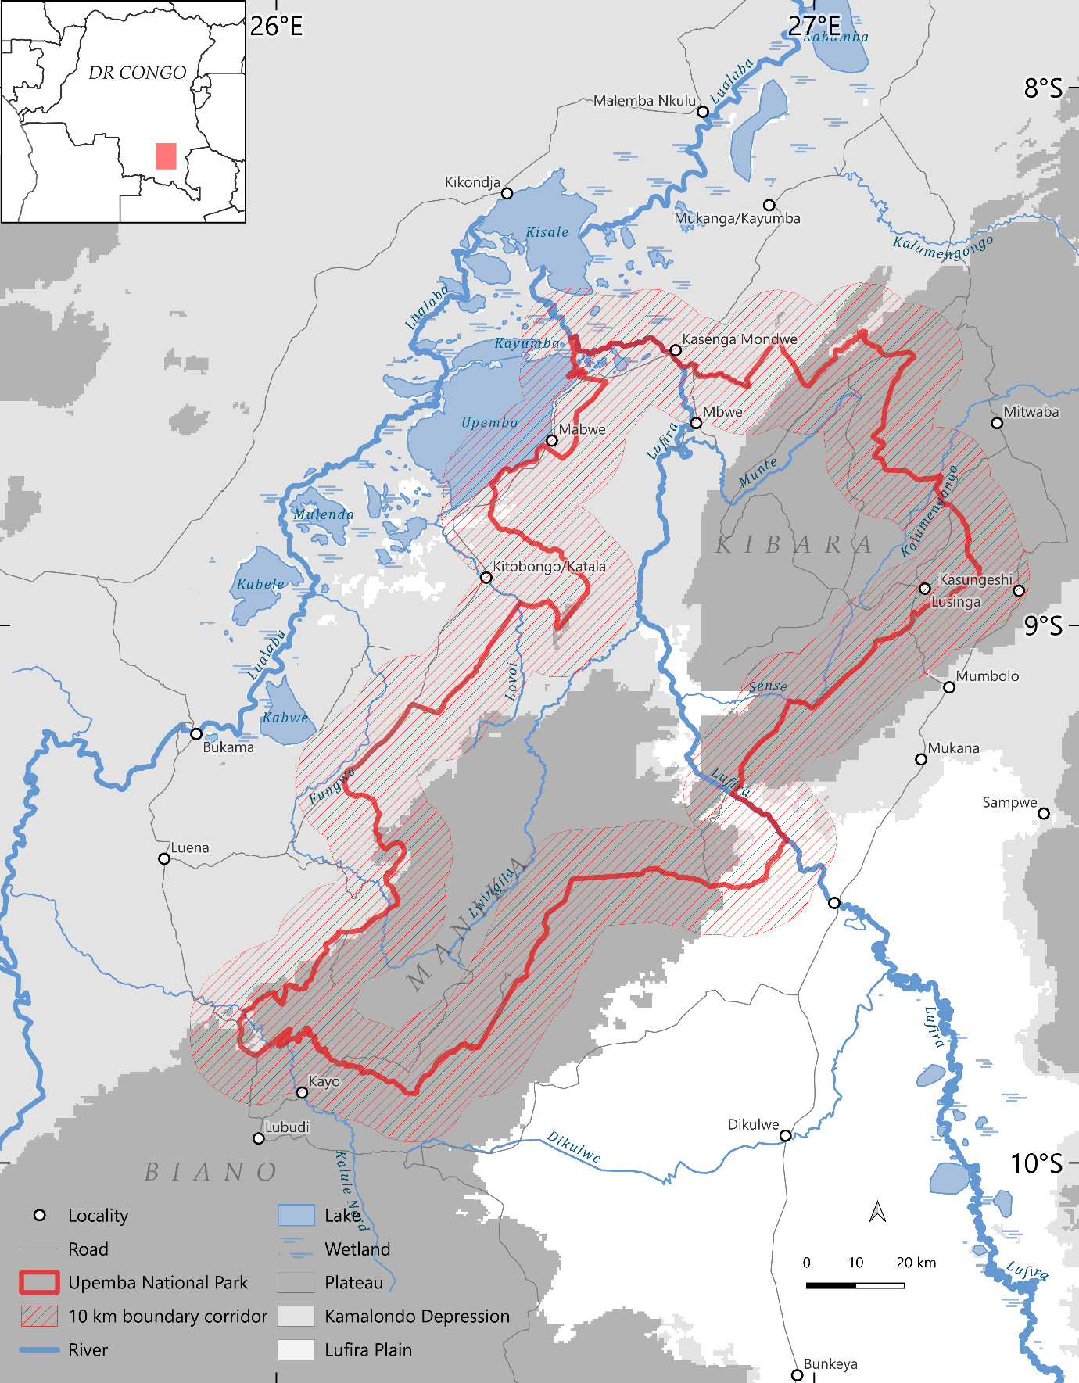
Figure 1. Study area and primary spatial design. The map shows Upemba National Park, the Depression and Plateau landscape comparison groups retained for inference, the third landscape group (Lufira Plain) outside the primary inferential scope, and the symmetric 10 km corridors inside and outside the legal boundary. Perennial-water cells were excluded from the analytical grid.
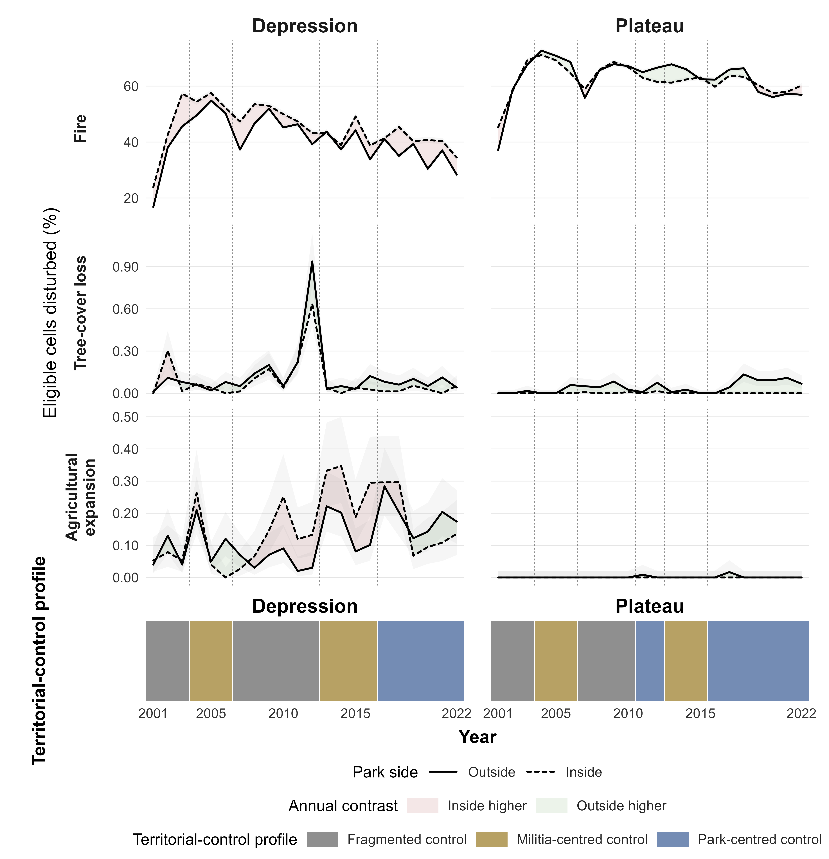
Figure 2. Annual disturbance trajectories inside and outside Upemba National Park, 2001–2022. Panels show the percentage of eligible 500 m cells affected by fire, first tree-cover loss, and first agricultural expansion within the Depression and Plateau landscape groups. Dashed lines denote cells inside the park and solid lines denote cells outside the park within the symmetric 10 km boundary corridor. Shading between trajectories indicates whether annual disturbance was higher inside or outside. Vertical dashed lines and the lower strip mark changes in reconstructed territorial-control profiles.
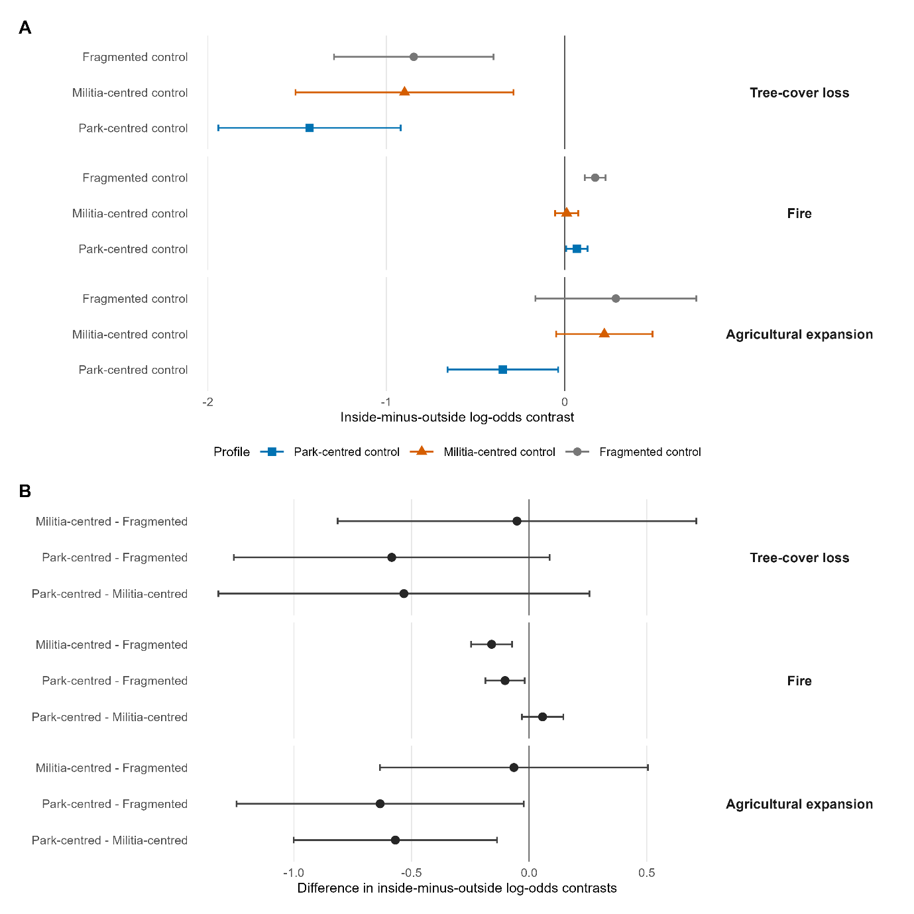
Figure 3. Primary territorial-control profile contrasts for tree-cover loss, fire, and agricultural expansion within the symmetric 10 km boundary corridor using the 25% event definition. (A) Estimated inside-minus-outside log-odds contrasts under each profile. (B) Pairwise differences between profile-specific contrasts. Points are estimates and horizontal bars are 95% confidence intervals. Positive profile contrasts indicate higher modelled disturbance probability inside the park; negative values indicate lower probability inside. Fire estimates derive from the strict-valid beta-binomial model; tree-cover-loss and agricultural-expansion estimates derive from inverse-variance-weighted two-stage models with HC3 covariance.
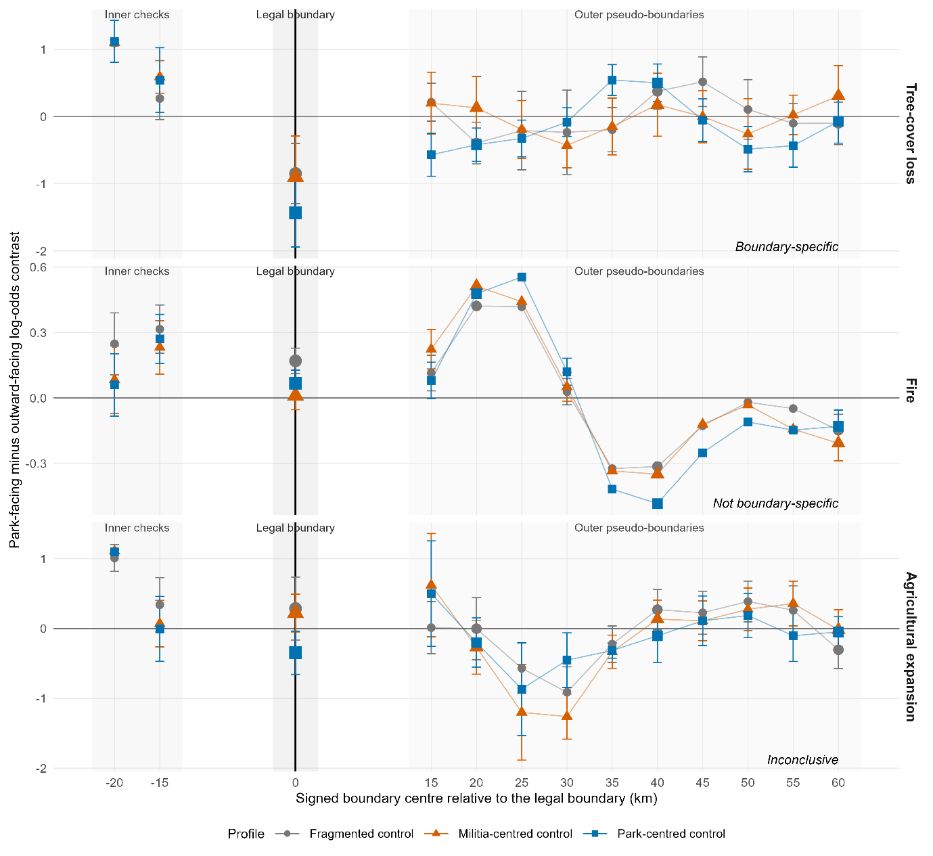
Figure 4. Spatial boundary-location diagnostic for profile-specific inside-minus-outside log-odds contrasts. Estimates are shown at the legal boundary (0 km), two inner descriptive checks (−20 and −15 km), and outer pseudo-boundaries centred from +15 to +60 km. Points show profile-specific estimates and vertical bars show available 95% confidence intervals. Tree-cover-loss estimates at the legal boundary were more negative than those at all evaluated outer offsets. Comparable or larger fire contrasts recurred at outer offsets, while agricultural-expansion estimates were too sparse and unstable for interpretation. Inner checks for the sparse outcomes had limited event support. Full fit-validity and descriptive-classification details are reported in Tables S15–S16 and Figure S3.
Table 2. Synthesis of primary results for the 25% event definition within the symmetric 10 km boundary corridor. Boundary-location assessments compare the legal boundary with spatially offset pseudo-boundaries. Full numerical profile contrasts and pairwise differences are reported in Tables S8–S9.
Outcome | Primary model | Events | Primary result | Boundary-location assessment | Robustness
Tree-cover loss | Weighted two-stage HC3 | 519 | Lower inside under all profiles; largest negative estimate under park-centred control. No pairwise 95% CI excluded zero. | Profile contrasts boundary-specific; partial support for park-centred versus fragmented. | Direction stable to weighting and the 20 km and all-cell sensitivities; weaker at 5 km and unsupported at the sparse 50% threshold.
Fire | Strict-valid beta-binomial | 508,320 | Higher inside under fragmented and park-centred control; near zero under militia-centred control. Militia-centred and park-centred differed from fragmented. | Profile contrasts not boundary-specific; partial support for militia-centred versus fragmented. | Point-estimate ordering was broadly consistent across thresholds and spatial domains; interval inference was restricted to valid fits.
Agricultural expansion | Weighted two-stage HC3 | 518 | Lower inside only under park-centred control. Park-centred differed from fragmented and militia-centred in the weighted model. | Inconclusive because of sparse support and unstable pseudo-boundary fits. | Sensitive to weighting, threshold, and spatial domain.

4. Discussion
Upemba’s legal boundary did not produce a uniform conservation divide. Instead, it retained a selective spatial signature that differed among disturbance processes and persisted across major changes in territorial control. Tree-cover loss was consistently lower inside the park under all three territorial-control profiles, and the legal-boundary contrasts were more negative than those at the evaluated outer offsets. Fire showed a different pattern: inside–outside contrasts varied among control profiles, but comparable contrasts recurred away from the legal boundary, indicating that park designation did not uniquely organise burning. Agricultural expansion was lower inside during park-centred control, but sparse events and sensitivity to analytical choices prevented a firm conclusion. The results therefore suggest that legal boundaries may remain more strongly aligned with persistent, site-specific land transitions than with recurrent processes shaped by mobile access and broader landscape dynamics.
The persistent tree-cover-loss contrast is the clearest result. It occurred under all three territorial-control profiles, including periods when park institutions had collapsed or remained severely constrained, and was therefore not confined to periods of expanded park operational reach. Tree-cover loss, as measured here, represents spatially fixed canopy removal, although the satellite product does not identify its cause or establish that conversion was permanent. Activities that generate such loss—including clearing for cultivation, settlement, charcoal production, or infrastructure—generally require repeated access, sustained labour, and some expectation that land use at a particular site can continue. The park boundary may increase the costs or risks of these activities through patrol exposure, tenure uncertainty, customary restrictions, limited supporting infrastructure, or expectations of future enforcement. We did not measure these mechanisms directly. Nevertheless, the unusually negative tree-cover-loss contrasts at the legal boundary, relative to the evaluated spatial offsets, are less consistent with an explanation based solely on a broad regional environmental gradient.
This boundary-location pattern does not demonstrate that park institutions exercised uniform control or that the processes producing lower tree-cover loss were socially legitimate. Territorial control, legal jurisdiction, conservation intent, and institutional legitimacy are analytically distinct. Authority in Upemba remained partial, contested, and spatially uneven throughout much of the study period. Lower interior tree-cover loss may therefore reflect the combined consequences of legal designation, historical settlement patterns, accessibility, customary authority, insecurity, coercion, and expectations about future control rather than conservation governance alone. The more negative point estimate under park-centred control is consistent with stronger regulation of site-specific clearing, but the pairwise profile comparisons do not establish a distinct additional effect of expanded park operations relative to other territorial-control configurations.
Fire provides a substantive counterpoint and illustrates why disturbance indicators should not be treated as interchangeable proxies for conservation outcomes. Burning can reflect livelihood practices, pasture management, hunting, accidental spread, vegetation and fuel conditions, or park management, and a burned cell reveals nothing about the actor, purpose, or ecological consequence of ignition (Archibald et al., 2010; Kelly et al., 2020). Unlike clearing or agricultural establishment, fire can occur during temporary or mobile access, spread beyond its point of ignition, and require no continued occupation of a site. It may therefore respond less directly to forms of access regulation that operate through fixed territorial limits. Historical accounts from Upemba describe hunting-related burning, including the use of fire to flush animals, smoke rodents from burrows, and promote fresh regrowth that attracts game (Delvaux 1950; Leeuwe et al., 2009). Such practices provide one plausible reason why burning could remain widespread even where persistent land clearing is more strongly differentiated by the park boundary. The near-zero fire contrast during militia-centred periods indicates greater similarity between the two sides of the boundary during those years, but the satellite record cannot determine whether this reflected changing access, displacement, altered ignition practices, fuel dynamics, or some combination. More fundamentally, because similar contrasts recurred away from the legal boundary, the profile-level fire pattern cannot be attributed specifically to the park or its governance.
Higher modelled fire probability inside the park during fragmented and park-centred periods should not be interpreted as evidence of greater ecological degradation. In African savannas and woodlands, neither more nor less burning has a uniform ecological meaning; outcomes depend on fire frequency, season, intensity, vegetation, and management objectives (Archibald et al., 2010; Kelly et al., 2020). Where site-specific clearing is constrained, burning may remain widespread because it requires less fixed investment and forms part of established livelihood or ecological regimes. The divergence between fire and tree-cover loss is therefore informative: it suggests that a legal boundary may differentiate persistent land transitions tied to particular places while remaining permeable to recurrent, mobile processes.
Agricultural expansion is conceptually consistent with this distinction because cultivation generally requires repeated access and continued use of a site. A decline during expanded park operations is therefore plausible. However, the evidence is too weak to support an independent conclusion. Low event counts, numerous zero-event strata, and sensitivity to weighting, event thresholds, spatial domains, and pseudo-boundary location all constrained interpretation. Agricultural expansion therefore provides suggestive but inconclusive evidence of changing site-specific land use during park-centred control.
The historically reconstructed territorial-control profiles allowed us to examine satellite outcomes across documented configurations of authority rather than reducing governance to a single measure of institutional strength. Upemba did not progress linearly from weak to strong conservation management. Park institutions, armed groups, customary authorities, state forces, communities, and external organisations exercised overlapping and spatially uneven authority, and similar configurations recurred across distinct historical episodes. The earlier transition towards park-centred control on the Plateau than in the Depression further illustrates the spatial unevenness of governance change. This variation supports historically grounded comparison, but it does not create experimental treatments. Profile transitions coincided with changes in displacement, infrastructure, military operations, market access, and wider political conditions. Historical evidence therefore identifies periods and plausible mechanisms without isolating actor-specific causal effects.
The spatial diagnostic also changes how remote-sensing evidence from protected areas should be interpreted. Areas outside protected boundaries are not generic untreated controls; they are historically structured landscapes with distinct settlement histories, institutions, conflicts, and access regimes. Conditioning comparisons on landscape group and year reduced major measured differences between the two sides of the boundary, while spatially offset pseudo-boundaries tested whether observed contrasts were exceptional at the legal boundary or recurred along broader landscape gradients. Tree-cover loss was lower inside the park, and the legal-boundary contrast was exceptional relative to the evaluated offsets. Fire varied among territorial-control profiles but showed no equivalent boundary alignment. An analysis confined to the legal boundary could have described both patterns as consequences of protection despite their fundamentally different spatial evidence. Independent satellite observations can complement management self-assessments and interrupted field monitoring, particularly in governance-fragile protected areas where conventional monitoring remains incomplete (Coad et al., 2015; Fromont et al., 2024). Protected-area evaluations should therefore ask not only whether an inside–outside difference exists, but also whether the legal boundary is exceptional relative to plausible alternative spatial divisions, particularly where protected-area placement and surrounding landscape gradients are non-random (Gohr et al., 2022).
Several limitations constrain interpretation. The analysis covers one protected area and two landscape comparison groups, and its conclusions cannot be generalised directly to other conflict-affected parks. One researcher with prior field and conservation experience in Upemba reconstructed the territorial-control chronology. Coding preceded inspection of disturbance outcomes and drew on a documented evidence base, but alternative assignments remain possible, and transition-year and episode-omission diagnostics addressed only part of this uncertainty. Annual categorical profiles also simplify within-year, within-group, and hybrid forms of authority. Model-based confidence intervals do not fully capture dependence among consecutive years within historical episodes. Tree-cover loss and agricultural expansion were sparse, and agricultural estimates were particularly sensitive to measurement and spatial design. All outcomes inherit classification error from their source satellite products, while remote sensing cannot identify actors, intentions, or social consequences (Olofsson et al., 2014; Kerner et al., 2024). Finally, the deterministic and spatially overlapping pseudo-boundaries provide a diagnostic of boundary-location specificity rather than a randomised counterfactual distribution.
Despite these limitations, the evidence supports a consistent outcome-specific conclusion. Upemba’s legal boundary retained a selective spatial signature across major changes in territorial control: tree-cover-loss risk was consistently lower inside the park, and the legal-boundary contrasts were more negative than those at the evaluated outer offsets, whereas fire reflected broader spatial and historical dynamics that the boundary did not uniquely contain. This finding does not establish a causal effect of legal protection or identify the actors and mechanisms responsible for lower interior tree-cover loss. It shows that legal boundaries can remain materially relevant to some persistent, site-specific land transitions under fragmented and contested authority while remaining permeable to recurrent landscape processes such as fire. Evaluations of governance-fragile protected areas should therefore combine independent satellite observations with historical reconstruction, distinguish among disturbance processes, and test whether apparent inside–outside differences are exceptional at the legal boundary rather than components of broader spatial gradients.

References
Andam, K.S., Ferraro, P.J., Pfaff, A., Sánchez-Azofeifa, G.A., Robalino, J.A., 2008. Measuring the effectiveness of protected area networks in reducing deforestation. Proceedings of the National Academy of Sciences 105, 16089–16094. https://doi.org/10.1073/pnas.0800437105
Archibald, S., Nickless, A., Govender, N., Scholes, R.J., Lehsten, V., 2010. Climate and the inter-annual variability of fire in southern Africa: a meta-analysis using long-term field data and satellite-derived burnt area data. Global Ecology and Biogeography 19, 794–809. https://doi.org/10.1111/j.1466-8238.2010.00568.x
Blankespoor, B., Dasgupta, S., Wheeler, D., 2017. Protected areas and deforestation: new results from high-resolution panel data. Natural Resources Forum 41, 55–68. https://doi.org/10.1111/1477-8947.12118
Brooks, M.E., Kristensen, K., van Benthem, K.J., Magnusson, A., Berg, C.W., Nielsen, A., Skaug, H.J., Mächler, M., Bolker, B.M., 2017. glmmTMB balances speed and flexibility among packages for zero-inflated generalized linear mixed modeling. The R Journal 9, 378–400. https://doi.org/10.32614/RJ-2017-066
Brugière, D., 2020. Public-private partnership for protected areas: current situation and prospects in French-speaking Africa. IUCN-Papaco.
Chuvieco, E., Pettinari, M.L., Lizundia-Loiola, J., Storm, T., Padilla Parellada, M., 2018. ESA Fire Climate Change Initiative (Fire_cci): MODIS Fire_cci Burned Area Pixel product, version 5.1. https://doi.org/10.5285/58f00d8814064b79a0c49662ad3af537
Coad, L., Leverington, F., Knights, K., Geldmann, J., Eassom, A., Kapos, V., Kingston, N., de Lima, M., Zamora, C., Cuardros, I., Nolte, C., Burgess, N.D., Hockings, M., 2015. Measuring impact of protected area management interventions: current and future use of the Global Database of Protected Area Management Effectiveness. Philosophical Transactions of the Royal Society B 370, 20140281. https://doi.org/10.1098/rstb.2014.0281
Daskin, J.H., Pringle, R.M., 2018. Warfare and wildlife declines in Africa’s protected areas. Nature 553, 328–332. https://doi.org/10.1038/nature25194
Delvaux, H., 1950. L’occupation du Katanga 1891-1900; Notes et souvenirs du seul survivant. Imbelco, Elisabethville.
de Merode, E., Smith, K.H., Homewood, K., Pettifor, R., Rowcliffe, M., Cowlishaw, G., 2007. The impact of armed conflict on protected-area efficacy in Central Africa. Biology Letters 3, 299–301. https://doi.org/10.1098/rsbl.2007.0010
Duffy, R., Massé, F., Smidt, E., Marijnen, E., Büscher, B., Verweijen, J., Ramutsindela, M., Simlai, T., Joanny, L., Lunstrum, E., 2019. Why we must question the militarisation of conservation. Biological Conservation 232, 66–73. https://doi.org/10.1016/j.biocon.2019.01.013
Fromont, C., Carrière, S.M., Bédécarrats, F., Razafindrakoto, M., Roubaud, F., 2024. Long-term socio-environmental monitoring of protected areas is a persistent weak point in developing countries: literature review and recommendations. Biological Conservation 290, 110434. https://doi.org/10.1016/j.biocon.2023.110434
Gaynor, K.M., Fiorella, K.J., Gregory, G.H., Kurz, D.J., Seto, K.L., Withey, L.S., Brashares, J.S., 2016. War and wildlife: linking armed conflict to conservation. Frontiers in Ecology and the Environment 14, 533–542. https://doi.org/10.1002/fee.1433
Geldmann, J., Barnes, M., Coad, L., Craigie, I.D., Hockings, M., Burgess, N.D., 2013. Effectiveness of terrestrial protected areas in reducing habitat loss and population declines. Biological Conservation 161, 230–238. https://doi.org/10.1016/j.biocon.2013.02.018
Geldmann, J., Manica, A., Burgess, N.D., Coad, L., Balmford, A., 2019. A global-level assessment of the effectiveness of protected areas at resisting anthropogenic pressures. Proceedings of the National Academy of Sciences 116, 23209–23215. https://doi.org/10.1073/pnas.1908221116
Gohr, C., von Wehrden, H., May, F., Ibisch, P.L., 2022. Remotely sensed effectiveness assessments of protected areas lack a common framework: a review. Ecosphere 13, e4053. https://doi.org/10.1002/ecs2.4053
Gorelick, N., Hancher, M., Dixon, M., Ilyushchenko, S., Thau, D., Moore, R., 2017. Google Earth Engine: planetary-scale geospatial analysis for everyone. Remote Sensing of Environment 202, 18–27. https://doi.org/10.1016/j.rse.2017.06.031
Gray, C.L., Hill, S.L.L., Newbold, T., Hudson, L.N., Börger, L., Contu, S., Hoskins, A.J., Ferrier, S., Purvis, A., Scharlemann, J.P.W., 2016. Local biodiversity is higher inside than outside terrestrial protected areas worldwide. Nature Communications 7, 12306. https://doi.org/10.1038/ncomms12306
Hansen, M.C., Potapov, P.V., Moore, R., Hancher, M., Turubanova, S.A., Tyukavina, A., Thau, D., Stehman, S.V., Goetz, S.J., Loveland, T.R., Kommareddy, A., Egorov, A., Chini, L., Justice, C.O., Townshend, J.R.G., 2013. High-resolution global maps of 21st-century forest cover change. Science 342, 850–853. https://doi.org/10.1126/science.1244693
Hasson, M., 2015. Katanga: Des animaux et des hommes. Musée royal de l’Afrique centrale, Tervuren.
Joppa, L.N., Pfaff, A., 2009. High and far: biases in the location of protected areas. PLOS ONE 4, e8273. https://doi.org/10.1371/journal.pone.0008273
Jones, K.R., Venter, O., Fuller, R.A., Allan, J.R., Maxwell, S.L., Negret, P.J., Watson, J.E.M., 2018. One-third of global protected land is under intense human pressure. Science 360, 788–791. https://doi.org/10.1126/science.aap9565
Kelly, L.T., Giljohann, K.M., Duane, A., Aquilué, N., Archibald, S., Batllori, E., Bennett, A.F., Buckland, S.T., Canelles, Q., Clarke, M.F., Fortin, M.-J., Hermoso, V., Herrando, S., Keane, R.E., Lake, F.K., McCarthy, M.A., Morán-Ordóñez, A., Parr, C.L., Pausas, J.G., Penman, T.D., Regos, A., Rumpff, L., Santos, J.L., Smith, A.L., Syphard, A.D., Tingley, M.W., Brotons, L., 2020. Fire and biodiversity in the Anthropocene. Science 370, eabb0355. https://doi.org/10.1126/science.abb0355
Kerner, H., Nakalembe, C., Yang, A., Zvonkov, I., McWeeny, R., Tseng, G., Becker-Reshef, I., 2024. How accurate are existing land cover maps for agriculture in Sub-Saharan Africa? Scientific Data 11, 486. https://doi.org/10.1038/s41597-024-03306-z
Leverington, F., Costa, K.L., Pavese, H., Lisle, A., Hockings, M., 2010. A global analysis of protected area management effectiveness. Environmental Management 46, 685–698. https://doi.org/10.1007/s00267-010-9564-5
Lou, Z., Peng, D., Shi, Z., Wang, H., Liu, K., Zhang, Y., Yan, X., Chen, Z., Ye, S., Yu, L., Hu, J., Lv, Y., Peng, H., Zhang, Y., Zhang, B., 2025. AFCD: An Annual Cropland Extent Dataset for Africa at 30 m spatial resolution from 2000 to 2022. https://doi.org/10.5281/zenodo.14920706
Lunstrum, E., 2014. Green militarization: anti-poaching efforts and the spatial contours of Kruger National Park. Annals of the Association of American Geographers 104, 816–832. https://doi.org/10.1080/00045608.2014.912545
MacKinnon, J.G., White, H., 1985. Some heteroskedasticity-consistent covariance matrix estimators with improved finite sample properties. Journal of Econometrics 29, 305–325. https://doi.org/10.1016/0304-4076(85)90158-7
Marijnen, E., Verweijen, J., 2016. Selling green militarization: the discursive (re)production of militarized conservation in the Virunga National Park, Democratic Republic of the Congo. Geoforum 75, 274–285. https://doi.org/10.1016/j.geoforum.2016.08.003
McNicol, I.M., Keane, A., Burgess, N.D., Bowers, S.J., Mitchard, E.T.A., Ryan, C.M., 2023. Protected areas reduce deforestation and degradation and enhance woody growth across African woodlands. Communications Earth & Environment 4, 1–14. https://doi.org/10.1038/s43247-023-01053-4
Olofsson, P., Foody, G.M., Herold, M., Stehman, S.V., Woodcock, C.E., Wulder, M.A., 2014. Good practices for estimating area and assessing accuracy of land change. Remote Sensing of Environment 148, 42–57. https://doi.org/10.1016/j.rse.2014.02.015
Pekel, J.-F., Cottam, A., Gorelick, N., Belward, A.S., 2016. High-resolution mapping of global surface water and its long-term changes. Nature 540, 418–422. https://doi.org/10.1038/nature20584
R Core Team, 2026. R: A language and environment for statistical computing. R Foundation for Statistical Computing, Vienna.
Van Leeuwe, H., Henschel, P., Pélissier, C., Moyer, D., 2009. Recensement des grands mammifères et impacts humains: Parcs Nationaux de l’Upemba et de Kundelungu, République Démocratique du Congo. ICCN/WCS/USFWS/Panthera.

