A protected-area boundary separates tree-cover loss but not fire across changing territorial control

Abstract
Protected areas in conflict-affected landscapes may retain legal boundaries while practical authority shifts among conservation institutions, state forces, customary authorities, communities, and armed groups. We combined annual satellite observations from 2001–2022 with a historically reconstructed chronology of territorial control in Upemba National Park, Democratic Republic of the Congo. Within environmentally structured landscape comparison groups, we estimated inside–outside contrasts in recurrent fire, first tree-cover loss, and first agricultural expansion under fragmented, militia-centred, and park-centred control. We then compared estimates at the legal boundary with spatially offset pseudo-boundaries to determine whether comparable contrasts recurred elsewhere in the landscape.
Tree-cover loss was consistently lower inside the park under fragmented, militia-centred, and park-centred control, with inside-minus-outside log-odds contrasts of −0.846, −0.898, and −1.430, respectively. Under all three profiles, the legal-boundary estimates were more negative than those observed at the evaluated outer pseudo-boundaries. Fire showed a different pattern: contrasts were positive under fragmented control (0.170) and park-centred control (0.068) but near zero under militia-centred control (0.011). Comparable or larger fire contrasts recurred at outer pseudo-boundaries, indicating that the legal boundary did not uniquely organize burning. Agricultural expansion was lower inside only under park-centred control (−0.347), but sparse events and sensitivity to analytical choices made this result inconclusive.
Upemba’s legal boundary therefore retained a selective spatial signature under changing territorial control, consistently differentiating site-specific tree-cover loss but not recurrent fire. Evaluations of governance-fragile protected areas should distinguish among disturbance processes and test whether apparent inside–outside contrasts are exceptional at the legal boundary rather than components of broader spatial gradients.

Keywords
armed conflict; protected-area effectiveness; remote sensing; territorial control; tree-cover loss; fire; Democratic Republic of the Congo

1. Introduction
Protected areas are commonly evaluated by comparing ecological conditions inside their legal boundaries with conditions outside them. This approach can provide valuable evidence, but it often assumes that management institutions exercise reasonably stable authority, that the boundary marks a meaningful change in land-use regulation, and that surrounding areas provide an interpretable comparison. Conflict-affected protected areas frequently violate all three assumptions. Armed groups, state forces, customary authorities, conservation organisations, and local communities may exercise overlapping and spatially uneven authority, while insecurity, displacement, and changing access reshape land use on both sides of the boundary (de Merode et al., 2007; Marijnen and Verweijen, 2016; Duffy et al., 2019). Under these conditions, legal protection, practical territorial control, and institutional legitimacy may diverge. A protected-area boundary can retain material consequences even when park institutions do not control the territory continuously, while reduced disturbance can arise through coercion, displacement, inaccessibility, or other processes that cannot be equated with legitimate conservation success. Here, territorial control refers to the practical capacity of actors to shape who can enter, extract, cultivate, settle, or burn within a landscape. It is analytically distinct from legal jurisdiction, conservation intent, institutional legitimacy, and exclusive sovereignty.
These settings are also difficult to evaluate empirically. Insecurity restricts field access, interrupts ecological monitoring, and increases reliance on management reports and retrospective accounts. Existing protected-area management-effectiveness databases remain incomplete and dominated by self-assessment, particularly in regions where monitoring capacity is weakest (Leverington et al., 2010; Coad et al., 2015; Fromont et al., 2024). Satellite observations provide an important independent source of environmental evidence because they can measure fire, tree-cover loss, and agricultural expansion consistently across inaccessible landscapes and long time periods (Hansen et al., 2013; Chuvieco et al., 2018; Lou et al., 2025). Remote sensing has therefore become central to assessments of protected-area outcomes (Blankespoor et al., 2017; Gohr et al., 2022; McNicol et al., 2023). However, satellite measurements do not identify the actors, intentions, or institutions responsible for observed change. They record land-surface outcomes, not governance quality, social legitimacy, or causal mechanisms.
Interpretation also depends on the disturbance process being measured. Site-specific activities such as forest clearing, settlement, and agricultural establishment generally require repeated access, labour, investment, and some expectation that land use can persist. These activities may therefore respond strongly to boundaries, tenure arrangements, enforcement, and other forms of territorial regulation. Fire differs. Burning is recurrent, can occur during temporary or mobile access, responds strongly to vegetation and weather, and can spread beyond its point of ignition (Archibald et al., 2010; Kelly et al., 2020). A legal boundary or governing actor may therefore differentiate tree-cover loss or agricultural expansion without producing an equivalent fire contrast. Treating these outcomes as interchangeable indicators of anthropogenic pressure risks obscuring how different activities respond to authority, access, and landscape conditions. Protected-area evaluation should instead ask which processes a legal boundary can plausibly regulate and whether the selected satellite indicators capture those processes.
A further difficulty is determining whether an apparent inside–outside difference is genuinely associated with the protected-area boundary. Protected areas are rarely placed randomly, and their interiors often differ from surrounding land in accessibility, terrain, hydrology, vegetation, settlement history, and exposure to markets. Even after conditioning on measured environmental characteristics, a contrast at the legal boundary may reflect a broader regional gradient rather than a boundary-specific process (Gohr et al., 2022). Conventional inside–outside analyses can therefore overstate the role of protection when they do not examine whether comparable contrasts recur at nearby locations. Spatially offset comparison boundaries provide a useful diagnostic: if a contrast is exceptional at the legal boundary and does not recur along nearby pseudo-boundaries, the evidence for boundary specificity is stronger. If similar contrasts occur repeatedly elsewhere, the legal boundary may not be the principal spatial structure organizing the outcome.
We address these problems in Upemba National Park, southeastern Democratic Republic of the Congo. Created in 1939, Upemba spans plateaus, savannas, woodlands, wetlands, and the Kamalondo Depression. Its legal status remained continuous, but practical authority changed repeatedly during the study period. The attack on the Lusinga headquarters on 28 May 2004 marked a collapse of routine park operations and withdrawal from parts of the landscape. Gédéon’s surrender in 2006 preceded a period of limited and negotiated conservation re-entry; donor-supported technical assistance strengthened operations around the Plateau during 2010–2011; renewed armed insecurity again contracted park reach after 2012; and systematic operations expanded on the Plateau from 2016 and in the Depression from 2017. These transitions remained spatially uneven and did not establish uniform or uncontested control. Upemba therefore provides a rare opportunity to examine whether a legal protected-area boundary retained measurable environmental consequences across recurrent configurations of fragmented, militia-centred, and park-centred territorial control (Van Leeuwe et al., 2009; Hasson, 2015; Brugière, 2020; Tables S6A–S6B).
We combine annual satellite observations from 2001–2022 with a historically reconstructed chronology of territorial control. We first derive landscape comparison groups that condition boundary comparisons on environmental and accessibility context. We then estimate annual inside–outside contrasts in tree-cover loss, agricultural expansion, and fire within each landscape group and relate those contrasts to three recurrent territorial-control profiles. Finally, we compare the legal-boundary estimates with spatially offset pseudo-boundaries inside and outside the park. We ask three questions. First, did disturbance differ between the two sides of Upemba’s legal boundary? Second, did the magnitude or direction of that contrast vary among territorial-control profiles? Third, was each contrast specifically aligned with the legal boundary, or did similar patterns recur elsewhere in the landscape? By separating satellite measurements, historical interpretation, and causal claims, we evaluate whether legal protection retained selective spatial consequences under fragmented authority and whether those consequences differed between site-specific land transitions and recurrent fire.

2. Methods

2.1 Study system and spatial design
We studied Upemba National Park in southeastern Democratic Republic of the Congo, a protected area of approximately 10,000 km² spanning the Kibara and Manika plateaus and extending west into the Kamalondo, or Upemba, Depression wetland complex (Fig. 1). We assembled spatial data over a broader rectangular domain covering the park, the Kamalondo Depression, adjacent hunting reserves, and surrounding settlements. We excluded the Copperbelt mining districts and Kundelungu Plateau because their environmental conditions and land-use systems differed substantially from those of the focal landscape. The resulting “Upemba landscape” extended from 25.48 to 27.50°E and from 10.4 to 7.8°S.
We digitized the park boundary from the official delimitation in Ordonnance 75-241 du 22 juillet 1975 and aligned the boundary, disturbance layers, and reference-period landscape covariates to a common 500 m grid in UTM Zone 35S (EPSG:32735). We rasterized the park polygon to this grid and derived a signed-distance surface, with negative values inside and non-negative values outside the park. We excluded cells classified as perennial water, defined from the JRC Global Surface Water product as water present during all 12 months or with at least 90% occurrence (Pekel et al., 2016).
The primary analysis compared cells within 10 km on either side of the park boundary. We selected this symmetric corridor before inspecting territorial-control profile coefficients by comparing 5, 10, and 20 km corridors and the complete landscape using measured covariate balance and event support. The 5 km corridor provided the strongest balance, with median and maximum absolute standardized mean differences of 0.119 and 0.371, but retained only 313 tree-cover-loss and 392 agricultural-expansion events. The 10 km corridor retained 519 tree-cover-loss and 518 agricultural-expansion events, with median and maximum absolute standardized mean differences of 0.187 and 0.733. Wider domains increased event support but produced substantially greater measured imbalance. We therefore treated 10 km as a boundary-adjacent compromise between measured comparability and sparse-event support, while using the 5 km, 20 km, and complete-landscape domains as spatial sensitivities (Tables S4–S5). This selection reduces major measured differences but does not make the two sides environmentally equivalent.
Areas outside Upemba do not constitute untreated controls. They are historically structured landscapes shaped by settlement, customary authority, armed conflict, displacement, state intervention, accessibility, and resource use. We therefore interpret the estimated inside–outside differences as conditional spatial contrasts across the legal park boundary, not as causal effects of legal protection.
We acquired and initially harmonized remote-sensing data in Google Earth Engine and completed raster processing, clustering, event construction, and statistical analysis in R 4.5.3 (Gorelick et al., 2017; R Core Team, 2026). Package versions and computational-environment details are reported in Table S18. Expanded details on the spatial design and construction of the landscape comparison groups are provided in Supplementary Methods S1.

2.2 Disturbance measurements
We measured annual fire, tree-cover loss, and agricultural expansion from 2001 through 2022. These indicators represent different land-surface processes and do not provide interchangeable measures of human activity. Fire is recurrent and can reflect interacting climatic, vegetation, access, livelihood, and management processes. Tree-cover loss and agricultural expansion identify site-specific disturbance events that generally require sustained access and leave persistent remotely detectable signatures. We therefore analysed each outcome separately and did not interpret fire as a direct measure of hunting or poaching. Table 1 summarizes the source products, annual event definitions, and outcome-specific risk-set rules.
We derived fire from the ESA Fire Climate Change Initiative FireCCI version 5.1 burned-area pixel product (Chuvieco et al., 2018). For 2001–2020, we accessed the product through Google Earth Engine. For 2021–2022, we used the official monthly continental pixel-product rasters distributed through the Centre for Environmental Data Analysis archive. These monthly rasters contain the first detected burn day of year at approximately 250 m resolution. We combined the April–October rasters for each year and retained burn dates from day of year 100 through 300, inclusive. We converted qualifying native pixels to a seasonal binary burned-status layer and projected this layer to the canonical 500 m grid using area-averaging, so each target value represented the fraction of the complete 500 m cell classified as burned during the focal season. We classified a cell as burned when this fraction reached 0.25. We retained the earliest qualifying burn date for descriptive analyses only. Burned cells remained eligible in subsequent years because fire was a recurrent outcome.
FireCCI distinguishes observed-unburned, unobserved, and non-burnable native pixels. We audited the 2021–2022 monthly files using the original whole-cell aggregation procedure and reproduced the authoritative 500 m classifications exactly. No native pixel in the study domain remained unobserved throughout April–October in either year, so missing-observation handling did not alter any primary fire classification or model stratum. Detailed product provenance, file checksums, native-state codes, and audit results are reported in Table S17.
We measured tree-cover loss with Hansen Global Forest Change version 1.12 (Hansen et al., 2013). For each year, we converted the native 30 m loss-year layer to a cumulative binary loss surface and calculated the proportion of valid 30 m subpixels within each complete 500 m cell whose recorded loss year was at or before the focal year. We assigned the first year in which this whole-cell cumulative loss fraction reached 0.25 as the tree-cover-loss event. We restricted the risk set to 500 m cells with mean tree cover of at least 30% in 2000. Each eligible cell contributed annual observations through its first event year and left the tree-cover-loss risk set thereafter.
We measured agricultural expansion with the Annual Cropland Extent Dataset for Africa (Lou et al., 2025). We converted each annual 30 m cropland layer to a binary native surface and aggregated it to the proportion of each 500 m cell classified as cropland. Agricultural expansion was the first detected annual transition from a cropland fraction below 0.25 in the preceding year to a fraction of at least 0.25 in the focal year. The 2000 layer provided the baseline state for transitions beginning in 2001. This definition identifies a first remotely detected threshold crossing rather than necessarily permanent conversion. Each cell contributed observations through its first event year and left the agricultural-expansion risk set thereafter. Expanded disturbance-processing, harmonization, risk-set, and measurement-validation procedures are provided in Supplementary Methods S3 and Table S17.
We used 0.25 as a pragmatic common cell-level event definition selected before model fitting. Applying one threshold simplified comparison of spatial contrasts but did not equalize the resolution, error structure, or ecological meaning of the three products. We therefore repeated event construction at thresholds of 0.10 and 0.50. We use these classified products to estimate relative spatial contrasts rather than unbiased annual disturbed area; classification error and product disagreement remain relevant even when the same product and definition are applied on both sides of the boundary (Olofsson et al., 2014; Kerner et al., 2024).
For each outcome, we expanded the 500 m data into annual cell-level risk sets and aggregated them by landscape comparison group, year, and park side. Each stratum contained the number of event cells, (y), and the number of eligible cells, (n). All eligible cells contributed to every annual fire risk set. Cells contributed to tree-cover-loss and agricultural-expansion risk sets until their first detected event.
Table 1. Remote-sensing products and annual disturbance-event definitions. Primary events were defined using a 25% threshold on the common 500 m grid; 10% and 50% thresholds were evaluated as measurement sensitivities.
Outcome | Source product | Years | Native resolution | Event definition | Risk-set rule | Primary threshold | Sensitivity thresholds
Fire | ESA FireCCI v5.1 | 2001–2022 | 250 m | ≥25% of a 500 m cell burned during DOY 100–300 | All eligible cells remain at risk annually | 25% | 10%, 50%
Tree-cover loss | Hansen Global Forest Change v1.12 | 2001–2022 | 30 m | First year cumulative loss reaches ≥25% of a 500 m cell | Cells with ≥30% tree cover in 2000; removed after first event | 25% | 10%, 50%
Agricultural expansion | Annual Cropland Extent Dataset for Africa | 2001–2022 | 30 m | First annual transition from <25% to ≥25% cropland | Eligible cells removed after first event | 25% | 10%, 50%

2.3 Landscape comparison groups
We derived landscape comparison groups to structure boundary comparisons among areas with broadly similar environmental conditions and accessibility. These groups are pragmatic analytical strata rather than discrete or internally homogeneous socio-ecological systems. They reduce large measured differences in disturbance opportunity but cannot eliminate unmeasured spatial confounding.
We assembled reference-period covariates describing elevation, slope, a binary indicator of at least 30% mean tree cover in 2000, distance to permanent water, 1981–2010 precipitation, potential and actual evapotranspiration, climatic water balance, aridity, soil organic carbon, soil pH, clay and sand content, distance to built-up areas present by 2000, and travel time to cities (Table S1). The travel-time product represents 2015 network conditions. We included it as a measure of durable regional transport and market-access structure rather than as a strictly pre-2001 covariate and evaluated its influence in a separate clustering sensitivity.
We excluded cells lacking elevation or slope. We replaced missing accessibility, distance-to-settlement, and distance-to-water values with their observed maxima, representing the least accessible or most distant conditions, and replaced missing values in the remaining covariates with their medians. We transformed accessibility and the two distance variables using (\log(1+x)) and standardized all clustering features to zero mean and unit variance.
We fitted k-means partitions for (k=2) through (k=15). We evaluated mean silhouette width using the same random sample of 20,000 cells for every value of (k), drawn with seed 42. The silhouette criterion selected (k=3). We fitted the final three-group partition to all eligible cells with 25 random starts and seed 123 and evaluated stability across additional seeds. Because k-means does not impose spatial continuity, we reassigned cells whose label matched no more than one of their eight neighbours to the modal label in the surrounding eight-cell neighbourhood. Full silhouette, seed-stability, and de-speckling diagnostics are reported in Tables S2–S3 and Figure S1.
We retained two groups for outcome analysis: the “Depression”, corresponding principally to the Kamalondo Depression, and the “Plateau”, corresponding principally to the Kibara and Manika plateaus. We excluded the Lufira Plain before outcome modelling because its spatially restricted park intersection accounted for only 786 cells, or 3.7% of park-interior cells, within the primary corridor and did not support an independently reconstructed territorial-control chronology comparable with those of the Depression and Plateau. A subsequent support audit confirmed that the Lufira Plain contained no interior tree-cover-loss events and only two interior agricultural-expansion events during 2001–2022 (Table S5).
Removing the 2015 accessibility covariate again selected three groups, retained the Depression and Plateau configurations, and reproduced 96.8% of primary-corridor assignments after optimal label matching. Because this sensitivity did not cross the pre-specified threshold for a material partition change, we retained the complete reference-period partition and did not rerun the outcome models (Table S3; Fig. S1).

2.4 Territorial-control profiles
The lead author reconstructed annual territorial-control profiles separately for the Depression and Plateau from 2001 through 2022. The evidence base comprised dated archival records, park and NGO documentation, technical assessments, humanitarian reporting, media coverage, and a wider historical synthesis of Upemba. We prioritized sources that could be assigned to a particular landscape group, year, or transition. When sources conflicted, greater weight was given to contemporaneous records with direct spatial or institutional relevance, and the disagreement was recorded in the evidence chronology. The coding focused on two actor complexes with documented capacity to regulate or constrain access: Upemba National Park institutions, including ranger deployment, patrol reach, infrastructure, external support, and practical enforcement capacity; and armed groups described in the source record as Mai-Mai. State forces, customary authorities, local administrations, communities, and external conservation organisations informed the interpretation but were not represented as separate statistical categories.
We assigned each landscape-group year to one of three recurrent profiles. Fragmented control describes periods in which neither park institutions nor militia exercised consolidated control and access remained weakly regulated, spatially fragmented, or negotiated. Militia-centred control describes periods in which armed-group presence materially structured access while park enforcement had collapsed or remained severely constrained. Park-centred control describes periods of expanded park operational reach and regulatory capacity, although insecurity and incomplete territorial coverage persisted. The profiles summarize documented configurations of partial control rather than exclusive authority.
The lead author’s historical research and conservation work in Upemba provided access to local records and spatial context but also meant that the reconstruction was conducted by a single, non-blinded expert. To limit interpretive flexibility, all assignments were fixed before inspection of the remote-sensing outcomes; every historical episode was linked to documented evidence, transition rationales, coding confidence, and plausible alternative dates; and coding uncertainty was examined through transition-year and episode-omission diagnostics. Tables S6A–S6B provide the complete frozen chronology and evidentiary basis.
Fragmented control occurred during 2001–2003 in both groups, 2007–2012 in the Depression, and 2007–2010 on the Plateau. Militia-centred control occurred during 2004–2006 in both groups, 2013–2016 in the Depression, and 2013–2015 on the Plateau. Park-centred control occurred during 2011–2012 and 2016–2022 on the Plateau and during 2017–2022 in the Depression. The profiles comprised 16, 13, and 15 landscape-group years and four, four, and three contiguous historical episodes, respectively. Consecutive years within one episode do not constitute independent historical replications. Tables S6A–S6B report the complete landscape-group-year chronology, source citations, transition rationales, and uncertainty notes; Table S7 summarizes profile and episode support. The evidence hierarchy, coding procedure, handling of conflicting evidence, and episode-level uncertainty assessment are described in Supplementary Methods S2.

2.5 Outcome-specific statistical models
We first plotted annual event proportions separately by landscape comparison group and park side (Fig. 2). These trajectories describe the observed data and support model interpretation; formal inference used separate models for recurrent fire and the two sparse first-transition outcomes.
For fire, let s index landscape comparison group, t year, and k park side, with k = 0 outside and k = 1 inside. Let Yₛₜₖ denote the number of burned cells among Nₛₜₖ cells at risk. We fitted aggregated counts using a beta-binomial regression with a logit link in glmmTMB (Brooks et al., 2017):
$$Y_{stk}∼BetaBinomial\left(N_{stk},p_{stk},ϕ\right)$$
$$logit\left(p_{stk}\right)=α_{st}+β_{F}k+δ_{M}kI\left(G_{st}=M\right)+δ_{P}kI\left(G_{st}=P\right)$$
where αₛₜ denotes a fixed effect for each landscape-group × year combination, Gₛₜ denotes the territorial-control profile, and fragmented control is the reference category. The fixed effects absorb conditions shared by the two sides within the same landscape group and year, including common annual shocks, but do not control unmeasured factors that differ between sides within a group-year.
The inside–outside log-odds contrast under fragmented control is βF. The corresponding contrasts under militia-centred and park-centred control are βF + δM and βF + δP. We estimated these complete profile-specific contrasts and all pairwise differences among them. Positive values indicate higher modelled fire probability inside the park; negative values indicate lower probability inside. The raw interaction coefficients δM and δP represent differences from fragmented control and are not themselves complete boundary contrasts.
We fitted the primary fire model to the harmonized 0.25 event definition within the symmetric 10 km corridor. We assessed numerical validity using optimizer convergence, model-matrix rank, Hessian definiteness, finite parameter estimates, and maximum framework and independently calculated numerical gradients. We refined the valid reference fit with BFGS using 20,000 maximum iterations and a relative tolerance of 10⁻¹², and required a positive-definite Hessian and both maximum gradients below 0.001. We report conditional, model-based 95% Wald confidence intervals for the complete profile contrasts and pairwise differences (Table S14). Because these intervals do not model serial dependence among years within historical episodes, we interpret them alongside threshold, spatial-domain, transition-year, and episode-omission diagnostics rather than as independent annual replications.
Beta-binomial models for tree-cover loss and agricultural expansion failed numerical-validity checks because events were sparse and unevenly distributed among group-years, producing combinations of non-convergence, non-positive-definite Hessians, and excessive gradients. We therefore based primary inference for these outcomes on a two-stage analysis of annual inside–outside contrasts.
For each eligible landscape-group year, we added 0.5 to the event and non-event counts in all four cells of the inside–outside 2 × 2 table and calculated the corrected log-odds difference:
Dₛₜ = log[(yₛₜ,in + 0.5)/(nₛₜ,in − yₛₜ,in + 0.5)] − log[(yₛₜ,out + 0.5)/(nₛₜ,out − yₛₜ,out + 0.5)]
We approximated its sampling variance as
Vₛₜ = 1/(yₛₜ,in + 0.5) + 1/(nₛₜ,in − yₛₜ,in + 0.5)
+ 1/(yₛₜ,out + 0.5) + 1/(nₛₜ,out − yₛₜ,out + 0.5)
We omitted group-years without cells at risk on both sides and fitted the remaining contrasts using an inverse-variance-weighted linear model:
$$D_{st}=μ_{G_{st}}+λ_{s}+ε_{st}$$
where μGₛₜ denotes the territorial-control profile and λₛ the landscape-group fixed effect. We used the unnormalised weight 1/Vₛₜ. Estimated marginal means represent adjusted inside–outside log-odds contrasts under each profile. We calculated all pairwise profile differences and used HC3 heteroskedasticity-consistent covariance estimates for confidence intervals (MacKinnon and White, 1985). We repeated the analysis without inverse-variance weights because the first-stage variance approximation does not model spatial dependence among cells. HC3 addresses leverage and heteroskedasticity but does not account for residual dependence between the two landscape groups observed in the same calendar year; we therefore interpret sparse-outcome precision cautiously. The 44 landscape-group years represented only eleven contiguous historical episodes, and consecutive years within an episode do not constitute independent historical replications. We therefore treat Wald and HC3 intervals as conditional model-based summaries rather than as uncertainty estimates from independent historical treatments. Substantive inference emphasizes the direction of profile-specific contrasts and their concordance across measurement thresholds, spatial domains, transition-year alternatives, episode omissions, and boundary-location diagnostics.
All reported estimates describe conditional associations between territorial-control profiles and inside–outside disturbance contrasts. We do not interpret coefficients, confidence intervals, or p-values as actor-specific causal effects.

2.6 Robustness and boundary-location diagnostics
We organized the supplementary analyses into four evidentiary components. The primary specification used the 10 km corridor, the 0.25 event threshold, the harmonized 2001–2022 fire series, the strict-valid beta-binomial fire model, and the weighted two-stage tree-cover-loss and agricultural-expansion models. Directly matched robustness analyses comprised 0.10 and 0.50 event thresholds, 5 and 20 km corridors, the complete landscape, and unweighted sparse-outcome models (Tables S10–S12; Fig. S2). Separate historical diagnostics shifted plausible transition years and omitted one contiguous territorial-control episode at a time (Table S13). These diagnostics used the complete landscape and, for the sparse outcomes, an earlier model implementation; we therefore interpret them as historical sensitivity analyses rather than direct replications of the primary 10 km estimates. Technical validation comprised the fire-processing audit, comparison with the superseded 2021–2022 fire implementation, optimizer refinement, baseline-forest-mask verification, agricultural-product reproduction, clustering reproducibility, and clustering without the 2015 accessibility covariate (Tables S14 and S17). Finally, we used spatially offset pseudo-boundaries as a separate diagnostic of boundary-location specificity (Tables S15–S16; Fig. S3).
For the boundary-location diagnostic, the actual park boundary was centred at signed distance 0 and used the primary corridor from −10 to +10 km. We fixed outer pseudo-boundaries at +20, +40, and +60 km before model fitting. Their 20 km-wide corridors were spatially separated and lay entirely outside the legal park. We also evaluated a dense outer gradient centred from +15 to +60 km at 5 km intervals. At each outer pseudo-boundary, we compared the side facing toward the park with the side facing away from it using the same outcome definitions, territorial-control profiles, and outcome-specific models.
We use “boundary-specific” in the supplementary classification as descriptive shorthand for an estimate that was exceptional relative to the evaluated pseudo-boundaries under this deterministic rule. The term does not denote a randomized null test, a causal effect of legal designation, or a probability that the park boundary generated the observed contrast.
Park geometry provided only two supported inner pseudo-boundaries, centred at −15 and −20 km. Their corridors overlapped substantially and retained few tree-cover-loss and agricultural-expansion events, so we treated them as individual descriptive checks rather than as an exchangeable reference distribution.
We classified an actual-boundary estimate as boundary-specific when it lay outside the range of the three spaced outer estimates, was not reproduced across the dense outer gradient, and was not contradicted by a supported inner check. We classified evidence as partially boundary-specific when the actual estimate was distinct from the spaced outer set but recurred within the dense gradient, or when only a subset of pairwise profile differences met the full criterion. We classified a result as not boundary-specific when comparable estimates recurred at outer pseudo-boundaries, and as inconclusive when sparse events or invalid model diagnostics prevented comparison. Because the pseudo-boundaries overlap spatially and are deterministic rather than randomized, we interpret their ranges and ranks descriptively and not as permutation distributions or formal p-values (Table S16; Fig. S3). Supplementary Methods S4 provides the complete estimation procedures, numerical-validity criteria, and boundary-specificity classification rules.

3. Results
The primary 10 km corridor contained 42,554 500 m cells, comprising 20,548 cells inside and 22,006 cells outside Upemba National Park. Across 2001–2022, the analytical datasets contained 508,320 burned cell-years, 519 first tree-cover-loss events, and 518 first agricultural-expansion events. Fire was frequent in both landscape groups, whereas tree-cover loss and agricultural expansion were sparse and concentrated principally in the Depression (Fig. 2). Fragmented, militia-centred, and park-centred control contributed 16, 13, and 15 landscape-group years, respectively, distributed across four, four, and three distinct historical episodes (Table S7); spatial and event support for the primary corridor are reported in Tables S4–S5.
Tree-cover loss was less frequent inside the park under all three territorial-control profiles (Fig. 3A; Table 2). The estimated inside-minus-outside log-odds contrasts were −0.846 under fragmented control (95% CI: −1.293 to −0.399), −0.898 under militia-centred control (−1.509 to −0.287), and −1.430 under park-centred control (−1.941 to −0.919). Although the park-centred estimate was the most negative, none of the pairwise profile differences had a 95% confidence interval excluding zero (Fig. 3B). Exact profile-specific estimates and pairwise differences are reported in Tables S8–S9. The contrasts remained negative in the unweighted model and in the 20 km and complete-landscape analyses, weakened in the 5 km corridor, and retained their direction under the 10% event threshold. The 50% threshold left too few events for comparable inference (Tables S10–S12; Figure S2).
The tree-cover-loss contrasts were also specifically aligned with the legal park boundary (Fig. 4). All three actual-boundary estimates were more negative than their counterparts at the +20, +40, and +60 km outer pseudo-boundaries and fell below the range observed along the dense outer gradient. For example, the park-centred contrast was −1.430 at the legal boundary, compared with −0.417, 0.504, and −0.070 at the three spaced outer boundaries. The inner checks contained only two and ten events and therefore provided limited additional evidence, but they did not overturn the outer-boundary pattern. Pairwise profile differences were less spatially distinctive: only the park-centred versus fragmented comparison received partial boundary-specific support. Complete boundary-level estimates and classifications are reported in Tables S15–S16 and Figure S3.
Fire showed a different pattern. The estimated inside-minus-outside contrast was positive under fragmented control (0.170, 95% CI: 0.112 to 0.229), approximately zero under militia-centred control (0.011, −0.054 to 0.075), and positive but smaller under park-centred control (0.068, 0.008 to 0.128; Fig. 3A). Relative to fragmented control, the contrast declined under both militia-centred control (difference: −0.160, −0.247 to −0.072) and park-centred control (−0.102, −0.186 to −0.019), whereas park-centred and militia-centred control did not clearly differ (0.057, −0.031 to 0.145; Fig. 3B). Exact profile-specific estimates and pairwise differences are reported in Tables S8–S9. The point estimates retained the same broad ordering across event thresholds and spatial domains, although interval-based inference was restricted to numerically valid fits (Tables S11–S14; Fig. S2).
The fire contrasts were not specific to the legal boundary. None of the three actual-boundary estimates fell outside the range of the spaced outer pseudo-boundaries, and similar or larger contrasts recurred along the dense outer gradient (Fig. 4). The fragmented-control contrast, for example, was 0.170 at the legal boundary but ranged from −0.314 to 0.422 across the +20, +40, and +60 km pseudo-boundaries. Only the militia-centred versus fragmented pairwise difference received partial boundary-specific support. The fire results therefore show that the boundary-adjacent contrast varied among territorial-control profiles, but not that the legal boundary uniquely organized the spatial pattern of burning. See Tables S15–S16 and Figure S3 for the complete boundary-location diagnostic.
Agricultural expansion provided weaker and more sensitivity-dependent evidence. The estimated inside-minus-outside contrasts were 0.286 under fragmented control (95% CI: −0.164 to 0.737), 0.222 under militia-centred control (−0.048 to 0.492), and −0.347 under park-centred control (−0.657 to −0.037; Fig. 3A). In the weighted primary model, park-centred control differed from fragmented control by −0.633 (−1.244 to −0.023) and from militia-centred control by −0.569 (−1.001 to −0.137), whereas fragmented and militia-centred control did not clearly differ (Fig. 3B). Exact profile-specific estimates and pairwise differences are reported in Tables S8–S9. The park-centred contrast remained negative in the unweighted model, but pairwise precision weakened, and estimates changed across thresholds and spatial domains. Sparse events, numerous zero-event strata, and variable pseudo-boundary estimates prevented a boundary-specific classification (Fig. 4). We therefore present agricultural expansion as a secondary, inconclusive result rather than as evidence of a distinct park-centred effect. Its weighting, threshold, spatial-domain, and boundary-location sensitivities are reported in Tables S10–S12 and S15–S16 and Figures S2–S3.
Technical validation did not alter the primary analytical inputs. Removing the 2015 accessibility covariate preserved the three-group clustering solution and reproduced 96.8% of primary-corridor assignments, while the final FireCCI audit reproduced the authoritative 2021–2022 classifications exactly (Tables S3 and S17; Fig. S1). Across 38 valid transition-year and episode-omission scenarios, all three tree-cover-loss contrasts retained a negative sign. None of the three fire contrasts retained a consistent sign across all scenarios. For agricultural expansion, only the park-centred contrast remained negative throughout, but its magnitude was highly unstable. Because these historical diagnostics used the complete landscape and, for the sparse outcomes, an earlier model implementation, they assess sensitivity to historical coding rather than directly reproducing the primary 10 km estimates (Table S13).
Overall, the legal boundary consistently separated tree-cover-loss risk under all three territorial-control profiles. Fire contrasts varied among profiles but recurred away from the legal boundary, while the agricultural-expansion pattern remained too sparse and specification-sensitive for a firm conclusion.
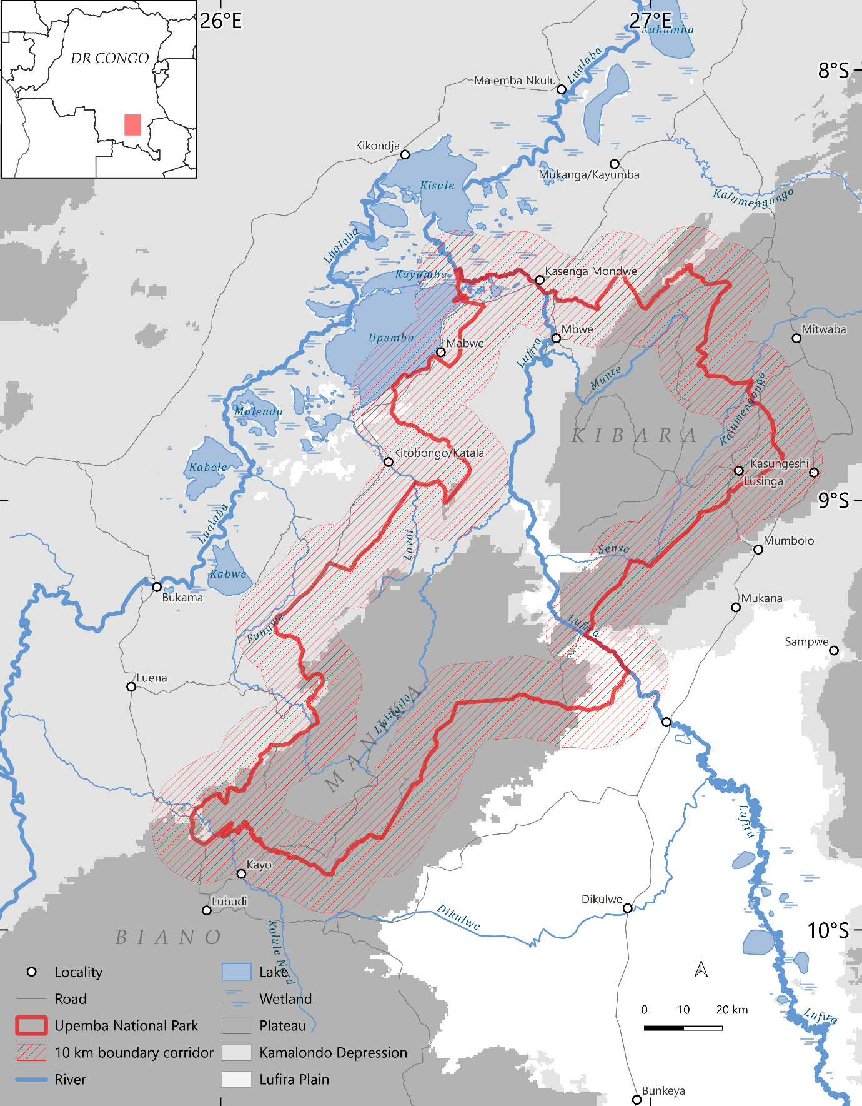
Figure 1. Study area and primary spatial design. The map shows Upemba National Park, the Depression and Plateau landscape comparison groups retained for inference, the third landscape group (Lufira Plain) outside the primary inferential scope, and the symmetric 10 km corridors inside and outside the legal boundary. Perennial-water cells were excluded from the analytical grid.
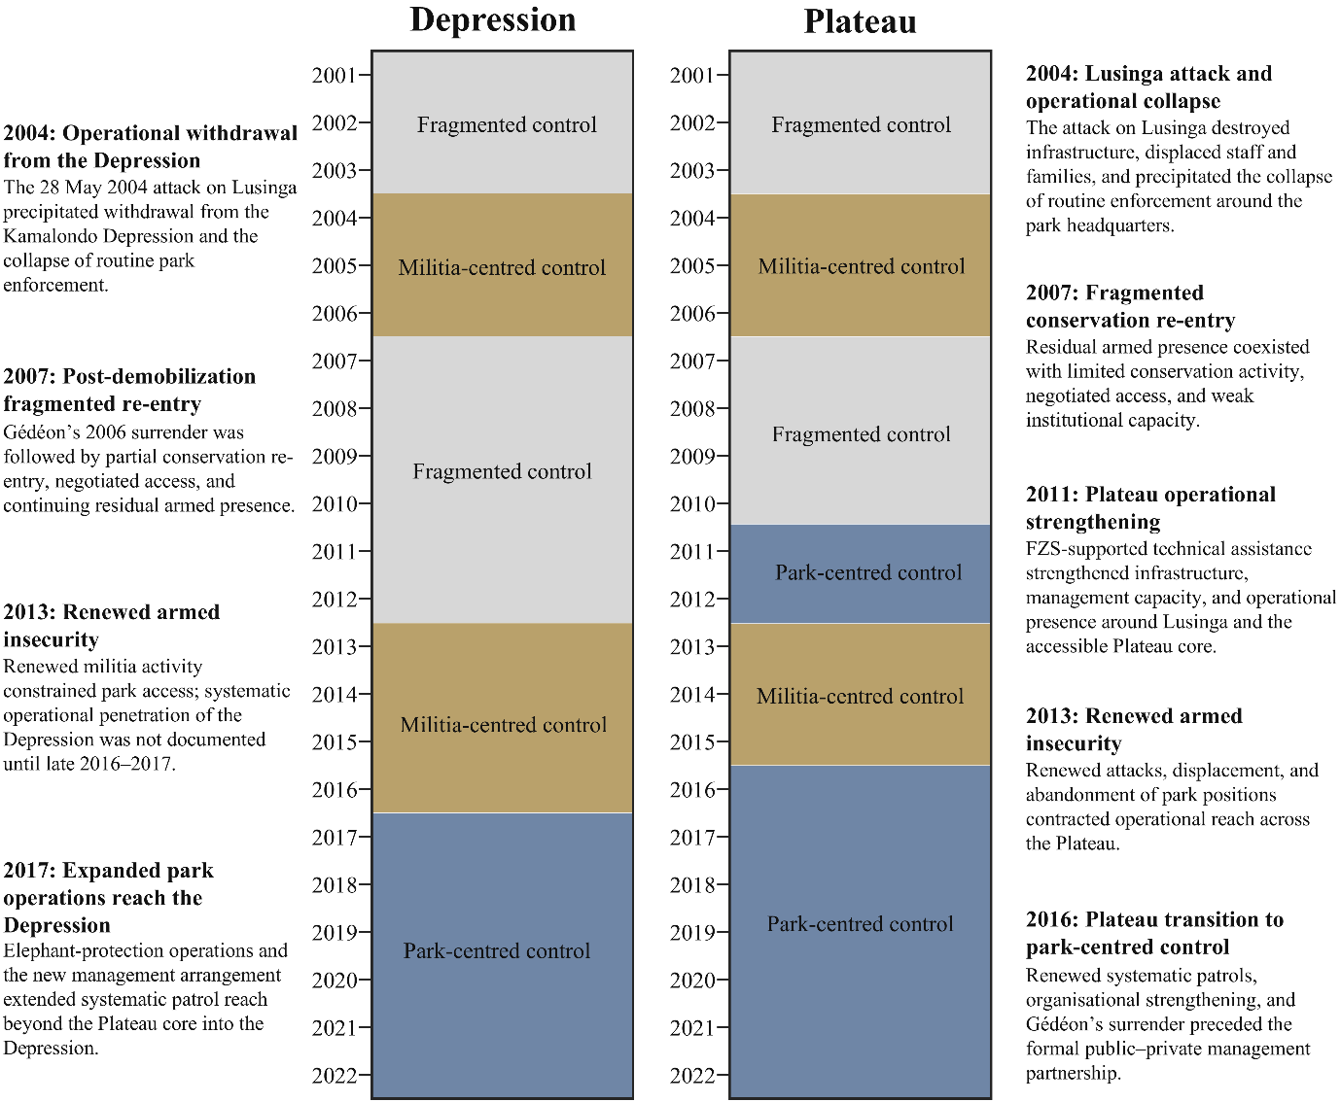
Figure 2. Reconstructed territorial-control profiles for the Depression and Plateau landscape comparison groups, 2001–2022. Profiles summarize recurrent configurations of practical territorial control rather than exclusive sovereignty or institutional legitimacy. Fragmented control denotes periods without consolidated park or militia control; militia-centred control denotes periods when armed-group presence materially structured access while park enforcement was severely constrained; and park-centred control denotes periods of expanded park operational reach despite continuing insecurity and incomplete coverage. Annotations identify the principal historical transitions. Complete evidence, uncertainty assessments and plausible alternative dates are reported in Tables S6A–S6B.
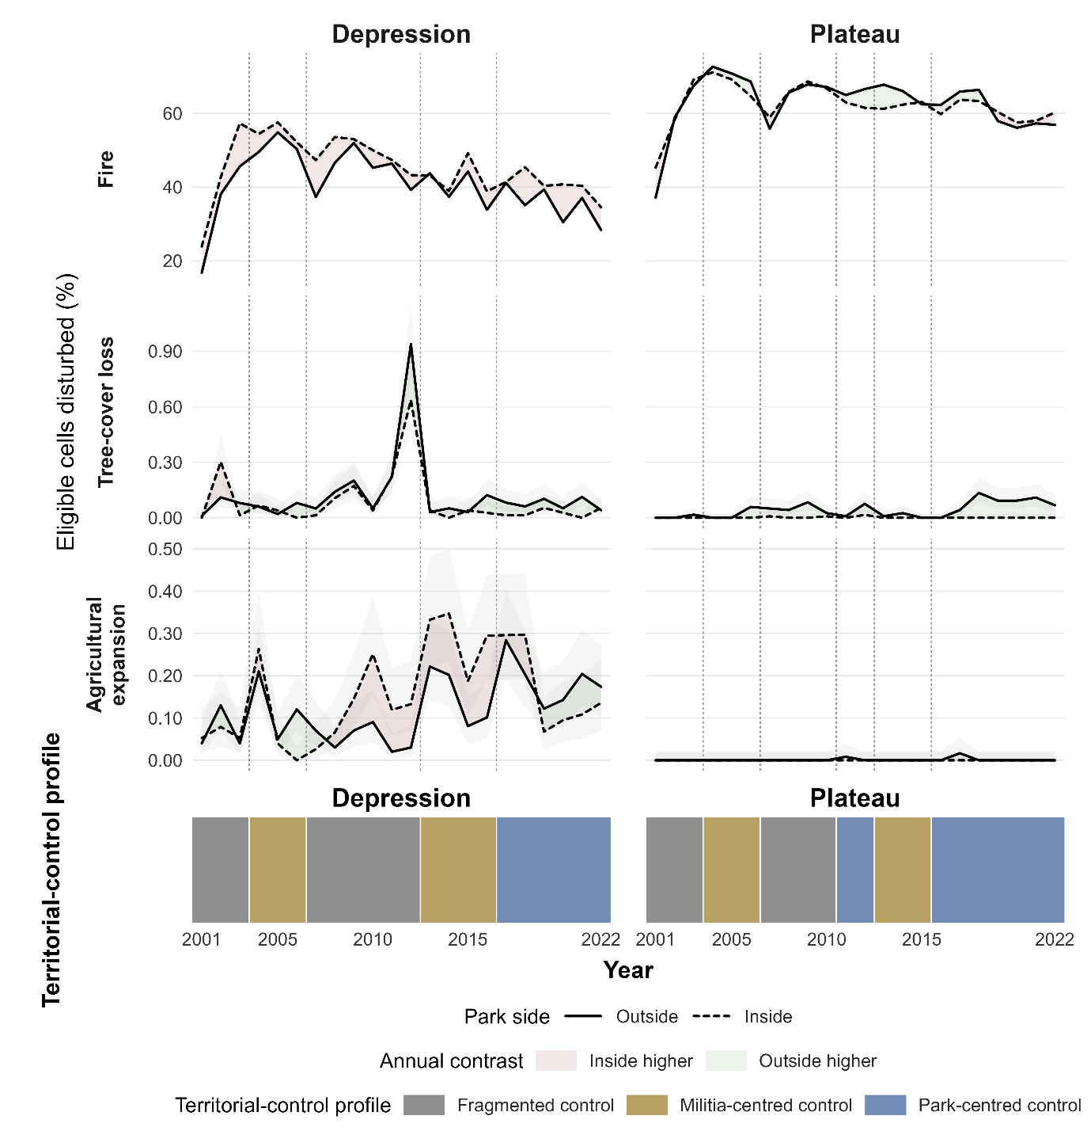
Figure 2. Annual disturbance trajectories and territorial-control profiles in the Depression and Plateau landscape comparison groups, 2001–2022. Rows show the annual proportion of eligible cells experiencing fire, tree-cover loss, and agricultural expansion. Solid lines represent observations outside the park and dashed lines observations inside the park. Pink shading identifies years in which the observed proportion was higher inside, and green shading years in which it was higher outside; faint grey ribbons show binomial uncertainty around the annual proportions. Bottom strips show the reconstructed fragmented, militia-centred, and park-centred profiles, and vertical dotted lines mark profile transitions.
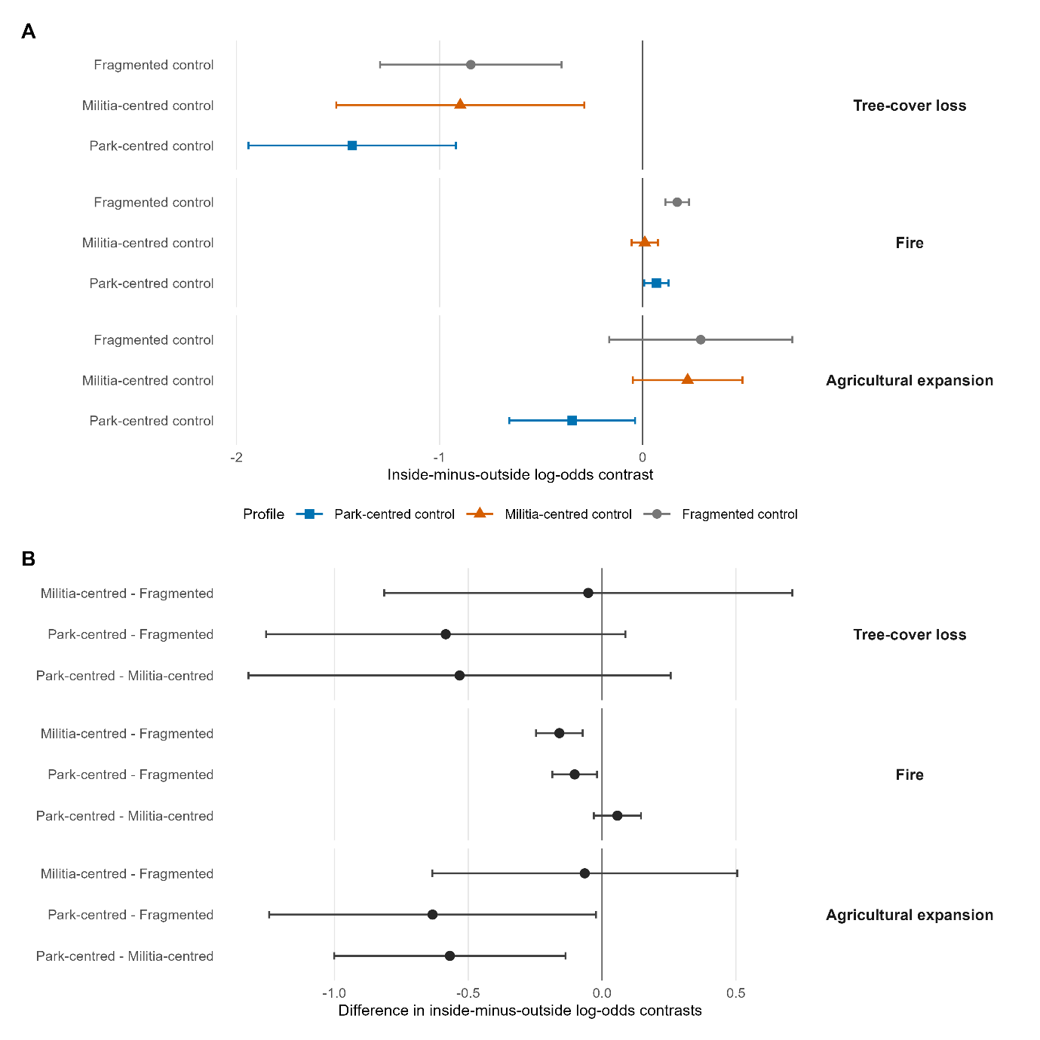
Figure 3. Primary territorial-control profile contrasts for tree-cover loss, fire, and agricultural expansion within the symmetric 10 km boundary corridor using the 25% event definition. (A) Estimated inside-minus-outside log-odds contrasts under each profile. (B) Pairwise differences between profile-specific contrasts. Points are estimates and horizontal bars are 95% confidence intervals. Positive profile contrasts indicate higher modelled disturbance probability inside the park; negative values indicate lower probability inside. Fire estimates derive from the strict-valid beta-binomial model; tree-cover-loss and agricultural-expansion estimates derive from inverse-variance-weighted two-stage models with HC3 covariance.
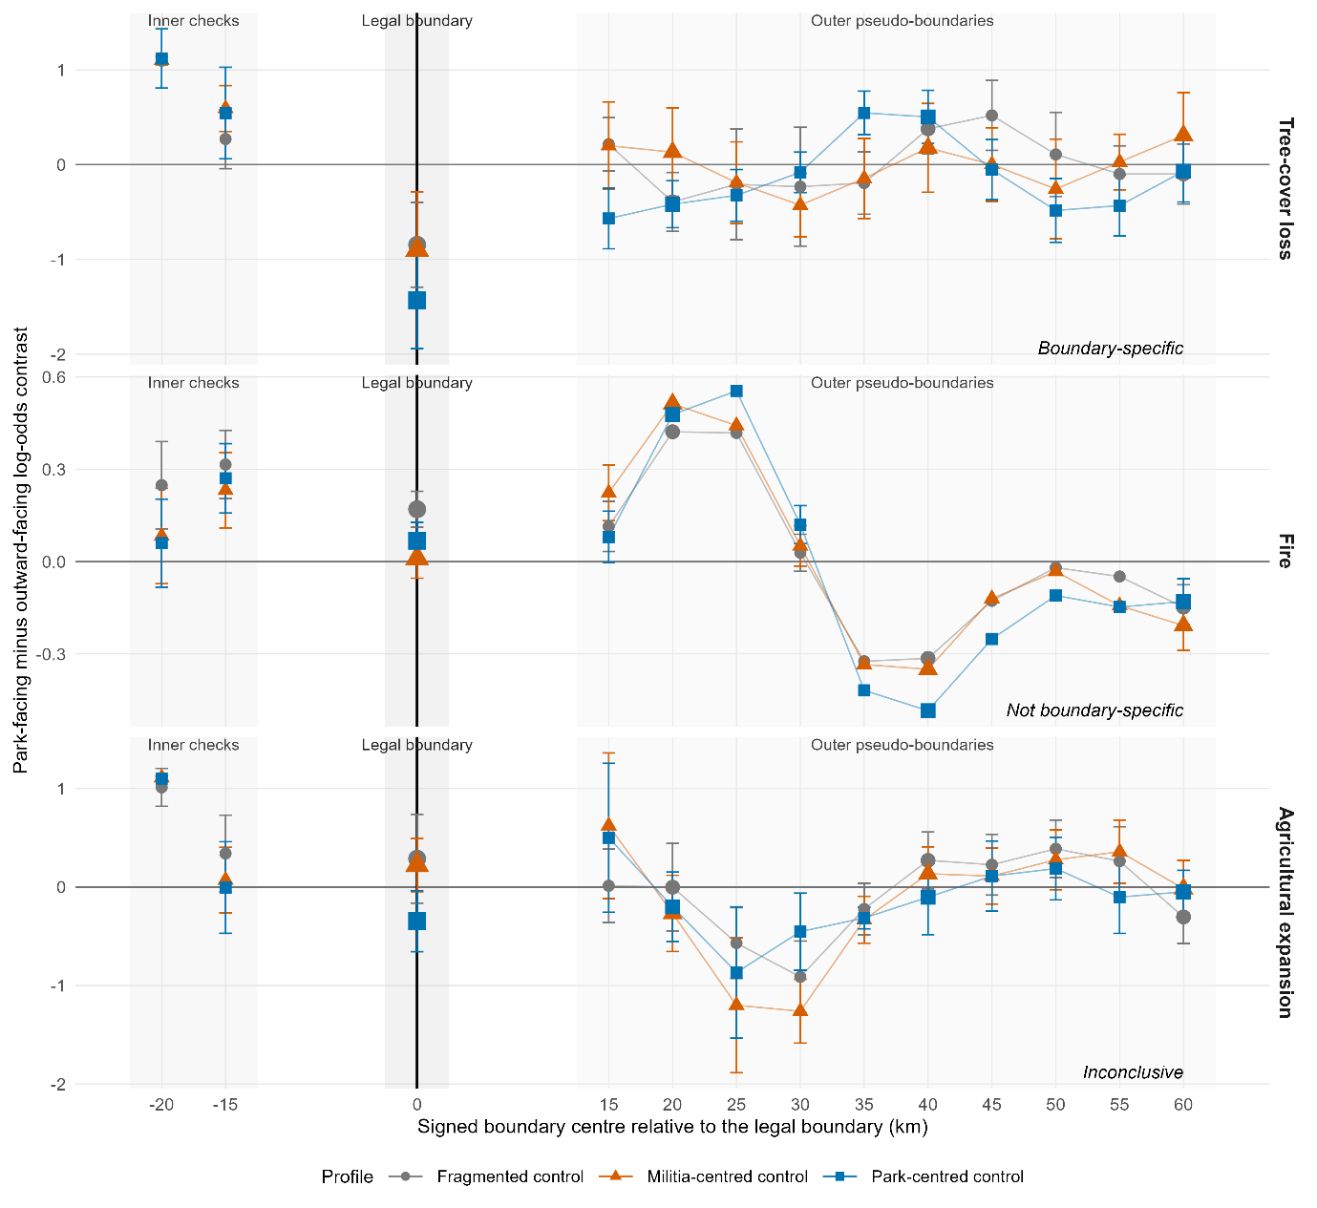
Figure 4. Spatial boundary-location diagnostic for profile-specific inside-minus-outside log-odds contrasts. Estimates are shown at the legal boundary (0 km), two inner descriptive checks (−20 and −15 km), and outer pseudo-boundaries centred from +15 to +60 km. Points show profile-specific estimates and vertical bars show available 95% confidence intervals. Tree-cover-loss estimates at the legal boundary were more negative than those at all evaluated outer offsets. Comparable or larger fire contrasts recurred at outer offsets, while agricultural-expansion estimates were too sparse and unstable for interpretation. Inner checks for the sparse outcomes had limited event support. Full fit-validity and descriptive-classification details are reported in Tables S15–S16 and Figure S3.
Table 2. Synthesis of primary results for the 25% event definition within the symmetric 10 km boundary corridor. Boundary-location assessments compare the legal boundary with spatially offset pseudo-boundaries. Full numerical profile contrasts and pairwise differences are reported in Tables S8–S9.
Outcome | Primary model | Events | Primary result | Boundary-location assessment | Robustness
Tree-cover loss | Weighted two-stage HC3 | 519 | Lower inside under all profiles; largest negative estimate under park-centred control. No pairwise 95% CI excluded zero. | Profile contrasts boundary-specific; partial support for park-centred versus fragmented. | Direction stable to weighting and the 20 km and all-cell sensitivities; weaker at 5 km and unsupported at the sparse 50% threshold.
Fire | Strict-valid beta-binomial | 508,320 | Higher inside under fragmented and park-centred control; near zero under militia-centred control. Militia-centred and park-centred differed from fragmented. | Profile contrasts not boundary-specific; partial support for militia-centred versus fragmented. | Point-estimate ordering was broadly consistent across thresholds and spatial domains; interval inference was restricted to valid fits.
Agricultural expansion | Weighted two-stage HC3 | 518 | Lower inside only under park-centred control. Park-centred differed from fragmented and militia-centred in the weighted model. | Inconclusive because of sparse support and unstable pseudo-boundary fits. | Sensitive to weighting, threshold, and spatial domain.

4. Discussion
Upemba’s legal boundary did not produce a uniform disturbance divide. Tree-cover loss remained lower inside the park under fragmented, militia-centred, and park-centred territorial control, and this contrast was unusually strong at the legal boundary relative to spatially offset comparisons. Fire differed: the inside–outside contrast varied among territorial-control profiles but comparable and larger contrasts recurred away from the legal boundary. Agricultural expansion suggested lower interior conversion during park-centred control, but sparse events and sensitivity to analytical choices prevented a firm conclusion. Legal boundaries and changing configurations of territorial control therefore corresponded with different land-surface processes selectively rather than producing a single conservation effect.
The persistent tree-cover-loss contrast is the clearest result. It occurred under all three territorial-control profiles and was therefore not confined to periods of expanded park operational reach. Tree-cover loss represents spatially fixed canopy removal, although the satellite product does not identify its cause or establish that conversion was permanent. Activities that can generate such loss—including clearing for cultivation, settlement, charcoal production, or infrastructure—generally require repeated access, labour, and some expectation that activity at a site can continue. The park boundary may raise the costs or risks of these activities through patrol exposure, uncertain tenure, expectations of future enforcement, customary restrictions, or limited supporting infrastructure. We did not measure these mechanisms directly. Nevertheless, the exceptional magnitude of the tree-cover-loss contrast at the legal boundary makes an explanation based solely on a broad regional environmental gradient less plausible.
This boundary signal does not demonstrate that park institutions exercised uniform control or that the processes producing it were socially legitimate. Authority in Upemba remained partial, contested, and spatially uneven throughout much of the study period. The territorial-control profiles identify the principal configuration of practical authority, not exclusive sovereignty. Lower tree-cover loss inside the park may therefore reflect the combined consequences of legal designation, historical settlement patterns, accessibility, customary authority, insecurity, coercion, and expectations about future control. The more negative point estimate during park-centred control is consistent with stronger regulation of site-specific clearing, but the pairwise comparisons do not establish a distinct additional effect of park-centred control.
Fire provides a substantive counterpoint. Burning can reflect livelihood practices, pasture management, hunting, accidental spread, vegetation and fuel conditions, or park management, and a burned cell does not reveal the actor, purpose, or ecological consequence of ignition (Archibald et al., 2010; Kelly et al., 2020). Unlike clearing or agricultural establishment, burning can occur during temporary access, spread beyond its point of ignition, and require no continued occupation. It may therefore respond less directly to stable, site-specific territorial control. The near-zero fire contrast during militia-centred periods indicates greater similarity between the two sides of the boundary, but the satellite record cannot determine whether this resulted from changing access, displacement, ignition practices, fuel continuity, or other processes. Because similar contrasts recurred at outer pseudo-boundaries, we cannot attribute the profile pattern specifically to legal protection or park enforcement.
Higher fire occurrence inside the park during fragmented and park-centred periods should not be interpreted as greater ecological degradation. In African savannas and woodlands, neither more nor less burning has a uniform ecological meaning; effects depend on frequency, season, intensity, vegetation, and management objectives (Archibald et al., 2010; Kelly et al., 2020). Fire may remain widespread where site-specific clearing is constrained because it requires less fixed investment and forms part of established livelihood or ecological regimes. The divergence between fire and tree-cover loss is therefore informative. It suggests that a legal boundary may strongly differentiate activities tied to particular sites while remaining permeable to recurrent processes associated with mobile access and environmental spread.
Agricultural expansion is compatible with the proposed distinction between site-specific and recurrent processes, but it does not provide independent support for it. The primary model estimated lower expansion inside the park during park-centred control, yet sparse events, numerous zero-event strata, and sensitivity to weighting, thresholds, spatial domains, and pseudo-boundary location prevent a robust interpretation. Agriculture requires repeated access and continued land use, so a decline during expanded park operational reach is plausible. However, the low event count, extensive zero-event strata, sensitivity to weighting, thresholds and spatial domains, and unstable pseudo-boundary estimates prevent a robust conclusion. Agricultural expansion therefore provides suggestive evidence of changing site-specific land use, not an independently established effect of park-centred control.
The historically reconstructed profiles allowed us to interpret these outcomes without reducing governance to a continuous measure of institutional strength. Upemba did not progress linearly from weak to strong conservation management. Park institutions, armed groups, customary authorities, state forces, communities, and external organisations exercised overlapping forms of authority, and comparable territorial configurations recurred in separate historical episodes. The transition toward park-centred control also occurred earlier on the Plateau than in the Depression. This variation supports historically grounded comparison, but it does not create experimental treatments. Profile transitions coincided with changes in displacement, infrastructure, military operations, market access, and wider political conditions. Historical evidence therefore defines periods and plausible mechanisms but cannot isolate actor-specific causal effects.
The spatial diagnostic also changes how the remote-sensing results should be interpreted. Areas outside protected boundaries are not generic untreated controls; they have distinct settlement histories, institutions, conflicts, and access regimes. Conditioning comparisons on landscape group and year reduced major measured differences, while the offset boundaries tested whether the observed contrasts were exceptional at the legal boundary. Tree-cover loss was both lower inside and boundary-specific. Fire varied among territorial-control profiles but was not boundary-specific. An analysis confined to the legal boundary could have described both patterns as effects of protection, despite their different spatial evidence. Protected-area evaluations should therefore separate the presence of an inside–outside contrast from evidence that the legal boundary specifically structures that contrast (Gohr et al., 2022).
Several limitations constrain inference. The analysis covers one protected area and two landscape comparison groups, and its conclusions cannot be generalized directly to other conflict-affected protected areas. One researcher reconstructed the territorial-control chronology. Coding preceded inspection of the disturbance outcomes and drew on a documented evidence base, but alternative coding remains possible. Annual categorical profiles also simplify within-year, within-group, and hybrid forms of authority. Model-based intervals do not fully capture dependence among consecutive years within historical episodes. Tree-cover loss and agricultural expansion were sparse, and agricultural estimates were particularly sensitive to measurement and spatial design. All outcomes inherit classification error from their source products, while remote sensing cannot identify actors, intentions, or social consequences (Olofsson et al., 2014; Kerner et al., 2024). Finally, the deterministic and spatially overlapping pseudo-boundaries provide a diagnostic of location specificity rather than a randomized counterfactual distribution.
Despite these limitations, the evidence supports a consistent outcome-specific distinction. Upemba’s legal boundary retained a selective spatial signature across major changes in territorial control: tree-cover-loss risk was consistently lower inside the park and the legal-boundary contrasts were more negative than those observed at the evaluated outer offsets, whereas fire reflected broader spatial and historical dynamics that the boundary did not uniquely contain. This finding does not establish a causal effect of legal protection or identify the actors and mechanisms responsible for lower tree-cover loss. It shows that legal boundaries can remain materially aligned with some site-specific land transitions under fragmented authority while remaining permeable to recurrent processes such as fire. Evaluations of governance-fragile protected areas should therefore combine independent satellite observations with historical reconstruction, distinguish among disturbance processes, and test whether apparent inside–outside differences are exceptional at the legal boundary.

References
Archibald, S., Nickless, A., Govender, N., Scholes, R.J., Lehsten, V., 2010. Climate and the inter-annual variability of fire in southern Africa: a meta-analysis using long-term field data and satellite-derived burnt area data. Global Ecology and Biogeography 19, 794–809. https://doi.org/10.1111/j.1466-8238.2010.00568.x
Blankespoor, B., Dasgupta, S., Wheeler, D., 2017. Protected areas and deforestation: new results from high-resolution panel data. Natural Resources Forum 41, 55–68. https://doi.org/10.1111/1477-8947.12118
Brooks, M.E., Kristensen, K., van Benthem, K.J., Magnusson, A., Berg, C.W., Nielsen, A., Skaug, H.J., Mächler, M., Bolker, B.M., 2017. glmmTMB balances speed and flexibility among packages for zero-inflated generalized linear mixed modeling. The R Journal 9, 378–400. https://doi.org/10.32614/RJ-2017-066
Brugière, D., 2020. Public-private partnership for protected areas: current situation and prospects in French-speaking Africa. IUCN-Papaco.
Chuvieco, E., Pettinari, M.L., Lizundia-Loiola, J., Storm, T., Padilla Parellada, M., 2018. ESA Fire Climate Change Initiative (Fire_cci): MODIS Fire_cci Burned Area Pixel product, version 5.1. https://doi.org/10.5285/58f00d8814064b79a0c49662ad3af537
Coad, L., Leverington, F., Knights, K., Geldmann, J., Eassom, A., Kapos, V., Kingston, N., de Lima, M., Zamora, C., Cuardros, I., Nolte, C., Burgess, N.D., Hockings, M., 2015. Measuring impact of protected area management interventions: current and future use of the Global Database of Protected Area Management Effectiveness. Philosophical Transactions of the Royal Society B 370, 20140281. https://doi.org/10.1098/rstb.2014.0281
de Merode, E., Smith, K.H., Homewood, K., Pettifor, R., Rowcliffe, M., Cowlishaw, G., 2007. The impact of armed conflict on protected-area efficacy in Central Africa. Biology Letters 3, 299–301. https://doi.org/10.1098/rsbl.2007.0010
Duffy, R., Massé, F., Smidt, E., Marijnen, E., Büscher, B., Verweijen, J., Ramutsindela, M., Simlai, T., Joanny, L., Lunstrum, E., 2019. Why we must question the militarisation of conservation. Biological Conservation 232, 66–73. https://doi.org/10.1016/j.biocon.2019.01.013
Fromont, C., Carrière, S.M., Bédécarrats, F., Razafindrakoto, M., Roubaud, F., 2024. Long-term socio-environmental monitoring of protected areas is a persistent weak point in developing countries: literature review and recommendations. Biological Conservation 290, 110434. https://doi.org/10.1016/j.biocon.2023.110434
Gohr, C., von Wehrden, H., May, F., Ibisch, P.L., 2022. Remotely sensed effectiveness assessments of protected areas lack a common framework: a review. Ecosphere 13, e4053. https://doi.org/10.1002/ecs2.4053
Gorelick, N., Hancher, M., Dixon, M., Ilyushchenko, S., Thau, D., Moore, R., 2017. Google Earth Engine: planetary-scale geospatial analysis for everyone. Remote Sensing of Environment 202, 18–27. https://doi.org/10.1016/j.rse.2017.06.031
Hansen, M.C., Potapov, P.V., Moore, R., Hancher, M., Turubanova, S.A., Tyukavina, A., Thau, D., Stehman, S.V., Goetz, S.J., Loveland, T.R., Kommareddy, A., Egorov, A., Chini, L., Justice, C.O., Townshend, J.R.G., 2013. High-resolution global maps of 21st-century forest cover change. Science 342, 850–853. https://doi.org/10.1126/science.1244693
Hasson, M., 2015. Katanga: Des animaux et des hommes. Musée royal de l’Afrique centrale, Tervuren.
Kelly, L.T., Giljohann, K.M., Duane, A., Aquilué, N., Archibald, S., Batllori, E., Bennett, A.F., Buckland, S.T., Canelles, Q., Clarke, M.F., Fortin, M.-J., Hermoso, V., Herrando, S., Keane, R.E., Lake, F.K., McCarthy, M.A., Morán-Ordóñez, A., Parr, C.L., Pausas, J.G., Penman, T.D., Regos, A., Rumpff, L., Santos, J.L., Smith, A.L., Syphard, A.D., Tingley, M.W., Brotons, L., 2020. Fire and biodiversity in the Anthropocene. Science 370, eabb0355. https://doi.org/10.1126/science.abb0355
Kerner, H., Nakalembe, C., Yang, A., Zvonkov, I., McWeeny, R., Tseng, G., Becker-Reshef, I., 2024. How accurate are existing land cover maps for agriculture in Sub-Saharan Africa? Scientific Data 11, 486. https://doi.org/10.1038/s41597-024-03306-z
Leverington, F., Costa, K.L., Pavese, H., Lisle, A., Hockings, M., 2010. A global analysis of protected area management effectiveness. Environmental Management 46, 685–698. https://doi.org/10.1007/s00267-010-9564-5
Lou, Z., Peng, D., Shi, Z., Wang, H., Liu, K., Zhang, Y., Yan, X., Chen, Z., Ye, S., Yu, L., Hu, J., Lv, Y., Peng, H., Zhang, Y., Zhang, B., 2025. AFCD: An Annual Cropland Extent Dataset for Africa at 30 m spatial resolution from 2000 to 2022. https://doi.org/10.5281/zenodo.14920706
MacKinnon, J.G., White, H., 1985. Some heteroskedasticity-consistent covariance matrix estimators with improved finite sample properties. Journal of Econometrics 29, 305–325. https://doi.org/10.1016/0304-4076(85)90158-7
Marijnen, E., Verweijen, J., 2016. Selling green militarization: the discursive (re)production of militarized conservation in the Virunga National Park, Democratic Republic of the Congo. Geoforum 75, 274–285. https://doi.org/10.1016/j.geoforum.2016.08.003
McNicol, I.M., Keane, A., Burgess, N.D., Bowers, S.J., Mitchard, E.T.A., Ryan, C.M., 2023. Protected areas reduce deforestation and degradation and enhance woody growth across African woodlands. Communications Earth & Environment 4, 1–14. https://doi.org/10.1038/s43247-023-01053-4
Olofsson, P., Foody, G.M., Herold, M., Stehman, S.V., Woodcock, C.E., Wulder, M.A., 2014. Good practices for estimating area and assessing accuracy of land change. Remote Sensing of Environment 148, 42–57. https://doi.org/10.1016/j.rse.2014.02.015
Pekel, J.-F., Cottam, A., Gorelick, N., Belward, A.S., 2016. High-resolution mapping of global surface water and its long-term changes. Nature 540, 418–422. https://doi.org/10.1038/nature20584
R Core Team, 2026. R: A language and environment for statistical computing. R Foundation for Statistical Computing, Vienna.
Van Leeuwe, H., Henschel, P., Pélissier, C., Moyer, D., 2009. Recensement des grands mammifères et impacts humains: Parcs Nationaux de l’Upemba et de Kundelungu, République Démocratique du Congo. ICCN/WCS/USFWS/Panthera.

