Separating environmental outcomes from conservation attribution under changing territorial control

Abstract
Protected-area evaluations often treat legal designation as a stable intervention, although practical authority can change while boundaries remain fixed. We examined whether Upemba National Park’s legal boundary aligned with disturbance under fragmented, militia-centred, and park-centred territorial-control profiles. We combined a historical chronology with recurrent fire and first tree-cover-loss and agricultural-expansion threshold crossings in 500 m cells during 2001–2022. We estimated profile-specific inside–outside contrasts within landscape groups and compared the legal boundary with ten outward pseudo-boundaries.
At the primary threshold, tree-cover-loss odds were 57–76% lower inside under all profiles; pairwise profile differences remained uncertain. Legal-boundary estimates were more negative than all evaluated outward estimates. This result weakened in the better-balanced 5 km corridor and at the sparse 50% threshold. Fire contrasts were higher under fragmented than militia-centred or park-centred control, but comparable contrasts and sign reversals occurred away from the legal line. Agricultural first-expansion estimates remained sensitive to the analysis period, persistence definition and uncertainty calculation.
A favourable land-surface outcome did not identify the actor, mechanism, conservation intent or legitimacy that produced it. Historical reconstruction, process-specific satellite observations and boundary-location diagnostics therefore answer distinct questions when protected-area authority changes over time. The estimates describe conditional spatial associations rather than causal effects of legal protection.

Keywords
protected-area boundary; territorial control; environmental equifinality; remote sensing; tree-cover loss; fire; Democratic Republic of the Congo

1. Introduction
Legal designation establishes jurisdiction: it defines a protected area’s boundary and formal rules. Practical authority concerns who can implement or contest those rules. Protected areas are commonly evaluated by comparing environmental conditions inside and outside their boundaries, often finding lower habitat loss or pressure inside (Andam et al., 2008; Geldmann et al., 2013, 2019; Gray et al., 2016; McNicol et al., 2023). Yet the capacity to regulate access can change while the legal line remains fixed. Protected areas territorialise space through rules and authorised actors, but these institutions remain contested and historically variable (Bassett and Gautier, 2014; Holmes, 2014). Their environmental expression therefore requires evidence about practical authority as well as legal jurisdiction.
The first problem is practical authority. In conflict-affected protected areas, park agencies, armed groups, state forces, customary authorities, communities, and conservation organisations may exercise overlapping and uneven influence (de Merode et al., 2007; Gaynor et al., 2016; Daskin and Pringle, 2018). Insecurity can weaken enforcement, intensify extraction, displace settlement, or restrict mobility, while conservation responses may themselves rely on coercive territorial control (Lunstrum, 2014; Marijnen and Verweijen, 2016; Duffy et al., 2019). We define territorial control as the practical capacity to shape who can enter, extract, cultivate, settle, or burn. This operational capacity is distinct from legal jurisdiction, governance quality, conservation intent, observed outcome, and legitimacy.
The second problem is process dependence. Tree-cover loss records spatially fixed canopy removal. Substantial cell-level loss often requires repeated access, labour, transport, and some expectation of site persistence, although the product neither identifies cause nor establishes permanent conversion. Boundaries, tenure expectations, patrol exposure, and infrastructure may therefore structure where it occurs. Fire is recurrent and mobile, responds to fuel and weather, can occur during temporary access, and can spread beyond its ignition point (Archibald et al., 2010; Kelly et al., 2020). It may arise from hunting, pasture management, cultivation, accidental spread, ecological processes, or conservation management. A fire detection therefore cannot be equated with poaching, and a boundary may structure canopy removal without producing an equivalent fire pattern.
The third problem is spatial attribution. Protected areas often occupy remote, topographically constrained, or less agriculturally attractive land, so simple inside–outside comparisons can conflate protection with pre-existing environmental and accessibility differences (Joppa and Pfaff, 2009). Matching and stratification reduce observed imbalance (Andam et al., 2008; Geldmann et al., 2013; Ghoddousi et al., 2022), but they do not show that the legal line organises the remaining contrast. Similar contrasts may recur along regional gradients in vegetation, hydrology, settlement, markets, or land-use history. We therefore use outward pseudo-boundaries as a complementary, one-sided diagnostic. A legal estimate that exceeds the evaluated offsets indicates unusual alignment with the legal line within the sampled outer domain; recurrent or sign-reversing contrasts indicate broader spatial structure. The deterministic, overlapping offsets neither test uniqueness in every direction nor provide randomised counterfactuals.
Historical reconstruction and satellite observation answer different parts of these problems. Historical sources can define changes in practical authority and plausible mechanisms, but remain incomplete and institutionally situated. Satellite products observe land-surface outcomes consistently across inaccessible terrain, yet cannot identify actors, intentions, legitimacy, or displaced pressure (Hansen et al., 2013; Chuvieco et al., 2018; Gohr et al., 2022). We therefore fixed the chronology before inspecting outcomes and did not treat satellite measures as observations of institutions.
We apply this design to Upemba National Park, Democratic Republic of the Congo, where legal protection remained continuous while practical authority shifted among fragmented, militia-centred, and park-centred configurations. We combine a pre-outcome chronology with annual fire, tree-cover-loss, and agricultural-expansion observations for 2001–2022, condition comparisons on environmental and accessibility context, and compare the legal boundary with ten outward pseudo-boundaries. We ask whether disturbance differed across the legal line, whether the contrast varied among broad authority profiles, and whether it was unusual among the evaluated offsets. The study contributes empirical evidence that the primary tree-cover-loss contrast remained negative under each profile and exceeded all outward-offset estimates; a method that keeps historical reconstruction, process-specific observations, and spatial diagnostics separate; and a conceptual distinction among environmental outcome, spatial attribution, institutional attribution, conservation intent, and legitimacy.

2. Methods

2.1 Study system and spatial design
Upemba National Park covers approximately 10,000 km² in southeastern Democratic Republic of the Congo, spanning the Kibara and Manika plateaus and the Kamalondo (Upemba) Depression wetland complex (Fig. 1). We analysed a broader domain from 25.48 to 27.50°E and 10.4 to 7.8°S, excluding the Copperbelt mining districts and Kundelungu Plateau because their environmental conditions and land-use histories differed from the focal landscape. We projected all layers to UTM Zone 35S (EPSG:32735), aligned them to a 500 m grid, excluded perennial water with JRC Global Surface Water (Pekel et al., 2016), and digitised the legal boundary from Ordonnance no. 75-241 (République du Zaïre, 1975). The legal line crosses several environmental settings and follows physical features only in places.
The primary analysis used symmetric 10 km corridors on either side of the legal boundary. Before examining profile-specific results, we compared 5, 10, and 20 km corridors and the full domain on measured covariate balance and sparse-event support. The 10 km corridor retained 519 tree-cover-loss and 518 agricultural-expansion events; median and maximum absolute standardised mean differences were 0.187 and 0.733. The better-balanced 5 km corridor (0.119 and 0.371) retained fewer events. We therefore treat 10 km as a balance–support compromise, not a matched or randomised design, and report other domains as sensitivities (Table S4). All estimates are conditional spatial contrasts, not causal effects of designation.
We acquired the remote-sensing layers in Google Earth Engine and completed harmonisation, clustering, risk-set construction, and statistical analysis in R 4.5.3 (Gorelick et al., 2017; R Core Team, 2026).
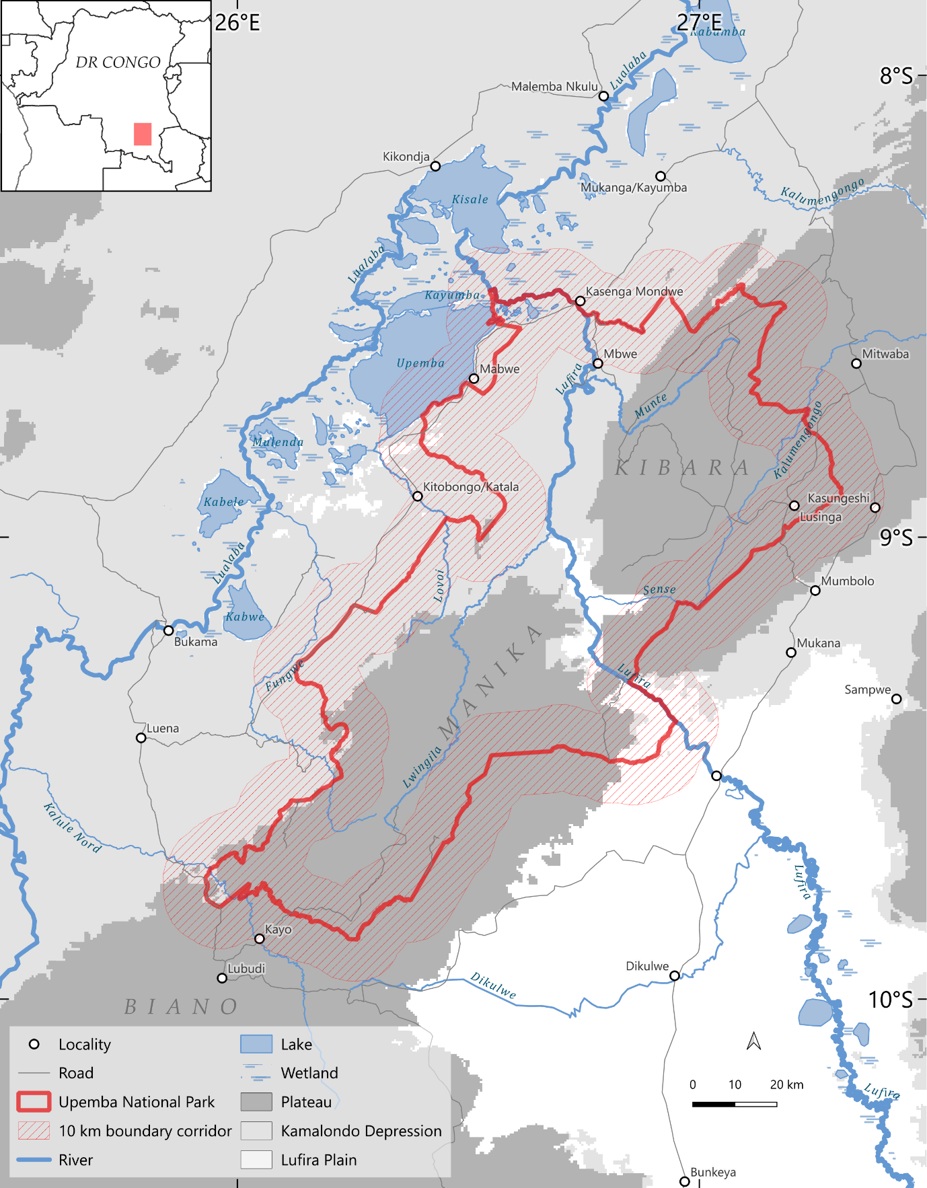
Figure 1. Study area and primary spatial design. Upemba National Park, retained Depression and Plateau comparison groups, excluded Lufira Plain cluster, and symmetric 10 km corridors. Perennial-water cells were excluded. The legal boundary crosses rivers, plateaus, wetlands, and transition zones rather than a single environmental discontinuity. Map lines delineate study areas and do not necessarily depict accepted national boundaries.

2.2 Landscape comparison groups
We used landscape comparison groups to condition boundary contrasts on broad environmental and accessibility context. These pragmatic strata are neither complete nor internally homogeneous socio-ecological systems. The selected clustering solution showed modest separation (mean silhouette width 0.270), and residual measured imbalance remained within the 10 km design; stratification reduces but cannot eliminate confounding.
Reference-period covariates represented terrain, baseline tree cover, hydrology, climate, soils, distance to built-up areas, and travel time to cities (Table S1). We transformed skewed distance and accessibility variables, standardised all features, and fitted k-means solutions for k = 2–15. The selected k = 3 solution maximised mean silhouette width (0.270), only slightly above k = 7 (0.261), confirming broad rather than sharply separated strata. An eight-neighbour modal rule reassigned isolated cells. Because travel time was the only wall-to-wall accessibility surface and represented 2015 conditions, we repeated clustering without it (Tables S2–S3).
We labelled the three statistical clusters by dominant geography and retained Depression and Plateau because both intersected the park and supported outcome estimation and an independent chronology. The Depression principally represents a long-occupied wetland landscape with fishing, cultivation, exchange, settlement, and political organisation (Hasson, 2015; Nikis, 2021). The higher, cooler Plateau was historically less attractive to agriculture, more sparsely settled, and later served as wildlife refugia (Delvaux, 1950; Hasson, 2015). We use this history only to establish contrasting long-term land-use contexts. We excluded Lufira Plain before modelling because it had little park-interior support and no interior tree-cover-loss event (Table S5). Removing travel time reproduced 96.8% of primary-corridor assignments (Table S3).

2.3 Historical reconstruction of territorial control
We reconstructed annual territorial-control profiles separately for the Depression and Plateau for 2001–2022 from dated archival, park, NGO, technical, humanitarian, media, and historical sources. We fixed the chronology before inspecting satellite outcomes: history defined periods, locations, and plausible mechanisms; satellite products measured outcomes independently. The chronology is a documented interpretation of an uneven record, not a governance-quality index, normative ranking, causal treatment, or complete census of authority.
Coding focused on park institutions—ranger deployment, patrol reach, infrastructure, external support, and enforcement capacity—and armed groups described as Mai-Mai. The latter label aggregates formations that differed among episodes. Evidence on state forces, customary authorities, administrations, communities, and conservation organisations informed interpretation but did not define separate statistical categories. We prioritised records assignable to a landscape group, year, or transition and retained source disagreements in Table S6.
We assigned each landscape-group year to fragmented, militia-centred, or park-centred control. Fragmented control denotes no consolidated park or militia authority; militia-centred control denotes armed-group presence that materially structured access while park enforcement had collapsed or remained severely constrained; park-centred control denotes expanded park operational reach despite continuing insecurity and incomplete coverage. Labels pool non-identical, contiguous episodes and do not imply homogeneous actors, exclusive sovereignty, equal intensity, conservation intent, or legitimacy. Their value is to show how a fixed legal boundary operated under changing practical authority (Fig. 2; Tables S6–S7).
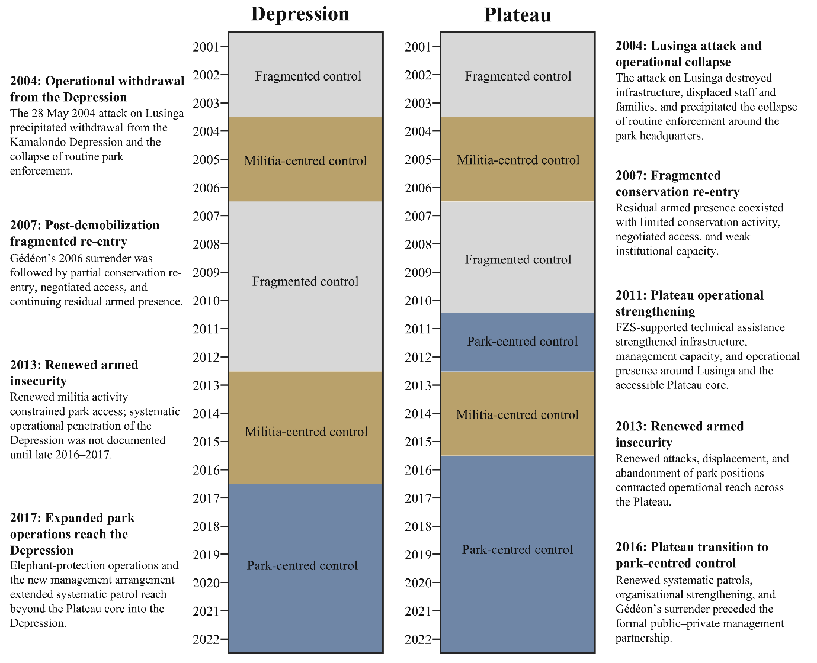
Figure 2. Reconstructed territorial-control chronology for the Depression and Plateau, 2001–2022. Colours denote fragmented, militia-centred, and park-centred control; annotations summarise transitions in practical authority. FZS denotes Frankfurt Zoological Society. The profiles classify broad operational access conditions, not homogeneous actors, governance quality, or causal treatments (Table S6).

2.4 Disturbance measurements
We measured recurrent fire and first threshold crossings of tree-cover loss and agricultural expansion for 2001–2022. These outcomes represent different land-surface processes, not interchangeable indicators of human activity or biodiversity. We harmonised products to the 500 m grid and used 25% of cell area as the primary minimum mapped footprint; 10% and 50% were sensitivities. One 250 m FireCCI pixel can meet the 25% fire threshold, whereas tree-cover loss and agriculture require the corresponding fraction of 30 m pixels. The shared footprint does not equalise ecological meaning or error. We estimate relative contrasts rather than unbiased disturbed area (Olofsson et al., 2014; Kerner et al., 2024; Table S16).
Fire used ESA FireCCI v5.1 (approximately 250 m; Chuvieco et al., 2018). We retained day-of-year 100–300 to represent the broad regional dry-season regime; the filter neither identifies ignition nor separates anthropogenic from natural burning. A 500 m cell was burned when at least 25% of its area was detected. All eligible cells re-entered each annual risk set because fire is recurrent.
Tree-cover loss used Hansen Global Forest Change v1.12 (Hansen et al., 2013). Eligibility required at least 30% mean tree cover in 2000. The event year was the first year cumulative mapped loss reached 25% of the cell. This estimand is an initial operational threshold crossing, not annual deforestation, all canopy loss, its cause, or permanent conversion; removing a cell after its event also precludes analysis of later regrowth or reclearing.
Agricultural expansion used the Annual Cropland Extent Dataset for Africa (Lou et al., 2025). An event was the first observed transition from below to at least 25% cropland, after which the cell left the risk set. Baseline agricultural cells were retained, so a subsequent decline and recrossing could define their first detected expansion within the observation window. This is not first-ever cultivation. We reconstructed annual 2000–2022 cropland fractions and verified every first-crossing date against the primary input. These observations support separate persistence, reversal and annual-presence analyses (Supplementary Methods S7; Tables S18–S20). None measures net agricultural change.

2.5 Statistical estimation
We expanded cells into outcome-specific annual risk sets and aggregated events and eligible cells by landscape group, year, and park side. Pairing sides within each group-year removes shared conditions from the contrast but not residual spatial gradients, side-specific temporal change, or dependence among neighbouring cells.
Frequent, overdispersed fire counts were fitted with a beta-binomial logit model in glmmTMB (Brooks et al., 2017). Landscape-group × year fixed effects represented the outside baseline; park-side interactions with profile estimated inside–outside contrasts:
Y_stk ~ BetaBinomial(N_stk, p_stk, φ) (1)
logit(p_stk) = α_st + β_F k + δ_M k I(G_st = M) + δ_P k I(G_st = P) (2)
Here, Y and N are burned and eligible cells for landscape s, year t, and side k; p is burning probability and φ dispersion. The fixed effect α_st absorbs conditions shared within each group-year. The inside–outside log-odds contrast is β_F under fragmented control, β_F + δ_M under militia-centred control, and β_F + δ_P under park-centred control. Positive values indicate higher burning inside. The beta-binomial absorbs extra-binomial variation but not explicit spatial or serial autocorrelation.
Tree-cover-loss and agricultural-expansion counts were too sparse for valid beta-binomial fits. For each eligible group-year we therefore calculated a Haldane–Anscombe-corrected inside–outside log-odds difference. Adding 0.5 prevents infinite values in zero-event strata but makes very sparse strata correction-sensitive:
D_st = log[(y_st,in + 0.5)/(n_st,in − y_st,in + 0.5)] − log[(y_st,out + 0.5)/(n_st,out − y_st,out + 0.5)] (3)
We modelled D_st by territorial-control profile and a landscape-group fixed effect:
D_st = μ_(G_st) + λ_s + ε_st (4)
Each annual contrast received inverse approximate-variance weight 1/V_st, increasing the influence of better-supported group-years without correcting spatial dependence:
V_st = 1/(y_st,in + 0.5) + 1/(n_st,in − y_st,in + 0.5) + 1/(y_st,out + 0.5) + 1/(n_st,out − y_st,out + 0.5) (5)
We estimated pooled profile contrasts and pairwise differences with HC3 covariance (MacKinnon and White, 1985); an unweighted model tested weighting sensitivity. HC3 addresses leverage and heteroskedasticity, not serial dependence within episodes, dependence between landscapes in the same year, or spatial dependence inherited from cell counts. Forty-four landscape-group years represented only 11 contiguous episodes. We therefore interpret confidence intervals as conditional model-based summaries and do not treat profiles as actor-specific causal effects.

2.6 Robustness and boundary-location diagnostics
We varied event threshold (10%, 25%, 50%), spatial domain (5, 10, 20 km and full domain), and weighting. We distinguished the earlier exploratory chronology checks (Table S12) from the recovered, matched primary-corridor analyses of one- and two-year profile lags and transition-year exclusions (Supplementary Methods S5; Table S21). These assess temporal alignment, with altered eligible years; they do not identify delayed causal effects. Fire harmonisation and optimizer checks are reported in Supplementary Methods S3–S4 and Table S13. The retained 10% and 25% BFGS fits meet strict numerical criteria; the 50% fit does not meet the independent-gradient criterion.
To diagnose spatial alignment, we compared the legal boundary (0 km) with ten outward pseudo-boundaries centred +15 to +60 km in 5 km steps. Each symmetric corridor contrasted the park-facing and outward-facing sides using the same outcome definitions, temporal labels, models, and landscape group. Profile labels at offsets denote periods in Upemba’s chronology, not control of those locations.
The park-facing band at the +15 km pseudo-boundary spans +5–15 km from the legal line and overlaps the primary outside band over +5–10 km. It is not an independent outside control. Overlap among offset corridors also prevents treating their estimates as independent replications.
We report whether each legal estimate was more extreme than all ten outward estimates and the complete sequence. The one-sided, deterministic, overlapping offsets are descriptive: they cannot establish uniqueness in every direction and do not form independent observations, a confidence interval, a randomised null, or a causal counterfactual. Finite outer fire estimates that failed strict fit criteria appear without interval-based inference.

2.7 Additional agricultural and seasonal diagnostics
Persistent first establishment required a crossing to at least 25% cropland and at least two of the next three calendar years at that threshold, including year +1 or +2. All three follow-ups had to be valid. Candidate years were 2001–2019, with follow-up through 2022. We compared this model with first crossing over both 2001–2019 and the original 2001–2022 period, preserving the landscape groups, corridor and two-stage specification. A later qualifying recrossing could replace an earlier transient crossing; cells exited after the dated qualifying crossing, not its confirmation year.
For annual presence, all eligible cells remained in the annual 2001–2022 sample, including baseline agricultural cells and cells observed after establishment. We applied the same paired landscape-year log-odds design to annual classifications and calculated intervals from 499 resamples of whole cell histories in fixed 5 km spatial blocks. Blocks were sampled within landscape groups; boundary-crossing blocks retained both sides. This addresses repeated observations and local spatial dependence conditional on the observed chronology, but not dependence between blocks or uncertain historical coding. We separated two-year classification reversal from persistent establishment, and static Hansen loss–gain overlap from dated recovery (Supplementary Methods S7).
An appendix figure compares monthly CHIRPS v2.0 rainfall with unfiltered monthly FireCCI51 mapped burned area in the same corridor during 2021 (Fig. S3; Supplementary Methods S6). We selected the year using observation coverage, weighted precipitation by area and displayed missing-fire-area bounds. The figure illustrates one seasonal cycle rather than a causal or long-term rainfall–fire relationship.

3. Results
The 10 km corridor contained 42,554 cells (20,548 inside; 22,006 outside). Of 936,188 fire cell-years, 508,320 were burned; the sparse outcomes recorded 519 primary tree-cover-loss and 518 agricultural-expansion events. Most sparse events occurred in the Depression: the Plateau contributed four inside and 111 outside tree-cover-loss events and three agricultural events (Tables S4–S5). The chronology comprised 16 fragmented, 13 militia-centred, and 15 park-centred landscape-group years across 11 episodes (Fig. 2; Table S7). Descriptive annual trajectories appear in Fig. S2.
At the primary 25% cumulative-loss threshold, odds of first crossing were lower inside under fragmented (OR = 0.43, 95% CI 0.27–0.67), militia-centred (0.41, 0.22–0.75), and park-centred control (0.24, 0.14–0.40; Fig. 3A; Table S8). The park-centred point estimate was most negative, but all pairwise intervals included zero (Fig. 3B; Table S9). These pooled estimates do not establish the contrast within every episode. Under every profile, the legal estimate was more negative than all ten outward-offset estimates (Fig. 4; Table S14). Direction persisted without weighting, at 10%, and in 20 km and full-domain analyses. In the better-balanced 5 km corridor, all point estimates remained negative, but only the park-centred interval excluded zero. At 50%, estimates approached zero with only 79 events (Tables S10–S11; Fig. S1; Table S17).
Fire varied among profiles in the primary model but did not align exceptionally with the legal boundary. The inside–outside log-odds contrast was positive under fragmented control (0.170, 95% CI 0.112–0.229), near zero under militia-centred control (0.011, −0.054–0.075), and positive but smaller under park-centred control (0.068, 0.008–0.128; Fig. 3A). Relative to fragmented control, contrasts were lower under militia-centred (−0.160, −0.247 to −0.072) and park-centred control (−0.102, −0.186 to −0.019); the latter two did not clearly differ (Fig. 3B; Tables S8–S9). Every legal estimate fell within the outward-offset range, where similar contrasts and sign reversals occurred (Fig. 4; Table S14). Some outer points failed strict fit criteria, and exploratory chronology diagnostics changed signs (Table S12).
The primary agricultural model retained 518 events (254 inside, 264 outside). Cell IDs, coordinates, sides, dates and corridor flags agreed between the primary input and post-event classifications. Restriction to 2001–2019 retained 442 first crossings, and corrected persistence retained 414 qualifying establishments. The park-centred contrast changed from −0.347 [−0.657, −0.037] in the full-period first-crossing model to −0.240 [−0.611, 0.131] in its restricted refit, then to −0.235 [−0.753, 0.284] under corrected persistence (Table S18). Shortening the period explained most of the point-estimate shift. The persistence standard error increased; overlapping intervals do not establish equivalent effects. The superseded 431-event estimate, −0.237 [−0.642, 0.168], used incomplete follow-up and is not the corrected result.
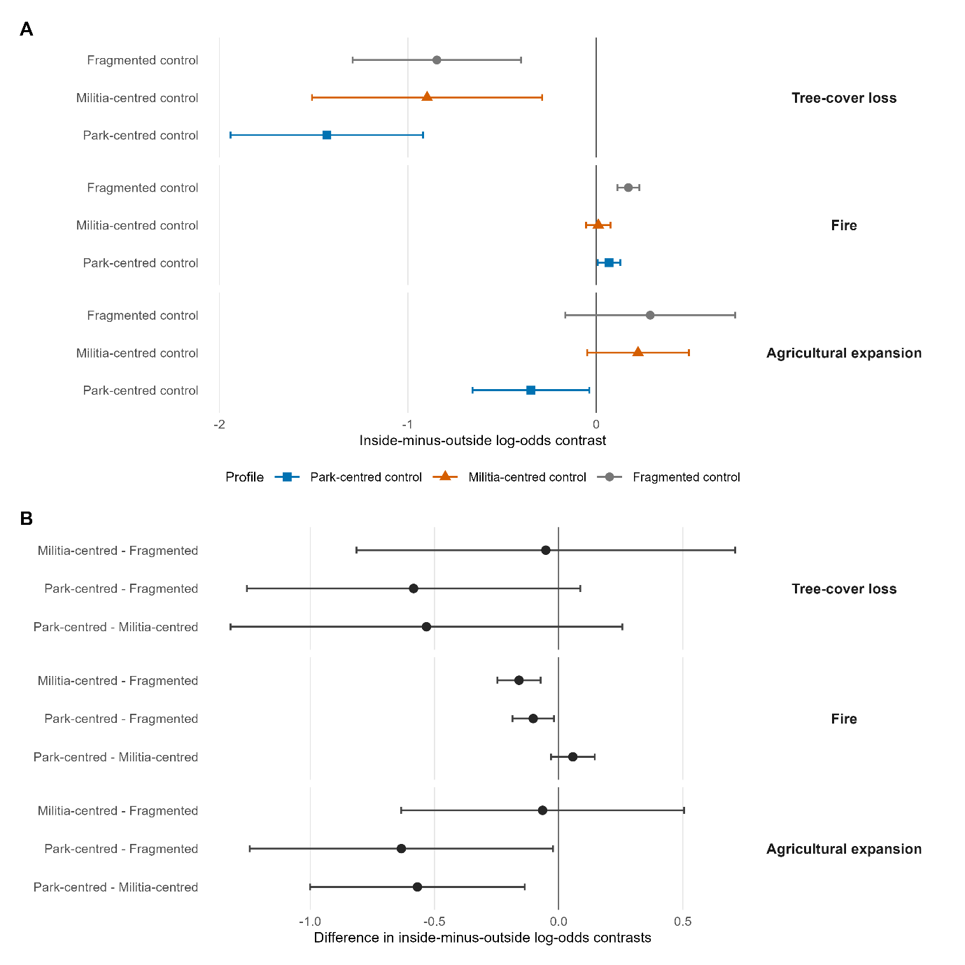
Figure 3. Primary pooled contrasts at the 25% threshold within the symmetric 10 km corridor. Panel A shows profile-specific inside-minus-outside log odds: positive values indicate higher disturbance inside, negative values lower disturbance inside. Panel B shows the first named profile’s contrast minus the second named profile’s contrast: positive values mean the contrast is more positive under the first profile, not necessarily higher disturbance inside. Bars are 95% conditional intervals calculated from the fitted covariance: SE(Lβ) = √(LΣLᵀ), including covariance between coefficients. They are not differences between interval endpoints. Fire uses a beta-binomial model; sparse outcomes use weighted two-stage models and HC3 covariance. Unresolved pairwise differences do not establish equivalence. Primary intervals do not account for all spatial or temporal dependence.
Among original corridor crossings with two valid follow-ups, 10/236 inside (4.2%) and 13/227 outside (5.7%) fell below 25% in both following years; 18 inside and 37 outside events lacked sufficient follow-up. Full-domain values were 10/237 and 193/2,092 (Table S19). These are classification reversals, not ecological recovery. Annual-presence estimates were negative under all profiles (−1.549, −1.356 and −1.175); spatial-bootstrap intervals were much wider than HC3 intervals and included zero for militia-centred and park-centred periods (Table S18). Prevalence answers a different question from first expansion, with substantial spatial uncertainty.
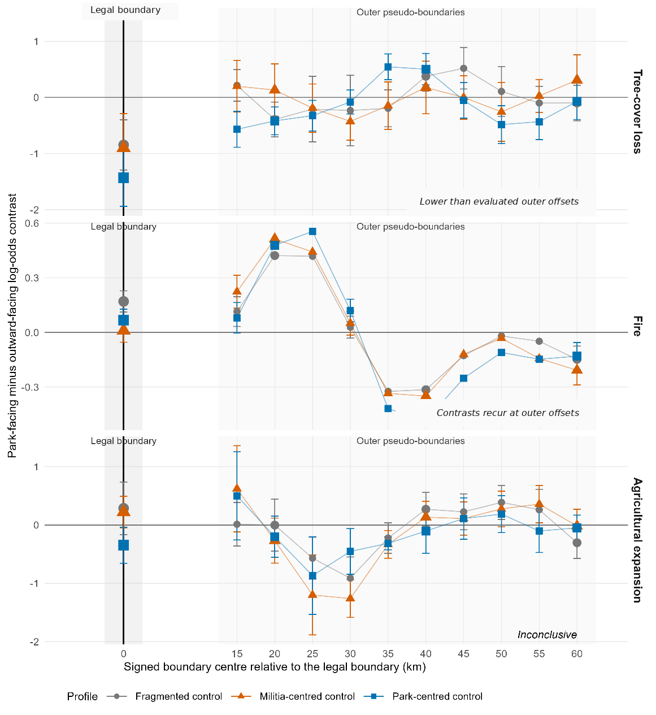
Figure 4. Outward boundary-location diagnostic. Profile-specific park-facing minus outward-facing log-odds contrasts are shown at the legal boundary and ten outward pseudo-boundaries (+15 to +60 km). Tree-cover-loss estimates at the legal line were more negative than all outward estimates; fire estimates fell within the outer range, including sign reversals; agriculture was unstable. Some outer fire points failed strict fit criteria and are shown without interpretable intervals. Temporal profile labels refer to Upemba’s chronology, not actor control at offsets. The one-sided, overlapping offsets are descriptive, not independent observations, a confidence interval, a randomised null, or a causal counterfactual (Table S14).

4. Discussion
At the primary 25% threshold, Upemba’s legal boundary aligned with lower tree-cover-loss odds under all three broad authority profiles, and each legal estimate was more negative than every evaluated outward estimate. The better-balanced 5 km corridor retained negative point estimates but supported only the park-centred interval; the sparse 50% threshold did not support the pattern. Fire varied among profiles yet recurred and reversed at outward offsets, and agriculture remained inconclusive. The empirical contribution is therefore specific: one operational tree-cover-loss contrast aligned unusually with the legal line across contrasting practical-authority configurations.
This cross-profile pattern illustrates environmental equifinality: one outcome can arise from several plausible configurations (Williams et al., 2020). Lower tree-cover-loss odds under militia-centred and park-centred control do not imply equivalent effects, identical mechanisms, conservation success under militia authority, or persistence within each episode. Profiles differed in actors, regulatory capacity, intentions, coercion, and legitimacy, while pairwise estimates did not show that one profile produced a stronger reduction. The outcome therefore cannot identify who produced it, why it arose, or whether the means were legitimate.
Process dependence helps explain the divergence. Substantial canopy removal is spatially fixed and often requires repeated access, labour, transport, and expected site persistence. A boundary may alter those conditions through patrol exposure, tenure uncertainty, customary recognition, infrastructure, or anticipated enforcement, even without uniform control. We could not distinguish cultivation, charcoal production, timber extraction, or other causes, so these remain hypotheses. Fire requires less permanence, can accompany mobile access, and responds strongly to fuel and weather. Upemba’s history supports hunting-related burning as one possible mechanism (Delvaux, 1950; Van Leeuwe et al., 2009), but FireCCI cannot identify hunting or poaching. Its lack of legal-boundary specificity points equally to wider fuel, livelihood, displacement, or access dynamics.
The pseudo-boundaries change attribution. Stratification reduced measured imbalance but could not show whether the legal line organised the residual contrast. Tree-cover-loss estimates at that line exceeded every evaluated outward estimate, strengthening location-specific spatial alignment within the sampled outer domain without proving a legal-protection effect or uniqueness around the full boundary. Fire contrasts recurred and reversed away from the park, showing how a legal-line analysis alone could over-attribute a regional pattern to protection. Pseudo-boundaries therefore ask whether the legal boundary is unusually aligned with an outcome, whereas matching or stratification asks whether comparison cells are similar.
Remote sensing cannot complete institutional, ecological, or normative attribution. It provides reproducible land-surface observations where insecurity disrupts field monitoring (Gohr et al., 2022; Fromont et al., 2024), but does not observe species responses, actors, motives, coercion, distributional effects, intent, or legitimacy. Historical sources narrow plausible interpretations yet privilege recorded actors and events. Community accounts, patrol information, ecological field data, and social investigation remain necessary to evaluate mechanism, biodiversity outcome, and legitimacy (Borrini-Feyerabend et al., 2013). The evidence is layered: satellites establish outcome, offsets assess spatial alignment, history characterises authority, and other evidence supports institutional and normative attribution.
This design extends protected-area evaluations that match or stratify inside and outside land by adding two separations often omitted: authority can change while the legal line remains fixed, and different disturbance processes need not respond similarly. In conflict research, the chronology avoids treating ‘conflict’ as a uniform treatment; in remote-sensing assessment, the offsets test whether a legal-line contrast merely reproduces broader spatial structure. Applications should reconstruct control at the finest defensible scale, fix coding before outcome inspection, archive source-level decisions, and use independent adjudication where feasible. The method is transferable precisely because it keeps chronology, measurement, and spatial diagnosis contestable rather than combining them into a governance score.
Future pressures could alter the pattern without changing legal status. Roads linked to mineral development, urban charcoal demand, and agricultural market integration lower transport costs and increase the profitability and permanence of clearing. Southeastern DRC already shows miombo loss associated with charcoal demand (Muteya et al., 2023), while proposed transport and lithium projects may connect remote parts of the Upemba landscape to markets (La Lettre du Continent, 2018; Zijin Mining Group, 2025). Monitoring should therefore track roads, charcoal supply chains, settlement, crop markets, biodiversity responses, and canopy loss rather than treat the present contrast as a durable institutional property.
Several limitations constrain inference. The study covers one protected area and two coarse strata with modest cluster separation; the 10 km design retained residual imbalance (maximum |SMD| 0.733), and sparse events were concentrated in the Depression. Profiles pool non-identical episodes and armed formations, simplify hybrid authority, and rest on incomplete, institutionally situated documents. Forty-four landscape-group years represent only 11 contiguous episodes, while the models do not explicitly resolve spatial or serial dependence; confidence intervals are conditional summaries. First-event outcomes do not describe subsequent land states. Annual cropland fractions support the separate diagnostics reported here, but threshold reversal does not demonstrate abandonment or recovery. Static Hansen gain cannot establish post-loss recovery (Supplementary Methods S7). The tree-cover-loss result weakened in the 5 km corridor and attenuated at the sparse 50% threshold. Recovered matched lag analyses check temporal alignment but cannot identify causal delays. The spatial bootstrap broadens agricultural uncertainty; primary fire and tree-loss intervals remain conditional on unmodelled dependence. Fire does not identify ignition cause, no outcome measures biodiversity directly, and the one-sided overlapping offsets diagnose only the evaluated outer domain.
Protected-area evaluation should separate five questions: what outcome occurred; whether the legal boundary is unusually aligned with it among evaluated alternatives; which institutions plausibly structured access; whether those actors pursued conservation; and whether their authority and practices were legitimate. In Upemba, primary tree-cover-loss odds were lower inside under all three profiles and the legal estimates were more negative than the outward offsets, whereas fire reflected broader spatial dynamics. This supports interpreting protected-area boundaries as historically contingent territorial institutions whose environmental expression must be evaluated in relation to practical authority and disturbance process. It does not convert a favourable land-surface pattern into evidence of biodiversity conservation effectiveness.

Data availability and declarations
Data and code availability. Source satellite products are available from the providers in Tables S1 and S16. Scripts, compact derived tables and reproducibility records are retained in the analytical repository. The repository is currently private; an anonymised reviewer-access route and a persistent public deposit must be confirmed before submission. Restricted historical documents require rights-holder permission and appropriate security safeguards; Table S6 identifies the evidence used.
Ethics statement. This study collected no new human-participant or animal data; it used remotely sensed products and documentary sources.

Declaration of generative AI and AI-assisted technologies in the manuscript preparation process
During preparation, ChatGPT and Codex (OpenAI) assisted with structural and language revision, code correction, reproducibility checks and generation of data-derived plots. Author review, editing, verification and responsibility for the final article must be confirmed before submission.

References
Andam, K.S., Ferraro, P.J., Pfaff, A., Sánchez-Azofeifa, G.A., Robalino, J.A., 2008. Measuring the effectiveness of protected area networks in reducing deforestation. Proceedings of the National Academy of Sciences 105, 16089–16094. https://doi.org/10.1073/pnas.0800437105
Archibald, S., Nickless, A., Govender, N., Scholes, R.J., Lehsten, V., 2010. Climate and the inter-annual variability of fire in southern Africa: a meta-analysis using long-term field data and satellite-derived burnt area data. Global Ecology and Biogeography 19, 794–809. https://doi.org/10.1111/j.1466-8238.2010.00568.x
Bassett, T.J., Gautier, D., 2014. Regulation by territorialization: the political ecology of conservation and development territories. EchoGéo 29. https://doi.org/10.4000/echogeo.14038
Borrini-Feyerabend, G., Dudley, N., Jaeger, T., Lassen, B., Pathak Broome, N., Phillips, A., Sandwith, T., 2013. Governance of Protected Areas: From Understanding to Action. Best Practice Protected Area Guidelines Series No. 20. IUCN, Gland.
Brooks, M.E., Kristensen, K., van Benthem, K.J., Magnusson, A., Berg, C.W., Nielsen, A., Skaug, H.J., Mächler, M., Bolker, B.M., 2017. glmmTMB balances speed and flexibility among packages for zero-inflated generalized linear mixed modeling. The R Journal 9, 378–400. https://doi.org/10.32614/RJ-2017-066
Chuvieco, E., Pettinari, M.L., Lizundia-Loiola, J., Storm, T., Padilla Parellada, M., 2018. ESA Fire Climate Change Initiative (Fire_cci): MODIS Fire_cci Burned Area Pixel product, version 5.1. https://doi.org/10.5285/58f00d8814064b79a0c49662ad3af537
Daskin, J.H., Pringle, R.M., 2018. Warfare and wildlife declines in Africa’s protected areas. Nature 553, 328–332. https://doi.org/10.1038/nature25194
Delvaux, H., 1950. L’occupation du Katanga 1891–1900: Notes et souvenirs du seul survivant. Imbelco, Elisabethville.
de Merode, E., Smith, K.H., Homewood, K., Pettifor, R., Rowcliffe, M., Cowlishaw, G., 2007. The impact of armed conflict on protected-area efficacy in Central Africa. Biology Letters 3, 299–301. https://doi.org/10.1098/rsbl.2007.0010
Duffy, R., Massé, F., Smidt, E., Marijnen, E., Büscher, B., Verweijen, J., Ramutsindela, M., Simlai, T., Joanny, L., Lunstrum, E., 2019. Why we must question the militarisation of conservation. Biological Conservation 232, 66–73. https://doi.org/10.1016/j.biocon.2019.01.013
Fromont, C., Carrière, S.M., Bédécarrats, F., Razafindrakoto, M., Roubaud, F., 2024. Long-term socio-environmental monitoring of protected areas is a persistent weak point in developing countries: literature review and recommendations. Biological Conservation 290, 110434. https://doi.org/10.1016/j.biocon.2023.110434
Gaynor, K.M., Fiorella, K.J., Gregory, G.H., Kurz, D.J., Seto, K.L., Withey, L.S., Brashares, J.S., 2016. War and wildlife: linking armed conflict to conservation. Frontiers in Ecology and the Environment 14, 533–542. https://doi.org/10.1002/fee.1433
Geldmann, J., Barnes, M., Coad, L., Craigie, I.D., Hockings, M., Burgess, N.D., 2013. Effectiveness of terrestrial protected areas in reducing habitat loss and population declines. Biological Conservation 161, 230–238. https://doi.org/10.1016/j.biocon.2013.02.018
Geldmann, J., Manica, A., Burgess, N.D., Coad, L., Balmford, A., 2019. A global-level assessment of the effectiveness of protected areas at resisting anthropogenic pressures. Proceedings of the National Academy of Sciences 116, 23209–23215. https://doi.org/10.1073/pnas.1908221116
Ghoddousi, A., Loos, J., Kuemmerle, T., 2022. An outcome-oriented, social–ecological framework for assessing protected area effectiveness. BioScience 72, 201–212. https://doi.org/10.1093/biosci/biab114
Gohr, C., von Wehrden, H., May, F., Ibisch, P.L., 2022. Remotely sensed effectiveness assessments of protected areas lack a common framework: a review. Ecosphere 13, e4053. https://doi.org/10.1002/ecs2.4053
Gorelick, N., Hancher, M., Dixon, M., Ilyushchenko, S., Thau, D., Moore, R., 2017. Google Earth Engine: planetary-scale geospatial analysis for everyone. Remote Sensing of Environment 202, 18–27. https://doi.org/10.1016/j.rse.2017.06.031
Gray, C.L., Hill, S.L.L., Newbold, T., Hudson, L.N., Börger, L., Contu, S., Hoskins, A.J., Ferrier, S., Purvis, A., Scharlemann, J.P.W., 2016. Local biodiversity is higher inside than outside terrestrial protected areas worldwide. Nature Communications 7, 12306. https://doi.org/10.1038/ncomms12306
Hansen, M.C., Potapov, P.V., Moore, R., Hancher, M., Turubanova, S.A., Tyukavina, A., Thau, D., Stehman, S.V., Goetz, S.J., Loveland, T.R., Kommareddy, A., Egorov, A., Chini, L., Justice, C.O., Townshend, J.R.G., 2013. High-resolution global maps of 21st-century forest cover change. Science 342, 850–853. https://doi.org/10.1126/science.1244693
Hasson, M., 2015. Katanga: Des animaux et des hommes. Musée royal de l’Afrique centrale, Tervuren.
Holmes, G., 2014. Defining the forest, defending the forest: political ecology, territoriality, and resistance to a protected area in the Dominican Republic. Geoforum 53, 1–10. https://doi.org/10.1016/j.geoforum.2014.01.015
Joppa, L.N., Pfaff, A., 2009. High and far: biases in the location of protected areas. PLOS ONE 4, e8273. https://doi.org/10.1371/journal.pone.0008273
Kelly, L.T., Giljohann, K.M., Duane, A., Aquilué, N., Archibald, S., Batllori, E., Bennett, A.F., Buckland, S.T., Canelles, Q., Clarke, M.F., Fortin, M.-J., Hermoso, V., Herrando, S., Keane, R.E., Lake, F.K., McCarthy, M.A., Morán-Ordóñez, A., Parr, C.L., Pausas, J.G., Penman, T.D., Regos, A., Rumpff, L., Santos, J.L., Smith, A.L., Syphard, A.D., Tingley, M.W., Brotons, L., 2020. Fire and biodiversity in the Anthropocene. Science 370, eabb0355. https://doi.org/10.1126/science.abb0355
Kerner, H., Nakalembe, C., Yang, A., Zvonkov, I., McWeeny, R., Tseng, G., Becker-Reshef, I., 2024. How accurate are existing land cover maps for agriculture in Sub-Saharan Africa? Scientific Data 11, 486. https://doi.org/10.1038/s41597-024-03306-z
La Lettre du Continent, 2018. Le lithium de Manono arrivera-t-il un jour à Lubumbashi par la route? Africa Intelligence, 6 November 2018. https://www.africaintelligence.fr/afrique-centrale/2018/11/06/le-lithium-de-manono-arrivera-t-il-un-jour-a-lubumbashi-par-la-route,108330905-art (accessed 28 June 2026).
Lou, Z., Peng, D., Shi, Z., Wang, H., Liu, K., Zhang, Y., Yan, X., Chen, Z., Ye, S., Yu, L., Hu, J., Lv, Y., Peng, H., Zhang, Y., Zhang, B., 2025. AFCD: An Annual Cropland Extent Dataset for Africa at 30 m spatial resolution from 2000 to 2022. https://doi.org/10.5281/zenodo.14920706
Lunstrum, E., 2014. Green militarization: anti-poaching efforts and the spatial contours of Kruger National Park. Annals of the Association of American Geographers 104, 816–832. https://doi.org/10.1080/00045608.2014.912545
MacKinnon, J.G., White, H., 1985. Some heteroskedasticity-consistent covariance matrix estimators with improved finite sample properties. Journal of Econometrics 29, 305–325. https://doi.org/10.1016/0304-4076(85)90158-7
Marijnen, E., Verweijen, J., 2016. Selling green militarization: the discursive (re)production of militarized conservation in the Virunga National Park, Democratic Republic of the Congo. Geoforum 75, 274–285. https://doi.org/10.1016/j.geoforum.2016.08.003
McNicol, I.M., Keane, A., Burgess, N.D., Bowers, S.J., Mitchard, E.T.A., Ryan, C.M., 2023. Protected areas reduce deforestation and degradation and enhance woody growth across African woodlands. Communications Earth & Environment 4, 392. https://doi.org/10.1038/s43247-023-01053-4
Muteya, H.K., N’Tambwe Nghonda, D.-D., Kalenda, F.M., Strammer, H., Kankumbi, F.M., Malaisse, F., Bastin, J.-F., Sikuzani, Y.U., Bogaert, J., 2023. Mapping and quantification of miombo deforestation in the Lubumbashi charcoal production basin (DR Congo): spatial extent and changes between 1990 and 2022. Land 12, 1852. https://doi.org/10.3390/land12101852
Nikis, N., 2021. Upemba Depression. In: Potts, D.T., Harkness, E., Neelis, J., McIntosh, R. (Eds.), The Encyclopedia of Ancient History: Asia and Africa. John Wiley & Sons. https://doi.org/10.1002/9781119399919.eahaa006292
Olofsson, P., Foody, G.M., Herold, M., Stehman, S.V., Woodcock, C.E., Wulder, M.A., 2014. Good practices for estimating area and assessing accuracy of land change. Remote Sensing of Environment 148, 42–57. https://doi.org/10.1016/j.rse.2014.02.015
Pekel, J.-F., Cottam, A., Gorelick, N., Belward, A.S., 2016. High-resolution mapping of global surface water and its long-term changes. Nature 540, 418–422. https://doi.org/10.1038/nature20584
République du Zaïre, 1975. Ordonnance no. 75-241 du 22 juillet 1975 relative à la délimitation du Parc national de l’Upemba et au régime applicable dans son périmètre. Leganet. https://www.leganet.cd/Legislation/Droit%20administratif/Environnement/O.75.241.22.07.1975.htm (accessed 19 July 2026).
R Core Team, 2026. R: A language and environment for statistical computing. R Foundation for Statistical Computing, Vienna. https://www.R-project.org/.
Van Leeuwe, H., Henschel, P., Pélissier, C., Moyer, D., 2009. Recensement des grands mammifères et impacts humains: Parcs Nationaux de l’Upemba et de Kundelungu, République Démocratique du Congo. ICCN/WCS/USFWS/Panthera.
Williams, T.G., Guikema, S.D., Brown, D.G., Agrawal, A., 2020. Assessing model equifinality for robust policy analysis in complex socio-environmental systems. Environmental Modelling & Software 134, 104831. https://doi.org/10.1016/j.envsoft.2020.104831
Zijin Mining Group, 2025. Manono Northeast Lithium Exploration Project. Zijin Mining Group Co., Ltd. https://www.zijinmining.com/global/program-detail-71798.htm (accessed 28 June 2026).

