A protected-area boundary separates tree-cover loss but not fire under fragmented territorial control
Supplementary Material

Supplementary Methods
All analyses used the canonical 500 m grid and land mask. Socio-ecological system units, disturbance-event construction, territorial-control chronology, and boundary-permeability models follow the reproducible scripts and tabular outputs distributed with this repository.
Transition-year and episode-omission diagnostics are reported in Table S13 only. The former historical diagnostic figure is not part of the final supplementary figure sequence.
The final supplementary figures are Figure S1 (clustering diagnostics), Figure S2 (threshold and spatial-domain sensitivities), and Figure S3 (pairwise pseudo-boundary diagnostic).

Supplementary Tables
Tables S1-S18 are distributed as CSV files in outputs/publication/supplement/tables. Table S13 is reproduced below because it records the complete transition-year and episode-omission diagnostic summary.
Supplementary table | CSV file
Table S01 | outputs/publication/supplement/tables/Table_S01_landscape_comparison_covariates.csv
Table S02 | outputs/publication/supplement/tables/Table_S02_clustering_solution_selection.csv
Table S03 | outputs/publication/supplement/tables/Table_S03_clustering_stability_and_accessibility_sensitivity.csv
Table S04 | outputs/publication/supplement/tables/Table_S04_spatial_design_balance_and_event_support.csv
Table S05 | outputs/publication/supplement/tables/Table_S05_landscape_group_and_side_support.csv
Table S06 | outputs/publication/supplement/tables/Table_S06_territorial_control_chronology.csv
Table S07 | outputs/publication/supplement/tables/Table_S07_profile_and_episode_support.csv
Table S08 | outputs/publication/supplement/tables/Table_S08_primary_profile_specific_contrasts.csv
Table S09 | outputs/publication/supplement/tables/Table_S09_primary_pairwise_profile_differences.csv
Table S10 | outputs/publication/supplement/tables/Table_S10_weighted_and_unweighted_sparse_outcome_models.csv
Table S11 | outputs/publication/supplement/tables/Table_S11_threshold_sensitivity.csv
Table S12 | outputs/publication/supplement/tables/Table_S12_spatial_domain_sensitivity.csv
Table S13 | outputs/publication/supplement/tables/Table_S13_landscape_transition_and_episode_diagnostics.csv
Table S14 | outputs/publication/supplement/tables/Table_S14_fire_optimizer_diagnostics.csv
Table S15 | outputs/publication/supplement/tables/Table_S15_actual_and_pseudo_boundary_profile_contrasts.csv
Table S16 | outputs/publication/supplement/tables/Table_S16_boundary_specificity_classifications.csv
Table S16 | outputs/publication/supplement/tables/Table_S16_pseudo_boundary_pairwise_differences.csv
Table S17 | outputs/publication/supplement/tables/Table_S17_measurement_and_validation_decisions.csv
Table S18 | outputs/publication/supplement/tables/Table_S18_reproducibility_environment_and_authoritative_inputs.csv

Table S13. Transition-year and episode-omission diagnostics.
These complete-landscape diagnostics use an earlier sparse-outcome implementation and are not direct replications of the primary 10 km models. The table reports the reference estimate and the full range across all valid transition-year and episode-omission scenarios. Sign retention indicates whether all valid scenario estimates retained the non-zero sign of the reference estimate.
Outcome | Profile | Valid scenarios | Reference estimate | Minimum | Maximum | Sign retained
Agricultural expansion | Fragmented control | 38 | 0.50123627669277 | -0.0927003302797806 | 0.587906047861677 | No
Agricultural expansion | Militia-centred control | 38 | 0.121886108403553 | -0.515635641304756 | 0.353183059874765 | No
Agricultural expansion | Park-centred control | 38 | -0.521259435317188 | -16.2754905875838 | -0.413845538944505 | Yes
Fire | Fragmented control | 38 | -0.0313746932894314 | 0.104061398591442 | 0.341067627848715 | No
Fire | Militia-centred control | 38 | -0.167613478684898 | -0.0386335511946995 | 0.196260477897935 | No
Fire | Park-centred control | 38 | -0.216156094535368 | -0.0958630009348002 | 0.347743349175818 | No
Tree-cover loss | Fragmented control | 38 | -0.742989646378223 | -1.45640747888402 | -0.774579691463316 | Yes
Tree-cover loss | Militia-centred control | 38 | -1.77110834177277 | -2.47374687775203 | -1.05314432047023 | Yes
Tree-cover loss | Park-centred control | 38 | -2.590601861582 | -4.50034497625592 | -2.54481505864252 | Yes

Supplementary Figures

Figure S1. Clustering diagnostics.
Mean silhouette profiles, no-accessibility comparison, and agreement metrics.
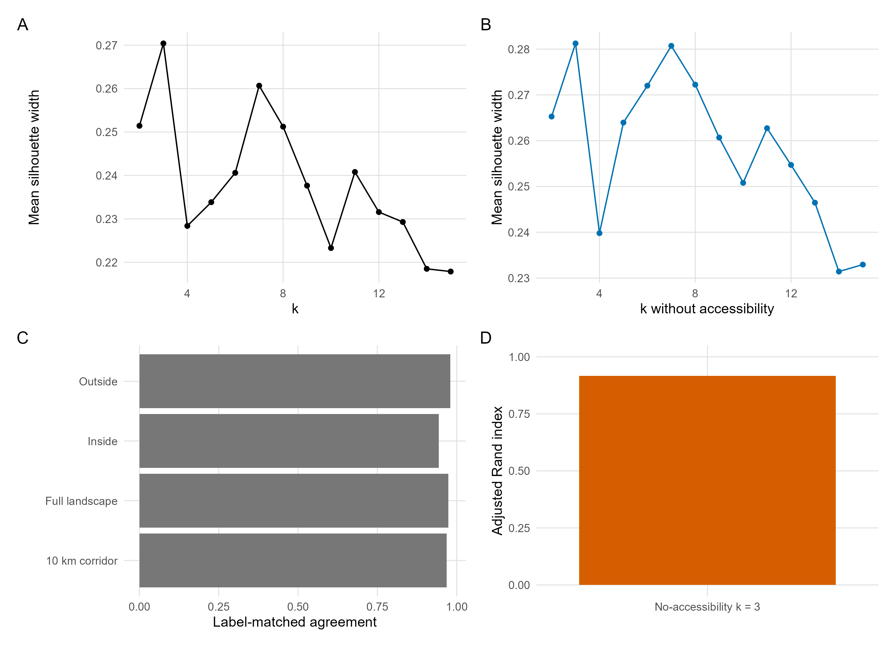

Figure S2. Threshold and spatial-domain sensitivities.
Profile-specific contrasts across thresholds and spatial domains; the 25% / 10 km row is the primary specification and muted points indicate non-strict fire fits.
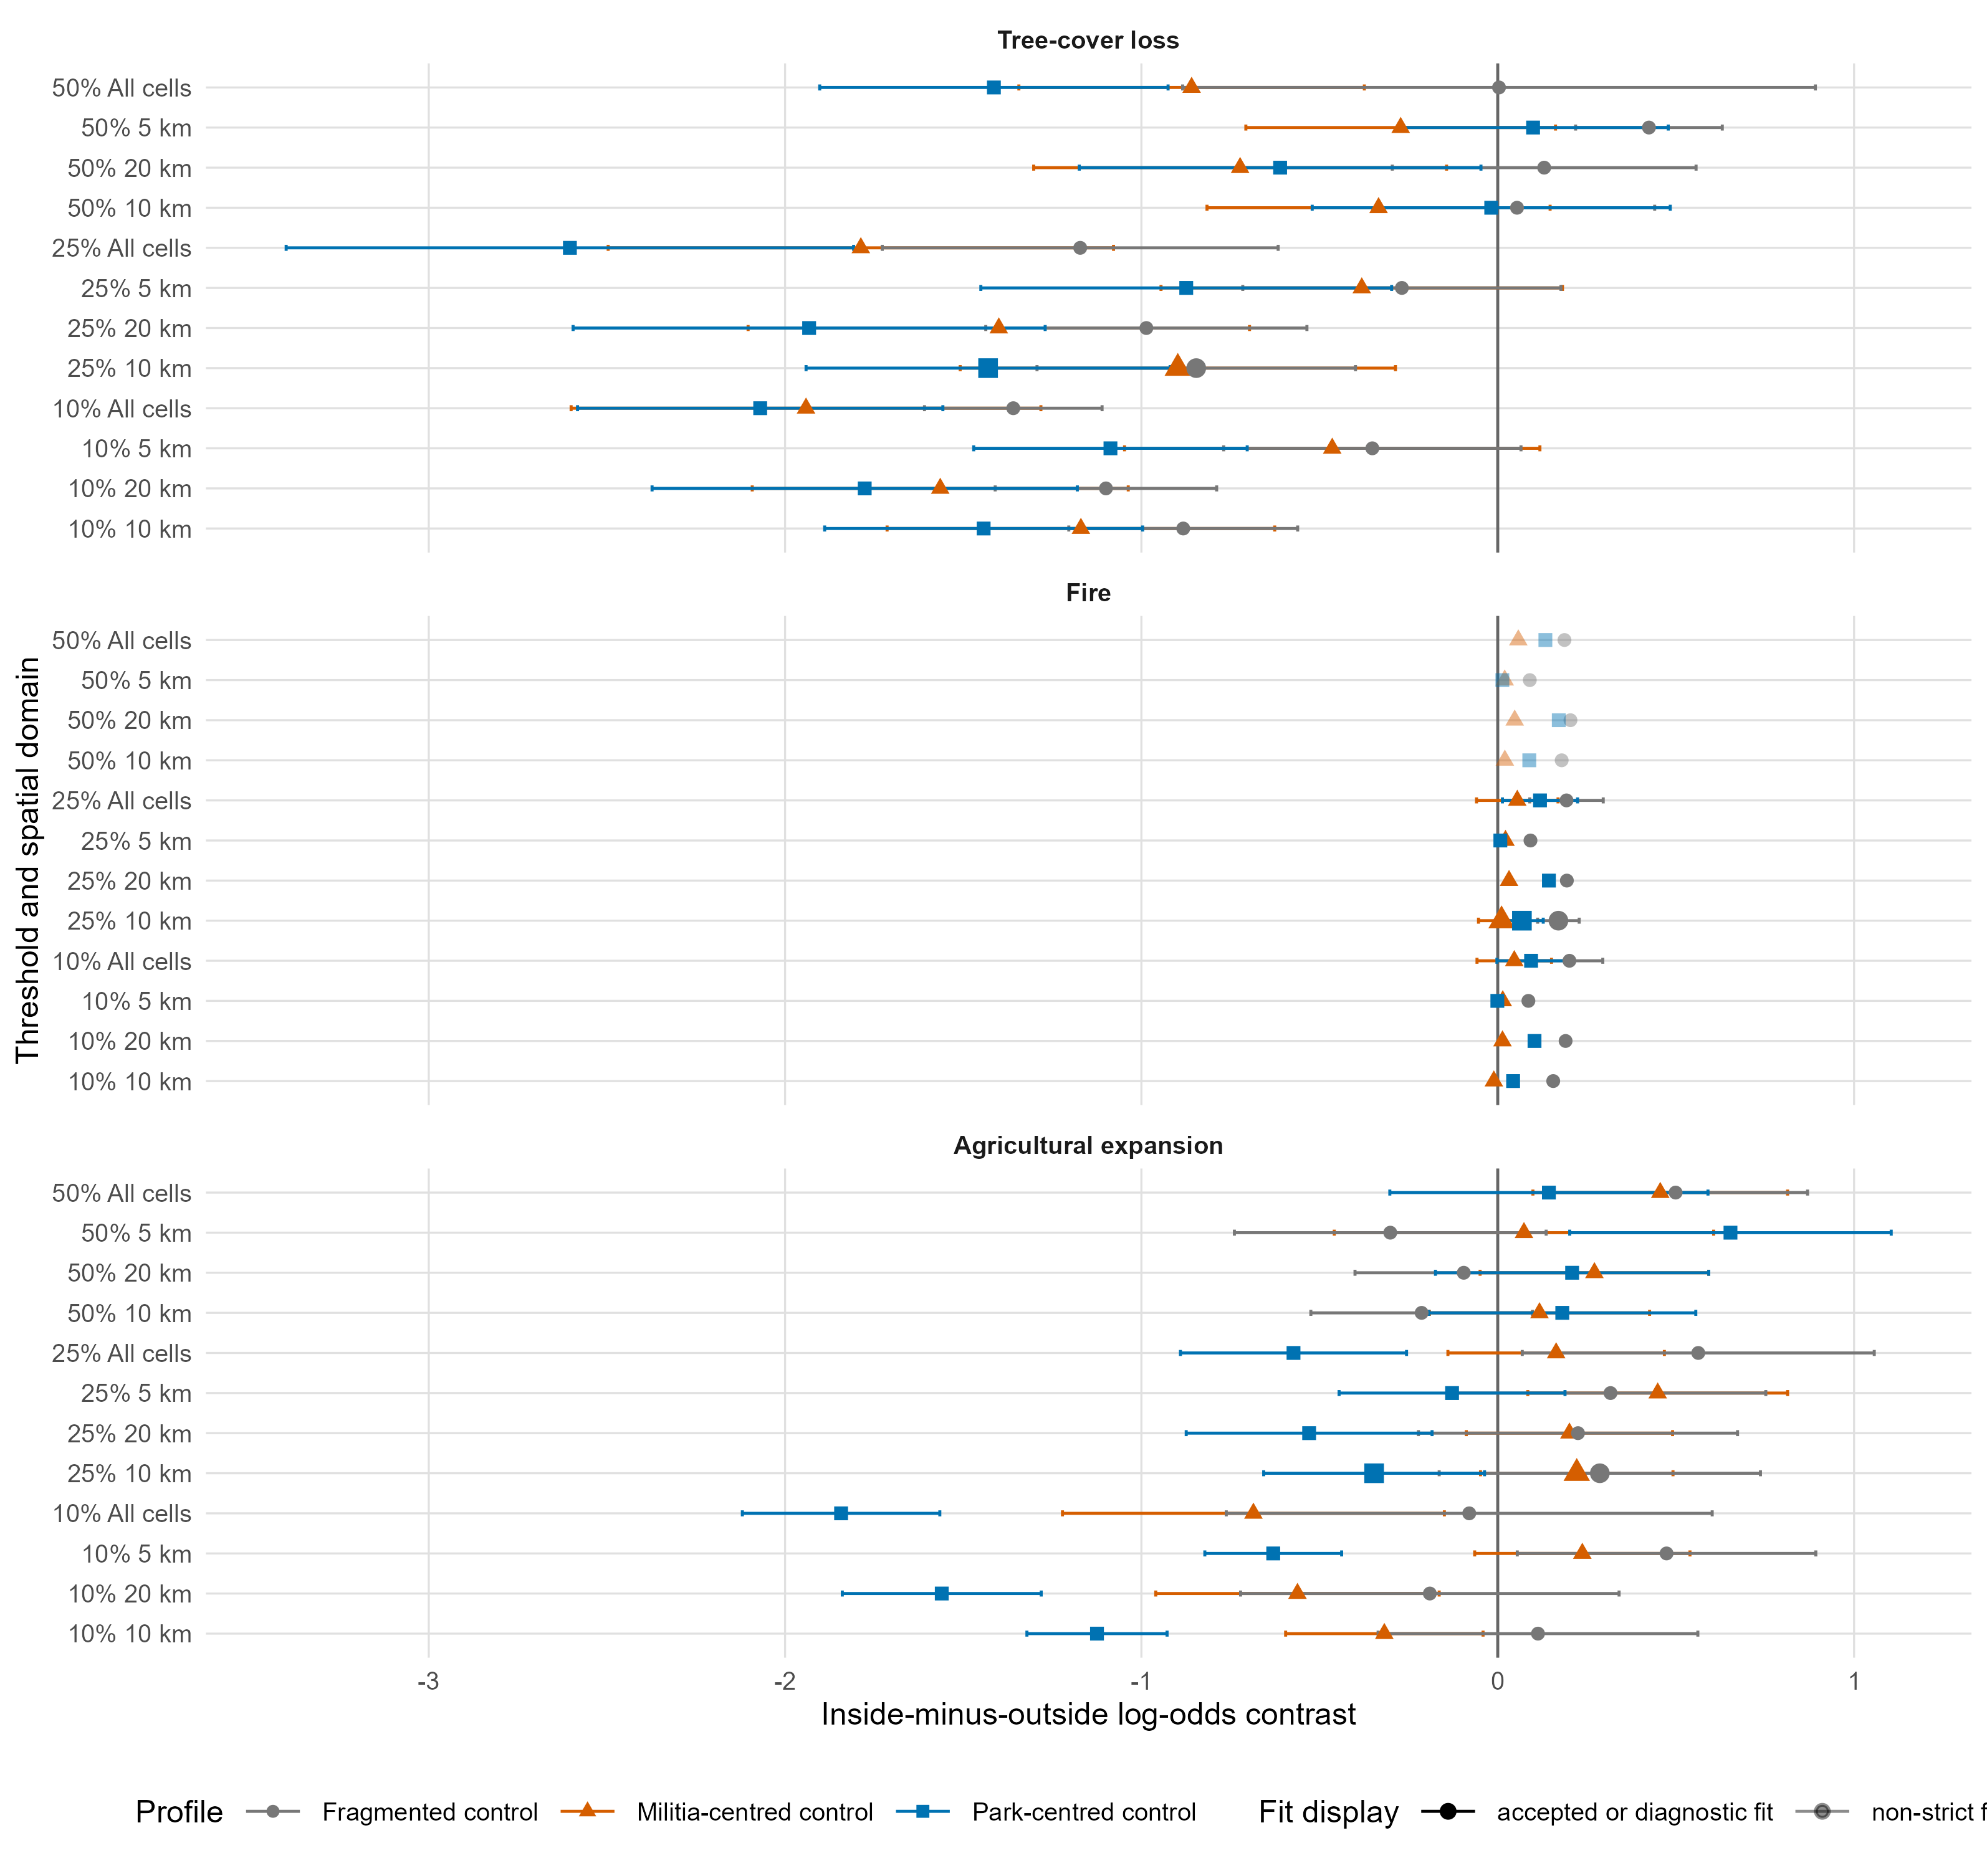

Figure S3. Pairwise pseudo-boundary diagnostic.
Pairwise differences are shown at the legal boundary, supported inner checks, and outer pseudo-boundaries. Filled symbols denote accepted or strict-valid estimates; open symbols denote finite non-strict fire fits or sparse estimates with limited support.
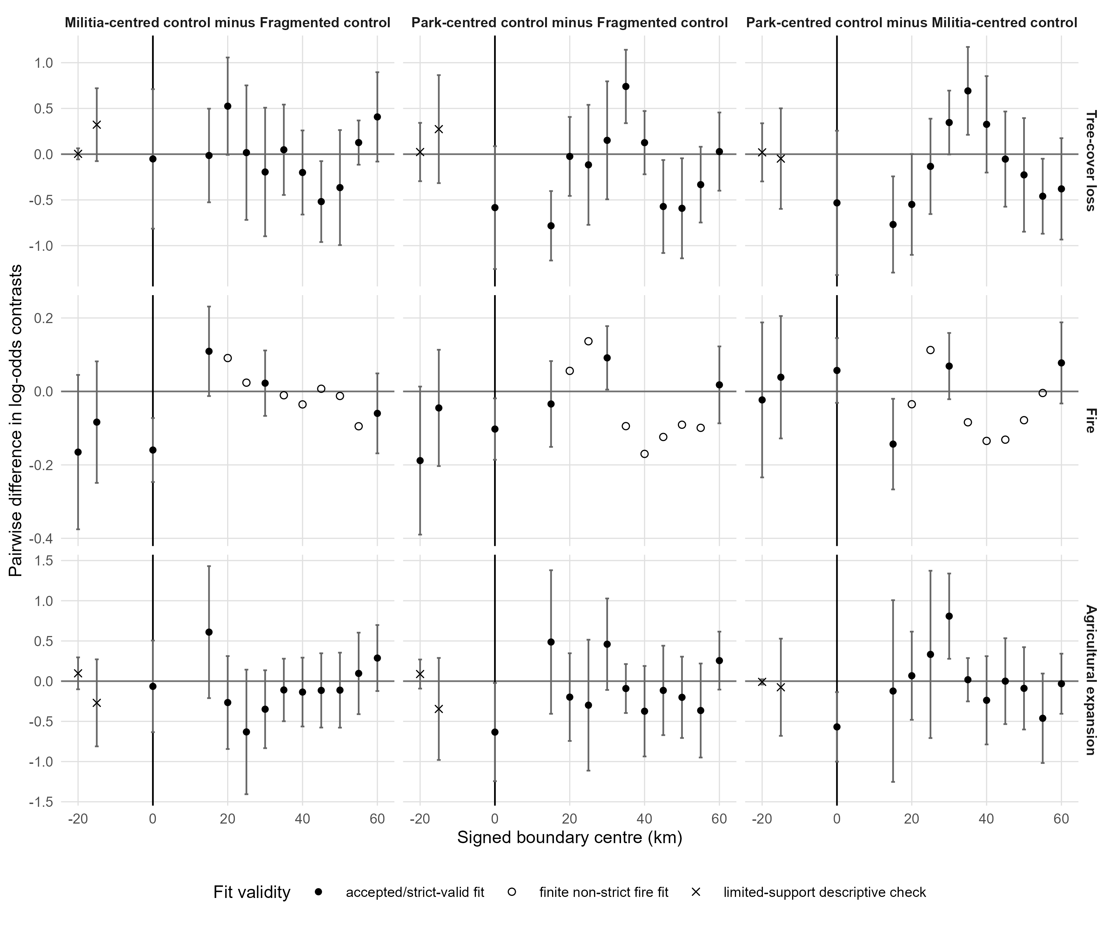

Supplementary Source Data
Supplementary source data are distributed in outputs/publication/supplement/source_data and the main figure/table source-data directories. Restricted raw evidence and large raw geospatial inputs are not included in this repository.

