ER Diagram:

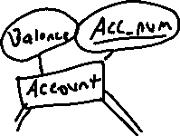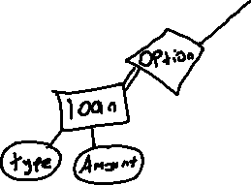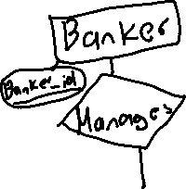

Relational database schema:

**Customer**



|  |  |  |  |  |
| --- | --- | --- | --- | --- |
| **Name** | **Address** | **Phone** | **Cust_ID** | **Branch_no** |

**Account**



|  |  |  |
| --- | --- | --- |
| **Balance** | **Acc-num** | **Cust_ID** |

**Loan**



|  |  |  |  |  |
| --- | --- | --- | --- | --- |
| **Amount** | **Type** | **Loan_id** | **Branch_no** | **Acc_num** |



**Branch**

|  |  |  |
| --- | --- | --- |
| **Name** | **Location** | **Branch_no** |

**Transaction**

|  |  |  |  |
| --- | --- | --- | --- |
| **ID** | **Acc_num** | **Amount** | **Date** |

Application program design:

Function1: Customer_withdraw

//This function allows customers to access the balance from the **account** table and subtract from their balance.

Input: Cust_ID, Acc_num, Amount

Steps:

1)Check Cust_ID provided in the Customer table

2)Access Account based on Acc_num

3)Retrieve and display balance information

4)Subtract Amount from current balance

5)Display new balance information

Function2: Loan_Withdraw

//This function allows customers to take out a loan, this will instantiate a loan tuple and will access the customer and loan table

Input: Acc_Num, loanType,LoanAmount

1)Check Cust_ID provided in the Customer table

2)Create new Loan tuple

3)Update Loan type with input LoanType and update loan amount with LoanAmount

4)Create new loan_id

5)Display Loan table

Function3: Customer_info_update

//This function allows users to update their Customer information by accessing the customer table

Input: Cust_id , Name, address, phone

1. Check Cust_ID provided in the Customer table
2. Update Customer Name with name provided in input
3. Update Customer address with address provided in input
4. Update Customer phone with phone number provided in input
5. Display updated customer table

Function4: New_loan

//This function uses the branch table to enable new loans being created

Input:Branch_num, Type, Amount

1)Check Branch_num provided in Branch table

2)Create new Loan tuple

3)Update Type information with input type

4)Update Amount information with input amount

5)Display new loan table