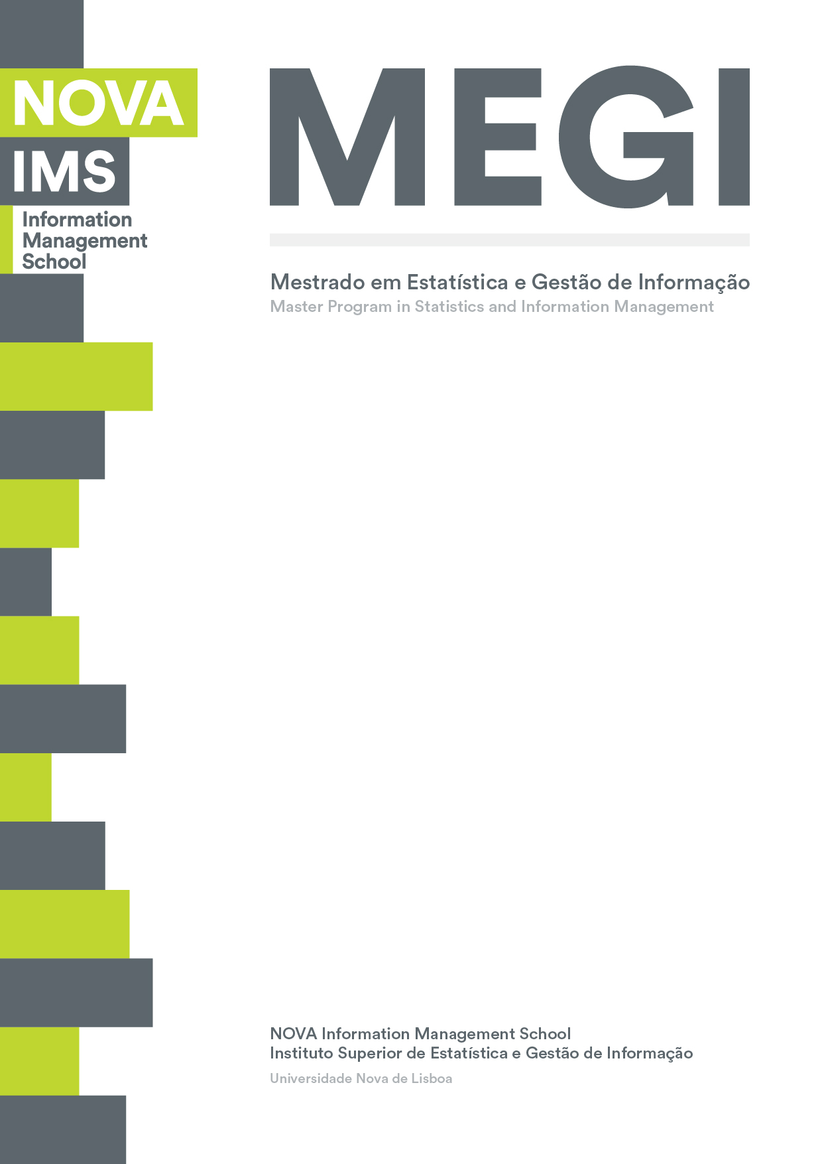

**BUSINESS CASES WITH DATA SCIENCE**

**MASTER’S DEGREE PROGRAM IN DATA SCIENCE AND ADVANCED ANALYTICS – MAJOR IN DATA SCIENCE**

**Business Case 1 – Wonderful Wines of the World**

Group H

Hiromi Nakashima, m20201025

Manuel A. F. Carreiras, m20200500

Luis F. R. Agottani, m202000621

Venâncio Munhangane, m20200579

February, 2021

THIS IS JUST AN EXAMPLE OF THE INDEX. FEEL FREE TO CHANGE THE STRUCTURE

TABLE OF coNtenTs

1. INTRODUCTION 1

2. BUSINESS UNDERSTANDING 2

2.1. Business Objectives 2

2.2. Business Success criteria 2

2.3. Determine Data Mining goals 2

3. PREDICTIVE ANALYTICS PROCESS 3

3.1. Data understanding 3

3.2. Data preparation 3

3.3. Modeling 4

3.4. Evaluation 4

4. RESULTS EVALUATION 6

5. CONCLUSIONS 7

5.1. Considerations for model improvement 7

6. REFERENCES 8

7. APPENDIX (OPTIONAL) 10

FigureS iNDEX

Figure 1 - Variable Information 3

Figure 2 - Data preparation process 4

Figure 3 - Clusters Distribution over RFM classes 4

Table INDEX

Table 1 - Data Mining Goals 2

# 

# INTRODUCTION

This project we were designated to analyze a wine company’s dataset named Wonderful Wines of the World (WWW). WWW is a 7-year-old enterprise, which sells wine through three channels: catalogs, web site and physical stores (10 branches). The purchase can be done in the physical stores, telephone or online.

At this moment, WWW keep clients engaged by sending them a newsletter with the updates of wine world. Despite the fact that the database of WWW has only 4-year-old, the company recently organized a marketing activity which aggressively increased the data volume. One of the current pain points is a lack of cross selling strategies which supports the trade profit.

This project was developed with 10.000 samples of the current WWW’s customers database that purchased in the last 18 months. The report was adjusted in four main parts based in CRISP-DM methodology [CRISP-DM ARTICLE].

# BUSINESS UNDERSTANDING

At this stage we defined the essential business guidelines to grant a good result of the project. In order to develop the best solution to WWW the business understanding was based on the current reality of the company presented at the introduction.

## Business Objectives

The goals of WWW are:

* Improve the familiarity of the database by creating a classification for each client and develop marketing strategies by profile;
* Be able to classify new customers;
* Improve the Return on Investment (ROI) by understanding the client value.

## Business Success criteria

Based on the business objectives description, two main results were defined to guarantee the success of this project: identify the profile of the new customers since the first purchase, develop marketing strategies to reach all market segments and improve the trading profit.

## Determine Data Mining goals

Based on the business goals we converted to Data Mining language as shown in the table below Table 1 - Data Mining Goals

|  |  |
| --- | --- |
| Business Goal | Data Mining Goal |
| Classify the currently clients by profile | Clustering the clients |
| Ranking the clients to understand the ROI | Apply the recency, frequency and monetary value (RFM) |
| Identify the new customer profile | Apply a predictive model |

# PREDICTIVE ANALYTICS PROCESS

## Data understanding

The initial process of understanding the problem was explained in the introduction and data structure (Figure X/METADATA PRINT). 30 columns and 10001 entries were identified, all of them represented by numeric features. After a better understanding of the metadata and the features, we recognized that 10 features were binary then we converted them to Boolean type. Also, on this step some columns were drop due to its insignificance for the project (Data Exploration, Notebook Reference)

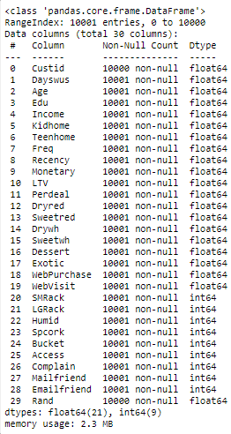

Figure 1 – Variable Information

## Data preparation

The diagram below presents the data preparation steps followed to reach the final model in this project (Figure X).

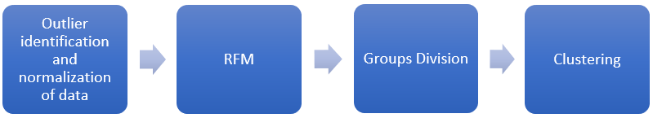

Figure 2 - Data preparation process

Firstly, we identified the outliers and normalized the data. Subsequently were develop a RFM analysis to classify the value of each customer, by this classification we reached to 5 clusters which the client quality. After we clustered the clients by groups to reach a better profile clustering of the client. The result is presented below (Figure X).

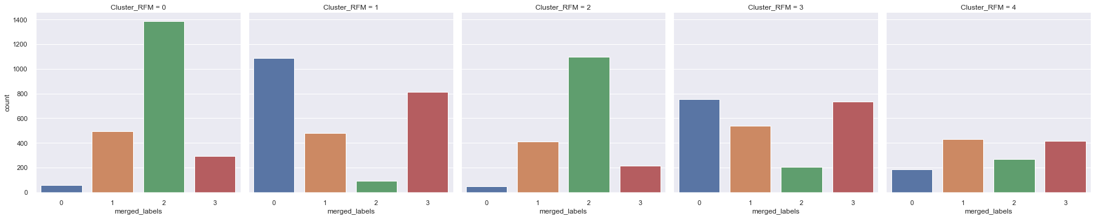

Figure 3 - Clusters Distribution over RFM classes

## Modeling

Bla, bla.

## Evaluation

Results described in technical terms (e.g., reached an Accuracy of 95%).

# RESULTS EVALUATION

Describe the degree to which the model meets the business objectives. If that cannot be done without the application of the model in a real environment, describe how could that be done.

Assess the data mining results in respect to the business success criteria.

# CONCLUSIONS

Final remarks on the project.

## Considerations for model improvement

Bla, Bla

# REFERENCES

Author, A. A., Author, B. B., & Author, C. C. (Year). Title of article. *Title of Periodical, volume number* (issue number), pages.

# APPENDIX (OPTIONAL)