VS Studio for Python

in the Azure Cloud — in 3 Steps
A beginner's tutorial · CGS · no experience needed.

Manuel A. Figallo
Statistical Programmer IV and Analyst · CGS
Version 2.0
Last updated 16 September 2026

Document control
Every change to this tutorial is recorded below. Check the version on the cover against the newest row here before you follow it — the screens in VS Code change, and so does this document.
Date | Version | Changed by | Description of the change
16 Sep 2026 | 2.0 | Manuel A. Figallo | Added cover page, document control, contents, terminology (IDE), a Next Steps section on import statements and cgs_ai, and a conclusion.
11 Sep 2026 | 1.0 | Manuel A. Figallo | First issued. Introduction, Steps 1-3 with screenshots, troubleshooting.

To propose a change, contact Manuel A. Figallo. Please quote the version number on the cover.

Contents
Document control 2
Contents 3
Introduction 4
Terminology — the five words used throughout 5
Step 1 — Prepare your folder 6
Step 2 — Learn two definitions and three rules 7
Step 3 — Write and run your first program 8
If something goes wrong 12
Next Steps — import, and the cgs_ai package 13
Conclusion 15

HOW TO USE THIS TUTORIAL
Work through Steps 1, 2 and 3 in order, at a computer.
Every action is numbered and has a picture of what you should see.
Next Steps is optional on the first pass — come back to it once the three steps feel easy.

Introduction
By the end of this tutorial you will have written and run a Python program, saved in the Azure cloud, on your own machine. It takes about fifteen minutes, and assumes you have never programmed.

Why is Python so important?
It is the language CMS uses. The Centers for Medicare and Medicaid Services use Python throughout, so sharing work with them means reading Python.
It is the common language of data science. Whatever the specialism, the examples and the answers online are written in Python.
It is already inside the tools you use. Excel and Power BI both run Python now, so it extends software you already have open.
It is free, and it is everywhere. No licence to request, and the skill moves with you between teams and jobs.

Why Visual Studio Code?
Python is the language. Visual Studio Code — "VS Code" — is where you write it. You could use Notepad, but VS Code gives you four things Notepad cannot:
• Write and run in one window — editor on top, terminal underneath.
• It understands Python: keywords are coloured and typos are underlined before you run anything.
• It opens your cloud folder directly, leaving the files in OneDrive.
• It is what the rest of the team uses, so instructions match your screen.

WHAT YOU NEED BEFORE YOU START
A CGS Windows machine with Visual Studio Code installed.
Your OneDrive account signed in — the cloud icon in the taskbar.
That is all. Python itself is already on the machine.

Terminology — the five words used throughout
Five words come up again and again. None of them are complicated, and knowing them makes the rest of this tutorial read easily.
IDE, or "coding environment"
One program that gives you everything you need to write code in a single window: somewhere to type it, somewhere to run it, and help spotting mistakes. VS Code is an IDE. Word is where you write documents; an IDE is where you write programs.
Python
The language you write in. A file of Python is just text, which is why any editor can open it — but an IDE understands it.
Script, or program
One file of Python instructions, ending in .py. Yours will be hello_world.py.
Terminal
The panel at the bottom of VS Code where you type commands and where your program's output appears. It is how you RUN what you wrote.
Package, or library
Somebody else's code, bundled up so you can use it without writing it again. cgs_ai is ours.
THE ONE TO REMEMBER
IDE = coding environment = VS Code.
If somebody says "open your IDE", they mean open VS Code.

STEP 1 Prepare your folder

GOAL
Understand where VS Code keeps your work, and make the one folder this tutorial uses.

A note about storage
Your code has to live somewhere. Save it to your laptop's hard disk and it exists in exactly one place. We are going to use OneDrive instead — the Azure cloud — for four reasons:
It future-proofs the code base. Work saved in the cloud outlives the machine it was written on.
You get 100 GB, reachable anywhere. From any CGS machine you sign in to, without copying anything.
It is backed up, and it is reliable. Previous versions can be restored. A local folder has neither.
It is shareable. A colleague can be given the folder. No zipping, no emailing.
1.1 Open File Explorer and go to your OneDrive folder.
1.2 Create this folder path inside it, one folder at a time: code, then python, then tests.
C:\Users\<your-id>\OneDrive - bcbsscgov\code\python\tests
Replace <your-id> with your own Windows user name. The screenshots in this tutorial show 731o, which is the author's — yours will be different, and everything else will look the same.
KEY TAKEAWAY
Your Python work lives in the Azure cloud, not on your laptop.
Every file in this tutorial goes in the tests folder you just made.

STEP 2 Learn two definitions and three rules

GOAL
Know what a workspace is, and know which parts of VS Code you must not use at CGS.

What is a workspace?
A FILE is one program — hello_world.py. A WORKSPACE is a saved note of which folder you were working in, which files you had open, and how the window was arranged.
Think of it as a bookmark for a whole project rather than one page. Open it tomorrow and VS Code puts everything back as you left it. A workspace is a small .code-workspace file; it does not contain your code, it only points at it.

Three things you must not use
VS Code ships with features aimed at the public internet. CGS restricts them, because your code and the data it touches must not leave the organisation. You will see all three on screen — leave them alone:
Copilot The AI suggestion feature, and the "Type copilot to use Copilot CLI" message you will see in the terminal. Ignore it. It sends what you are writing to an outside service.
GitHub "Clone Git Repository..." on the Welcome screen, and the source control icon down the left edge. Do not publish or clone code. Internal code belongs on the network share, not on a public host.
"Sign In" The account icon at the bottom-left, and any prompt to sign in or turn on Settings Sync. Stay signed out. Signing in links this machine to an external account.
If VS Code prompts you for any of the three, dismiss the prompt and carry on — nothing in this tutorial needs them. If you are unsure whether something is permitted, ask before you click: your team owns the current policy.
KEY TAKEAWAY
A workspace remembers your project; a file holds your code.
Copilot, GitHub and Sign In are off limits. You need none of them.

STEP 3 Write and run your first program

GOAL
Launch VS Code, learn the screen, and run a Python program that prints Hello, World!

3.1 Find VS Code. In the Windows taskbar search box, type: Visual Studio Code — then press Enter.

The Windows search box. Type the name, then press Enter.
3.2 The Welcome screen opens. Under Start, click "New File...".
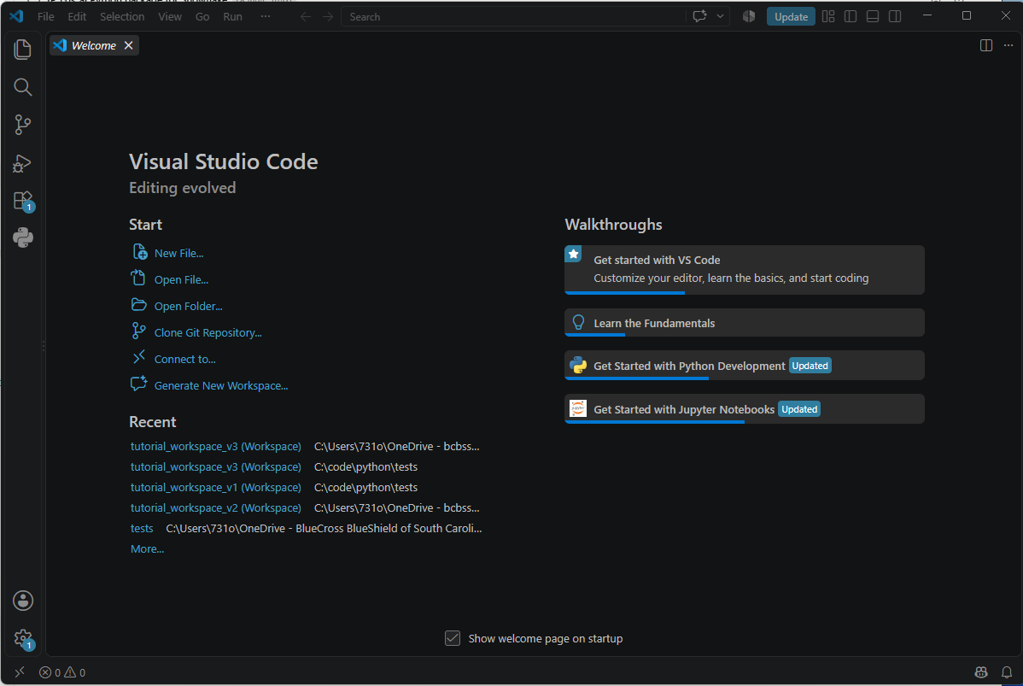
The VS Code Welcome screen. 'New File...' is top-left, under Start.
3.3 Name the file hello_world.py and save it into your tests folder. The .py on the end is what makes it a Python program.
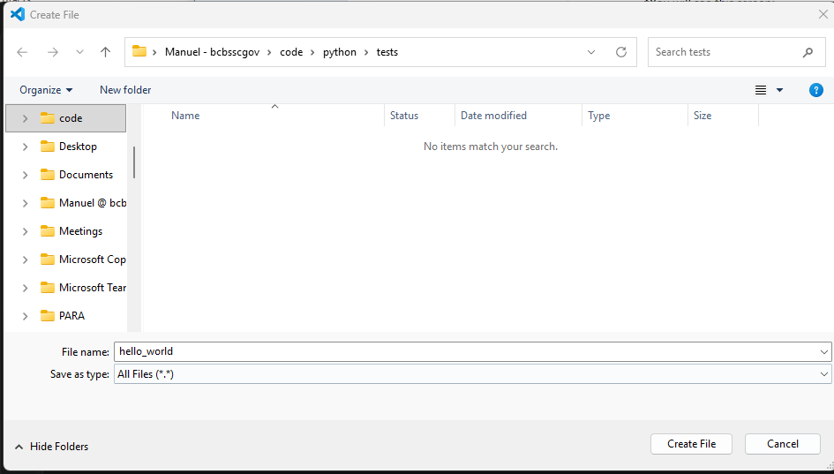
The Create File box. Note the folder path along the top: code > python > tests.
3.4 Check it arrived. Open the tests folder in File Explorer — hello_world should be there.
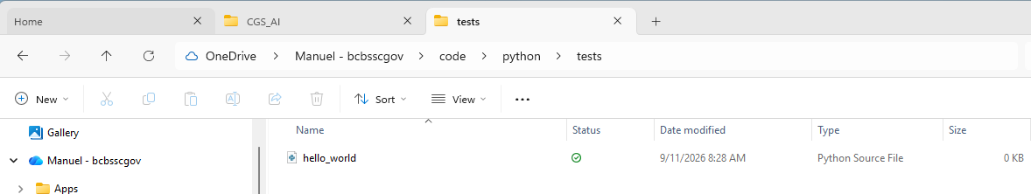
hello_world in your OneDrive tests folder. The cloud tick means it is backed up.
3.5 Type these two lines into the file, then press Ctrl+S to save.
#This is my first python comment
print("Hello, World!")
Line 1 starts with # , which makes it a COMMENT — a note for humans that Python ignores. Line 2 is the program: print puts whatever is inside the brackets on the screen.
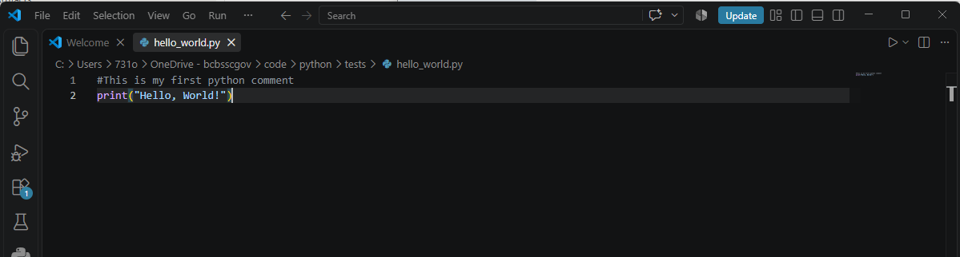
Two lines of Python. Line 1 is a comment; line 2 is the program.
3.6 Save a workspace: File → Save Workspace As... Name it hello_world_workspace and save it in the same tests folder.
Why bother? Because tomorrow you will want to carry on. Opening the workspace reopens this folder and this file, arranged as you left them — instead of navigating back through OneDrive each time. It costs one click now and saves several every day after.
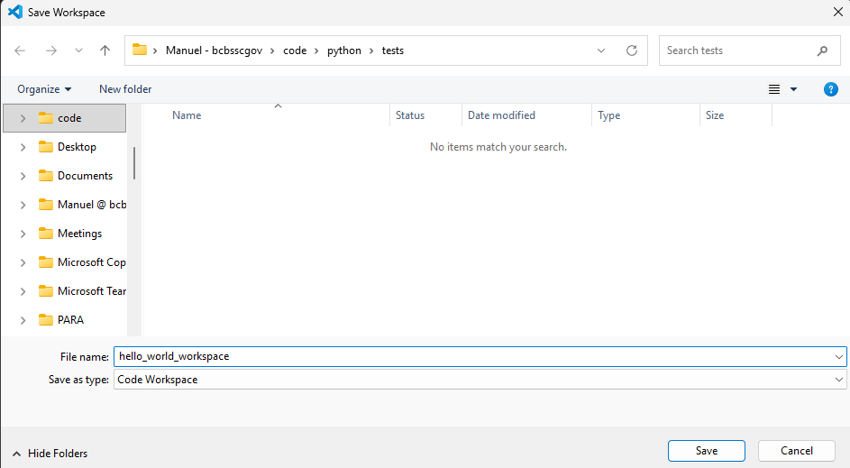
Save Workspace As... Note 'Save as type: Code Workspace'.
3.7 Open the terminal. Click Toggle Panel at the top-right, or press Ctrl+J.
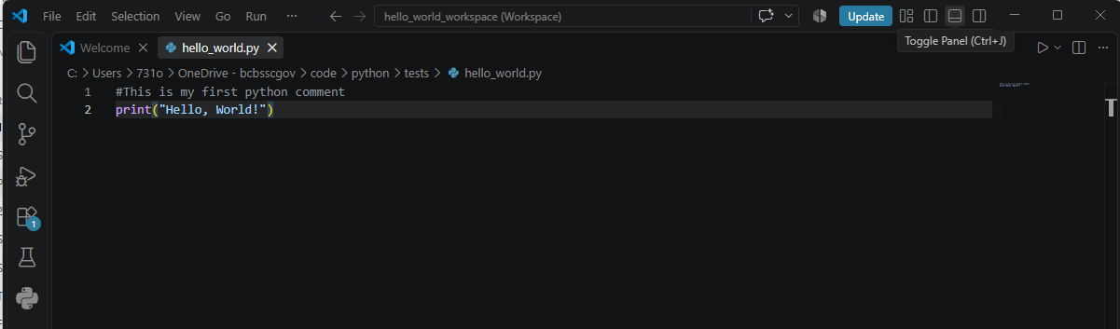
Toggle Panel, top-right. The keyboard shortcut is Ctrl+J.
3.8 The terminal appears along the bottom. This is where you type commands and where your program's output will show up.
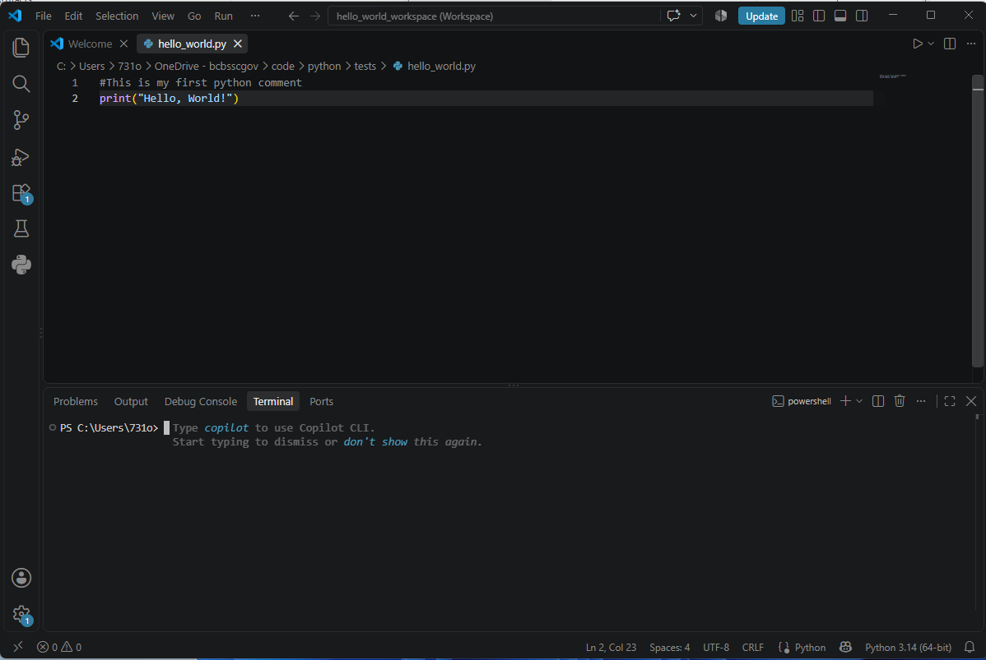
The terminal, open at the bottom. Yours starts in your home folder, not in tests.
3.9 Move the terminal into your folder with the cd command. Type it exactly, including the double quotes:
cd "C:\Users\<your-id>\OneDrive - bcbsscgov\code\python\tests"
cd means "change directory". The double quotes are REQUIRED here, because "OneDrive - bcbsscgov" has spaces in it; without them the command stops at the first space and fails.
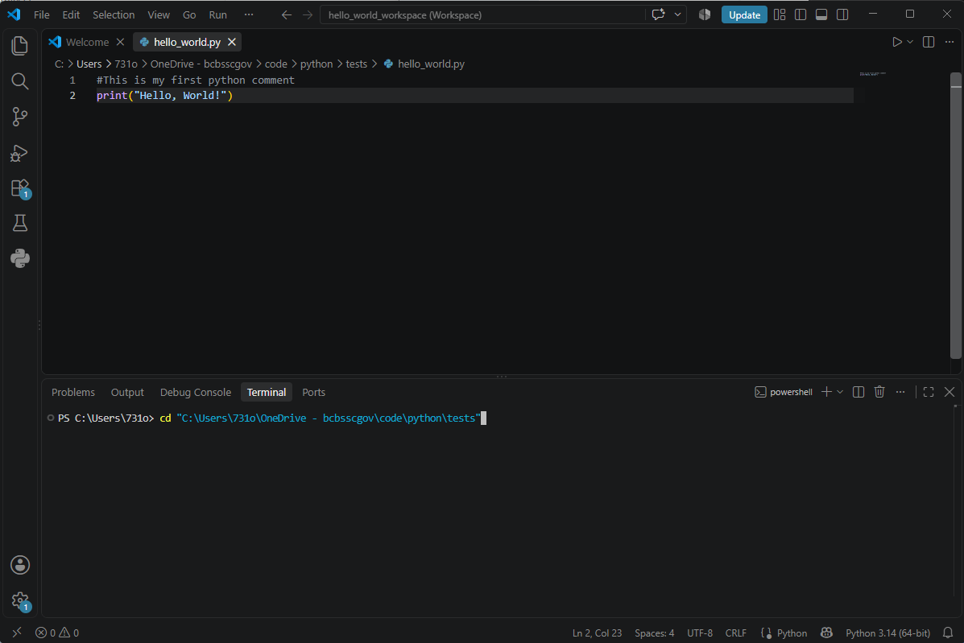
The cd command typed in. The double quotes matter -- the path has spaces in it.
3.10 Run it. Type this and press Enter:
python hello_world.py
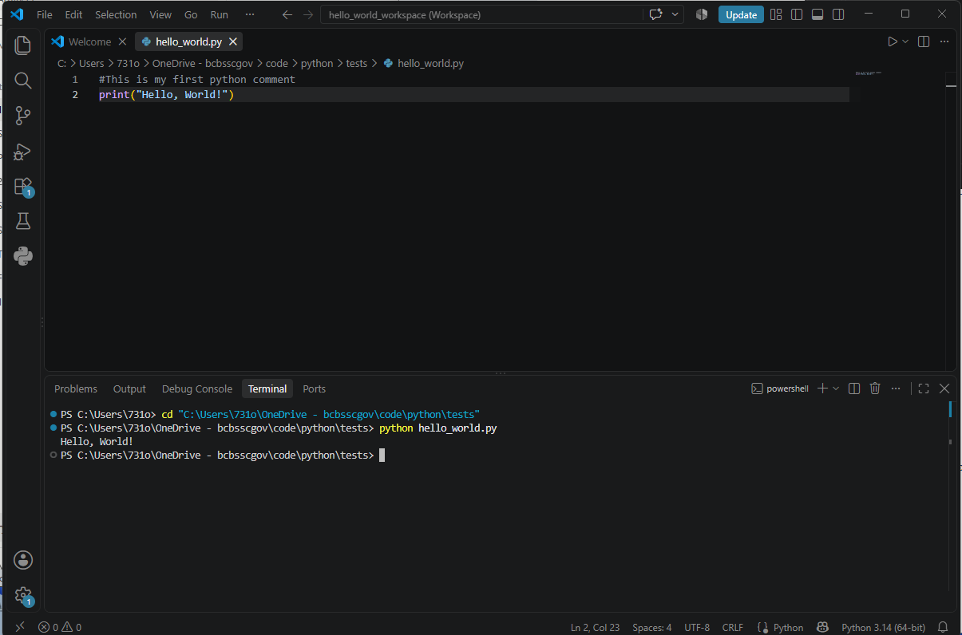
Hello, World! Your first Python program has run.
KEY TAKEAWAY
You created a Python file in the Azure cloud, wrote a comment and a program, saved a workspace, and ran it from the terminal.
That is the whole loop: write, save, run. Everything else builds on it.

If something goes wrong
python: command not found, or 'python' is not recognized
Python is not on the path for this terminal. Try py hello_world.py instead, and tell your team if neither works.
can't open file ... No such file or directory
The terminal is not in your tests folder. Repeat action 3.9, and check the quotes are there.
The terminal shows a message about Copilot
Expected, and harmless. Ignore it and type your command — see Step 2.

NEXT STEPS import, and the cgs_ai package

GOAL
Learn what an import statement does, then use it to reach CGS's own Python package.

The import statement
So far your program has been self-contained. Real work is not: you borrow code somebody has already written and tested. The IMPORT statement is how you reach it.
So why did print work without one? Because print is a BUILT-IN function — Python loads a small set of the most common functions for you, every time, without being asked. Writing import builtins is therefore optional; it changes nothing. For everything else — any other library, and any package of ours — the import IS required, and without it Python will not know the name.
N.1 Open hello_world.py again and add these comment lines above your program:
#The import statement gives your current script access to code written in another file or library.
#It prevents you from having to reinvent the wheel,
#import builtins
#This is my first python comment
print("Hello, World!")
Note that #import builtins is itself commented out — the # in front of it means Python skips the line entirely. It is there to be read, not run, because print already works without it.
N.2 Save with Ctrl+S and run it again in the terminal:
python hello_world.py
The output is identical: Hello, World! Comments changed what the file says to a human, and nothing about what it does.

CGS has its own Python package: cgs_ai
cgs_ai is a package we built and maintain. It holds the work this department repeats — turning an extract into a formatted report, sending it to the people who need it, scanning a share for what matters — as functions you call by name. You import it exactly the way you would import any well-known library.
Why that matters: the alternative is everybody solving the same problem privately, in their own style, with their own bugs. A package makes one tested answer available to the whole team, and makes the AI work we are building next possible — because AI solutions need clean, repeatable data plumbing underneath them, and that plumbing is what cgs_ai is.
N.3 Create a new file called hello_cgs_ai.py in your tests folder, exactly as you created hello_world.py in Step 3.
N.4 Type this in, then save it:
# The folder that CONTAINS the cgs_ai package folder.
SHARE = r"\\a70admed.com\R1\CGS\APPS\SAS\UNIT\SAS_G\GSIT_Prod\MANUAL\cgs_ai"
CGS_AI_HOME = SHARE + r"\src\py\lite"
# STEP 1. Import the python package
# Telling Python where to look, then importing cgs_ai exactly like pandas.
import sys
sys.path.insert(0, CGS_AI_HOME)
import cgs_ai
#STEP 2. Run examples
#Example 1
result = cgs_ai.doBasicHello()
print(result)
#Example 2
result = cgs_ai.doPersonalizedHello('Alice')
print(result)
N.5 Run it:
python hello_cgs_ai.py
You should see two lines back:
Hello, World!
Hello, Alice!
That second line is the point. doPersonalizedHello took something you gave it — 'Alice' — and gave back a different answer. Every other function in cgs_ai works the same way: you pass in what makes your job different, and the package handles what is the same for everybody.
MORE TO COME
These two examples are deliberately trivial — they prove the import worked and nothing more.
More advanced examples, using the reporting and email functions, will follow in the next tutorial.

Conclusion
Three steps, and none of them difficult. Learn them, then practise them until they are automatic — because everything that follows, for the rest of your Python work, sits on top of exactly these.
Step 3 is the one that matters most. It taught you the whole loop:
THE LOOP
WRITE → SAVE → RUN
Write the code. Press Ctrl+S. Type python yourfile.py and press Enter. Look at what came back. Then go round again.
Every program ever written, of any size, is that loop repeated.

Repetition is the only thing that makes it stick. Change the words in the quotes and run it again. Add another print. Break it on purpose and read the error. Ten minutes of that is worth more than an hour of reading.

Why cgs_ai matters to CGS
The package you imported at the end is not a teaching exercise. It is how this team gets leverage from Python:
Code written once is reused by everyone. A report format, a mail notification, a file scan — solved once, tested once, then called by name for the rest of the team.
It is OUR domain, not a generic toolbox. The functions know about claims, logs and CMS extracts, because we wrote them for that. No public library will ever fit our work this closely.
It is a box of Lego blocks. Small pieces that snap together differently for each job. The same few functions cover reporting, monitoring and analysis — you assemble them, you do not rebuild them.
It is the foundation for AI that delivers business results. AI needs clean, repeatable data plumbing beneath it. cgs_ai is that plumbing, which is what turns an interesting model into something that actually runs every night.
It makes the work auditable and consistent. One implementation means one output format and one place to fix a problem — which matters when the work supports Medicare operations.
It shortens the distance from idea to delivery. A request that used to mean days of new code becomes a handful of calls, so more ideas get tried and the good ones ship sooner.
None of that happens without people who can write, save and run. That is what this tutorial gave you, and it is why these three steps are worth practising until they are dull.
COMING SOON — cgs_ai
import cgs_ai
The same three steps, with our own package doing the work. Keep this tutorial; the next one starts from it.

Questions, or a correction to this tutorial? Please contact Manuel A. Figallo. cgs_ai is in beta — feedback is welcome now.

