Hello Ollama
A "hello world" browser GUI for a local Ollama installation: step-by-step guide

What you will build
A single web page (one HTML file, about 50 lines) where you type a question, click Ask, and see the answer from an AI model running on your own computer through Ollama. There is no framework, no installation of packages, and no middleware: the page talks directly to Ollama's built-in REST API.
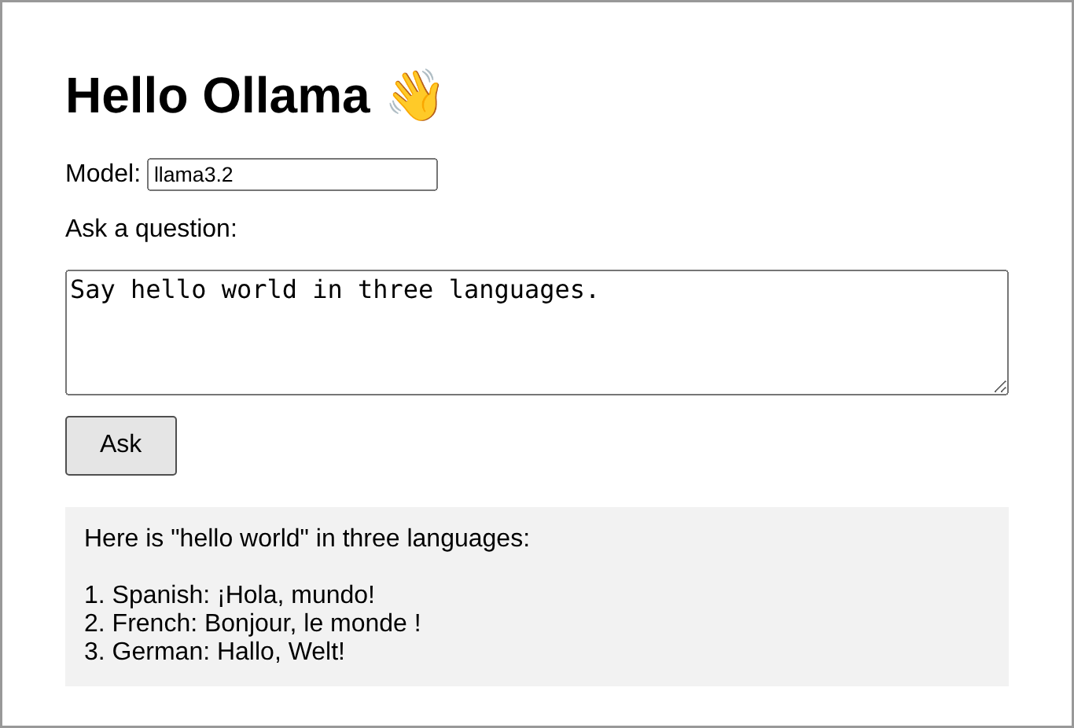
Figure 1. The finished page, showing a reply from the model.

How it works
When you click Ask, the browser's JavaScript sends one HTTP request to Ollama and waits for the full answer:
Browser page --POST /api/generate--> Ollama (localhost:11434) --> model
Browser page <------ JSON reply ------- Ollama
Item | Value
Endpoint | POST http://localhost:11434/api/generate
Request body | { "model": "llama3.2", "prompt": "...", "stream": false }
Reply (simplified) | { "model": "llama3.2", "response": "Hello...", "done": true }
What the page shows | The response field (or error if something went wrong)

Setting "stream": false makes Ollama return the whole answer in one piece, which keeps the code as short as possible. (The fuller GUI in this repository uses streaming so words appear as they are generated.)

What you need
- A Windows, macOS or Linux computer. 8 GB of RAM is enough for the small model used here.
- About 3 GB of free disk space for Ollama and the model.
- A web browser (Chrome, Edge, Firefox or Safari).
- Python 3, used only to serve the page with one command. It is pre-installed on macOS and Linux; on Windows get it from python.org or the Microsoft Store. (No Python? See Troubleshooting.)

Step-by-step instructions

Step 1. Install Ollama
- Windows / macOS: download the installer from https://ollama.com/download, run it, and keep Ollama running (it appears as an icon in the system tray / menu bar).
- Linux: run curl -fsSL https://ollama.com/install.sh | sh

Step 2. Download a model and check Ollama is running
Open a terminal (Windows: PowerShell or Command Prompt; macOS: Terminal) and run:
ollama pull llama3.2
curl http://localhost:11434
The first command downloads the model (about 2 GB, once). The second should print Ollama is running. On Windows you can instead open http://localhost:11434 in your browser.
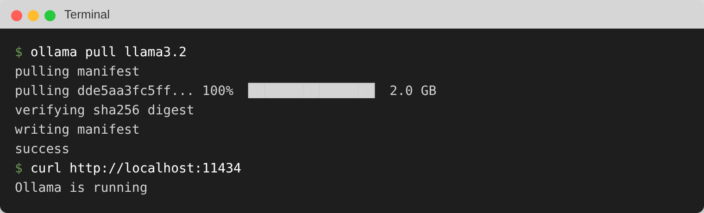
Figure 2. Downloading the model and confirming Ollama is running.

Step 3. Create the HTML file
- Create a new folder called hello-world (for example on your Desktop).
- Open a plain-text editor: Notepad (Windows), TextEdit in plain-text mode (macOS), or VS Code.
- Copy the complete code from the Appendix at the end of this document and paste it in.
- Save it inside the folder as index.html. In Notepad, set "Save as type" to "All files" and "Encoding" to "UTF-8" so it is not saved as index.html.txt.

Step 4. Start a small local web server
In the terminal, go into the folder and start Python's built-in web server:
cd Desktop/hello-world
python -m http.server 8000
On Windows, if python is not recognised, try py -m http.server 8000. Leave this window open while you use the page; press Ctrl+C to stop it later.
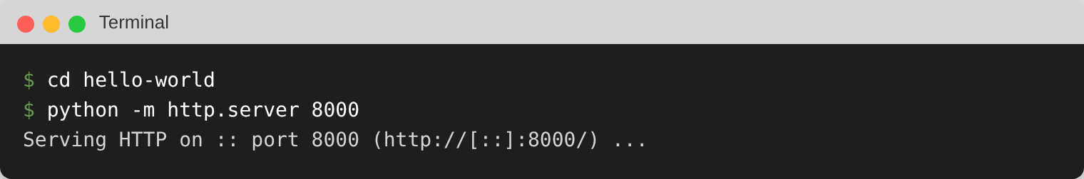
Figure 3. The local web server is running.
Why a web server? Browsers only let a page call another address (here, Ollama on port 11434) if that address allows it. This is called CORS. Ollama allows pages served from http://localhost by default, but not pages opened by double-clicking the file. Serving the page from localhost:8000 satisfies this with no configuration.

Step 5. Open the page
In your browser go to http://localhost:8000. You should see:
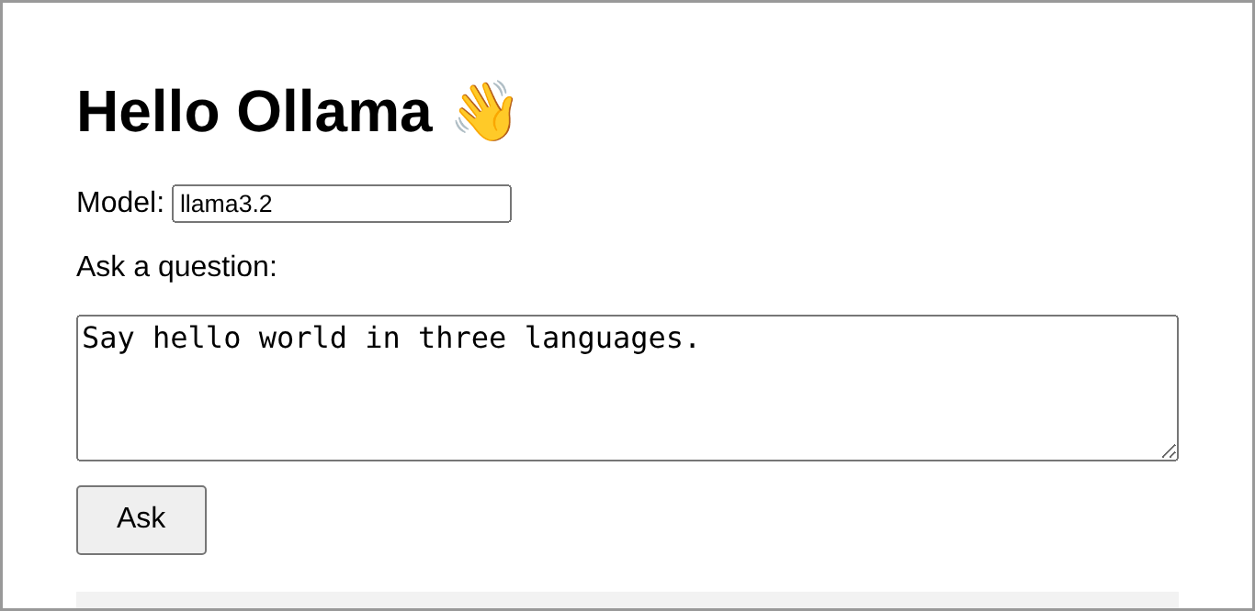
Figure 4. The Hello Ollama page, ready for a question.

Step 6. Ask a question
Keep the sample question or type your own and click Ask. The box shows "Thinking..." while the model works. The first answer can take 10 to 30 seconds because the model is loaded into memory; later answers are faster.
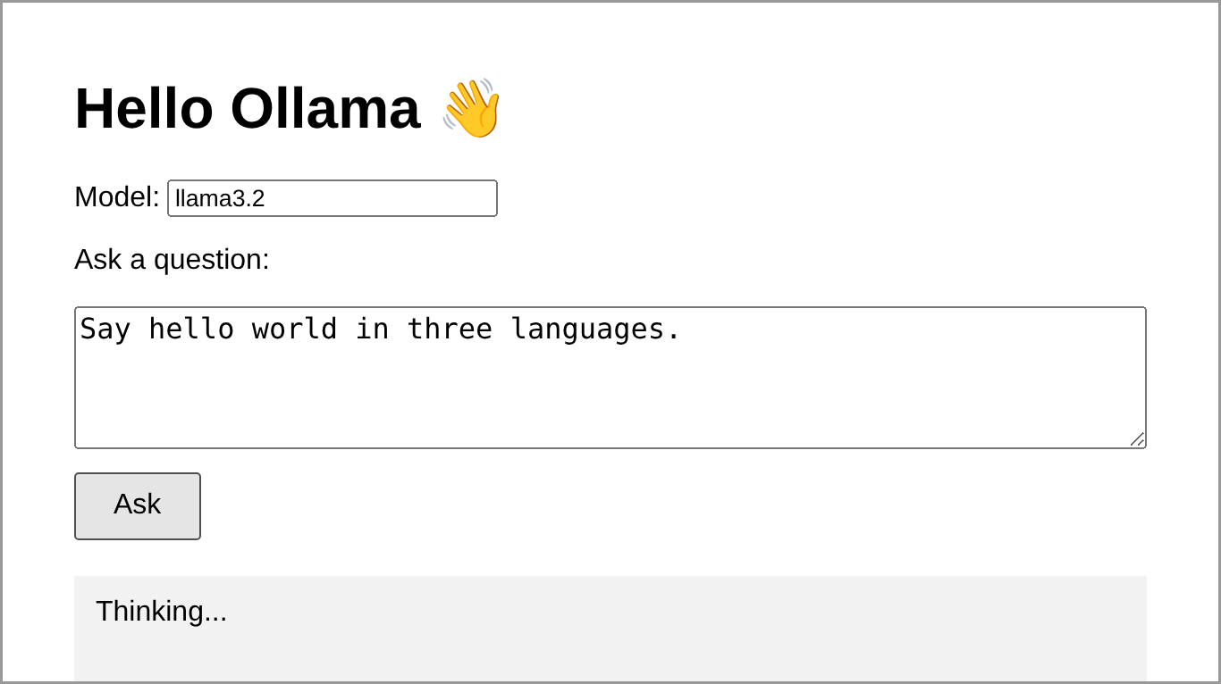
Figure 5. Waiting for the model.
When the reply arrives it replaces "Thinking...":
Figure 6. The reply. The wording of your model's answer will differ.
To use a different model, run ollama pull <name> (for example mistral or gemma3) and type its name in the Model box. Run ollama list to see the models you have.

Troubleshooting
What you see | What to do
Could not reach Ollama: Failed to fetch | Ollama is not running (start the Ollama app, or run "ollama serve"), or you opened the file by double-clicking instead of via http://localhost:8000.
model "llama3.2" not found | Run "ollama pull llama3.2", or type the name of a model you have ("ollama list").
Page does not load at localhost:8000 | The Python server is not running or you are in the wrong folder. Repeat Step 4.
Port 8000 already in use | Use another port, e.g. "python -m http.server 8080", and open http://localhost:8080.
No Python installed | Allow all origins in Ollama, then double-click index.html. Windows: add a user environment variable OLLAMA_ORIGINS with value *, then quit and restart Ollama. macOS: run launchctl setenv OLLAMA_ORIGINS "*" and restart Ollama. Only do this on a personal computer.
It is very slow | Normal on the first question. On older computers try a smaller model, e.g. "ollama pull llama3.2:1b".

To see the exact error, press F12 in the browser and open the Console tab.

Next steps
- Use the fuller GUI in the same repository (ollama-gui/index.html), which adds streaming replies, a model list, chat history and a Stop button.
- Put AnythingLLM or Open WebUI in front of Ollama to chat with your own documents or support multiple users (see the repository README).

Appendix: complete code (index.html)
Copy everything below into a file named index.html.
<!doctype html>
<html>
<head>
<meta charset="utf-8">
<title>Hello Ollama</title>
<style>
body { font-family: Arial, sans-serif; max-width: 600px; margin: 40px auto; padding: 0 16px; }
textarea { width: 100%; height: 80px; font-size: 16px; box-sizing: border-box; }
button { margin-top: 8px; padding: 8px 20px; font-size: 16px; }
#answer { margin-top: 20px; padding: 12px; background: #f2f2f2; white-space: pre-wrap; min-height: 40px; }
</style>
</head>
<body>
<h1>Hello Ollama 👋</h1>

<label>Model: <input id="model" value="llama3.2"></label>
<p>Ask a question:</p>
<textarea id="question">Say hello world in three languages.</textarea>
<br>
<button onclick="ask()">Ask</button>

<div id="answer"></div>

<script>
async function ask() {
const answer = document.getElementById("answer");
answer.textContent = "Thinking...";

try {
// Send the question to Ollama's REST API and wait for the full reply.
const response = await fetch("http://localhost:11434/api/generate", {
method: "POST",
body: JSON.stringify({
model: document.getElementById("model").value,
prompt: document.getElementById("question").value,
stream: false
})
});
const data = await response.json();
answer.textContent = data.response || data.error;
} catch (err) {
answer.textContent = "Could not reach Ollama: " + err.message;
}
}
</script>
</body>
</html>

