VS Studio for Python

in the Azure Cloud — in 3 Steps
A beginner's tutorial · CGS · no experience needed

Introduction
By the end of this tutorial you will have written and run a Python program, saved in the Azure cloud, on your own machine. It takes about fifteen minutes, and assumes you have never programmed.

Why is Python so important?
It is the language CMS uses. The Centers for Medicare and Medicaid Services use Python throughout, so sharing work with them means reading Python.
It is the common language of data science. Whatever the specialism, the examples and the answers online are written in Python.
It is already inside the tools you use. Excel and Power BI both run Python now, so it extends software you already have open.
It is free, and it is everywhere. No licence to request, and the skill moves with you between teams and jobs.

Why Visual Studio Code?
Python is the language. Visual Studio Code — "VS Code" — is where you write it. You could use Notepad, but VS Code gives you four things Notepad cannot:
• Write and run in one window — editor on top, terminal underneath.
• It understands Python: keywords are coloured and typos are underlined before you run anything.
• It opens your cloud folder directly, leaving the files in OneDrive.
• It is what the rest of the team uses, so instructions match your screen.

WHAT YOU NEED BEFORE YOU START
A CGS Windows machine with Visual Studio Code installed.
Your OneDrive account signed in — the cloud icon in the taskbar.
That is all. Python itself is already on the machine.

STEP 1 Prepare your folder

GOAL
Understand where VS Code keeps your work, and make the one folder this tutorial uses.

A note about storage
Your code has to live somewhere. Save it to your laptop's hard disk and it exists in exactly one place. We are going to use OneDrive instead — the Azure cloud — for four reasons:
It future-proofs the code base. Work saved in the cloud outlives the machine it was written on.
You get 100 GB, reachable anywhere. From any CGS machine you sign in to, without copying anything.
It is backed up, and it is reliable. Previous versions can be restored. A local folder has neither.
It is shareable. A colleague can be given the folder. No zipping, no emailing.
1.1 Open File Explorer and go to your OneDrive folder.
1.2 Create this folder path inside it, one folder at a time: code, then python, then tests.
C:\Users\<your-id>\OneDrive - bcbsscgov\code\python\tests
Replace <your-id> with your own Windows user name. The screenshots in this tutorial show 731o, which is the author's — yours will be different, and everything else will look the same.
KEY TAKEAWAY
Your Python work lives in the Azure cloud, not on your laptop.
Every file in this tutorial goes in the tests folder you just made.

STEP 2 Learn two definitions and three rules

GOAL
Know what a workspace is, and know which parts of VS Code you must not use at CGS.

What is a workspace?
A FILE is one program — hello_world.py. A WORKSPACE is a saved note of which folder you were working in, which files you had open, and how the window was arranged.
Think of it as a bookmark for a whole project rather than one page. Open it tomorrow and VS Code puts everything back as you left it. A workspace is a small .code-workspace file; it does not contain your code, it only points at it.

Three things you must not use
VS Code ships with features aimed at the public internet. CGS restricts them, because your code and the data it touches must not leave the organisation. You will see all three on screen — leave them alone:
Copilot The AI suggestion feature, and the "Type copilot to use Copilot CLI" message you will see in the terminal. Ignore it. It sends what you are writing to an outside service.
GitHub "Clone Git Repository..." on the Welcome screen, and the source control icon down the left edge. Do not publish or clone code. Internal code belongs on the network share, not on a public host.
"Sign In" The account icon at the bottom-left, and any prompt to sign in or turn on Settings Sync. Stay signed out. Signing in links this machine to an external account.
If VS Code prompts you for any of the three, dismiss the prompt and carry on — nothing in this tutorial needs them. If you are unsure whether something is permitted, ask before you click: your team owns the current policy.
KEY TAKEAWAY
A workspace remembers your project; a file holds your code.
Copilot, GitHub and Sign In are off limits. You need none of them.

STEP 3 Write and run your first program

GOAL
Launch VS Code, learn the screen, and run a Python program that prints Hello, World!

3.1 Find VS Code. In the Windows taskbar search box, type: Visual Studio Code — then press Enter.
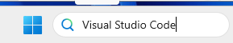
The Windows search box. Type the name, then press Enter.
3.2 The Welcome screen opens. Under Start, click "New File...".
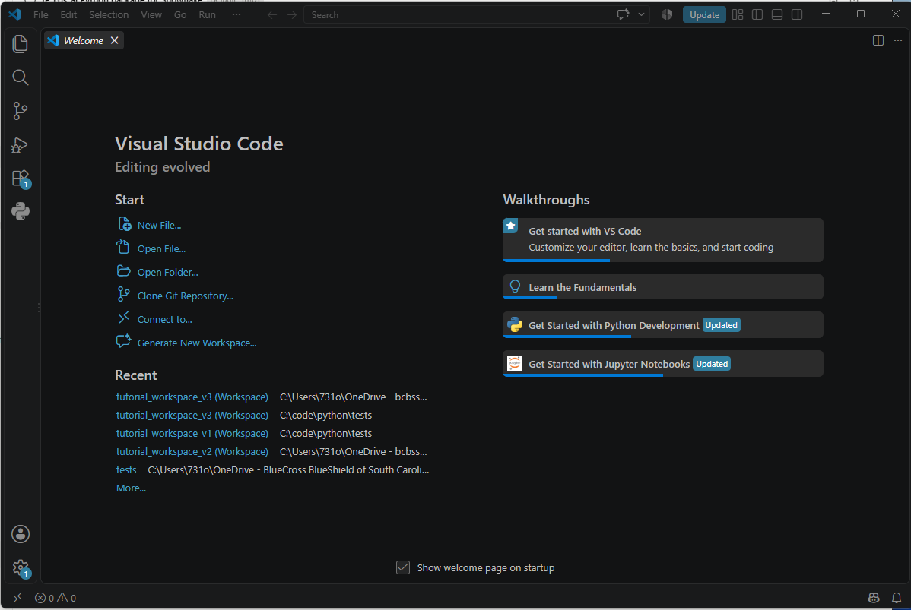
The VS Code Welcome screen. 'New File...' is top-left, under Start.
3.3 Name the file hello_world.py and save it into your tests folder. The .py on the end is what makes it a Python program.
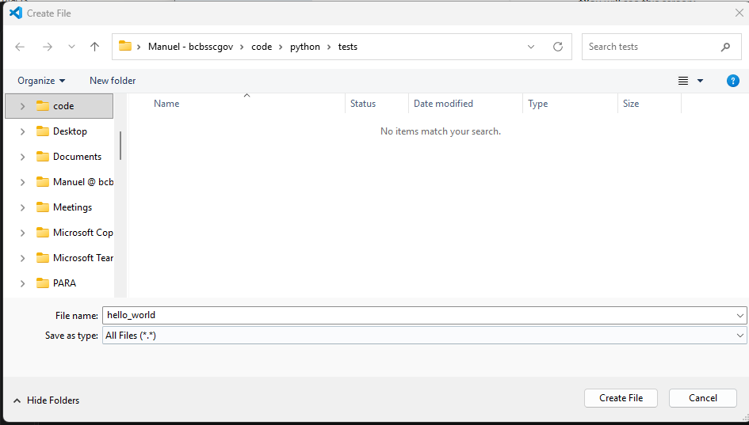
The Create File box. Note the folder path along the top: code > python > tests.
3.4 Check it arrived. Open the tests folder in File Explorer — hello_world should be there.
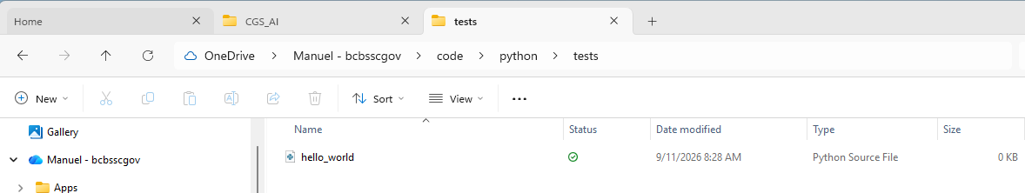
hello_world in your OneDrive tests folder. The cloud tick means it is backed up.
3.5 Type these two lines into the file, then press Ctrl+S to save.
#This is my first python comment
print("Hello, World!")
Line 1 starts with # , which makes it a COMMENT — a note for humans that Python ignores. Line 2 is the program: print puts whatever is inside the brackets on the screen.
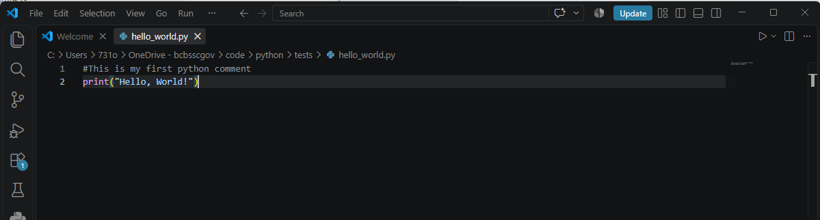
Two lines of Python. Line 1 is a comment; line 2 is the program.
3.6 Save a workspace: File → Save Workspace As... Name it hello_world_workspace and save it in the same tests folder.
Why bother? Because tomorrow you will want to carry on. Opening the workspace reopens this folder and this file, arranged as you left them — instead of navigating back through OneDrive each time. It costs one click now and saves several every day after.
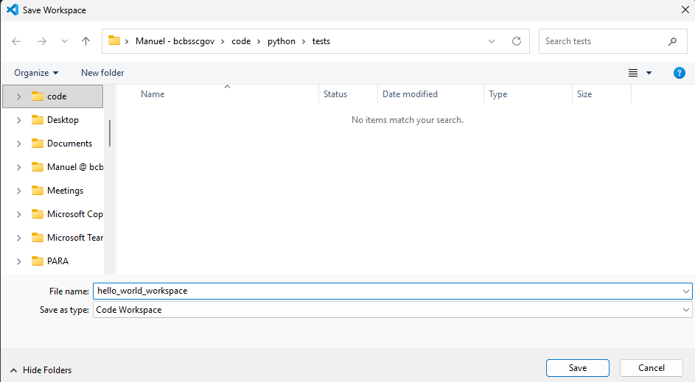
Save Workspace As... Note 'Save as type: Code Workspace'.
3.7 Open the terminal. Click Toggle Panel at the top-right, or press Ctrl+J.
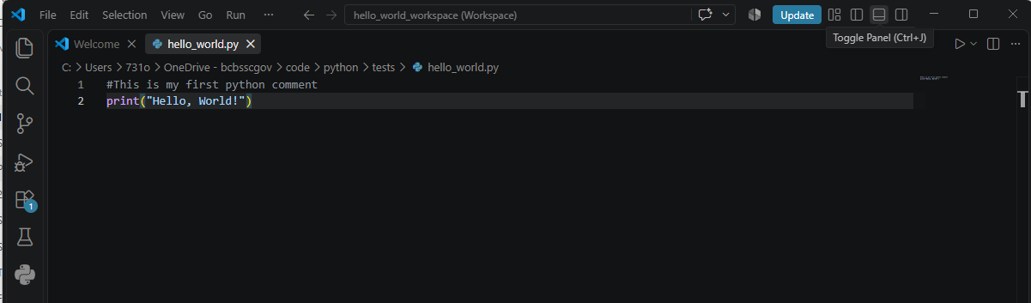
Toggle Panel, top-right. The keyboard shortcut is Ctrl+J.
3.8 The terminal appears along the bottom. This is where you type commands and where your program's output will show up.
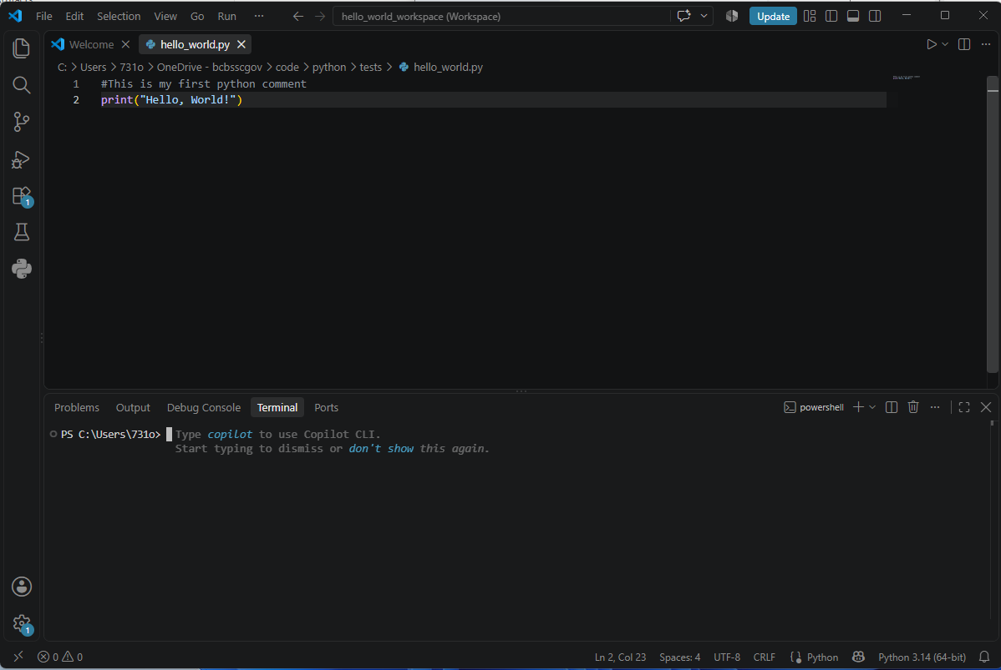
The terminal, open at the bottom. Yours starts in your home folder, not in tests.
3.9 Move the terminal into your folder with the cd command. Type it exactly, including the double quotes:
cd "C:\Users\<your-id>\OneDrive - bcbsscgov\code\python\tests"
cd means "change directory". The double quotes are REQUIRED here, because "OneDrive - bcbsscgov" has spaces in it; without them the command stops at the first space and fails.
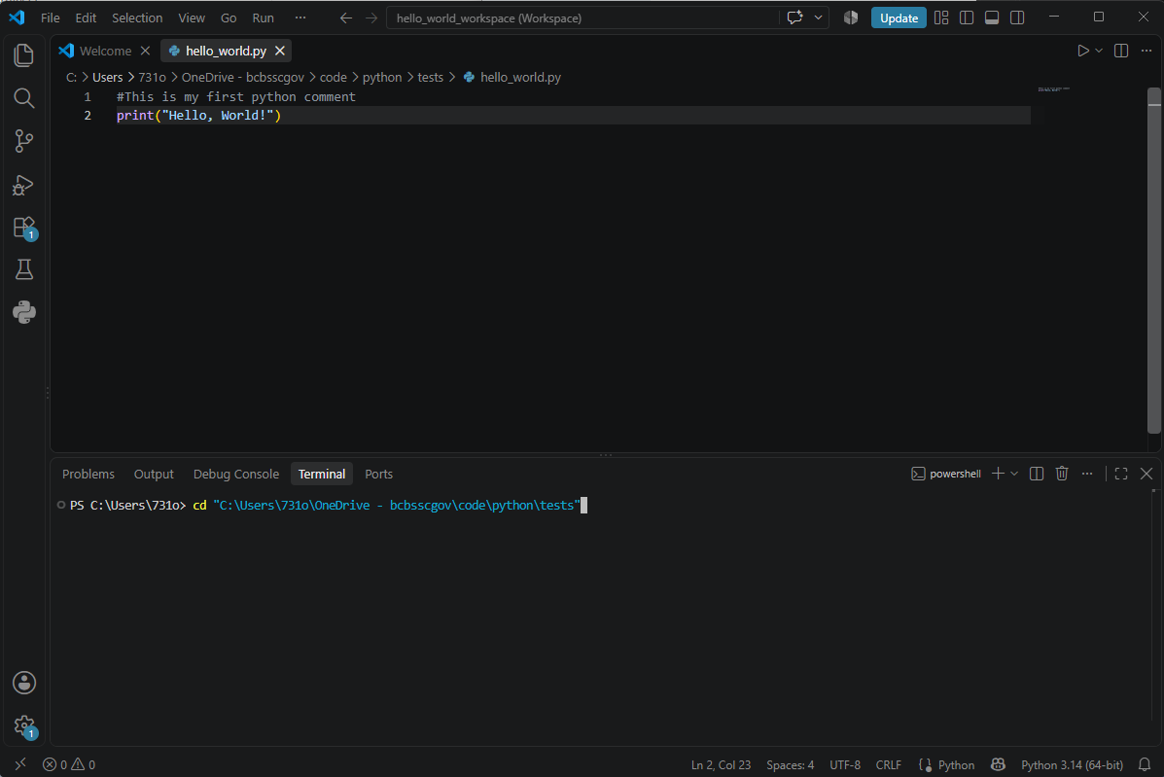
The cd command typed in. The double quotes matter -- the path has spaces in it.
3.10 Run it. Type this and press Enter:
python hello_world.py
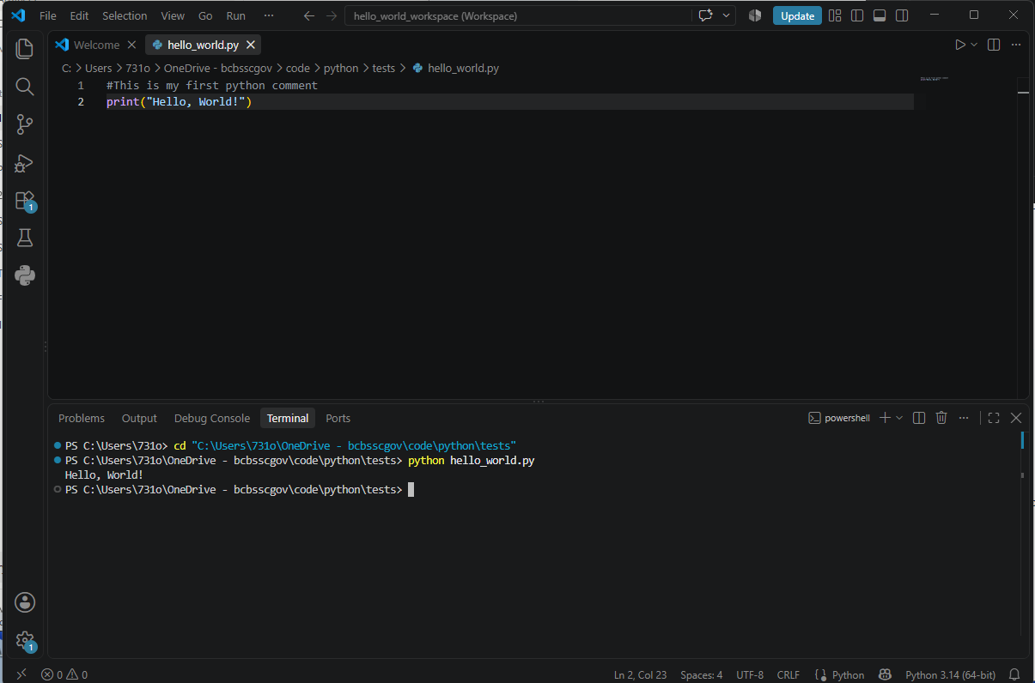
Hello, World! Your first Python program has run.
KEY TAKEAWAY
You created a Python file in the Azure cloud, wrote a comment and a program, saved a workspace, and ran it from the terminal.
That is the whole loop: write, save, run. Everything else builds on it.

If something goes wrong
python: command not found, or 'python' is not recognized
Python is not on the path for this terminal. Try py hello_world.py instead, and tell your team if neither works.
can't open file ... No such file or directory
The terminal is not in your tests folder. Repeat action 3.9, and check the quotes are there.
The terminal shows a message about Copilot
Expected, and harmless. Ignore it and type your command — see Step 2.

What comes next
This tutorial looked small on purpose. What you actually built is the foundation every later session depends on: a cloud folder, a working editor, a terminal you can run code from, and a file that runs.
That foundation is what the cgs_ai Python modules will be delivered onto. cgs_ai is our own Python package — it holds the work we all repeat, such as turning an extract into a formatted report and sending it on, as functions you call by name. Those modules are forthcoming, and when they arrive the instructions will begin exactly where this tutorial ends: open your workspace, open the terminal, run the file.
Before then, practise the loop. Change the words inside the quotes and run it again. Add another print line. Getting comfortable with write, save, run is the only preparation needed.
COMING SOON — cgs_ai
import cgs_ai
The same three steps, with our own package doing the work. Keep this tutorial; the next one starts from it.

Questions, or a correction to this tutorial? Please contact Manuel Figallo. cgs_ai is in beta — feedback is welcome now.

