# Port Forwarder

First of all in order to resolve dependencies please refer to README.md in root folder.

After having the dependencies resolved go into src folder and run the following commands on the terminal.

npm install –g electron  
npm install –g bower  
npm install –g electron-prebuilt  
bower install bower.json

This will make sure electron is installed and bower will get all of the libraries required for the GUI.

To run the application simply go “electron .” or “npm start” in the src directory

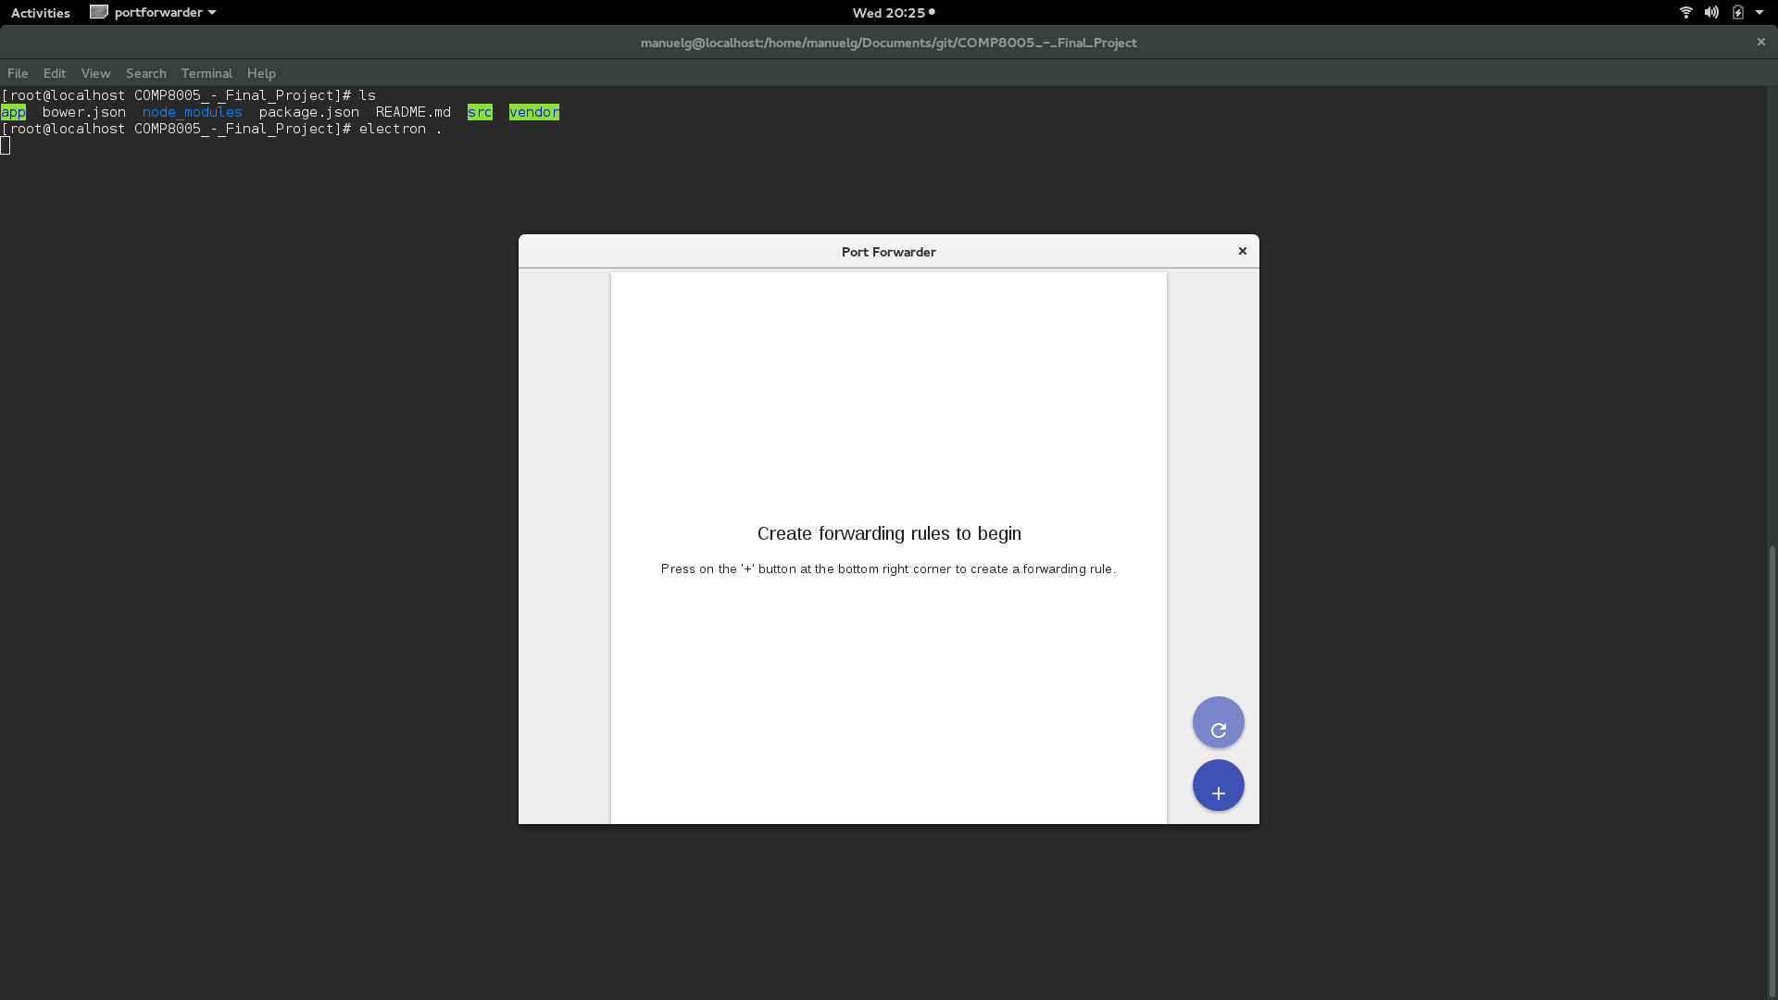

Right after launching the program the user can now start adding rules. To add a new row just press the “+” button and fill the new row with the desired information.

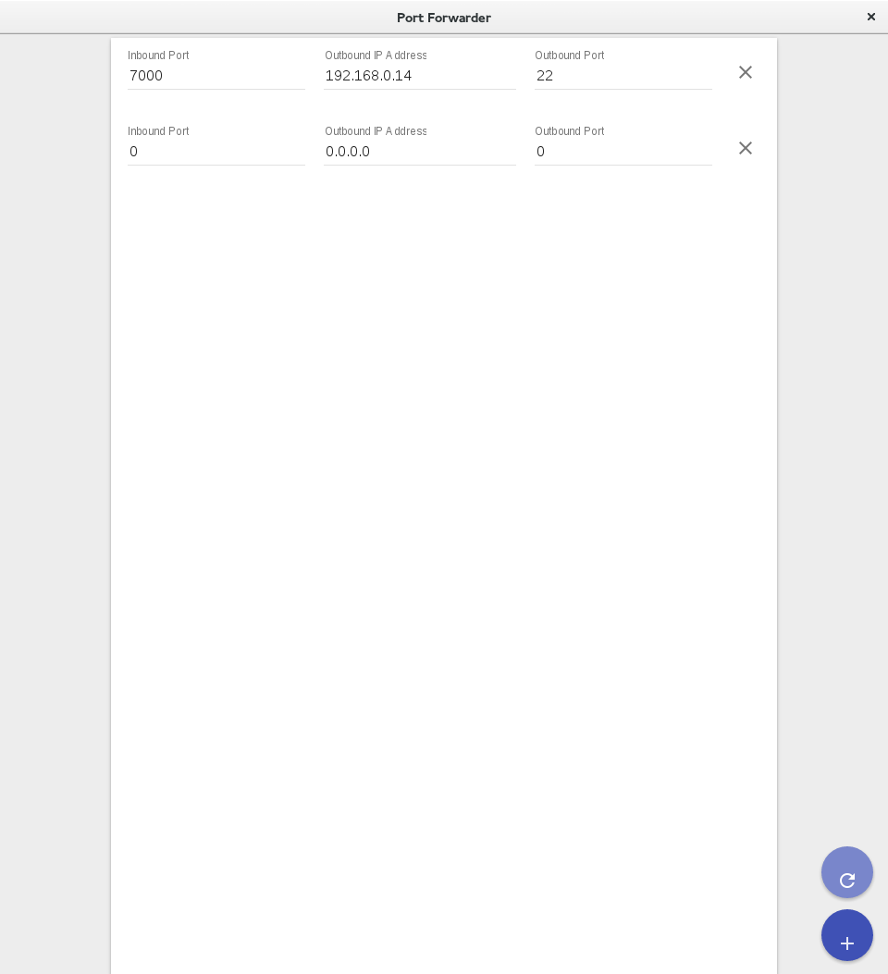

After adding the desired new rule(s) press the “Refresh” Button in order to apply the rules.

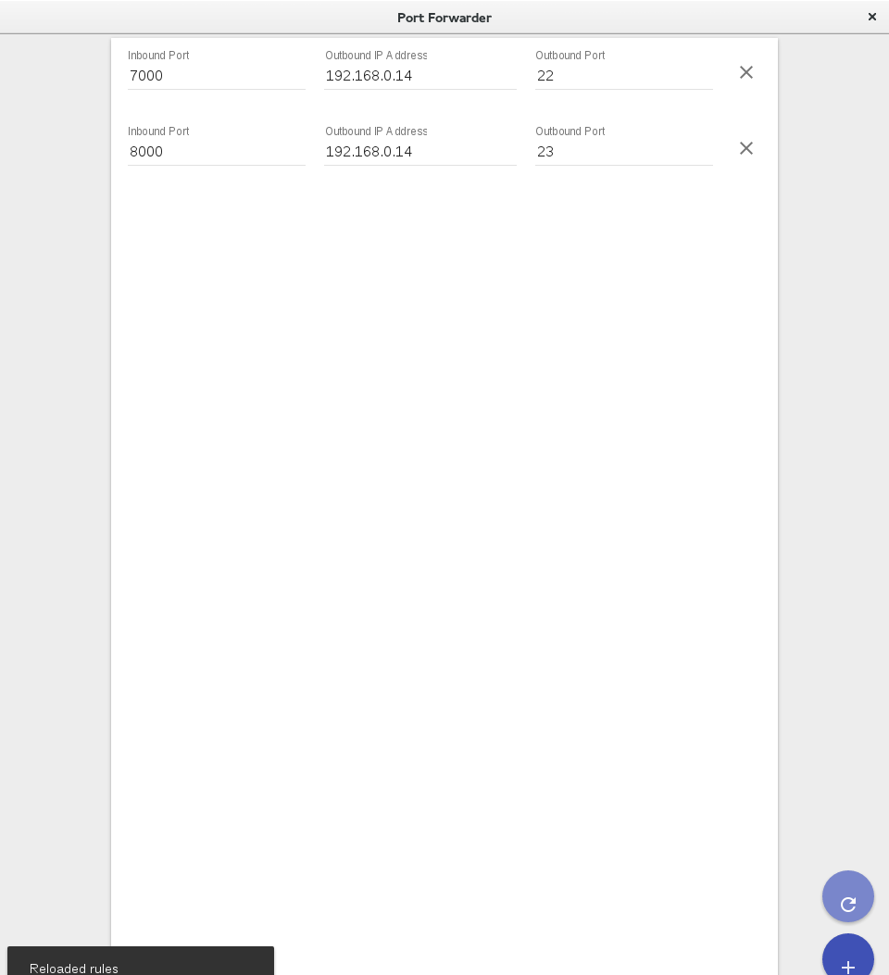

If one of the rules want to be deleted just press the “X” button next to the row/rule.

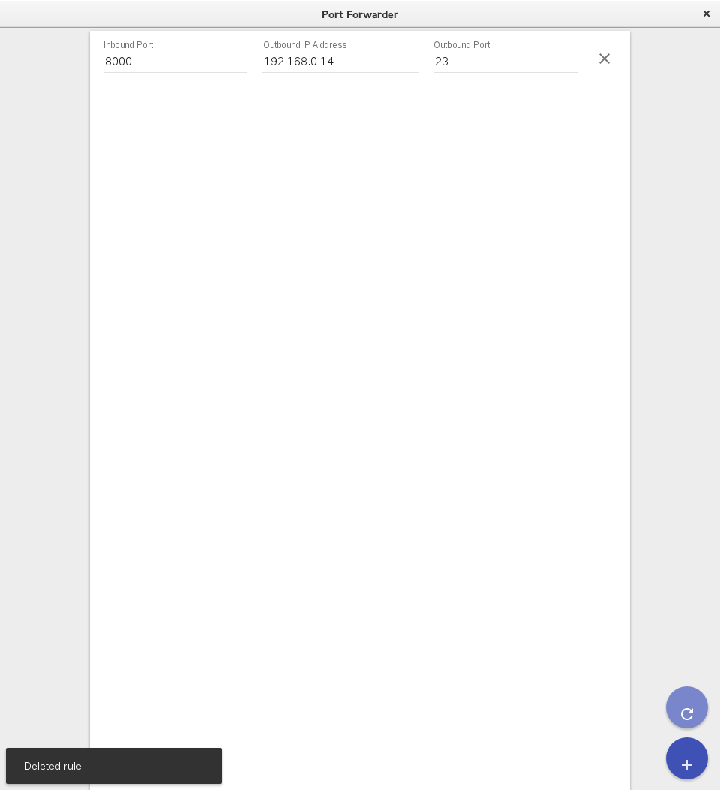

To forward traffic to a website the user can either use the domain name of the website or its IP Address.

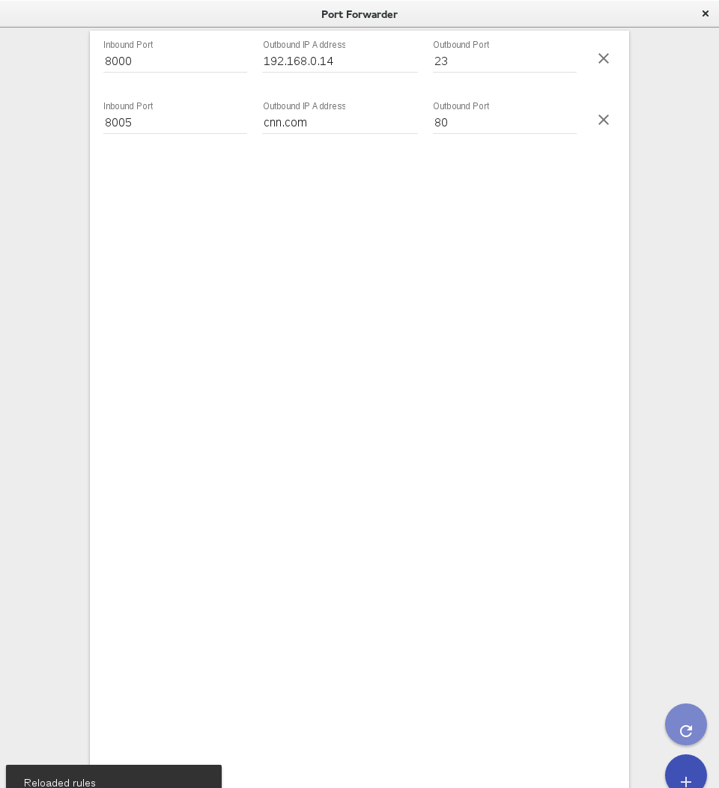

To forward traffic to an https website the user can again use the domain name or its IP address; nevertheless, the port selected would have to be 443 in order to force the application to use SSL Sockets for the connections.

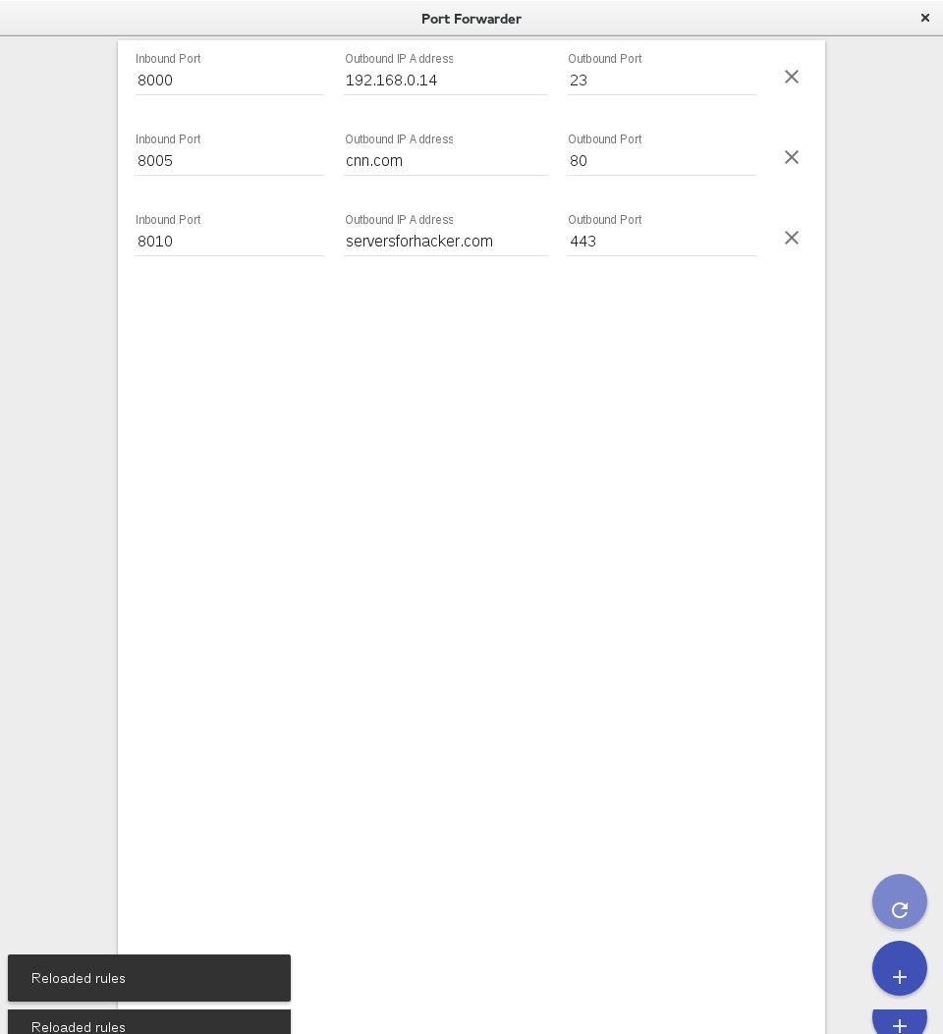

Once you are done using the program simply close the program and it will close all the connections.