Latayan, Manuel R
CPE4A
CPE19L
Exercise 5
Example No. 1: This program will create big and small rectangles with background and foreground colors. Save the program using sample10.asm as the filename
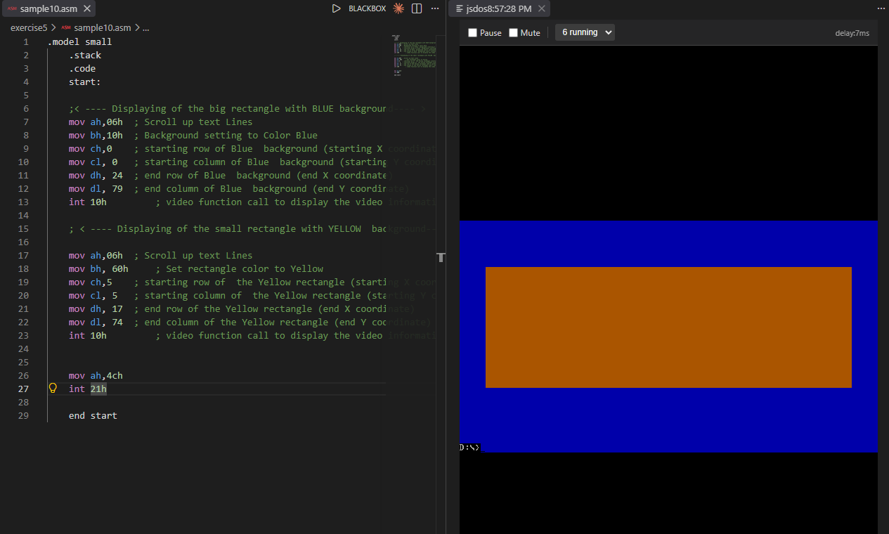

Example No. 2: This program is a combination of Function 09h, Interrupt 10h video function call with scroll down text lines and Cursor Position. It will display the string variables on the coordinates that is specified inside the multiple layer of screen displays. Save the program using sample11.asm as the filename
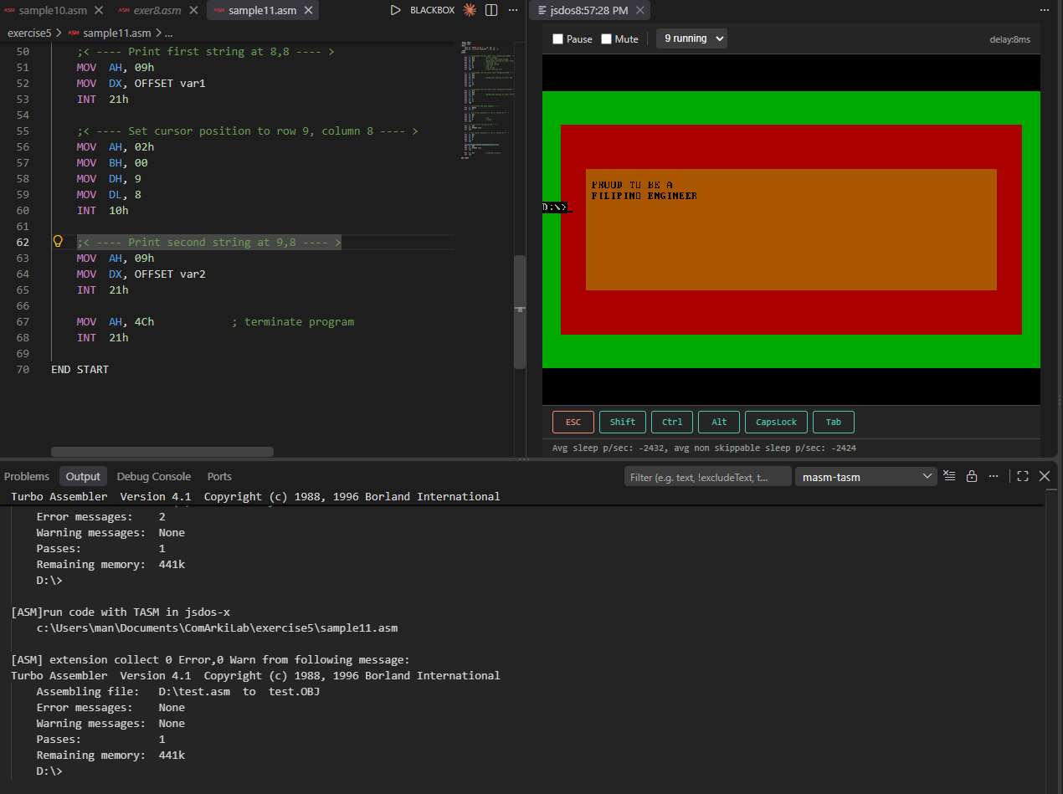

Machine Problem 1:
Create a program that will display the color coding values of the resistor using Interrupt Function 10h. Use string character printing and cursor positioning to display what ever information needs to be displayed in each Resistor color. Graph the coordinates by drawing the expected output. Save the program using Exer11.asm as the filename.
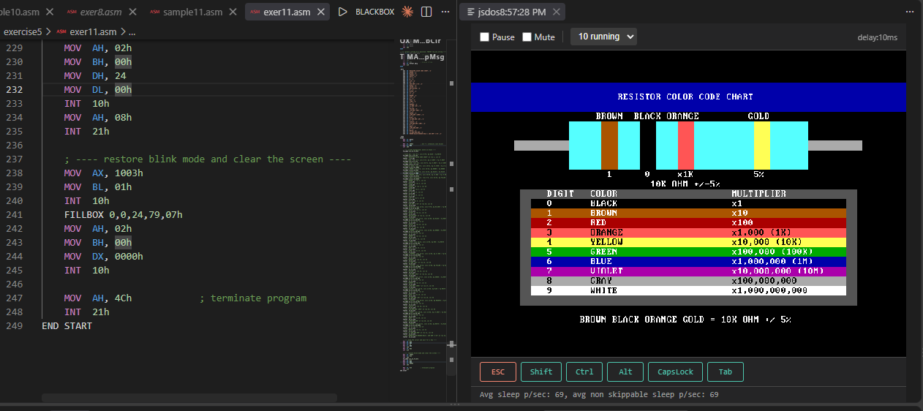

Machine Problem 2:
Create your own LOGO using Interrupt Function 10h that will display variation of colors with coordinates. Use string character printing and cursor positioning to display what ever information you want to be displayed in the LOGO design. Graph the coordinates by drawing the expected output. Save the program using Exer12.asm as the filename.
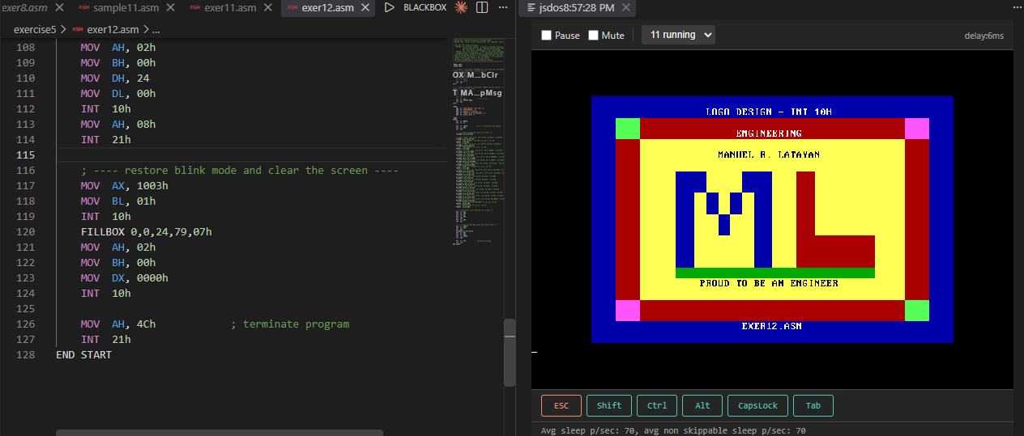

Machine Problem 3:
Create a program using Interrupt Function 10h that will display standard TV color bars following the standard sizes. Use string character printing and cursor positioning to display your favorite International or Local TV Network information in the color bars. Graph the coordinates by drawing the expected output. Save the program using Exer13.asm as the filename.
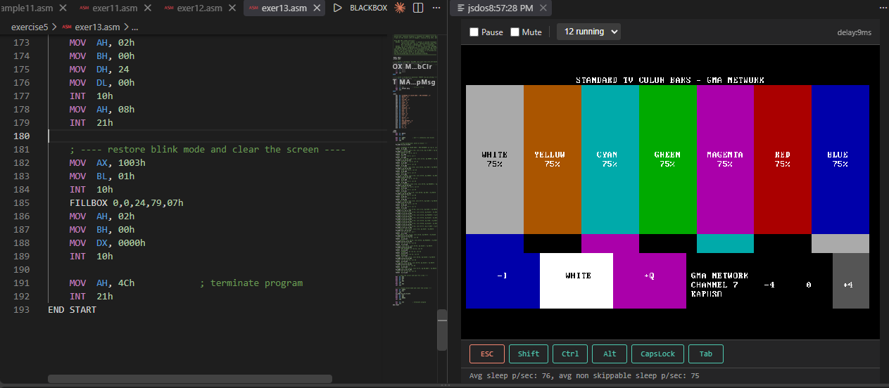

Machine Problem 4:
Create a program using Interrupt Function 10h that will display the mobile phone below with your desired colors and coordinates. Use string character printing and cursor positioning to display what ever information you want to be displayed in the LCD of the mobile phone. Graph the coordinates on the figure below. Save the program using Exer14.asm as the filename.
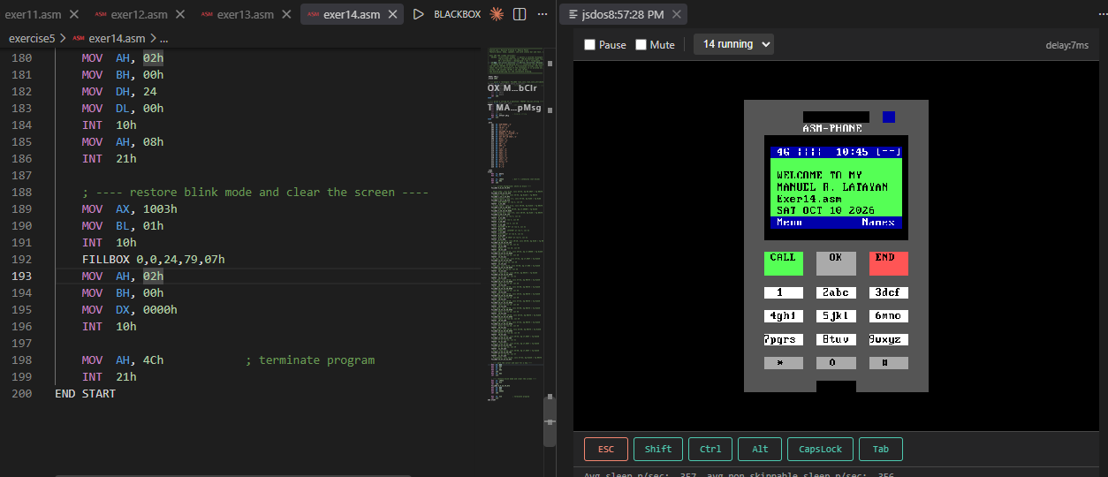

Machine Problem 5:
Create a program using Interrupt Function 10h that will display a chess board with any combination of two colors that you want. Graph the coordinated on the figure below and shade each square of differing colors. Save the program using Exer15.asm as the filename.
