Latayan, Manuel R
CPE4A
CPE19L
Exercise 4
Example No. 1: The program will display the string characters shown below. Save the program using sample8.asm as the filename
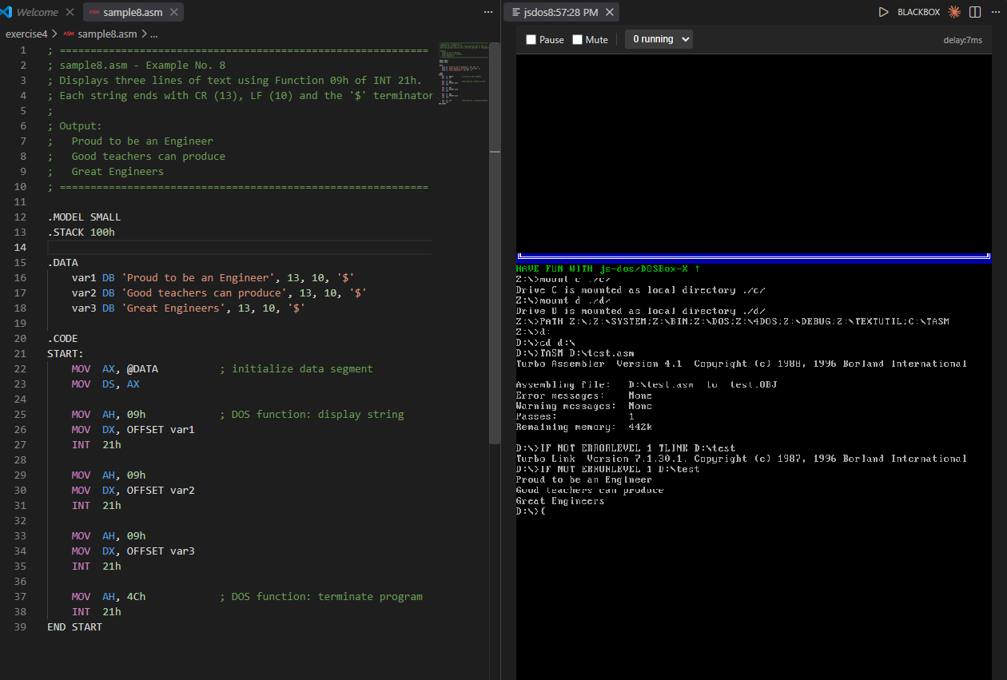

Example No. 2: Using the same function 09h and DOS INT 21h service routine, string characters showing abstract designs can also be created as shown below. Save the program using sample9.asm as the filename
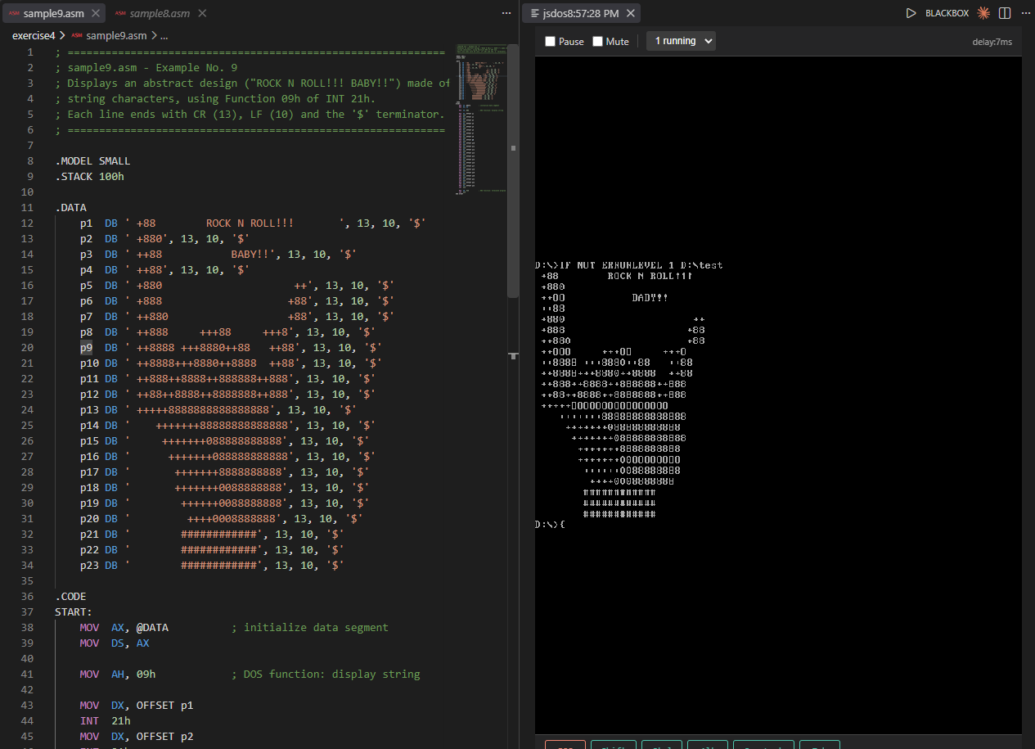

Machine Problem 1:
Create a program using Function 09h that will display the string output shown below using the carriage return and line feed option. Save the program using Exer8.asm as the filename.
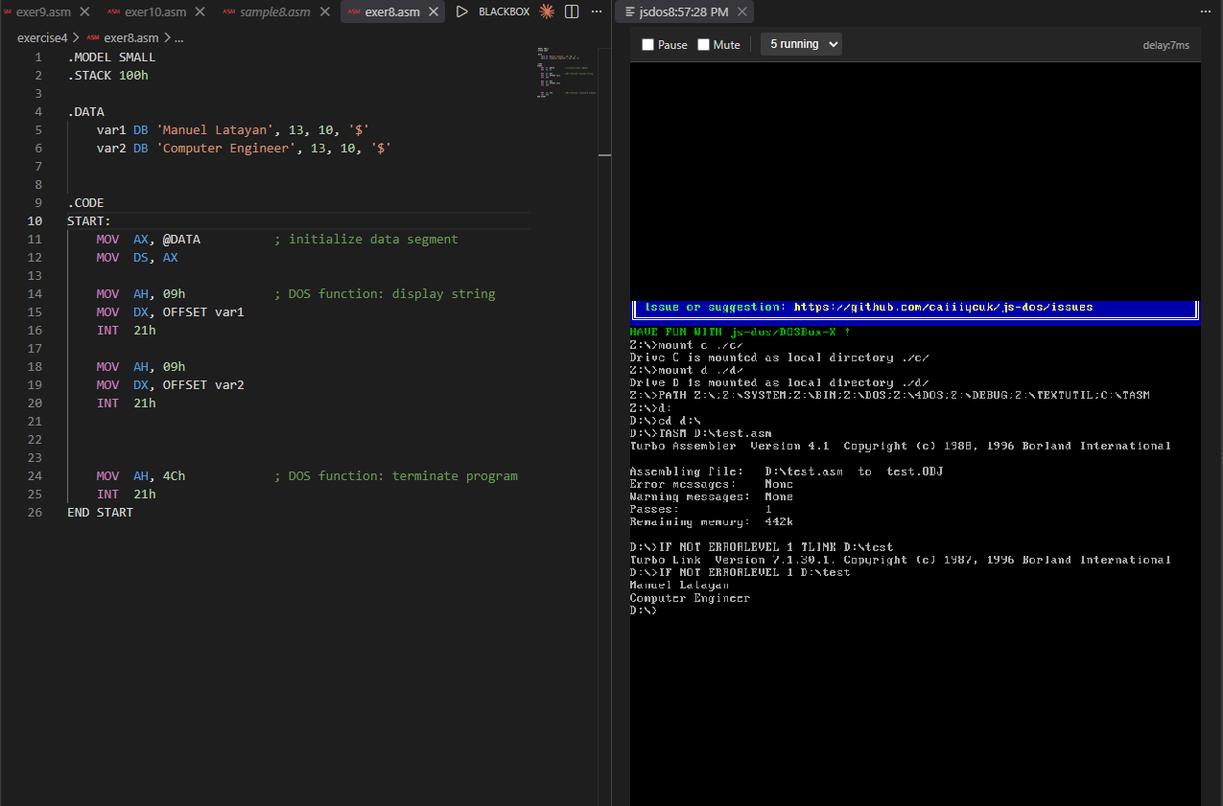

Machine Problem 2:
Create a personalized calling card that may follow the given format below using Function 09h that will display the string output. You can also choose your own border design and logo according to your design. Save the program using Exer9.asm as the filename.
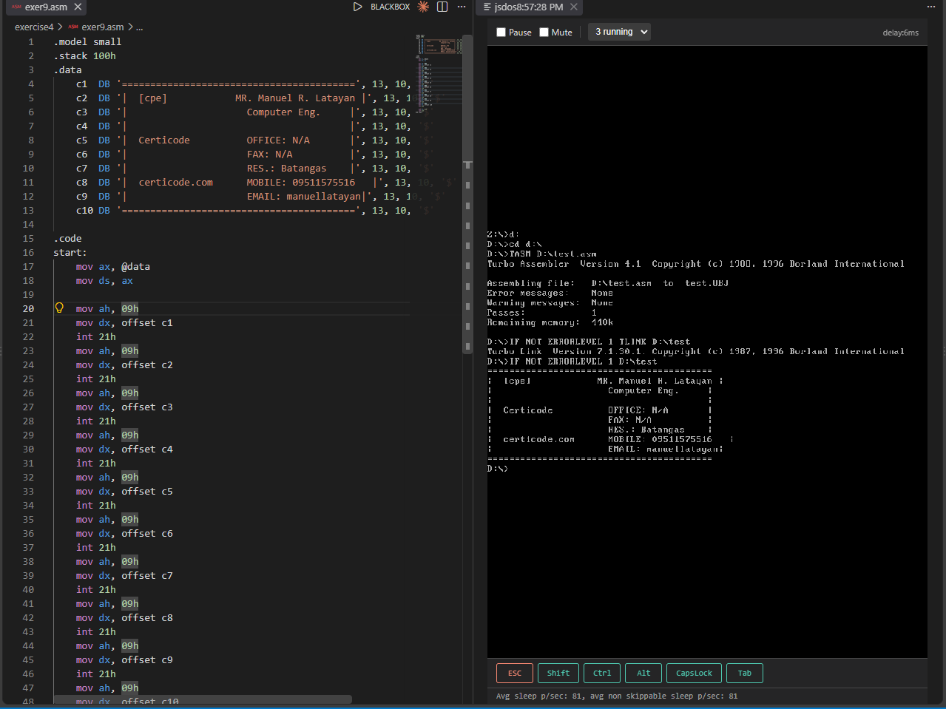

Machine Problem 3:
Create a program using Function 09h that will display a list of your favorite TV shows in any TV Network local or international. Save the program using Exer10.asm as the filename
