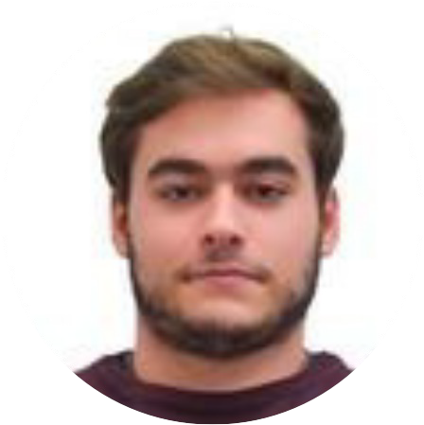

Personal Information

[manuelmribeiro2021@gmail.com](mailto:manuelmribeiro2021@gmail.com)

MANUEL RIBEIRO

University of Minho | MiEGSI

# About me

Recently concluded my Master's in Engineering and Information Systems Management at University of Minho, Portugal.

Technology has always been an important part of my life and I have always been interested in the different ways it has changed society as a whole and how it continues to do so. I love overcoming challenges as a team and exploring new technologies and philosophies.

[www.linkedin.com/in/](http://www.linkedin.com/in/)manuelrribeiro

# Education

manuel-ribeiro.com

|  |  |
| --- | --- |
| 2018 - 2023 | Master's in Engineering and Information Systems Management |
| 2009 - 2018 | University of Minho, Braga  Cólegio D. Diogo de Sousa, Braga |
| 2004 - 2009 | Externato Marista de Lisboa, Lisbon |

ManuelRibeiro89247

(+351) 925640960

Portuguese

Lamaçães, Braga

20-07-2000

# Languages



English Courses

Portuguese English

# Knowledge

C# HTML/CSS

React JavaScript Python

2017

2016

2014

2013

# Thesis

Summer School English

*LAL, New York*

International Student Club

*Haileybury College, Hertford*

Language Explorer Dublin

*Malvern House, Dublin*

International Student Club

*Haileybury College, Hertford*

# Hard and Soft Skills



Hard Worker Problem-solver Team Player Creative

# Areas of Interest

System innovation Digital transformation Knowledge management App development

Sign Language Translation using Mixed Reality (18)

App developed in Unity capable of translating sign

 language to text and spoken language to text. Uses Azure Services for voice transcription and MediaPipe for sign identification.

# Hobbies

Handball

Played handball for over six years in a federated level

3d printing (FDM)

Experience in optimizing and slicing different 3d models in Cura and some experience in creating my own 3d models using Blender

Fish/shrimp keeping

Avid fish keeper with experience in aquarium maintenance, fish care, and some shrimp breeding