Climatic Models of Amphibian Sensitivity to Climate Change: A Systematic Literature Review

Natalie V. Sánchez¹ , Manuel Spinola¹, Branko Hilje²
¹Instituto Internacional en Conservación y Manejo de Vida Silvestre
²Escuela de Ingeniería Forestal, Instituto Tecnológico de Costa Rica

Abstract
Falta

Keywords: Amphibians, Anurans, BioClim, Community Ecology, Global Warming, MaxEnt, Species Distribution Modeling

Introduction

Current predictions of global climatic change continue projecting the temperature increase of 1.5◦C in the next five years (WMO 2025), and even higher increases of 5.7◦C in the next century (IPCC, 2021). This temperature poses challenges to the current and future state of biodiversity. Declines and extinctions of plant and animal populations have been recorded over the past few decades (Martin & Maron 2012, Ceballos et al. 2017). Among the animals’ groups most threatened by climate change are the amphibians. Amphibians’ declines linked to climate change are documented since the late eighties (Pounds et al. 2006), mainly due to their sensitivity to climatic conditions such as precipitation and temperature, which affect their reproduction, dispersion, and survival (Pounds 2001, Todd 2011, Zumbado-Ulate et al. 2021).
Climatic modeling, particularly projecting climate change scenarios, has improved over the years, contributing to our understanding of the effects of climate on biodiversity and entire ecosystems (Harris et al. 2014, Agudelo-Hz et al 2019). The most common type of climatic modeling includes spatial modeling of species distribution ranges, known as species distribution models (SDMs), and their use revealed trends of amphibians declines under future scenarios of temperature increase worldwide (Vasconcelos et al. 2012, Agudelo-Hz et al 2019). Currently, these models can incorporate land-use change variations in their projections and assess climatic impacts under more complex scenarios on species. However, there are still limited examples in the literature of SDMs that include landscape changes and anthropogenic disturbances (e.g. deforestation, urbanization) as interacting variables in future climate change scenarios (Anunciação et al. 2023, Proios et al. 2024).
As the technological advances allow improvements in modeling species distribution shifts across space and time for threatened animal groups, there is still a lack of consensus on the methodological steps to follow and the variables to include in these models. With the recent inclusion of presence data from online repositories such as GBIF (gbif.org), SDMs benefit from the increase of data points associated with specific localities, in addition to the traditional use of data from museum specimens and scientific literature (Vasconcelos et al. 2012, García et al. 2013, Marcer et al. 2022). Modeling algorithms also benefit from the availability of large datasets and online bioclimatic data, such as the WORLDCLIM datasets. Yet these models still require expert assessment to evaluate their performance and ensure that predictions align with the biology of the study group. For amphibian range shifts under climate change, the SDMs are a useful tool for predicting future distributions, considering specific variables like the extent of suitable area and the extinctions risk (Mi et al. 2023, Pottier et al. 2025). Nonetheless, despite the great applicability of these models in conservation, few studies have assessed amphibian populations at the regional or national level (Vasconcelos et al. 2018, Anunciação et al. 2023). This pattern is particular true in the Tropics, which host the highest amphibian species richness (Tobar-Suárez et al. 2022).
In this study, our main goal is to contribute to the understanding of the main causes of amphibians’ geographic range shifts under climate change scenarios in the Tropics. We reviewed the literature from 2010 to 2025 on amphibians’ distributions changes from current to future distributions under climate change scenarios. We highlighted the methodological approaches used for the future estimates on the species range comparing model performance variation across the studies.

Methods

We conducted a systematic literature review following the guidelines of the Preferred Reporting Items for Systematic Reviews and Meta-Analyses (PRISMA; Moher et al. 2009). On June 4, 2025, we searched two electronic databases: Scopus and Web of Science (WoS). The search terms were “amphibian* AND tropic* AND climate change*” for Scopus and “amphibian* AND tropic* AND climate change*” for WoS, restricted to publications from 2010 to the present. The searches retrived 184 records from Scopus and 69 records from WoS (Figure 1). After removing duplicates, we screened titles and abstracts keeping only articles mentioning species modeling and climate change, resulting in 74 references retained from Scopus and 30 from WoS (Figure 1). In the next step, we read the methods sections and reviewed to identify studies that explicitly applied algorithms to calculate distribution shifts of amphibians under climate change scenarios. From the 74 Scopus references, 57 were excluded, leaving 17 articles for full-text review (Figure 1). From the 30 WoS references, 23 were excluded (including one duplicate), leaving 6 articles for full-text review (Figure 1). In total, 23 articles met the inclusion criteria and were retained for full article read, data extraction, and synthesis.
We excluded articles that did not reported any model algoritm for species distribution in future climate changes scenarios. Some studies did reported current distribution of the amphibians but did not projected species shift distrubutions; therefore, those studies were excluded from the review. Additionally, we excluded articles that the distrubtution range of the study species were mainly outside the Tropics and global datasets of multiple taxa, since our main focus are Tropical species of amphibians.

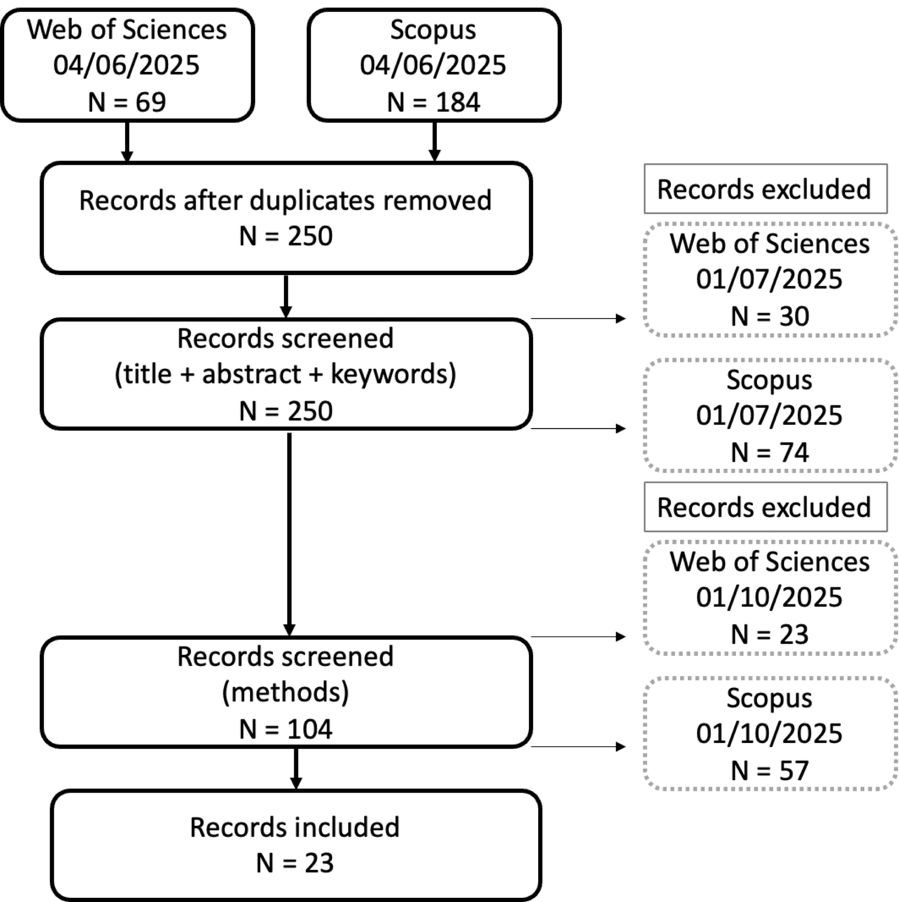
Figure 1. Flow diagram of articles screened and selected to be included in the systematic literature review following thePreferred Reporting Items for Systematic Reviews and Meta-Analyses (PRISMA).

As result, from the 23 studies, we excluded Zumbado et al. (2021), Vasconcelos et al. (2012), Davies et al. (2018), Courtois et al. (2016) since they did not projected changes in amphibians under climate change scenarios. We excluded Forero-Medina et al. (2011) since they did not use any algorithm to predict species range changes under climate change scenarios, the authors projected potential movements using temperature increases using ArcMap (v 9.3 ESRI 2009). Toranza & Maneyro 2013 was excluded since the study location is Uruguay, outside the Tropics. We excluded Zank et al. (2014) and Medina et al. (2020) since the study area goes beyond localities in the Tropics for the genus Melanophryniscus and Leptodactylus. Finally, we excluded He et al. (2023), Mi et al. (2023), Pottier et al. (2025), and Souza et al. (2022), since the reported global assessments of amphibian and other taxa, going out of the objective of this study of highlight the regional and local evaluation of amphibian declines in the Tropics.

Results
For our systematic literature review, we extracted data from 5 articles that met our criteria (Table 1). In all the reviewed articles, the authors used the 19 bioclimatic variables from the WORLDCLIM database v.1.4 (www.worldclim.org) (Hijmans et al., 2005). Most of the studies, represented the climate change scenarios using the Representative Concentration Pathway (RCP) from the 5th assessment report of the Intergovernmental Panel on Climate Change (IPCC, 2013). Mainly, the RCP4.5 called “stabilization” emissions scenario, moderate decrease in emissions is expected, given the implementation of green technologies and the expansion of forest areas (Thomson et al. 2011), extending to the year 2050 (average 2041 to 2060), and the RCP8.5 called “trend” scenario, linear advance in the projections of population growth, higher demand for energy resources, and absence of global policies for climate change (Riahi et al. 2011), extending to the year 2050 (average 2041 to 2060).
We extracted from the articles the modeling algorithms, predictive variables, number of species, spatial location, and the authors and year of publication. We presented each article according to the algorithm used to predict the future distribution shifts in amphibians distributions.

MaxEnt: Maxium Entropy
Agudelo-Hz et al. (2019) used Maxent to model the potential shift distribution (Spatial Distribution Models, SDM) of Colombian’ Andes anurans (30 spp) under two climate change scenarios, including land use change. The authors modified the Maxent algorithm: feature class (FC) and the regularization multiplier (β ranged from 0.5 to 5) and created 60 combinations for an equal number of models for each species. For each species, used the seven AOGCM and all occurrence localities. They evaluated model performance calculating the commission and omission error values using partial ROC curves test. Land cover/use map (year 2005) and a map of elevation at 90 m resolution for the species distribution. At least seven species will lose %70 of their current range due to climate change and land use conditions at high elevations.
Ballestero-Barrera et al. (2022) compared the current and future (2070) distribution of 62 endemic anurans species in the Tropical Dry Forest of Mexico, under two Representative Concentration Pathways RCP (RCP 4.5 and RCP 8.5), with the goal to identify changes in potential species richness between the two climatic scenarios. The authors obtained data occurrence data mainly from the Global Biodiversity Information Facility (www.gbif.org), literature and a local repository. For species distribution models, the authors used MaxEnt and specified the maximum number of iterations = 500, convergence threshold = 0.00001, and 10 replicates. Model performance using the cross-validation of the area under the curve (AUC) of the receiver operating curve (ROC), with values ranging from 1 (perfect fit to the model), to 0. The models had good predictive capacity with AUC values greater than 0.9, except for 5 species (values ranged between 0.74 and 0.89). Decline in RCP 4.5 and RCP 8.5 scenarios.

Other models
Anunciação et al. 2023 integrates ecological trait information into classical species distribution models (SDMs) analysis to account for climate change impacts on species distribution ranges at larger geographic regions and along environmental gradients. The authors decided to avoid the use of GBIF data to avoid biases due to varying data quality and spatial coverage, instead they looked for records in published literature, dissertations and theses in Google Scholar and universities libraries. This study performed four algorithms (BIOCLIM, Domain, MaxEnt, and Support Vector Machines) and the performance of each method was not included. They compared between climatic (RCP 4.5 and RCP 8.5) and temporal scenarios (years 2050 and 2070) using Kruskal-Wallis test for taxonomic richness and functional richness. The main result was the loss on amphibian species in all evaluated scenarios and suggest incorporating into the species distribution models habitat loss and fragmentation caused by agricultural development, urbanization, and economic mobility.
Vasconcelos et al. 2018 studied the amphibians (alpha and beta diversity) of the Cerrado and the Atlantic Forest of Brazil under climate change scenarios. The species included 350 species of anurans in the Atlantic Forest and 155 species in the Cerrado. The authors obtained the occurrence data from GBIF and museum specimens. The authors used ROP 2.6 and ROP 8.5 for future climate change scenarios. They estimated Ecological Niche Models (ENM or Species Distribution Models SDM), using four modeling algorithms: generalized linear models (GLM), boosted regression trees (BRT), random forest (RF), and support vector machines (SVM). Model performance was evaluated with the area under the curve (AUC) of the receiver operation characteristic (ROC), a threshold-independent statistic that ranges from 0 (model equivalent to a random prediction) to 1 (perfect model discrimination between presence and absence records, and the true skill statistic (TSS), a threshold-dependent statistic that ranges from -1 (model equivalent to a random prediction) to 1 (perfect model fit). All models had a strong predictive power: AUC range (0.973 – 0.936) and TSS range (0.934 – 0.863).
García et al. (2013) estimated the ecological niche modeling the present-data only of 29 endemic amphibian species of the Tropical Dry Forest of Mexico. The database used is part of a larger dataset (García 2006) of 63 amphibian species of Mexico. The authors projected ecological niche models for the climate change scenarios of 2020, 2050, and 2080 using the Intergovernmental Panel on Climatic Change Data Distribution Centre (IPCC-DDC): climate model CGCM2, and CGCM2 A2 scenario with project a relatively high temperature increase compared to other scenarios (3.75° latitude x 3.75° longitude spatial resolution). The authors divided the data in two groups for modeling, species with > 20 distinct geographic coordinates, and the second group of species < 20 distinct geographic coordinates. They measured model performance using the ROC curve (Fielding&Bell 1997), looking at the area under the curve (AUC) values for models produced with MaxEnt and Bioclim. AUC value ≈ 0.5 indicates no predicted capability and AUC value ≈ 1.0 indicates the higher predictive power. GARP models were evaluated with a X2 test comparing the omission rate (the percentage of correct points incorrectly predicted). Ten with ArcMap they compared the proportion of spatial correspondence from the models generated with the three algorithms. The general trend was range constrain and or disappearance of current high potential richness areas through time for 21 amphibian species, a decrease in the current distribution of the potential richness from 3.2% to 0.40% under the predicted climate change conditions for 2080. In this article, the authors compared the area of prediction between the model algorithms, MaxEnt showed the highest variability among species among future climate projections and BioClim showed less variability overall.
Synthesis and conclusion
Across studies using species distribution models (SDMs) to assess amphibian responses to climate change, a consistent pattern emerges: significant reductions in suitable habitat and projected declines in species richness. Research employing MaxEnt such as Agudelo-Hz et al. (2019) and Ballestero-Barrera et al. (2022), which used extensive occurrence datasets (e.g. GBIF) and evaluated multiple climate scenarios, incorporating land-use change. These studies generally report strong model performance and predict substantial range contractions, with some species losing up to 70% of their current distribution.
Studies using multiple algorithms (e.g., Anunciação et al. 2023; Vasconcelos et al. 2018; García et al. 2013) similarly predict substantial declines in amphibian diversity across regions such as the Cerrado, Atlantic Forest, and Tropical Dry Forest of Mexico. Ensemble method approaches consistently show high predictive accuracy and reveal reductions in both taxonomic and functional richness under mid- and late-century scenarios (2050–2080). Methodological differences among studies include variation in data sources (i.e. one study avoiding GBIF due to bias), the use of distinct climate models, thresholds, and performance metrics. Despite these differences, all studies converge on the conclusion that climate change, often compounded by land-use transformation, will reduce amphibian habitat availability and reshape community composition across Neotropical ecosystems.
As the ultimate goal of species distribution modeling is to support the planning of future protected areas (Lemieux & Scott 2005; Mansourian et al. 2009, García et al. 2013), this systematic literature review makes it evident that current protected area networks may no longer be adequate in the future. Therefore, regional and local assessments of shifts of amphibians and other threatened species are needed in the face of climate change.
Acknowledgments
We acknowledge the National University of Costa Rica for its financial support. PPAA name and number.

References
Agudelo-Hz, W. J., Urbina-Cardona, N., & Armenteras-Pascual, D. (2019). Critical shifts on spatial traits and the risk of extinction of Andean anurans: an assessment of the combined effects of climate and land-use change in Colombia. Perspectives in Ecology and Conservation, 17(4), 206-219.
Anunciação, P. R., Ernst, R., Martello, F., Vancine, M. H., de Carvalho, L. M. T., & Ribeiro, M. C. (2023). Climate-driven loss of taxonomic and functional richness in Brazilian Atlantic Forest anurans. Perspectives in Ecology and Conservation, 21(4), 274-285.
Ballesteros-Barrera, C., Tapia-Pérez, O., Zárate-Hernández, R., Leyte-Manrique, A., Martínez-Bernal, A., Vargas-Miranda, B., Martínez-Coronel, M., & Ortiz-Burgos, S. (2022). The Potential Effect of Climate Change on the Distribution of Endemic Anurans from Mexico’s Tropical Dry Forest. Diversity, 14(8), 650.
Ceballos, G., Ehrlich, P. R., & Dirzo, R. (2017). Biological annihilation via the ongoing sixth mass extinction signaled by vertebrate population losses and declines. Proceedings of the national academy of sciences, 114(30), E6089-E6096.
Garcia, A., Ortega-Huerta, M. A., & Martinez-Meyer, E. (2013). Potential distributional changes and conservation priorities of endemic amphibians in western Mexico as a result of climate change. Environmental Conservation, 41(1), 1-12.
Marcer, A., Chapman, A. D., Wieczorek, J. R., Xavier Picó, F., Uribe, F., Waller, J., & Ariño, A. H. (2022). Uncertainty matters: ascertaining where specimens in natural history collections come from and its implications for predicting species distributions. Ecography, 2022(9), e06025.
Martin, T. E., & Maron, J. L. (2012). Climate impacts on bird and plant communities from altered animal–plant interactions. Nature Climate Change, 2(3), 195-200.
Pounds, J.A., Bustamante, M. R., Coloma, L. A., Consuegra, J. A., Fogden, M. P., Foster, P. N., ... & Young, B. E. (2006). Widespread amphibian extinctions from epidemic disease driven by global warming. Nature, 439(7073), 161-167.
Pounds, J.A. (2001) Climate and amphibian declines. Nature 410: 639–640.
Proios, K., Michailidou, D. E., Lazarina, M., Tsianou, M. A., & Kallimanis, A. S. (2024). Climate and Land Use Changes Impact the Future of European Amphibian Functional Diversity. Land, 13(8), 1206.
Todd, B. D., Scott, D. E., Pechmann, J. H., & Gibbons, J. W. (2011). Climate change correlates with rapid delays and advancements in reproductive timing in an amphibian community. Proceedings of the Royal Society B: Biological Sciences, 278(1715), 2191-2197.
Tobar-Suárez, C., Urbina-Cardona, N., Villalobos, F., & Pineda, E. (2022). Amphibian species richness and endemism in tropical montane cloud forests across the Neotropics. Biodiversity and Conservation, 31(1), 295-313.
Vasconcelos, T. S., do Nascimento, B. T., & Prado, V. H. (2018). Expected impacts of climate change threaten the anuran diversity in the Brazilian hotspots. Ecology and Evolution, 8(16), 7894-7906.
Zumbado‐Ulate, H., García‐Rodríguez, A., & Searle, C. L. (2021). Species distribution models predict the geographic expansion of an enzootic amphibian pathogen. Biotropica, 53(1), 221-231.

Table 1. Modeling algorithms used by research article including specific information on predictive variables, grid size, and a general description of the amphibian species included at each study.
Modeling algorithms | Predictive variables | Grid size | Species | Region/Country | Author(s) & year
MaxEnt  Species Distribution Models (SDM) | Current climatic conditions: 19 bioclimatic variables WorldClim data base v.1.4 second arcs.  Climate change scenarios: Representative Concentration Pathway (RCP) RCP4.5 and RCP8.5.  Atmosphere-Ocean Global Circulation Models (AOGCMs) four for RCP4.5 and three for RCP8.5  Local land use change scenarios | ~1 km2 | 30 spp of anurans in 4 families Bufonidae (4 sp.); Centrolenidae (2 sp.); Craugastoridae (22 sp.), and Hylidae (2 sp.); and 10 genera (Atelopus, Rhinella, Osornophryne, Centrolene, Nyphagus, Hypodactylus,Pristimantis, Tachiramantis, Dendropsophus and Colomascirtus). | Andes region, Colombia | Agudelo-Hz et al. 2019
MaxEnt  Species Distribution Models (SDM) | Current climatic conditions: 19 bioclimatic variables WorldClim data base v.1.4 second arcs.  Climate change scenarios: Representative Concentration Pathway (RCP) RCP4.5 and RCP8.5. | ~1 km2 | 62 endemic anuran species in the families Bufonidae, Craugastoridae, Eleutherodactylidae, Hylidae, and Ranidae),  17 genera. | Tropical Dry Forest, Mexico | Ballestero-Barrera et al. 2022
Bioclim, Domain, MaxEnt, and Support Vector Machines (SVM)  Species Distribution Models (SDM) | Current climatic conditions: 19 bioclimatic variables WorldClim data base at a spatial resolution of 2.5 min.  Climate change scenarios: Representative Concentration Pathway (RCP) RCP4.5 and RCP8.5.  Occurrence data and ecological trait information | Spatial resolution 2.5 min | 171 spp of amphibians of the Atlantic Forest occurrence data  109 species of anurans from 15 families. High representativeness of Aromobatidae and Ranidae, followed by Hylidae and Leptodactylidae. | Atlantic Forest, Brazil | Anunciaçao et al. 2023
Generalized linear models (GLM), boosted regression trees (BRT), random forest (RF), and support vector machines (SVM).  Ecological Niche Models (ENM or SDM) | Current climatic conditions: 19 bioclimatic variables WorldClim data base at a spatial resolution of ~10 km (9 variables used in the models).  WorldClim dataset for baseline climatic niches into future climatic scenarios.  Climate change scenarios: Representative Concentration Pathway (RCP) RCP2.6 and RCP8.5.  Three AOGCMs: CCSM4, MRI-CGCM3, and IPSL-CM5A-LR. | ~ 10 km | 350 spp of anuran in the Atlantic Forest and 155 spp in the Cerrado. | Cerrado and Atlantic Forest, Brazil | Vasconcelos et al. 2018
MaxEnt, Genetic Algorithm for Rule-set Production (GARP), and Bioclim.  Ecological Niche Modelling analysis | Current climatic conditions: 19 bioclimatic variables WorldClim data base for 1960-1990 and 1950-2000, seven selected for modeling.  Climate change scenarios: Intergovernmental Panel on Climatic Change Data Distribution Centre (IPCC-DDC). Climate Model CGCM2, and CGCM2 A2 scenario. | Spatial resolution ~ 1 km² | 29 endemic amphibian spp | Tropical Dry Forest, Mexico | García et al. 2013

