Sample description
Wheat kernels (415) representing 43 different varieties or variety mixtures from two different locations in Denmark made up the calibration set, while wheat kernels (108) representing 11 different varieties from one location made up the test set10. All kernels were randomly chosen from bulk samples. The test samples were acquired with the calibration samples, but stored for about 2 additional months before measurement in order to provide a check for temporal drift in the samples and instrumentation.
Y , to be calibrated, contain the protein content.
Data (Matlab format)
wheat_ds.mat X training set
Calibration_Y.mat Y training set
test set: Validation_X.mat Validation_Y.mat

AIM
Predict the protein content from NIT ( near infrared transmission) spectra
How to do
- Esplorative PCA of Calibration_X ( check for cluster , outliers, important spectral regions)
  - Try different preprocessing among weighted baseline, MSC, 2nd Derivative, and choose the best one or the best combination of baseline + MSC or baseline + 2nd derivative or 2nd derivative + MSC
- PLS of Calibration_X/Calibration_Y
  - Use the best preprocessing chosen before + mean center, Y mean centered
  - Use crossvalidation (scegli lo schema di cancellazione)
  - Fit the model; choose the best number of components
  - Inspect inner – relation, residuals, leverage
  - Inspect Ymeas/Yfit Ymeas/YCV
  - Inspect residual
  - Plot and interpret PLS weights, regression coefficients, VIP and decide which are the most important spectral regions to predict Y
  - Predict test set
  - Plot Ymeasured/Y_pred del test set
  - Eventually select a subset of spectral region and see if PLS model improve

INFORMAZIONI PER INTERPRETAZIONE RISULTATI

The use of the lower near infrared wavelength range (780-1100 nm) has allowed for transmittance measurements on whole grains due to more powerful radiation and lower absorbances in this range. By applying near infrared transmittance (NIT), a larger portion of the sample is irradiated and the homogenisation and packing of the sample is thus less critical.

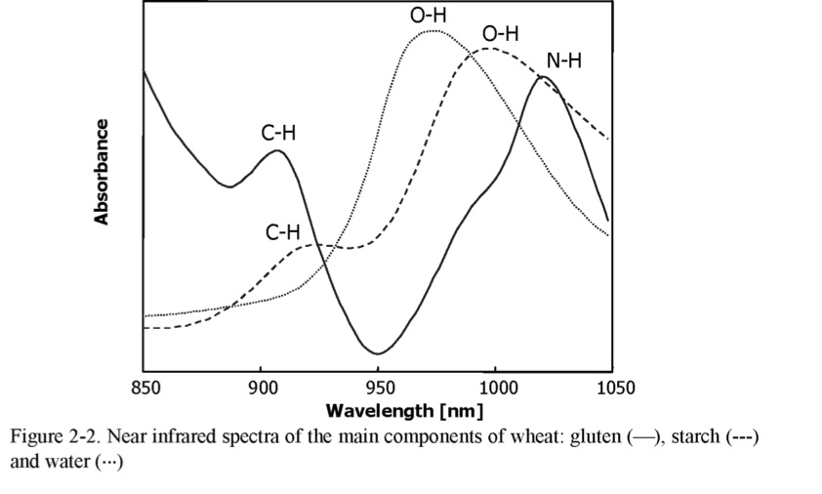
NIT spectra using an Infratec instrument from Foss Tecator cover the spectral region from 850 nm to 1050 nm containing primarily the second overtones of O-H (carbohydrates and water) and N-H (protein) stretching vibrations and the third overtone of the C-H (fats) stretching vibration. Near infrared spectra of gluten, starch and water in the spectral region of 850-1050 nm are shown in Figure 2-2 with assignments of the second and third overtones of fundamental N-H, C-H and 0-H stretching corresponding to the expected band in this region.

