AWS Cloud Cost Analysis Report
Example Data Platform | June – August 2026

1. Project Overview
Field | Value
Project Name | Example Data Platform
AWS Account ID | 123456789012
AWS Profile | cost-audit
Primary Region | us-west-2 (Oregon)
Created by | Cloud Engineering
Period of Report | June 2026 – August 2026 (3 complete months)
Report Generated | 17 September 2026
Data Source | AWS Cost Explorer API (ce:GetCostAndUsage), UnblendedCost
Evidence Pack | cost-report-jun-aug-2026/ (raw API responses + derived CSVs)

2. Executive Summary
Gross AWS spend for the Example Data Platform account over June–August 2026 totalled $30,849.57, an average of $10,283.19 per month. Spend was flat between June ($9,950.68) and July ($9,617.81), then rose sharply in August to $11,281.08 — a +17.3% month-over-month move that accounts for essentially all of the period's +13.4% net change. The August increase is not broad-based: two services, Amazon RDS and AWS Glue, contribute $1,205.30 of the $1,663.27 July-to-August rise between them (72% of it).
Both of those increases were traced to a single named resource. The RDS increase is one Aurora Serverless v2 cluster that ran against its capacity ceiling for most of August; the Glue increase is a concentrated set of ETL jobs, reconstructed run-by-run in Section 6. Neither is organic growth, and both are addressable.

Key Findings
- Total spend for the period: $30,849.57 | Average monthly: $10,283.19
- Overall trend: increasing (+13.4% from June to August), with the entire move concentrated in August (+17.3% vs July)
- Largest cost increase: Amazon RDS (Aurora) (+$591.05, +35.3%) — a single Aurora Serverless v2 cluster
- Largest cost reduction: Amazon CloudWatch (−$36.66, −5.5%) — no material reductions occurred this period
- Top 3 services by period spend: AWS Glue ($5,834.65), Amazon RDS (Aurora) ($5,713.15), Amazon QuickSight ($3,032.45)

Service-Level Preview
- Aurora Serverless v2 capacity 4.2× in August (1,165 → 4,851 ACU-hours, +$470) — the cluster sat pinned at its 8.0 ACU maximum with CPU at 100% for 12 full days
- AWS Glue +$713 in August (3,524 → 5,073 DPU-hours) — a sustained baseline shift, not a spike: median daily Glue cost rose from $37 to $65
- A new Glue billing line, ETL-DPU-Hour-Gen2, appears for the first time in August (102.7 DPU-hours, $31.63) at $0.308/DPU-hour — 30% below the $0.44 Gen1 rate
- AWS Config swung −$91 then +$179 on configuration-item volume (125k → 95k → 144k items recorded)
- Fixed-price services (QuickSight capacity packs, MWAA Large environment, Support) account for roughly $2,000/month and did not move

3. Service-Level Insights
Services are ranked by gross spend over the period. The ten below cover 92.3% of all spend; each entry gives the month-by-month figures, the trend, the root cause established from usage-type data, and the single most important action.

1. AWS Glue: Sustained baseline shift (+12.1% over the period, +46.0% in August)
Jun 2026: $2,020.27 | Jul 2026: $1,550.55 | Aug 2026: $2,263.83
Net change: +$243.56 (+12.1%) from period start to end | Period total: $5,834.65 (18.9% of all spend)
Billed DPU-hours moved 4,591.5 → 3,524.0 → 5,073.2 at a flat $0.44/DPU-hour. August is not a spike: median daily Glue spend rose from $37 in July to $65 in August, meaning the everyday floor moved rather than a few large days landing. A new billing line, ETL-DPU-Hour-Gen2, also appears for the first time in August (102.7 DPU-hours, $31.63) at $0.308/DPU-hour. Section 6 attributes this spend run-by-run to named jobs.
Recommendation: Act on the per-job findings in Section 6 — in particular the short-run billing floor, which is the largest single source of waste.

2. Amazon RDS (Aurora): Sharp increase (+35.3%), entirely one Aurora Serverless v2 cluster
Jun 2026: $1,674.36 | Jul 2026: $1,773.39 | Aug 2026: $2,265.41
Net change: +$591.05 (+35.3%) from period start to end | Period total: $5,713.15 (18.5% of all spend)
Every other RDS line is flat or grows slowly with storage: the provisioned db.r7i.2xlarge instance is constant at $1,121.95/month, and Aurora storage and backup grow with data volume. The increase is Aurora:ServerlessV2Usage, which went 931.9 → 1,165.2 → 4,850.6 ACU-hours at $0.12/ACU-hour. Section 5 shows this is a single cluster, sessions-index-db-1, running at its configured 8.0 ACU maximum with CPU pinned at 100%.
Recommendation: Treat this as a capacity and performance problem first (see Section 5) — the cost is a symptom of a database that could not scale further.

3. Amazon QuickSight: Stable (+1.8%); three quarters of it is fixed capacity
Jun 2026: $975.25 | Jul 2026: $1,026.68 | Aug 2026: $1,030.52
Net change: +$55.27 (+5.7%) from period start to end | Period total: $3,032.45 (9.8% of all spend)
$750/month is fixed and unchanging: a Q Query capacity 500-pack ($250), a Reader capacity 500-pack ($250) and the Amazon Q QuickSight fee ($250). The only moving parts are seats — Author Pro grew $80.00 → $151.40 while Enterprise seats fell $144.00 → $127.87, a net migration of users onto the more expensive Author Pro tier.
Recommendation: Audit Author Pro seats against actual authoring activity; the capacity packs are worth reviewing against real query and reader volume.

4. AWS Support (Business): Tracks spend by definition (+12.6%)
Jun 2026: $904.27 | Jul 2026: $874.23 | Aug 2026: $1,018.31
Net change: +$114.04 (+12.6%) from period start to end | Period total: $2,796.81 (9.1% of all spend)
Business Support is billed as a percentage of monthly AWS usage, so it rises and falls with the rest of the bill. Its August increase is a direct consequence of the Glue and RDS increases, not an independent cost event.
Recommendation: No direct action. Every dollar saved elsewhere reduces this line by roughly 9% of that amount.

5. Amazon VPC: Increasing (+14.3%), driven by network appliance hours
Jun 2026: $806.72 | Jul 2026: $903.38 | Aug 2026: $921.71
Net change: +$114.99 (+14.3%) from period start to end | Period total: $2,631.81 (8.5% of all spend)
This is almost entirely fixed hourly infrastructure rather than traffic: site-to-site VPN tunnels ($264.05 → $334.80, an added tunnel in July), Client VPN endpoint hours ($223.20), Transit Gateway attachment hours ($111.60) and in-use public IPv4 addresses ($107.92). Data processing is a minor component.
Recommendation: Audit idle Client VPN endpoints and unattached or unused public IPv4 addresses — both bill continuously whether used or not.

6. Amazon MWAA: Flat (+1.3%)
Jun 2026: $745.53 | Jul 2026: $768.85 | Aug 2026: $774.78
Net change: +$29.25 (+3.9%) from period start to end | Period total: $2,289.17 (7.4% of all spend)
One Large MWAA environment at $712.80–$736.56/month plus a small additional-worker charge. The cost is essentially fixed and did not respond to the August workload increase elsewhere.
Recommendation: Evaluate whether a Medium environment class carries the current DAG load; this is the clearest fixed-cost reduction available.

7. Amazon CloudWatch: Slight decrease (−5.5%)
Jun 2026: $668.83 | Jul 2026: $607.01 | Aug 2026: $632.17
Net change: −$36.66 (−5.5%) from period start to end | Period total: $1,908.00 (6.2% of all spend)
Custom metric monitoring dominates at $460–$505/month — roughly 75% of the service — with log data ingestion at $91–$106/month a distant second. The decline came from fewer custom metrics, not reduced logging.
Recommendation: Inventory custom metrics and retire those no longer on a dashboard or alarm; each metric bills monthly whether read or not.

8. Amazon S3: Steady growth (+10.8%)
Jun 2026: $484.77 | Jul 2026: $504.07 | Aug 2026: $536.91
Net change: +$52.14 (+10.8%) from period start to end | Period total: $1,525.75 (4.9% of all spend)
Storage is the whole story: TimedStorage-ByteHrs rose $461.78 → $520.08, a consistent ~6%/month compound increase, while request charges fell. This is data accumulation, not access-pattern change.
Recommendation: Enable Intelligent-Tiering on the largest data-lake prefixes and set a lifecycle policy on Glue temporary output, which is rarely read after the job completes.

9. Amazon EC2 — Compute: Flat (+4.9%)
Jun 2026: $456.67 | Jul 2026: $470.99 | Aug 2026: $479.27
Net change: +$22.60 (+4.9%) from period start to end | Period total: $1,406.93 (4.6% of all spend)
Steady instance hours with no material change across the period.
Recommendation: Run Compute Optimizer and evaluate Graviton equivalents for any long-running instances.

10. AWS Config: Volatile (+19.7%), tracking resource churn
Jun 2026: $445.50 | Jul 2026: $354.07 | Aug 2026: $533.14
Net change: +$87.64 (+19.7%) from period start to end | Period total: $1,332.70 (4.3% of all spend)
Configuration items recorded moved 125,189 → 95,406 → 144,075, and conformance-pack evaluations followed the same shape (69,928 → 67,848 → 101,144). The August rise coincides with the Glue job creation and deletion activity documented in Section 6 — each job create, update and delete is a recorded configuration item.
Recommendation: Narrow the recorder's scope to resource types that carry compliance obligations; high-churn ephemeral resources are the expensive ones.

4. Cost Breakdown

4.1 August 2026 Costs (Most Recent Complete Month)
All figures are gross charges. Services billing under $5.00 in the month are aggregated into a single row.
AWS Service | Amount | % of Total | What it is being used for
Amazon RDS (Aurora) | $2,265.41 | 20.1% | Aurora PostgreSQL — one provisioned r7i.2xlarge cluster + one Serverless v2 cluster
AWS Glue | $2,263.83 | 20.1% | Serverless ETL jobs — 194 jobs, billed in DPU-hours
Amazon QuickSight | $1,030.52 | 9.1% | BI dashboards — Q/Reader capacity packs, Amazon Q fee, Author Pro & Enterprise seats
AWS Support (Business) | $1,018.31 | 9.0% | Business Support plan (percentage of spend, $100 minimum)
Amazon VPC | $921.71 | 8.2% | Site-to-site VPN tunnels, Client VPN, Transit Gateway, public IPv4 addresses
Amazon MWAA | $774.78 | 6.9% | One Large MWAA environment plus additional workers
Amazon CloudWatch | $632.17 | 5.6% | Custom metric monitoring, log ingestion, alarms and vended logs
Amazon S3 | $536.91 | 4.8% | Object storage — data lake, Glue outputs and CloudTrail archive
AWS Config | $533.14 | 4.7% | Configuration item recording and conformance-pack rule evaluations
Amazon EC2 — Compute | $479.27 | 4.2% | EC2 instance hours
AWS Secrets Manager | $332.99 | 3.0% | Secret storage and API requests
EC2 - Other | $181.50 | 1.6% | EBS volumes, snapshots, NAT and Elastic IP charges
Amazon ECS | $141.88 | 1.3% | ECS / Fargate task compute
Elastic Load Balancing | $83.75 | 0.7% | ALB / NLB load-balancer hours and LCUs
IAM Access Analyzer | $42.60 | 0.4% | IAM external- and unused-access analyzers
Amazon EMR | $28.61 | 0.3% | EMR cluster hours
AWS Key Management Service | $9.00 | 0.1% | KMS customer-managed keys and cryptographic operations
Other Services (5 items) | $4.71 | 0.0% | Aggregated services under $5.00/month each
Total | $11,281.08 | 100.0% | All billed AWS services for the month

4.2 Historical Comparison (June – August 2026)
AWS Service | Jun 2026 | Jul 2026 | Aug 2026 | MoM Change (Jul→Aug)
AWS Glue | $2,020.27 | $1,550.55 | $2,263.83 | ↑ +$713.28 (+46.0%)
Amazon RDS (Aurora) | $1,674.36 | $1,773.39 | $2,265.41 | ↑ +$492.02 (+27.7%)
Amazon QuickSight | $975.25 | $1,026.68 | $1,030.52 | ↑ +$3.84 (+0.4%)
AWS Support (Business) | $904.27 | $874.23 | $1,018.31 | ↑ +$144.08 (+16.5%)
Amazon VPC | $806.72 | $903.38 | $921.71 | ↑ +$18.33 (+2.0%)
Amazon MWAA | $745.53 | $768.85 | $774.78 | ↑ +$5.93 (+0.8%)
Amazon CloudWatch | $668.83 | $607.01 | $632.17 | ↑ +$25.16 (+4.1%)
Amazon S3 | $484.77 | $504.07 | $536.91 | ↑ +$32.84 (+6.5%)
Amazon EC2 — Compute | $456.67 | $470.99 | $479.27 | ↑ +$8.28 (+1.8%)
AWS Config | $445.50 | $354.07 | $533.14 | ↑ +$179.07 (+50.6%)
AWS Secrets Manager | $324.18 | $335.35 | $332.99 | ↓ −$2.36 (−0.7%)
EC2 - Other | $177.13 | $179.05 | $181.50 | ↑ +$2.45 (+1.4%)
Amazon ECS | $114.78 | $108.76 | $141.88 | ↑ +$33.12 (+30.5%)
Elastic Load Balancing | $64.86 | $76.84 | $83.75 | ↑ +$6.91 (+9.0%)
IAM Access Analyzer | $40.80 | $41.60 | $42.60 | → +$1.00 (+2.4%)
Amazon EMR | $31.38 | $29.45 | $28.61 | → −$0.84 (−2.9%)
AWS Key Management Service | $9.00 | $8.99 | $9.00 | → +$0.01 (+0.1%)
Total | $9,950.68 | $9,617.81 | $11,281.08 | ↑ +$1,663.27 (+17.3%)
Trend: ↑ increasing · ↓ decreasing · → stable.

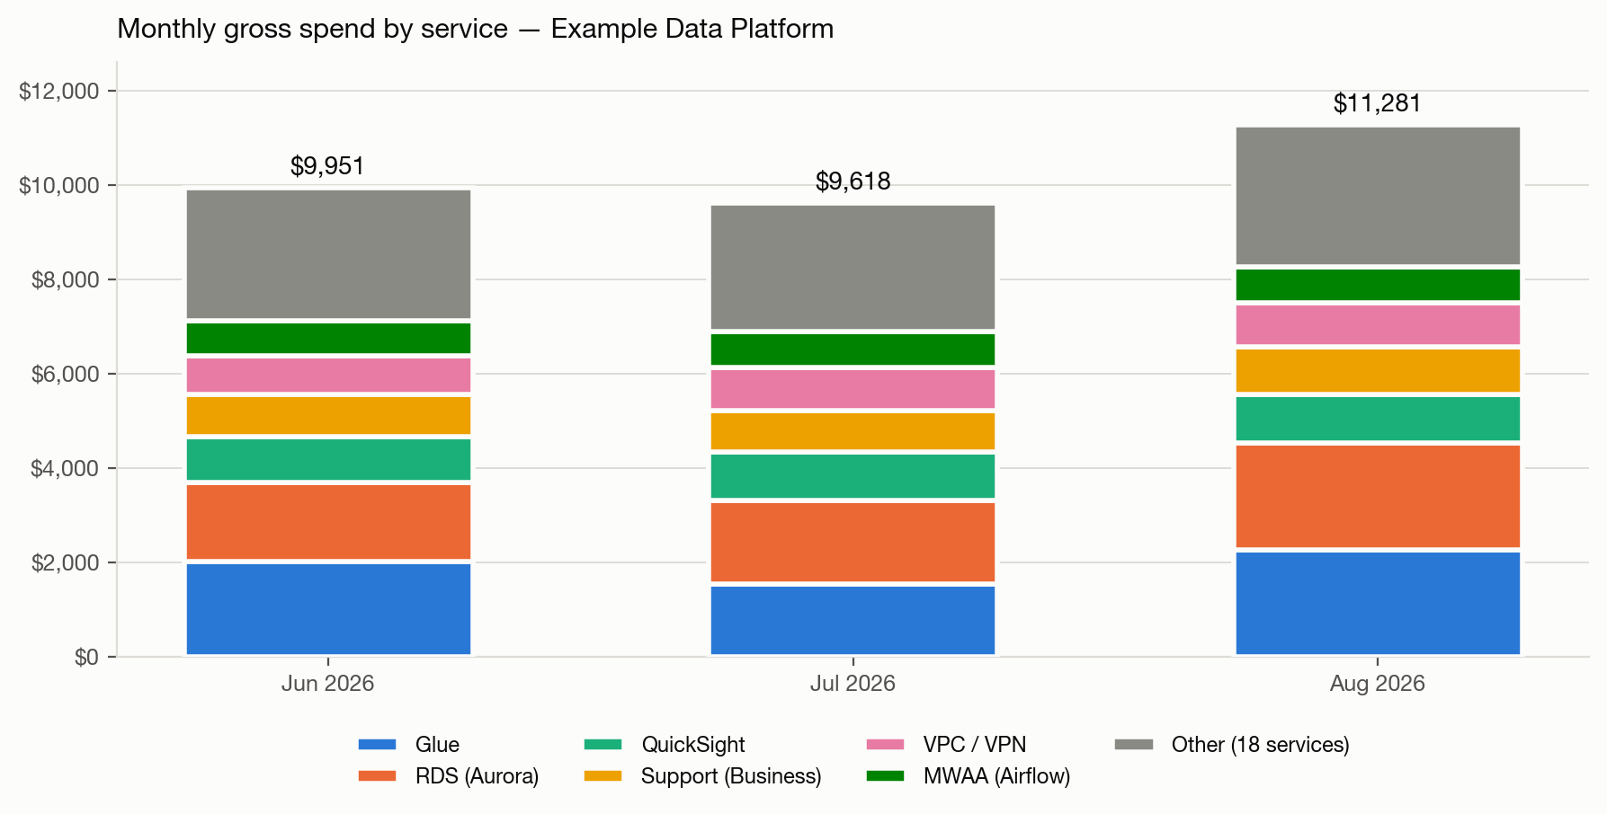
Figure 1 — Monthly gross spend by service. The top six services and an aggregate of the remaining 18.

5. Aurora Serverless v2 Deep Dive — sessions-index-db-1
Amazon RDS is the account's second-largest service and produced the single largest increase of the period. Cost Explorer attributes that increase to one usage type, Aurora:ServerlessV2Usage, but a usage type is not an answer. This section identifies the cluster, reconciles its measured capacity against the bill, and establishes what actually happened.

5.1 Method and Attribution Coverage
Two sources were used. Cost Explorer supplies billed ACU-hours at daily granularity. CloudWatch supplies the cluster's actual ServerlessDatabaseCapacity at one-hour resolution — one-hour period is required, not a finer one, because CloudWatch retains five-minute data for only 63 days and June falls outside that window.
The cluster inventory was built from CloudWatch list-metrics rather than describe-db-clusters, because the RDS API only returns clusters that still exist and a deleted cluster keeps its cost on the bill. list-metrics returned exactly one cluster emitting ServerlessDatabaseCapacity in the period — sessions-index-db-1 — so no deleted cluster is hiding in this line.
Month | Billed ACU-hours | CloudWatch ACU-hours | Coverage | Residual | Cost
Jun 2026 | 931.9 | 931.8 | 100.0% | 0.1 | $111.83
Jul 2026 | 1,165.2 | 1,165.2 | 100.0% | 0.0 | $139.83
Aug 2026 | 4,850.6 | 4,850.6 | 100.0% | -0.0 | $582.08
Period | 6,947.8 | 6,947.7 | 100.0% | 0.1 | $833.73
Coverage is 100.0% because a single cluster accounts for the entire usage type; the residual is rounding only. The implied unit rate, $833.73 ÷ 6,947.8 ACU-hours, is $0.12000/ACU-hour exactly — confirming the right column is being read. Every figure in this section is measured, not inferred.

5.2 What Happened
The cluster's capacity is shown in Figure 2. Three regimes are visible.

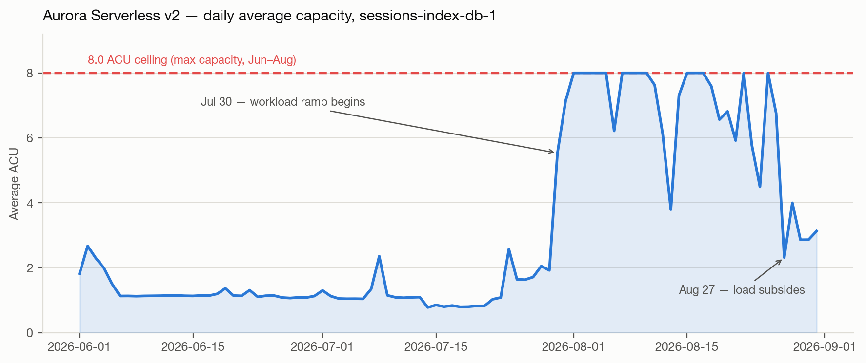
Figure 2 — Daily average ACU for sessions-index-db-1 against its configured 8.0 ACU maximum.
Period | Avg ACU | Behaviour
Jun 1 – Jul 23 | 1.0 – 1.3 | Idle baseline. Capacity floats just above the 0.5 ACU minimum; CPU ~10%.
Jul 24 – Jul 29 | 1.6 – 2.6 | First contact with the ceiling. Daily maximum reaches 8.0 ACU for the first time; CPU 20–31%.
Jul 30 – Aug 26 | 3.8 – 8.0 | Saturation. CPU averages 100% on twelve full days, on which capacity never leaves 8.0 ACU.
Aug 27 – Aug 31 | 2.3 – 3.1 | Load subsides. Capacity falls away from the ceiling; CPU 27–50%.

5.3 This Is a Capacity Ceiling, Not a Raised Floor
The distinction matters, because the two have opposite remedies. A raised minimum ACU would mean somebody was paying for idle capacity, and the fix would be to lower it. That is not what happened here.
- The hourly minimum observed on almost every day, including most of August, is 0.50 ACU — the floor was never raised.
- The hourly maximum from July 24 onward is exactly 8.00 ACU and never exceeds it, while CPU utilisation reaches exactly 100.0%.
- On twelve August days the cluster billed exactly 192.0 ACU-hours — 8.0 ACU × 24 hours — meaning it sat at its ceiling continuously.
- CloudTrail records exactly one ModifyDBCluster call on this cluster in the last 90 days: 1 September 2026, raising maximum capacity from 8.0 to 12.0 ACU. Throughout June–August the ceiling was 8.0.
⚠ Finding: for most of August this database was running at its maximum configured capacity with CPU saturated at 100%. The $470 cost increase is the visible symptom; the operational risk is that the cluster had no headroom left to absorb further load. Query latency during this window should be reviewed independently of cost.
The maximum was raised to 12.0 ACU on 1 September 2026, outside this report period. If the workload that drove August persists, September will bill more than August — the ceiling that capped the cost has been lifted. That is the correct fix for availability, but it removes the cap on spend, and it should be paired with a budget alarm.

5.4 Recommendations
Action | Target | Estimated impact | Effort
Identify the workload that began on 30 July and confirm it is intended | sessions-index-db-1 | Up to $470/month if unintended | Low
Review query latency and error rates for the saturation window (Jul 30 – Aug 26) | sessions-index-db-1 | Reliability, not cost | Low
Set a CloudWatch alarm on ServerlessDatabaseCapacity at 90% of maximum | sessions-index-db-1 | Prevents silent recurrence | Low
Set a billing alarm on Aurora ACU-hours now that the ceiling is 12.0 | Account | Caps exposure after the 1 Sep change | Low
Review slow queries and indexing before treating 12.0 ACU as the new normal | sessions-index-db-1 | Potentially structural | Medium

6. AWS Glue Deep Dive — DPU-Hours by Job
AWS Glue is the account's largest service at $5,834.65 for the period, and the statement "Glue rose $713 in August" is a fact, not a finding. Cost Explorer stops at the usage type, so this section reconstructs Glue spend run-by-run to identify the individual jobs responsible.
Glue is included here at the reader's request rather than because it crossed a threshold: at 18.9% of period spend and 18% of the net change it sits below the usual triggers for this level of investigation. The justification is the shape of the change — August's rise came from the everyday baseline (median daily spend $37 → $65), not from identifiable spikes, and a baseline shift cannot be explained at service level.
A note on what this cost to produce: cost-allocation tags would have answered the question directly, but ce:ListCostAllocationTags returns AccessDeniedException on this linked account — the ledger controls tags. The reconstruction below required 16,951 CloudTrail archive objects scanned via S3 Select (344,346 Glue events, 460 seconds) plus a second 12,381-object scan, a 74-day CloudTrail Event-history sweep, and 194 Glue API job histories. Activating cost-allocation tags at the ledger would make all of it unnecessary next quarter.

6.1 Method and Attribution Coverage
Four sources were combined, because no single one is complete:
- Glue GetJobRuns — per-run DPUSeconds, the billed figure and authoritative where present. It is incomplete: it only returns runs for jobs that still exist.
- CloudTrail Event history — StartJobRun events, swept one UTC day per worker. Reaches back exactly 90 days, to 19 June 2026.
- CloudTrail S3 archive — the same events before that boundary, read with S3 Select. Required because the 90-day horizon falls in the middle of this report's June.
- CloudWatch Logs — log-stream spans supply durations for runs the Glue API never returned.
Run durations were priced in order of evidence quality: per-run DPUSeconds where the API had it; otherwise that job's own median billed duration measured across its surviving runs; and only for jobs with no surviving runs at all, a log-stream span plus a 14-second startup offset. Preferring a job's own measured runs matters — for the largest job the span estimator overshoots true billed duration by 3.9%, measured against 40 runs with known DPUSeconds. Worker sizing was taken from a CreateJob/UpdateJob timeline and each run priced at the configuration in force when it ran, with every timestamp normalised to UTC first.
Month | Billed DPU-h | Glue API | CloudTrail | S3 archive | Attributed | Coverage | Residual
Jun 2026 | 4591.5 | 1780.1 | 1571.1 | 449.1 | 3800.2 | 82.8% | 791.3
Jul 2026 | 3524.0 | 3273.0 | 0.1 | 0 | 3273.1 | 92.9% | 250.9
Aug 2026 | 5175.9 | 4536.2 | 363.8 | 0 | 4899.9 | 94.7% | 276.0
PERIOD | 13291.4 |  |  |  | 11973.2 | 90.1% | 1318.2

What the residual is
Period coverage is 90.1%, at the lower edge of what this method targets. The residual is not uniform and its two components are different in kind:
- A flat baseline of roughly 8 DPU-hours per day across July and August (median 8.2, mean 8.5). At ~24,500 runs in the period this is about 0.04 DPU-hours per run of per-run provisioning overhead that DPUSeconds does not capture. It is expected and benign.
- A June concentration of 791 DPU-hours, almost all of it on 17–20 June. This is deleted jobs. CloudTrail records 80 DeleteJob calls covering 63 distinct jobs during the period, 28 of them on 19 June and 52 on 20 June — precisely the days the residual appears. 40 of those 63 deleted jobs have no StartJobRun event in CloudTrail at all, because runs launched by a Glue trigger or workflow are not user-initiated API calls. Such a run is invisible to both sources at once: the Glue API lost it with the job, and CloudTrail never recorded it. Their cost is real and remains on the bill; it cannot be attributed to a job name.
Two checks were run against this reconstruction. Midnight-crossing runs — whose DPU-hours bill on a different day than they start — account for only 12.3 DPU-hours across the period, so day-boundary error is not material. Four August days attribute slightly above billed usage (100.9–108.5%), caused by small-sample median durations on three recently-created bookings jobs; the excess is about 20 DPU-hours, 0.15% of the period, and is reported here rather than clamped. No figure in this section was adjusted to improve coverage.

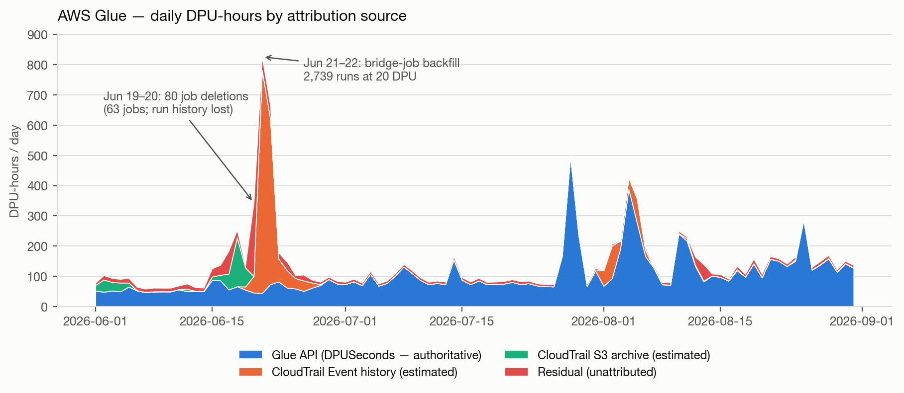
Figure 3 — Daily Glue DPU-hours by attribution source. The red band is unattributed spend; it is thin everywhere except the 17–20 June job-deletion window.

6.2 Where the Glue Money Went
24,542 job runs were attributed across the period, totalling 11,973.3 DPU-hours. Spend is highly concentrated: the single largest job is 23.7% of all attributed DPU-hours, and the top three are 38.0%.

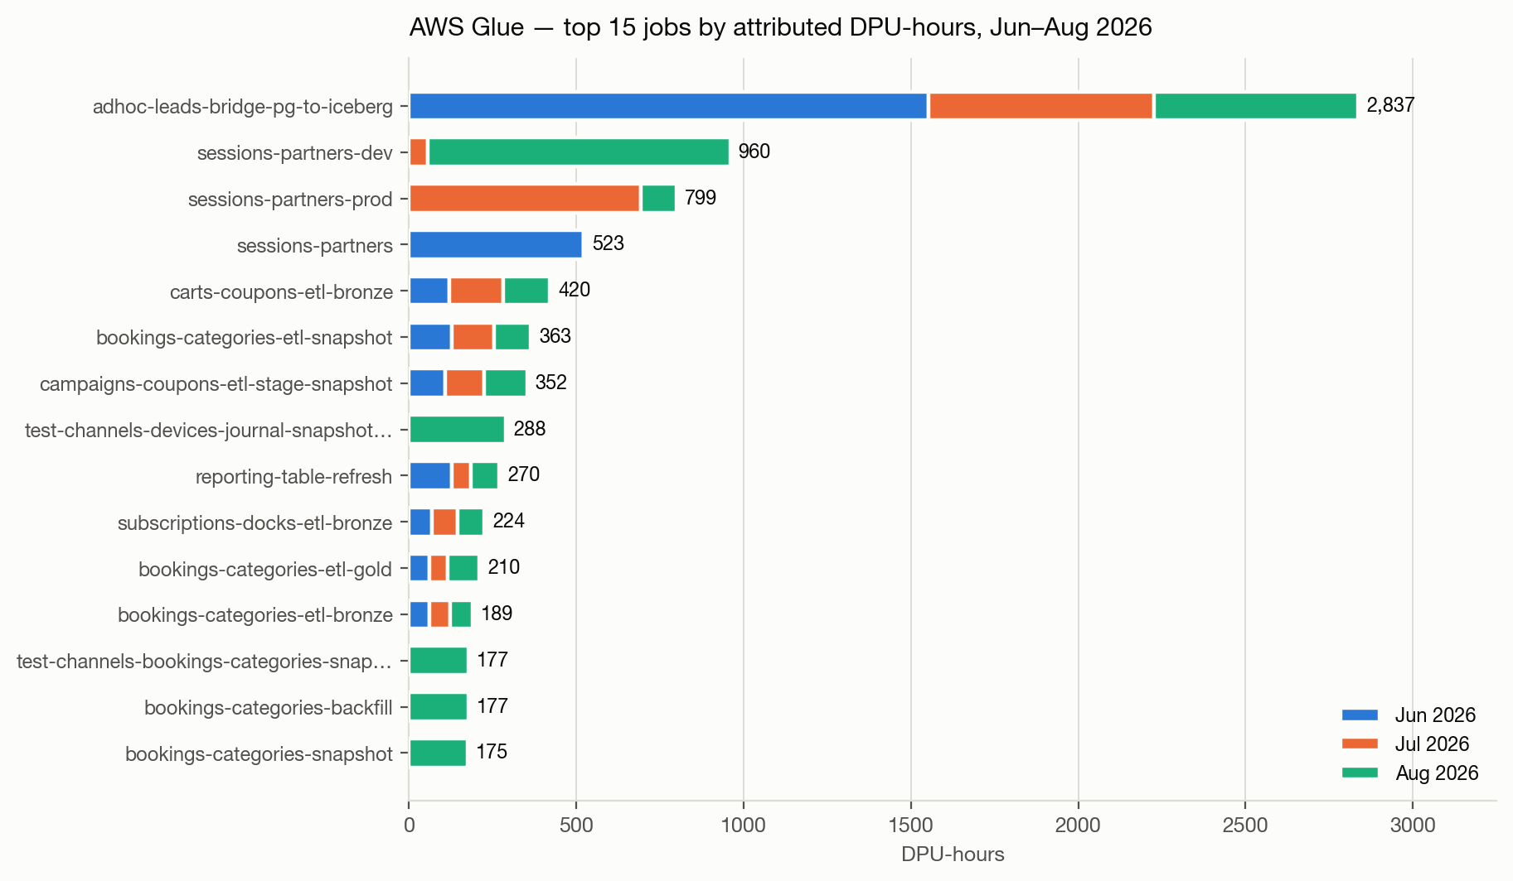
Figure 4 — Top 15 Glue jobs by attributed DPU-hours, segmented by month.

6.3 The Workloads That Explain the Period

adhoc-leads-bridge-pg-to-iceberg — 8,791 runs, $1,248
The largest Glue consumer in the account, and invisible to the Glue API for most of its life. The job was created on 20 June, deleted, and recreated on 28 June; GetJobRuns returns no run before the recreate date, so all 3,833 of its June runs came from CloudTrail. Its configuration timeline, read from CreateJob/UpdateJob, explains the June spike:
Timestamp (UTC) | Configuration | DPU | Event
20 Jun 14:37 | 3 × G.1X | 3 | CreateJob — first appearance
20 Jun 20:32 | 10 × G.2X | 20 | UpdateJob — scaled up 6.7×
22 Jun 22:06 | 5 × G.2X | 10 | UpdateJob — scaled back down
28 Jun 19:38 | 5 × G.2X | 10 | CreateJob — job recreated after deletion
The job ran 1,563 times on 21 June and 1,176 times on 22 June while configured at 20 DPU — that two-day backfill is the entire June Glue spike. It was then resized down to 10 DPU and has run on a steady schedule of roughly 72 runs per day since. The resize on 22 June is a real optimisation and is credited in Section 9.
Its runs are short: median billed duration 85.0 seconds, measured across 4,958 runs with known DPUSeconds. 13.0% of them bill at or below Glue's one-minute minimum. This is the account's clearest efficiency problem and is quantified in 6.5.

The sessions-partners family — 3 jobs, 2,281 DPU-hours, $1,004
Three separate jobs (sessions-partners, sessions-partners-dev, sessions-partners-prod) together make up 19.1% of attributed Glue spend. The distribution is worth noting: the dev variant consumed 959.5 DPU-hours across just 65 runs — 14.8 DPU-hours per run, more than the production variant's 799.0 DPU-hours across 27 runs. A development job outspending its production counterpart usually means it is being run against full-size data.
This family also correlates in time with Section 5: sessions-partners-prod's two heaviest runs were on 28 and 29 July, immediately before the Aurora cluster sessions-index-db-1 began saturating on 30 July. The names and the timing line up, but this report does not establish a causal link — confirming it requires checking whether these jobs write to that cluster, which is a code question rather than a billing one.

The August increase
August's rise is broad within Glue rather than a single job: a cluster of bookings-categories jobs (snapshot, gold, bronze, backfill, download) created and repeatedly recreated between 1 and 6 August, the test-channels jobs, and continued bridge-job volume. This is consistent with the median-daily-spend shift: more scheduled work running every day, not one large event.

6.4 Per-Job Ranking
Glue Job | DPU-hours | Est. Cost | Runs | Failed | % of Glue
adhoc-leads-bridge-pg-to-iceberg | 2836.9 | $1,248.22 | 8791 | 20 | 23.7%
sessions-partners-dev | 959.5 | $422.17 | 65 | 21 | 8.0%
sessions-partners-prod | 799.0 | $351.58 | 27 | 12 | 6.7%
sessions-partners | 522.7 | $229.98 | 357 | 0 | 4.4%
carts-coupons-etl-bronze | 419.9 | $184.75 | 95 | 2 | 3.5%
bookings-categories-etl-snapshot | 363.4 | $159.88 | 254 | 17 | 3.0%
campaigns-coupons-etl-stage-snapshot | 352.4 | $155.07 | 99 | 0 | 2.9%
test-channels-devices-journal-snapshot-test | 288.4 | $126.88 | 183 | 1 | 2.4%
reporting-table-refresh | 269.7 | $118.66 | 117 | 13 | 2.3%
subscriptions-docks-etl-bronze | 224.4 | $98.72 | 96 | 1 | 1.9%
bookings-categories-etl-gold | 210.2 | $92.48 | 311 | 7 | 1.8%
bookings-categories-etl-bronze | 189.4 | $83.33 | 104 | 5 | 1.6%
test-channels-bookings-categories-snapshot… | 177.2 | $77.97 | 108 | 1 | 1.5%
bookings-categories-backfill | 176.7 | $77.73 | 133 | 1 | 1.5%
bookings-categories-snapshot | 174.9 | $76.94 | 81 | 0 | 1.5%
adhoc-leads-run-model | 165.5 | $72.83 | 729 | 6 | 1.4%
tiers-gauges-etl-bronze | 159.8 | $70.29 | 118 | 4 | 1.3%
tiers-signups-etl-bronze | 145.5 | $64.02 | 117 | 2 | 1.2%
subscriptions-lanes-etl-bronze | 139.8 | $61.53 | 97 | 1 | 1.2%
campaigns-coupons-etl-bronze | 110.1 | $48.42 | 112 | 4 | 0.9%
Estimated cost applies the confirmed $0.44/DPU-hour Gen1 rate. Jobs below the top 20 each account for under 1% of Glue spend.

6.5 Efficiency Findings
- Short-run billing floor. adhoc-leads-bridge-pg-to-iceberg runs 8,791 times with a median billed duration of 85 seconds, and 13.0% of runs bill at or under the 60-second minimum. Glue also bills provisioning overhead per run — measured here as roughly 0.04 DPU-hours per run across the account. The lever is batching, not right-sizing: running this job every hour instead of roughly every 12 minutes would cut per-run overhead by about 80% without changing a line of transformation logic.
- Failure waste. 732 runs across the account finished in FAILED, STOPPED or TIMEOUT state and still billed, costing approximately $232.75 for the period — 4.0% of Glue spend. bookings-categories-etl-snapshot (17 failures) and sessions-partners-dev (21 failures) are the largest contributors.
- Ungoverned and experimental jobs. 23 jobs carry a test- prefix and consumed 658.7 DPU-hours ($289.83); several are named after individual engineers. A further 13 adhoc- prefixed jobs consumed 3,164.4 DPU-hours ($1,392.31). Together that is 29% of attributed Glue spend in jobs whose names mark them as non-production.
- Job churn. 63 jobs were deleted and many recreated during the period. Beyond making cost attribution impossible after the fact, each create, update and delete is a recorded AWS Config configuration item — this is a visible driver of the Config increase in Section 7.
- A cheaper billing tier is already available. The Gen2 (Glue 5.0) rate is $0.308/DPU-hour against $0.44 for Gen1 — 30% less for identical work. In August only 102.7 of 5,175.9 billed DPU-hours (2.0%) used it.

6.6 Glue-Specific Recommendations
Action | Target | Estimated impact | Effort
Batch runs of adhoc-leads-bridge-pg-to-iceberg from ~12-minute to hourly intervals | adhoc-leads-bridge-pg-to-iceberg | ≈ $250–400/quarter | Medium
Migrate remaining jobs to the Gen2 (Glue 5.0) billing tier | All Glue jobs | ≈ 30% of migrated DPU-hours | Medium
Add failure alerting and retry caps; investigate the two highest-failure jobs | bookings-categories-etl-snapshot, sessions-partners-dev | ≈ $230/quarter | Low
Run sessions-partners-dev against sampled rather than full-size data | sessions-partners-dev | Up to $422/quarter | Low
Set a retention policy for test- and adhoc- prefixed jobs | 36 non-production jobs | Reduces churn and Config cost | Low
Ask the ledger account to activate cost-allocation tags | Account | Removes the need for this reconstruction | Low

7. Cost Drivers & Key Findings

7.1 Combined Drivers Summary
Gross spend rose from $9,950.68 in June to $11,281.08 in August, a net +$1,330.40 (+13.4%). June and July were effectively flat; the entire movement is an August step change of $1,663.27 (+17.3%). Two services account for $1,205.30 — 72% — of that step, and both trace to identifiable resources rather than diffuse growth. The rest of the increase is a mechanical consequence: AWS Support bills as a percentage of spend, and AWS Config bills per configuration item recorded, so both rose because other things did. Nothing in the period reduced cost materially.

7.2 Cost Drivers Table
Service | Period Change | Primary Reason
Amazon RDS (Aurora) | +$591.05 | Aurora Serverless v2 cluster sessions-index-db-1 saturated its 8.0 ACU ceiling from 30 July (Section 5)
AWS Glue | +$243.56 | Sustained rise in ETL DPU-hours; per-job attribution in Section 6
Amazon VPC | +$114.99 | An additional site-to-site VPN tunnel from July (+$70.75/month) plus more in-use public IPv4 addresses
AWS Support (Business) | +$114.03 | Billed as a percentage of monthly spend — rises mechanically with the Glue and RDS increases
AWS Config | +$87.65 | Configuration items recorded rose 125,189 → 144,075, tracking Glue job create/update/delete churn
Amazon QuickSight | +$55.27 | Net migration of seats from Enterprise to the more expensive Author Pro tier
Amazon S3 | +$52.13 | Organic storage growth (~6%/month compound); request charges fell
Threshold: every service whose gross cost moved by more than $50 between June and August.

7.3 Key Findings
- The August increase is two resources, not a trend. One Aurora cluster and one cluster of Glue jobs explain 72% of it; the account's other 22 services were collectively stable.
- A database ran out of capacity and nobody noticed from the bill. sessions-index-db-1 spent twelve full days pinned at 100% CPU against its maximum ACU. The cost signal ($470) is small; the reliability signal is not.
- Roughly $2,000/month is fixed regardless of usage — QuickSight capacity packs ($750), the MWAA Large environment (~$737), Client VPN and Transit Gateway hours (~$335), and IAM Access Analyzer ($42.60). These are the least examined and most reliably reducible costs in the account.
- Glue's cost is dominated by very short runs. The largest consumer bills the majority of its runs at or near Glue's one-minute minimum, which makes batching — not right-sizing — the effective lever (Section 6).
- Cost-allocation tags are unavailable on this linked account, so every per-resource figure in this report had to be reconstructed from CloudTrail and CloudWatch. Activating tags at the ledger would make this routine.

8. Cost Optimization Recommendations

Short Term (0–30 days)
- Aurora — set a CloudWatch alarm on ServerlessDatabaseCapacity at 90% of the maximum, and a billing alarm on Aurora ACU-hours. The ceiling was raised to 12.0 ACU on 1 September, so the cap that limited August's cost no longer exists.
- Aurora — confirm the workload that started on 30 July is intended. If it is a runaway or a misconfigured job, this is a $470/month recovery and a reliability fix at once.
- Glue — address the short-run billing floor on adhoc-leads-bridge-pg-to-iceberg (Section 6.5). Batching its work reduces cost without touching capacity.
- VPC — audit Client VPN endpoints, the second site-to-site tunnel added in July, and in-use public IPv4 addresses. All bill per hour whether or not traffic flows.
- CloudWatch — inventory custom metrics (roughly 75% of the service's cost) and retire those not backing a dashboard or alarm.
- Config — narrow the recorder's scope to resource types with a compliance obligation; the Glue job churn documented in Section 6 is what drives this line.

Medium Term (1–3 months)
- MWAA — evaluate whether a Medium environment class carries the current DAG load. At ~$737/month flat this is the single largest fixed cost with an obvious smaller tier.
- QuickSight — run a monthly active-author audit. Author Pro seats grew $80 → $151 while Enterprise fell; confirm each Pro seat is authoring. Re-check the three $250 capacity packs against actual query and reader volume.
- Glue — migrate remaining jobs to the Gen2 (Glue 5.0) billing tier. It appeared in August at $0.308/DPU-hour versus $0.44 for Gen1 — a 30% reduction on identical work.
- S3 — enable Intelligent-Tiering on the largest data-lake prefixes and expire Glue temporary output, which is rarely read after a job completes.
- Aurora — review slow queries and indexing on sessions-index-db-1 before accepting 12.0 ACU as the new baseline.

Long Term (3+ months)
- Ask the ledger account to activate cost-allocation tags, then enforce Environment / Team / Workload tags on every Glue job and database. This report required a four-source reconstruction that tagging would make unnecessary.
- Consolidate the test- and adhoc- prefixed Glue jobs. A meaningful share of DPU-hours belongs to jobs whose names mark them as experiments, several owned by individual engineers.
- Evaluate a Compute Savings Plan once EC2, ECS and Lambda usage has been stable for a quarter.
- Introduce a monthly cost review against this report's baseline — $10,283/month average — so a step change like August's is caught in week one rather than at quarter end.

9. Actions Taken
Only changes with a clearly visible signature in the cost or configuration data are asserted below as fact. Work such as instance-class changes, log-retention tweaks or licence downgrades is invisible at this level of granularity and is not inferred. The table should be extended by the team with work this data cannot see.
Action | Completed | Evidence | Dollar Impact
AWS Glue job adhoc-leads-bridge-pg-to-iceberg resized down from 20 DPU (10 × G.2X) to 10 DPU (5 × G.2X) | 22 Jun 2026 | CloudTrail UpdateJob, 22 Jun 22:06 UTC | ≈ −$0.25 per run at constant volume
Aurora Serverless v2 maximum capacity raised 8.0 → 12.0 ACU on sessions-index-db-1 | 1 Sep 2026 | CloudTrail ModifyDBCluster, 1 Sep 20:01 UTC | Increases cost; resolves the saturation in Section 5
Glue Gen2 (Glue 5.0) billing tier enters use | Aug 2026 | New ETL-DPU-Hour-Gen2 usage type, 102.7 DPU-h | −30% per DPU-hour on migrated jobs
— to be completed by the team: retention policy changes, licence downgrades, instance-class changes — | — | Not visible at service granularity | —
Over June–August 2026 total monthly cost moved from $9,950.68 to $11,281.08, a net +13.4% change. No optimization in the period produced a visible reduction; the two changes with a clear signature — the Glue resize on 22 June and the Aurora ceiling raise on 1 September — were operational responses rather than cost work. The savings identified in Section 8 are therefore all still available.

10. Evidence

10.1 Cost Explorer Links
Each link opens Cost Explorer pre-filtered to this report's period (1 June – 31 August 2026).
1. Overall Period — All Services → Open in Cost Explorer
GROUP chart, monthly granularity, grouped by service, no filter
2. Top Services Comparison → Open in Cost Explorer
STACK chart, monthly, the six largest services by period spend
3. AWS Glue — Daily Trend by Usage Type → Open in Cost Explorer
LINE chart, daily, grouped by usage type — shows ETL-DPU-Hour and the new Gen2 line
4. Amazon RDS — Daily Trend by Usage Type → Open in Cost Explorer
LINE chart, daily — isolates Aurora:ServerlessV2Usage, the largest increase of the period
5. Amazon VPC — Daily Trend by Usage Type → Open in Cost Explorer
LINE chart, daily — VPN, Client VPN, Transit Gateway and public IPv4 hours
6. AWS Config — Daily Trend by Usage Type → Open in Cost Explorer
LINE chart, daily — configuration items recorded and conformance-pack evaluations
7. Amazon S3 — Storage Growth → Open in Cost Explorer
LINE chart, daily — TimedStorage-ByteHrs growth
8. Amazon CloudWatch — Daily Trend by Usage Type → Open in Cost Explorer
LINE chart, daily — custom metric monitoring vs log ingestion
If a link opens the Cost Explorer home screen instead of the filtered report, use the plain-text URLs in section 10.2 — copy the whole line into the address bar.

10.2 Appendix: Cost Explorer URLs (plain text)
Word and some other viewers rewrite a hyperlink whose target contains a '#' fragment. Plain text cannot be rewritten, so these are the authoritative copies.
1. Overall Period — All Services
https://123456789012-a1b2c3d4.us-east-1.console.aws.amazon.com/costmanagement/home?region=us-west-2#/cost-explorer?chartStyle=GROUP&costAggregate=unBlendedCost&startDate=2026-06-01&endDate=2026-08-31&granularity=Monthly&groupBy=%5B%22Service%22%5D&filter=%5B%5D&excludeForecasting=false&futureRelativeRange=CUSTOM&historicalRelativeRange=CUSTOM&isDefault=true&reportMode=STANDARD&reportName=New+cost+and+usage+report&showOnlyUncategorized=false&showOnlyUntagged=false&usageAggregate=undefined&useNormalizedUnits=false
2. Top Services Comparison
https://123456789012-a1b2c3d4.us-east-1.console.aws.amazon.com/costmanagement/home?region=us-west-2#/cost-explorer?chartStyle=STACK&costAggregate=unBlendedCost&startDate=2026-06-01&endDate=2026-08-31&granularity=Monthly&groupBy=%5B%22Service%22%5D&filter=%5B%7B%22dimension%22%3A%7B%22id%22%3A%22Service%22%2C%22displayValue%22%3A%22Service%22%7D%2C%22operator%22%3A%22INCLUDES%22%2C%22values%22%3A%5B%7B%22value%22%3A%22AWS+Glue%22%2C%22displayValue%22%3A%22AWS+Glue%22%7D%2C%7B%22value%22%3A%22Amazon+Relational+Database+Service%22%2C%22displayValue%22%3A%22Amazon+Relational+Database+Service%22%7D%2C%7B%22value%22%3A%22Amazon+QuickSight%22%2C%22displayValue%22%3A%22Amazon+QuickSight%22%7D%2C%7B%22value%22%3A%22AWS+Support+%28Business%29%22%2C%22displayValue%22%3A%22AWS+Support+%28Business%29%22%7D%2C%7B%22value%22%3A%22Amazon+Virtual+Private+Cloud%22%2C%22displayValue%22%3A%22Amazon+Virtual+Private+Cloud%22%7D%2C%7B%22value%22%3A%22Amazon+Managed+Workflows+for+Apache+Airflow%22%2C%22displayValue%22%3A%22Amazon+Managed+Workflows+for+Apache+Airflow%22%7D%5D%7D%5D&excludeForecasting=false&futureRelativeRange=CUSTOM&historicalRelativeRange=CUSTOM&isDefault=true&reportMode=STANDARD&reportName=New+cost+and+usage+report&showOnlyUncategorized=false&showOnlyUntagged=false&usageAggregate=undefined&useNormalizedUnits=false
3. AWS Glue — Daily Trend by Usage Type
https://123456789012-a1b2c3d4.us-east-1.console.aws.amazon.com/costmanagement/home?region=us-west-2#/cost-explorer?chartStyle=LINE&costAggregate=unBlendedCost&startDate=2026-06-01&endDate=2026-08-31&granularity=Daily&groupBy=%5B%22UsageType%22%5D&filter=%5B%7B%22dimension%22%3A%7B%22id%22%3A%22Service%22%2C%22displayValue%22%3A%22Service%22%7D%2C%22operator%22%3A%22INCLUDES%22%2C%22values%22%3A%5B%7B%22value%22%3A%22AWS+Glue%22%2C%22displayValue%22%3A%22AWS+Glue%22%7D%5D%7D%5D&excludeForecasting=true&futureRelativeRange=CUSTOM&historicalRelativeRange=CUSTOM&isDefault=true&reportMode=STANDARD&reportName=New+cost+and+usage+report&showOnlyUncategorized=false&showOnlyUntagged=false&usageAggregate=undefined&useNormalizedUnits=false
4. Amazon RDS — Daily Trend by Usage Type
https://123456789012-a1b2c3d4.us-east-1.console.aws.amazon.com/costmanagement/home?region=us-west-2#/cost-explorer?chartStyle=LINE&costAggregate=unBlendedCost&startDate=2026-06-01&endDate=2026-08-31&granularity=Daily&groupBy=%5B%22UsageType%22%5D&filter=%5B%7B%22dimension%22%3A%7B%22id%22%3A%22Service%22%2C%22displayValue%22%3A%22Service%22%7D%2C%22operator%22%3A%22INCLUDES%22%2C%22values%22%3A%5B%7B%22value%22%3A%22Amazon+Relational+Database+Service%22%2C%22displayValue%22%3A%22Amazon+Relational+Database+Service%22%7D%5D%7D%5D&excludeForecasting=true&futureRelativeRange=CUSTOM&historicalRelativeRange=CUSTOM&isDefault=true&reportMode=STANDARD&reportName=New+cost+and+usage+report&showOnlyUncategorized=false&showOnlyUntagged=false&usageAggregate=undefined&useNormalizedUnits=false
5. Amazon VPC — Daily Trend by Usage Type
https://123456789012-a1b2c3d4.us-east-1.console.aws.amazon.com/costmanagement/home?region=us-west-2#/cost-explorer?chartStyle=LINE&costAggregate=unBlendedCost&startDate=2026-06-01&endDate=2026-08-31&granularity=Daily&groupBy=%5B%22UsageType%22%5D&filter=%5B%7B%22dimension%22%3A%7B%22id%22%3A%22Service%22%2C%22displayValue%22%3A%22Service%22%7D%2C%22operator%22%3A%22INCLUDES%22%2C%22values%22%3A%5B%7B%22value%22%3A%22Amazon+Virtual+Private+Cloud%22%2C%22displayValue%22%3A%22Amazon+Virtual+Private+Cloud%22%7D%5D%7D%5D&excludeForecasting=true&futureRelativeRange=CUSTOM&historicalRelativeRange=CUSTOM&isDefault=true&reportMode=STANDARD&reportName=New+cost+and+usage+report&showOnlyUncategorized=false&showOnlyUntagged=false&usageAggregate=undefined&useNormalizedUnits=false
6. AWS Config — Daily Trend by Usage Type
https://123456789012-a1b2c3d4.us-east-1.console.aws.amazon.com/costmanagement/home?region=us-west-2#/cost-explorer?chartStyle=LINE&costAggregate=unBlendedCost&startDate=2026-06-01&endDate=2026-08-31&granularity=Daily&groupBy=%5B%22UsageType%22%5D&filter=%5B%7B%22dimension%22%3A%7B%22id%22%3A%22Service%22%2C%22displayValue%22%3A%22Service%22%7D%2C%22operator%22%3A%22INCLUDES%22%2C%22values%22%3A%5B%7B%22value%22%3A%22AWS+Config%22%2C%22displayValue%22%3A%22AWS+Config%22%7D%5D%7D%5D&excludeForecasting=true&futureRelativeRange=CUSTOM&historicalRelativeRange=CUSTOM&isDefault=true&reportMode=STANDARD&reportName=New+cost+and+usage+report&showOnlyUncategorized=false&showOnlyUntagged=false&usageAggregate=undefined&useNormalizedUnits=false
7. Amazon S3 — Storage Growth
https://123456789012-a1b2c3d4.us-east-1.console.aws.amazon.com/costmanagement/home?region=us-west-2#/cost-explorer?chartStyle=LINE&costAggregate=unBlendedCost&startDate=2026-06-01&endDate=2026-08-31&granularity=Daily&groupBy=%5B%22UsageType%22%5D&filter=%5B%7B%22dimension%22%3A%7B%22id%22%3A%22Service%22%2C%22displayValue%22%3A%22Service%22%7D%2C%22operator%22%3A%22INCLUDES%22%2C%22values%22%3A%5B%7B%22value%22%3A%22Amazon+Simple+Storage+Service%22%2C%22displayValue%22%3A%22Amazon+Simple+Storage+Service%22%7D%5D%7D%5D&excludeForecasting=true&futureRelativeRange=CUSTOM&historicalRelativeRange=CUSTOM&isDefault=true&reportMode=STANDARD&reportName=New+cost+and+usage+report&showOnlyUncategorized=false&showOnlyUntagged=false&usageAggregate=undefined&useNormalizedUnits=false
8. Amazon CloudWatch — Daily Trend by Usage Type
https://123456789012-a1b2c3d4.us-east-1.console.aws.amazon.com/costmanagement/home?region=us-west-2#/cost-explorer?chartStyle=LINE&costAggregate=unBlendedCost&startDate=2026-06-01&endDate=2026-08-31&granularity=Daily&groupBy=%5B%22UsageType%22%5D&filter=%5B%7B%22dimension%22%3A%7B%22id%22%3A%22Service%22%2C%22displayValue%22%3A%22Service%22%7D%2C%22operator%22%3A%22INCLUDES%22%2C%22values%22%3A%5B%7B%22value%22%3A%22AmazonCloudWatch%22%2C%22displayValue%22%3A%22AmazonCloudWatch%22%7D%5D%7D%5D&excludeForecasting=true&futureRelativeRange=CUSTOM&historicalRelativeRange=CUSTOM&isDefault=true&reportMode=STANDARD&reportName=New+cost+and+usage+report&showOnlyUncategorized=false&showOnlyUntagged=false&usageAggregate=undefined&useNormalizedUnits=false

10.3 Appendix: Complete Service Breakdown — August 2026
AWS Service | August 2026 | % of Month
Amazon RDS (Aurora) | $2,265.41 | 20.08%
AWS Glue | $2,263.83 | 20.07%
Amazon QuickSight | $1,030.52 | 9.13%
AWS Support (Business) | $1,018.31 | 9.03%
Amazon VPC | $921.71 | 8.17%
Amazon MWAA | $774.78 | 6.87%
Amazon CloudWatch | $632.17 | 5.60%
Amazon S3 | $536.91 | 4.76%
AWS Config | $533.14 | 4.73%
Amazon EC2 — Compute | $479.27 | 4.25%
AWS Secrets Manager | $332.99 | 2.95%
EC2 - Other | $181.50 | 1.61%
Amazon ECS | $141.88 | 1.26%
Elastic Load Balancing | $83.75 | 0.74%
IAM Access Analyzer | $42.60 | 0.38%
Amazon EMR | $28.61 | 0.25%
AWS Key Management Service | $9.00 | 0.08%
Amazon ECR | $3.73 | 0.03%
AWS Step Functions | $0.40 | 0.00%
AWS Systems Manager | $0.26 | 0.00%
Amazon Athena | $0.21 | 0.00%
AWS Cost Explorer | $0.11 | 0.00%
Total | $11,281.08 | 100.00%

10.4 Appendix: Period Totals by Service
AWS Service | Jun 2026 | Jul 2026 | Aug 2026 | Period Total | % of Period
AWS Glue | $2,020.27 | $1,550.55 | $2,263.83 | $5,834.65 | 18.9%
Amazon RDS (Aurora) | $1,674.36 | $1,773.39 | $2,265.41 | $5,713.15 | 18.5%
Amazon QuickSight | $975.25 | $1,026.68 | $1,030.52 | $3,032.45 | 9.8%
AWS Support (Business) | $904.27 | $874.23 | $1,018.31 | $2,796.81 | 9.1%
Amazon VPC | $806.72 | $903.38 | $921.71 | $2,631.81 | 8.5%
Amazon MWAA | $745.53 | $768.85 | $774.78 | $2,289.17 | 7.4%
Amazon CloudWatch | $668.83 | $607.01 | $632.17 | $1,908.00 | 6.2%
Amazon S3 | $484.77 | $504.07 | $536.91 | $1,525.75 | 4.9%
Amazon EC2 — Compute | $456.67 | $470.99 | $479.27 | $1,406.93 | 4.6%
AWS Config | $445.50 | $354.07 | $533.14 | $1,332.70 | 4.3%
AWS Secrets Manager | $324.18 | $335.35 | $332.99 | $992.52 | 3.2%
EC2 - Other | $177.13 | $179.05 | $181.50 | $537.68 | 1.7%
Amazon ECS | $114.78 | $108.76 | $141.88 | $365.42 | 1.2%
Elastic Load Balancing | $64.86 | $76.84 | $83.75 | $225.45 | 0.7%
IAM Access Analyzer | $40.80 | $41.60 | $42.60 | $125.00 | 0.4%
Amazon EMR | $31.38 | $29.45 | $28.61 | $89.44 | 0.3%
AWS Key Management Service | $9.00 | $8.99 | $9.00 | $26.99 | 0.1%
Amazon ECR | $3.08 | $3.37 | $3.73 | $10.17 | 0.0%
Claude Opus 4.6 (Amazon Bedrock Edition) | $2.38 | $0.00 | $0.00 | $2.38 | 0.0%
AWS Step Functions | $0.34 | $0.38 | $0.40 | $1.12 | 0.0%
Amazon Athena | $0.27 | $0.47 | $0.21 | $0.95 | 0.0%
AWS Systems Manager | $0.26 | $0.26 | $0.26 | $0.79 | 0.0%
AWS Cost Explorer | $0.02 | $0.05 | $0.11 | $0.18 | 0.0%
Claude Sonnet 4.5 (Amazon Bedrock Edition) | $0.03 | $0.00 | $0.00 | $0.03 | 0.0%
Total | $9,950.68 | $9,617.81 | $11,281.08 | $30,849.57 | 100.0%

10.5 Reproducing This Data
Every figure in this report is reproducible from the evidence pack in cost-report-jun-aug-2026/, which contains the unmodified Cost Explorer API responses in raw/ alongside the derived CSVs. The Cost Explorer query used is:
Service charges by month
aws ce get-cost-and-usage --profile cost-audit \
--time-period Start=2026-06-01,End=2026-09-01 --granularity MONTHLY \
--metrics UnblendedCost --group-by Type=DIMENSION,Key=SERVICE \
--filter '{"Not":{"Dimensions":{"Key":"RECORD_TYPE","Values":["Credit","Refund"]}}}'
The Aurora deep dive additionally uses CloudWatch ServerlessDatabaseCapacity at 3600-second period, and the Glue deep dive uses the Glue GetJobRuns API, CloudTrail Event history, the CloudTrail S3 archive and CloudWatch Logs stream spans. Reconstruction scripts and their intermediate outputs accompany the evidence pack.

