This code creates the below architecture based components

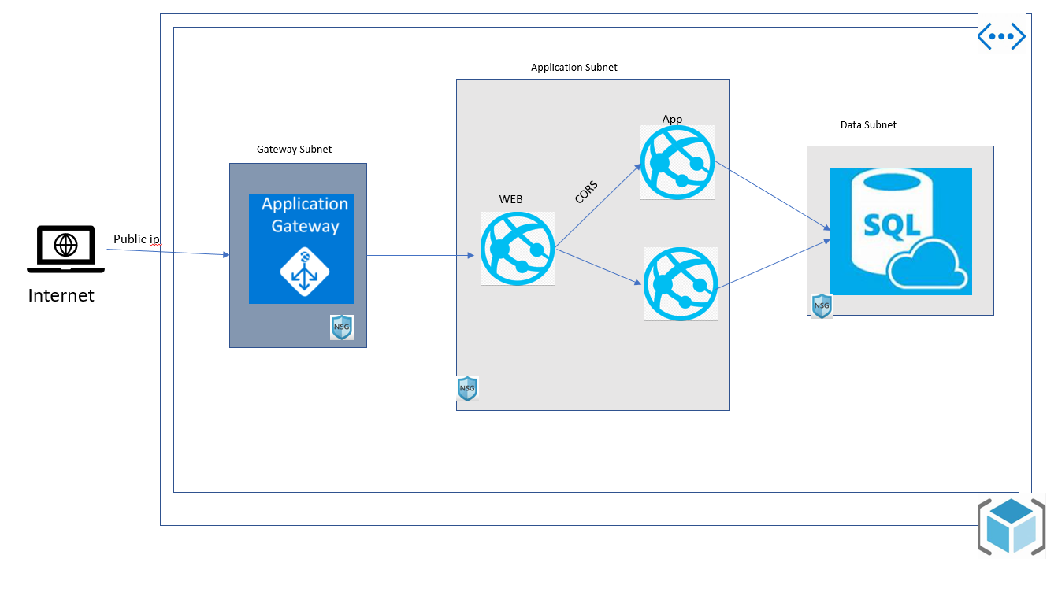

The structure of the code is

* Modules [ having individual components]
* Main [ having the code to call the complete infrastructure

The execution process

* Terraform init [ create backend.tf ]
* Terraform plan
* Terraform validate
* Terraform Apply

ss