**Steps to create and install Django app**

Create virtual environment for your project

Create django_project -> django-admin startproject <project_name>

Install django -> pip install django

Install decouple -> pip install decouple or pip install python-decouple

Create django app -> python manage.py startapp <app_name>

Steps to create Business PayPal account in India

Follow below link to create PayPal account in India:

<https://www.youtube.com/watch?v=Oy1r1aTwVqw&t=144s>

Next:

After creating Business PayPal account go to: <https://developer.paypal.com/>

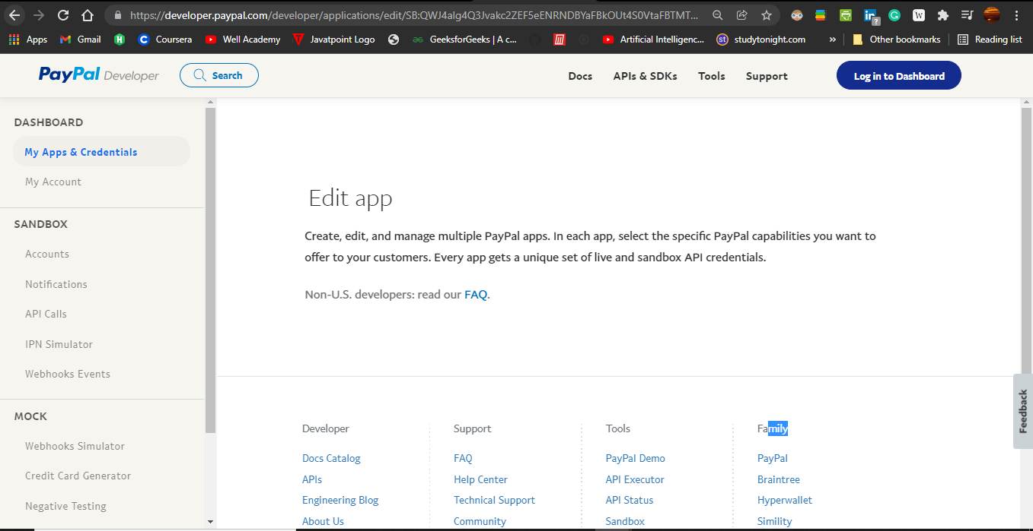

1. Login to Dashboard using your business PayPal mail id created in the first step.

Go to Sandbox -> Account

Here you need to create sandbox two sandbox account one is for Business account and another one is personal account.

(Sandbox accounts is used to create for testing amount transactions we can’t make it transactions directly so we use it for testing process in the development stage)

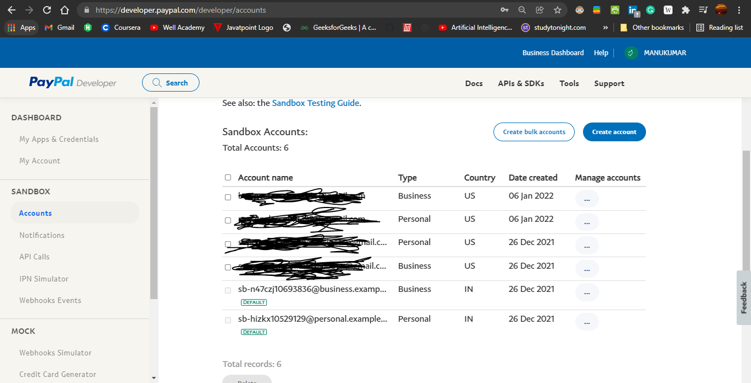

1. Click on Create account

Create sandbox page will pop up from there select Account type = Personal (Buyer account)

Click on create custom account [This sandbox personal account is for sending money].

Select – Personal account

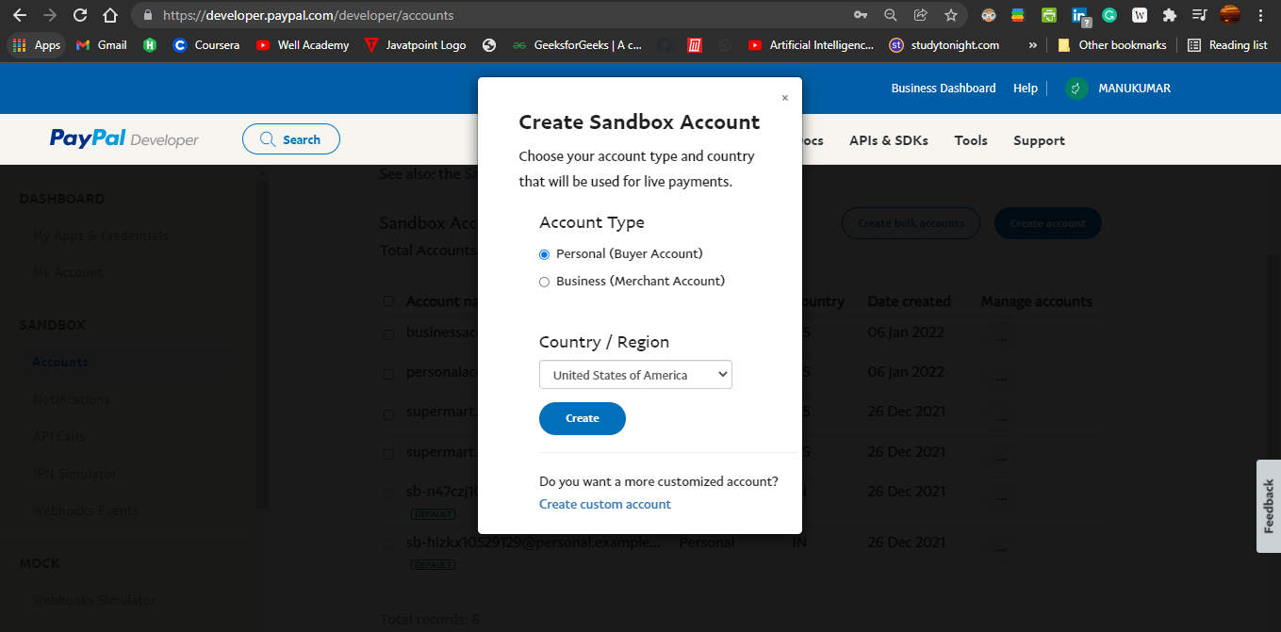

Note: Give any mail id name with @gmail.com, it’s just for checking transaction process.

Fill the form with mail id, password, firstname, lastname and Paybalance with some $5000 for testing purpose and leave rest of the things as it is. Click on create account button.

Again create one more account i.e. for Business (Merchant account)

Click on create custom account [This sandbox business account is for receiving money].

Select – Business account

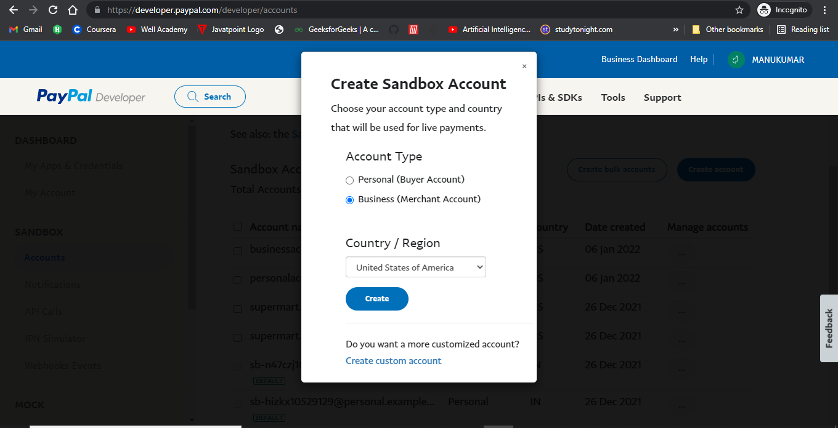

Note: Give any mail id name with @gmail.com it’s just for fake.

Fill the form with mail id and password, firstname, lastname and Paybalance with some $1000 for testing purpose and leave rest of the things as it is. Click on create account button.

It will take two mins to activate account no need to worry. If it shows it’s processing.

Next:

Click on the left hand side of the dashboard -> My apps and Credentials

Rest api apps:

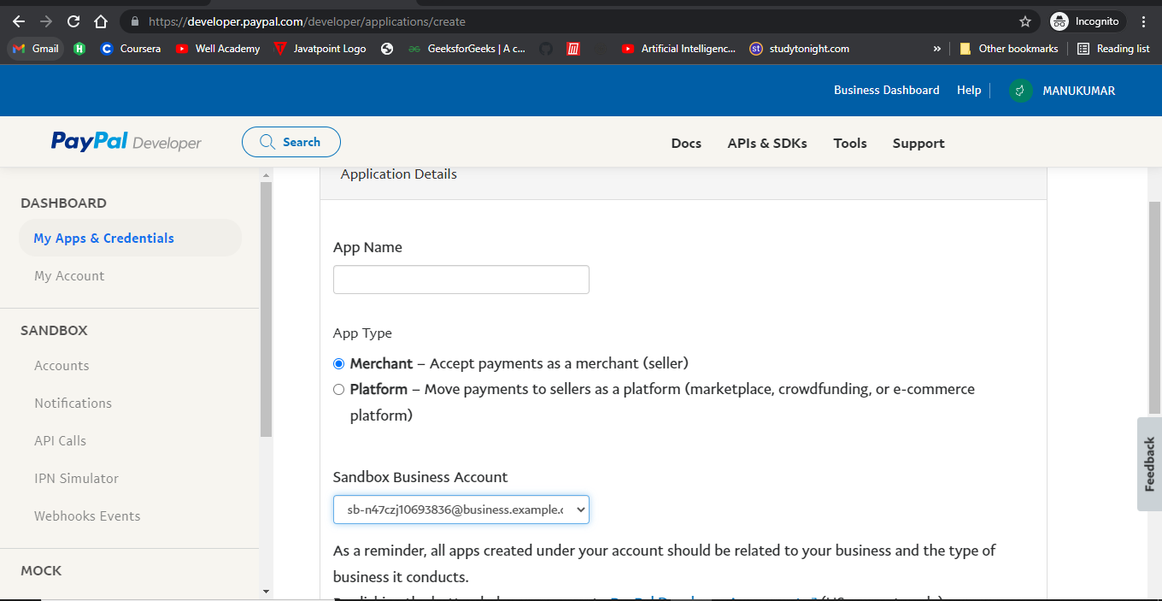

Create app with any name

Select App type Merchant: By default it’s merchant

Select Business sandbox account click on create app

It will create client ID and secret ID.

Next:

Go to Google and type:

PayPal check out button or else copy and paste the below link Google. Because sometimes PayPal check out button don’t shows proper link, so I have given link below.

https://developer.paypal.com/demo/checkout/#/pattern/client

From there copy the code I have shown below:

<!-- Set up a container element for the button -->

<div id="paypal-button-container"></div>

<!-- Include the PayPal JavaScript SDK -->

**<script src="https://www.paypal.com/sdk/js?client-id=test&currency=USD"></script>**

<script>

// Render the PayPal button into #paypal-button-container

paypal.Buttons({

style: {

color: 'blue',

shape: 'pill',

label: 'pay',

height: 40

}

}).render('#paypal-button-container');

</script>

Paste it on your <name> .html page.

Here in the script tag shown below, you should add the Client ID created above: copy the client ID from the created app and paste it in clientid =”………..” [Remove “test” marked in the red color and paste your Client ID].

**<script src="https://www.paypal.com/sdk/js?clientid=test&currency=USD"></script>**

Next:

Go to Sandbox PayPal account [Search in the Google]

If you didn’t get copy and paste below Link I have given below:

<https://www.sandbox.paypal.com/signin?returnUri=https%3A%2F%2Fwww.sandbox.paypal.com%2Fmyaccount%2Fsummary&state>=

Login using your PayPal Sandbox Personal Account to check the balance.

You will see the amount you added in the account i.e $5000

And also

Login using your PayPal Sandbox Business Account to check the balance.

You will see the amount you added in the account i.e $1000

After creating all these steps: Run the server -> python manage.py runserver

Go to -><http://127.0.0.1:8000>/payment to your local host address and you will see the payment page with some static products and address.

Click on Pay with PayPal shown in the right side of the below image:

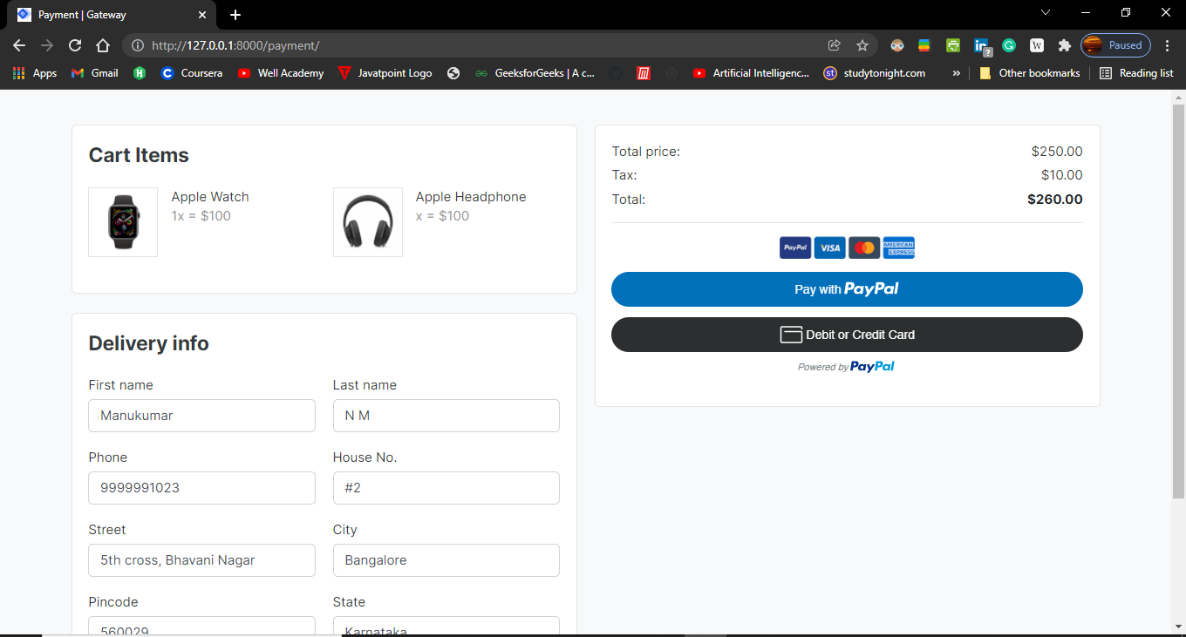

You will get PayPal login page. Shown below

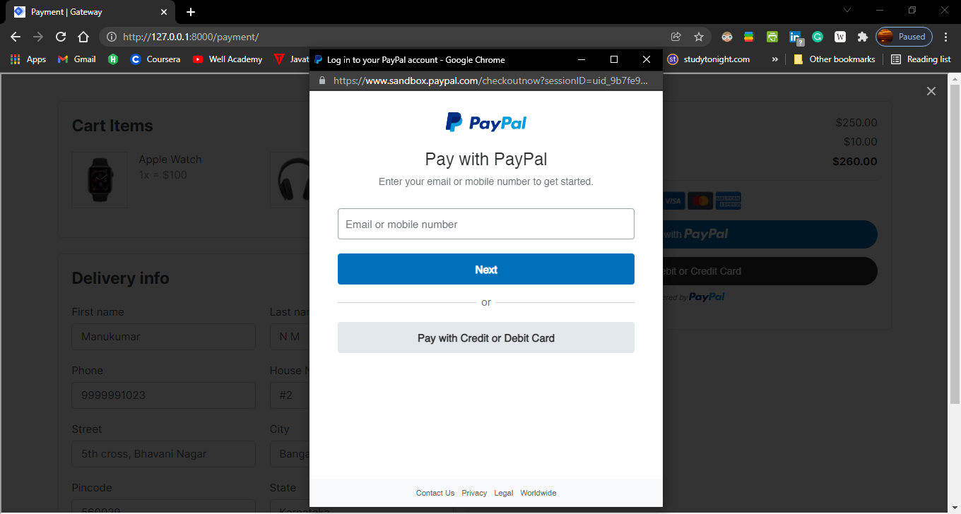

Enter your personal Sandbox PayPal account mail id which you are created and enter a password. You will see the below image with amount of $260 USD that I have added statically and with shipment address and etc, and with your name called Hi… Personal.

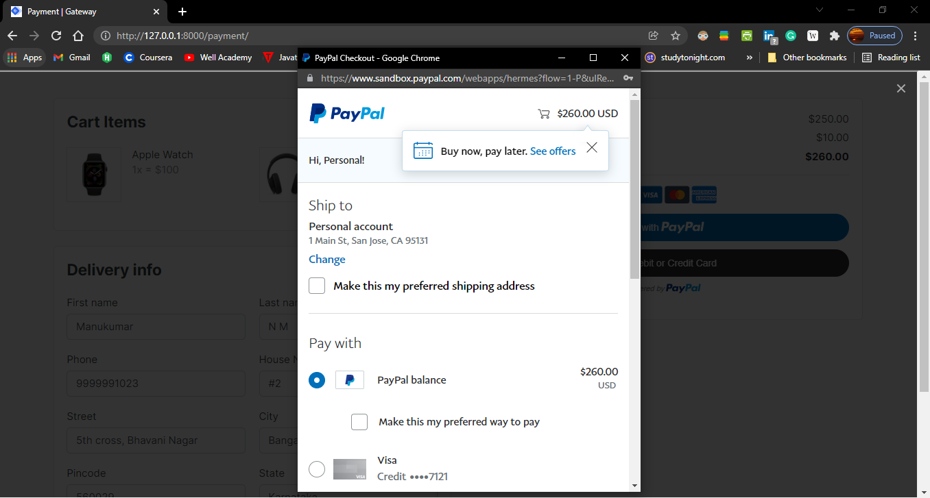

Next click on Pay with PayPal balance ->$260 and Pay Now button.

### You will get one Alert message of successful transaction and you will see the Thank you for your payment! Message on the payment page.

### C:\Users\Manukumar N M\Desktop\Thank you for payment.PNG

### Now, you go and check the payment from PayPal Sandbox Personal account amount is debited with $260 and it’s created to Sandbox Business account.

### You can by login to that PayPal sandbox accounts.

### That’s all about PayPal payment gateway.

### 