|  |
| --- |
| ____  ***Project task 1***  *Pololu Zumo 32U4*  Doc.-Number: Dokument2  Doc.-Version: A2  299792458 |
| Customer:  NewTec  Development  Buchenweg 3  89284 Pfaffenhofen a. d. Roth  Germany |
|  |
| Author:  Team: 🏁~~ ō͡≡o\  Hs Offenburg |

Change History

|  |  |  |
| --- | --- | --- |
| Doc.-Version | Description of Modification | Date |
| A1 | Initial revision |  |
| A2 | Use case diagram, use case description and requirements | 20.03.24 |
|  |  |  |
|  |  |  |
|  |  |  |
|  |  |  |
|  |  |  |
|  |  |  |
|  |  |  |
|  |  |  |
|  |  |  |
|  |  |  |
|  |  |  |
|  |  |  |
|  |  |  |
|  |  |  |
|  |  |  |
|  |  |  |

Release

|  |  |  |  |  |
| --- | --- | --- | --- | --- |
|  | Name | Responsibility | Date | Signature |
| Creation |  |  |  | i.A. |
| Verification |  |  |  | i.A. |
| Approval |  |  |  | i.A. |
| Release |  |  |  | i.A. |

Table of Contents

Change History 2

Release 2

Table of Contents 3

List of Tables 4

List of Figures 4

1 General 5

1.1 Scope of Document 5

1.2 Abbreviations 5

1.3 Terminology 5

1.4 Referenced Documents 5

1.5 Applicable Standards 5

2 Introduction 6

2.1 System Overview 6

2.2 Interface Overview 6

2.3 Scenarios 6

3 Requirements 6

3.1 Functional Requirements 6

3.2 Non-Functional Requirements 6

3.2.1 Safety & Security 6

3.2.2 Data 6

3.2.3 Environmental Conditions 6

3.2.4 Quality 6

3.2.5 Computer Resources 6

3.2.6 Design Constraints 7

3.2.7 Product Documentation 7

3.2.8 Production 7

3.2.9 Logistic 7

3.2.10 Commercial Requirements 7

3.2.11 Further Requirements 7

4 Interface 7

4.1 External Interfaces 7

5 Document Management 7

5.1 Document Creation 7

6 Appendix 7

6.1 (Appendix X) 7

List of Tables

Table 1: Abbreviations………………………………………………………………………………………………….. 5

Table 2: Terminology…………………………………………………………………………………………………… 5

Table 3: Referenced Documents……………………………………………………………………………………… 5

Table 4: Applicable Standards…………………………………………………………………………………………. 5

List of Figures

**Es konnten keine Einträge für ein Abbildungsverzeichnis gefunden werden.**

# General

## Scope of Document

## Abbreviations

|  |  |
| --- | --- |
| Abbreviation | Description |
| N/A | Not applicable |

Table 1: Abbreviations

## Terminology

|  |  |
| --- | --- |
| Term | Description |
| N/A | N/A |

Table 2: Terminology

## Referenced Documents

|  |  |  |
| --- | --- | --- |
| Reference | Document-Identification | Description |
| [1] | N/A | N/A |
|  | N/A | N/A |

Table 3: Referenced Documents

## Applicable Standards

|  |  |  |
| --- | --- | --- |
| Reference | Document-Identification | Description |
| [1] | N/A | N/A |
|  | N/A | N/A |

Table 4: Applicable Standards

# Introduction

## System Overview

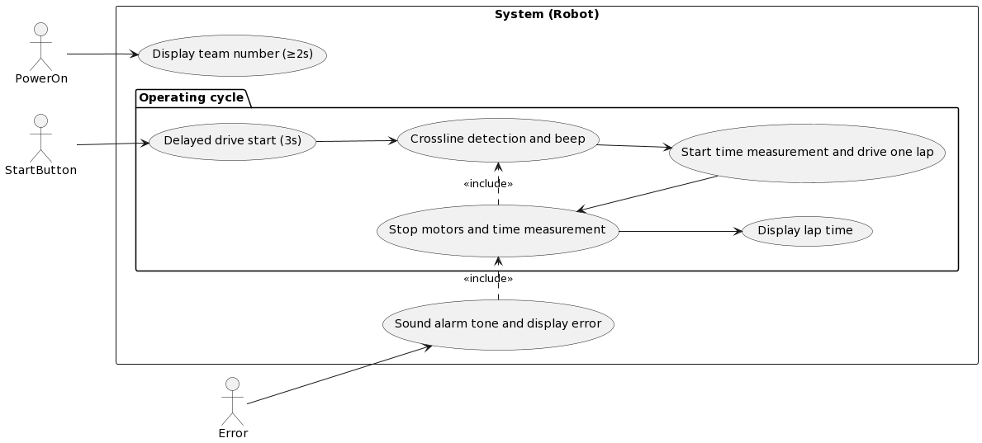

## PlantUML diagramInterface Overview

## Scenarios

**System Overview**

|  |  |
| --- | --- |
| Name | Display team number |
| Short description | Displays a static team number on the OLED display for at least 2s |
| Precondition | System boot is finished |
| Postcondition | none |
| Error case | none |
| Actors | PowerOn |
| Trigger | Finalization of system boot |
| Stand sequence | The system boot is finished. Then the displays shows a static team number on the OLED display for at least 2s |
| Alternative sequences | none |

|  |  |
| --- | --- |
| Name | Delayed drive start |
| Short description | The system waits for 3s and then starts to drive |
| Precondition | No operating cycle is running |
| Postcondition | none |
| Error case | none |
| Actors | StartButton |
| Trigger | StartButton released |
| Stand sequence | The StartButton is released. Then the system waits for 3s and then starts to drive. |
| Alternative sequences | none |

|  |  |
| --- | --- |
| Name | Crossline detection and beep |
| Short description | When the LineSensors detect a crossline the Buzzer sounds a short beep |
| Precondition | none |
| Postcondition | none |
| Error case | none |
| Actors | none |
| Trigger | Delayed drive start is finished |
| Stand sequence | The delayed drive start is finished. As soon as the LineSensors detect a crossline the Buzzer sounds a short beep. |
| Alternative sequences | none |

|  |  |
| --- | --- |
| Name | Start time measurement and drive one lap |
| Short description | After reaching the start position the time measurement starts and a whole lap is driven. |
| Precondition | none |
| Postcondition | none |
| Error case | none |
| Actors | none |
| Trigger | Crossline is detected for the first time in the operating cycle |
| Stand sequence | The crossline is detected for the first time in the operating cycle. The time measurement starts and a whole lap is driven. |
| Alternative sequences | none |

|  |  |
| --- | --- |
| Name | Stop motors and time measurement |
| Short description | After reaching the finish position the motors and the time measurement stop |
| Precondition | none |
| Postcondition | none |
| Error case | none |
| Actors | none |
| Trigger | Crossline is detected for the second time in the operating cycle |
| Stand sequence | The crossline is detected for the second time in the operating cycle. The motors and the time measurement stop. |
| Alternative sequences | none |

|  |  |
| --- | --- |
| Name | Display lap time |
| Short description | After finishing one lap the OLED display shows the lap time |
| Precondition | The crossline was detected for two time in the operating cycle. |
| Postcondition | none |
| Error case | none |
| Actors | none |
| Trigger | The lap was finished without an error |
| Stand sequence | The crossline is detected for the second time in the operating cycle. The OLED display shows the lap time. |
| Alternative sequences | none |

**Interface Overview**

|  |  |
| --- | --- |
| Name | Timer |
| Short description | Measures the time of a lap |
| Precondition | none |
| Postcondition | none |
| Error case | none |
| Actors | LCD-Display |
| Trigger | Usecase “Driving” is active |
| Stand sequence | Timer is started/stopped as soon as the robot crosses the start/finish line |
| Alternative sequences | none |

|  |  |
| --- | --- |
| Name | Driving |
| Short description | Controls the direction of travel of the robot through the motors and line sensors |
| Precondition | Usecase "Vehicle start" was active for at least 2 seconds and |
| Postcondition | Robot must stand still |
| Error case | Robot must stop |
| Actors | none |
| Trigger | The button to start the lap on the robot was pressed |
| Stand sequence | The robot starts after 3 seconds and automatically follows the black line from start to finish |
| Alternative sequences | none |

|  |  |
| --- | --- |
| Name | Vehicle start |
| Short description | The robot remains in this state for at least 2 seconds, during which time the team number is shown on the LCD display and all necessary initializations are carried out |
| Precondition | none |
| Postcondition | none |
| Error case | none |
| Actors | LCD-Display |
| Trigger | Power on |
| Stand sequence | After starting, the group number is shown on the LCD display for 2 seconds and all initializations are made |
| Alternative sequences | none |

|  |  |
| --- | --- |
| Name | Line detection |
| Short description | Erkennt die Schwarzelinie und gibt Rückmeldung an den Usecase Driving |
| Precondition | none |
| Postcondition | none |
| Error case | none |
| Actors | Line sensor |
| Trigger | none |
| Stand sequence | The line sensors are read out and the data transmitted to "Driving" |
| Alternative sequences | none |

|  |  |
| --- | --- |
| Name | Motor control |
| Short description | Controls the motors |
| Precondition | none |
| Postcondition | none |
| Error case | none |
| Actors | Motors |
| Trigger | none |
| Stand sequence | Controls the motors depending on "Driving" |
| Alternative sequences | none |

# Requirements

## Functional Requirements

The robot shall start driving 3s after the operator presses the startbutton.

If the robot detects the start line ALL of the following instances apply

* the robot shall emit a short beep via speaker
* the robot shall start the time measurement for the lap

If the robot detects the end line ALL of the following instances apply

* the robot shall emit a short beep via speaker
* the robot shall end the time measurement for the lap
* the robot shall display the measured time for the lap on the OLED-display
* the robot shall stop any motion

The robot shall complete one lap in 20s or less.

If the robot leaves the track, the robot shall redetect the track in 5s or less.

If the robot detects an error ALL of the following instances apply

* the robot shall emit an alarm signal via speaker
* the robot shall display the errorreason on the OLED
* the robot shall stop any motion

After power-on the robot shall display the team-number on the OLED-display for at least 2s.

## Non-Functional Requirements

### Safety & Security

authentification, authorisation, integrity

### Data

input/output, data characteristics(numeric,etc), data area/border, database

### Environmental Conditions

temperature, humidity, atmospheric pressure, shock/vibration, liquids, radiation

### Quality

lifetime, availibility, operational readiness, reliability, maintainability

### Computer Resources

The software shall be hardware independent.

The programmer shall write the software in the programming language C.

The software shall at most use 80% of the available flash memory.

### Design Constraints

standards, technical characteristics, material, marking/naming, electromagnetical compatibility, adaption/flexibility/exchangeability

### Product Documentation

Instructions

### Production

### Logistic

### Commercial Requirements

### Further Requirements

# Interface

## External Interfaces

# Document Management

## Document Creation

# Appendix

## (Appendix X)

robot Zumo32U4

OLED organic light emitting diode

OLED-display display on the robot

startbutton button on the robot, accessible for input

speaker buzzer on the robot