**Project Report**

# Name: Manushree Patel Roll No: AU2340014 ENR112 Section 1

**Problem Definition**

This project is based on image processing which will include various

functionalities such as flipping, mirroring, adding of two images

and spotting the difference between two images

**Solution Algorithm for the Problem Statement**

**Adding Two Images:**

1. Load two images using `imread`.

2. Resize the second image to match the dimensions of the first using `imresize`.

3. Loop through each pixel and add corresponding pixel values from both images. (in all the three channels for RGB image)

4. Display the resulting added image.

**Spotting Differences Between Two Images:**

1. Load two images using `imread`.

2. Resize one image to match the other’s dimensions.

3. Subtract the pixel values of the second image from the first.

4. Display the difference image.

**Brightening/Darkening an Image:**

1. Load the image using `imread`.

2. Brighten: Add a constant value to each pixel.

3. Darken: Subtract a constant value from each pixel.

4. Display the original, brightened, and darkened images.

**Image Mirroring/Flipping:**

1. Load the image using `imread`.

2. Horizontal flip: Reverse the order of columns.

3. Vertical flip: Reverse the order of rows.

4. Display the original, horizontally flipped, and vertically flipped images.

**MATLAB Functionalities Applied**

imread`: Reads images into MATLAB.

imresize: Resizes an image to specific dimensions.

Pixel-wise Operations:

- `I(i,j,k) + J(i,j,k)`: Adds pixel values for image addition.

- `x - y`: Subtracts pixel values to spot differences.

- `a + 75` or `a - 75`: Adjusts pixel values to brighten or darken an image.

Array Indexing:

- `A(:, end:-1:1, :)`: Horizontally flips an image.

- `A(end:-1:1, :, :)`: Vertically flips an image.

- `imshow`: Displays images.

- `subplot`: Organizes multiple plots in one figure window.

- `size`: Retrieves image dimensions.

**Screenshots of Output for Different Boundary Conditions**

Include the following:

1. Adding Images: Show the original images and the resultant added image.

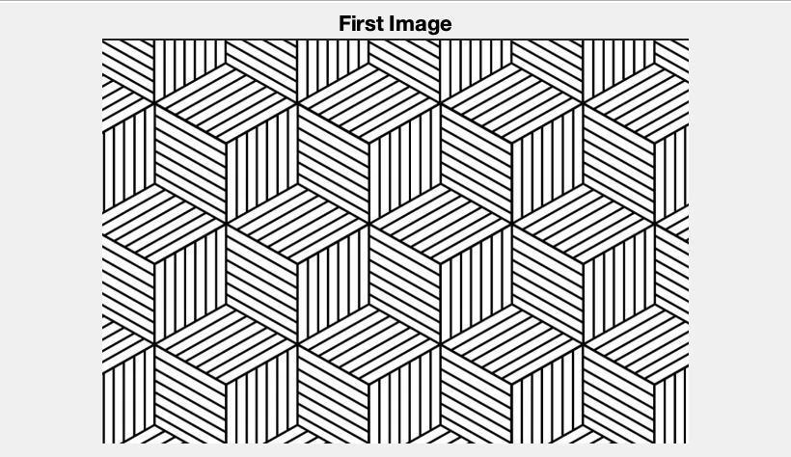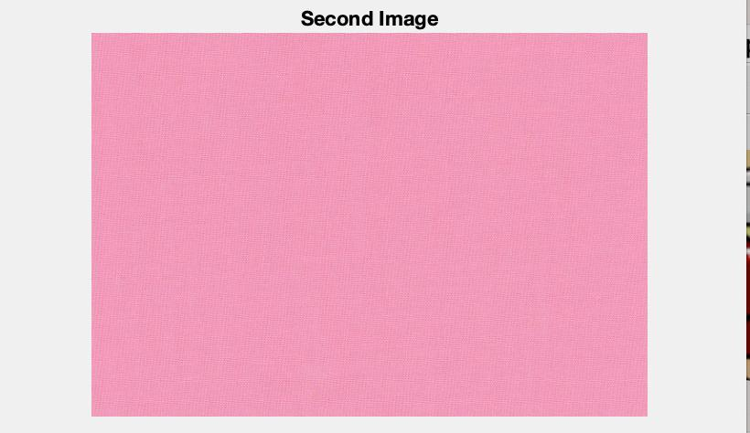

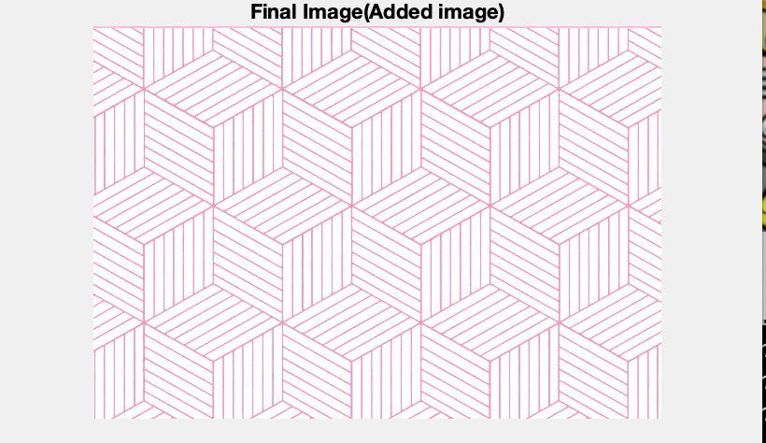

1. Spotting Differences: Show two similar images and their difference output to highlight changes.

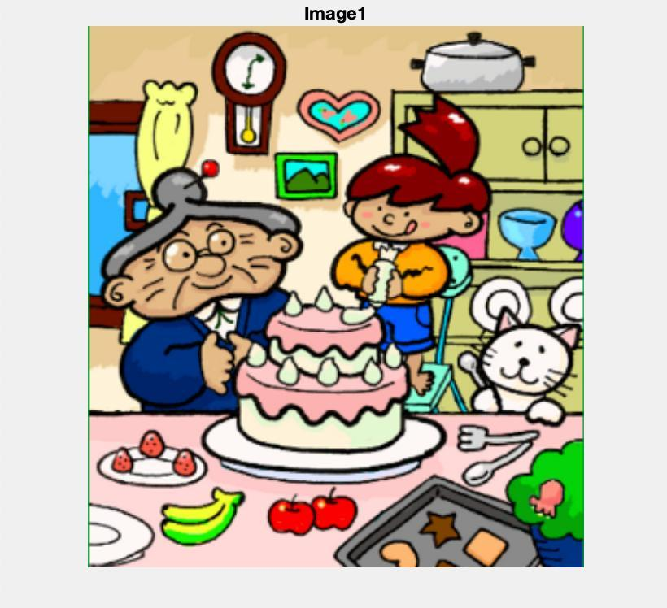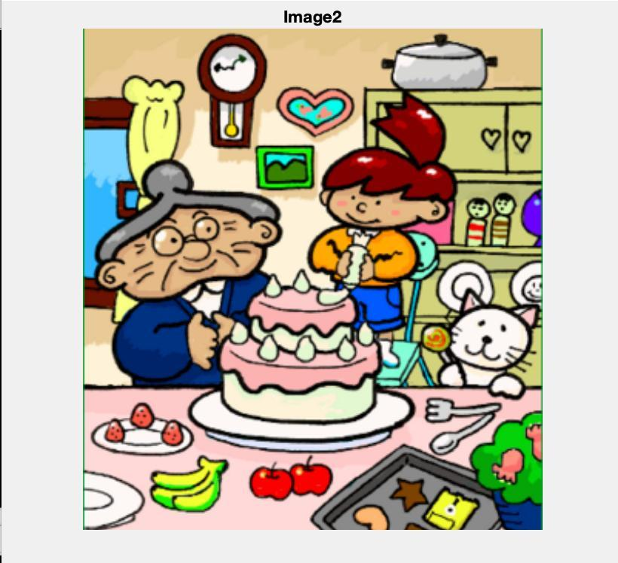

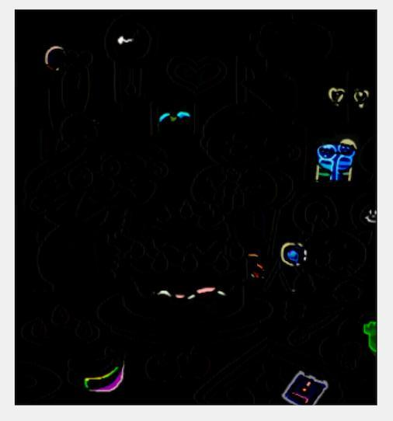

1. Brightening/Darkening: Display the original image, a brightened version, and a darkened version side by side.

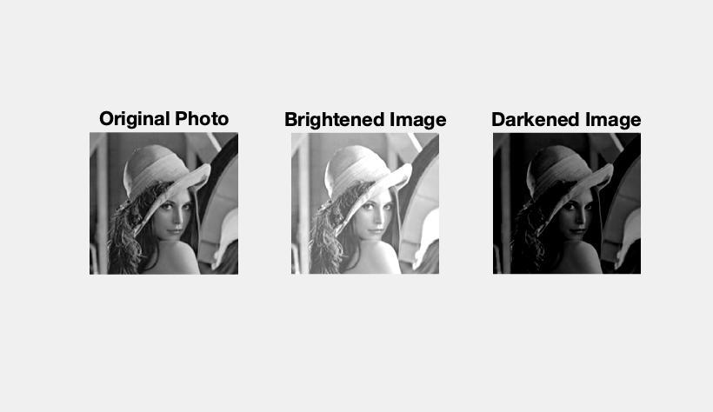

1. Mirroring (Flipping): Show the original image, horizontally mirrored image, and vertically mirrored image.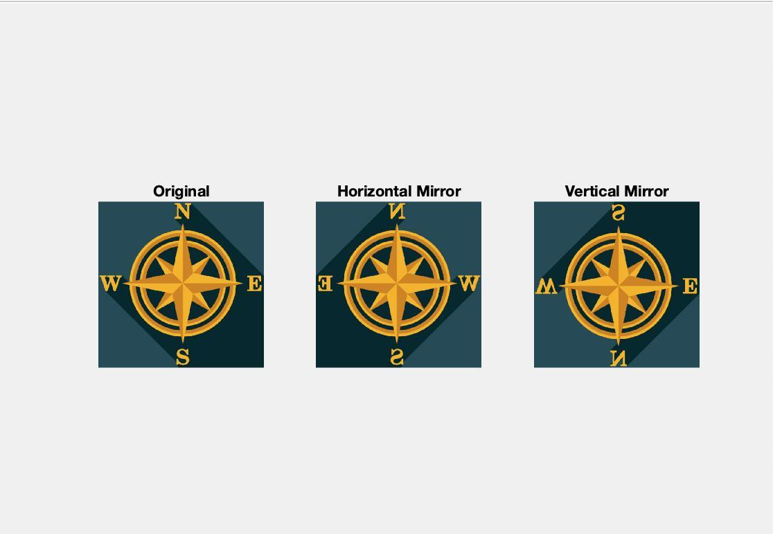

**Concluding Remarks and Overall Learning**

This project demonstrates fundamental image processing techniques using MATLAB. Practical implications include:

- Image Addition: Useful for blending images or creating composite effects in photography.

Real Life Use:

* HDR Imaging: A high dynamic-range image that combines multiple exposure levels.

•⁠ ⁠Watermarking: A logo or text is added to an image.

- Spotting Differences: Applied in quality control or forensic image analysis.

Real life Use:

* Quality Control: It identifies defects or variations in the manufactured products.
* Detection of changes: The technique monitors environmental or structural changes over time in satellite images.

- Brightening/Darkening: Enhances visibility or creates visual effects.

Real life Use:

* Medical Imaging: It improves the contrast in X-rays or in MRI scans for improved diagnosis.
* Surveillance: Enhances clarity in low-light camera footage.

- Mirroring/Flipping: Used in UI design, animations, and symmetry analysis.

Real life Use:

* Virtual Fitting Rooms: Mirroring in AR apps simulates the user's view.

•⁠ ⁠Image Augmentation: Enhances datasets in AI and machine learning by introducing variations.