**CSE100 PROJECT REPORT**

**SECTION 2 GROUP 4**



**STOCK MARKET SIMULATION**

**MANUSHREE PATEL AU2340014**

**DEVASHREE PARIKH AU2340067**

**KANISHA NAWAB AU2320148**

**JAIN NIRJARA AU2340010**

**TABLE OF CONTENTS:**

| NO. | CONTENT |
| --- | --- |
| 1. | ABSTRACT |
| 2. | OBJECTIVES |
| 3. | FLOWCHART |
| 4. | FUNCTIONALITIES |

**ABSTRACT:**

This project is a simulation of a real-life stock market site. It is designed to provide our users with an educational experience in the financial market. In this simulator, you can view, analyze, buy, or even sell stocks. We also have a subscription model. To buy or sell stocks, it is mandatory to be a subscriber. However, viewing and analyzing can be done by signing up. We have also given the option of logging in.

**OBJECTIVES:**

* We want to give the users a hands-on experience.

● A small-scale simulation prototype of actual stock market sites.

● Enable risk-free trading skill development.

● Offer a realistic market experience.

● Allows the user to make an informed decision by looking at the graphs

● Provide a pathway to real-life trading.

**FLOWCHART:**

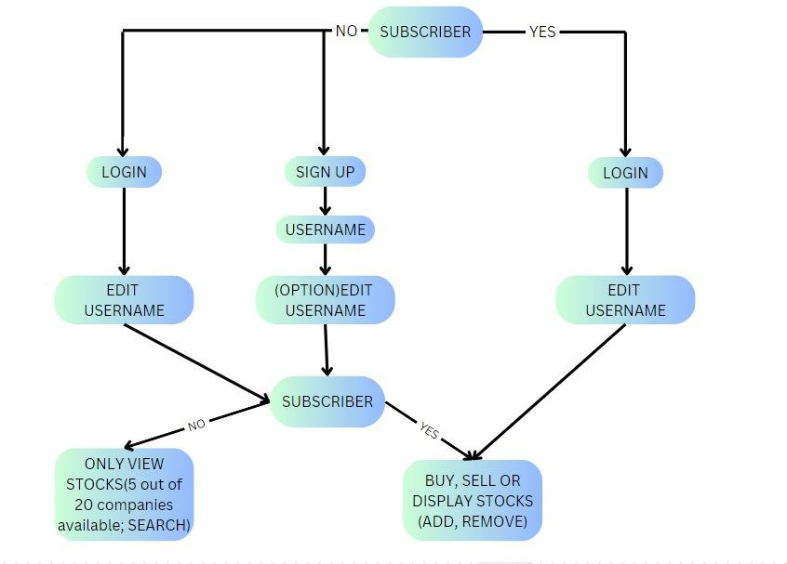

**FUNCTIONALITIES:**

1. **Login and Signup:**

* **One of the validations we have added is that any username wont be used twice.**

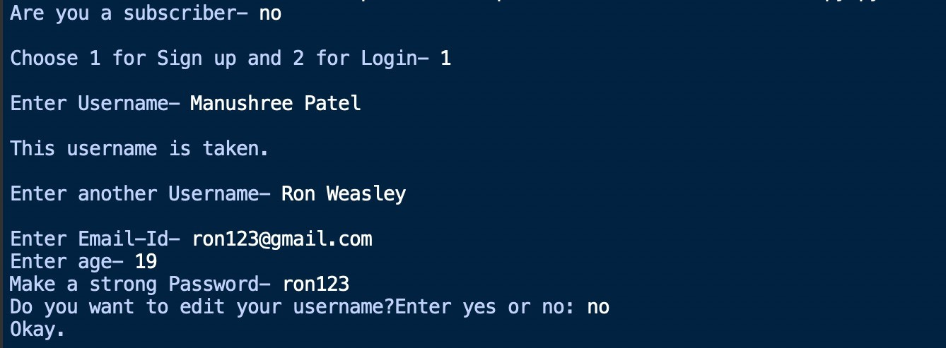

* The first question that will be asked to the user is whether he/she is a subscriber or not.
* After that, there are two options, sign up and log in, in which two different text files will be generated according to the option selected with the entered information about username, password, and email ID.
* One additional functionality that we have implemented in the login and sign-up is the validation of the username. If the username is already in the database, then it can’t be retaken, and the program asks the user to enter another username.
* We have also added age validation, so if the person using this program is under 18, then a warning will be shown that the user is too young for this.
* After entering the email ID and age again, the person is asked if he/she wants to edit the entered username. (EDIT FUNCTIONALITY)

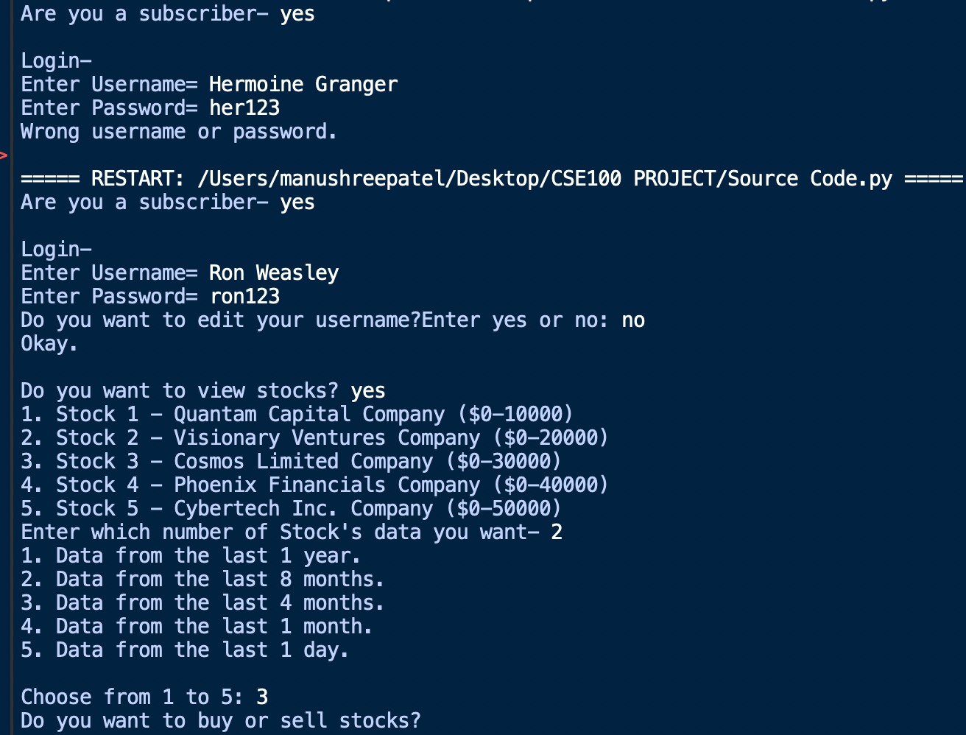

* If the user is already a subscriber, then the program will ask for login credentials. If the entered username and password do not match the already existing one in the database created during the sign-up process, then it will display the wrong username or password, and the program will terminate.
* After entering the appropriate credentials for login, the user will be able to access stocks.
* **When you are only here to view stocks for the first time:**

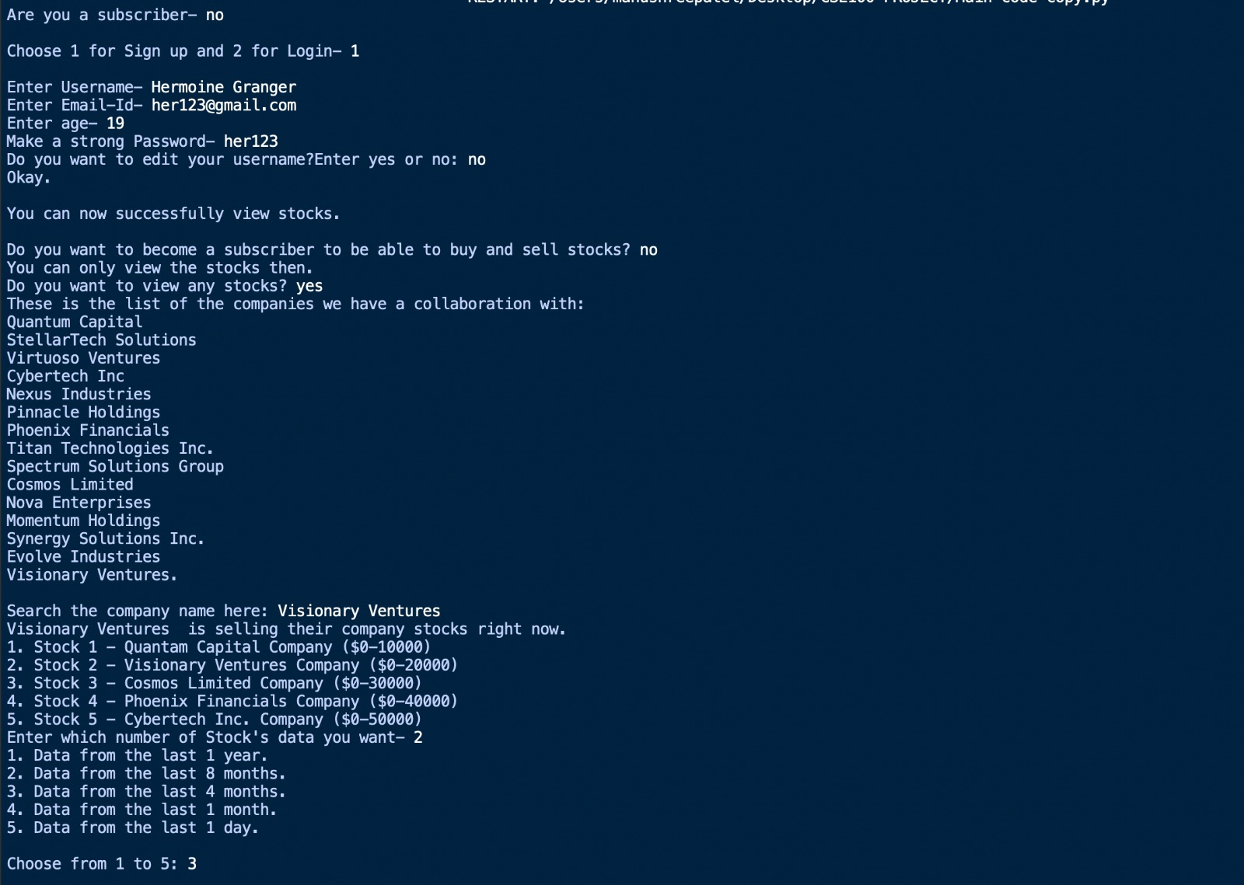

* If the user does not wish to become a subscriber, then he/she will be considered a viewer and will not be able to buy/sell stocks but will only be able to view the stocks.
* In the view stocks option, we have listed 20 companies, out of which only 5 companies are selling their stocks right now, so here, the search algorithm is used to search whether the user entered the company is selling the stocks or not. [SEARCH FUNCTIONALITY]

1. **Add & Remove:**

Here, it is in the format of buying and selling of stocks.

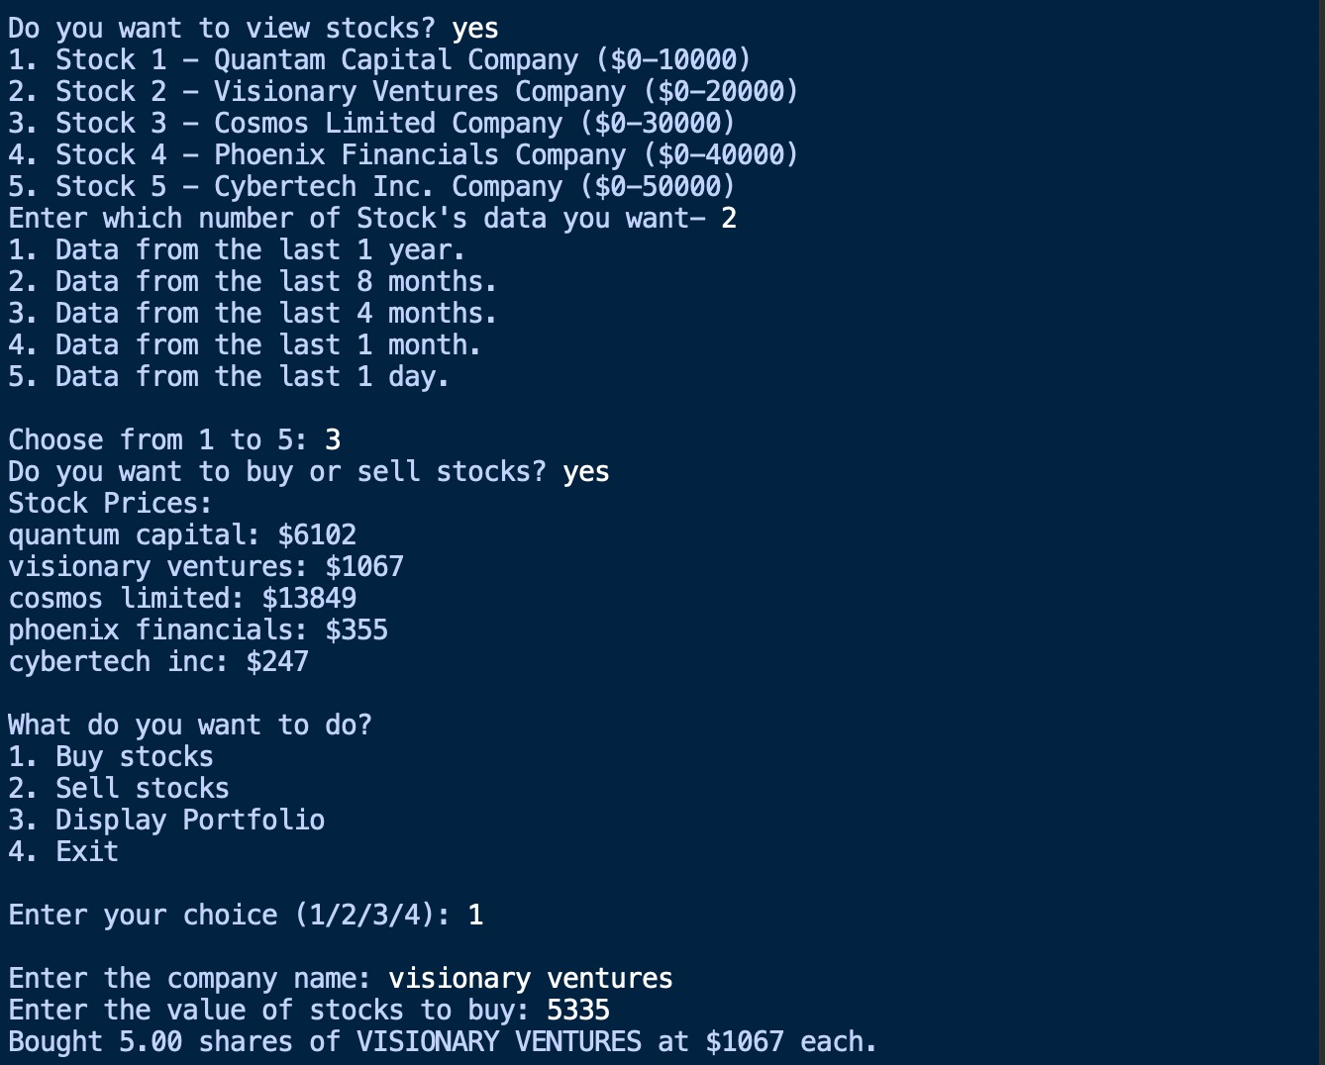

* If the user becomes a subscriber, then the user will be able to buy, sell, and display the portfolio of the 5 companies listed by the programmer.
* A particular price will be associated with the shares of each company which will enable users to see how much money they need to invest to buy how much stock of that particular company.

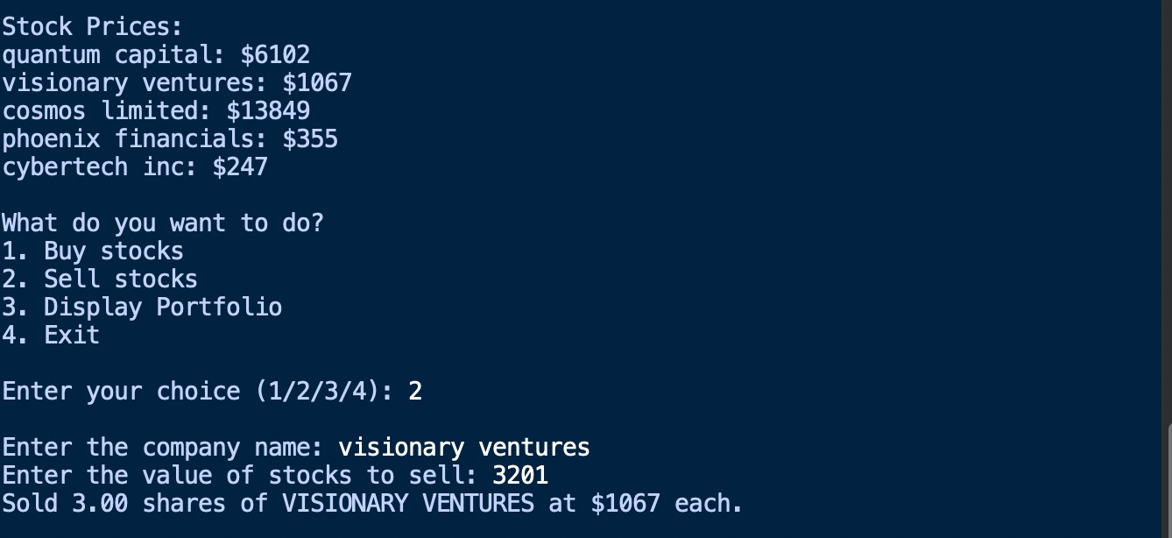

* The user can sell stocks of only those companies from which he/she has already bought stocks, or it will display that there are no stocks of that company to sell. [ADD and REMOVE FUNCTIONALITY]

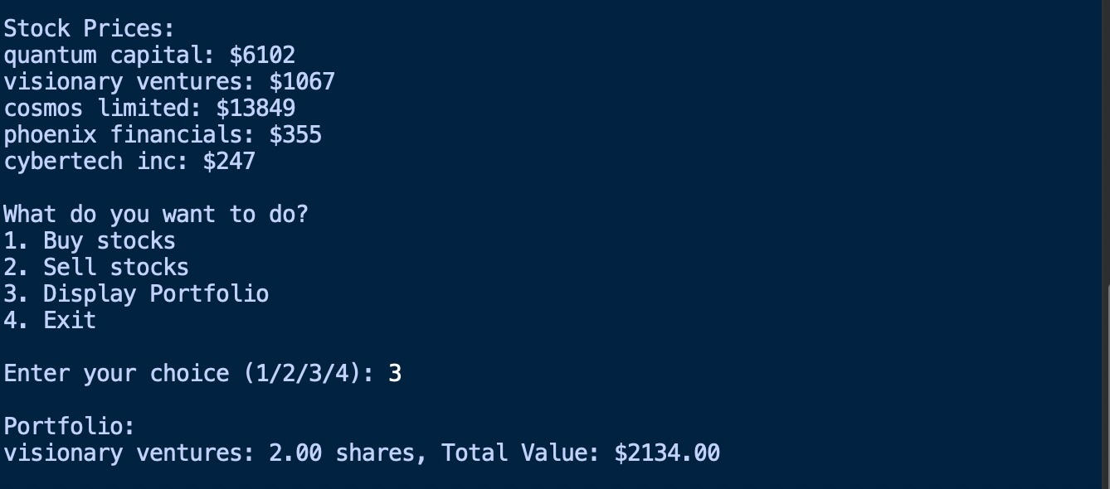

* The display portfolio enables the user to see the end result of how many shares he/she owns of which company after buying and selling transactions.



* On selecting the exit option, the user will be out of the menu and the program will terminate.

**( c ) Menu options for stocks [GRAPH]:**

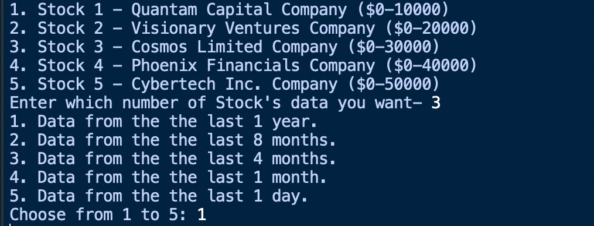

* This is the menu option for the stocks of the listed 5 companies along with the price range and specific timeline options for users to see the prices of the stocks.
* Upon selecting the timeline, an appropriate graph will be displayed showing the price trend of the stocks of that particular company over that time which will allow the user to make an informed decision as to where and how much money he should invest in stocks of these companies.
* Only 4 graphs will be created as for one day price there will be no graph but text files for all 5 timelines will be created for users to see variation in prices daily for the timeline selected.

**(d) Graphs:**

As you can see, we have provided 5 different timelines for a specific company.



