1. **GOOGLEDOCS_CREATE_DOCUMENT**

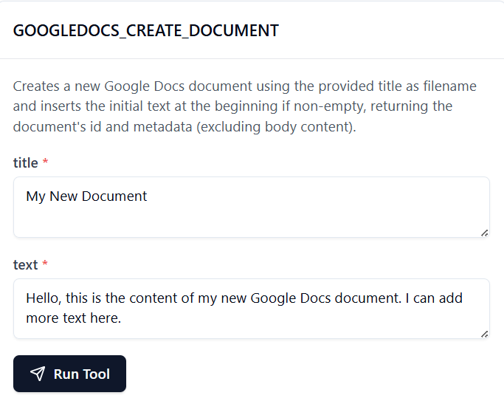

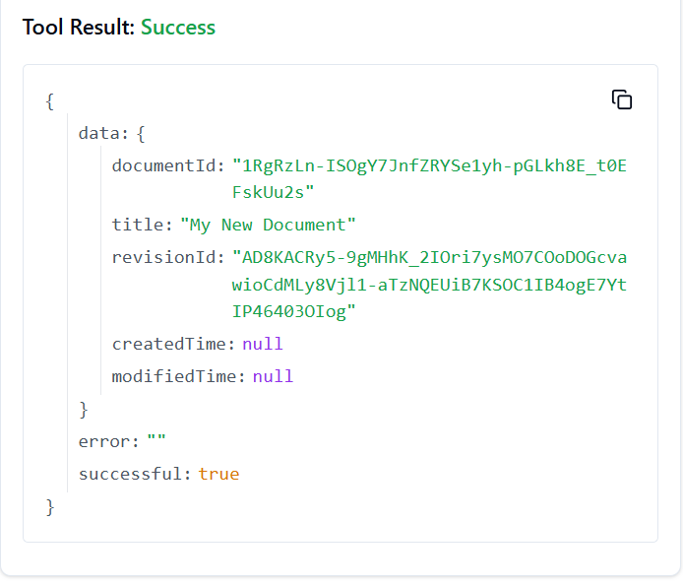

2. **GOOGLEDOCS_COPY_DOCUMENT**

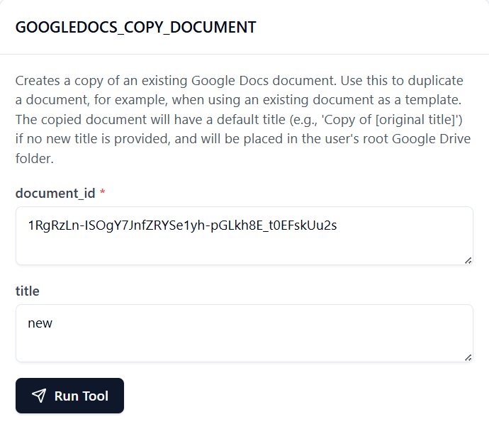

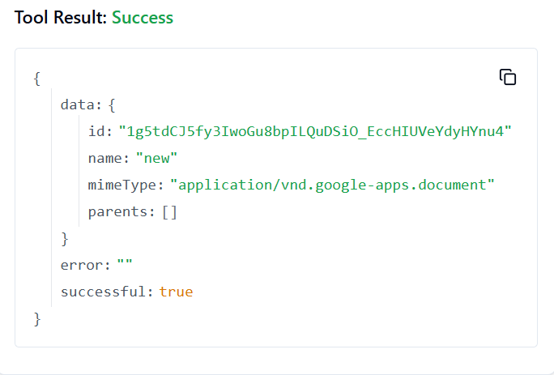

3. **GOOGLEDOCS_CREATE_DOCUMENT_MARKDOWN**

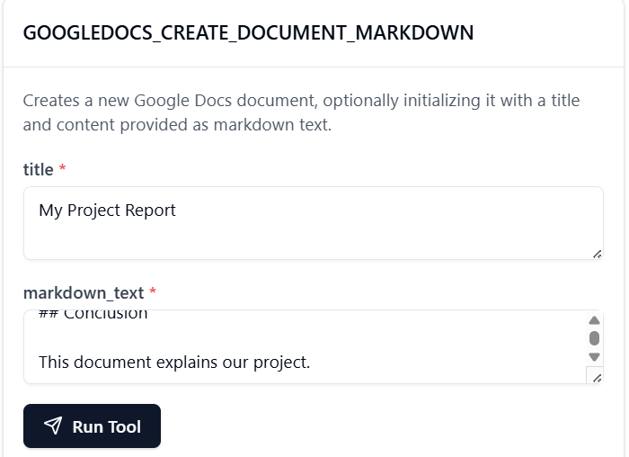

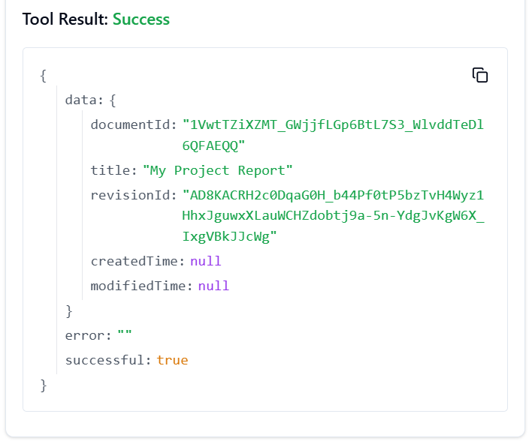

4. **GOOGLEDOCS_CREATE_FOOTNOTE**

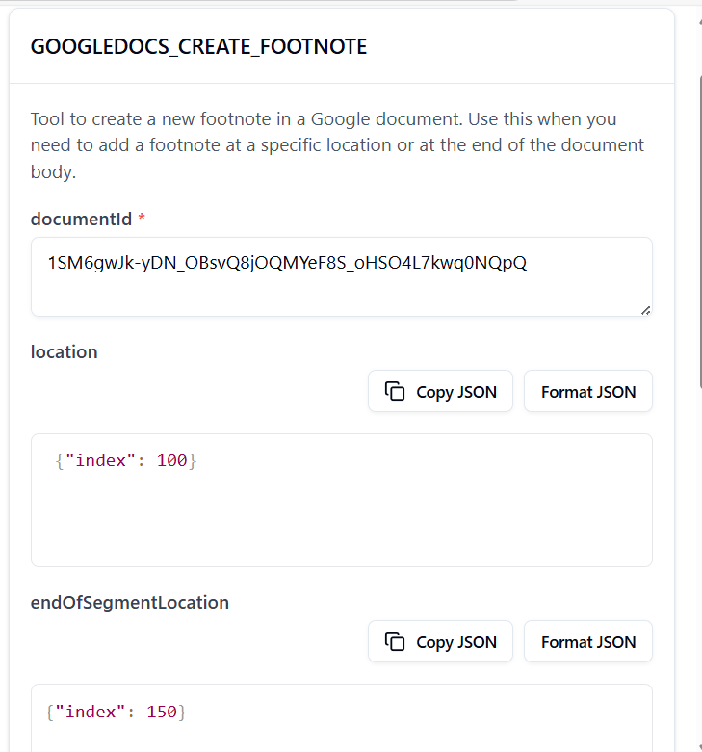

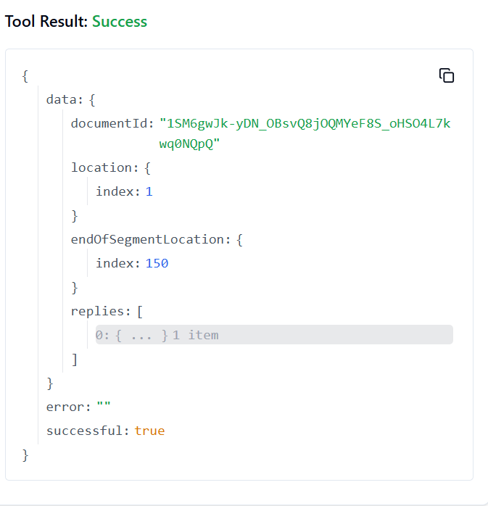

5. **GOOGLEDOCS_CREATE_HEADER**

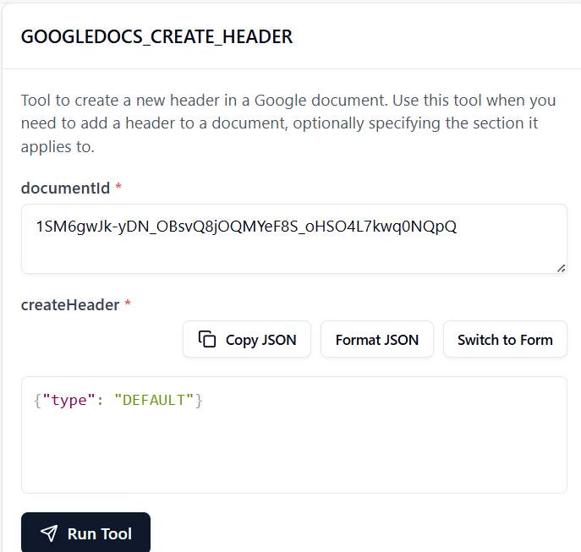

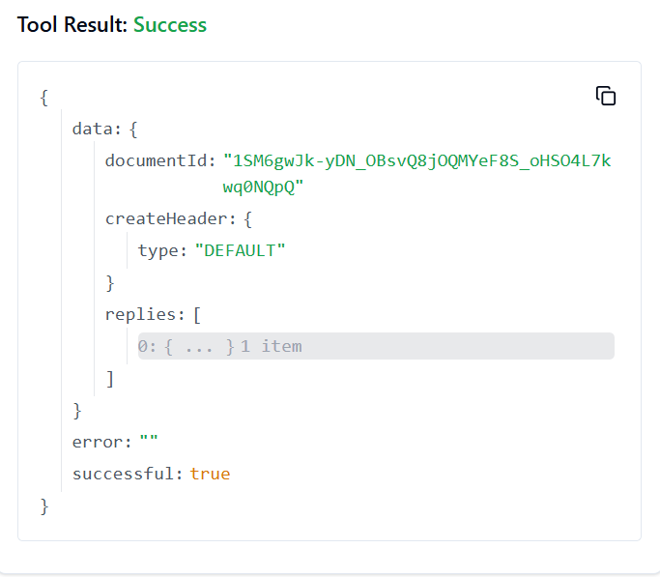

6. **GOOGLEDOCS_CREATE_NAMED_RANGE**

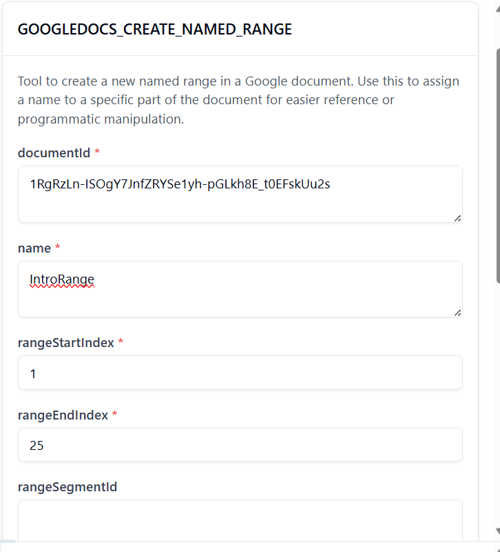

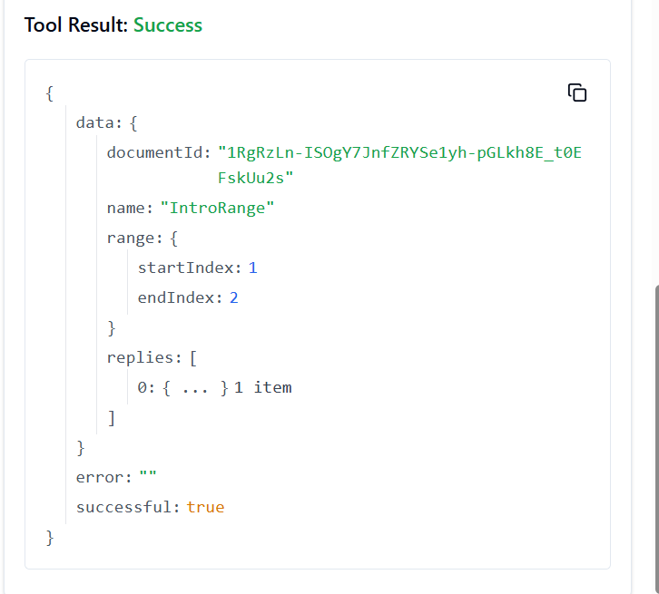

7. **GOOGLEDOCS_CREATE_PARAGRAPH_BULLETS**

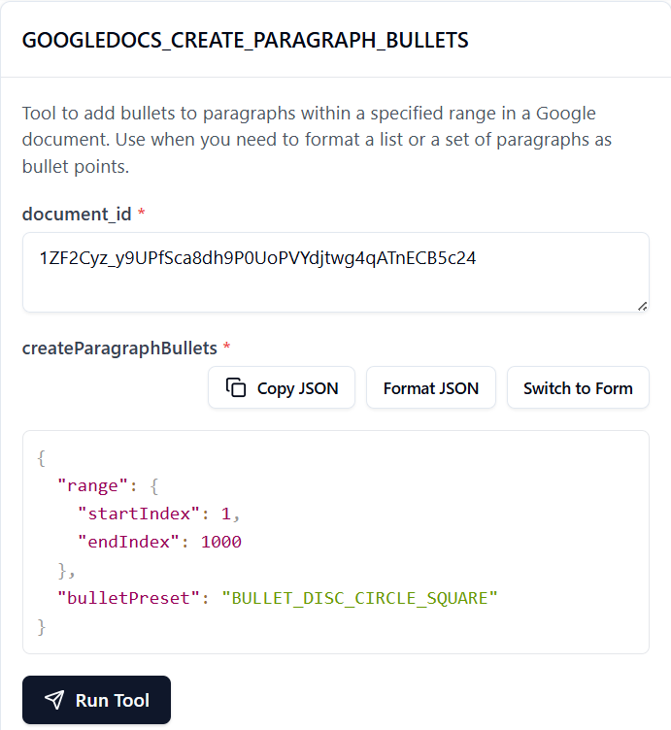

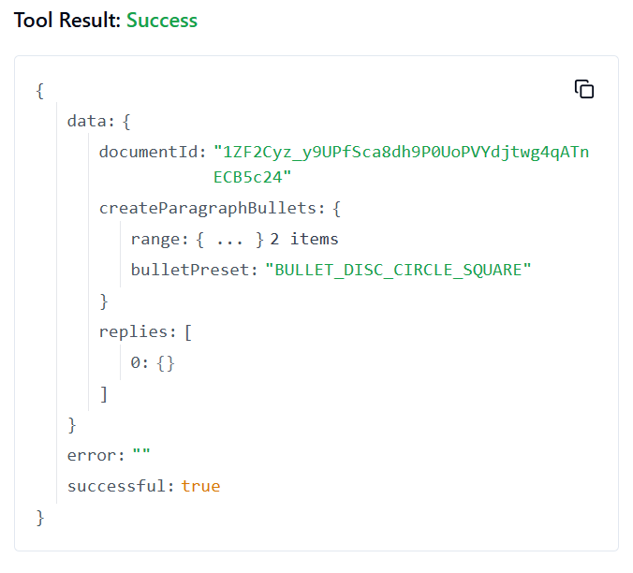

8. 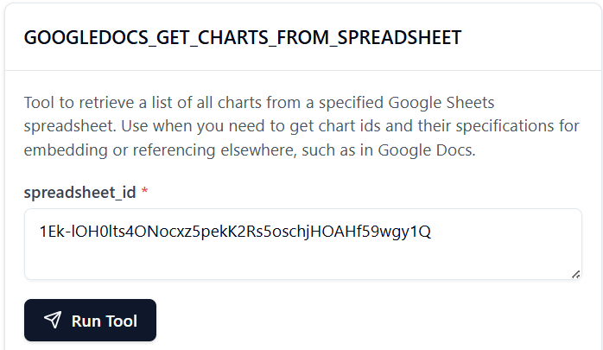

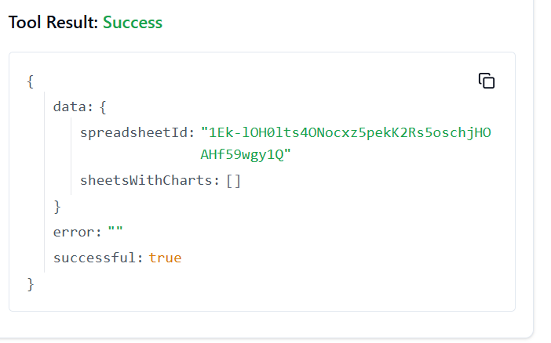

9. **GOOGLEDOCS_GET_DOCUMENT_BY_ID**

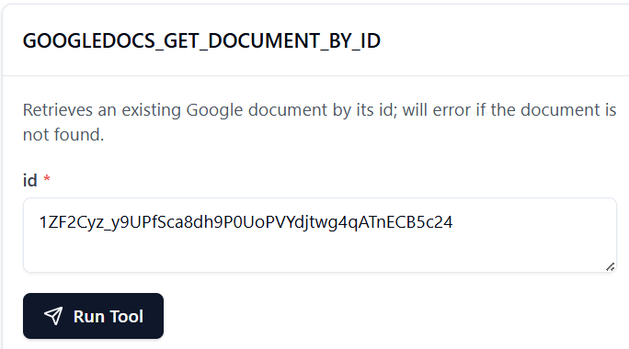

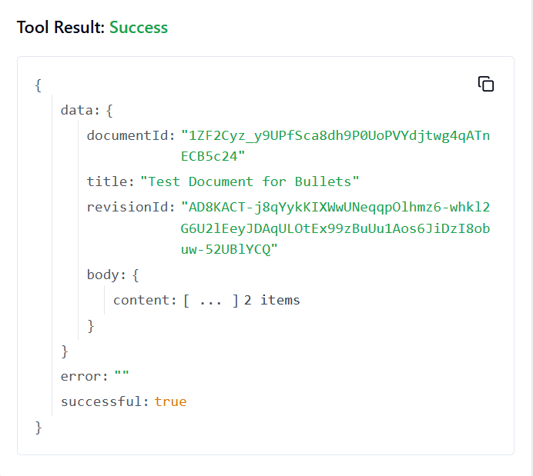

10. **GOOGLEDOCS_INSERT_INLINE_IMAGE**

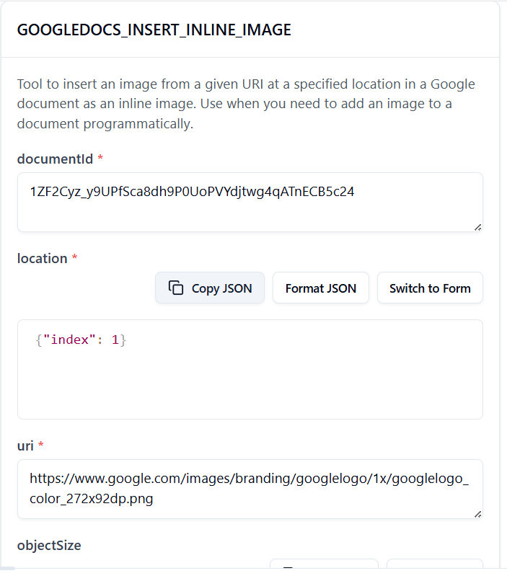

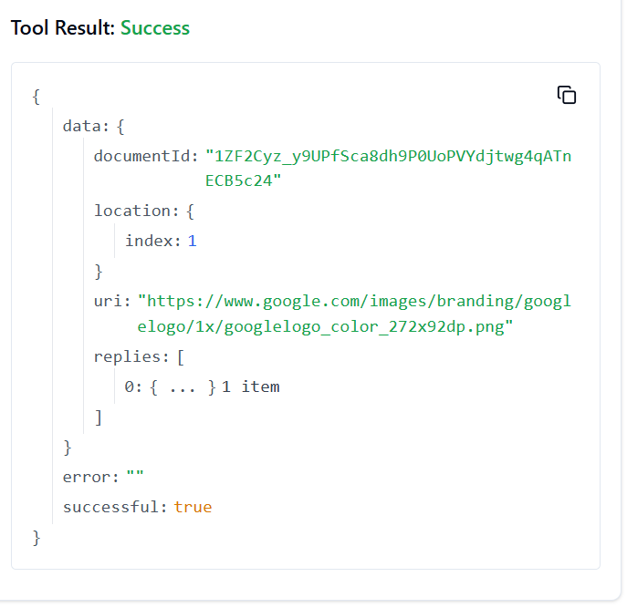

11. **GOOGLEDOCS_INSERT_PAGE_BREAK**

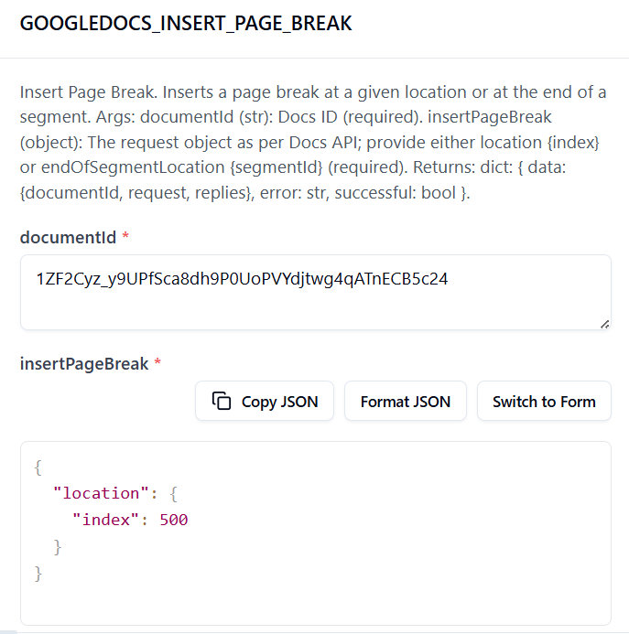

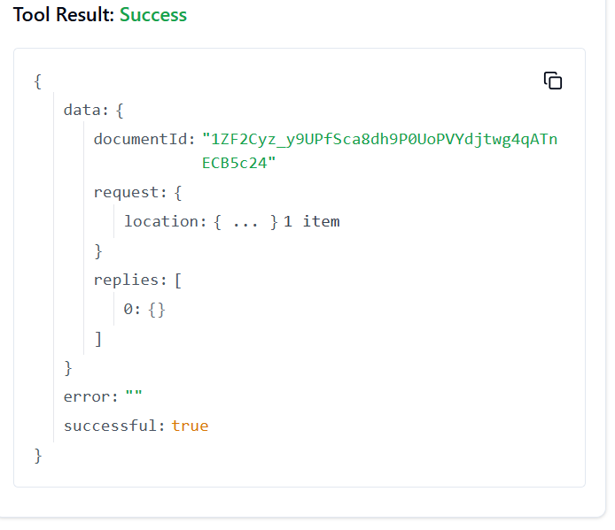

12. **GOOGLEDOCS_INSERT_TABLE_ACTION**

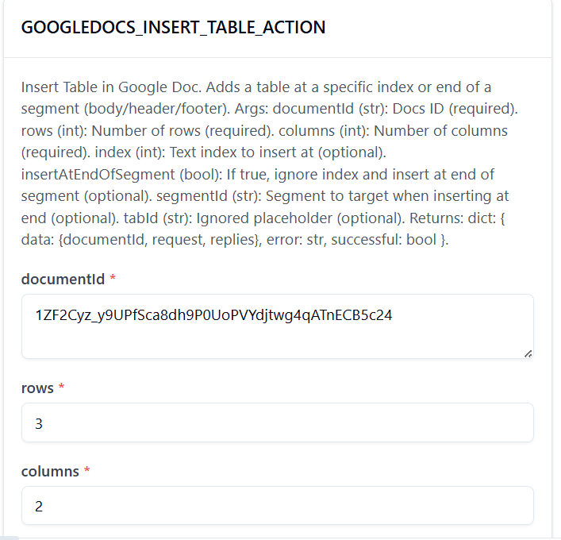

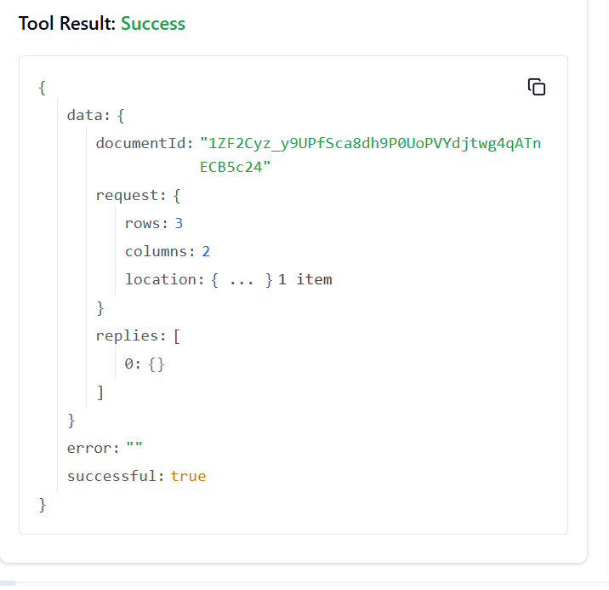

13. **GOOGLEDOCS_INSERT_TABLE_COLUMN**

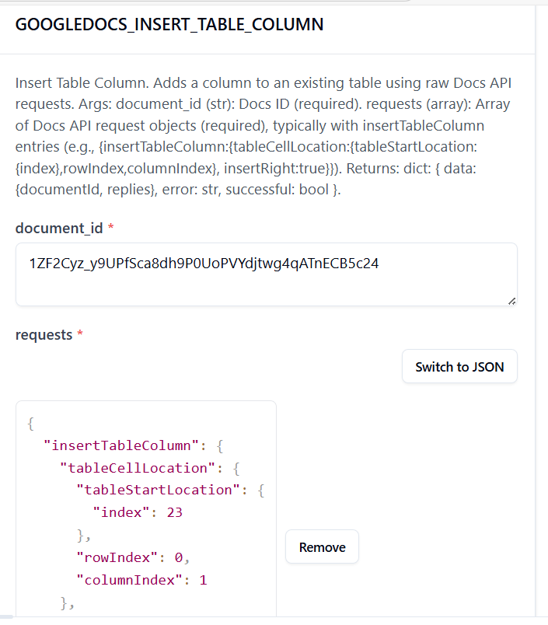

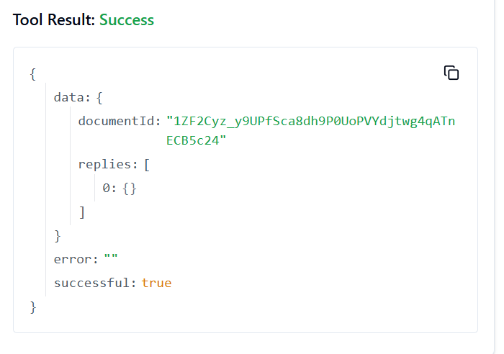

14. **GOOGLEDOCS_LIST_SPREADSHEET_CHARTS_ACTION**

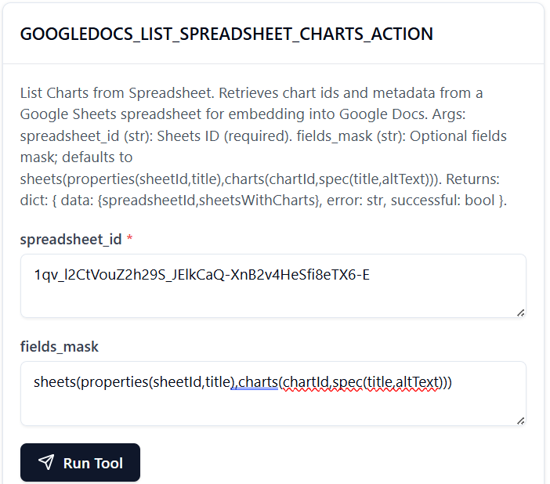

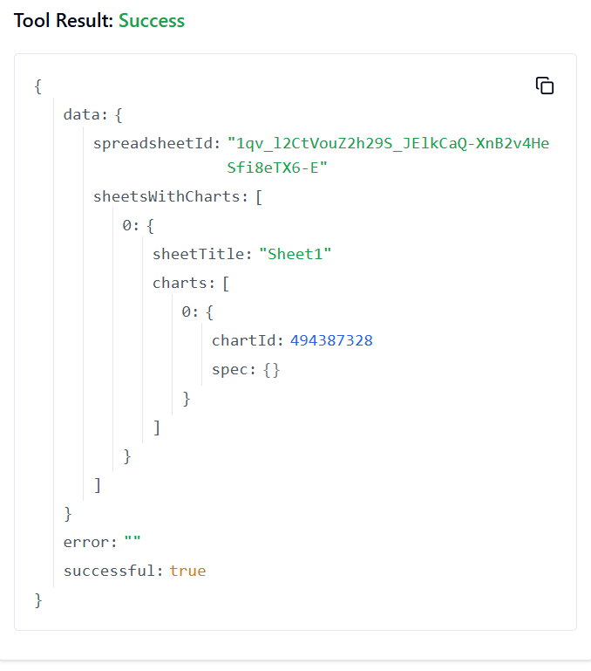

15. **GOOGLEDOCS_REPLACE_ALL_TEXT**

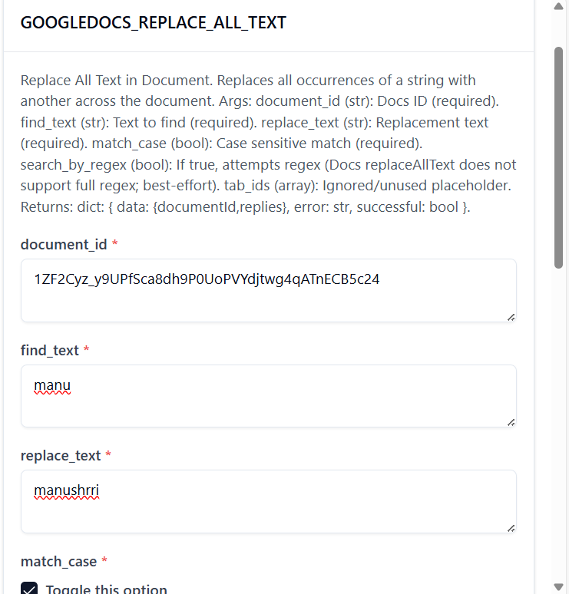

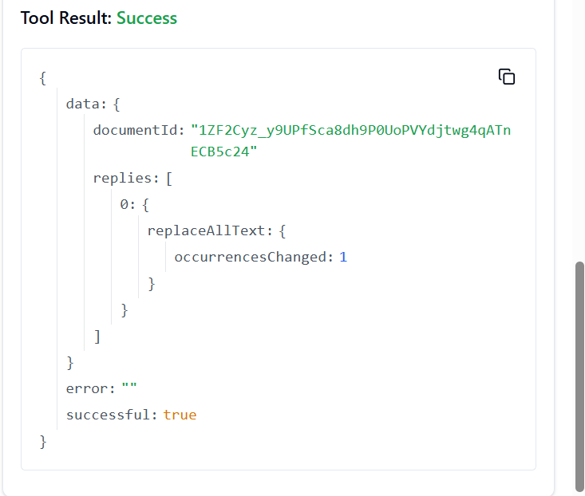

16. **GOOGLEDOCS_REPLACE_IMAGE**

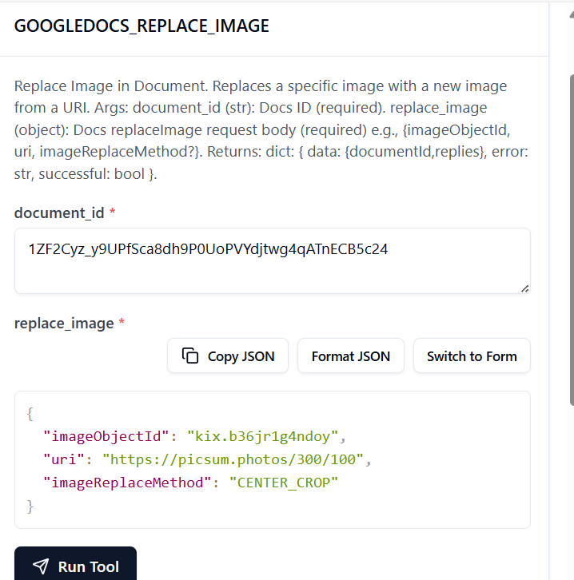

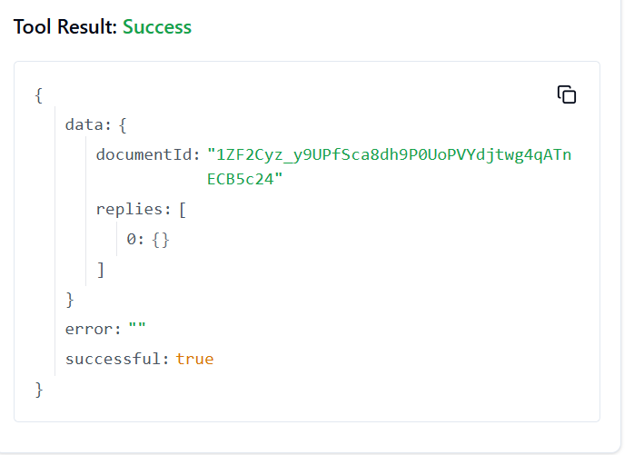

17. **GOOGLEDOCS_SEARCH_DOCUMENTS**

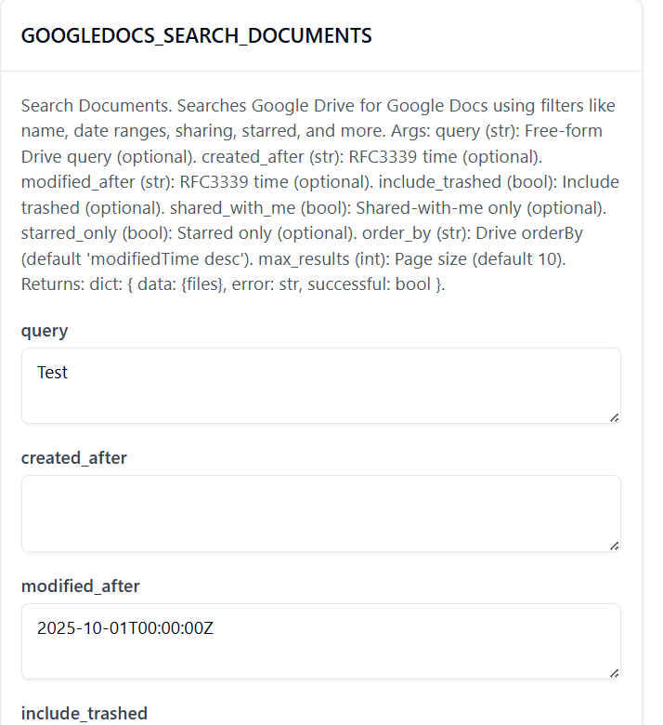

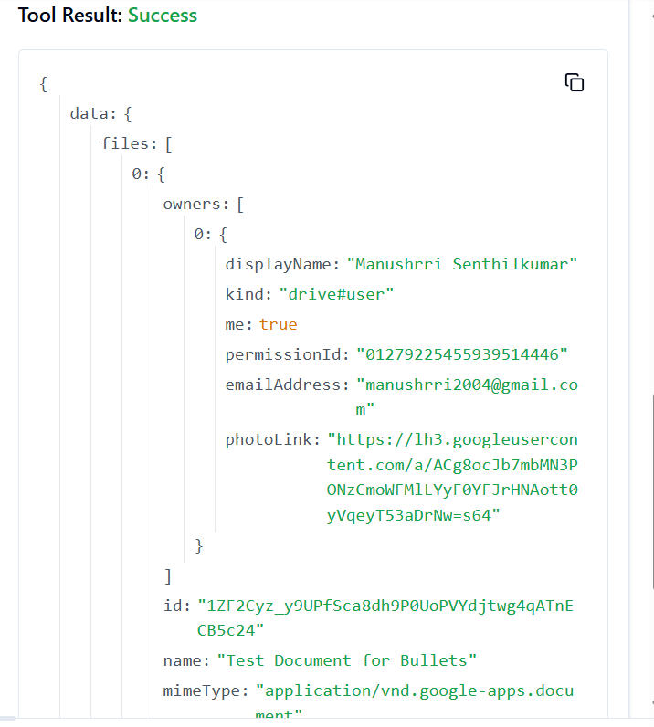

18. **GOOGLEDOCS_UPDATE_EXISTING_DOCUMENT**

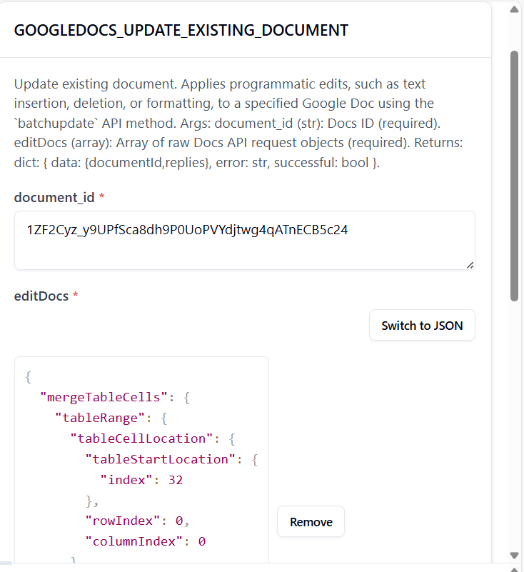

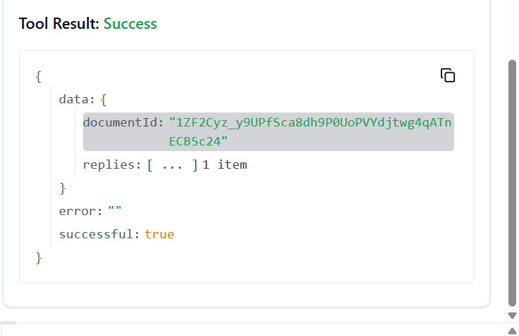

19. **GOOGLEDOCS_UNMERGE_TABLE_CELLS**

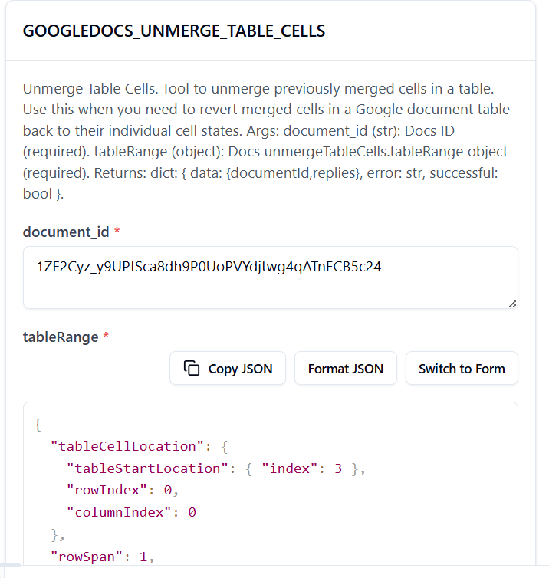

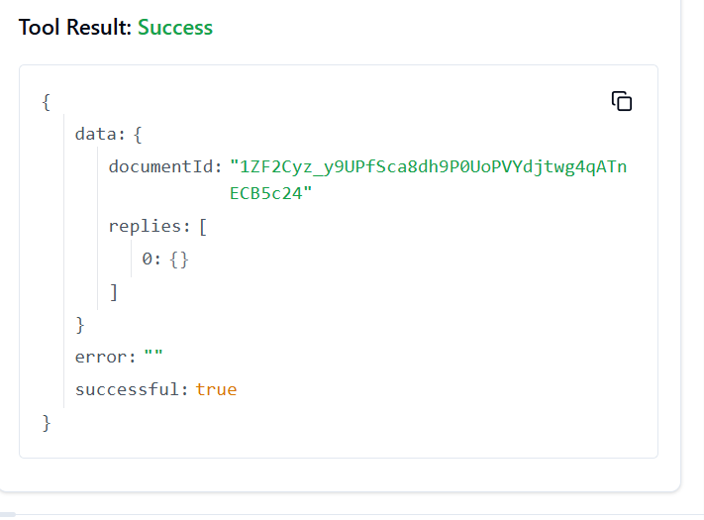

20. **GOOGLEDOCS_UPDATE_DOCUMENT_MARKDOWN**

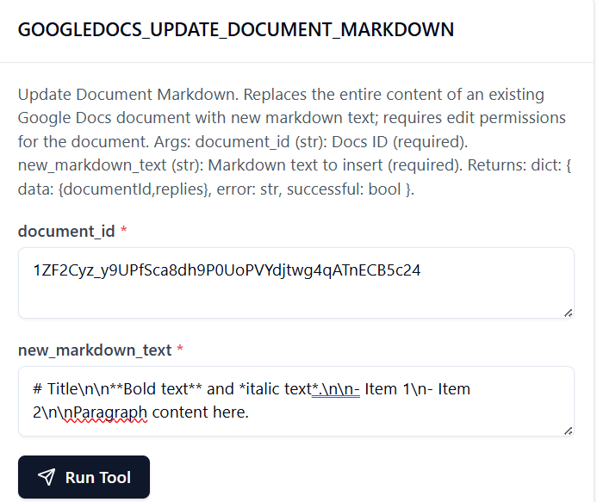

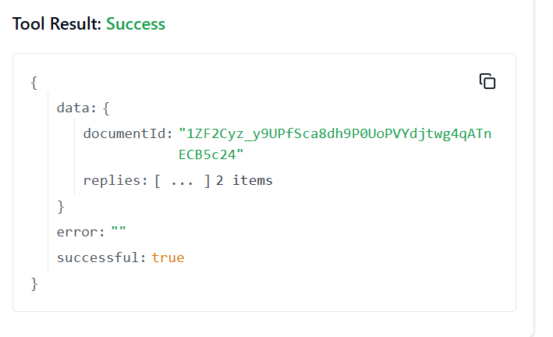

21. **GOOGLEDOCS_UPDATE_DOCUMENT_STYLE**

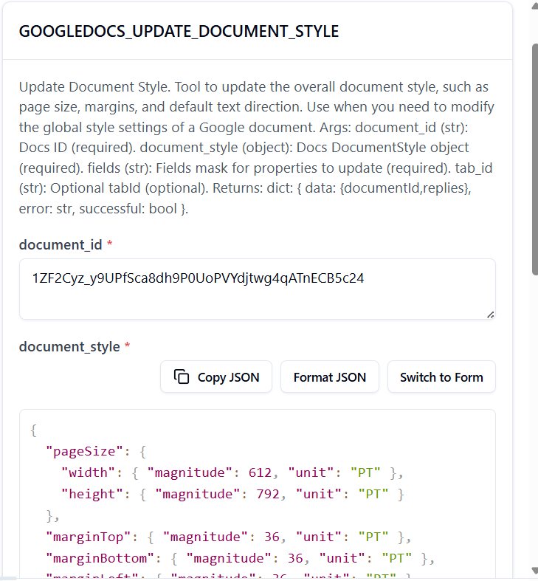

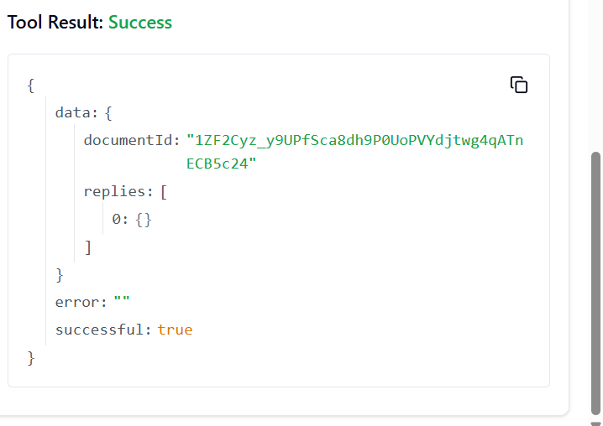

22. **GOOGLEDOCS_INSERT_TEXT_ACTION**

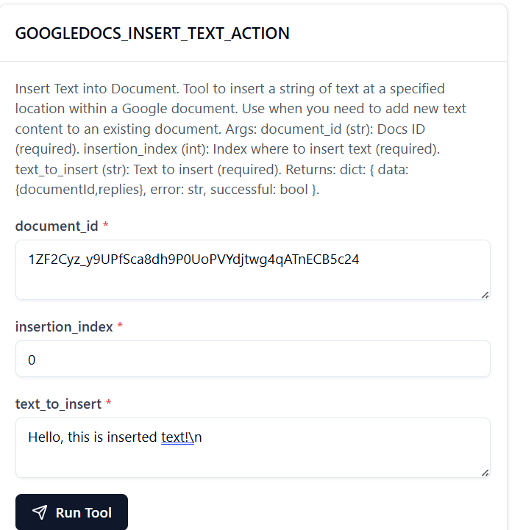

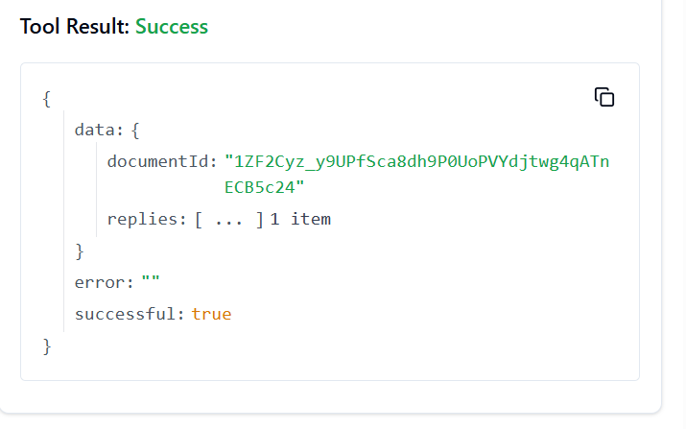

23. **GOOGLEDOCS_DELETE_CONTENT_RANGE**

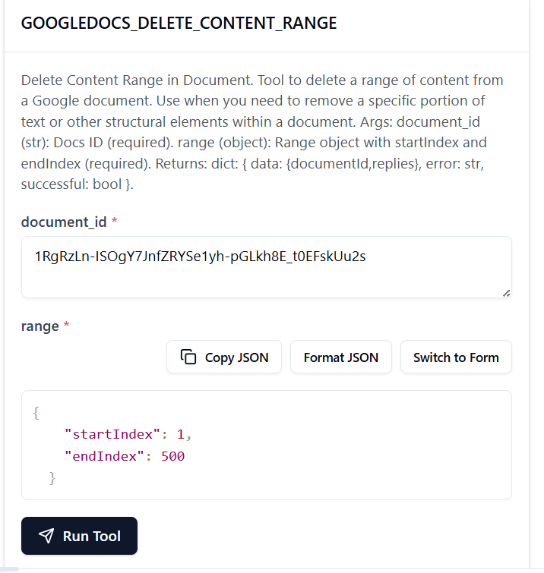

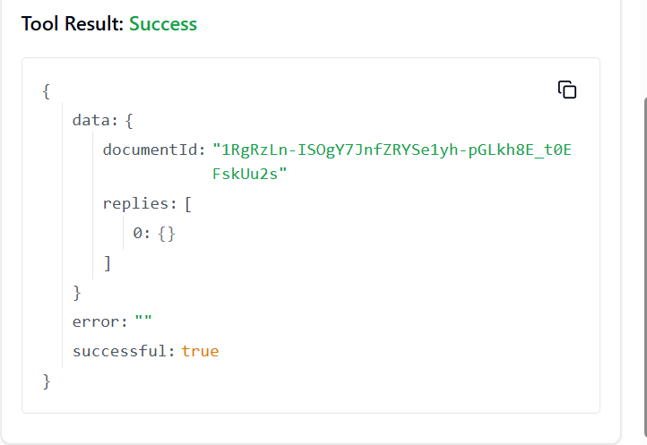

24. **GOOGLEDOCS_DELETE_HEADER**

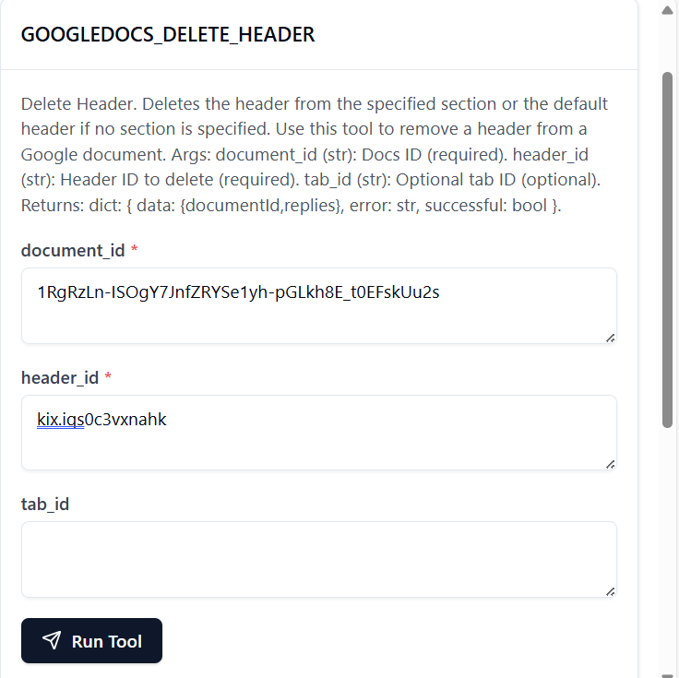

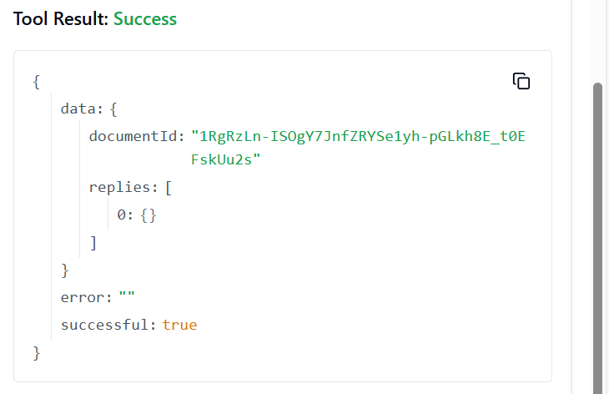

25. **GOOGLEDOCS_DELETE_NAMED_RANGE**

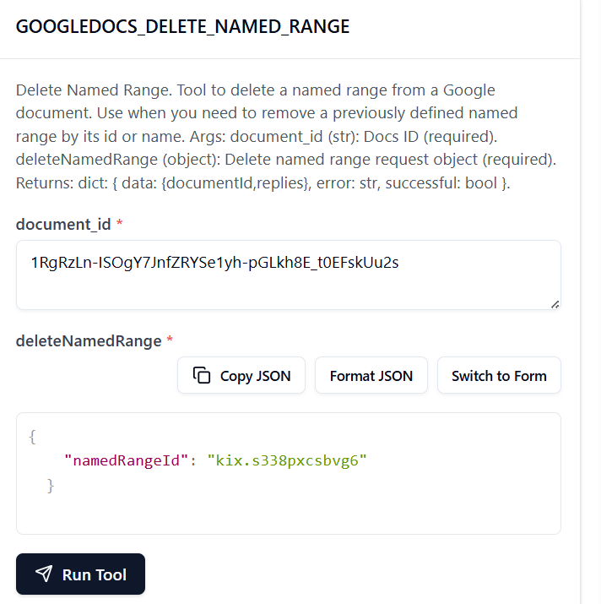

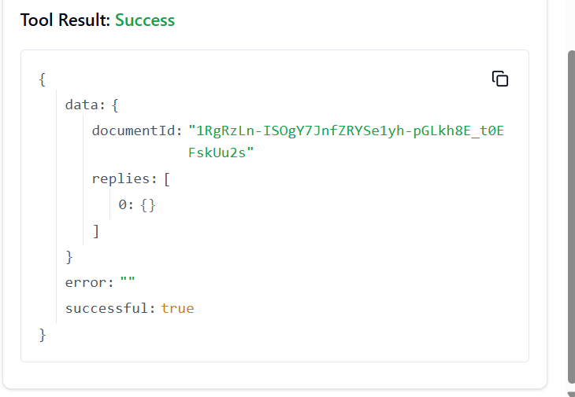

26. **GOOGLEDOCS_DELETE_PARAGRAPH_BULLETS**

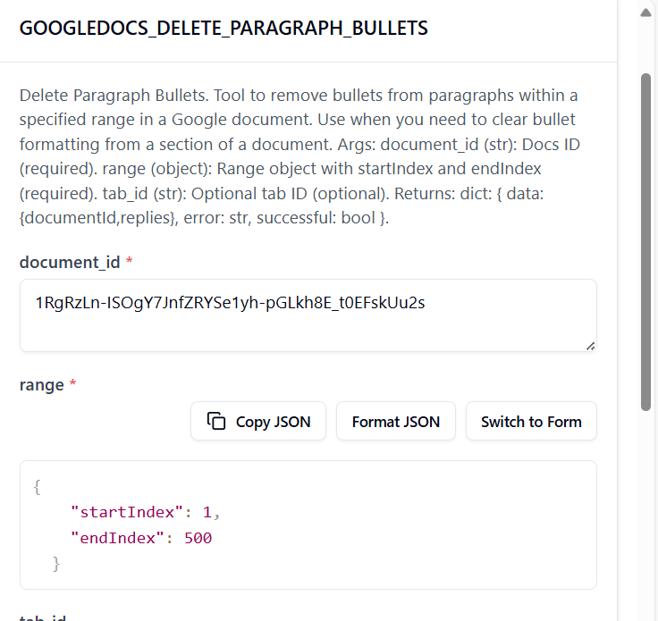

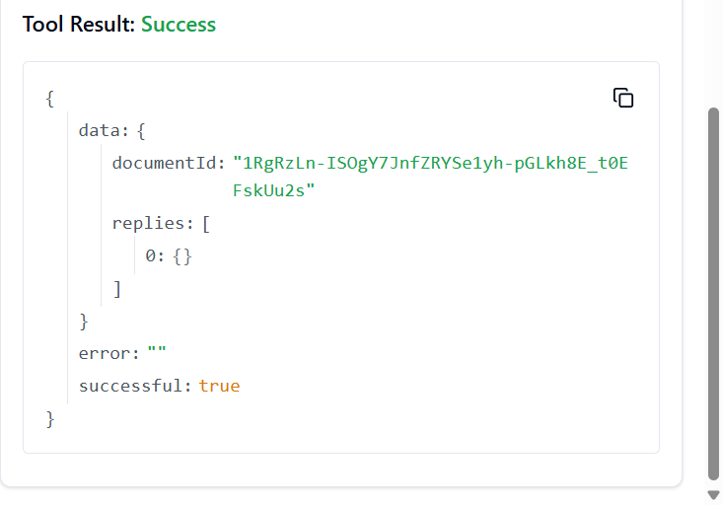

27. **GOOGLEDOCS_DELETE_TABLE**

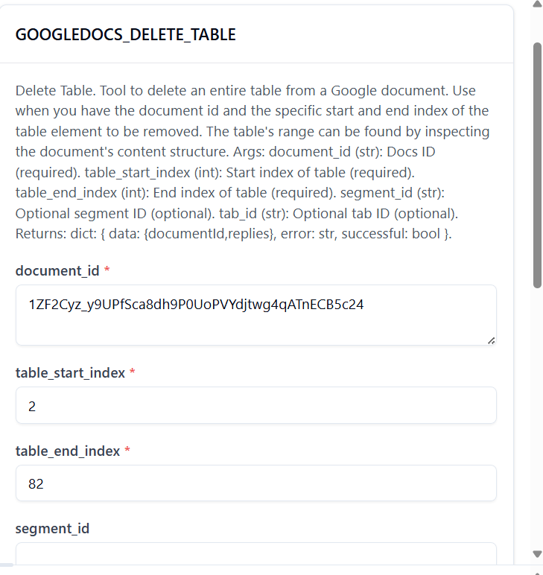

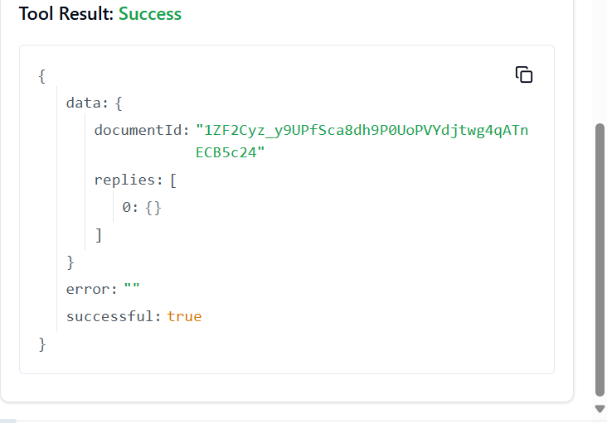

28. **GOOGLEDOCS_DELETE_TABLE_COLUMN**

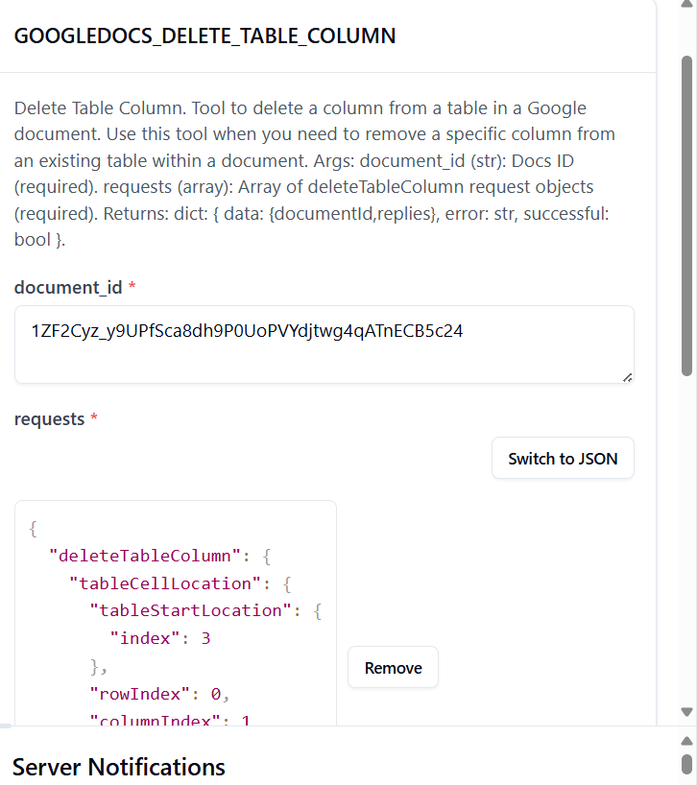

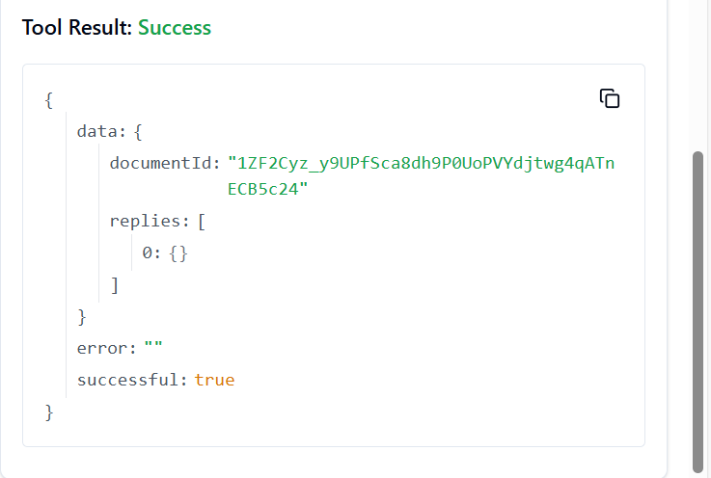

29. **GOOGLEDOCS_DELETE_TABLE_ROW**

