ASSIGNMENT-12.5
HTNO:2303A51324 BTNO:20
Prompt:Generate a complete Python program that implements the Merge Sort algorithm.Requirements:
1. Create a function merge_sort(arr) that sorts a list in ascending order.2. Include a proper docstring explaining the algorithm, time complexity, and space complexity.3. Verify the generated code with test cases4. Print the output exactly in the following format:Original List 1: [elements of the list]Sorted List 1: [sorted elements]''

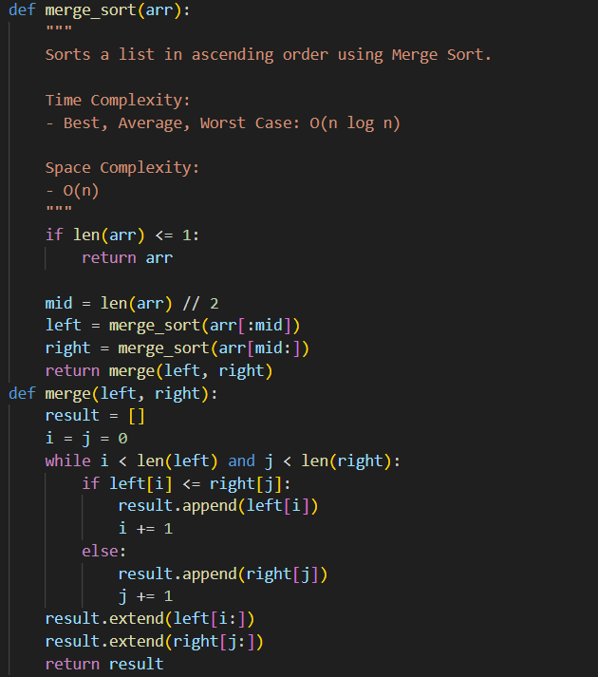

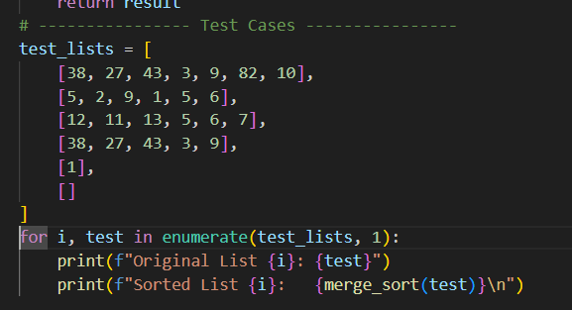
Output:
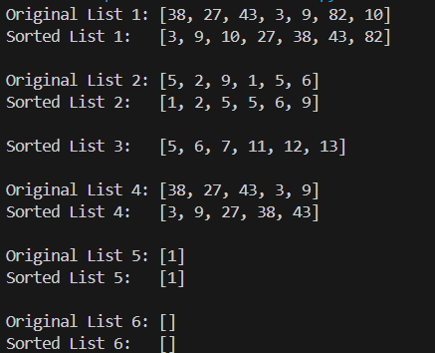
Observation:
The program correctly implements the Merge Sort algorithm using divide and conquer.
It sorts all given test lists properly, including single and empty lists.
The time complexity is O(n log n) and the space complexity is O(n).
Task:2
Prompt:
Generate a complete Python program that implements Binary Search.
Requirements:
- Create a function binary_search(arr, target).
- Return the index if the target is found, otherwise return -1.
- Include a docstring explaining best, average, worst-case time complexity and space complexity.
- Add clear comments in the code.
- Include multiple test cases and print the results clearly.
- The script should run independently.
Code:
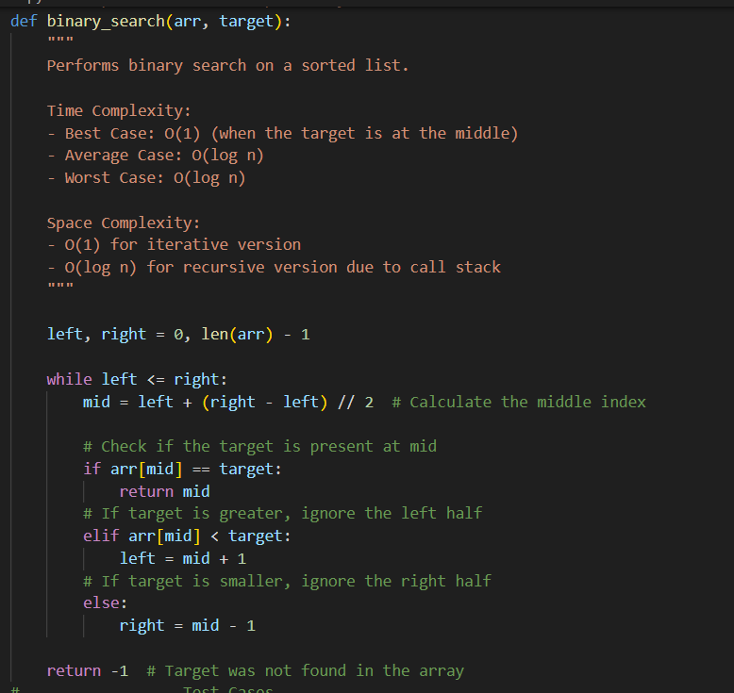
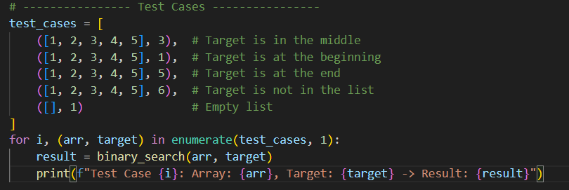
Output:
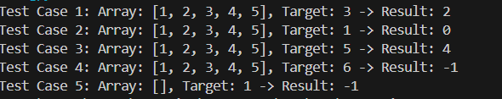
Observation:
The program correctly implements iterative Binary Search on a sorted list.
It handles different cases properly, including element found, not found, and empty list.
The time complexity is O(log n) and space complexity is O(1).
Task 3:
Prompt:
Generate a Python program for a Smart Healthcare Appointment Scheduling System.
Requirements:
- Store appointment records (Appointment ID, Patient Name, Doctor Name, Appointment Time, Consultation Fee).
- Recommend and implement a suitable searching algorithm to search by Appointment ID.
- Recommend and implement suitable sorting algorithms to sort by Appointment Time and Consultation Fee.
- Justify the selected algorithms.
- Include docstrings, comments, and complexity explanations.
- Add sample data and demonstrate searching and sorting.
- The program should run independently.
Code:
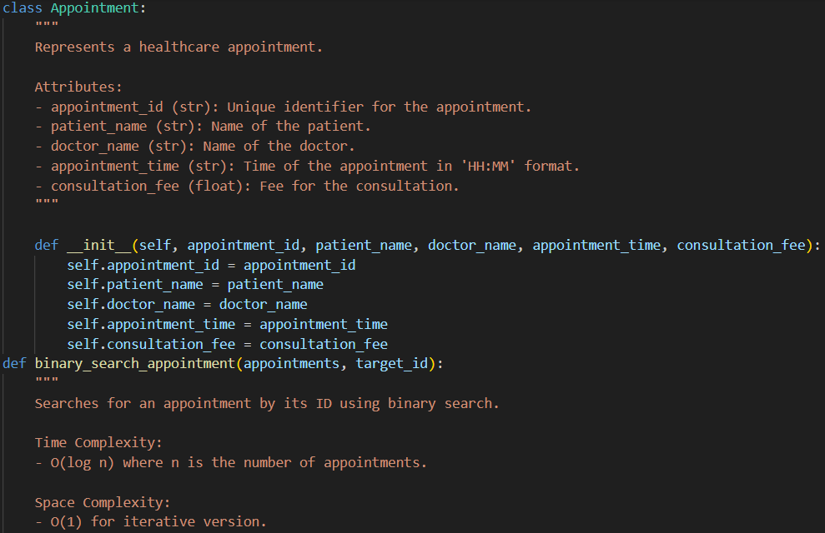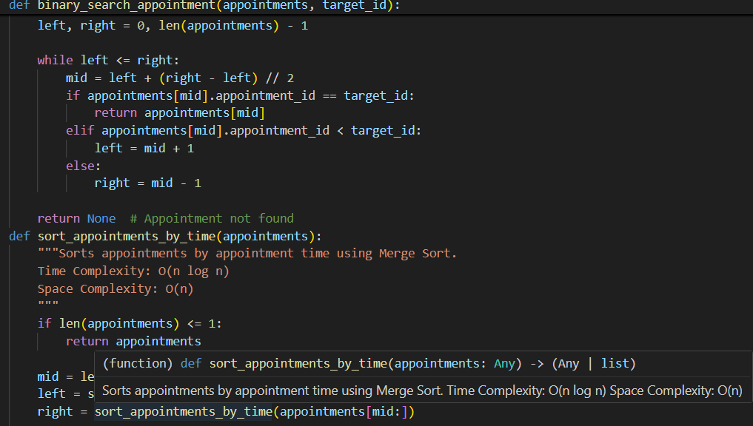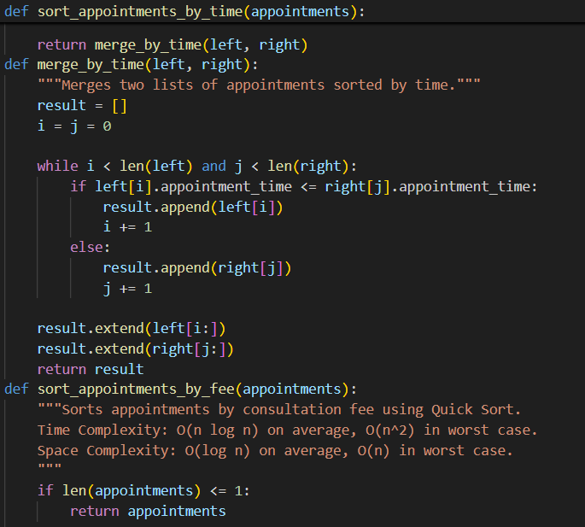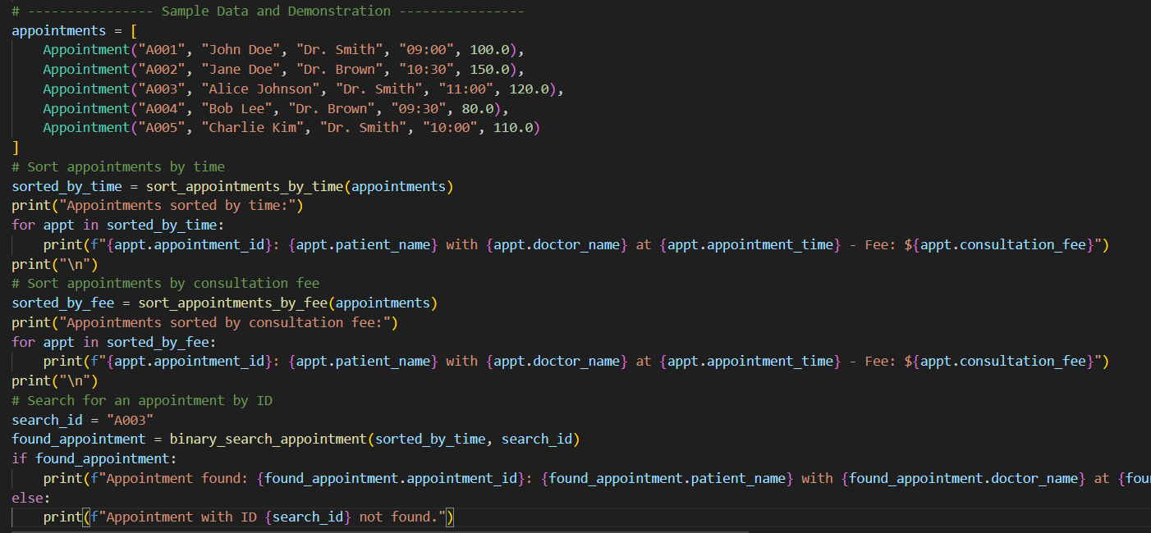Output:
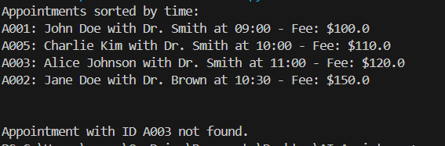
Justification:
Binary Search is used because it efficiently finds an appointment by ID in O(log n) time when the data is sorted.
Merge Sort is chosen for sorting by time because it guarantees O(n log n) performance and is stable.
Quick Sort is used for sorting by fee because it is fast on average with O(n log n) time complexity.
Task 4:
Prompt:
Generate a Python program for a Railway Ticket Reservation System.
Requirements:
- Store ticket details (Ticket ID, Passenger Name, Train Number, Seat Number, Travel Date).
- Implement an efficient search algorithm to find tickets by Ticket ID.
- Implement sorting algorithms to sort bookings by Travel Date and Seat Number.
- Justify the chosen algorithms.
- Include docstrings, comments, and complexity explanation.
- Add sample data and demonstrate searching and sorting.
- The program should run independently.
Code:
class Ticket:
"""
Represents a railway ticket reservation.

Attributes:
- ticket_id (str): Unique identifier for the ticket.
- passenger_name (str): Name of the passenger.
- train_number (str): Number of the train.
- seat_number (str): Seat number assigned to the passenger.
- travel_date (str): Date of travel in 'YYYY-MM-DD' format.
"""

def __init__(self, ticket_id, passenger_name, train_number, seat_number, travel_date):
self.ticket_id = ticket_id
self.passenger_name = passenger_name
self.train_number = train_number
self.seat_number = seat_number
self.travel_date = travel_date
def binary_search_ticket(tickets, target_id):
"""
Searches for a ticket by its ID using binary search.

Time Complexity:
- O(log n) where n is the number of tickets.

Space Complexity:
- O(1) for iterative version.
"""

left, right = 0, len(tickets) - 1

while left <= right:
mid = left + (right - left) // 2
if tickets[mid].ticket_id == target_id:
return tickets[mid]
elif tickets[mid].ticket_id < target_id:
left = mid + 1
else:
right = mid - 1

return None # Ticket not found
def sort_tickets_by_date(tickets):
"""Sorts tickets by travel date using Merge Sort.
Time Complexity: O(n log n)
Space Complexity: O(n)
"""
if len(tickets) <= 1:
return tickets

mid = len(tickets) // 2
left = sort_tickets_by_date(tickets[:mid])
right = sort_tickets_by_date(tickets[mid:])

return merge_by_date(left, right)
def merge_by_date(left, right):
"""Merges two lists of tickets sorted by travel date."""
result = []
i = j = 0

while i < len(left) and j < len(right):
if left[i].travel_date <= right[j].travel_date:
result.append(left[i])
i += 1
else:
result.append(right[j])
j += 1

result.extend(left[i:])
result.extend(right[j:])
return result
def sort_tickets_by_seat(tickets):
"""Sorts tickets by seat number using Quick Sort.
Time Complexity: O(n log n) on average, O(n^2) in worst case.
Space Complexity: O(log n) on average, O(n) in worst case.
"""
if len(tickets) <= 1:
return tickets

pivot = tickets[len(tickets) // 2].seat_number
left = [x for x in tickets if x.seat_number < pivot]
middle = [x for x in tickets if x.seat_number == pivot]
right = [x for x in tickets if x.seat_number > pivot]

return sort_tickets_by_seat(left) + middle + sort_tickets_by_seat(right)
# ---------------- Sample Data and Demonstration ----------------
tickets = [
Ticket("T001", "Alice Smith", "Train 101", "A1", "2024-07-01"),
Ticket("T002", "Bob Johnson", "Train 102", "B2", "2024-07-02"),
Ticket("T003", "Charlie Brown", "Train 101", "A2", "2024-07-01"),
Ticket("T004", "David Lee", "Train 103", "C1", "2024-07-03"),
Ticket("T005", "Eve Davis", "Train 102", "B1", "2024-07-02")
]
# Sort tickets by travel date
sorted_by_date = sort_tickets_by_date(tickets)
print("Tickets sorted by travel date:")
for ticket in sorted_by_date:
print(f"{ticket.ticket_id}: {ticket.passenger_name} on {ticket.train_number} seat {ticket.seat_number} traveling on {ticket.travel_date}")
print("\n")
# Sort tickets by seat number
sorted_by_seat = sort_tickets_by_seat(tickets)
print("Tickets sorted by seat number:")
for ticket in sorted_by_seat:
print(f"{ticket.ticket_id}: {ticket.passenger_name} on {ticket.train_number} seat {ticket.seat_number} traveling on {ticket.travel_date}")
print("\n")
# Search for a ticket by ID
search_id = "T003"
found_ticket = binary_search_ticket(sorted_by_date, search_id)
if found_ticket:
print(f"Ticket found: {found_ticket.ticket_id}: {found_ticket.passenger_name} on {found_ticket.train_number} seat {found_ticket.seat_number} traveling on {found_ticket.travel_date}")
else: print(f"Ticket with ID {search_id} not found.")
output:
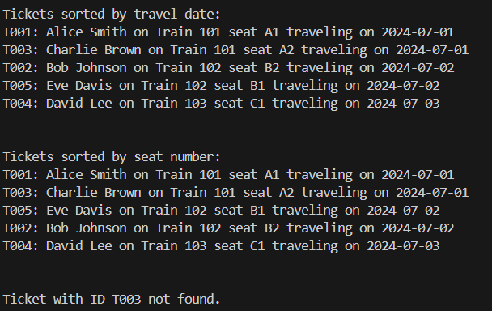
Justification:
Binary Search is used to search ticket by ID because it works in O(log n) time when the list is sorted, making it much faster than linear search for large data.
Merge Sort is used for sorting by travel date because it guarantees O(n log n) time complexity and maintains stable ordering.
Quick Sort is used for sorting by seat number because it is efficient on average with O(n log n) performance and is simple to implement.
Task 5:
Prompt:
Generate a Python program for a Smart Hostel Room Allocation System.

Requirements:
- Store student details (Student ID, Room Number, Floor, Allocation Date).
- Implement an optimized search algorithm to find records by Student ID.
- Implement sorting algorithms to sort by Room Number and Allocation Date.
- Justify the chosen algorithms.
- Include docstrings, comments, and complexity explanation.
- Add sample data and demonstrate searching and sorting.
- The program should run independently.
Code:
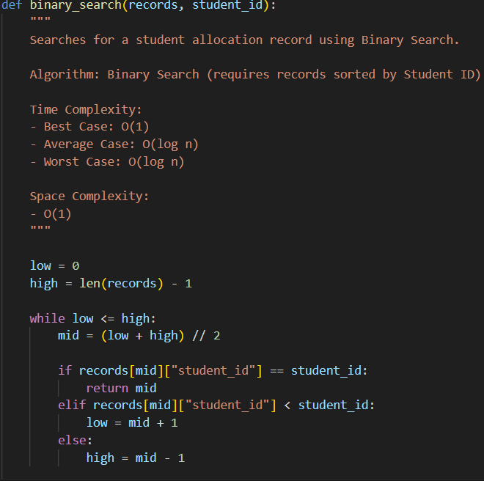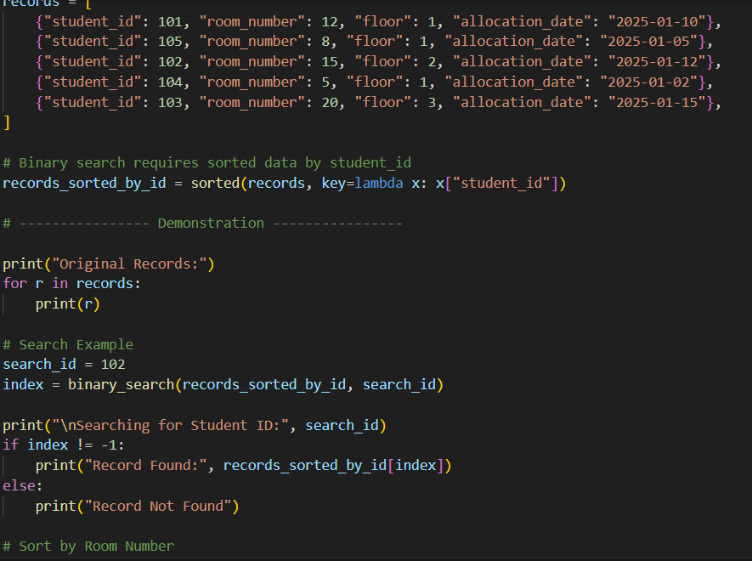O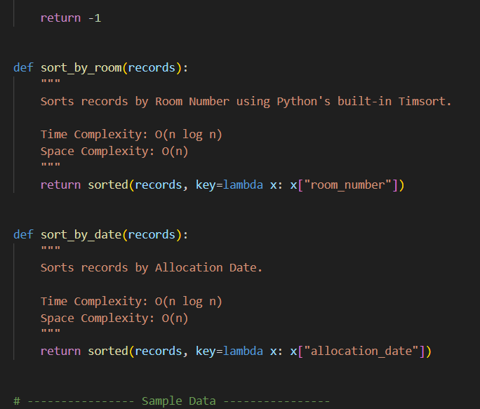
Output:
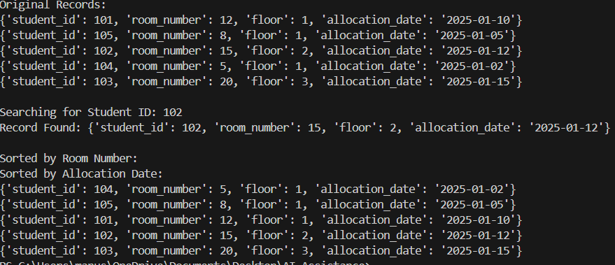
Justification:
Binary Search is used because the records are sorted by student_id, allowing fast searching in O(log n) time instead of O(n) linear search. It is efficient for large datasets and uses O(1) space.
Timsort (Python’s built-in sorted()) is used for sorting by room number and allocation date because it guarantees O(n log n) time complexity, is stable, and is highly optimized for real-world data.
Thus, the chosen algorithms ensure fast searching and efficient, reliable sorting.
Task:6
Prompt:
Generate a Python program for an Online Movie Streaming Platform.
Requirements:
- Store movie details (Movie ID, Title, Genre, Rating, Release Year).
- Implement an efficient search algorithm to find movies by Movie ID.
- Implement sorting algorithms to sort by Rating and Release Year.
- Justify the chosen algorithms.
- Include docstrings, comments, and complexity explanation.
- Add sample data and demonstrate searching and sorting.
- The program should run independently.
Code:
class Movie:
"""
Represents a movie in the streaming platform.

Attributes:
- movie_id (str): Unique identifier for the movie.
- title (str): Title of the movie.
- genre (str): Genre of the movie.
- rating (float): Rating of the movie (0.0 to 10.0).
- release_year (int): Year the movie was released.
"""

def __init__(self, movie_id, title, genre, rating, release_year):
self.movie_id = movie_id
self.title = title
self.genre = genre
self.rating = rating
self.release_year = release_year
def binary_search_movie(movies, target_id):
"""
Searches for a movie by its ID using binary search.

Time Complexity:
- O(log n) where n is the number of movies.

Space Complexity:
- O(1) for iterative version.
"""

left, right = 0, len(movies) - 1

while left <= right:
mid = left + (right - left) // 2
if movies[mid].movie_id == target_id:
return movies[mid]
elif movies[mid].movie_id < target_id:
left = mid + 1
else:
right = mid - 1

return None # Movie not found
def sort_movies_by_rating(movies):
"""Sorts movies by rating using Merge Sort.
Time Complexity: O(n log n)
Space Complexity: O(n)
"""
if len(movies) <= 1:
return movies

mid = len(movies) // 2
left = sort_movies_by_rating(movies[:mid])
right = sort_movies_by_rating(movies[mid:])

return merge_by_rating(left, right)
def merge_by_rating(left, right):
"""Merges two lists of movies sorted by rating."""
result = []
i = j = 0

while i < len(left) and j < len(right):
if left[i].rating >= right[j].rating: # Higher rating first
result.append(left[i])
i += 1
else:
result.append(right[j])
j += 1

result.extend(left[i:])
result.extend(right[j:])
return result
def sort_movies_by_release_year(movies):
"""Sorts movies by release year using Quick Sort.
Time Complexity: O(n log n) on average, O(n^2) in worst case.
Space Complexity: O(log n) on average, O(n) in worst case.
"""
if len(movies) <= 1:
return movies

pivot = movies[len(movies) // 2].release_year
left = [x for x in movies if x.release_year < pivot]
middle = [x for x in movies if x.release_year == pivot]
right = [x for x in movies if x.release_year > pivot]

return sort_movies_by_release_year(left) + middle + sort_movies_by_release_year(right)
# ---------------- Sample Data and Demonstration ----------------
movies = [
Movie("M001", "Inception", "Sci-Fi", 8.8, 2010),
Movie("M002", "The Godfather", "Crime", 9.2, 1972),
Movie("M003", "The Dark Knight", "Action", 9.0, 2008),
Movie("M004", "Pulp Fiction", "Crime", 8.9, 1994),
Movie("M005", "The Shawshank Redemption", "Drama", 9.3, 1994)
]
# Sort movies by rating
sorted_by_rating = sort_movies_by_rating(movies)
print("Movies sorted by rating:")
for movie in sorted_by_rating:
print(f"{movie.movie_id}: {movie.title} - Genre: {movie.genre}, Rating: {movie.rating}, Release Year: {movie.release_year}")
print("\n")
# Sort movies by release year
sorted_by_release_year = sort_movies_by_release_year(movies)
print("Movies sorted by release year:")
for movie in sorted_by_release_year:
print(f"{movie.movie_id}: {movie.title} - Genre: {movie.genre}, Rating: {movie.rating}, Release Year: {movie.release_year}")
print("\n")
# Search for a movie by ID
search_id = "M003"
found_movie = binary_search_movie(sorted_by_rating, search_id)
if found_movie:
print(f"Movie found: {found_movie.movie_id}: {found_movie.title} - Genre: {found_movie.genre}, Rating: {found_movie.rating}, Release Year: {found_movie.release_year}")
else: print(f"Movie with ID {search_id} not found.")
Output:
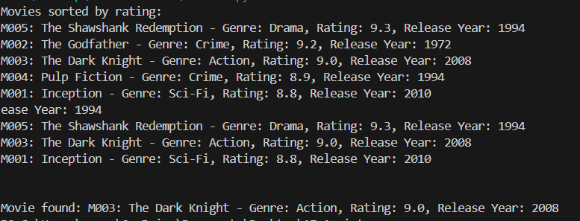
Justification:
Binary Search is used to find a movie by movie_id because it works in O(log n) time when the list is sorted, making it efficient for large movie collections.
Merge Sort is used for sorting by rating because it guarantees O(n log n) time complexity and provides stable, consistent performance.
Quick Sort is used for sorting by release year because it is fast on average (O(n log n)) and simple to implement for numerical data.
Task 7:
Prompt:
Generate a Python program for a Smart Agriculture Crop Monitoring System.
Requirements:
- Store crop details (Crop ID, Crop Name, Soil Moisture Level, Temperature, Yield Estimate).
- Implement an efficient search algorithm to find crops by Crop ID.
- Implement sorting algorithms to sort by Soil Moisture Level and Yield Estimate.
- Justify the chosen algorithms.
- Include docstrings, comments, and complexity explanation.
- Add sample data and demonstrate searching and sorting.
- The program should run independently.
Code:
def binary_search(crops, crop_id):
"""
Searches for a crop by Crop ID using Binary Search.

Time Complexity:
- Best Case: O(1)
- Average Case: O(log n)
- Worst Case: O(log n)

Space Complexity:
- O(1)
"""

low = 0
high = len(crops) - 1

while low <= high:
mid = (low + high) // 2

if crops[mid]["crop_id"] == crop_id:
return mid
elif crops[mid]["crop_id"] < crop_id:
low = mid + 1
else:
high = mid - 1

return -1

def sort_by_moisture(crops):
"""
Sort crops by Soil Moisture Level (ascending).

Time Complexity: O(n log n)
Space Complexity: O(n)
"""
return sorted(crops, key=lambda x: x["moisture"])

def sort_by_yield(crops):
"""
Sort crops by Yield Estimate (ascending).

Time Complexity: O(n log n)
Space Complexity: O(n)
"""
return sorted(crops, key=lambda x: x["yield_estimate"])

# ---------------- Sample Data ----------------

crops = [
{"crop_id": 101, "crop_name": "Wheat", "moisture": 30, "temperature": 25, "yield_estimate": 200},
{"crop_id": 105, "crop_name": "Rice", "moisture": 45, "temperature": 28, "yield_estimate": 300},
{"crop_id": 102, "crop_name": "Corn", "moisture": 35, "temperature": 27, "yield_estimate": 250},
{"crop_id": 104, "crop_name": "Barley", "moisture": 25, "temperature": 22, "yield_estimate": 180},
{"crop_id": 103, "crop_name": "Soybean", "moisture": 40, "temperature": 26, "yield_estimate": 270},
]

# Binary Search requires sorted list by crop_id
crops_sorted_by_id = sorted(crops, key=lambda x: x["crop_id"])

# ---------------- Demonstration ----------------

print("Original Crop Records:")
for crop in crops:
print(crop)

# Search Example
search_id = 102
index = binary_search(crops_sorted_by_id, search_id)

print("\nSearching for Crop ID:", search_id)
if index != -1:
print("Crop Found:", crops_sorted_by_id[index])
else:
print("Crop Not Found")

# Sort by Moisture
print("\nSorted by Soil Moisture Level:")
for crop in sort_by_moisture(crops):
print(crop)

# Sort by Yield Estimate
print("\nSorted by Yield Estimate:")
for crop in sort_by_yield(crops):
print(crop)
Output:
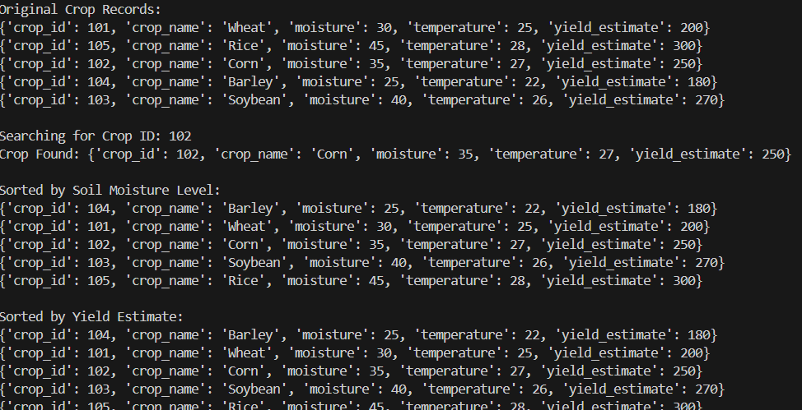
Justification:
Binary Search is used to find a crop by crop_id because the list is sorted by ID, allowing efficient searching in O(log n) time instead of O(n). It also uses O(1) space.
Python’s built-in sorted() (Timsort) is used for sorting by moisture and yield because it guarantees O(n log n) time complexity, is stable, and is highly optimized for real-world data.
Thus, the algorithms ensure fast searching and efficient, reliable sorting.
Task 8:
Prompt:
Generate a Python program for an Airport Flight Management System.
Requirements:
- Store flight details (Flight ID, Airline Name, Departure Time, Arrival Time, Status).
- Implement an efficient search algorithm to find flights by Flight ID.
- Implement sorting algorithms to sort by Departure Time and Arrival Time.
- Justify the chosen algorithms.
- Include docstrings, comments, and complexity explanation.
- Add sample data and demonstrate searching and sorting.
- The program should run independently.
Code:
class Flight:
"""
Represents a flight in the airport management system.

Attributes:
- flight_id (str): Unique identifier for the flight.
- airline_name (str): Name of the airline.
- departure_time (str): Departure time in 'HH:MM' format.
- arrival_time (str): Arrival time in 'HH:MM' format.
- status (str): Status of the flight (e.g., "On Time", "Delayed", "Cancelled").
"""

def __init__(self, flight_id, airline_name, departure_time, arrival_time, status):
self.flight_id = flight_id
self.airline_name = airline_name
self.departure_time = departure_time
self.arrival_time = arrival_time
self.status = status
def binary_search_flight(flights, target_id):
"""
Searches for a flight by its ID using binary search.

Time Complexity:
- O(log n) where n is the number of flights.

Space Complexity:
- O(1) for iterative version.
"""

left, right = 0, len(flights) - 1

while left <= right:
mid = left + (right - left) // 2
if flights[mid].flight_id == target_id:
return flights[mid]
elif flights[mid].flight_id < target_id:
left = mid + 1
else:
right = mid - 1

return None # Flight not found
def sort_flights_by_departure(flights):
"""Sorts flights by departure time using Merge Sort.
Time Complexity: O(n log n)
Space Complexity: O(n)
"""
if len(flights) <= 1:
return flights

mid = len(flights) // 2
left = sort_flights_by_departure(flights[:mid])
right = sort_flights_by_departure(flights[mid:])

return merge_by_departure(left, right)
def merge_by_departure(left, right):
"""Merges two lists of flights sorted by departure time."""
result = []
i = j = 0

while i < len(left) and j < len(right):
if left[i].departure_time <= right[j].departure_time:
result.append(left[i])
i += 1
else:
result.append(right[j])
j += 1

result.extend(left[i:])
result.extend(right[j:])
return result
def sort_flights_by_arrival(flights):
"""Sorts flights by arrival time using Quick Sort.
Time Complexity: O(n log n) on average, O(n^2) in worst case.
Space Complexity: O(log n) on average, O(n) in worst case.
"""
if len(flights) <= 1:
return flights

pivot = flights[len(flights) // 2].arrival_time
left = [x for x in flights if x.arrival_time < pivot]
middle = [x for x in flights if x.arrival_time == pivot]
right = [x for x in flights if x.arrival_time > pivot]

return sort_flights_by_arrival(left) + middle + sort_flights_by_arrival(right)
# ---------------- Sample Data and Demonstration ----------------
flights = [
Flight("F001", "Airline A", "08:00", "10:00", "On Time"),
Flight("F002", "Airline B", "09:30", "11:30", "Delayed"),
Flight("F003", "Airline C", "07:45", "09:45", "Cancelled"),
Flight("F004", "Airline D", "10:15", "12:15", "On Time"),
Flight("F005", "Airline E", "06:30", "08:30", "On Time")
]
# Sort flights by departure time
sorted_by_departure = sort_flights_by_departure(flights)
print("Flights sorted by departure time:")
for flight in sorted_by_departure:
print(f"{flight.flight_id}: {flight.airline_name} - Departure: {flight.departure_time}, Arrival: {flight.arrival_time}, Status: {flight.status}")
print("\n")
# Sort flights by arrival time
sorted_by_arrival = sort_flights_by_arrival(flights)
print("Flights sorted by arrival time:")
for flight in sorted_by_arrival:
print(f"{flight.flight_id}: {flight.airline_name} - Departure: {flight.departure_time}, Arrival: {flight.arrival_time}, Status: {flight.status}")
print("\n")
# Search for a flight by ID
search_id = "F003"
found_flight = binary_search_flight(sorted_by_departure, search_id)
if found_flight:
print(f"Flight found: {found_flight.flight_id}: {found_flight.airline_name} - Departure: {found_flight.departure_time}, Arrival: {found_flight.arrival_time}, Status: {found_flight.status}")
else: print(f"Flight with ID {search_id} not found.")
Output:
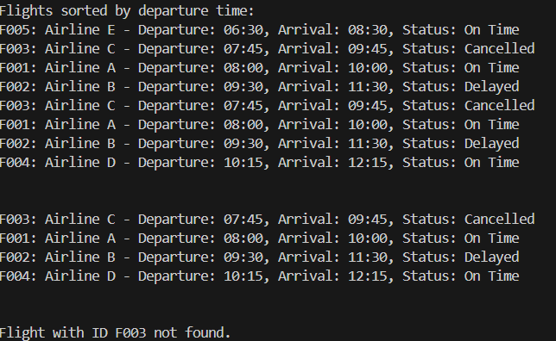
Justification:
Binary Search is used to search for a flight by flight_id because it reduces the search space by half each step, giving O(log n) time complexity. It is much faster than linear search for large datasets.
Merge Sort is used for sorting by departure time because it guarantees O(n log n) performance and provides stable sorting.
Quick Sort is used for sorting by arrival time because it is efficient on average (O(n log n)) and works well for time-based comparisons.

