Assignment-14.3
Name:E.Manu Sree
HTNO:2303A51324
Batch:20
Task 1: AI-Assisted Personal Portfolio Website
Prompt:
Create a beginner-friendly personal portfolio website using HTML, CSS, and JavaScript.Include sections: Home, About, Projects, and Contact using semantic HTML.Add a responsive navigation bar with smooth scrolling.
Use Flexbox or CSS Grid for layout so it works on mobile and desktop.In the Projects section, create cards with image, title, description, and hover effects.Use clean and modern styling with good spacing.Add a footer with the text: Manu Sree (CSE Student).Keep the code simple and well-structured. Code:
<!DOCTYPE html>
<html>
<head>
<meta charset="UTF-8">
<meta name="viewport" content="width=device-width,initial-scale=1.0">
<title>Portfolio</title>
<style>
*{margin:0;padding:0;box-sizing:border-box;font-family:Arial;scroll-behavior:smooth}
body{background:#f5f5f5}
nav{display:flex;justify-content:space-between;background:#222;color:#fff;padding:15px}
nav ul{display:flex;list-style:none}
nav li{margin:0 10px}
nav a{color:#fff;text-decoration:none}
nav a:hover{color:#00adb5}
section{text-align:center;padding:50px}
#home{background:#00adb5;color:#fff}
.projects{display:flex;flex-wrap:wrap;justify-content:center}
.card{background:#fff;width:250px;margin:10px;border-radius:10px;box-shadow:0 3px 6px gray;transition:.3s}
.card:hover{transform:scale(1.05)}
.card img{width:100%;height:140px}
footer{background:#222;color:#fff;text-align:center;padding:10px}
@media(max-width:768px){
nav ul{flex-direction:column}
.projects{flex-direction:column;align-items:center}
}
</style>
</head>

<body>

<nav>
<h2>Manu Sree</h2>
<ul>
<li><a href="#home">Home</a></li>
<li><a href="#about">About</a></li>
<li><a href="#projects">Projects</a></li>
<li><a href="#contact">Contact</a></li>
</ul>
</nav>

<section id="home">
<h1>Manu Sree</h1>
<p>CSE Student</p>
</section>

<section id="about">
<h2>About</h2>
<p>I am a CSE student interested in web development.</p>
</section>

<section id="projects">
<h2>Projects</h2>
<div class="projects">
<div class="card"><img src="https://images.unsplash.com/photo-1600891964599-f61ba0e24092"><h3>Restaurant</h3><p>Food website</p></div>
<div class="card"><img src="https://images.unsplash.com/photo-1555066931-4365d14bab8c"><h3>Portfolio</h3><p>Personal site</p></div>
</div>
</section>

<section id="contact">
<h2>Contact</h2>
<p>Email: manu@email.com</p>
</section>

<footer>© Manu Sree (CSE Student)</footer>

</body>
</html>
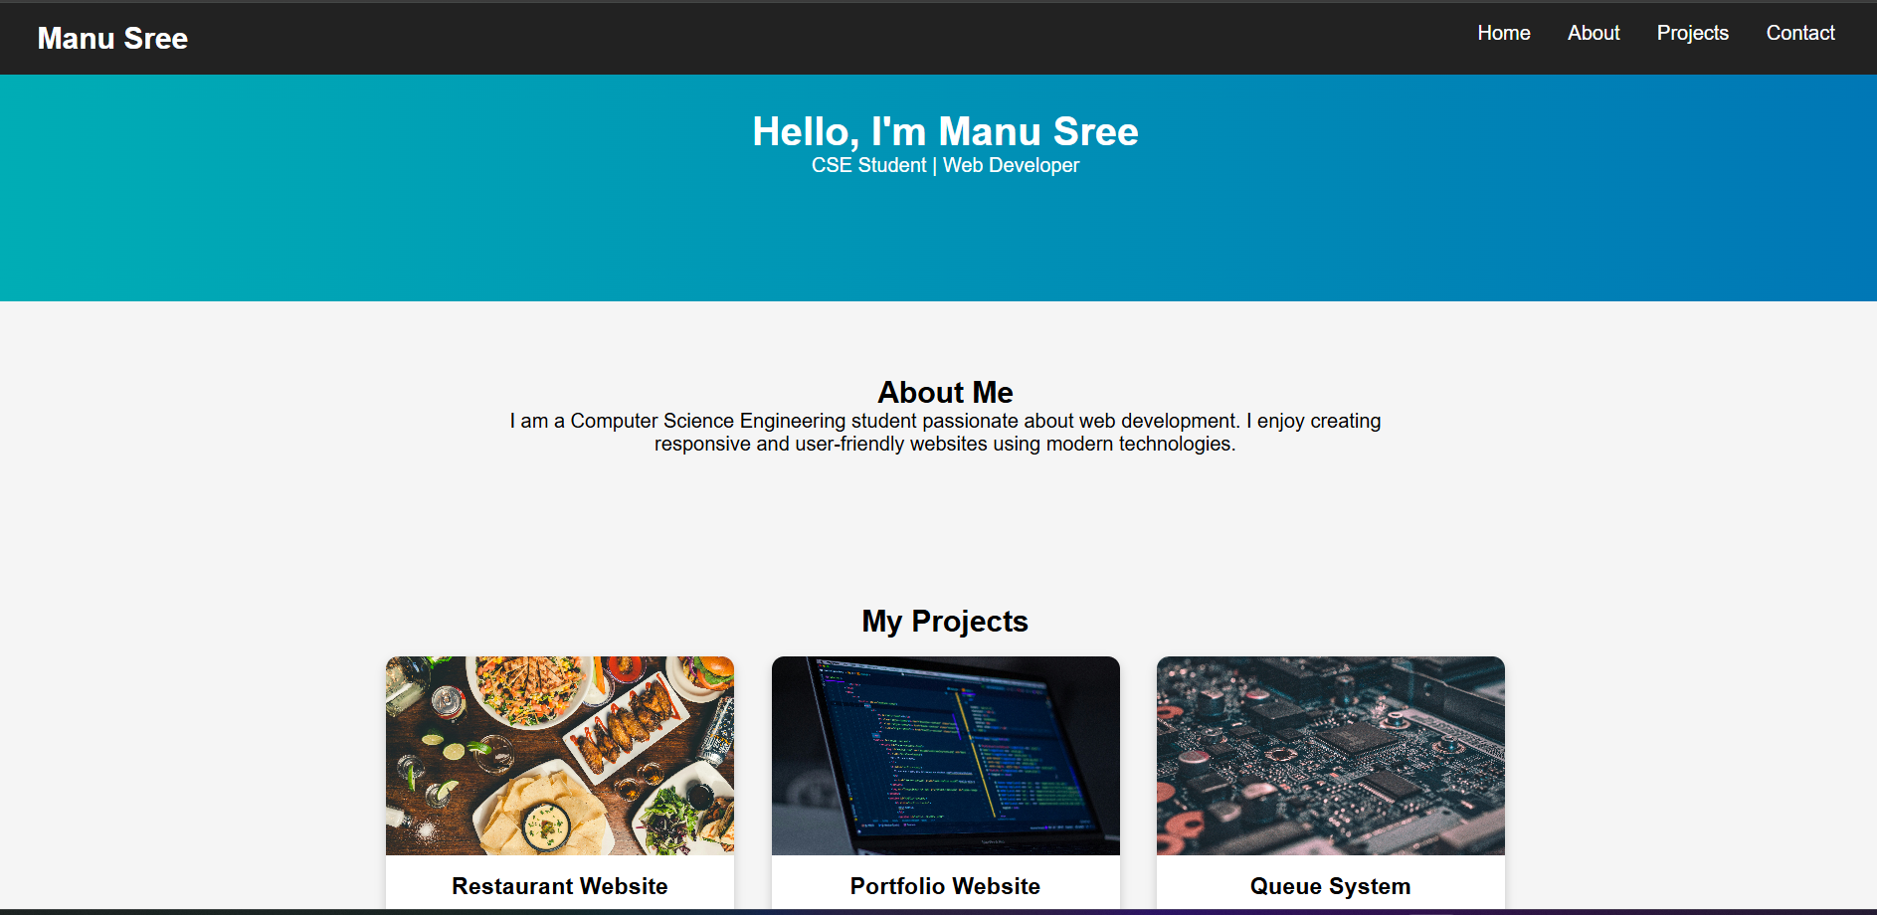
Explaination: This project is a personal portfolio website built using HTML, CSS, and JavaScript with sections like Home, About, Projects, and Contact.
It uses a responsive design with Flexbox, smooth navigation, and interactive project cards with hover effects.
The website has clean styling and includes a footer with the name Manu Sree (CSE Student).
Task:2
Prompt:
Create a simple and attractive restaurant landing page using HTML, CSS, and JavaScript. Requirements: Add a responsive navigation bar with links: Home, Menu, Gallery, Contact. Design a Menu section using CSS cards to display food items with name, image, and price. Implement a Gallery section with a JavaScript image slider (auto-slide + next/prev buttons). Add smooth animations and transitions (hover effects, fade-in, sliding effects). Ensure the page is responsive for mobile and desktop. Use clean, modern styling with good colors and spacing. give me effective page
Code:
<!DOCTYPE html>
<html>
<head>
<meta charset="UTF-8">
<meta name="viewport" content="width=device-width,initial-scale=1.0">
<title>Food Delight</title>
<style>
*{margin:0;padding:0;box-sizing:border-box;font-family:Arial;scroll-behavior:smooth}
body{background:#f9f9f9}
nav{display:flex;justify-content:space-between;background:#ff4d4d;color:#fff;padding:15px}
nav ul{display:flex;list-style:none}
nav li{margin:0 10px}
nav a{color:#fff;text-decoration:none}
nav a:hover{color:yellow}
.hero{text-align:center;padding:60px;background:url('https://images.unsplash.com/photo-1600891964599-f61ba0e24092') center/cover;color:#fff}
.menu,.gallery,.contact{text-align:center;padding:30px}
.menu-container{display:flex;flex-wrap:wrap;justify-content:center}
.card{background:#fff;width:220px;margin:10px;border-radius:10px;overflow:hidden;box-shadow:0 3px 6px gray;transition:.3s}
.card:hover{transform:scale(1.05)}
.card img{width:100%;height:140px}
.card p{color:green}
.slider img{width:70%;border-radius:10px}
button{padding:8px;margin:5px;border:none;background:#ff4d4d;color:#fff}
footer{background:#333;color:#fff;text-align:center;padding:10px}
@media(max-width:768px){
nav ul{flex-direction:column}
.menu-container{flex-direction:column;align-items:center}
.slider img{width:90%}
}
</style>
</head>

<body>

<nav>
<h2>Food Delight</h2>
<ul>
<li><a href="#">Home</a></li>
<li><a href="#menu">Menu</a></li>
<li><a href="#gallery">Gallery</a></li>
<li><a href="#contact">Contact</a></li>
</ul>
</nav>

<section class="hero">
<h1>Welcome to Food Delight</h1>
<p>Fresh & Tasty Food</p>
</section>

<section class="menu" id="menu">
<h2>Menu</h2>
<div class="menu-container">
<div class="card"><img src="https://images.unsplash.com/photo-1601924928588-972f2e7c3d8b"><h3>Pizza</h3><p>₹199</p></div>
<div class="card"><img src="https://images.unsplash.com/photo-1550547660-d9450f859349"><h3>Burger</h3><p>₹149</p></div>
<div class="card"><img src="https://images.unsplash.com/photo-1604908176997-125f25cc6f3d"><h3>Pasta</h3><p>₹179</p></div>
</div>
</section>

<section class="gallery" id="gallery">
<h2>Gallery</h2>
<div class="slider"><img id="slide" src="https://images.unsplash.com/photo-1504674900247-0877df9cc836"></div>
<button onclick="prev()">Prev</button>
<button onclick="next()">Next</button>
</section>

<section class="contact" id="contact">
<h2>Contact</h2>
<p>Email: food@email.com</p>
</section>

<footer>© 2026 Restaurant</footer>

<script>
let img=["https://images.unsplash.com/photo-1504674900247-0877df9cc836","https://images.unsplash.com/photo-1555992336-03a23c7b20ee","https://images.unsplash.com/photo-1546069901-ba9599a7e63c"],i=0;
function show(){document.getElementById("slide").src=img[i]}
function next(){i=(i+1)%img.length;show()}
function prev(){i=(i-1+img.length)%img.length;show()}
setInterval(next,3000);
</script>

</body>
</html>
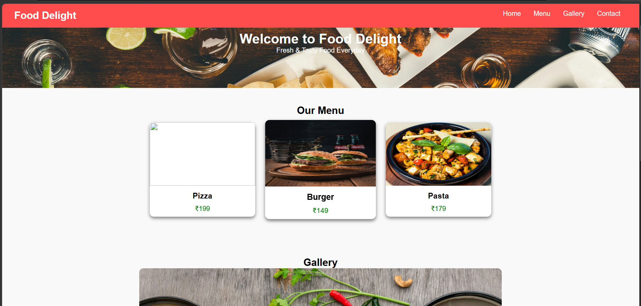
Task3:
Prompt: Create a responsive SR University fest registration form with Name, Email, Phone, Department, and Event fields.
Add CSS styling with a background image and clean layout for readability.
Include JavaScript for real-time validation (email format, phone length, required fields).
Code:
<!DOCTYPE html>
<html>
<head>
<title>SR University Fest Registration</title>

<style>
body {
font-family: Arial;
background: url('https://images.unsplash.com/photo-1523580494863-6f3031224c94') no-repeat center center/cover;
margin: 0;
}

.form-box {
width: 350px;
margin: 80px auto;
padding: 20px;
background: rgba(255,255,255,0.9);
border-radius: 10px;
}

input, select {
width: 100%;
padding: 8px;
margin: 8px 0;
}

button {
width: 100%;
padding: 10px;
background: blue;
color: white;
border: none;
}

.error {
color: red;
font-size: 12px;
}
</style>
</head>

<body>

<div class="form-box">
<h2>Fest Registration</h2>

<form onsubmit="return validateForm()">
<input type="text" id="name" placeholder="Name">
<div id="nameError" class="error"></div>

<input type="email" id="email" placeholder="Email">
<div id="emailError" class="error"></div>

<input type="text" id="phone" placeholder="Phone Number">
<div id="phoneError" class="error"></div>

<select id="dept">
<option value="">Select Department</option>
<option>CSE</option>
<option>ECE</option>
<option>EEE</option>
</select>

<select id="event">
<option value="">Select Event</option>
<option>Coding</option>
<option>Hackathon</option>
<option>Quiz</option>
</select>

<button type="submit">Register</button>
</form>
</div>

<script>
function validateForm() {
let valid = true;

let name = document.getElementById("name").value;
let email = document.getElementById("email").value;
let phone = document.getElementById("phone").value;

document.getElementById("nameError").innerText = "";
document.getElementById("emailError").innerText = "";
document.getElementById("phoneError").innerText = "";

if (name == "") {
document.getElementById("nameError").innerText = "Name required";
valid = false;
}

let emailPattern = /^[^ ]+@[^ ]+\.[a-z]{2,3}$/;
if (!email.match(emailPattern)) {
document.getElementById("emailError").innerText = "Invalid email";
valid = false;
}

if (phone.length != 10 || isNaN(phone)) {
document.getElementById("phoneError").innerText = "Enter valid 10-digit number";
valid = false;
}

return valid;
}
</script>

</body>
</html>
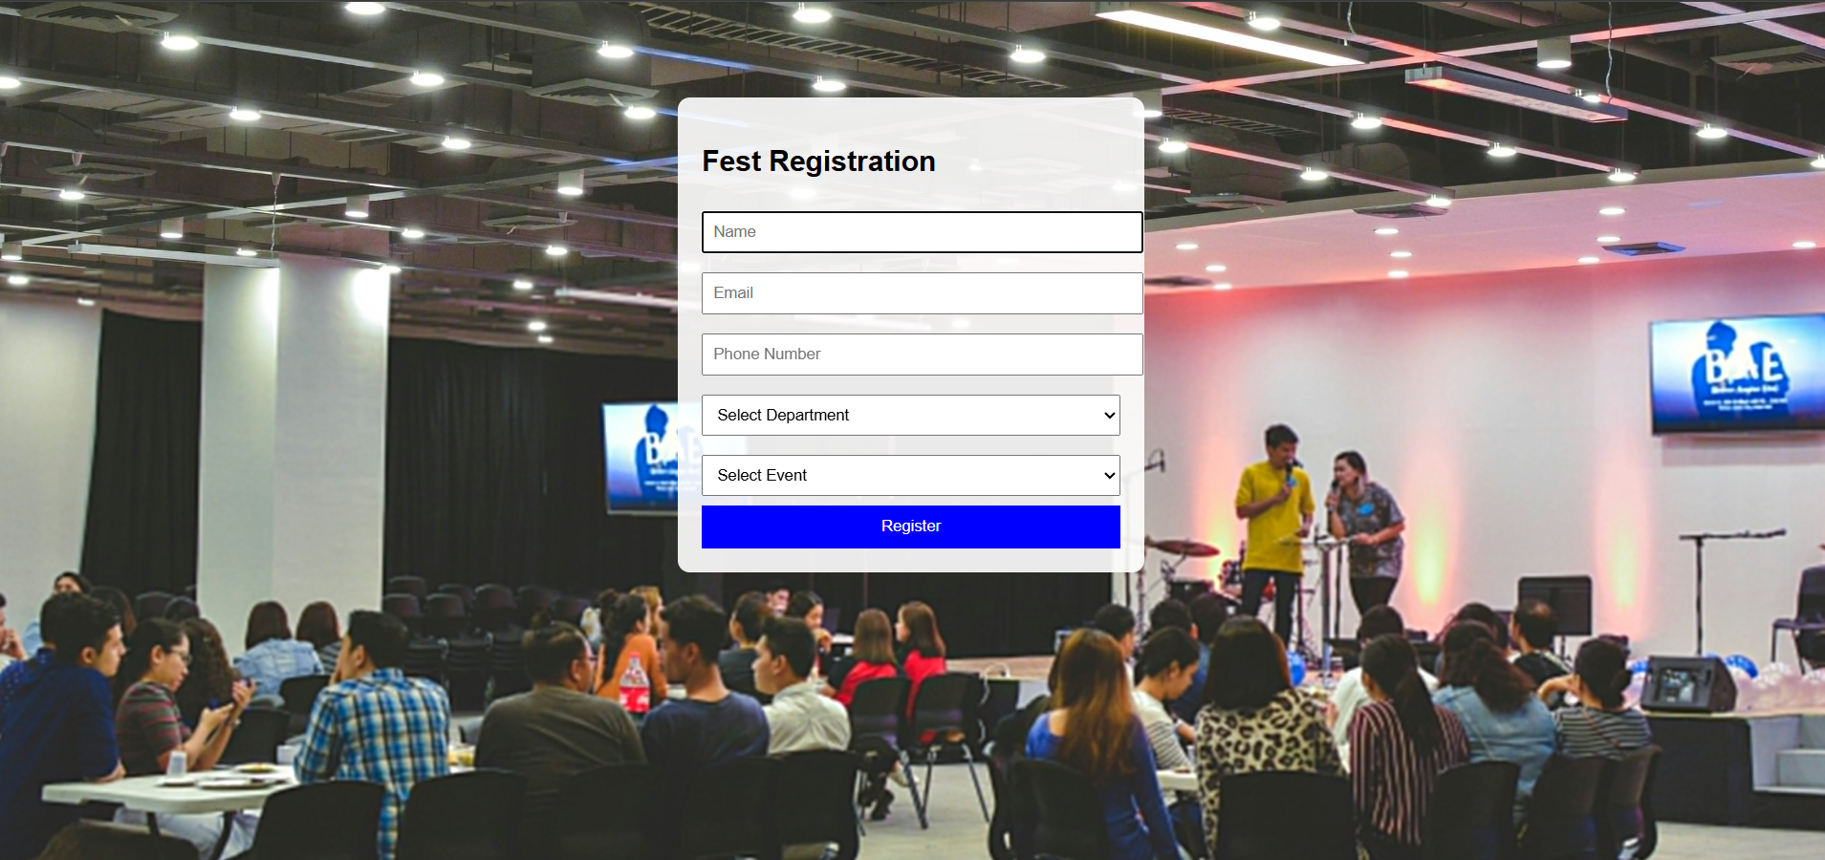

Explaination:
The HTML form collects user details like name, email, phone, department, and event in a simple layout.
CSS adds a background image and styles the form to make it clean, centered, and easy to read.
JavaScript validates inputs (email format, 10-digit phone, required fields) and prevents submission if data is invalid.
Task4:
Create an e-commerce product page with a grid layout using HTML and CSS.
Add JavaScript “Add to Cart” functionality with a cart counter at the top-right.
Include visual feedback when items are added and a background image.
Code:
<!DOCTYPE html>
<html>
<head>
<title>E-Commerce Product Page</title>

<style>
body {
font-family: Arial;
margin: 0;
background: url('https://images.unsplash.com/photo-1512436991641-6745cdb1723f') no-repeat center center fixed;
background-size: cover;
}

/* Cart Counter */
.cart {
position: fixed;
top: 15px;
right: 20px;
background: black;
color: white;
padding: 10px 15px;
border-radius: 20px;
font-size: 18px;
}

/* Product Grid */
.container {
display: grid;
grid-template-columns: repeat(auto-fit, minmax(200px, 1fr));
gap: 20px;
padding: 60px;
}

/* Product Card */
.card {
background: rgba(255,255,255,0.9);
padding: 20px;
text-align: center;
border-radius: 10px;
box-shadow: 0 0 10px gray;
}

button {
padding: 10px;
background: green;
color: white;
border: none;
cursor: pointer;
border-radius: 5px;
}

button:hover {
background: darkgreen;
}
</style>
</head>

<body>

<!-- Cart Counter -->
<div class="cart">🛒 <span id="count">0</span></div>

<!-- Product Catalog -->
<div class="container">

<div class="card">
<h3>Product 1</h3>
<p>₹500</p>
<button onclick="addToCart(this)">Add to Cart</button>
</div>

<div class="card">
<h3>Product 2</h3>
<p>₹700</p>
<button onclick="addToCart(this)">Add to Cart</button>
</div>

<div class="card">
<h3>Product 3</h3>
<p>₹900</p>
<button onclick="addToCart(this)">Add to Cart</button>
</div>

<div class="card">
<h3>Product 4</h3>
<p>₹1200</p>
<button onclick="addToCart(this)">Add to Cart</button>
</div>

</div>

<script>
let cartCount = 0;

function addToCart(btn) {
// Increase count
cartCount++;
document.getElementById("count").innerText = cartCount;

// Visual feedback
btn.innerText = "Added ✓";
btn.style.background = "gray";

// Reset after 1 second
setTimeout(() => {
btn.innerText = "Add to Cart";
btn.style.background = "green";
}, 1000);
}
</script>

</body>
</html>
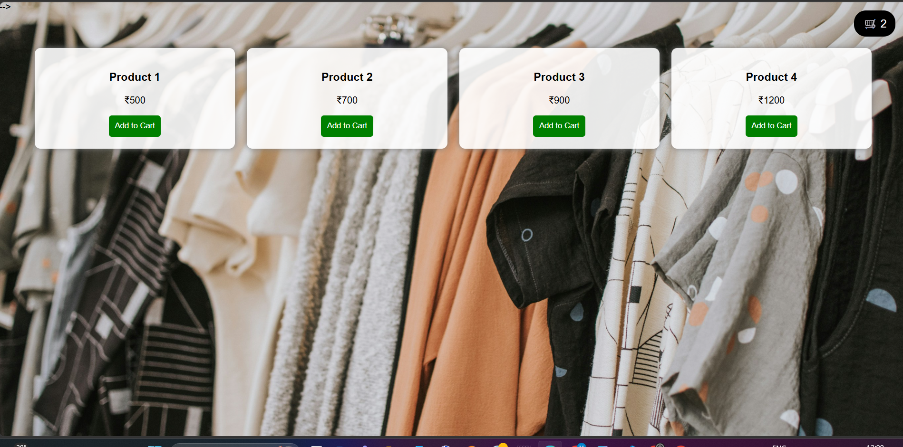

Explaination:
HTML creates a grid-based product catalog with cards and an “Add to Cart” button for each item.
CSS styles the layout, adds a background image, and positions the cart counter at the top-right corner.
JavaScript updates the cart count and gives visual feedback by temporarily changing the button when clicked.
Task5:
Prompt:
Create a responsive web page with header, navigation, main content, and footer using HTML and CSS.
Add responsive design using media queries for desktop, tablet, and mobile.
Include a background image without zoom and keep the layout clean and organized.
Code:
<!DOCTYPE html>
<html>
<head>
<title>Responsive Layout</title>

<style>
body {
margin: 0;
font-family: Arial;
background: url('https://images.unsplash.com/photo-1492724441997-5dc865305da7') no-repeat center center fixed;
background-size: 100% 100%; /* no zoom */
}

header {
background: black;
color: white;
padding: 15px;
text-align: center;
}

nav a {
color: white;
margin: 10px;
text-decoration: none;
}

.main {
display: flex;
padding: 20px;
}

.content {
flex: 3;
background: rgba(255,255,255,0.9);
padding: 20px;
margin-right: 10px;
}

.sidebar {
flex: 1;
background: rgba(200,200,200,0.9);
padding: 20px;
}

footer {
background: black;
color: white;
text-align: center;
padding: 10px;
}

/* Tablet */
@media (max-width: 768px) {
.main {
flex-direction: column;
}
}

/* Mobile */
@media (max-width: 480px) {
nav a {
display: block;
margin: 5px 0;
}
}
</style>
</head>

<body>

<header>
<h2>My Website</h2>
<nav>
<a href="#">Home</a>
<a href="#">About</a>
<a href="#">Contact</a>
</nav>
</header>

<div class="main">
<div class="content">
<h3>Main Content</h3>
<p>This is sample content for the webpage. It adjusts based on screen size.</p>
</div>

<div class="sidebar">
<h3>Sidebar</h3>
<p>Additional info or links</p>
</div>
</div>

<footer>
<p>© 2026 My Website | Contact: info@email.com</p>
</footer>

</body>
</html>
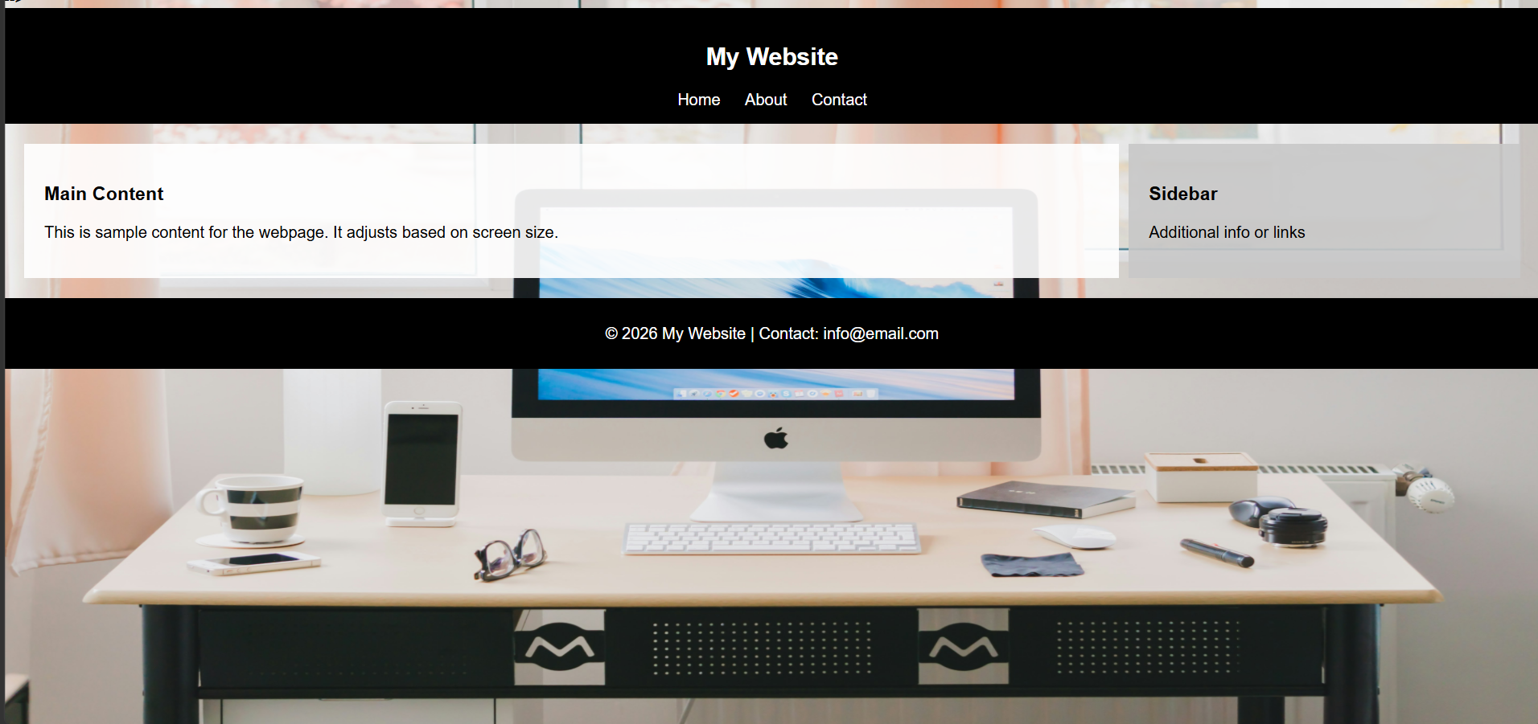
Explaination:
The HTML structure includes a header with navigation links, a main section (content + sidebar), and a footer for basic page layout.
CSS is used to style the layout, add a background image without zoom, and organize sections using Flexbox for a clean design.
Media queries make the page responsive, so it adjusts layout properly for desktop, tablet, and mobile screens.

