Assignment-10.5
Name:E.Manu Sree
HTNO:2303A51324
BTNO:20
Task 1:
Prompt:
Improve the readability of the following Python code by renaming unclear function and variable names to meaningful and descriptive names.
Do not change the logic of the program.
Return only the improved code.
def f(a, b):
return a + b
print(f(10, 20))

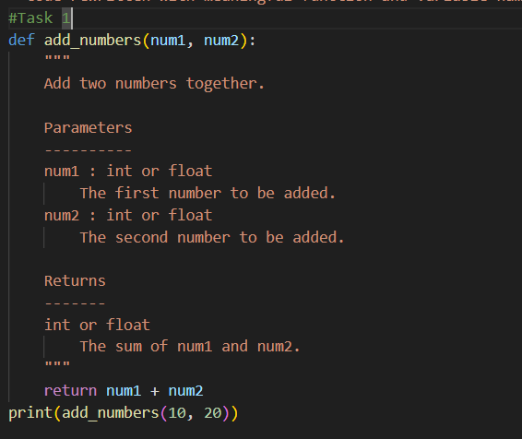
Result:
Observation:
The code defines a function add_numbers that adds two numbers and returns the result. It has clear variable names and a short description. When called with 10 and 20, it prints 30.
Task:2
Prompt:
Improve the following Python code by adding proper error handling.
Handle possible exceptions (such as division by zero) using try-except blocks.
Display clear and user-friendly error messages.
Do not change the main logic of the program.
Return only the improved code.

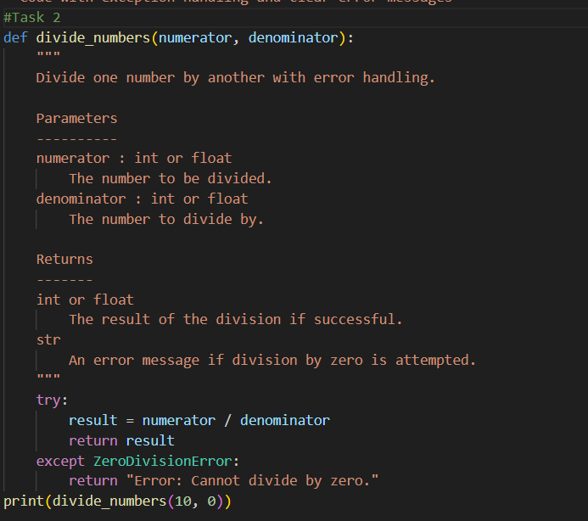
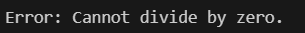
Observation:
The code defines a function divide_number that performs division with proper error handling. It uses a try-except block to catch a ZeroDivisionError and returns a clear error message if division by zero is attempted. When called with 10 and 0, it safely prints an error message instead of crashing.
Task 3:
Prompt:
Refactor the following Python program to improve readability, structure, and code quality.
Requirements:
- Follow PEP 8 coding standards.
- Use meaningful variable and function names.
- Organize the logic into appropriate functions.
- Add proper comments and a clear docstring.
- Include basic input validation (e.g., check if the marks list is not empty and contains valid numeric values).
- Do not change the core functionality (calculate total, average, and grade).
- Return only the improved code.
marks=[78,85,90,66,88]
t=0
for i in marks:
t=t+i
a=t/len(marks)
if a>=90:
print("A")
elif a>=75:
print("B")
elif a>=60:
print("C")
else:
print("F")
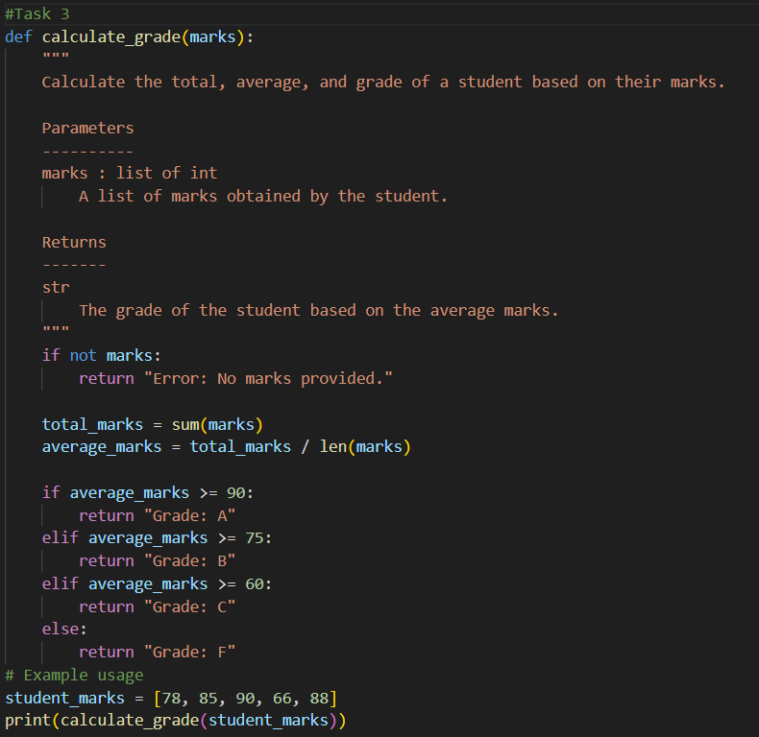
Observation:
The refactored code follows PEP 8 standards with clear function and variable names like calculate_grade, total_marks, and average_marks. It includes a proper docstring explaining parameters and return values, improving readability and documentation. Basic input validation is added to handle empty mark lists, making the program more reliable and user-friendly.
Task 4:
Prompt:
Add a proper docstring and simple inline comments to the following Python function. Do not change the logic. Return only the updated code.
def factorial(n):
result = 1
for i in range(1, n + 1):
result *= i
return result
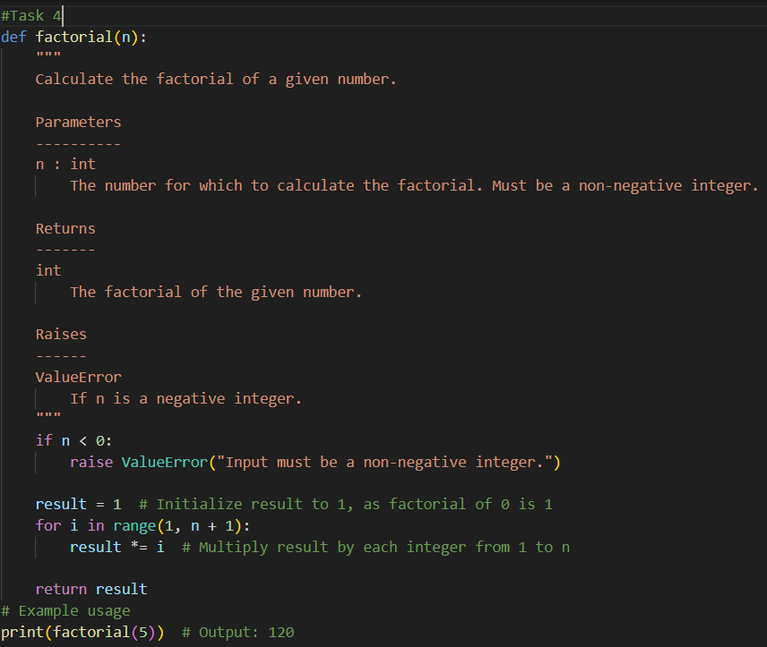

Observation:
The function factorial is well-documented with a clear docstring explaining its purpose, parameters, return value, and possible exceptions. It includes input validation to ensure the number is non-negative and raises a ValueError if invalid input is provided. Inline comments are added to explain important steps, improving readability and code clarity.
Task 5:
Improve the following Python password program by adding stronger validation rules (minimum length, uppercase, lowercase, digit, and special character). Refactor it using meaningful names, follow PEP 8, and add a docstring and simple comments. After the code, briefly explain how the improved version is better than the original.

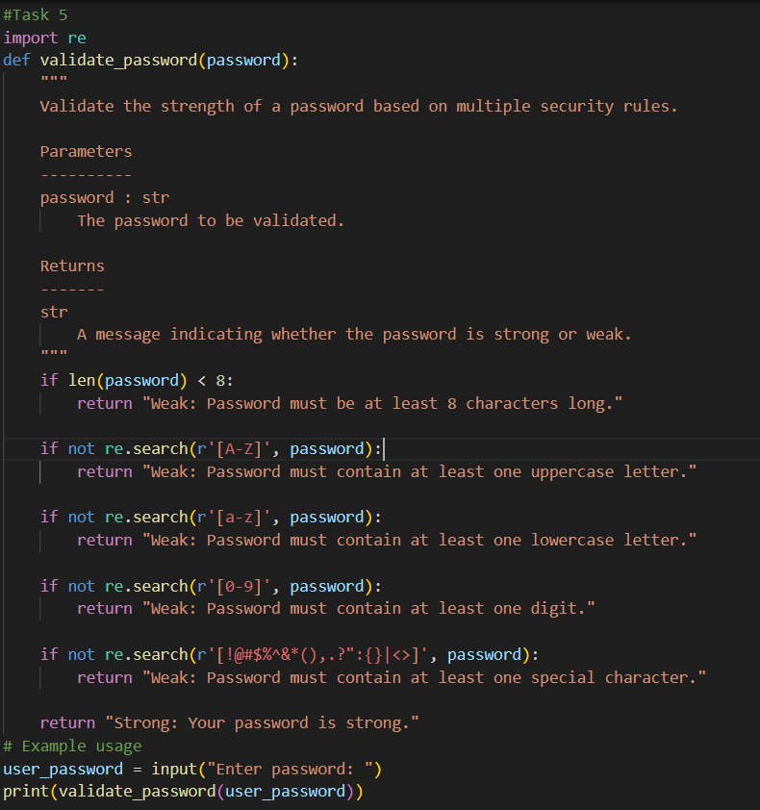
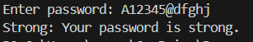
Observation:
The enhanced program uses a separate function validate_password with clear naming and proper documentation, improving readability and structure. It applies multiple security checks using regular expressions to ensure the password contains uppercase, lowercase, digits, special characters, and a minimum length. Compared to the original version, this implementation is more secure, maintainable, and robust because it enforces real-world password standards and provides clear feedback messages.

