# Abstract

In large organizations, the Learning and Development (L&D) team plays a crucial role in upskilling employees, ensuring compliance with training requirements, and fostering a culture of continuous learning. However, managing multiple training programs, tracking employee progress, and ensuring the relevance of content across diverse roles can be challenging. L&D teams often struggle with coordinating training schedules, personalizing learning paths, and gathering feedback to improve future programs. Additionally, with remote and hybrid work models becoming more prevalent, traditional in-person training methods are less feasible, requiring a shift to digital solutions.

# Business Requirements Document (BRD)

1. **Project Overview**

# Project Name: Growth Path

# Project Description: The Growth Path is designed to streamline the process of training and development within an organization. It enables Admin to create courses for the employees and assign course for the individual employees and provide employees with access to training courses, feedback mechanisms, and progress tracking. The goal is to enhance employee skills, ensure compliance with training requirements, and gather insights.

# Objectives

* To provide a centralized platform for managing training programs.
* To allow the admin to create, manage, and send notification for employees after assigning courses to employees.
* To track employee progress and gather feedback for continuous improvement.

# Scope

* + **In-Scope:**
    - Admin can create courses.
    - Employees can start in and complete courses.
    - Feedback collection after course completion.
    - Progress tracking for employees.

# Out-of-Scope:

* + - External course platform integration (e.g., third-party platforms).
    - Send notification through email**.**

# Stakeholders

* + - Growth Path (Admin) Team
    - Employees

# Business Requirements

* + BR1: Admin should be able to create courses.
  + BR2: Admin should be able to update or delete courses.
  + BR3: Admin should assign courses to employees and they get email notification. And then employee should be able to start the courses.
  + BR4: Employees should be able to update the number of modules completion status after completion of modules and they should provide feedback.
  + BR5: The system should collect feedback from employees after course completion.
  + BR6: The system should allow the admin to get the feedbacks of all employees.

# Success Criteria

* + Successful creation and assignment of courses.
  + High engagement and completion rates from employees.
  + Positive feedback and continuous improvement of course content**.**

# Functional Requirements Document (FRD)

1. **Introduction**

This document details the functional requirements of the Growth Path Application, focusing on the features that will be implemented to meet business objectives.

# Functional Requirements

* + **FR1: User Roles and Authentication**
    - The system must support Team roles: Growth Path Team (Admin), and Employee.
    - Each user should have secure login credentials and role-based access.

# FR2: Admin Course Management

* + - Admin should be able to add course, update/delete course and assign course.
    - Admin should input course details such as course name, description, end date and total modules.

# FR3: Employee Course Assignment

* + - The system should automatically send an email to the employee about the assigned course.
    - Employee can start their course and should update number of modules completion status.

# FR4: Employee Learning Interface

* + - Employees should log in and view assigned courses.
    - The system should show the employee’s progress based on updating modules completed.

# FR5: Feedback Collection

* + - Upon course completion, employees should fill out a feedback form with suggestions and a rating.
    - The feedback should be stored in the system.

# FR6: Admin Feedback Review

* + - Admin should be able to review feedback for each course.
    - Admin should be able to modify course content based on feedback.

**Workflow Diagram**

**Class Diagram**

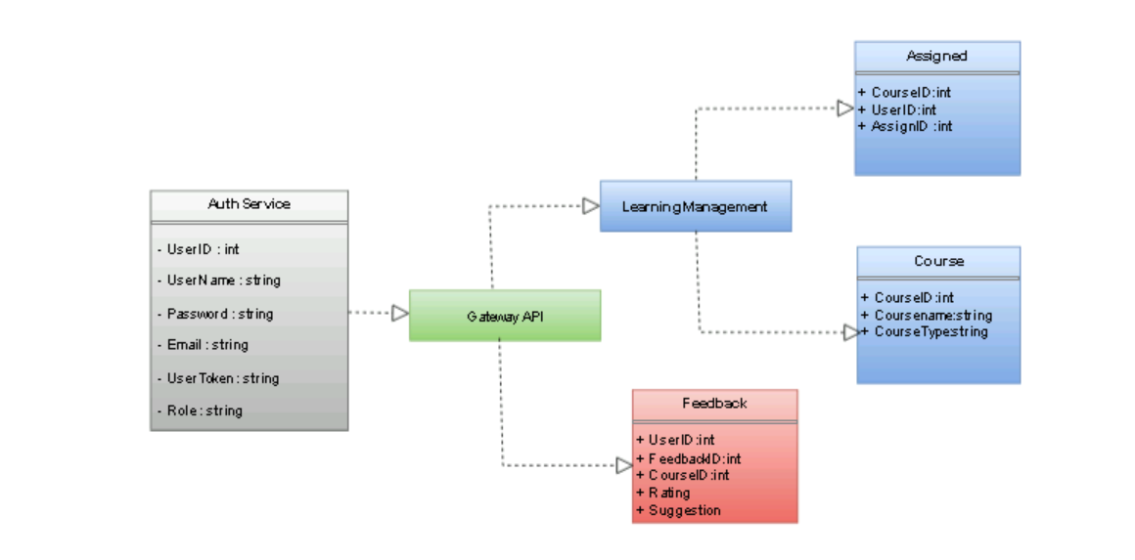

**Architecture Diagram**

