MANVENDER SINGH

Full Stack Developer

E **91 8865811265**  **08manvender@gmail.com** q [**https://www.linkedin.com/in/manvender-singh1b2979299/**](https://www.linkedin.com/in/manvender-singh1b2979299/)

q [**https://manvender-portfolio.vercel.app/**](https://manvender-portfolio.vercel.app/)  **Agra**

# SUMMARY

I am a passionate web developer with hands-on experience in building interactive and dynamic web applications using modern web technologies. My expertise includes HTML5, CSS3, JavaScript, and React.js, focusing on delivering responsive, user-friendly websites. I have developed projects like a Music Player App and a Bubble Pop Game, integrating features like dynamic content rendering and optimized performance across various devices

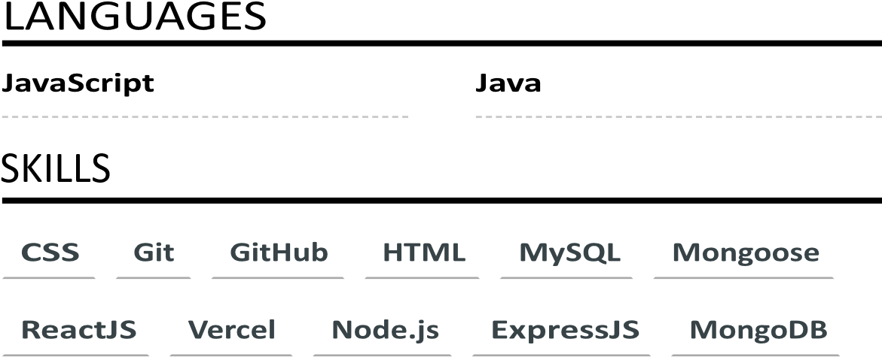

# EDUCATION

## B.C.A in Computer Science

**Dr. Bhimrao Ambedkar University**



## Senior Secondary Education (Class 12th)

**Radhaballabh Public School**



## High School Education(Class 10th)

**Radhaballabh Public School**

Agra

# COURSES

**Web development Course by Udemy**

# PROJECTS

# 

## Jarvis AI Assistant

[https://jarvis-by-manvender.vercel.app/ A](https://jarvis-by-manvender.vercel.app/) smart

voice-controlled assistant built using JavaScript with speech recognition and synthesis capabilities.

* **Voice Commands:** Recognizes user speech using **Web Speech API** SpeechRecognition)
* **Text-to-Speech:** Uses **SpeechSynthesis API** to respond dynamically.
* **Smart Greetings:** Greets the user based on the time of day.
* **Trivia Quiz Game:** Asks random questions and evaluates answers
* **Web Navigation:** Opens websites like **Google,**

**YouTube, Facebook, and Wikipedia** on command

[https://github.com/Manv8/code-reviewer A](https://github.com/Manv8/code-reviewer) web-

Code Reviewer

based AI-powered tool that automates and enhances the code review process using Google Gemini.

* Utilized React.js for building the interactive and dynamic user interface
* Structured the website layout with HTML5 and styled it with CSS3 for a professional presentation
* Implemented interactive elements and smooth transitions using JavaScript
* Deployed on Vercel for fast, scalable, and secure web hosting

## Music Player App

[https://music-player-manv.vercel.app/ A](https://music-player-manv.vercel.app/) web-based

music player app that incorporates various interactive features for a seamless user experience

* Structured the page and handled audio controls using HTML5
* Designed the layout, user interface, and responsiveness with CSS
* Implemented dynamic features such as play/pause, song navigation, and playlist management in JavaScript
* Handled song selection and switched between multiple tracks for dynamic playlist functionality
* Enabled song search by title or artist for enhanced user interaction