Database Management Systems

(UE23CS351A)

VAMusic – A Mini Spotify-Like Music Streaming Application
DBMS Mini Project Report

Title: Music Streaming Database
Section: F
Semester: 5th Sem – B.Tech CSE
Submitted by:
- Lohith Anand (PES1UG23CS332)
- Manit V Urs (PES1UG23CS349)

Submitted to:
Course Instructor: Vadiraja A
Department of Computer Science & Engineering
PES University

ABSTRACT
To implement a music streaming database using MySQL.
VAMusic is a mini Spotify-like music streaming and management application designed using MySQL, Python, Tkinter, and a fully normalized relational database. This project demonstrates the design and implementation of a complex DBMS-backed application featuring user authentication, music browsing, playlist management, listening history tracking, recommendations, analytics, triggers, stored procedures, and an Admin management module.
The system supports two roles: Admin and User. Admins manage all musical entities, including artists, albums, tracks, and genres. Users can browse music, search tracks, like songs, follow artists, create playlists, add tracks to playlists, and view listening analytics generated by SQL functions and triggers. The project follows a realistic music streaming workflow, implementing all CRUD operations, ACID transactions, triggers, and advanced SQL features.
The user interface for an Artist is in the future scope of this project.

1. USER REQUIREMENT SPECIFICATION
Purpose
The goal of VAMusic is to demonstrate a complete DBMS application that replicates the core functionalities of a real-world music streaming service. The system showcases robust relational schema design, transaction safety, integrity constraints, and a GUI application linked to the backend through Python.
Scope
The application includes:
- Full relational database for artists, albums, tracks, genres, playlists, listening history, and user profiles.
- Tkinter GUI for both Admin and User roles.
- Dynamic features like playlist creation, recommendations, and analytics.
- Triggers that maintain statistics automatically.
- Procedures for recommendations, searching, and playlist creation.
User Roles
Admin
- Add / update / delete:
  - Artists
  - Albums
  - Tracks
  - Genres
- Manage sample data
- View database summary
User
- Can log in or register if a new user
- Browse all tracks in the database.
- Search tracks that are available
- View album, artist, and genre info
- Create and manage playlists
- Add tracks to playlists
- Like/unlike tracks
- Follow/unfollow artists
- View listening history
- Get personalized analytics
- Get recommendations

2. SOFTWARE & TOOLS USED
- Database: MySQL 8.x
- Frontend: Tkinter (Python)
- Backend: Python (mysql-connector-python)
- IDE: VS Code
- Version Control: GitHub
- Platform: Windows 11

3. SYSTEM ANALYSIS
3.1 Existing System
Traditional streaming platforms are closed-source and not accessible for academic exploration. Students need a simplified but realistic environment for understanding database-driven streaming applications.
3.2 Proposed System
VAMusic provides:
- Full backend schema
- Dynamic frontend
- Playlists & recommendations
- Real-time updates using triggers
- Data analytics functions

4. ER DIAGRAM
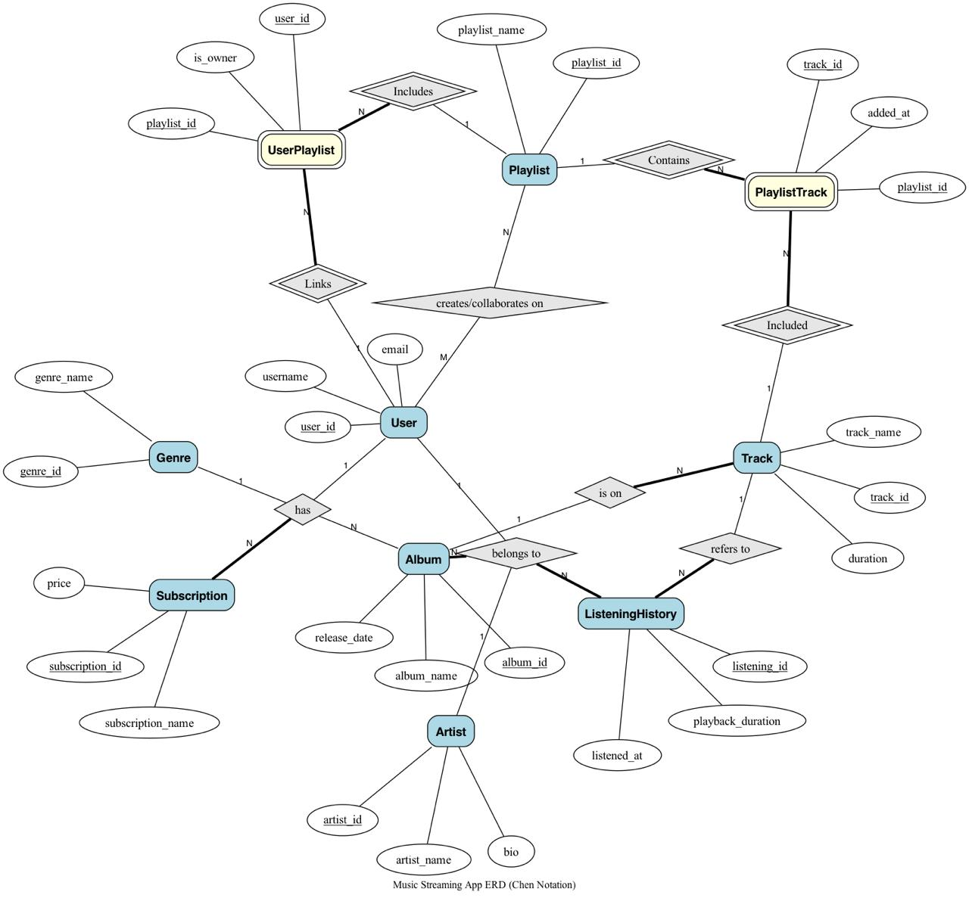

5. RELATIONAL SCHEMA
1) Genre(genre_id, genre_name, description)
Primary Key (PK) : genre_id
2) Subscription(subscription_id, plan_name, price, duration_days, download_limit, ad_free, high_quality, offline_mode, max_devices, description)
PK: subscription_id
3) User(user_id, username, email, password, first_name, last_name, country, date_of_birth)
PK: user_id
4) UserSubscription(user_subscription_id, user_id, subscription_id, start_date, end_date, status)**
Foreign Key (FK): (user_id → User), FK(subscription_id → Subscription)
5) Artist(artist_id, artist_name, bio, country, is_verified, monthly_listeners)
PK: artist_id
6) Album(album_id, album_title, artist_id, release_date, album_type, genre_id, record_label, total_tracks)**
FK(artist_id → Artist), FK(genre_id → Genre)
7) Track(track_id, track_title, album_id, duration_seconds, track_number, file_path, lyrics_path, is_explicit, play_count, trending_score, last_played)*
FK(album_id → Album)
8) Playlist(playlist_id, playlist_name, created_by, description, is_public, follower_count)*
FK(created_by → User)
9) PlaylistTrack(playlist_id, track_id, position, added_by*)**
Composite PK: (playlist_id, track_id)
FK(playlist_id → Playlist), FK(track_id → Track), FK(added_by → User)
10) UserPlaylist(user_id, playlist_id, is_owner)**
Composite PK: (user_id, playlist_id)
11) ListeningHistory(history_id, user_id, track_id, playback_duration, device_type, streaming_quality, listened_at, completed)**
FK(user_id → User), FK(track_id → Track)
12) UserFavorites(user_id, track_id)**
FK(user_id → User), FK(track_id → Track)
13) UserFollowing(follower_id, following_id, following_type)**

14) TrackArtist(track_id, artist_id, role)**
FK(track_id → Track), FK(artist_id → artis)

6. DATABASE DESIGN – DDL COMMANDS
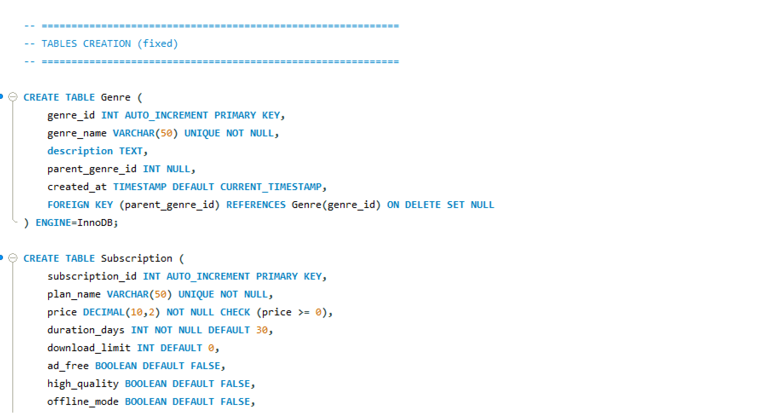
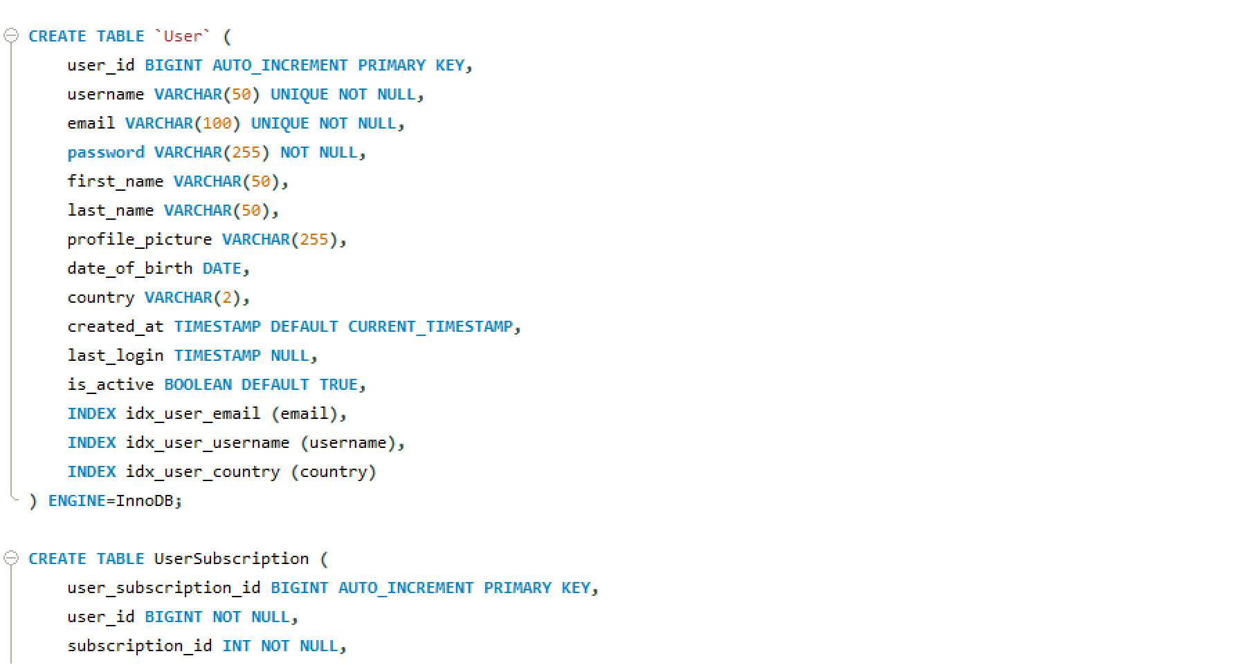
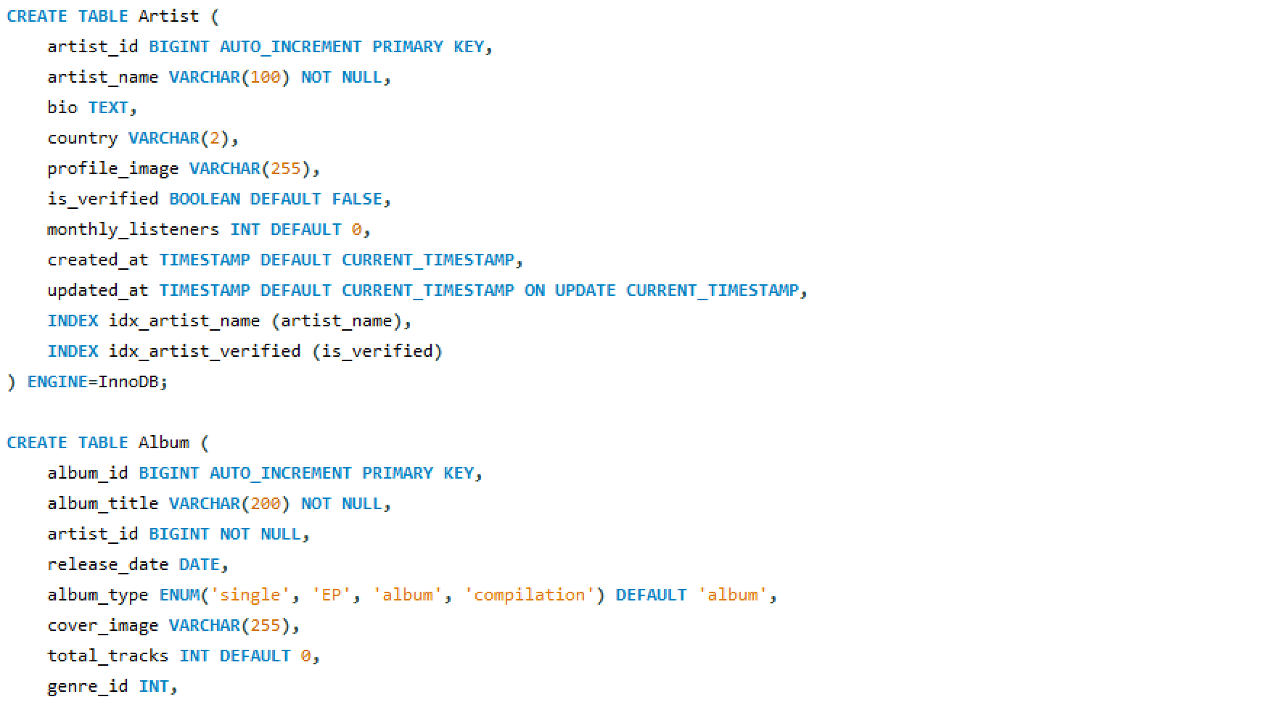

(ask sir if we have to screenshot all the DDL commands or few are enough, or do we have to paste the code)

7. TRIGGERS IMPLEMENTED
We have implemented the following 8 triggers:
update_play_count
Automatically increases play_count and updates last_played when user listens.
update_user_stats
Updates total_minutes and songs_played.
subscription_audit_log
Logs plan changes.
update_album_track_count_insert
Recalculates total_tracks after adding a track.
update_album_track_count_delete
Recalculates after deleting a track.
calculate_trending_score
Updates trending_score based on listening, favorites, and listeners.
update_playlist_followers_insert
Maintains follower_count.
update_playlist_followers_delete
Maintains follower_count.

Screenshot of the implemented Triggers
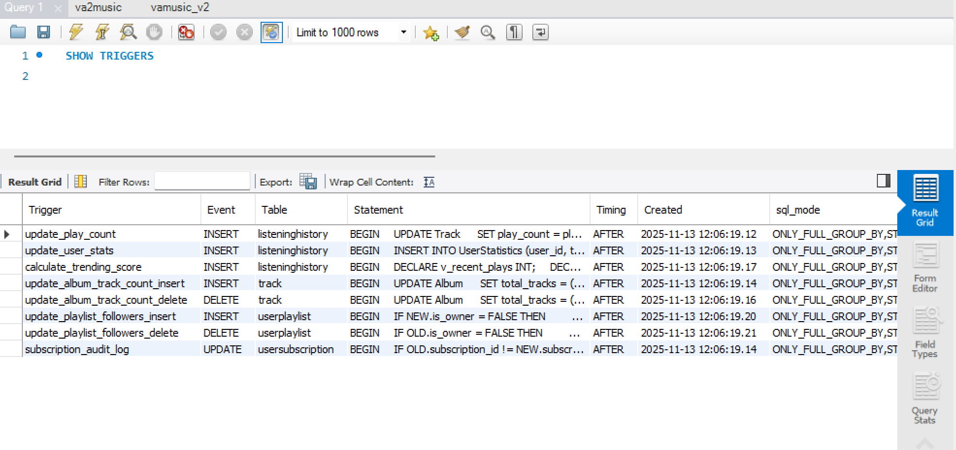

8. STORED PROCEDURES
Our system includes 5 Procedures:
GetUserRecommendations(user_id, limit)
Top-genre–based personalized recommendations.
GetUserAnalytics(user_id, period)
Daily/weekly/monthly/yearly insights.
GetTrendingTracks(limit)
Trending tracks by score.
CreatePlaylistWithTracks
Creates playlist & adds multiple tracks atomically.
SearchTracks(term, genre, artist)
Advanced search.

Screenshot of Procedures:
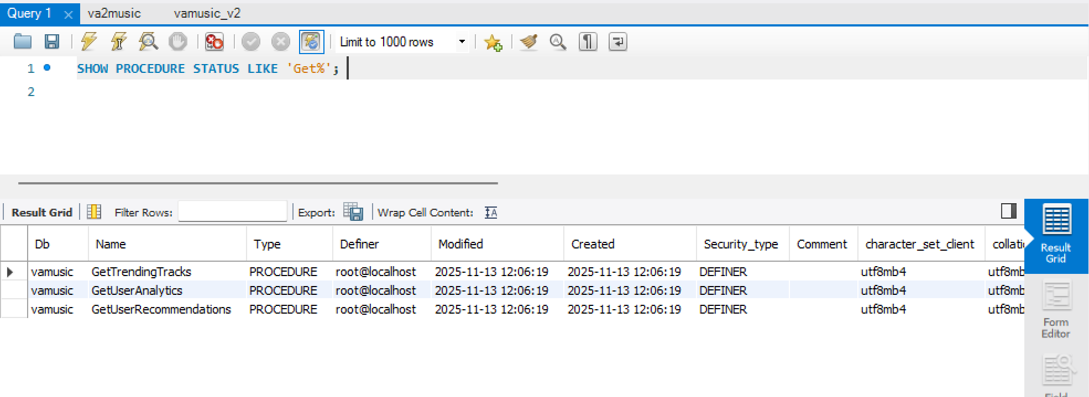
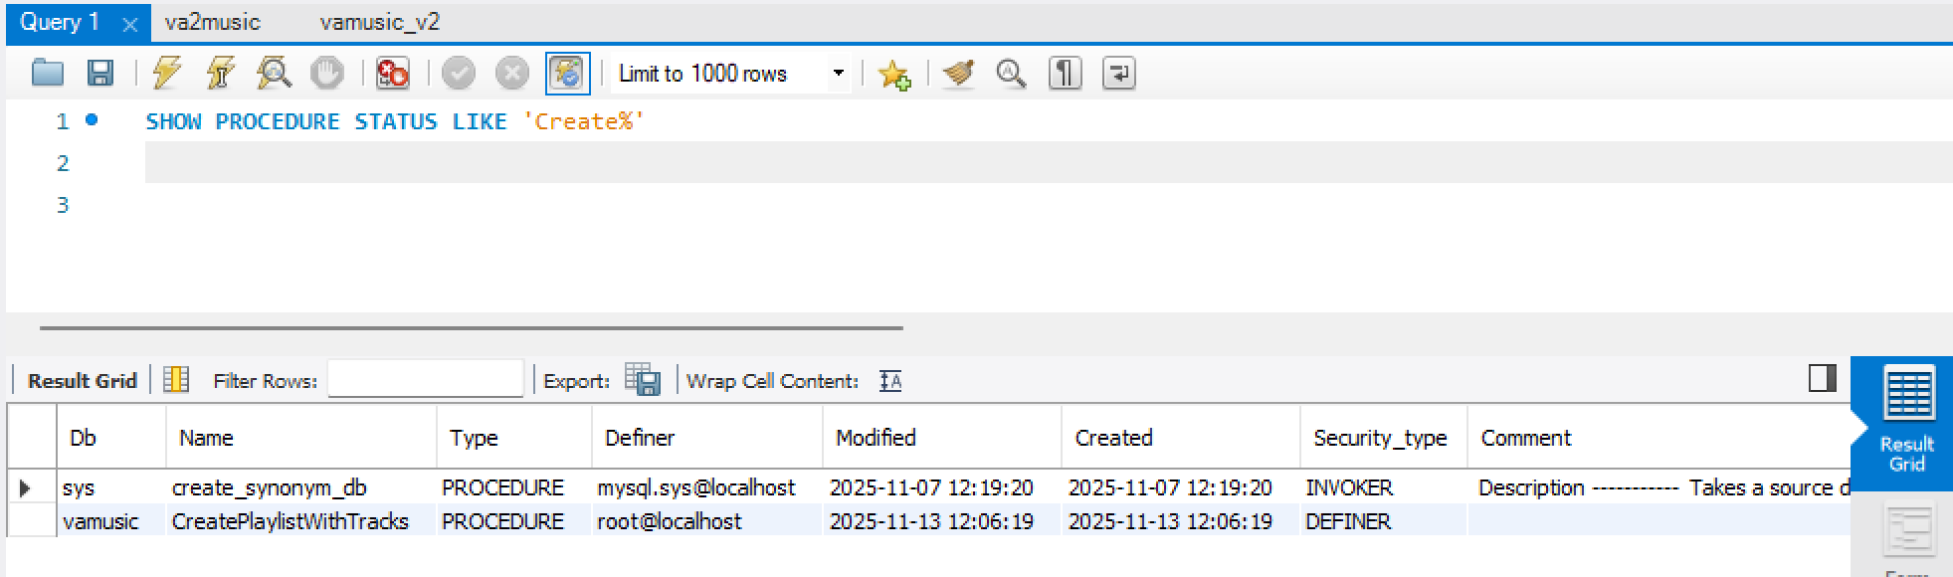
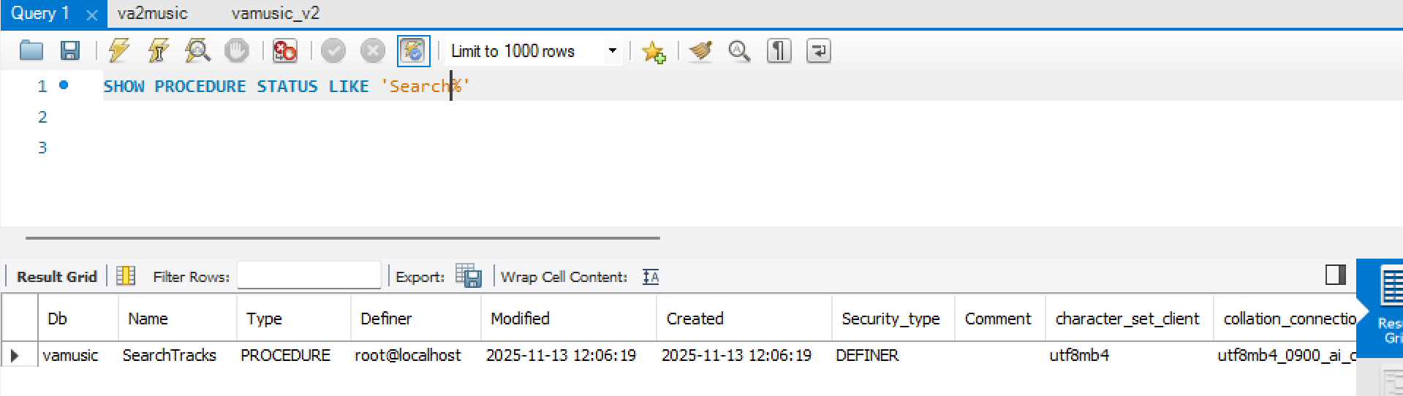
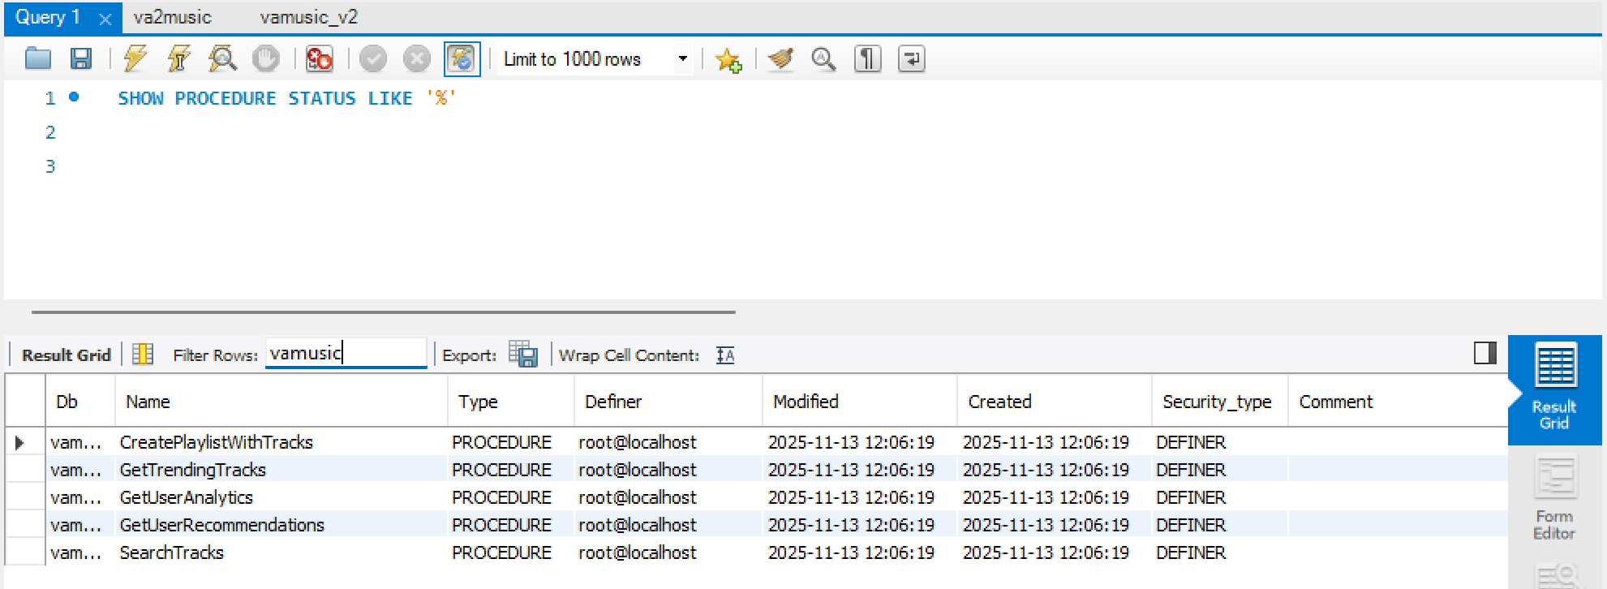

9. SQL FUNCTIONS
FormatDuration(seconds)
Returns HH:MM:SS.
GetUserTier(user_id)
Categorizes listeners based on total minutes.
CalculateMonthlyRevenue(month, year)
Computes subscription revenue.
GetPlaylistDuration(id)
Returns total playlist duration.
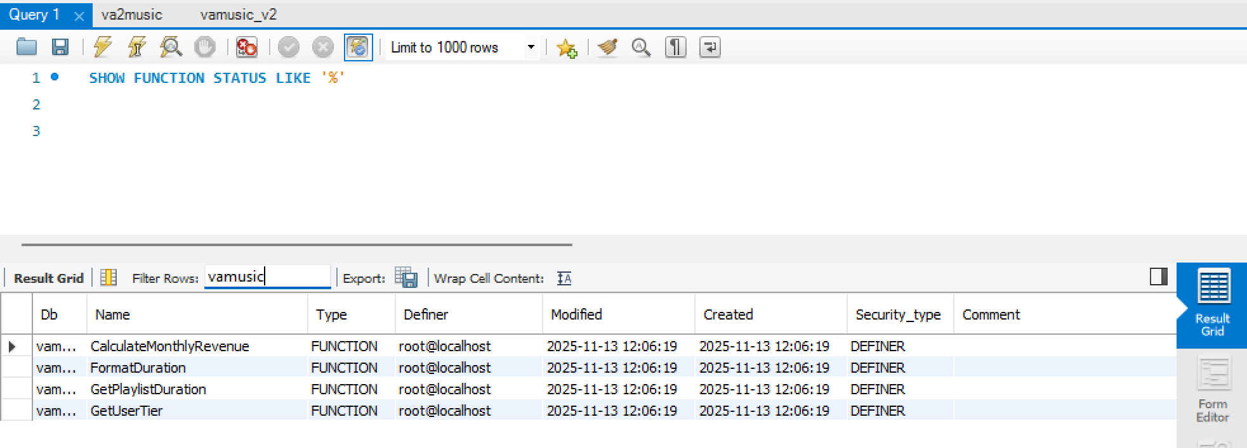

10. FINAL APPLICATION WORKFLOW (with required screenshots)
ADMIN UI FEATURES
✔ Add/Update/Delete Artist
Screenshot: Admin → Artist Management → Add Artist
✔ Add/Update/Delete Album
Screenshot: Admin → Albums → Add Album
✔ Add/Update/Delete Track
Screenshot: Admin → Tracks → Add Track (with duration)
✔ Database Summary
Screenshot: Admin → Dashboard showing counts

USER UI FEATURES
✔ Login & Registration
Screenshot: User Login screen
✔ Browse All Tracks
Screenshot: User → Browse Tab with list of tracks
✔ Add to Playlist
Screenshot: Popup showing playlist selection
✔ Create Playlist
Screenshot: User → Playlists Tab → Create New Playlist
✔ Like/Unlike Track
Screenshot: Any "Like" button pressed
✔ Listening History
Screenshot: History tab listing tracks
✔ Recommendations
Screenshot: Recommendation results after login
✔ Analytics
Screenshot: Analytics tab showing metrics, charts, or data
✔ Search
Screenshot: Search bar + filtered results

11. CRUD OPERATIONS – Summary Table
Entity | Create | Read | Update | Delete
User | Registration | Login, Browse | Profile update (future) | –
Artist | YES | YES | YES | YES
Album | YES | YES | YES | YES
Track | YES | YES | YES | YES
Playlist | YES | YES | YES | YES
PlaylistTrack | YES | YES | – | YES

12. JOINS, SUBQUERIES, AGGREGATION (Examples Used)
Our SQL heavily uses:
✔ Joins
Track + Album + Artist
User + Subscription
Playlist + PlaylistTrack
✔ Subqueries
Top genres
Trending score calculation
✔ Group By / Aggregations
COUNT, SUM, AVG inside analytics and trending procedures
✔ Nested queries
Inside recommendation procedure
✔ ACID Transactions
Used in CreatePlaylistWithTracks

13. RESULTS
The VAMusic application successfully demonstrates:
- Full relational DB design
- Working Admin & User UI
- End-to-end DB-driven music streaming features
- Advanced SQL concepts
- Smooth integration with Python

14. GITHUB DELIVERABLES
Repo Link::

15. CONCLUSION
The project satisfies all mini-project requirements and demonstrates a strong understanding of relational database design, SQL programming, GUI integration, and application development. The final VAMusic system is a compact but functional simulation of a real-world music streaming service like Spotify.

