AICTE | IBM SkillsBuild
Data Analytics with AI Academic Internship 2026
PROJECT REPORT
Retail Store Performance Analysis and Sales Prediction
A data analytics project using Python, statistics and machine learning
Submitted by
Maanveer Singh
Program conducted by BharatCares in association with AICTE

1. Introduction
A supermarket chain runs hundreds of stores that differ in size, stock range and customer traffic. Their sales also differ widely, and management needs to know what actually drives that difference. This project studies store-level data to answer that question and uses machine learning to check how much of store sales can be explained and predicted from the information available.

1.1 Problem Statement
Sales vary widely across stores, but it is unclear which store characteristics explain the variation. The project aims to measure the relationship between store size, stock range, customer traffic and sales, find the most and least efficient stores, segment the stores, and test whether sales can be predicted.

1.2 Objectives
- Clean and validate the dataset.
- Explore distributions, outliers and relationships between variables.
- Create business KPIs such as sales per sq yd and sales per customer.
- Test relationships with formal statistical tests.
- Segment stores using K-Means clustering.
- Build and compare regression models to predict store sales and report the results honestly.
- Convert the results into practical business recommendations.

2. Dataset Description
The analysis uses the Kaggle dataset "Supermarket Store Branches Sales Analysis" (author: surajjha101), saved as the file Use_Stores.csv, which contains 896 stores (one row per store) and five columns. There are no missing values, no duplicate rows and no zero or negative values. Store_Area is measured in square yards (sq yd) and Store_Sales in US dollars (USD).
Column | Description | Mean | Median | Min | Max
Store ID | Unique store identifier | 448.5 | 448.5 | 1 | 896
Store_Area | Store area (sq yd) | 1,485 | 1,477 | 775 | 2,229
Items_Available | Number of items stocked | 1,782 | 1,774 | 932 | 2,667
Daily_Customer_Count | Average customers per day | 786 | 780 | 10 | 1,560
Store_Sales | Store sales (USD) | 59,351 | 58,605 | 14,920 | 116,320

3. Tools and Technologies
Tool | Purpose
Python 3 | Programming language for the whole analysis
pandas, NumPy | Data loading, cleaning, feature engineering and aggregation
Matplotlib, Seaborn | Charts and visualisation
SciPy | Pearson and Spearman correlation, ANOVA, Kruskal-Wallis tests
scikit-learn | K-Means clustering, regression models, cross-validation, evaluation metrics
Jupyter Notebook | Interactive environment that combines code, output and explanations

4. Methodology
- Load the data and fix file quirks (a hidden BOM character and a trailing space in the first column name).
- Check data quality: missing values, duplicates, invalid values.
- Engineer KPIs and store size and traffic groups.
- Explore distributions and detect outliers with the IQR method.
- Analyse correlations and test them statistically.
- Compare store size groups and traffic groups; rank store efficiency.
- Segment stores with K-Means, choosing k with the elbow method and silhouette score.
- Train and compare regression models using 5-fold cross-validation and a 20% hold-out test set, against a mean-prediction baseline.
- Run robustness checks and derive recommendations.

5. Data Preparation

5.1 Data Cleaning and Quality Checks
The raw file began with a hidden byte-order mark and the first column was named "Store ID " with a trailing space. Both would cause errors when selecting columns, so the file is read with UTF-8-SIG encoding and column names are stripped and standardised (Store ID becomes Store_ID). The data contains no missing values, duplicate rows or duplicate store IDs, and every value is positive, so no rows were removed or imputed.

5.2 Feature Engineering
KPI | Formula | Business meaning
Sales_per_SqYd | Store_Sales / Store_Area | Revenue earned per unit of floor space
Sales_per_Customer | Store_Sales / Daily_Customer_Count | Average value of a customer visit
Customers_per_100SqYd | Daily_Customer_Count / Store_Area x 100 | Footfall density
Items_per_SqYd | Items_Available / Store_Area | Stock range density
Store_Size | Quartiles of Store_Area | Small, Medium, Large, Extra Large
Traffic_Level | Quartiles of Daily_Customer_Count | Low, Moderate, High, Peak

5.3 Outlier Analysis
Using the IQR rule, fewer than 1% of stores are outliers in any variable (five stores for area, five for items, three for customer count and one for sales). They look like genuine very large or very small stores, so they were kept. One store (ID 40) reports only 10 daily customers but USD 45,480 in sales, about USD 4,548 per customer, which is far above the typical value of about USD 75. This is probably a recording error. It was flagged and kept, and the modelling robustness check shows that removing it changes nothing.

6. Exploratory Data Analysis

6.1 Distributions
All four variables are roughly bell shaped with mild skew. The average store earns USD 59,351, and the middle half of stores earn between about USD 46,530 and USD 71,873.
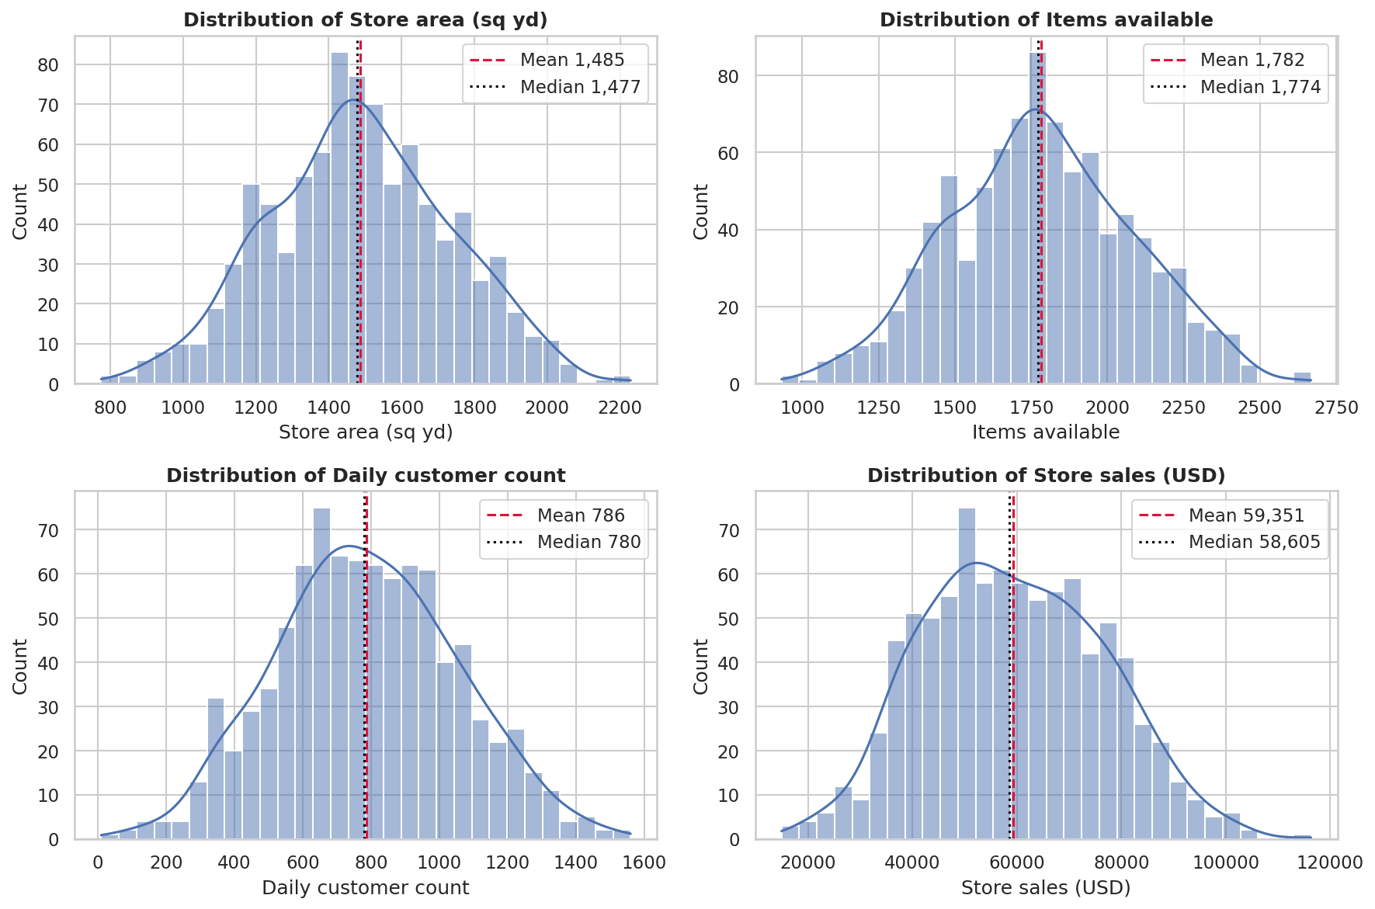
Figure 1: Distribution of store variables

6.2 Correlation Analysis
Two results stand out. First, Store_Area and Items_Available are almost perfectly correlated (r = 0.999); every store stocks about 1.2 items per sq yd, so the two columns carry the same information. Second, Store_Sales has almost no linear relationship with any other variable (r = 0.097 with area and 0.009 with customer count).
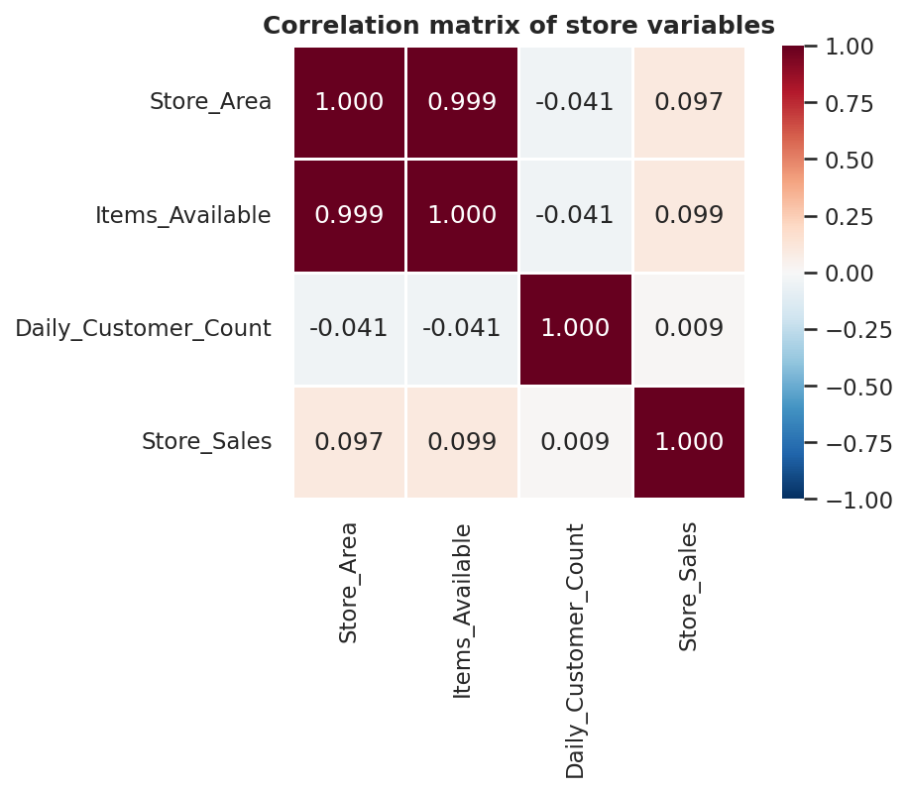
Figure 2: Correlation matrix
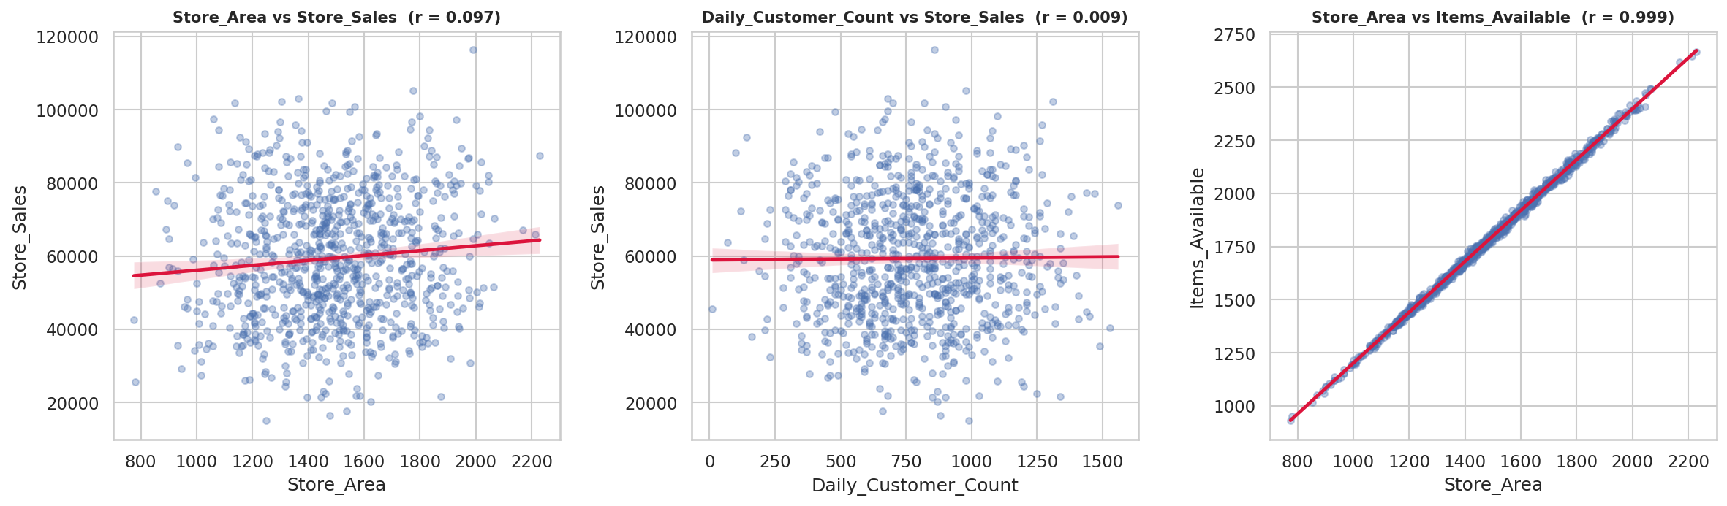
Figure 3: Key relationships between variables

7. Statistical Hypothesis Testing
At a 5% significance level, the null hypothesis is that a variable has no relationship with store sales. Pearson (linear) and Spearman (rank based) correlations were both calculated.
Variable vs Store_Sales | Pearson r | Pearson p | Spearman rho | Spearman p | R-squared (%)
Store_Area | 0.097 | 0.0035 | 0.089 | 0.0077 | 0.95
Items_Available | 0.099 | 0.0031 | 0.091 | 0.0064 | 0.98
Daily_Customer_Count | 0.009 | 0.7965 | 0.02 | 0.5596 | 0.01

Store area has a statistically significant but extremely weak relationship with sales, explaining less than 1% of the variation. With 896 stores, even a tiny effect can reach p < 0.05, so statistically significant does not mean practically important. Customer count shows no significant relationship. A one-way ANOVA (F = 1.92, p = 0.125) and a Kruskal-Wallis test (H = 5.27, p = 0.153) both show no significant difference in average sales between the four store-size groups.

8. Store Performance Analysis

8.1 Store Size
Store size | Stores | Avg area (sq yd) | Avg customers | Avg sales (USD) | Sales per sq yd (USD)
Small | 224 | 1,165 | 806 | 58,464 | 50.5
Medium | 225 | 1,406 | 784 | 57,863 | 41.2
Large | 223 | 1,561 | 779 | 59,617 | 38.2
Extra Large | 224 | 1,810 | 777 | 61,469 | 34.0

Total sales rise only slightly with size, but sales per sq yd fall steadily from USD 50.5 in small stores to USD 34.0 in extra-large stores. Extra space is not turning into proportionally more revenue.
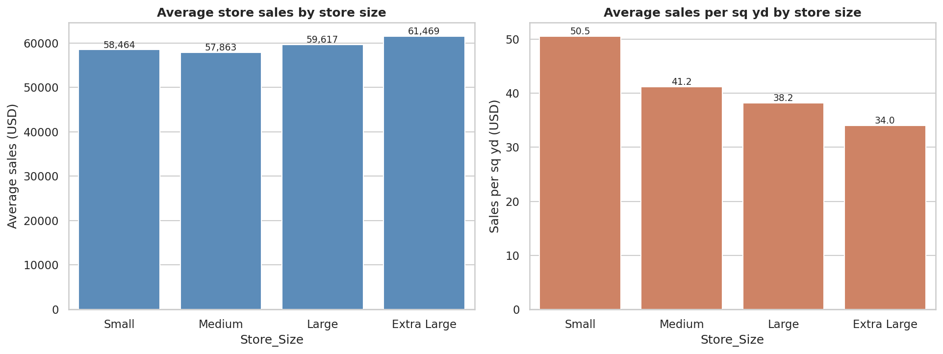
Figure 4: Sales and space efficiency by store size

8.2 Customer Traffic
Traffic level | Stores | Avg customers | Avg sales (USD) | Median sales per customer (USD)
Low | 227 | 454 | 58,448 | 126.0
Moderate | 228 | 697 | 59,319 | 83.4
High | 221 | 875 | 59,798 | 67.5
Peak | 220 | 1,134 | 59,868 | 52.7

Stores with Low, Moderate, High and Peak footfall all earn about the same total sales (roughly USD 58,000 to 60,000), so more customers do not bring more sales. Because total sales stay flat while customer counts rise, sales per customer falls steadily as traffic grows. This is largely arithmetic rather than a behavioural pattern, but the main message is clear: footfall alone does not lift store sales, so factors such as pricing, basket size and location must matter.
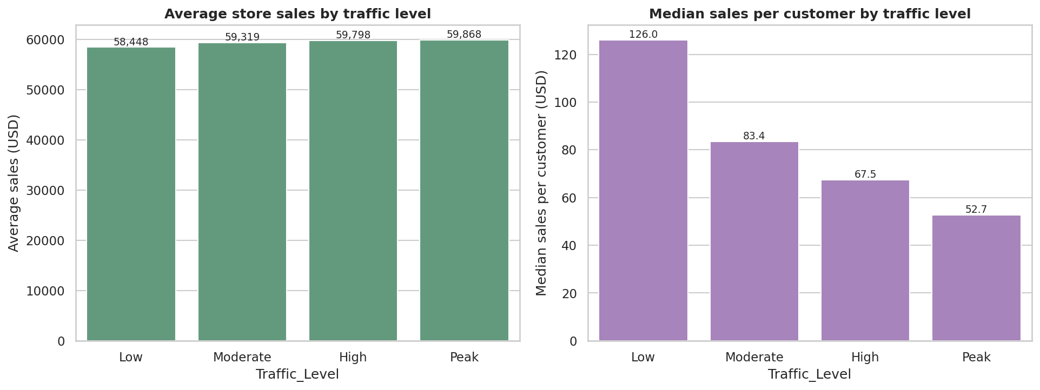
Figure 5: Sales and sales per customer by traffic level

8.3 Most and Least Efficient Stores
Stores were ranked by sales per sq yd. The five best and five worst stores are shown below.
Rank | Store ID | Area (sq yd) | Customers/day | Sales (USD) | Sales per sq yd
Top 1 | 557 | 932 | 820 | 89,760 | 96.3
Top 2 | 469 | 1,060 | 670 | 97,360 | 91.8
Top 3 | 745 | 854 | 660 | 77,740 | 91.0
Top 4 | 558 | 1,137 | 700 | 101,780 | 89.5
Top 5 | 340 | 966 | 900 | 85,470 | 88.5

Rank | Store ID | Area (sq yd) | Customers/day | Sales (USD) | Sales per sq yd
Bottom 1 | 853 | 1,477 | 880 | 16,370 | 11.1
Bottom 2 | 776 | 1,537 | 660 | 17,670 | 11.5
Bottom 3 | 373 | 1,876 | 1,340 | 21,650 | 11.5
Bottom 4 | 32 | 1,250 | 990 | 14,920 | 11.9
Bottom 5 | 594 | 1,624 | 870 | 20,270 | 12.5

The top-10 stores average about 999 sq yd, well below the chain average of about 1,485 sq yd, while the bottom-10 stores average about 1,533 sq yd and earn only USD 11 to USD 15 per sq yd.
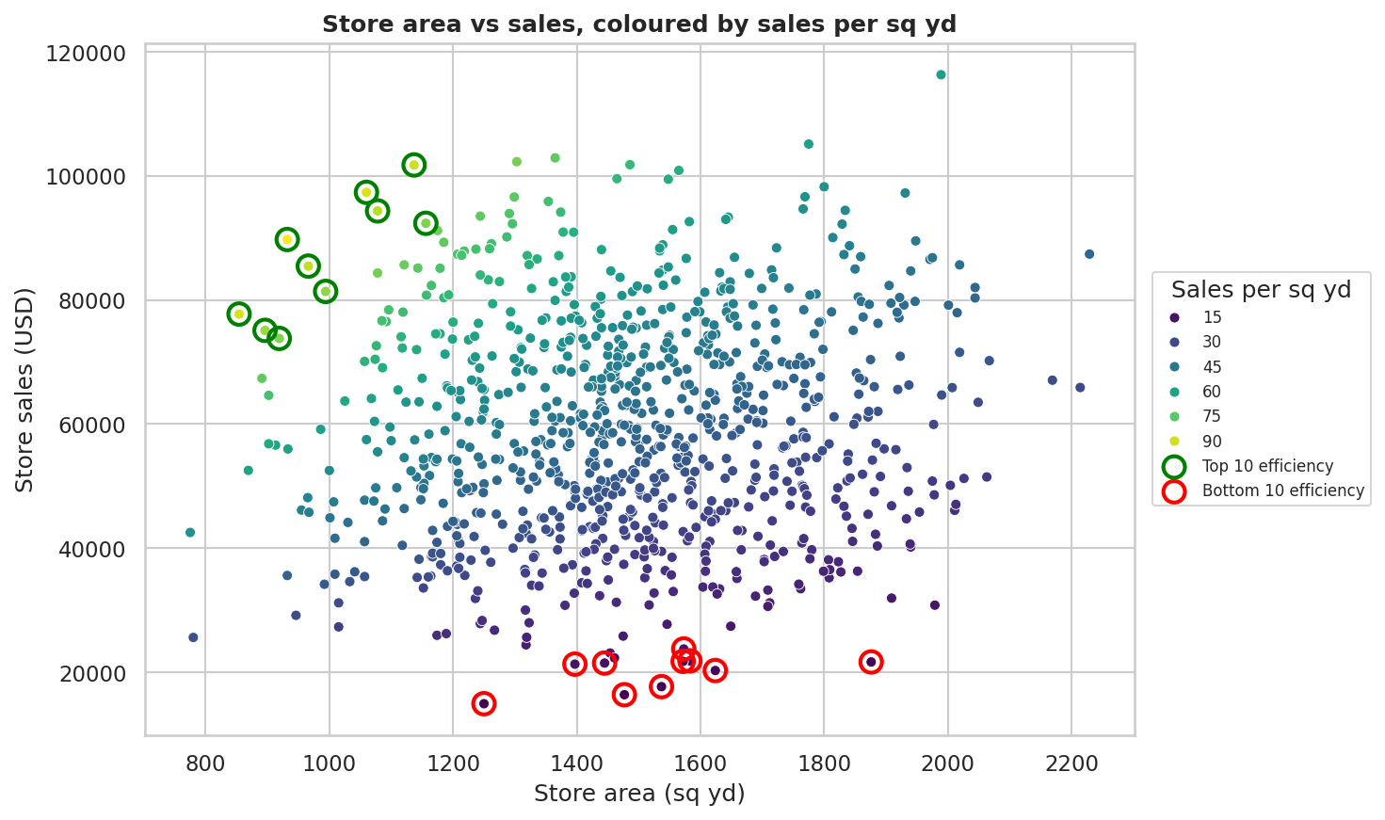
Figure 6: Store area vs sales coloured by sales per sq yd

9. Machine Learning: Store Segmentation
K-Means clustering grouped stores by area, customer traffic and sales (standardised first). Items_Available was left out because it duplicates Store_Area. The elbow and silhouette plots do not show a sharp optimum, so k = 4 was chosen for interpretability. The silhouette score is 0.23, which is low, so the segments are useful for planning but have fuzzy edges.
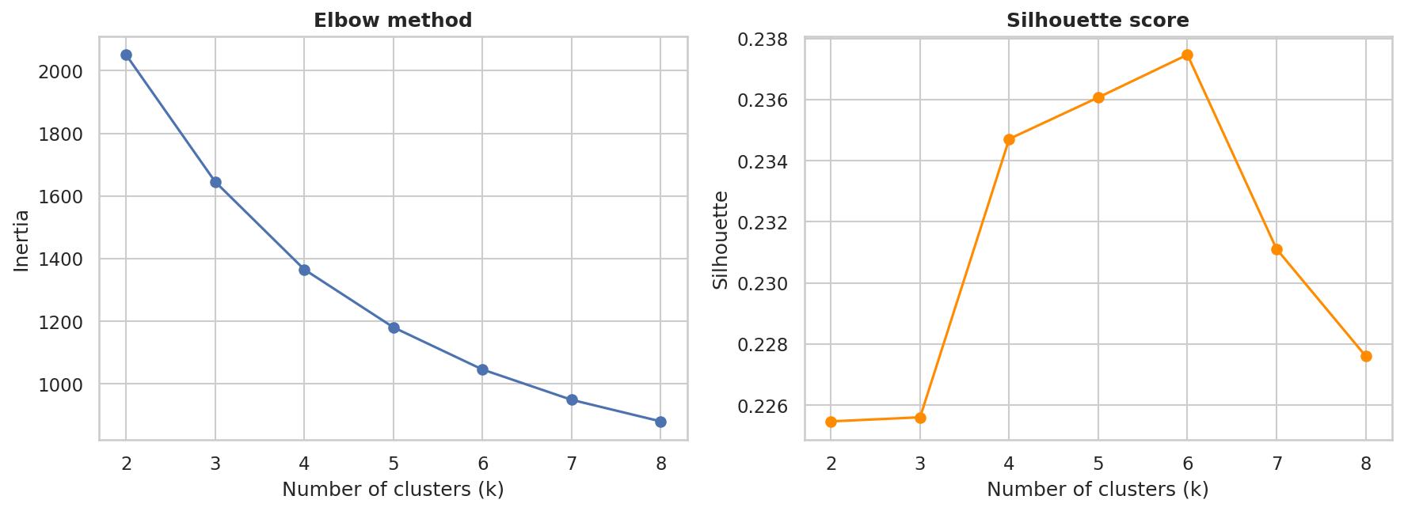
Figure 7: Elbow method and silhouette scores
Segment | Stores | Avg area (sq yd) | Avg customers | Avg sales (USD) | Sales per sq yd
High-Yield Stores | 212 | 1,368 | 789 | 78,863 | 58.7
Large High-Traffic Stores | 204 | 1,700 | 1,019 | 60,447 | 35.9
Large Low-Traffic Stores | 226 | 1,630 | 509 | 56,589 | 35.0
Underperforming Stores | 254 | 1,282 | 844 | 44,644 | 35.7

- High-Yield Stores: compact stores with average traffic and the highest sales, earning far more per sq yd than any other group.
- Large High-Traffic Stores: big stores with the busiest floors and above-average sales but low sales per sq yd.
- Large Low-Traffic Stores: big stores with the quietest floors; footfall is the main gap.
- Underperforming Stores: smaller stores with normal traffic but the lowest sales, so each visit is worth little.
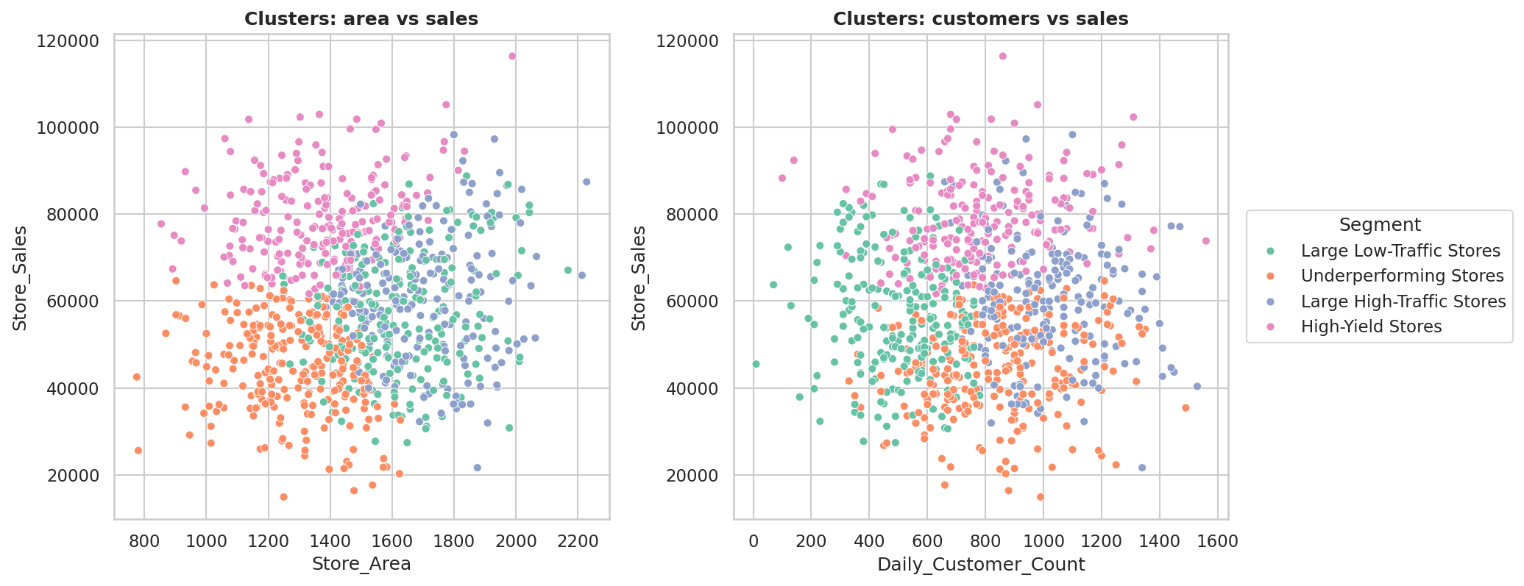
Figure 8: Store segments

10. Machine Learning: Sales Prediction

10.1 Setup
The goal was to predict Store_Sales from Store_Area and Daily_Customer_Count. Items_Available was excluded because it is 99.9% correlated with Store_Area. The engineered KPIs Sales_per_SqYd and Sales_per_Customer were deliberately not used as inputs: they are calculated from the target and would cause data leakage and fake accuracy. A DummyRegressor that always predicts the mean serves as the baseline. Models were evaluated with 5-fold cross-validation and an 80/20 train-test split.

10.2 Results
Model | CV R2 | CV MAE | CV RMSE | Test R2 | Test MAE | Test RMSE
Baseline (predict mean) | -0.007 | 14,209 | 17,192 | -0.003 | 13,293 | 16,518
Linear Regression | -0.003 | 14,138 | 17,158 | 0.003 | 13,278 | 16,469
Ridge Regression | -0.003 | 14,138 | 17,157 | 0.003 | 13,278 | 16,469
Random Forest | -0.042 | 14,272 | 17,478 | -0.08 | 13,640 | 17,145
Gradient Boosting | -0.03 | 14,305 | 17,387 | -0.023 | 13,334 | 16,679

No model meaningfully beats the baseline. Cross-validated R-squared is about zero for every model and slightly negative for the tree-based models, which overfit noise. Store area and customer count cannot predict store sales in this dataset. This is a valid and useful finding: it shows that sales depend on factors that are not recorded here, such as location, local income, pricing, product mix, promotions and basket size. Reporting this honestly is better than forcing a high score.
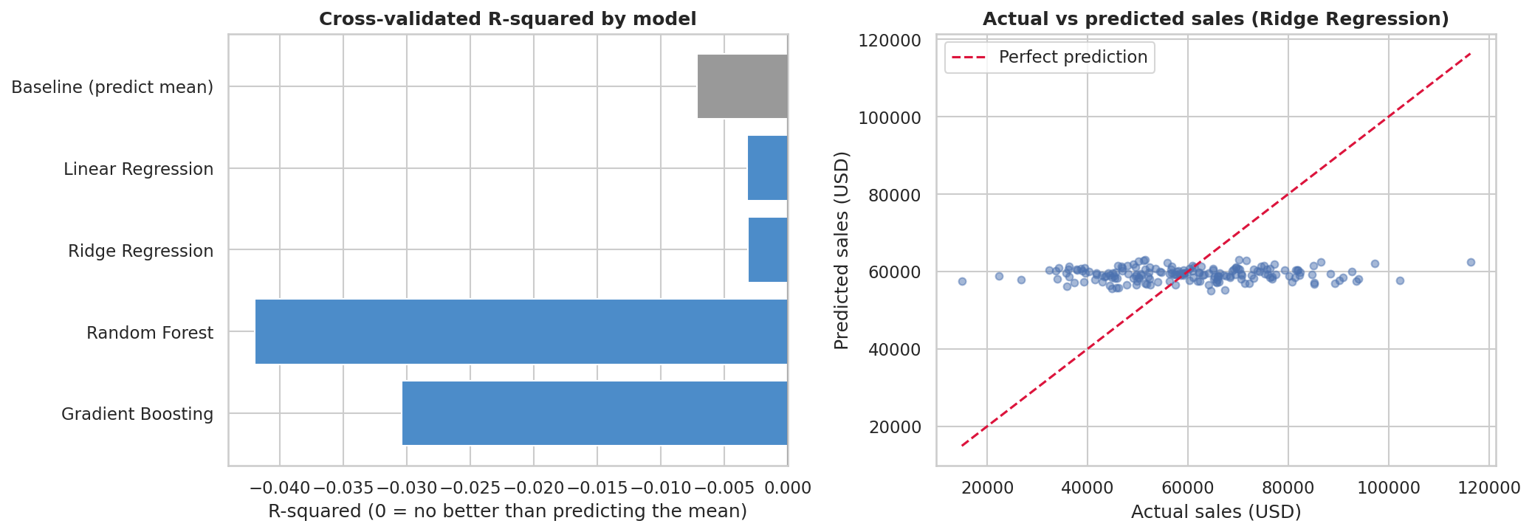
Figure 9: Model comparison and actual vs predicted sales

10.3 Robustness Checks
Removing the suspicious Store 40 or adding Items_Available as a third input leaves the linear model at an R-squared of about zero, and permutation importance is close to zero for both features. The weak result is therefore real and does not depend on one outlier or on the choice of inputs.

11. Key Findings
- The average store earns about USD 59,351; the middle half of stores earn USD 46,530 to USD 71,873.
- Store area and stock range are almost identical measures (r = 0.999).
- Store sales have almost no relationship with area (r = 0.097) or customer count (r = 0.009).
- Sales per sq yd fall from USD 50.5 (small stores) to USD 34.0 (extra-large stores), so larger stores use space less efficiently.
- Busier stores do not earn more in total; footfall alone does not lift sales.
- High-Yield Stores earn about USD 58.7 per sq yd compared with about USD 35 for every other segment.
- Machine learning models cannot meaningfully beat a simple average, so the key sales drivers are missing from the data.

12. Business Recommendations
- Do not expand floor space to grow sales. Compact, well-stocked layouts earn more per sq yd.
- Study the High-Yield segment. Compare its pricing, product mix, layout and staffing with other segments and copy what works.
- Review the least efficient stores (for example Stores 853, 776, 373, 32 and 594) for layout redesign, range changes or space reduction.
- Look beyond footfall. The busiest stores earn no more in total than the quietest ones, so test basket-building ideas such as bundles, loyalty offers and cross-selling, and track basket value alongside footfall.
- Verify the data for Store 40, whose customer count looks like a recording error.
- Collect richer data such as location type, local population and income, average basket value, staff numbers, promotion calendar and opening year to enable real sales prediction.

13. Limitations
- The dataset has one row per store and no dates, so seasonality and growth cannot be studied.
- Only four numeric columns are available; product, price and location information are missing.
- Items_Available duplicates Store_Area, so effectively only two independent inputs exist.
- All findings are associations in one snapshot of the data, not proof of cause and effect.
- The clusters are descriptive. They use sales as an input, so they summarise stores but are not a forecast.

14. Conclusion
Store size and footfall explain almost none of the difference in store sales. Larger stores do not sell proportionally more and busier stores do not earn more in total, so space efficiency matters more than size or traffic. Regression models could not meaningfully beat a simple average baseline, confirming that the real drivers of sales are not part of this dataset. K-Means segmentation nevertheless gives management four clear store types for targeted action, and the efficiency ranking shows which stores to learn from and which to fix.

15. Project Files
File | Description
Maanveer_Singh_Store_Performance_Analysis.ipynb | Complete analysis notebook with code, outputs and explanations
requirements.txt | List of Python libraries needed to run the project
Maanveer_Singh_ProjectReport.docx | This project report
README.md | Project overview, dataset link, setup and run instructions
Use_Stores.csv | Dataset used for the analysis

