**SIMULATE AND IMPLEMENT GO BACK N SLIDING WINDOW PROTOCOL (Only Output)**

**Using Dev C++**

**Program Name: Go_Back.c**

---------------------------------------------------------------------------------------------------------------------

**#include<stdio.h>  
#include<conio.h>  
void main()  
{  
char sender[50],receiver[50];  
int i,winsize;  
 printf("\n ENTER THE WINDOWS SIZE : ");  
scanf("%d",&winsize);  
 printf("\n SENDER WINDOW IS EXPANDED TO STORE MESSAGE OR WINDOW \n");  
 printf("\n ENTER THE DATA TO BE SENT: ");  
fflush(stdin);  
gets(sender);  
for(i=0;i<winsize;i++)  
receiver[i]=sender[i];  
receiver[i]=NULL;  
 printf("\n MESSAGE SEND BY THE SENDER:\n");  
 puts(sender);  
 printf("\n WINDOW SIZE OF RECEIVER IS EXPANDED\n");  
 printf("\n ACKNOWLEDGEMENT FROM RECEIVER \n");  
for(i=0;i<winsize;i++);  
printf("\n ACK:%d",i);  
 printf("\n MESSAGE RECEIVED BY RECEIVER IS : ");  
 puts(receiver);  
 printf("\n WINDOW SIZE OF RECEIVER IS SHRINKED \n");  
getch();  
}**

---------------------------------------------------------------------------------------------------------------------

**Output....**

[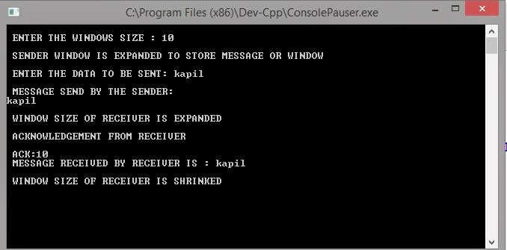](http://3.bp.blogspot.com/-YHo9mGOMp3U/VB5tF-jq67I/AAAAAAAAAO0/8aOX4W7KoVE/s1600/go%2Bback.JPG)

---------------------------------------------------------------------------------------------------------------------