**SIMULATE AND IMPLEMENT SELECTIVE REPEAT SLIDING WINDOW PROTOCOL**

**SIMULATE AND IMPLEMENT SELECTIVE REPEAT SLIDING WINDOW PROTOCOL PROGRAM IN DEV C++**

-----------------------------------------------------------------------------------------------------------  
  
//ducslectures.blogspot.in  
  
#include<iostream>  
using namespace std;  
#include<conio.h>  
  
#include<stdlib.h>  
  
#include<time.h>  
  
#include<math.h>  
  
  
  
#define TOT_FRAMES 500  
  
#define FRAMES_SEND 10  
  
  
  
class sel_repeat  
  
{  
  
private:  
  
int fr_send_at_instance;  
  
int arr[TOT_FRAMES];  
  
int send[FRAMES_SEND];  
  
int rcvd[FRAMES_SEND];  
  
char rcvd_ack[FRAMES_SEND];  
  
int sw;  
  
int rw;       //tells expected frame  
  
public:  
  
void input();  
  
void sender(int);  
  
void receiver(int);  
  
};  
  
void sel_repeat::input()  
  
{  
  
int n;     //no. of bits for the frame  
  
int m;    //no. of frames from n bits  
int i;  
cout<<"Enter the no. of bits for the sequence no. : ";  
  
cin>>n;  
  
m=pow(2,n);  
  
int t=0;  
  
fr_send_at_instance=(m/2);  
  
for(i=0;i<TOT_FRAMES;i++)  
  
{  
  
arr[i]=t;  
  
t=(t+1)%m;  
  
}  
  
for(i=0;i<fr_send_at_instance;i++)  
  
{  
  
send[i]=arr[i];  
  
rcvd[i]=arr[i];  
  
rcvd_ack[i]='n';  
  
}  
  
rw=sw=fr_send_at_instance;  
  
sender(m);  
  
}  
  
void sel_repeat::sender(int m)  
  
{  
  
for(int i=0;i<fr_send_at_instance;i++)  
  
{  
  
if(rcvd_ack[i]=='n')  
  
cout<<"SENDER : Frame "<<send[i]<<" is sent\n";  
  
}  
  
receiver(m);  
  
}  
  
void sel_repeat::receiver(int m)  
  
{  
  
time_t t;  
  
int f;  
int j;  
int f1;  
  
int a1;  
  
char ch;  
  
srand((unsigned)time(&t));  
  
for(int i=0;i<fr_send_at_instance;i++)  
  
{  
  
if(rcvd_ack[i]=='n')  
  
{  
  
f=rand()%10;  
  
//if f=5 frame is discarded for some reason  
  
//else frame is correctly recieved  
  
if(f!=5)  
  
{  
  
for(int j=0;j<fr_send_at_instance;j++)  
  
if(rcvd[j]==send[i])  
  
{  
  
cout<<"reciever:Frame"<<rcvd[j]<<"recieved correctly\n";  
  
rcvd[j]=arr[rw];  
  
rw=(rw+1)%m;  
  
break;  
  
}  
int j;  
if(j==fr_send_at_instance)  
  
cout<<"reciever:Duplicate frame"<<send[i]<<"discarded\n";  
  
a1=rand()%5;  
  
//if al==3 then ack is lost  
  
//else recieved  
  
if(a1==3)  
  
{  
  
cout<<"(acknowledgement "<<send[i]<<" lost)\n";  
  
cout<<"(sender timeouts-->Resend the frame)\n";  
  
rcvd_ack[i]='n';  
  
}  
  
else  
  
{  
  
cout<<"(acknowledgement "<<send[i]<<" recieved)\n";  
  
rcvd_ack[i]='p';  
  
}  
  
}  
  
else  
  
{int ld=rand()%2;  
  
//if =0 then frame damaged  
  
//else frame lost  
  
if(ld==0)  
  
{  
  
cout<<"RECEIVER : Frame "<<send[i]<<" is damaged\n";  
  
cout<<"RECEIVER : Negative Acknowledgement "<<send[i]<<" sent\n";  
  
}  
  
else  
  
{  
  
cout<<"RECEIVER : Frame "<<send[i]<<" is lost\n";  
  
cout<<"(SENDER TIMEOUTS-->RESEND THE FRAME)\n";  
  
}  
  
rcvd_ack[i]='n';  
  
}  
  
}  
  
}  
  
for(int j=0;j<fr_send_at_instance;j++)  
  
{  
  
if(rcvd_ack[j]=='n')  
  
break;  
  
}  
  
int i=0;  
  
for(int k=j;k<fr_send_at_instance;k++)  
  
{  
  
send[i]=send[k];  
  
if(rcvd_ack[k]=='n')  
  
rcvd_ack[i]='n';  
  
else  
  
rcvd_ack[i]='p';  
  
i++;  
  
}  
  
if(i!=fr_send_at_instance)  
  
{  
  
for(int k=i;k<fr_send_at_instance;k++)  
  
{  
  
send[k]=arr[sw];  
  
sw=(sw+1)%m;  
  
rcvd_ack[k]='n';  
  
}  
  
}  
  
cout<<"Want to continue";  
  
cin>>ch;  
  
cout<<"\n";  
  
if(ch=='y')  
  
sender(m);  
  
else  
  
exit(0);  
  
}  
  
int main()  
  
{  
  
  
sel_repeat sr;  
  
sr.input();  
  
//ducslectures.blogspot.in  
  
}

-----------------------------------------------------

**Output.......**

[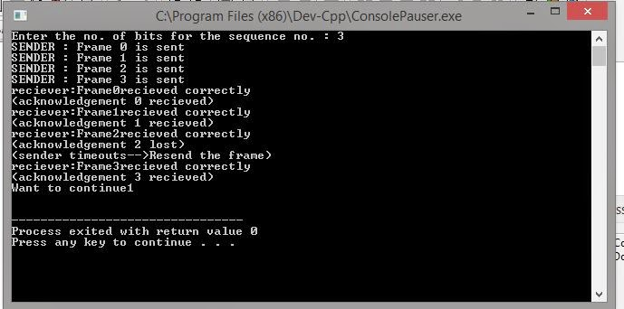](http://1.bp.blogspot.com/--89bm3AQxk8/VD7WWJ4JglI/AAAAAAAAAP4/Lv4VmcU9s6A/s1600/s1.JPG)

[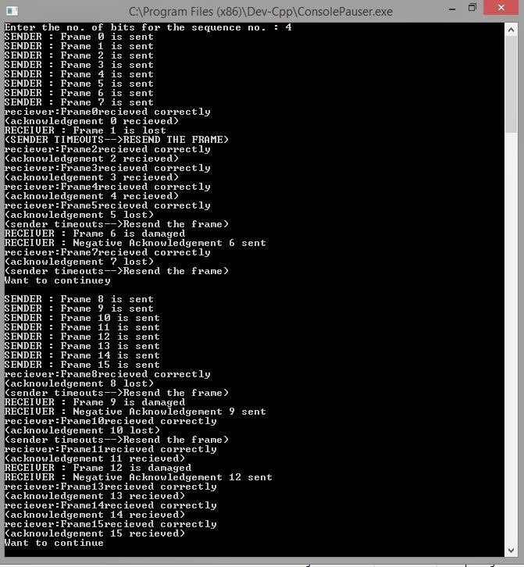](http://3.bp.blogspot.com/-hePXDirFz9I/VD7WrNtyfgI/AAAAAAAAAQA/V0iWLv9PnEc/s1600/s2.JPG)

------------------------------------------------------------------------------------------------------

**Program Finish....**