COMP 4621
Assignment 3
Wanderly – Dynamic Travel Discovery Website

Name: Manvi Aggarwal
Course: COMP 4621 – Web-Based Information Systems
Project: Wanderly Travel Discovery Website

MongoDB • Node.js • AngularJS • HTML • CSS

Part 1 – MongoDB Database

1.1 Description
For Part 1, I created a MongoDB database called COMP4621Assignment3. I used a users collection to store the login information and other details for each user. I added three test users first so I could make sure the database was working before connecting it to the website.

1.2 Test Data
Username | Password | Full Name | Email | Favourite Destination
mike | travel123 | Mike Acker | mike@example.com | Vancouver
david | explore456 | David Smith | david@example.com | Paris
sarah | journey789 | Sarah Lee | sarah@example.com | Tokyo

1.3 Database Code
db = db.getSiblingDB("COMP4621Assignment3");
db.users.deleteMany({});
db.users.insertMany([
{ username: "mike", password: "travel123",
fullName: "Mike Acker", email: "mike@example.com",
favouriteDestination: "Vancouver" },
{ username: "david", password: "explore456",
fullName: "David Smith", email: "david@example.com",
favouriteDestination: "Paris" },
{ username: "sarah", password: "journey789",
fullName: "Sarah Lee", email: "sarah@example.com",
favouriteDestination: "Tokyo" }
]);

1.4 Test Exhibits
The db.users.find() command confirmed that all three initial user documents were stored successfully.
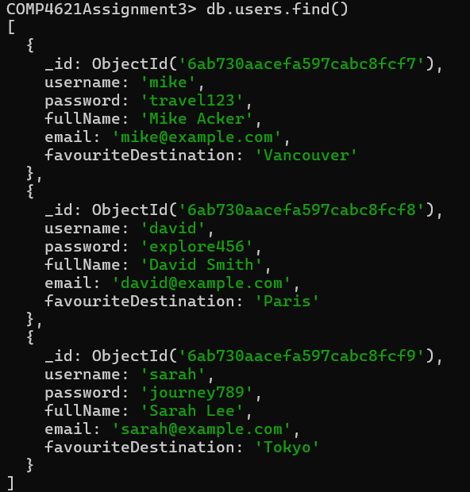
Figure 1. User documents stored in the MongoDB users collection.
The findOne() command was then used to retrieve Mike's document by username.
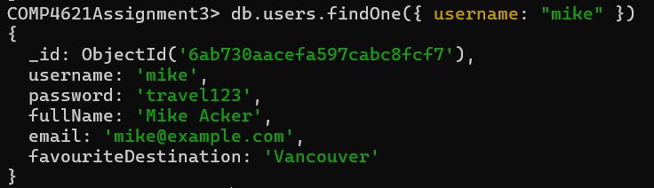
Figure 2. Retrieving a specific user from MongoDB.

Part 2 – AngularJS Client and Node.js Server

2.1 Description
For Part 2, I created a simple AngularJS login form where the user can enter a username and password. I used an HTTP POST request to send this information to the Node.js server. At this stage, I was mainly testing that AngularJS and Node.js could communicate correctly before adding the database login.

2.2 Core Client Code
$scope.login = function() {
$http.post("/login", $scope.user)
.then(function(response) {
$scope.message = response.data.message;
$scope.userDetails = response.data.user;
$scope.showRegistration = false;
})
.catch(function(error) {
$scope.userDetails = null;
$scope.message = error.data.message;
$scope.showRegistration = !!error.data.newUser;
});
};

2.3 Core Server Setup
const express = require("express");
const { MongoClient } = require("mongodb");
const app = express();
const PORT = 3000;
app.use(express.json());
app.use(express.static(__dirname));
const client = new MongoClient("mongodb://127.0.0.1:27017");
const dbName = "COMP4621Assignment3";

2.4 Test Exhibits
The login form was tested using David's credentials. The browser confirmed that the login information was received, while the Node.js command window displayed the username and password received from the client.
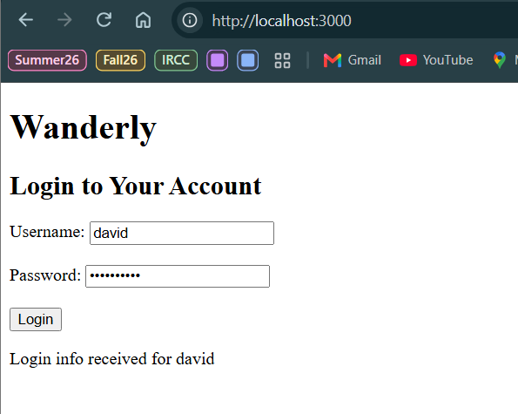
Figure 3. AngularJS login information sent to the Node.js server.
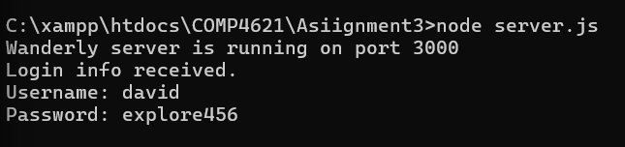
Figure 4. Node.js receiving the login information.
The server was then connected to MongoDB. The command window displayed a successful connection message before the web server started.
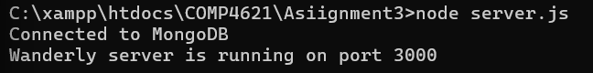
Figure 5. Successful Node.js connection to MongoDB.

Part 3 – User Authentication and Registration

3.1 Description
For Part 3, I connected the Node.js server to the MongoDB users collection so the login could check the actual database. I handled the three cases required in the assignment: a correct login, an existing username with the wrong password, and a new username. A new username is given the option to create an account.

3.2 Authentication Logic
const users = client.db(dbName).collection("users");
const user = await users.findOne({ username: username });
if (user) {
if (user.password === password) {
res.json({
success: true,
message: "Login successful!",
user: {
username: user.username,
fullName: user.fullName,
email: user.email,
favouriteDestination: user.favouriteDestination
}
});
} else {
res.status(401).json({
success: false,
message: "Incorrect password."
});
}
} else {
res.status(404).json({
success: false,
newUser: true,
message: "Username not found. You can create a new account."
});
}

3.3 Registration Logic
const existingUser = await users.findOne({ username: username });
if (!existingUser) {
await users.insertOne({
username: username,
password: password
});
res.json({
success: true,
message: "Account created successfully! You can now log in."
});
}

3.4 Test Cases
Test | Username | Password | Expected Result
Correct login | david | explore456 | Login succeeds and profile details display
Incorrect password | david | wrong password | Incorrect password message
Unknown username | alex | test password | Registration option appears
New account | claire | test345 | Account stored and can log in

3.5 Test Exhibits
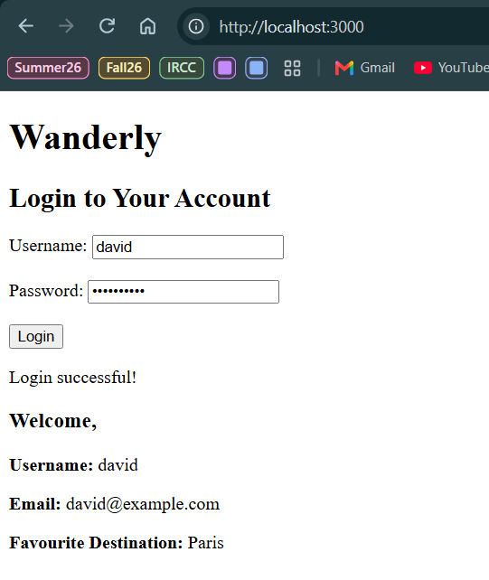
Figure 6. Successful login and retrieval of David's profile information.
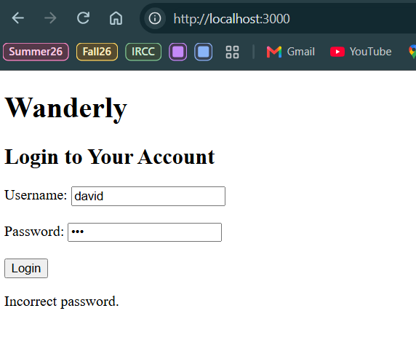
Figure 7. Incorrect-password error for an existing username.
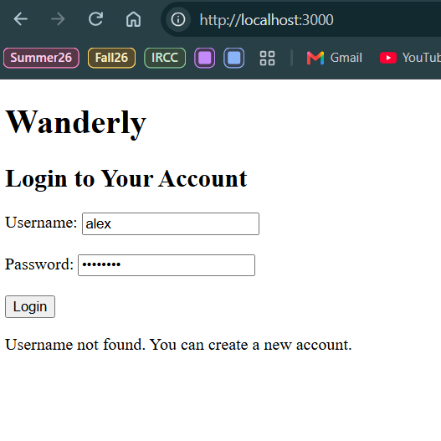
Figure 8. Unknown username detected by the authentication system.
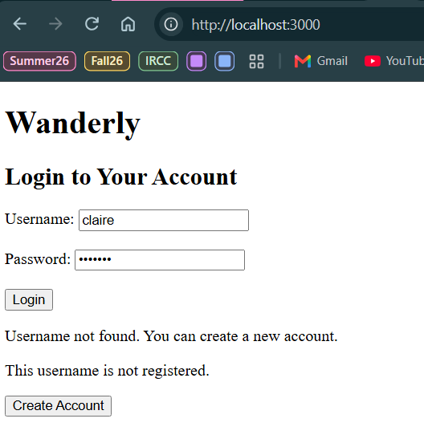
Figure 9. Create Account option displayed for a new username.
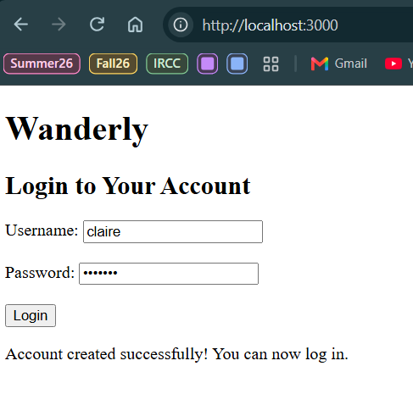
Figure 10. Successful creation of the new Claire account.
After registration, Claire was able to log in successfully. Because the new registration requirement stores only a username and password, the new account does not contain the optional profile fields used by the original test users.
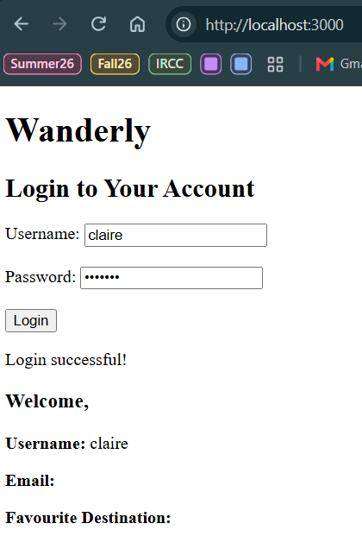
Figure 11. Newly registered user successfully logging in.
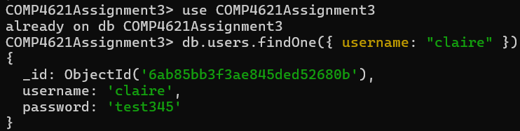
Figure 12. MongoDB verification of the newly registered Claire account.

Part 4 – Wanderly Dynamic Travel Website

4.1 Website Purpose and Structure
For Part 4, I turned the login project into a travel website called Wanderly. I chose a travel theme so the website would have useful public content in addition to the account feature. The final website has three main pages: Home, Destinations and Account, and visitors can browse destinations without creating an account.
I used the same navigation and CSS styling across the pages and added destination images and cards. The Home page features Vancouver, Paris, Tokyo and Jaipur. The Destinations page has more locations and an AngularJS search box so the displayed cards change based on what the user types.

4.2 Dynamic Destination Feature
$scope.destinations = [
{
name: "Jaipur",
country: "India",
image: "images/jaipur.jpg",
description: "A colourful city known for historic palaces, forts and traditional markets.",
bestFor: "History, culture and architecture"
}
];
<input type="text"
ng-model="searchText"
placeholder="Search destinations">
<div class="destination-card"
ng-repeat="destination in destinations | filter:searchText">
<img ng-src="{{ destination.image }}" alt="{{ destination.name }}">
<h2>{{ destination.name }}</h2>
</div>

4.3 Final Website Exhibits
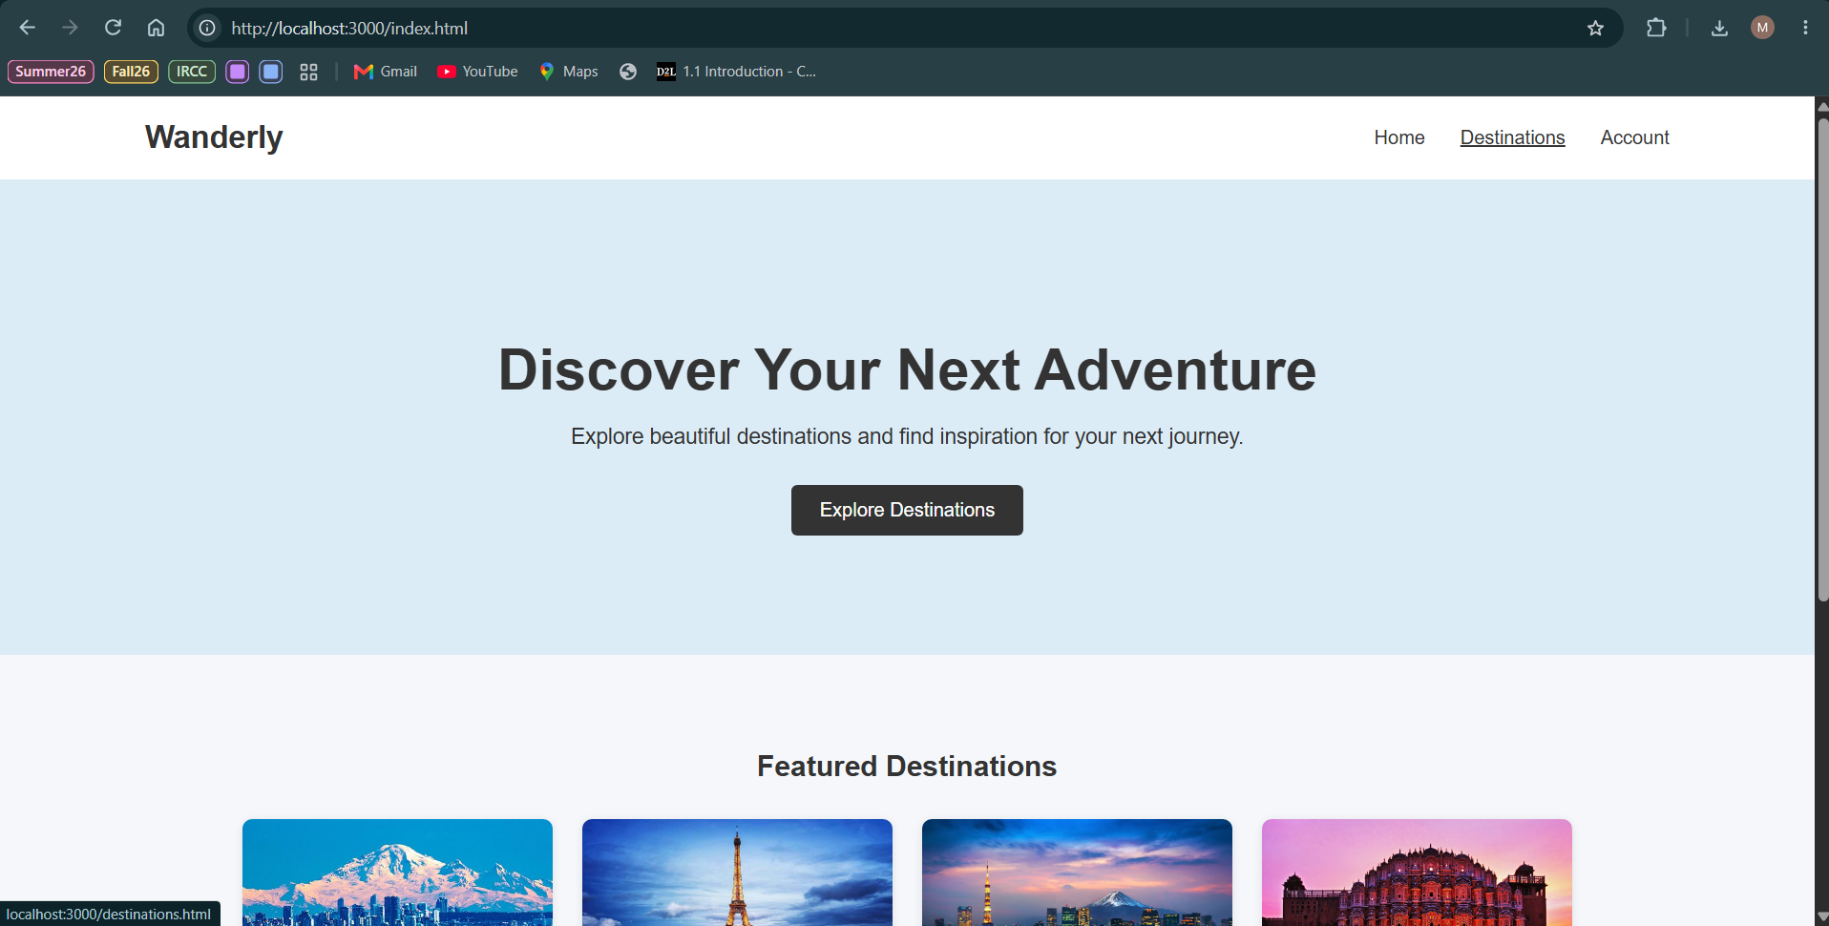
Figure 13. Wanderly Home page with navigation and main travel banner.
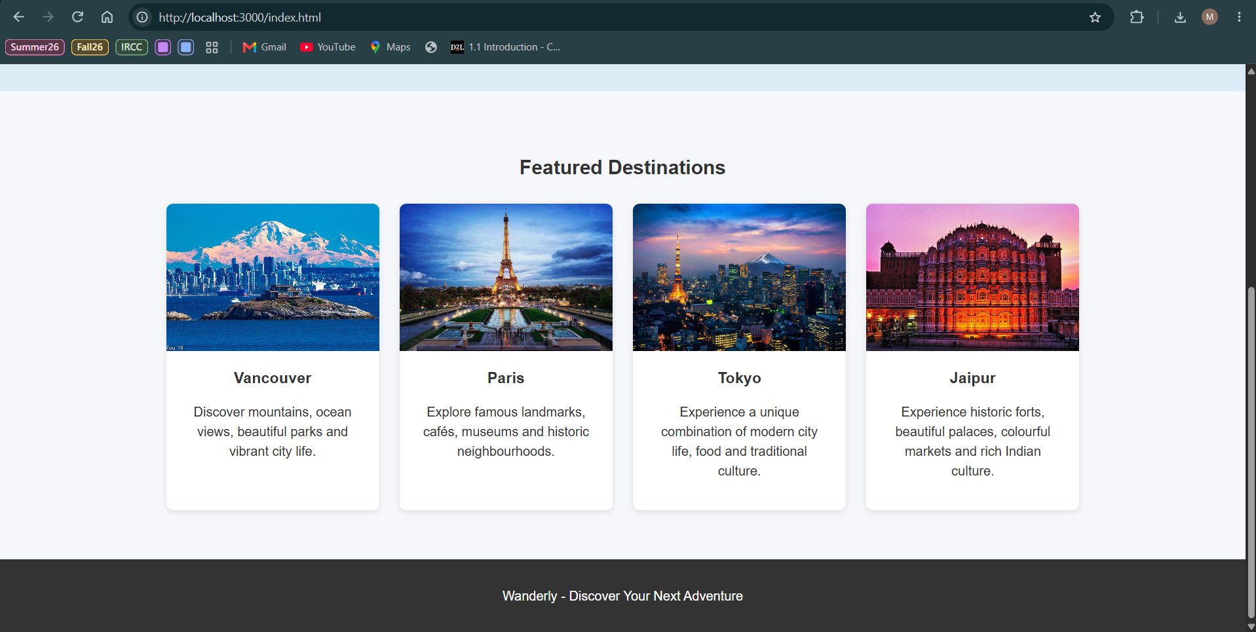
Figure 14. Featured destinations: Vancouver, Paris, Tokyo and Jaipur.
The Destinations page is public. AngularJS uses ng-model and filter to update the visible cards dynamically. Searching for India displays the matching Jaipur destination.
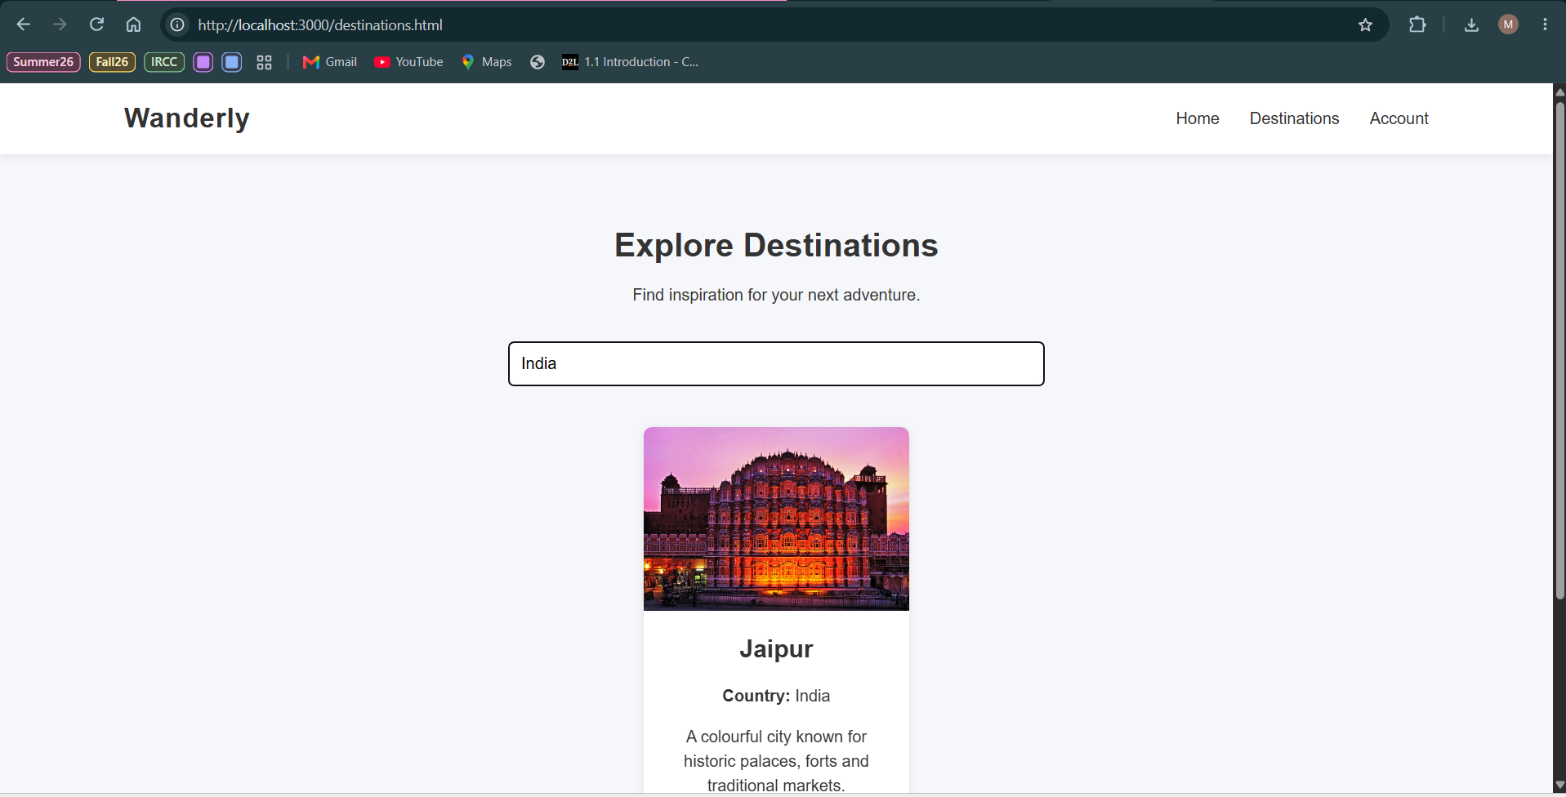
Figure 15. Dynamic destination search displaying Jaipur for the search term India.
The Account page integrates the authentication system into the final website. A successful login displays the stored profile information for David.
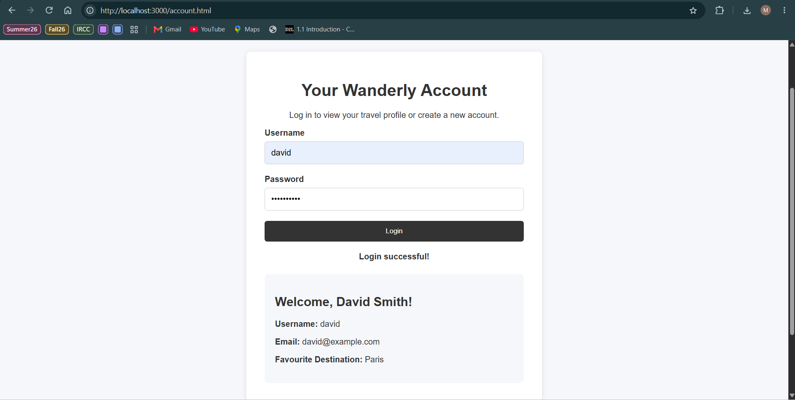
Figure 16. Final Wanderly Account page with an authenticated user profile.

4.4 Feature Summary
Feature | Implementation
Home page | Public landing page with featured destinations
Destination browsing | Travel information available without login
Destination search | AngularJS ng-model, ng-repeat and filter
Account login | AngularJS sends credentials to Node.js
Authentication | Node.js checks credentials against MongoDB
Registration | New username/password records can be inserted into MongoDB
User profile | Stored profile information displays after login
Visual design | Shared navigation, images, cards and CSS styling

Part 5 – Problems and Difficulties

5.1 Incorrect __dirname Variable
One of the first problems I ran into was a ReferenceError because I typed the Node.js __dirname variable incorrectly. I fixed the spelling in server.js and restarted the server. After that, Express was able to load the website files correctly.

5.2 Receiving Login Data in Node.js
I also got an error when Node.js tried to read the password from the request body. I checked the AngularJS POST request and the Express setup and made sure express.json() was being used before the login route. After fixing the request handling, Node.js could receive both the username and password.

5.3 Connecting Node.js to MongoDB
Another challenge was connecting the Node.js server to MongoDB. I installed the mongodb package, created a MongoClient for COMP4621Assignment3, and tested the connection before changing the login logic. I used the 'Connected to MongoDB' message in the command prompt to make sure this part was working.

5.4 Handling Different Login Situations
Another part I had some trouble with was getting the login to behave differently depending on what the user entered. I needed a correct username and password to log in, a wrong password to show an error, and a new username to show the Create Account option. I tested each case separately, which made it easier to see whether the problem was with MongoDB or my login conditions.

5.5 Integrating the Prototype into the Final Website
The first version of the project was mainly a plain login page for testing. For Part 4, I moved the login into an Account page and added separate Home and Destinations pages. I used the same navigation and stylesheet on the pages, then tested the login and registration again to make sure the changes had not broken anything.

Conclusion
Overall, this assignment helped me understand how MongoDB, Node.js and AngularJS can work together in one website. I started by creating and testing the database, then connected the AngularJS login page to Node.js, added the MongoDB login and registration functionality, and finally used everything together in the Wanderly website.
The main thing I learned from this assignment was how the client, server and database communicate with each other. Testing each part separately also made it easier to find and fix problems before putting the whole website together.

