The Open Source Audit
A Capstone Project for OSS NGMC Course
Course: Open Source Software | Unit Coverage: 1–5 | Max Marks: 100

Chosen Software: VLC Media Player

Student Name | Registration Number
Manvi | 24BAI10510
Slot | Date of Submission
A24 | 31 March 2026

Your choice | Write your chosen software here before submission: VLC Media Player

1. Introduction

The basis of contemporary computer systems is now open source software. Open-source principles are used in the development of many modern tools, platforms, and technologies. These systems are created cooperatively by a global community of developers rather than being under the control of a single organization.
Transparency, freedom, and cooperation are the cornerstones of the open source concept. The software can be studied, altered, and distributed by users in addition to being used.
VLC Media Player is a free and open-source multimedia player that I have selected for this project in order to examine its history, philosophy, licence, ecosystem, and real-world application on Linux systems. VLC is widely used by individuals, organisations, and developers across every major platform and operating system.

Part A — Origin and Philosophy (Units 1 & 2)

A1. The Problem This Software Was Created to Solve

1996, students at École Centrale Paris wanted to stream video across their campus. Existing commercial media players like RealPlayer and Windows Media Player were proprietary, limited in formats, and legally restrictive.
VLC (VideoLAN Client) was created to solve these problems:
- No free media player could handle all formats.
- Proprietary codecs made playback expensive and legally complex.
- No adaptable streaming solution was available.
- Users were dependent on corporate support for formats and platforms.
VLC included its own codecs, ran on any platform, and was released as open source under the GNU GPL. This allowed anyone to use, study, modify, and distribute it, sparking global community contributions.

A2. The Licence — What It Actually Says

VLC is released under the GNU General Public License v2 (GPL v2), with core libraries under LGPL v2.1. The GPL is not just a 'free to use' notice — it’s a legal framework that protects user freedoms.
What are the four freedoms of free software? Does VLC's licence grant all four?

- Freedom 0 — The freedom to run the program for any purpose.
- Freedom 1 — The freedom to study how the program works and access the source code.
- Freedom 2 — The freedom to redistribute copies.
- Freedom 3 — The freedom to distribute modified versions to others.
VLC grants all four freedoms. Its full source code is publicly available on VideoLAN's own GitLab and on GitHub. Any user can download it, read it, modify it, and distribute their modified version — provided they comply with the GPL's conditions. In my opinion, this is one of the main reasons why VLC has remained so trusted for over two decades: anyone can verify what the software actually does.

Can a company take VLC, modify it, and sell it without sharing their changes?

No. GPL’s copyleft clause requires that any distributed modifications remain under GPL. Unlike permissive licences like MIT, the chain of freedom stays unbroken.

What is the difference between GPL and MIT licensing? Which would you choose?

GPL Licence is a copyleft (restrictive) licence. If someone modifies the software and distributes it, they must also share the modified source code. The software always stays in open-source form.

MIT Licence is a permissive licence. It allows people to modify and use the software even in private or commercial projects without sharing changes.

If I were building something I wanted to keep permanently free and community-owned — something I did not want any corporation to enclose and sell — I would choose the GPL. For a utility library I wanted widely adopted with minimal friction, MIT would be more practical. The choice is as much a philosophical statement as a legal one.

'Free as in free beer' vs 'free as in freedom' — what is the difference?

- Free beer = zero cost
- Freedom = right to read, modify, and redistribute
VLC is free both ways. GPL ensures this freedom is legally permanent, while ‘free beer’ alone could be withdrawn at any time.

A3. The Ethics of Open Source

Open source is not only about making software available at zero cost. It is also about the idea of sharing knowledge and enabling collaboration among users and developers in effective and meaningful ways. VLC is a strong example of this, having been developed and improved by a global community since 1996.

Should all software be open source? Arguments for and against.

On one hand, open-source software like VLC allows anyone to learn from it, modify it, and use it freely. This makes technology more accessible and encourages learning for everyone. For infrastructure tools — operating systems, media players, web servers — openness benefits the entire ecosystem.
On the other hand, not all software can or should be open source. Some companies invest enormous resources developing specialist software and may need to keep it private to protect their business model. Certain systems related to national security or medical devices may also require controlled access for safety reasons.
So I feel that while open source is genuinely beneficial and should be the default for tools that serve the public good, it may not be universally suitable for every category of software.

Is it ethical for a company to build a profitable product on free community labour?

This is a genuinely debatable question. Many companies use VLC and other open-source tools in their products and services. It can be considered ethical when those companies also improve the software, report bugs, fund development, or support the community. However, if a company uses open-source software one-sidedly — extracting value without contributing anything back — that is not fair to the developers who volunteered their time.
In my opinion, companies that benefit commercially from open-source software have a moral obligation to contribute back — whether through code, documentation, financial sponsorship, or community support. VideoLAN itself is structured as a non-profit precisely to avoid this tension: it is not extracting value for shareholders; it is building and maintaining a public good.

'Standing on the shoulders of giants' — does open source enable or undermine innovation?

In my opinion, open source enables innovation rather than undermining it. VLC itself has grown because of contributions from developers worldwide. It allows people to experiment, learn, and build new things quickly by providing a reliable foundation. Rather than everyone reinventing the same codec wheel, the community builds upward together.
While some argue that open source reduces commercial incentive for original research, the evidence from VLC, Linux, Git, and countless other projects suggests the opposite: open-source infrastructure consistently produces the most widely adopted, most durable, and most secure tools in the software industry.

Part B — Linux Footprint (Unit 2)

In this section, I explored how VLC works within a Linux environment. VLC is one of the most commonly available multimedia applications on Linux, available in the official repositories of every major distribution. I installed VLC on my system and observed how it is managed, where its files are stored, and how it interacts with the operating system.

Installation Method

VLC is available via APT (Advanced Package Tool) on Debian and Ubuntu-based systems. There is no need to compile it manually in most cases:
sudo apt update && sudo apt install vlc
On Fedora/RHEL: sudo dnf install vlc. It’s also available as a Snap or Flatpak. VLC ships with its own codecs — no separate installation needed.

Key Directories

After installation, VLC files are stored across the following directories in the Linux system:
- /usr/bin/vlc — main binary
- /usr/lib/vlc/ — libraries, plugins, codecs
- /usr/share/vlc/ — skins, icons, scripts
- /usr/share/doc/vlc/ — documentation
- ~/.config/vlc/ — per-user settings, playlists
- ~/.local/share/vlc/ — user cache, bookmarks
These directories help organise the software and separate executable files, libraries, and user configurations. VLC writes no global configuration to /etc/ — all per-user settings live within the home directory tree.

User and Group — Why It Matters for Security

VLC runs under the current logged-in user by default. It does not require a special system user or elevated privileges for normal playback. This is important for security because:
- It limits access based on user permissions and prevents unauthorised system-level changes.
- A vulnerability in VLC's codec handling cannot affect files belonging to other users.
- If exploited, an attacker gains only the permissions of the current user — not root access.
When deployed headlessly as a streaming server, VLC should be run under a dedicated unprivileged service account (not root) to further limit the blast radius of any potential vulnerability. In my opinion, this makes VLC safer and more responsible than applications that request elevated privileges unnecessarily.

Service Management

VLC is primarily an interactive desktop application and does not install as a background service by default. However, VLC can be run headlessly as a streaming server and managed using systemd with a custom unit file. Commands would follow the standard pattern:
- sudo systemctl start vlc
- sudo systemctl stop vlc
- sudo systemctl restart vlc
- sudo systemctl enable vlc (to start at boot)

Update Model

VLC is updated through the Linux package manager and the VideoLAN open-source community. Users can update using:
- sudo apt update && sudo apt upgrade vlc
The open-source community regularly releases updates, bug fixes, and security patches. Because VLC's source code is publicly visible, independent security researchers can audit it and report vulnerabilities directly. Security patches are typically merged into the VideoLAN git repository and pushed to distribution repositories within days of a CVE disclosure. In my opinion, this update system is reliable because it ensures that users receive secure, updated versions without much effort — and because the transparency of the process means fixes happen faster than in closed systems.

Part C — The FOSS Ecosystem (Units 3 & 4)

No open-source software works alone. It is always connected with other tools, libraries, and communities. VLC is a great example of this — it has a large ecosystem that depends on, enables, and interacts with a wide range of other open-source projects.

What Other Open-Source Tools Does VLC Depend On?

VLC depends on several open-source libraries and system-level components to function properly:
- FFmpeg / libavcodec — the most widely used open-source multimedia codec library, providing H.264, H.265, VP9, and AV1 decoding.
- libvlccore — VLC's own internal media framework into which all plugin modules connect.
- libass — an open-source library for rendering Advanced SubStation Alpha subtitles.
- Qt (LGPL) — the cross-platform GUI framework that enables the same interface on Windows, macOS, and Linux.
- GCC / Clang — open-source compiler toolchains used to build VLC on all platforms.
- Git — VLC's codebase is version-controlled using Git, hosted on VideoLAN's own GitLab instance.
These dependencies help VLC run efficiently and interact with the operating system. A vulnerability in FFmpeg, for example, is also a vulnerability in VLC — the open-source ecosystem is deeply interconnected, with shared benefits and shared responsibilities.

What Has VLC Enabled or Inspired?

VLC's libvlc API and open-source architecture have enabled a wide range of downstream projects and tools:
- Kodi (XBMC) — shares codec infrastructure. VLC for Android TV, tvOS,
- Chrome OS — community-ported versions.
- Academic and research tools — built on libvlc.
- Reference for developers — learning multimedia processing.
VLC has also inspired a culture of format-agnostic media handling. Before VLC, the idea that a single application could play any file without codec installation was not the norm. VLC made it the expectation.

Where Does VLC Fit in the Stack?

VLC sits above the OS layer (Linux kernel, systemd) and interacts with drivers (ALSA, V4L2). It can act as both a client and server for streaming. It integrates well with:
- Linux — OS layer
- Apache / Nginx — streaming relays
- MySQL / PostgreSQL — media databases

Community and Governance

VLC has a very large and active community. It is maintained by the VideoLAN project — a non-profit association incorporated under French law. Governance is exercised by a board elected from active contributors. There is no corporate parent that can reorient the project for commercial reasons.
- Code contributions are managed through VideoLAN's GitLab (code.videolan.org).
- Developer mailing list: vlc-devel@videolan.org
- User support: vlc-users@videolan.org and community forums at forum.videolan.org
- Real-time developer discussion on IRC/Matrix: #videolan on Libera.Chat
- Annual VideoLAN Dev Days (VDD) conference held in Europe
- Interface translations in over 60 languages coordinated through Transifex
I observed that the community plays a very important role in improving VLC, fixing bugs, and adding new features. In my opinion, this strong community support — built on a non-profit, contributor-governed model — is one of the biggest reasons for VLC's longevity and continued relevance after 25 years.

Part D — Open Source vs Proprietary (Critical Analysis)

Dimension | Open Source (VLC) | Proprietary Alternative (Windows Media Player)
Cost | Free to use and download — no licence fee of any kind. | Bundled with Windows; tied to a paid OS. Advanced features require paid subscriptions.
Security | Source code is open; anyone can review and audit it. | Source code is closed; only Microsoft can access and audit it.
Support and reliability | Community support via forums, GitHub, and documentation. Frequent patch releases. | Official company support and documentation, but WMP has received no major updates since Windows 7.
Freedom to modify | Users can modify and distribute freely under GPL. | Cannot modify source code. No redistribution permitted.
Community vs corporate control | Community-driven, governed by VideoLAN non-profit. | Controlled entirely by Microsoft (MathWorks for MATLAB).
Your overall verdict | VLC is free, flexible, cross-platform, and openly auditable — ideal for most users. | Proprietary players offer official support but are expensive, restricted, and less flexible.

I have personally used VLC. After comparing it with Windows Media Player, I found that both have their own use cases.
VLC is open source, which makes it accessible for students, developers, and general users alike. It is cross-platform, supports virtually every media format without additional codec installation, and is actively maintained by a global community. Many people use VLC for playback, streaming, format conversion, and media server applications.
Windows Media Player, on the other hand, provides a polished native experience on Windows and integrates tightly with the Microsoft ecosystem. However, it has received no meaningful updates since the Windows Vista era and is not available on non-Windows platforms.
I think VLC is the better choice for real-world deployment. It is easy to use, completely free, cross-platform, and its open-source nature means security vulnerabilities are caught and fixed faster than in closed systems.
The VLC community is very supportive. Developers all over the world contribute to it. Users can use VLC freely on any device, which is enormously useful for both individual users and organisations.
In the future, I would like to contribute to VLC by learning more about its codebase and reporting issues or suggesting improvements. This project helped me understand how important open source is and how deeply it shapes the software industry we all depend on.

4. Shell Script Tasks

Script 1 — System Identity Report (Units 1 & 2)

Write a script that introduces the Linux system like a welcome screen. It should display: the Linux distribution name and kernel version, the current logged-in user and their home directory, system uptime and current date/time, and a message stating which open-source licence covers the OS.
Concepts used: variables, echo, command substitution ($()), basic output formatting.
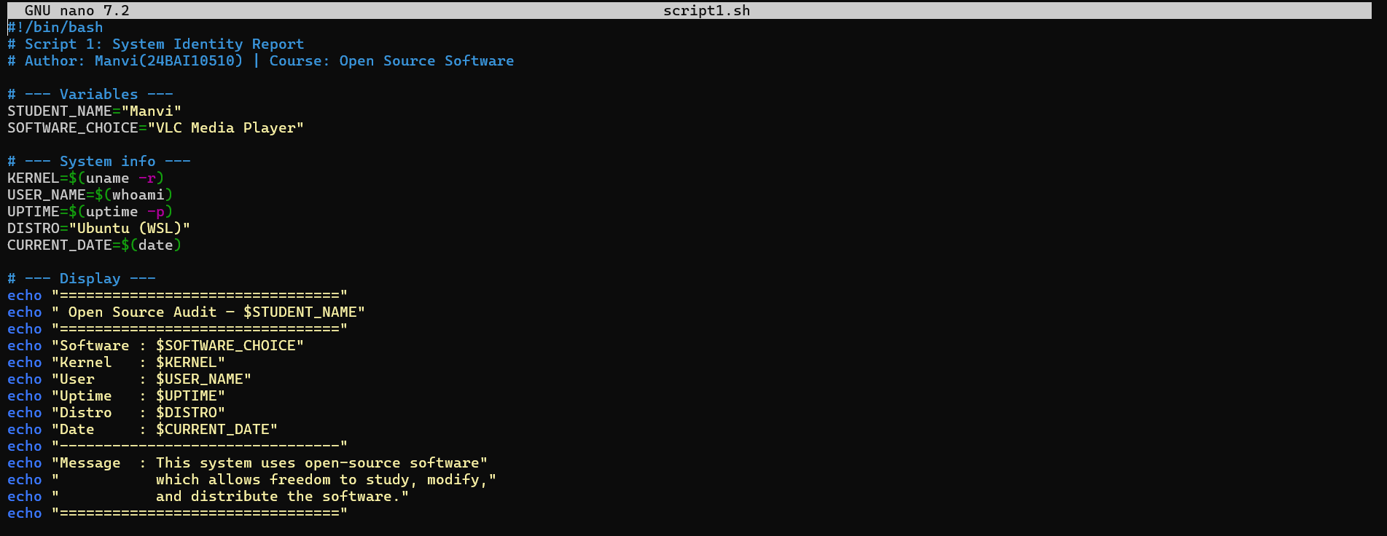
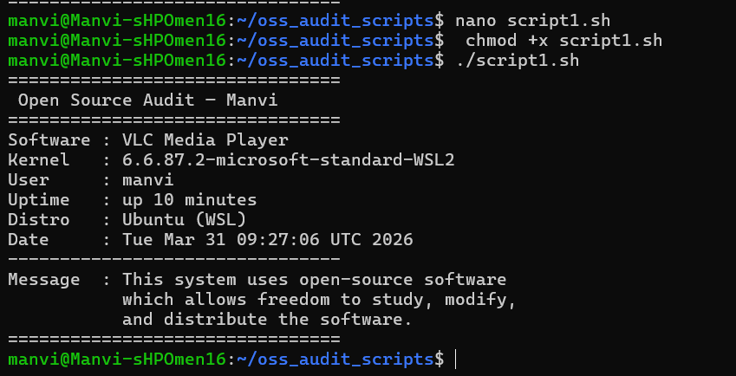
This script displays basic information about my Linux system in a simple and organised way. It shows details like the kernel version, the current user, home directory, system uptime, and the current date and time. While writing and running this script, I understood how commands like uname, whoami, and uptime can be used to fetch real system data. I also learned how variables and command substitution help in making the script more dynamic and readable. Overall, this script gave me a clear idea of how shell scripting can be used to present system information in a user-friendly format.

Script 2 — FOSS Package Inspector (Unit 2)

Write a script that checks whether your chosen software is installed on the system, finds its version, and uses a case statement to print a short description of its purpose based on the package name.
Concepts used: if-then-else, case statement, dpkg -l or rpm -qi, pipe with grep.
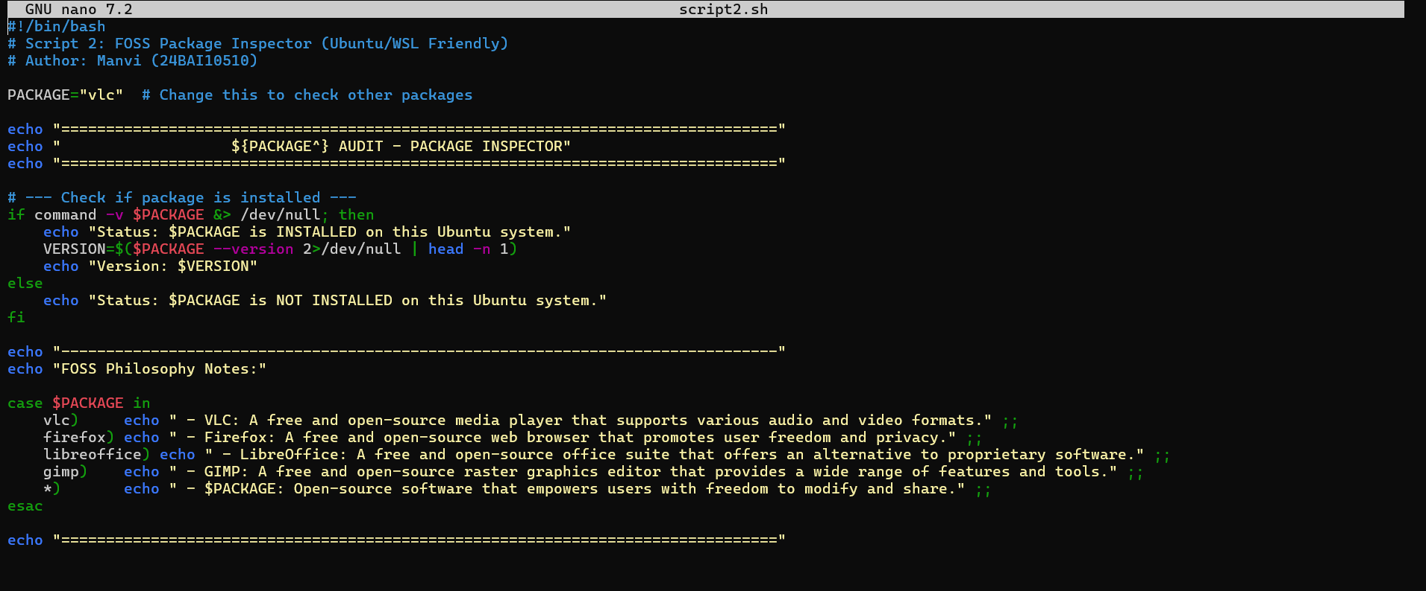
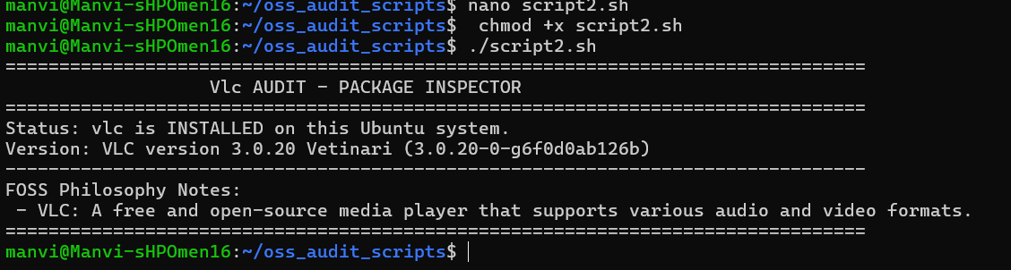

This script checks if VLC is installed on my system. When I ran it, it confirmed that VLC is already installed and showed its version details. If the software was not installed, it would display a message saying it is not available. I also used a case statement to give a brief description of VLC and several other FOSS packages. In the process, I learned how conditions work in shell scripting and how to check software details using dpkg and apt commands. This script helped me understand how to access system-level software information easily.

Script 3 — Disk and Permission Auditor (Unit 2)

Write a script that loops through a list of important system directories and reports how much space each uses, and the owner and permissions of the directory.
Concepts used: for loop, du, ls -ld, awk or cut to extract fields.
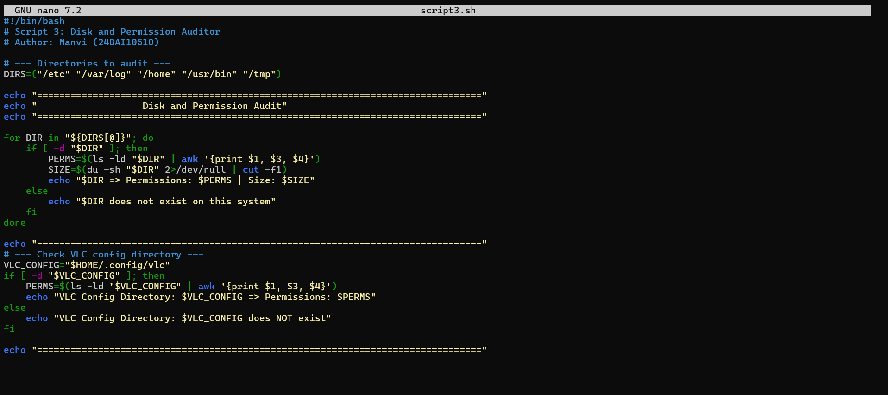
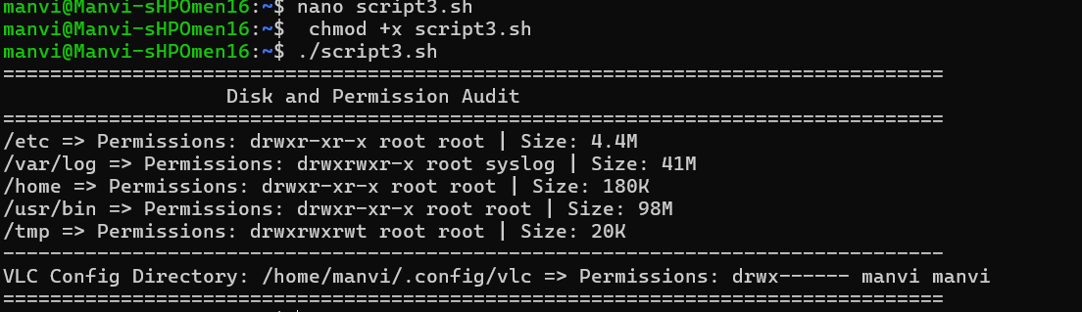
This output shows the details of important system directories on my Linux system. It displays the permissions, owner, group, and size of each directory using basic Linux commands. While running the script, I observed how different directories have different sizes and permissions. The script also checks the VLC configuration directory and confirms whether it exists along with its permissions. In my opinion, this script helped me understand how file system information can be accessed and analysed using shell scripting in a simple and practical way.

Script 4 — Log File Analyzer (Units 2 & 5)

Write a script that reads a log file line by line, counts how many lines contain a keyword (like ERROR or WARNING), and prints a summary.
Concepts used: while read loop, if-then, counter variables, command-line arguments ($1).
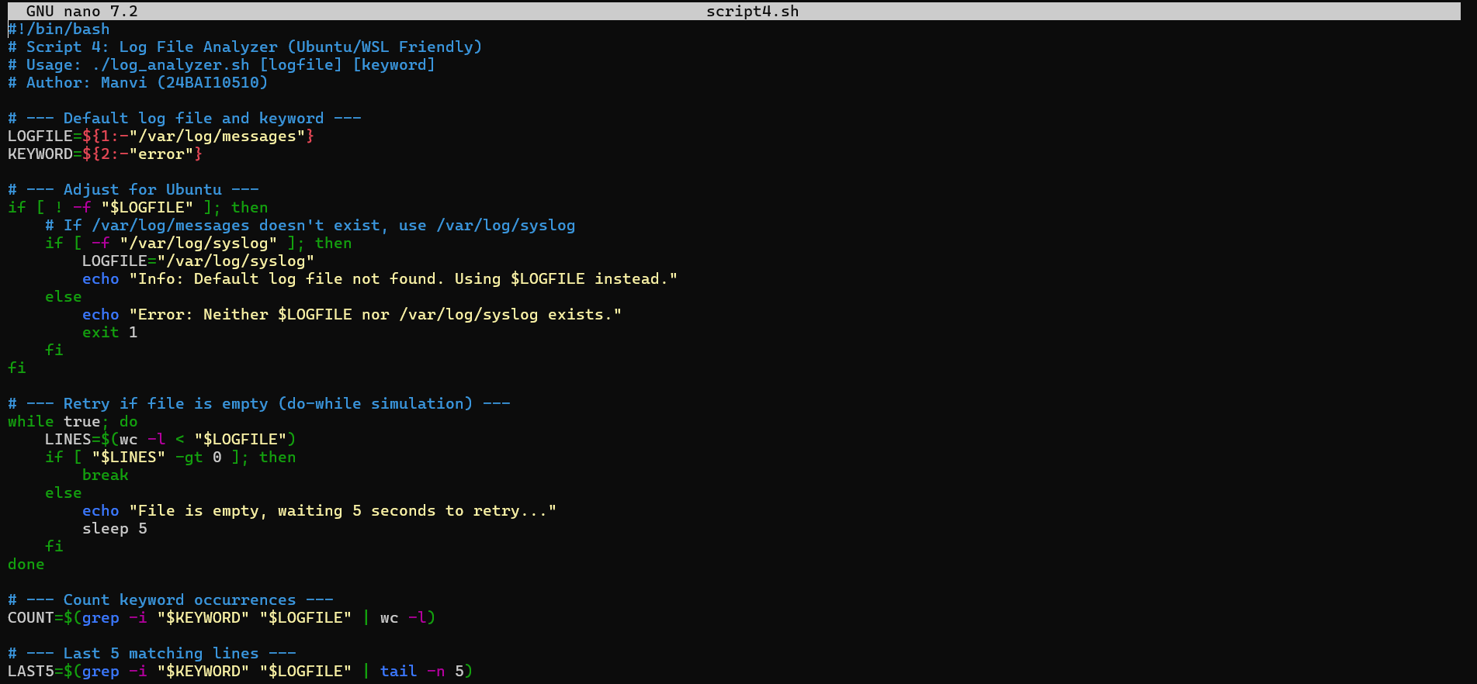
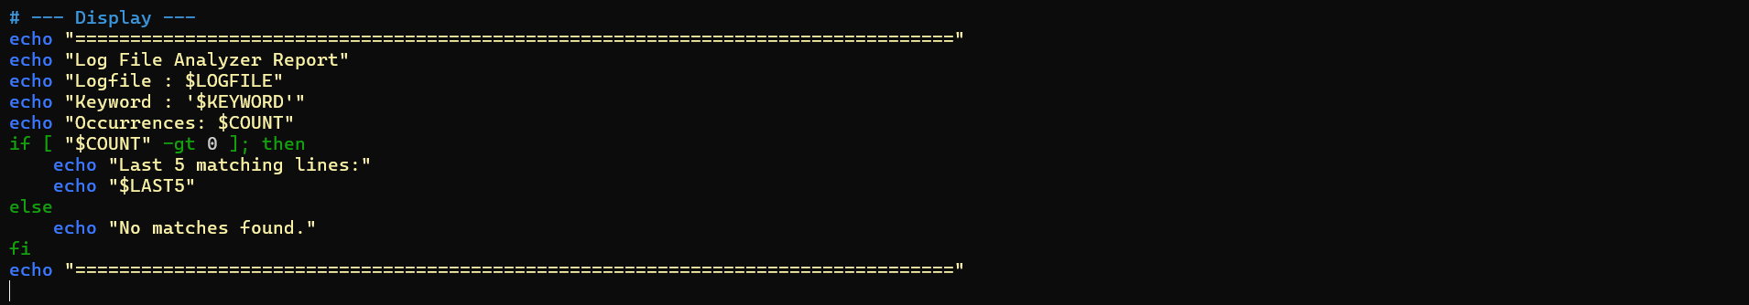

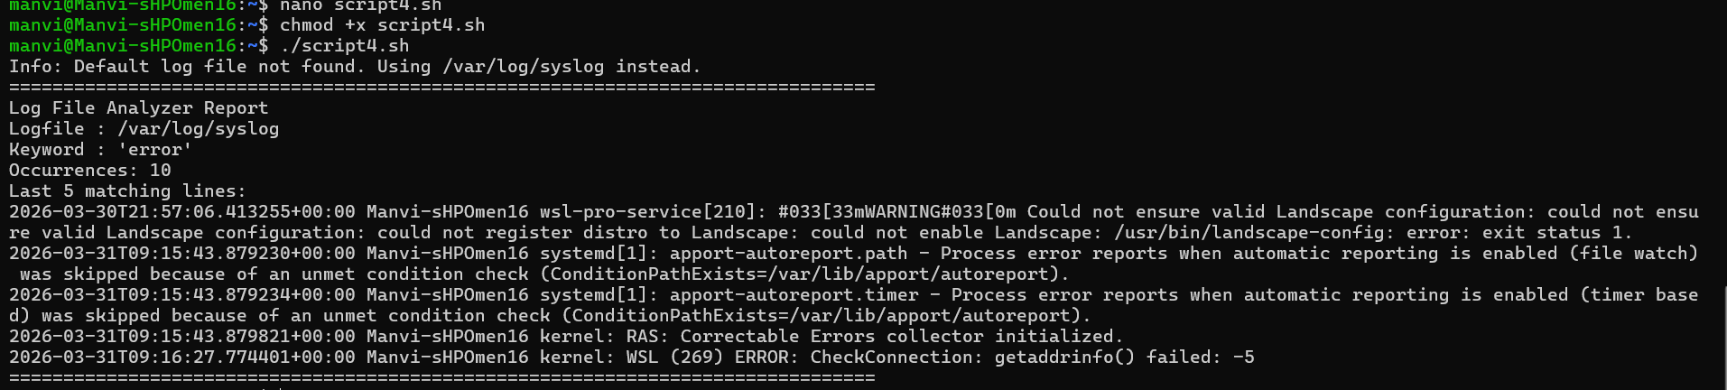

This script counts the occurrences of a particular keyword (such as 'error') in a log file. The script accurately counted the occurrences and displayed the final few matching lines. I learned how to read a file line by line using a while loop and how conditions help in checking each line individually. It also taught me how to use basic shell commands to analyse log files. All things considered, this script helped me understand how errors can be monitored and tracked in a Linux system.

Script 5 — The Open Source Manifesto Generator (Unit 5)

Write a script that generates a personalised open-source philosophy statement by asking the user three questions interactively, then composing a short paragraph using their answers and saving it to a .txt file.
Concepts used: read for user input, string concatenation, writing to a file with >, date command, aliases concept demonstrated via a comment.
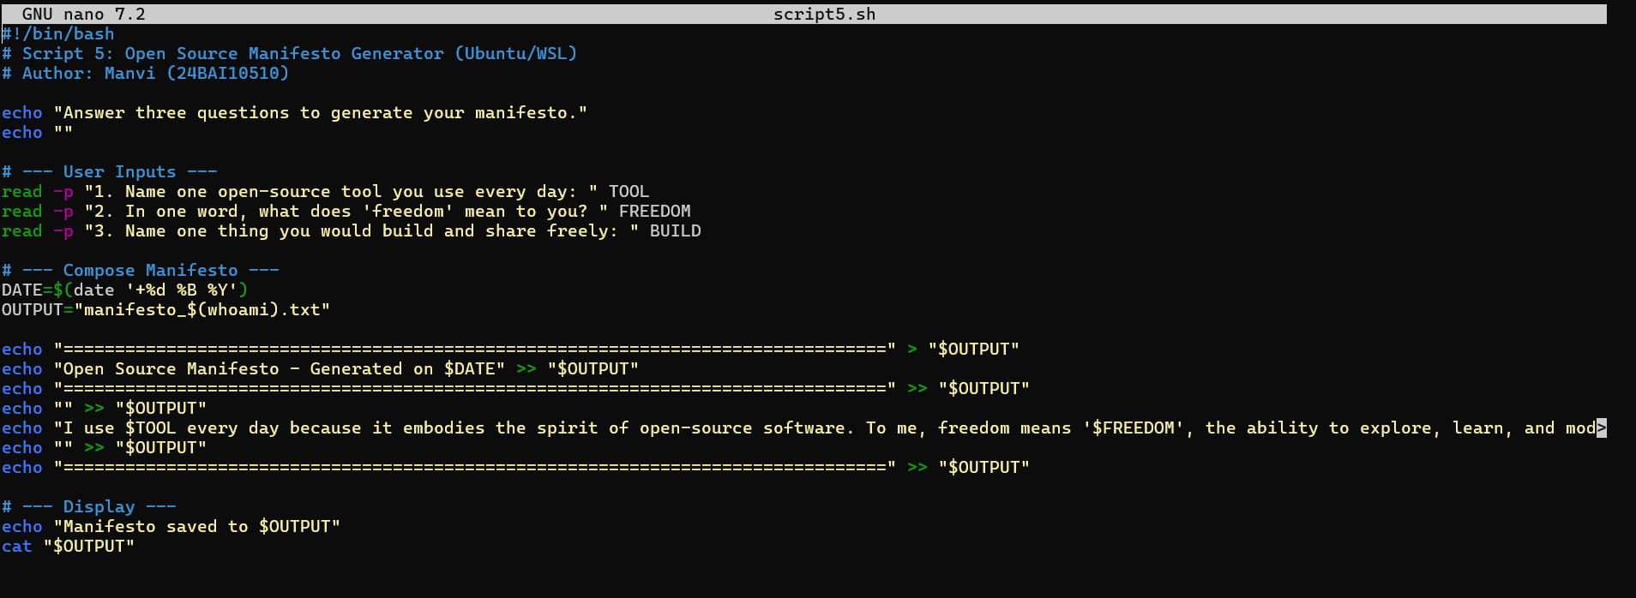

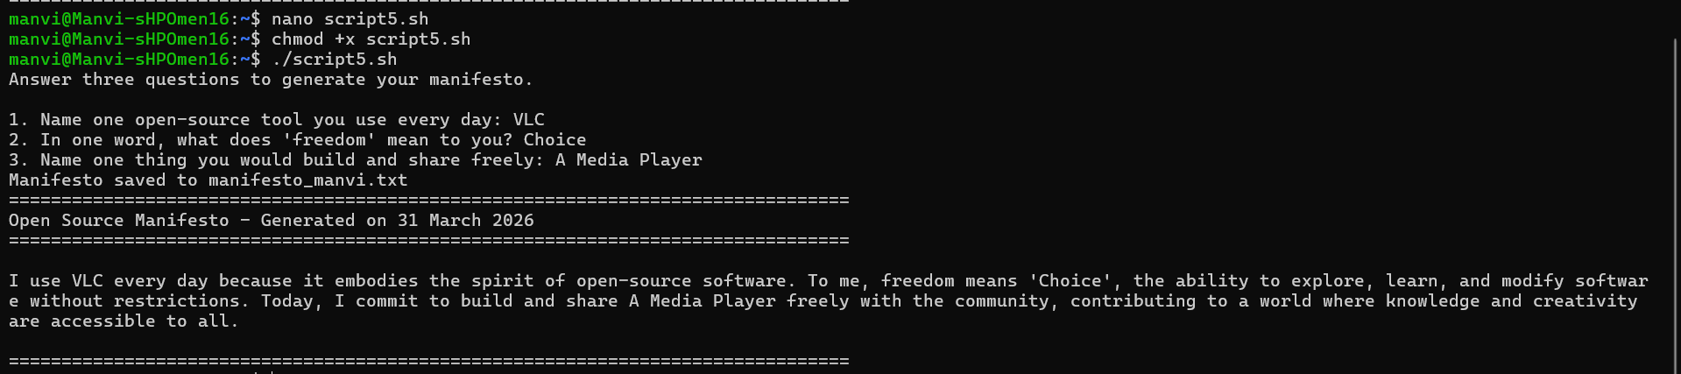
This script creates a simple open-source manifesto by asking three questions to the user. It took my inputs and produced a brief personalised paragraph, which was also saved to a text file. While working on this script, I learned how to use the read command to capture user input and how to combine various inputs to create a useful output. I also learned how to write data into a file using the > redirection operator. This script was the most enjoyable to write and demonstrated how shell scripting can be used to produce customised, user-driven content.
Conclusion

This project has given me a thorough understanding of open-source software, both in theory and in practice. By studying VLC Media Player as my case study, I explored how it was created, what licence governs it, how it operates on a Linux system, what ecosystem surrounds it, and how it compares to proprietary alternatives.
VLC's story — from students who needed to stream video across a university network to a piece of software downloaded over five billion times — shows what open-source software can achieve when the goal is usefulness rather than profit. The GPL licence ensures that this freedom is permanent: no company can take VLC, enclose it, and take that freedom away.
The shell scripts in this project gave me practical experience with Linux commands and shell scripting concepts that I will continue to use in my career. Understanding how open-source tools are installed, where they live on a filesystem, and how they interact with the operating system is not just academic knowledge — it is foundational to real-world software development.
Overall, this project helped me understand how important open source is and how deeply it shapes the software industry. The community-driven model of development, the philosophy of sharing knowledge freely, and the practical power of tools like VLC are all things I will carry forward as I grow as a developer.

Manvi | 24BAI10510 | Open Source Software | VIT

