**GIT ASSIGNMENTS**

**Question 3**

**Step 1:** Create a feature branch.

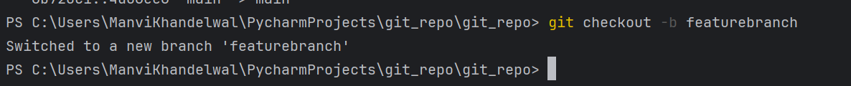

**Step 2:** Switch to the new branch.

**Step 3:** open the file and make some changes to it.

**Step 4:** Add and commit the changes to the new branch.

**Step 5:** Push the changes to the new feature branch.

**Step 6**: Create a pull request.

**Step 6**: As another user in the master branch make some changes to the same file.

**Step 7:** Add and commit the changes to the master branch.

**Step 8**: Push the changes to the master branch.

Note: There will be a conflict in the pull request, how do we resolve it??



