A PROJECT REPORT
ON
CAMPUSSAATHI: Academic Assignment Management System
Your Campus. Connected. Simplified.
Submitted in partial fulfillment of the requirement for the award of
Degree of
Bachelor of Technology in Artificial Intelligence & Data Science
Submitted to:
Rajasthan Technical University Kota (Raj.)


Submitted By:
Mausam (24EARAD096)
Manvi Asawa (24EARAD095)
Nikita (24EARAD112)
Nikita Rathore (24EARAD113)
Kusum (24EARAD088)
Session : 2026-27

Department of Artificial Intelligence & Data Science
ARYA COLLEGE OF ENGINEERING & I.T.
SP-42, RIICO INDUSTRIAL, KUKAS, JAIPUR



Department of Artificial Intelligence & Data Science

CERTIFICATE OF APPROVAL
The Project Report entitled “CampusSaathi – Academic Assignment Management System” submitted by “Mausam (24EARAD096), Manvi Asawa (24EARAD095), Nikita (24EARAD112), Nikita Rathore (24EARAD113), Kusum (24EARAD088)” has been examined by us and is hereby approved for carrying out the project leading to the award of degree “Bachelor of Technology in Artificial Intelligence & Data Science”. By this approval the undersigned does not necessarily endorse or approve any statement made, opinion expressed or conclusion drawn therein, but approve the pursuance of project only for the above mentioned purpose.

Mentor
Er. Mukesh Mishra

Department of Artificial Intelligence & Data Science

CERTIFICATE
This is to certify that the work embodied in this Project entitled “CampusSaathi – Academic Assignment Management System” being submitted by “Mausam (24EARAD096), Manvi Asawa (24EARAD095), Nikita (24EARAD112), Nikita Rathore (24EARAD113), Kusum (24EARAD088)” in partial fulfillment of the requirement for the award of “Bachelor of Technology in Artificial Intelligence & Data Science” to Rajasthan Technical University, Kota (Raj.) during the academic year 2026-27 is a record of bonafide piece of work, carried out by them under our supervision and guidance in the “Department of Artificial Intelligence & Data Science”, Arya College of Engineering & Information Technology, Jaipur.

Project Coordinator  Er. Ram Babu  Assistant Professor | HOD  Dr. Akhil Pandey  Professor

Department of Artificial Intelligence & Data Science

DECLARATION
We “Mausam, Manvi Asawa, Nikita, Nikita Rathore, Kusum”, students of Bachelor of Technology in Artificial Intelligence & Data Science, session 2026-27, Arya College of Engineering & Information Technology, Jaipur, hereby declare that the work presented in this Project entitled “CampusSaathi – Academic Assignment Management System” is the outcome of our own work, is bonafide and correct to the best of our knowledge and this work has been carried out taking care of Engineering Ethics. The work presented does not infringe any patented work and has not been submitted to any other University or anywhere else for the award of any degree or any professional diploma.

Mausam (24EARAD096)
Manvi Asawa (24EARAD095)
Nikita (24EARAD112)
Nikita Rathore (24EARAD113)
Kusum (24EARAD088)

Department of Artificial Intelligence & Data Science

ACKNOWLEDGEMENT
We, the undersigned members of the project group, wish to convey our profound gratitude and sincere appreciation to all individuals whose contributions facilitated the successful completion of this Project Based Learning (PBL) report, titled “CampusSaathi – Academic Assignment Management System.”
Our heartfelt thanks are extended to Prof.(Er) Ram Babu Buri, our esteemed project supervisor, for the insightful guidance, encouragement, and continuous support provided throughout the duration of this project.
We gratefully acknowledge the support provided by the faculty and staff of the Department of Artificial Intelligence & Data Science, Arya College of Engineering & Information Technology, Jaipur, for furnishing the resources and an academic environment essential for our learning and professional development.
We are further grateful to our friends and families for their steady encouragement and motivation. Finally, we express our appreciation for the collaboration and teamwork shown by every member of our project group:
Mausam (24EARAD096)
Manvi Asawa (24EARAD095)
Nikita (24EARAD112)
Nikita Rathore (24EARAD113)
Kusum (24EARAD088)

Department of Artificial Intelligence & Data Science

ABSTRACT
CampusSaathi (tagline: “Your Campus. Connected. Simplified.”) is a Java-based web application for academic assignment management. It provides a centralized platform on which teachers create assignments and optionally attach a PDF question paper, and students view the assignments relevant to their batch and open the associated question paper. The application is built with Java 21, Java Servlets (Jakarta Servlet API), JSP, JDBC and MySQL, is deployed on Apache Tomcat 11, and was developed using the Eclipse IDE.
The project addresses a practical problem: assignment details and question papers are often shared through separate channels, which makes them harder to organise and locate. CampusSaathi connects assignment creation, database storage, student-facing access, PDF document handling, authentication and existing marks-related functionality in a single application. Assignment information is stored in MySQL, while uploaded PDF documents are stored separately on the server file system under generated UUID-based filenames; the database stores only the generated filename. The PDF upload feature includes multipart form handling, a 10 MB size limit, PDF signature checking, and cleanup of the stored file if the database insertion fails. A dedicated servlet serves the PDFs and checks the user’s session and role, whether a teacher is authorized for the assignment, and whether a student’s batch matches the assignment’s batch.
This report describes the objective and scope, theoretical background, problem definition, requirements, planning, methodology, life cycle, data and process models, screen design, implementation structure, testing approach, operational manual, conclusions, future enhancements and references. The report deliberately distinguishes features that are part of the existing implementation from features whose end-to-end verification is still pending, and it does not describe CampusSaathi as a complete learning management system. Student submission of work, automatic grading, notifications and similar capabilities are not part of the current implementation and are listed only as future scope. Items that still need real evidence (screenshots, code listings, test results, names of supervising faculty) are highlighted in yellow so that they can be completed before submission.
Keywords: academic assignment management, Java Servlets, JSP, JDBC, MySQL, Apache Tomcat, role-based access control, session management, PDF upload, batch-based access.

Department of Artificial Intelligence & Data Science

TABLE OF CONTENTS
Chapter | Title
1 | Objective and Scope of the Project
2 | Theoretical Background
3 | Definition of the Problem
4 | System Analysis and User Requirements
5 | System Planning (PERT Chart and Timeline)
6 | Methodology Adopted and Hardware/Software Used
7 | Detailed Life Cycle of the Project
8 | ERD and DFD
9 | Processes Involved, Algorithms, Flowcharts and Database Diagram
10 | Input and Output Screen Design
11 | Code Sheet / Coding Evidence
12 | Testing
13 | User and Operational Manual
14 | Conclusions
15 | Future Enhancement
16 | References

1. OBJECTIVE AND SCOPE OF THE PROJECT

1.1 Project overview
CampusSaathi is a Java-based web application for academic assignment management. Its tagline is “Your Campus. Connected. Simplified.” The application gives teachers and students a centralized place to handle assignments: teachers create assignments and can attach a PDF question paper, while students see the assignments that belong to their batch and can open the question paper in the browser or download it. The application also contains authentication, role-based access checks, database integration and existing marks-related functionality.
The system is built on the Java web stack. Presentation is handled by JSP pages with HTML and CSS; request handling and business logic are implemented in Java Servlets that use the Jakarta Servlet API supported by Apache Tomcat 11; and persistence is handled through JDBC against a MySQL database. Uploaded PDF documents are not stored inside the database. They are stored in a separate directory on the server, and the database keeps only the generated filename of each document.
CampusSaathi is a focused academic assignment management system. It is not presented in this report as a complete learning management system, and no feature is described as implemented unless it is part of the existing application.

1.2 Primary objectives
- Provide a centralized application in which teachers can create and manage assignments.
- Allow teachers to attach an optional PDF question paper to an assignment while creating it.
- Allow students to view only the assignments relevant to their batch, together with status and marks information.
- Allow students to view or download the question paper of an assignment in PDF form.
- Provide teacher and student login with session-based authentication and role checks, so that each role has its own experience.
- Restrict access to uploaded PDF documents according to the logged-in user’s role and relationship to the assignment.
- Store assignment information in MySQL through JDBC and keep uploaded documents separately on the server.
- Document, organise and present the project professionally, including a GitHub repository and a team demonstration.

1.3 Scope of the current project
The scope of the current project covers two user roles. The Teacher role can create assignments by entering an assignment name, subject, student batch, description and maximum marks, can optionally upload a PDF question paper, and can use the existing marks-related functionality. The Student role can log in, view the assignments relevant to the student’s batch, see availability, status and marks information, and view or download an attached PDF question paper. Both roles are separated by session-based authentication and role checks.

1.4 In-scope technical responsibilities
- JSP-based user interface for login, teacher pages and the student assignment portal.
- Servlet-based request handling in the package com.campussaathi.controller.
- JDBC-based reading and writing of assignment records in MySQL.
- Session handling and role checks for protected functionality.
- Multipart PDF upload with size limit, PDF signature checking, UUID-based naming and cleanup on database failure.
- A PDF-serving servlet mapped to /assignment-pdf with access checks.
- Setup, deployment, testing and documentation of the application.

1.5 Features that are not claimed
To keep this report accurate, the following capabilities are not claimed as implemented in CampusSaathi: online assignment submission by students, automatic grading, e-mail or SMS notifications, AI-based evaluation, attendance management, timetable management, payment processing, mobile applications, cloud-based PDF storage, production-grade security and automated testing infrastructure. Some of these may be considered as future enhancements (Chapter 15), but they are not described as completed functionality.

1.6 Expected project outcomes
The expected outcome is a working Java web application that demonstrates assignment creation, database storage, batch-based assignment display, PDF question paper handling, authentication and role-based access, together with documentation that allows another developer to set up and run the project. The technical outcome also includes a GitHub repository, a database setup script, screenshots, a team demonstration video and this report. Final acceptance depends on demonstrated behaviour and review by the project mentor.

1.7 Status labels used in this report
Because some features still need end-to-end verification, the following labels are used to avoid over-claiming.
Label | Definition
Confirmed | Supported by project evidence such as a documented schema, a test result or a working demonstration.
Implemented – verification pending | Code exists in the application, but a complete successful test has not yet been recorded in this report.
Partial | Some parts exist, but the full workflow is incomplete.
Planned / Future scope | Discussed as an enhancement, but not part of the current implementation.
Unknown | Available project information does not establish the status.

Feature | Current status
Teacher and student login with sessions | Implemented – verification pending
Role checks for protected functionality | Implemented – verification pending
Assignment creation (name, subject, batch, description, maximum marks) | Implemented – verification pending
Optional PDF upload (10 MB limit, signature check, UUID filename, cleanup) | Implemented – end-to-end testing pending
Student assignment portal (batch-based display) | Implemented – verification pending
View PDF / Download PDF options | Implemented – verification pending
PDF access control (session, role, ownership, batch match) | Implemented – must be tested before any security claim
MySQL assignments table with pdf_filename column | Confirmed (schema documented in Chapter 8)
Existing marks-related functionality | Existing – exact behaviour to be documented after verification
Online submission, auto-grading, notifications, mobile app, cloud storage | Not implemented – future scope only

2. THEORETICAL BACKGROUND

2.1 Academic information systems
Academic information systems support the collection, organisation, retrieval and management of educational records and activities. In a college setting these records can include user identities, subjects, assessments, assignments, marks and announcements. Studies of learning management systems in higher education show that such systems are widely used to deliver course materials and coordinate coursework, and that their value depends on how well they fit the workflow of students and faculty [18]. A well-designed system makes the right information available to the right user while keeping responsibility for updates clear.
CampusSaathi applies this idea at a small scale. It concentrates on one workflow, the creation and delivery of assignments with optional question papers, and connects it with login, batch-based access and marks-related information.

2.2 Client–server and layered web architecture
A web application follows the client–server style: the browser acts as the client and sends requests, while the server validates the requests, applies application rules and accesses persistent data [11]. Layered designs separate presentation, application logic and data access so that each part can be understood and maintained independently. The Model–View–Controller (MVC) pattern is a common way of organising such code, with views that render pages, controllers that handle requests and a model that represents data [9], [10].
In CampusSaathi, JSP pages act as views, servlets in the package com.campussaathi.controller act as controllers, and JDBC code together with the MySQL database forms the data layer. The exact class-level separation must be described from the actual source code, not inferred from the pattern.

2.3 Java Servlets, JSP and the Jakarta namespace
A Java Servlet is a server-side component that receives an HTTP request, processes it and produces a response. JavaServer Pages (JSP) allow dynamic content to be embedded in HTML and are compiled to servlets by the container. Both run inside a servlet container such as Apache Tomcat [21], [22].
When Java EE moved to the Eclipse Foundation as Jakarta EE, the package names changed from javax.* to jakarta.*. Apache Tomcat 10 and later, including Tomcat 11 used in this project, implement the jakarta.servlet.* namespace. Code written with the older javax.servlet.* imports does not compile or run correctly on Tomcat 11 without migration. For this reason all servlet code in CampusSaathi must use jakarta.servlet.* imports.

2.4 JDBC and relational databases
The relational model organises data into tables made of rows and columns and uses keys and constraints to represent identity and relationships [1]. Database textbooks describe how entities, attributes, primary keys and constraints are used to design reliable schemas [2], [3]. MySQL is a widely used relational database management system [23].
Java Database Connectivity (JDBC) is the standard Java API for sending SQL statements to a relational database and reading the results [24]. In CampusSaathi, servlets use JDBC to insert and read assignment records. Using parameterised statements (PreparedStatement) is the recommended way to pass user input to SQL because it reduces the risk of SQL injection, one of the most common web application vulnerabilities [14]. Whether every query in the project uses parameterised statements must be confirmed by reviewing the source code.

2.5 Authentication, sessions and authorization
Authentication determines who a user is; authorization determines what that user is allowed to do. Role-Based Access Control (RBAC) assigns permissions to roles and users to roles [12]. In a Java web application the container provides an HttpSession object that keeps information about a logged-in user across requests, and servlets can check this session before serving protected content.
A role label shown in the user interface is not a security boundary. Server-side code must check the session and role for every protected request, and should follow the principle of least privilege [13]. For CampusSaathi, this means that student pages, teacher pages and the PDF-serving servlet must each verify the user’s session and role on the server. These checks are part of the implementation, but they are marked in this report as requiring testing before a security claim is made.

2.6 File upload handling and document storage
HTML forms upload files using the multipart/form-data encoding defined in RFC 7578 [19]. Servlets can read the uploaded file as a Part object. Safe handling of uploads normally includes limiting the file size, validating the file type by content rather than only by the filename extension, generating a server-side filename instead of trusting the client’s filename, and keeping uploaded files outside the publicly served web folder [14].
CampusSaathi follows this approach: the maximum upload size is 10 MB, the file’s PDF signature is checked, the stored filename is generated using a UUID (a universally unique identifier, see RFC 4122 [20]), and the document is kept in a separate directory on the server while the database stores only the generated filename. If the database insertion fails after the file has been saved, the saved file is removed.

2.7 Software engineering lifecycle and testing
A software lifecycle organises work from problem definition and requirements, through design and implementation, to testing, deployment and maintenance [4], [5], [7]. Requirements engineering reduces ambiguity by describing stakeholders, functional behaviour, constraints and acceptance criteria [6]. UML provides standard notations for use cases, classes, sequences and activities [8]. Testing checks whether the implementation satisfies the requirements and whether later changes introduce regressions [15], [16]. Usability principles help ensure that screens are understandable to their users [17].

3. DEFINITION OF THE PROBLEM

3.1 Problem context
Academic assignments and question papers can be difficult to organise when assignment information and documents are shared through separate channels. A teacher may announce an assignment in one place, send the question paper somewhere else and record marks in a third place. Students then need to find the correct information, and they may be uncertain whether they have the latest question paper or whether it belongs to their batch.

3.2 Problem statement
The project problem is to design and develop a Java-based web application in which teachers can create and manage assignments with optional PDF question papers, and students can access the assignments and question papers relevant to their batch, with authentication, role-based access checks and database storage that keep the information organised and appropriately restricted.

3.3 Limitations of the existing approach considered
- Assignment details and question papers are distributed across separate channels.
- Students may have difficulty identifying which assignments belong to their batch.
- Question papers shared through general-purpose channels may be accessible to people who should not have them.
- Assignment records and marks information are not linked in one place.
- Client-side restrictions alone are not enough; access to documents must be enforced on the server.

3.4 Proposed solution
CampusSaathi provides a centralized application that connects assignment creation, database storage, student-facing assignment access, PDF document handling, authentication and existing assessment-related functionality. Teachers create the assignment once; the information is stored in MySQL; the question paper is stored separately on the server; and students see the assignments that match their batch. A dedicated servlet controls access to the stored PDFs.

3.5 Success criteria
Criterion | Evidence needed
Login works for both roles | Successful and unsuccessful login tests for a teacher and a student account.
Role separation | Teacher pages are not usable by a student and the reverse; evidenced by test cases TC-05 and TC-06 (Chapter 12).
Assignment creation | A new assignment appears in the assignments table and on the correct student pages.
PDF upload | A valid PDF is stored under a UUID-based name and the same name is stored in pdf_filename.
Upload validation | Oversized and non-PDF files are rejected; no orphan file remains after a failed database insert.
Batch-based display | A student sees only the assignments of the student’s own batch.
PDF access control | Users who are not authorized cannot open a PDF through /assignment-pdf.
Documentation accuracy | The README, setup guide and this report match the verified behaviour of the application.

3.6 Constraints and assumptions
The project is developed as a college Project Based Learning (PBL) work by a team of five students with assigned module responsibilities. The technology stack is fixed: Java 21, Java Servlets, JSP, JDBC, MySQL, Apache Tomcat 11, HTML, CSS and the Eclipse IDE. The application uses the Jakarta Servlet API associated with Tomcat 11. The report assumes that the existing working application is documented, organised and verified, not rebuilt. It does not assume that all features have passed every test.

4. SYSTEM ANALYSIS AND USER REQUIREMENTS

4.1 Stakeholders
Stakeholder | Primary interest | Expected system interaction
Teacher | Create assignments, attach question papers and manage marks-related information. | Logs in, creates assignments, uploads an optional PDF and uses marks-related pages.
Student | Find assignments of the student’s batch and access question papers. | Logs in, views the assignment portal, opens or downloads PDFs.
Project team | Build, integrate, test and document the application. | Maintains code, database, documentation and the GitHub repository.
Project mentor / faculty | Evaluate scope, engineering process and deliverables. | Reviews the report, repository and demonstration.

4.2 Functional requirements
The requirements below describe the behaviour of the existing application. They must be matched with the actual screens and servlets during verification before being labelled as tested.

FR-01 Authentication
The application shall provide a login for teachers and students and shall create a session for a successfully authenticated user.

FR-02 Role-aware access
The application shall distinguish teacher and student users and shall check the session and role before allowing protected functionality.

FR-03 Assignment creation
A teacher shall be able to create an assignment by entering the assignment name, subject, student batch, description and maximum marks. The assignment name, subject and batch are mandatory fields in the database.

FR-04 Optional PDF question paper
A teacher shall be able to attach one PDF question paper while creating an assignment. The upload shall be limited to 10 MB, the file shall be checked for a PDF signature, the stored file shall receive a UUID-based name, and the generated name shall be saved in the database.

FR-05 Failure handling for uploads
If the database insertion fails after a PDF has been stored, the stored file shall be deleted.

FR-06 Student assignment portal
A student shall see the assignments relevant to the student’s batch, with assignment details and available status and marks information.

FR-07 View and download PDF
When an assignment has an attached question paper, the student portal shall offer a View PDF option and a Download PDF option.

FR-08 PDF access control
The PDF-serving servlet shall check the user’s session and role, shall check that a teacher is authorized for the assignment, and shall check that a student’s batch matches the assignment’s batch.

FR-09 Persistence
Assignment records shall be stored in MySQL through JDBC, while PDF documents are stored separately on the server.

FR-10 Marks-related functionality
The existing teacher-side assessment and marks-related functionality shall continue to work alongside the assignment features. Its detailed behaviour is to be documented after verification.

FR-11 Validation and error handling
Input shall be validated and errors shall be handled in a controlled way, without exposing internal details or secrets to the user.

4.3 Non-functional requirements
Category | Requirement
Security | Keep credentials out of source control; enforce role checks on the server; restrict document access; keep uploaded files outside the web-served folders.
Reliability | Avoid orphaned files and inconsistent records when an upload or a database operation fails.
Usability | Provide understandable labels, validation messages and clearly visible View/Download options.
Maintainability | Keep JSP views, servlets and database access logically separated and documented.
Portability | Document how to configure the database connection and the upload directory so that the project can run on another machine.
Compatibility | Use the Jakarta Servlet API (jakarta.servlet.*) compatible with Apache Tomcat 11 and Java 21.
Data integrity | Use NOT NULL constraints, defaults and a primary key in the assignments table.
Privacy | Use test data in screenshots and sample files; do not publish real student information.
Testability | Define repeatable manual test cases for login, role access, upload and PDF access.

4.4 Use cases
Use case | Actor | Expected outcome
Log in | Teacher / Student | An authenticated session is created and the user reaches the role-specific pages.
Create assignment | Teacher | A validated assignment record is stored in MySQL.
Attach PDF question paper | Teacher | A valid PDF is stored under a UUID name and linked to the assignment.
View assignments of own batch | Student | Only assignments of the student’s batch are listed.
View or download PDF | Student / Teacher | The PDF opens in the browser or downloads, if the user is authorized.
Manage marks-related information | Teacher | Existing marks-related functionality is available.
See status and marks | Student | Status and marks information is shown in the portal.

4.5 Traceability
Every requirement should be linked to its implementation and to at least one test case, so that a design diagram or feature list is not mistaken for proof of completion.
Requirement | Implementing component | Test cases (Chapter 12)
FR-01, FR-02 | Login and session/role-check code [class/file names to be confirmed] | TC-01 to TC-06
FR-03, FR-04, FR-05, FR-09 | TeacherAssignmentsServlet | TC-07 to TC-12
FR-06, FR-07 | StudentAssignmentsServlet and JSP view | TC-13, TC-14
FR-08 | AssignmentPdfServlet (/assignment-pdf) | TC-15 to TC-18
FR-10 | Existing marks-related code [to be confirmed] | TC-19, TC-20

5. SYSTEM PLANNING (PERT CHART AND TIMELINE)

5.1 Planning approach
The project was organised in stages: problem definition and scope, requirements, design, module implementation, integration, testing, and finally documentation, GitHub preparation and the demonstration video. The table below gives the planned schedule. The team should adjust the week numbers to match its own logbook before submission.
Phase | Milestone | Expected output
1 | Team formation, mentor selection, scope | Agreed project idea, module responsibilities, abstract.
2 | Requirements (SRS) | Functional and non-functional requirements, constraints.
3 | Design | Use cases, data design, ERD, DFD and flowcharts.
4 | Database and UI design | assignments schema, page layouts.
5–8 | Module implementation | Login/roles, assignment management, student portal, marks-related functionality, PDF upload.
9–10 | Integration and testing | Integrated workflow, defect list, regression checks.
11 | Documentation | README, setup guide, database script, screenshots, report.
12 | Final review | Presentation video, GitHub repository check, viva preparation.

5.2 Dependencies
Authentication and the database are foundational dependencies, because teacher pages, the student portal and the PDF servlet all rely on a valid session and on the assignments table. The PDF upload depends on the upload directory and the pdf_filename column. Student-side PDF access depends on the assignment records created by the teacher side. Integration should start before coding is finished, and testing needs stable test accounts and clean test data.

5.3 PERT representation
The dependency sequence is: A) scope and objectives → B) requirements → C) system design → D) database and UI design → E) module implementation → F) integration → G) testing and verification → H) report, slides and README → I) demonstration video and final viva. Some work overlaps, for example documentation can start while testing is in progress.
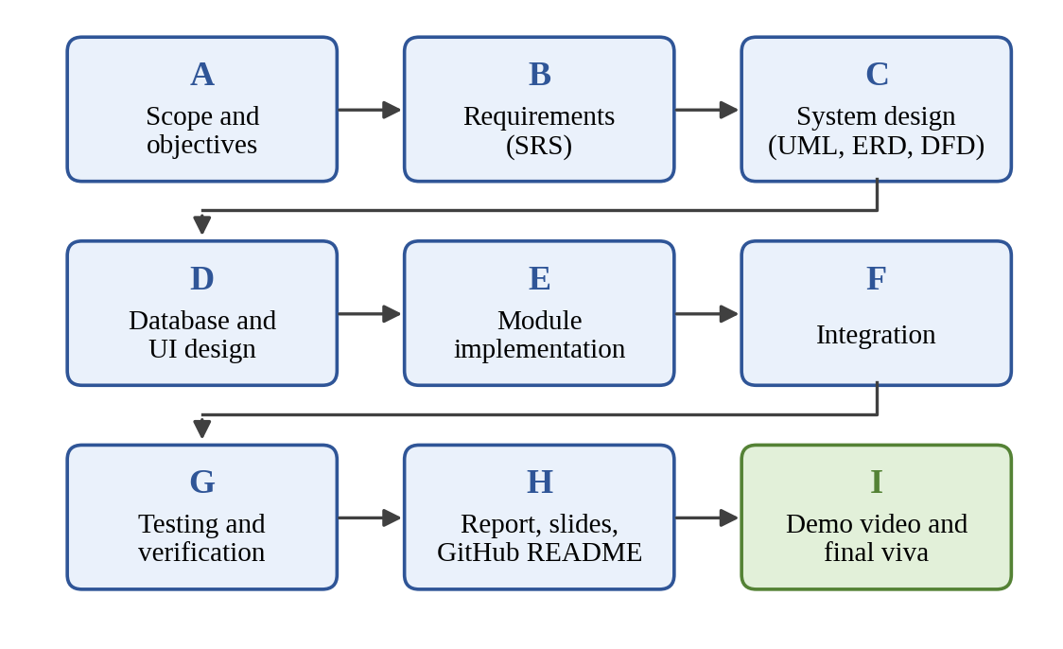
Figure 5.1: PERT-style dependency sequence of the project activities

5.4 Risk planning
Risk | Impact | Mitigation
Using javax.servlet.* instead of jakarta.servlet.* | Code fails to compile or run on Tomcat 11. | Use Jakarta imports consistently and check new code against Tomcat 11.
Damaging the working project while organising files | Loss of working code. | Keep the CampusSaathi_Backup folder; make a fresh backup before major changes.
Credentials published to GitHub | Unauthorized database access. | Keep passwords out of the repository; use placeholders and a .gitignore.
Machine-specific upload path | Uploads fail on another computer. | Document how to create and configure the upload directory.
Untested access control | Unauthorized document access remains undetected. | Run the authorization test cases before any security claim.
MySQL ‘No database selected’ error | Queries fail during demonstration. | Run SHOW DATABASES; and USE <database>; before queries.
Documentation drift | Report does not match the application. | Update the report from the verified build, screenshots and schema.

5.5 Team responsibilities
Member | Roll number | Module
Mausam | 24EARAD096 | Database and Data Management
Manvi Asawa | 24EARAD095 | Assignment Management
Nikita | 24EARAD112 | Authentication and Access Control
Nikita Rathore | 24EARAD113 | User Interface and Student Portal
Kusum | 24EARAD088 | Assessment, Integration and Testing

The module division above follows the presentation plan of the team. If the actual implementation or contribution history differs, the table must be corrected so that no individual contribution is overstated. The project coordinator is Er. Ram Babu (Assistant Professor) and the head of the department is Dr. Akhil Pandey (Professor).

6. METHODOLOGY ADOPTED AND HARDWARE/SOFTWARE USED

6.1 Methodology
The project follows a staged, iterative approach: define the problem and roles, capture requirements, create design artefacts, implement modules, integrate them, test the workflows and document the result. The staged plan gives milestones, while iterative testing lets defects be found during implementation instead of at the end. This approach is consistent with established software engineering lifecycle practices [4], [5], [7].

6.2 Requirements analysis
Requirements are collected by identifying each actor, the information the actor needs, the actions the actor may perform and the expected result. Each requirement is written so that it can be tested. For example, “login should work” is too broad; a testable version states the credentials used, the expected redirection and the pages that become accessible [6].

6.3 Design methodology
The design separates presentation, request handling and data access. JSP pages render the interface, servlets in com.campussaathi.controller process requests and enforce access checks, and JDBC code communicates with MySQL. Uploaded documents are kept outside the database. Data-flow diagrams, an entity description and flowcharts are used to describe the design [8]. Diagrams in this report show only components that are part of the existing application; components whose structure is not yet confirmed are drawn with dashed outlines.
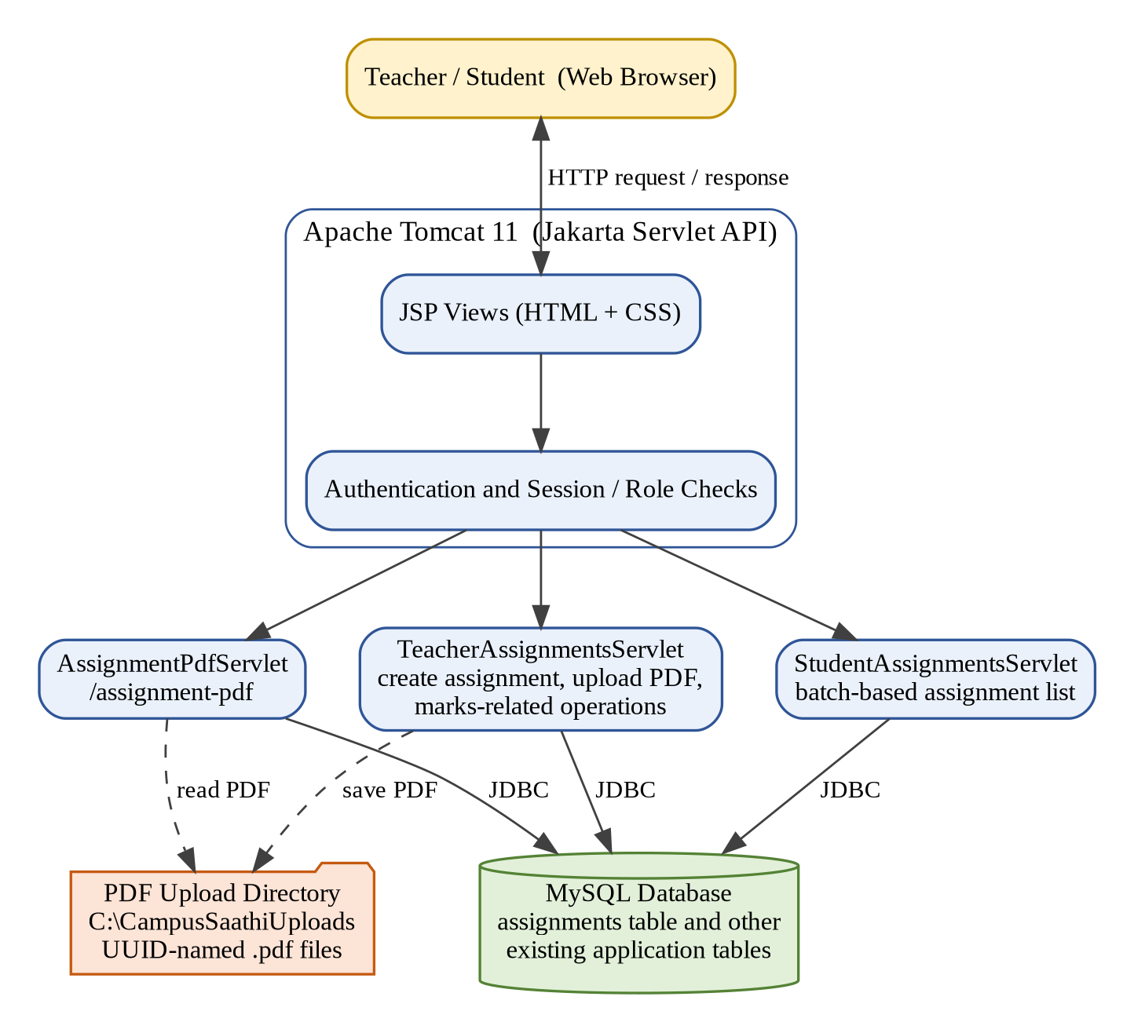
Figure 6.1: High-level architecture of CampusSaathi

6.4 Implementation methodology
The application is developed as a Java web project in the Eclipse IDE and run on Apache Tomcat 11. Features were added incrementally to an already working project. The PDF upload feature, for example, was integrated into the existing assignment creation flow by extending the teacher servlet, adding a pdf_filename column to the assignments table, adding a PDF-serving servlet and extending the student page. Existing working features are preserved, and the project is backed up before significant changes.

6.5 Hardware requirements
The minimum hardware requirements have not been benchmarked. A practical development and demonstration environment is a Windows computer that can run the Eclipse IDE, Java 21, Apache Tomcat 11, MySQL and a web browser at the same time. Final hardware recommendations should be based on actual testing, not on unsupported numerical specifications.

6.6 Software environment
Software / tool | Use in the project
Windows | Development and demonstration platform.
Java 21 | Programming language and runtime for servlets and JDBC code.
Java Servlets (Jakarta Servlet API) | Request handling, session checks, file upload and PDF serving.
JSP (JavaServer Pages) | Dynamic pages for login, teacher and student views.
JDBC | Connection between the Java code and MySQL.
MySQL | Relational database for assignment and other application records.
Apache Tomcat 11 | Servlet container used to deploy and run the web application.
HTML and CSS | Structure and styling of the user interface.
Eclipse IDE | Development environment (Dynamic Web Project).
Git / GitHub | Version control and public repository for the project documentation and code.
Word / presentation / video-editing tools | Report, slides and demonstration video.

6.7 Configuration and secrets
Database credentials and similar configuration must be kept separate from public documentation. The README, SQL sample files and this report must never contain real passwords, private keys or personal student information. Public setup instructions should use placeholders such as <your_database_name> and <your_password>. Before the repository is published, the source files should be searched for hard-coded credentials and local absolute paths.
The PDF upload directory is currently C:\CampusSaathiUploads on the development computer. This path suits the development machine, but other developers may not have the same Windows path; the setup guide therefore explains how to create and configure the upload directory for another machine.

6.8 Deployment and version control
The application is deployed to Apache Tomcat 11 from Eclipse. For sharing the project, a GitHub repository has been created; its root-level README.md, Java and JSP sources, database setup script, screenshots, documentation and demonstration video link are being organised. Files that should not be committed include compiled classes and build folders, temporary files, IDE metadata that is not needed by others, private configuration, passwords and uploaded student documents [25].
Repository link: https://github.com/Manviasawa2005/CampusSaathi

7. DETAILED LIFE CYCLE OF THE PROJECT

7.1 Initiation
The project began by defining the problem of scattered assignment information and identifying teachers and students as the two primary user groups. The team allocated module responsibilities and prepared the project abstract. The scope was organised around assignment management, a student portal, a database, authentication and access control, and assessment-related functionality.

7.2 Requirements and analysis
The requirements stage translated the project idea into specific user journeys: a teacher creates an assignment and may attach a PDF; a student sees the assignments of the student’s batch and can open the question paper; and each role sees only what it is permitted to see. Items that were uncertain were treated as open questions to verify, not silently converted into requirements.

7.3 Design
The design defines the assignments table, the separation between database and file storage, the servlets and their responsibilities, and the data and process flows presented in Chapters 8 and 9. A key design decision is to store the PDF files on the server file system and only their generated filenames in the database.

7.4 Implementation
The implementation is organised into modules that match the team’s responsibilities (Section 5.5): assignment management and PDF upload, database and JDBC connectivity, student portal and PDF viewing, authentication and access control, and assessment-related functionality with integration. The key classes are TeacherAssignmentsServlet, AssignmentPdfServlet (mapped to /assignment-pdf) and StudentAssignmentsServlet in the package com.campussaathi.controller.

7.5 PDF question paper enhancement
The optional PDF upload was integrated into assignment creation as a later enhancement. The teacher servlet was updated to accept multipart form data; the file is validated for size (10 MB) and PDF signature; a UUID-based filename is generated; the file is stored in C:\CampusSaathiUploads; and the generated filename is saved in the new pdf_filename column. If the database insert fails, the stored file is deleted. A new servlet at /assignment-pdf serves the stored files, and the student page shows View PDF and Download PDF options when a question paper is attached.
This feature has been integrated, but it must not be assumed to have passed every test. The test cases in Chapter 12 are used to verify it before a public demonstration.

7.6 Issues encountered and resolutions
Issue | Cause | Resolution
MySQL error 1046 (3D000): No database selected, when running a SELECT query on assignments. | The query was run in the MySQL client without selecting a database. | Run SHOW DATABASES;, select the project database with USE <database_name>;, then run DESCRIBE assignments; and the SELECT query.
Compatibility of servlet code with Tomcat 11. | Tomcat 11 uses the Jakarta namespace, not the older javax namespace. | Use jakarta.servlet.* imports in all servlet code.

7.7 Backup and repository preparation
Before significant changes, the working project is preserved in the CampusSaathi_Backup folder located beside the original project on the Desktop. The working project is not deleted, recreated or restructured without understanding the consequences for Eclipse and Tomcat deployment. The repository structure is chosen only after inspecting the real project structure (Eclipse Dynamic Web Project conventions).

7.8 Verification and maintenance
The next stage is a structured verification of the integrated application: login for both roles, assignment creation with and without a PDF, upload validation, student batch display, PDF view and download, PDF access control and the marks-related pages. Results are recorded in the test log (Chapter 12). Maintenance tasks include keeping the documentation consistent with the code and keeping credentials out of the repository.

8. ERD AND DFD

8.1 Entity-Relationship Diagram (ERD) principles
An ERD represents entities, attributes, keys and relationships [2], [3]. The ERD in this report is based only on what is documented for the current application. The assignments table is fully documented. The user accounts and the marks-related data exist in the application, but their column structure has not been included in this draft; they are therefore shown with dashed outlines and are not described in more detail than is known.

8.2 The assignments table
The assignments table is the main table of the assignment management module. The pdf_filename column was added to support the PDF upload feature.
Column | Type | Constraint / default | Purpose
assignment_id | INT | Primary key, auto-increment | Unique assignment identifier
assignment_name | VARCHAR(100) | NOT NULL | Assignment name
subject | VARCHAR(100) | NOT NULL | Subject
batch | VARCHAR(50) | NOT NULL | Student batch
description | TEXT | Nullable | Assignment description
max_marks | DECIMAL(5,2) | Default 10.00 | Maximum marks
created_by | INT | NOT NULL | Teacher identifier
created_at | TIMESTAMP | Default current timestamp | Creation time
pdf_filename | VARCHAR(255) | Nullable | Generated filename of the uploaded PDF

8.3 Relationships
The relationships that are known from the application design are: a teacher creates many assignments (created_by holds the teacher identifier); an assignment belongs to one batch, and a student sees an assignment when the student’s batch matches assignments.batch; and an assignment may refer to at most one stored PDF through pdf_filename, which is the name of a file in the upload directory. Whether created_by is declared as a foreign key, and how marks records link to assignments, must be confirmed from the actual database before they are drawn as database constraints.
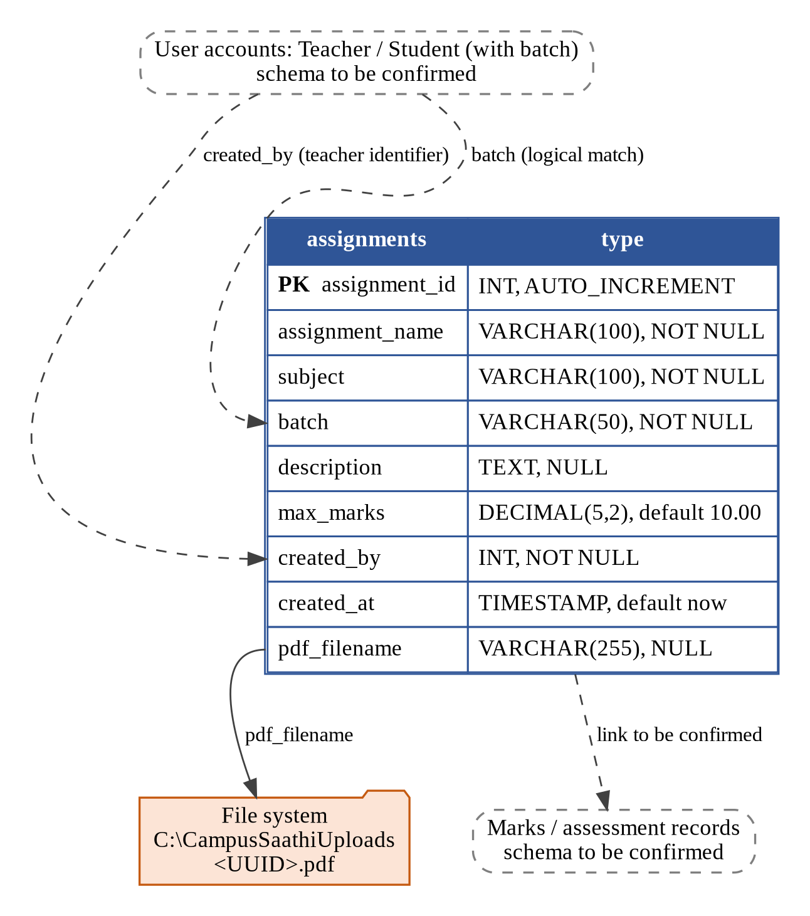
Figure 8.1: Data design based on the documented assignments table (dashed items to be confirmed)

8.4 Data Flow Diagram (DFD) – context level
At context level, CampusSaathi is a single process that interacts with two external entities, Teacher and Student. The teacher supplies login details, assignment data, an optional PDF and marks input, and receives dashboards, confirmations and marks views. The student supplies login details and view/download requests, and receives the assignment list, status and marks information and PDF files. The system reads and writes records in the MySQL database and stores and streams PDFs in the upload directory.
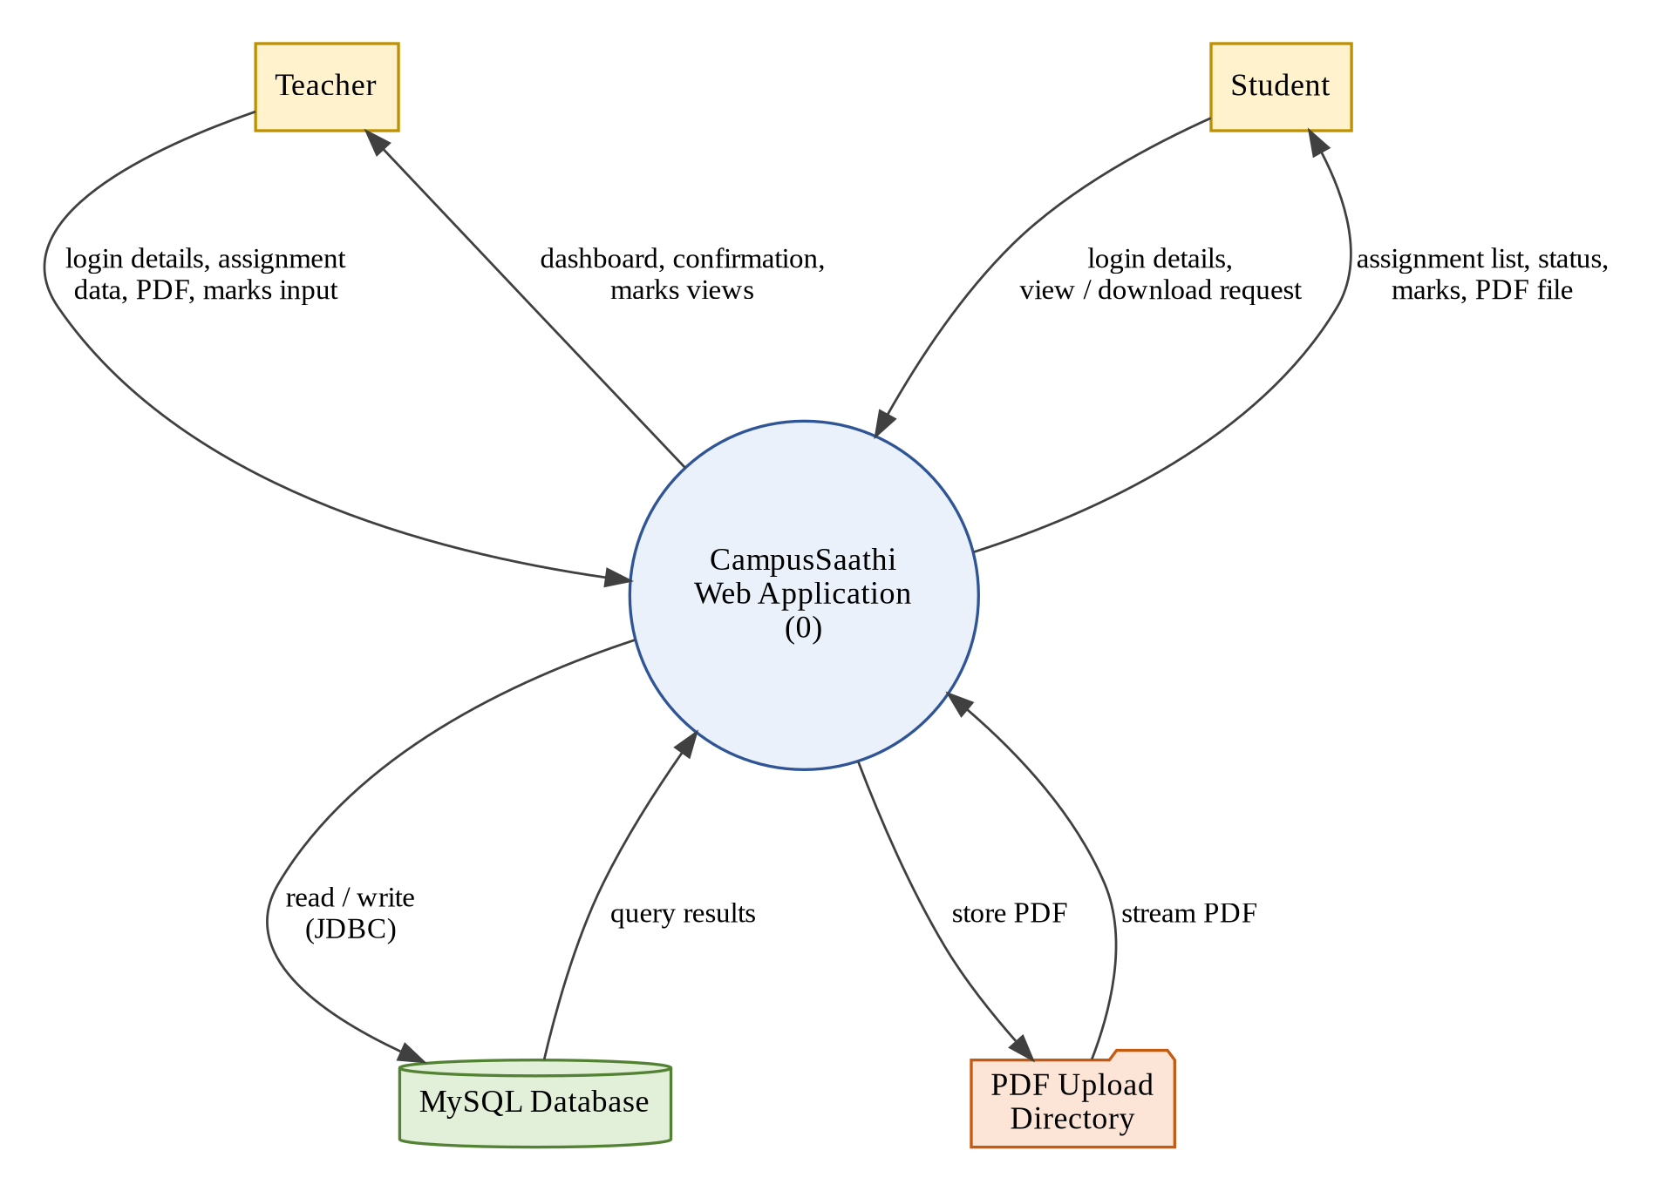
Figure 8.2: DFD – context level (Level 0)

8.5 DFD – level 1
- Authenticate user: receive credentials, verify them against stored user records and create a session.
- Create assignment: receive assignment details from the teacher, validate the fields and insert the record.
- Validate and store PDF: check size and PDF signature, generate a UUID filename, save the file and pass the filename to the insert.
- Display batch-based assignments: read the assignments of the student’s batch and present them with status and marks.
- Check access and serve PDF: verify session, role, teacher authorization or batch match, then stream the stored file.
- Marks-related operations: existing functionality to read and write marks-related information.
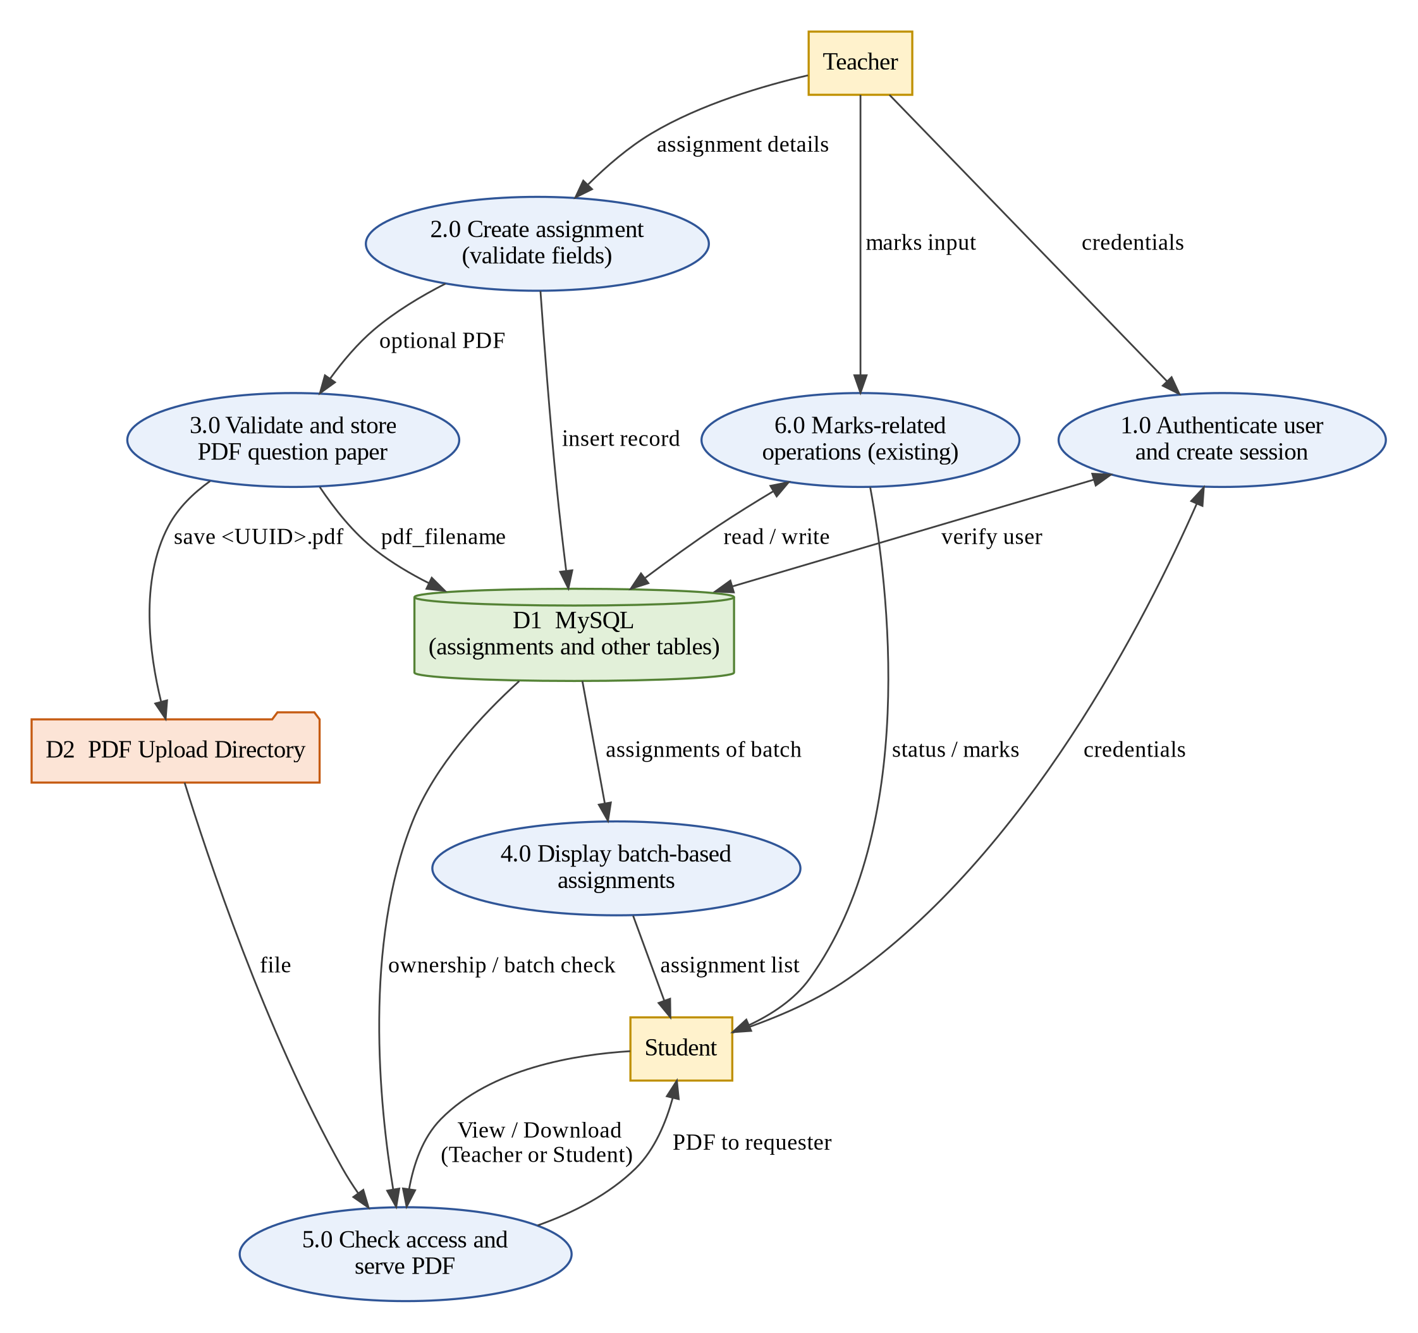
Figure 8.3: DFD – level 1

8.6 Data integrity and privacy
Data integrity relies on the primary key, the NOT NULL constraints and defaults of the assignments table, on validation in the servlets, and on removing a stored file when the database insertion fails. Privacy requires that students see only their own batch’s assignments and that a PDF is delivered only to an authorized user. Public documentation, screenshots and sample data must use test data, not real student records.

9. PROCESSES INVOLVED, ALGORITHMS, FLOWCHARTS AND DATABASE DIAGRAM

9.1 Login and session flow
The following flow describes the intended behaviour of the authentication module. The exact class names and messages must be confirmed against the source code.
- The user opens the login page and enters credentials.
- The application checks that the required fields are present.
- The credentials are checked against stored account records using JDBC.
- If they match, a session is created and the user’s identity and role are stored in it.
- The user is taken to the teacher pages or the student pages according to the role.
- Protected pages and servlets check the session and role before responding.
- If the session or role is missing or wrong, the request is not served.
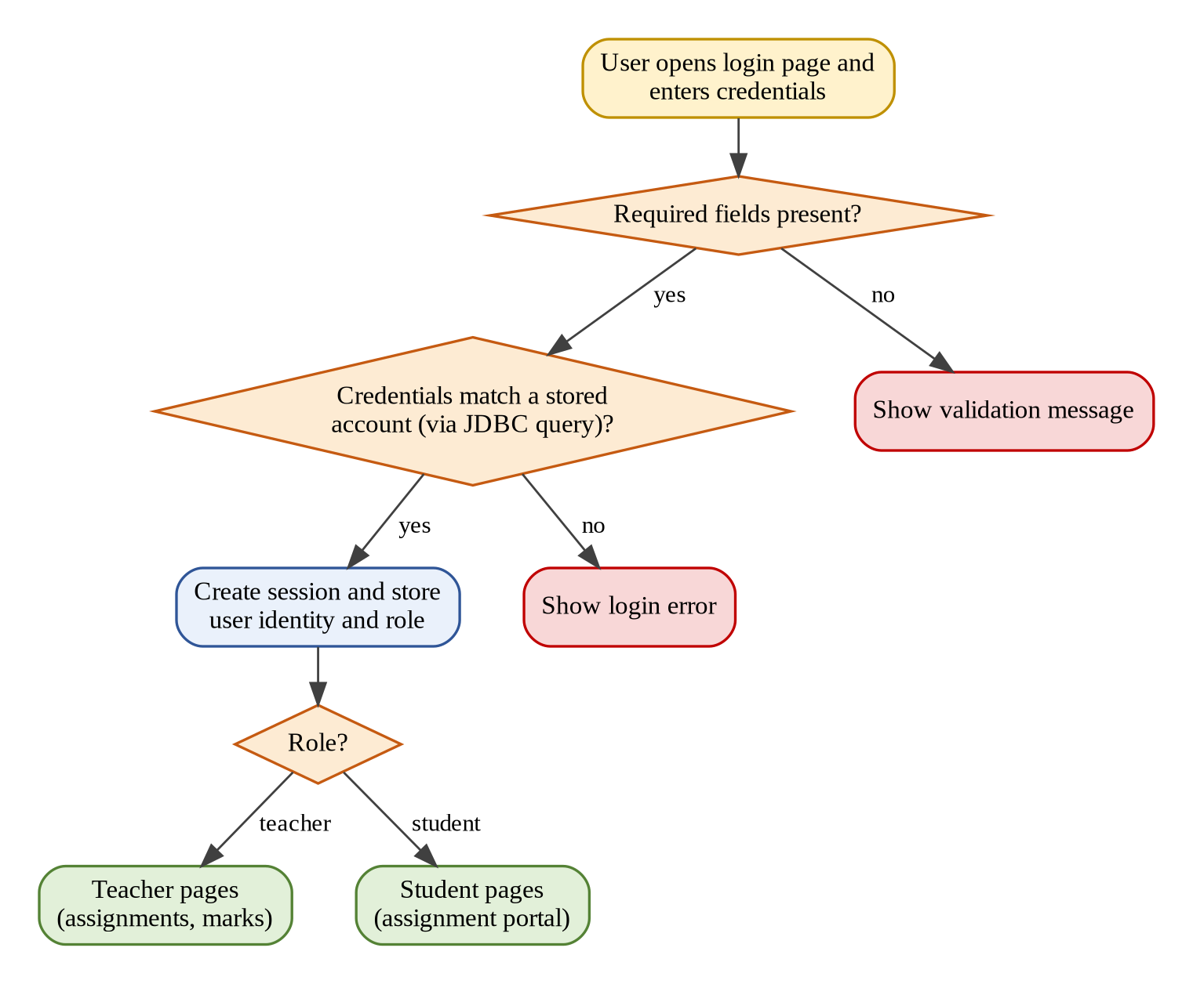
Figure 9.1: Login and session flowchart (intended behaviour)

9.2 Assignment creation flow
A teacher fills the assignment form (assignment name, subject, batch, description, maximum marks and an optional PDF) and submits it. TeacherAssignmentsServlet reads the fields, validates them, handles the optional PDF and inserts a row into the assignments table with the created_by value of the logged-in teacher. The teacher receives a confirmation or an error.

9.3 PDF upload algorithm
- Receive the multipart form submission from a teacher.
- Read the text fields and, if present, the PDF file part.
- If a file is present, reject it if it is larger than 10 MB.
- Check the file’s PDF signature; reject the file if the signature is not valid.
- Generate a UUID-based filename and save the file in the upload directory (C:\CampusSaathiUploads on the development machine).
- Insert the assignment row with the generated filename in pdf_filename (or NULL when no file was attached).
- If the database insertion fails, delete the saved file and report the error.
- On success, confirm the creation to the teacher.
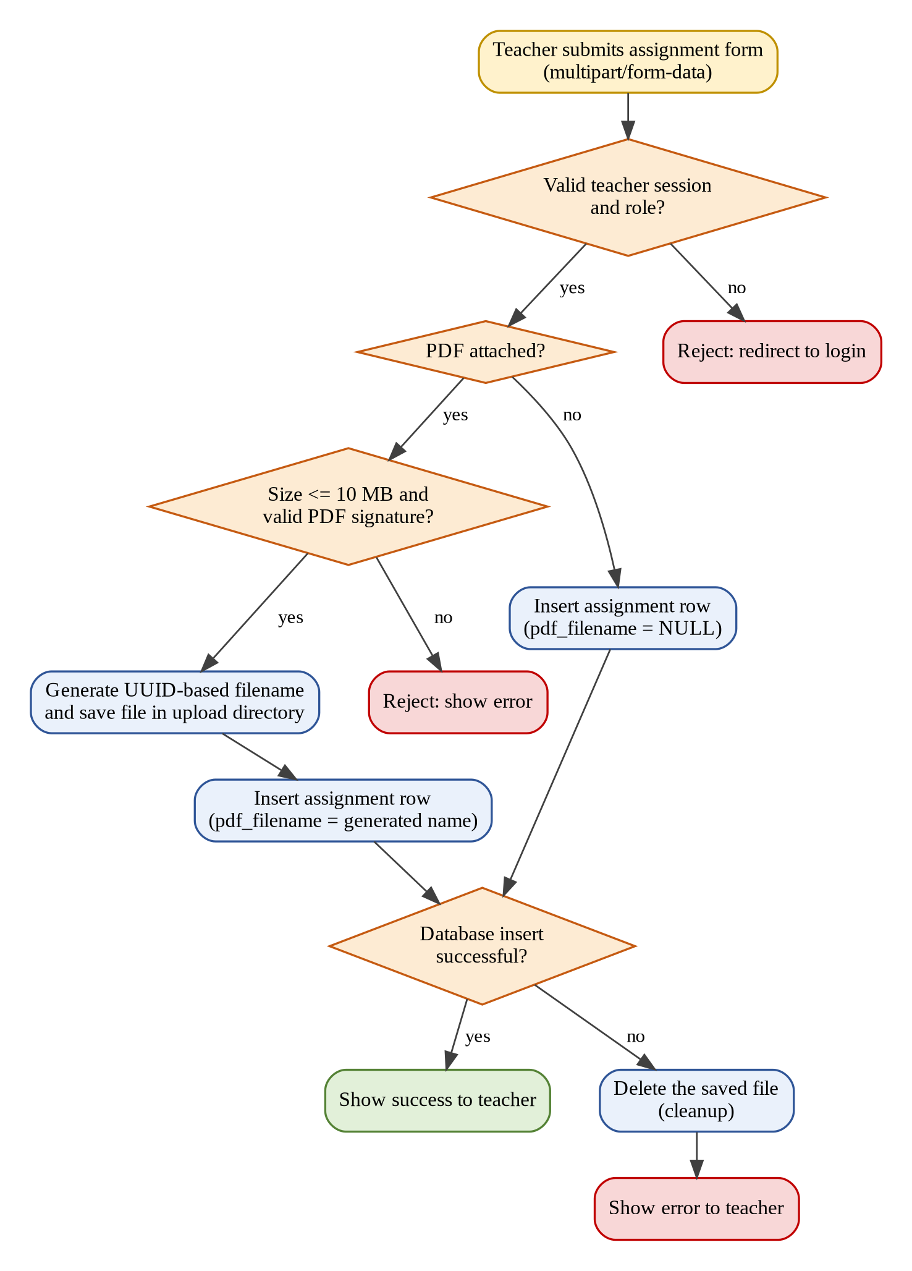
Figure 9.2: PDF upload and assignment creation flowchart (intended behaviour)

9.4 Student assignment retrieval flow
StudentAssignmentsServlet identifies the logged-in student and the student’s batch, retrieves the assignments with matching batch, retrieves the associated pdf_filename values, and passes the data to the JSP view. The view lists the assignment details and available status and marks information, and shows View PDF and Download PDF links only when a question paper is attached.

9.5 PDF serving and access-control algorithm
- Receive a request for /assignment-pdf with an assignment identifier.
- Check that a valid session exists; otherwise refuse.
- Look up the assignment and its pdf_filename; refuse if the assignment or the file does not exist.
- If the user is a teacher, check that the teacher is authorized for the assignment.
- If the user is a student, check that the student’s batch equals the assignment’s batch.
- If the check passes, open the file from the upload directory and stream it to the browser, either for viewing in the browser or as a download.
- If the check fails, refuse access.
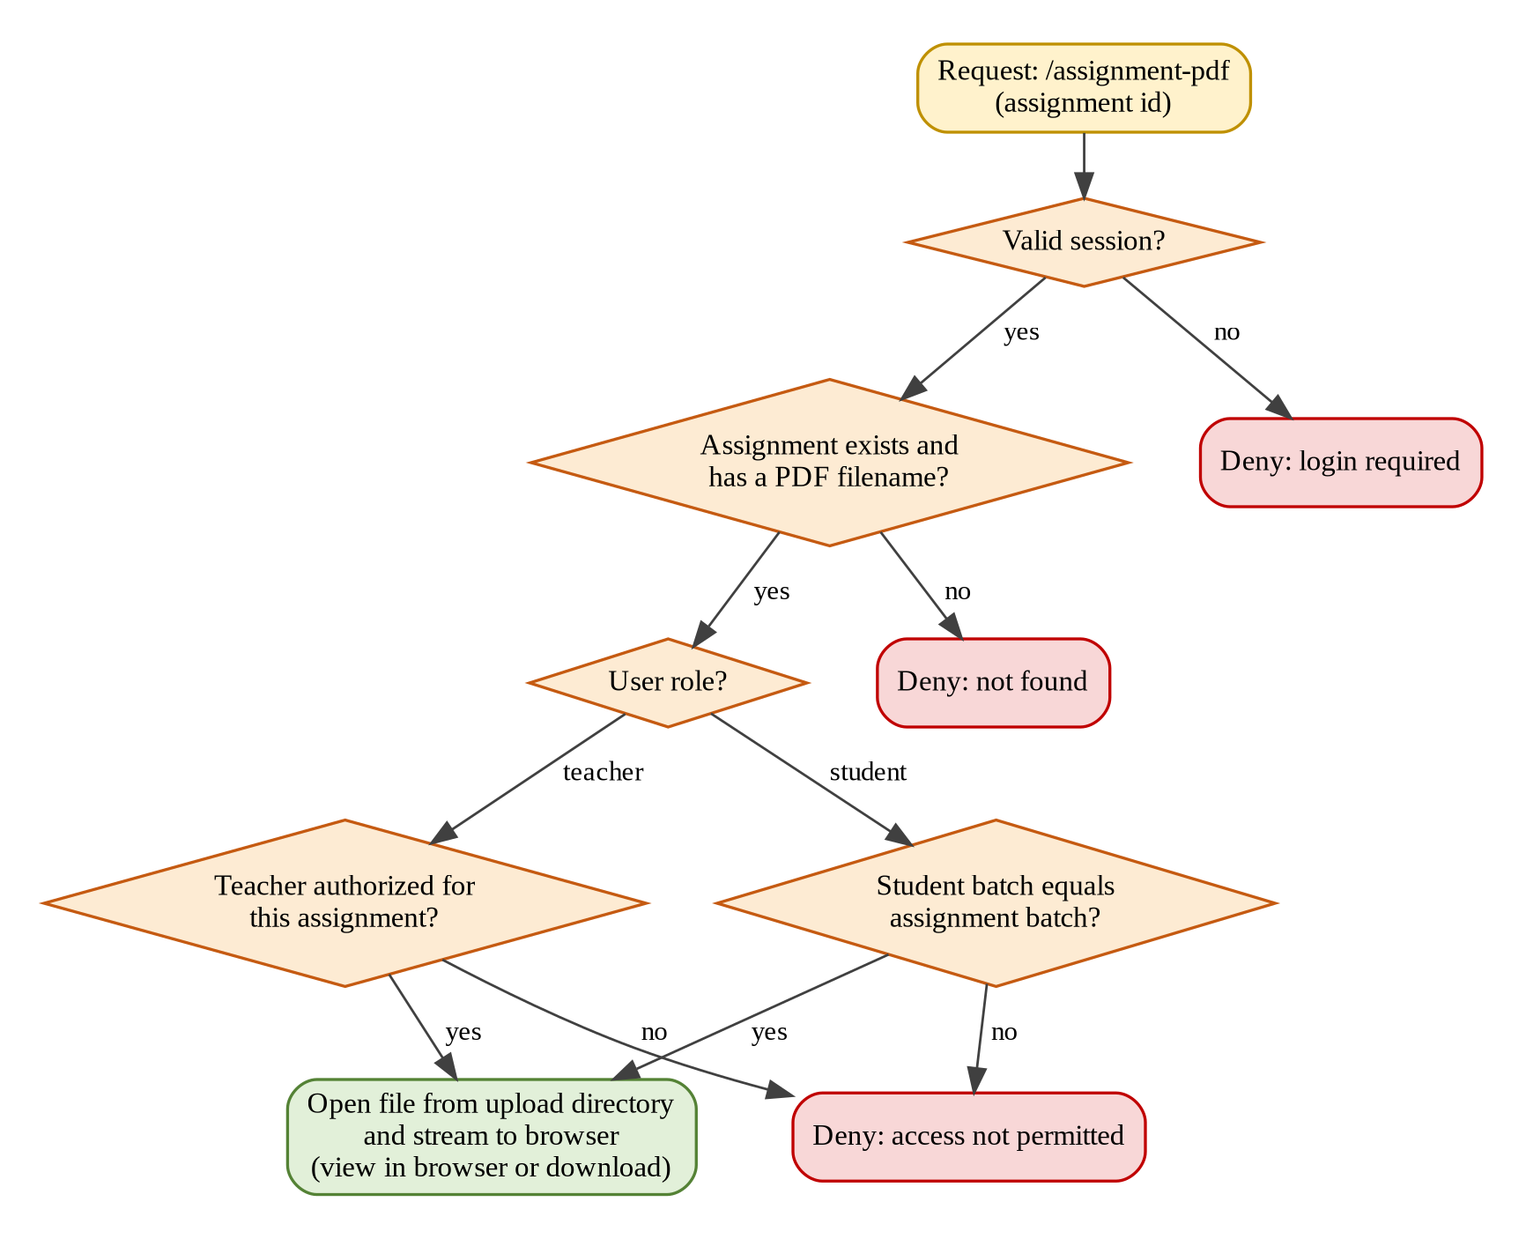
Figure 9.3: PDF access-control flowchart (intended behaviour)

9.6 Flowchart summary
Flowchart | Main decision points
Login | Are required fields present? Do the credentials match? Which role does the user have?
Assignment creation with PDF | Is the session valid? Is a PDF attached? Is it within 10 MB with a valid signature? Did the database insert succeed?
PDF access | Is the session valid? Does the assignment have a file? Is a teacher authorized or does a student’s batch match?

9.7 Algorithm for access-control verification
Input: one teacher account that created the assignment, a second teacher account, a student account of the assignment’s batch, a student account of a different batch, and an assignment with an attached PDF. Procedure: request /assignment-pdf without logging in; request it as each account; record whether the PDF is delivered or refused; compare the results with the expected outcome. This is a test procedure, not a claim that the test has already passed.

9.8 Database diagram caution
The database diagram must show only the tables that exist in the deployed schema. If a concept such as submissions, notifications or attendance is not present, it must not be drawn as an existing table.

10. INPUT AND OUTPUT SCREEN DESIGN

10.1 Screen design principles
The interface should make the user’s role, current task and the system response clear. Inputs need labels and clear indication of required fields; error messages should explain what the user can correct without exposing internal details; and View PDF and Download PDF options should be easy to recognise [17]. All screenshots included in the final report and repository must come from the running application and use clean test data.

10.2 Login screen
The login page is the entry point for teachers and students. It provides credential fields and a submit action, and handles missing or invalid credentials. Authentication is performed on the server; the role-specific behaviour after login must be demonstrated, not only the opening of a dashboard.
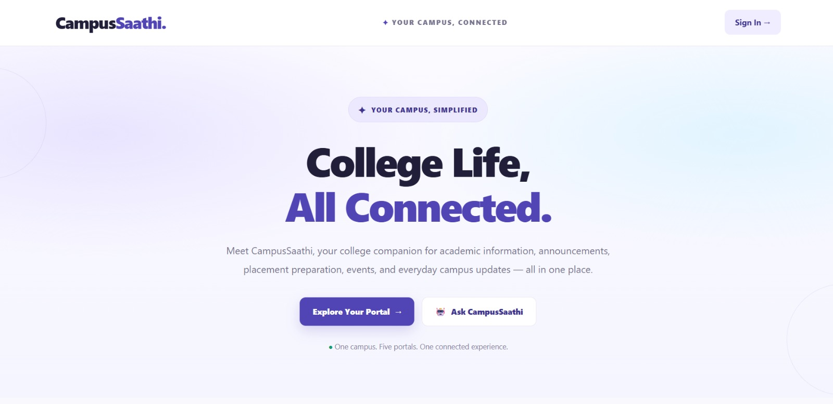
Figure 10.1: Login page

10.3 Teacher pages and assignment creation
The teacher assignment page contains the form for creating an assignment: assignment name, subject, student batch, description, maximum marks and an optional PDF question paper upload.
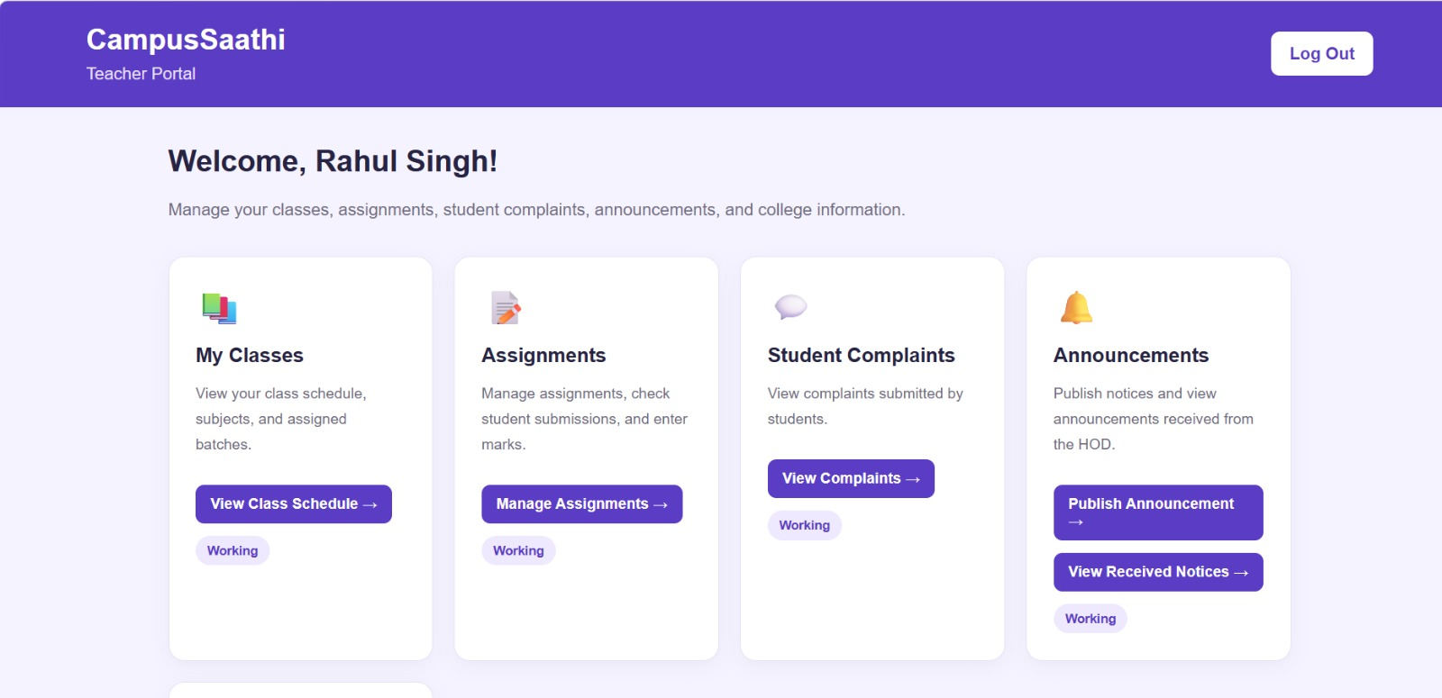
Figure 10.2: Teacher dashboard
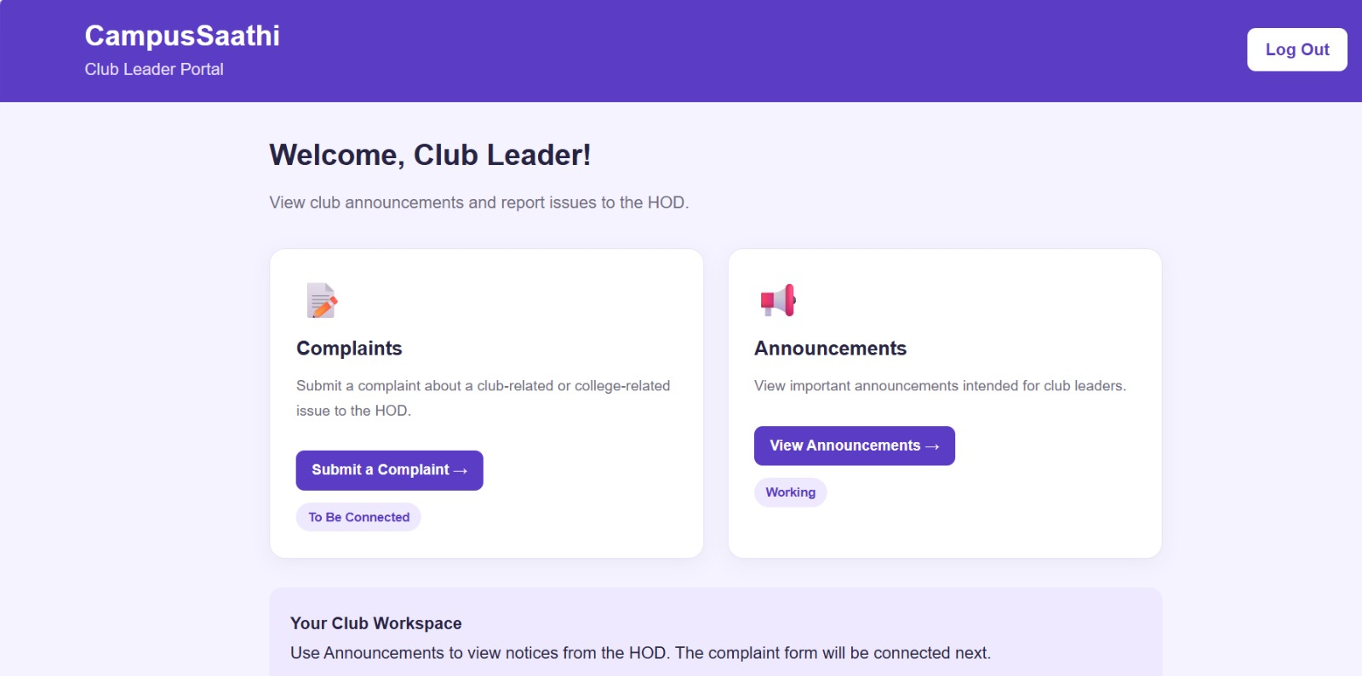
Figure 10.3: club leader dashboard
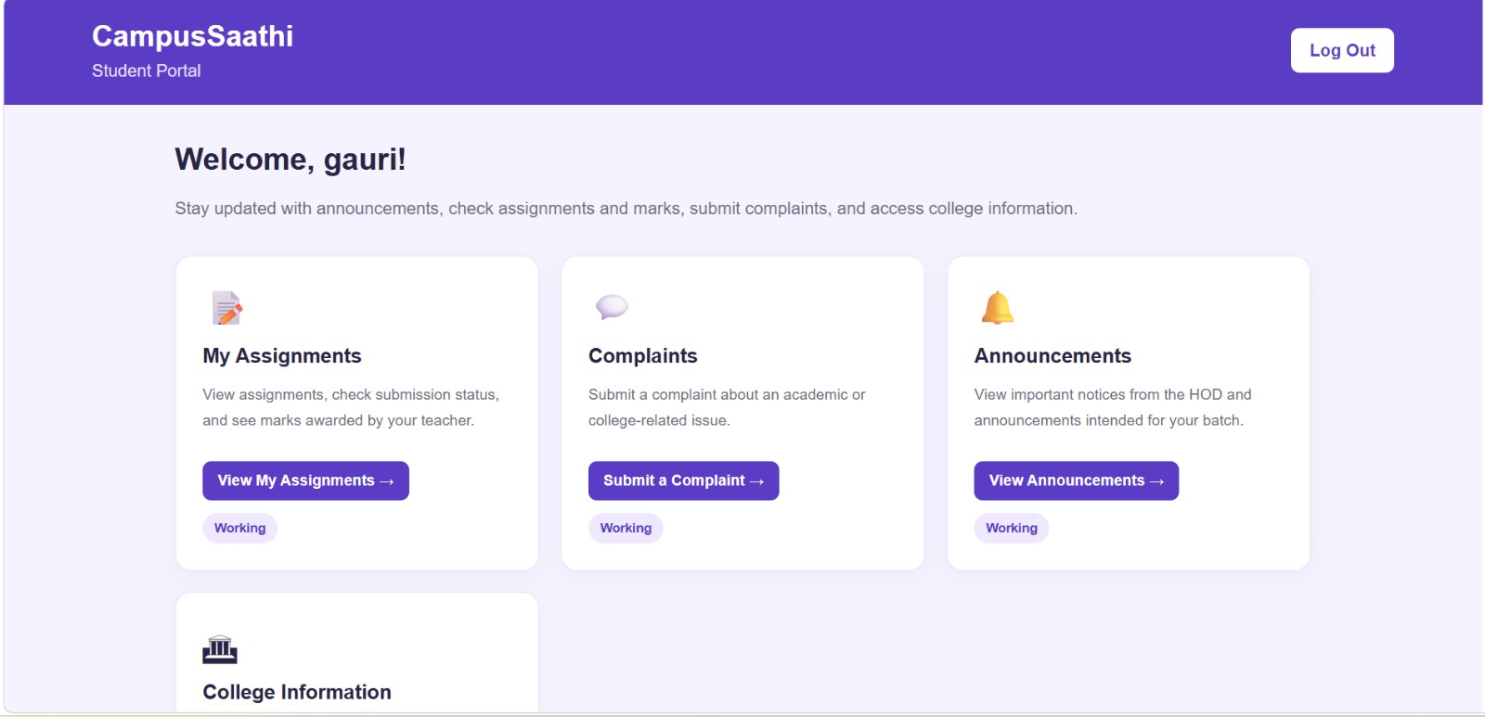
Figure 10.4:Student Dashboard

10.4 Database view
The stored assignment records, including the pdf_filename values, can be shown from the MySQL client using the queries given in Chapter 13.
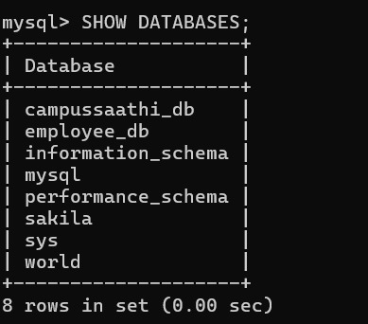
Figure 10.5: DATABASE TABLE

10.5 Student assignment portal
The student portal lists the assignments of the student’s batch with assignment details and available status and marks information. When a question paper is attached, View PDF and Download PDF options are shown.
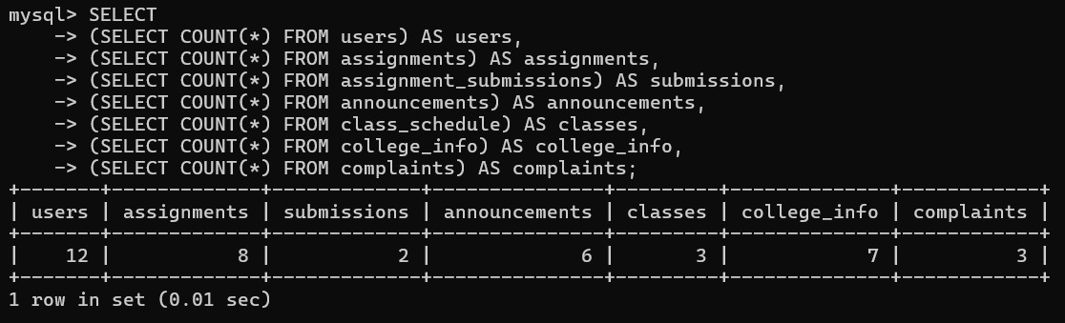
Figure 10.6:Sql Query
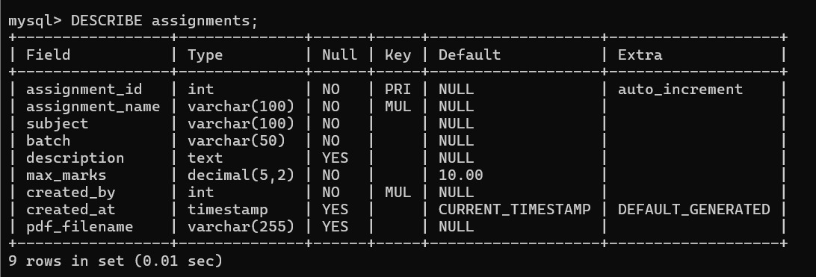
Figure 10.7 Table
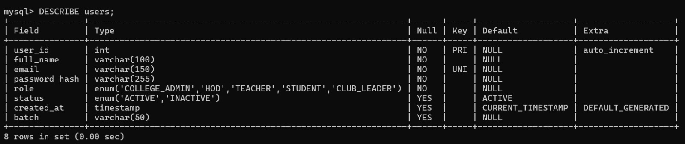
Figure 10.8 Database

10.6 Marks-related page
The existing marks-related functionality is available on the teacher side, and status or marks information appears in the student portal.
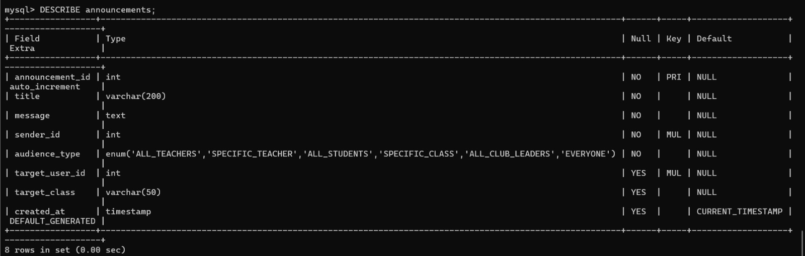
Figure 10.9: Marks-related page

10.7 Screenshot evidence checklist
Screenshot | Evidence to capture
Login | Current login page; a safe example of validation behaviour.
Teacher dashboard | Teacher role after login.
Assignment form | All fields including the PDF field.
Success message | Assignment created with test data.
MySQL records | assignments rows with pdf_filename; no personal data.
Student portal | Assignments of one batch, with View/Download PDF.
PDF view / download | PDF opened in browser and the downloaded file.
Marks-related page | Existing functionality that has been verified to work.

11. CODE SHEET / CODING EVIDENCE

11.1 Code organisation
CampusSaathi is a Java web application developed in Eclipse and deployed on Apache Tomcat 11. Its Java classes are in the package com.campussaathi.controller. The repository structure is decided only after checking whether the project follows Eclipse Dynamic Web Project conventions, so that Eclipse and Tomcat deployment are not broken.
Code element | Location / mapping | Responsibility
TeacherAssignmentsServlet | com.campussaathi.controller | Teacher-side assignment operations, assignment creation, optional PDF upload, PDF signature validation, saving the generated filename and existing marks-related functionality.
AssignmentPdfServlet | com.campussaathi.controller; URL /assignment-pdf | Serves uploaded PDFs; supports viewing or downloading; checks session, role and assignment access permissions.
StudentAssignmentsServlet | com.campussaathi.controller | Retrieves assignment information and PDF filenames, displays assignments to students, supports View PDF and Download PDF links, preserves status and marks information.
JSP pages, CSS | [to be listed from the project] | User interface for login, teacher and student pages.
Login / session / marks code | [class and file names to be confirmed] | Authentication, role checks and existing marks-related features.

11.2 Database setup script
The listing below is reconstructed from the documented schema of the assignments table. Before it is published as schema.sql, it should be compared with the output of SHOW CREATE TABLE assignments; on the real database. The database name is a placeholder and must be replaced with the actual name shown by SHOW DATABASES;.
-- CampusSaathi: assignments table (reconstructed from the documented schema)
-- Replace <your_database_name> with the real database name.
-- CREATE DATABASE IF NOT EXISTS <your_database_name>;
USE <your_database_name>;

CREATE TABLE IF NOT EXISTS assignments (
assignment_id INT NOT NULL AUTO_INCREMENT,
assignment_name VARCHAR(100) NOT NULL,
subject VARCHAR(100) NOT NULL,
batch VARCHAR(50) NOT NULL,
description TEXT NULL,
max_marks DECIMAL(5,2) DEFAULT 10.00,
created_by INT NOT NULL,
created_at TIMESTAMP DEFAULT CURRENT_TIMESTAMP,
pdf_filename VARCHAR(255) NULL,
PRIMARY KEY (assignment_id)
);
Listing 11.1: Setup script for the assignments table
Tables for user accounts and marks-related data also exist in the application. They are not included in Listing 11.1 because their structure has not been supplied; they must be added from the actual schema, and no tables, passwords or account details are to be invented.

11.3 Verification queries
SHOW DATABASES;
USE <your_database_name>;
DESCRIBE assignments;
SELECT assignment_id, assignment_name, subject, batch, description,
max_marks, created_by, pdf_filename
FROM assignments;
Listing 11.2: Queries used to inspect the assignments table

11.4 Servlet code excerpts
Selected excerpts of the real source code are to be inserted below, not generated sample code. Each excerpt should have a listing number, the class name, a short explanation and the behaviour it supports. Passwords, private keys and personal data must be removed. Servlet code must use the Jakarta namespace (jakarta.servlet.*)

11.5 Environment configuration
The database connection settings and the upload directory are environment-specific. They should be documented by their purpose, not by their values: the database URL, the database username, the database password and the PDF upload directory. Real passwords must never be committed to the repository or shown in screenshots. The upload directory used on the development machine is C:\CampusSaathiUploads; other machines must create and configure their own directory.

11.6 Code printing and readability
Selected excerpts are used instead of printing every source file. Code is shown in a monospaced font, each listing has a number and caption, and private information is removed.

12. TESTING

12.1 Testing objectives
Testing establishes whether the implemented behaviour satisfies the requirements, whether access restrictions work, whether data and files are stored consistently, and whether errors are handled safely [15], [16]. The testing in this project is manual and checklist-based. Automated testing infrastructure is not part of the current implementation. No test count or pass percentage is stated in this report; the results must be recorded from actual execution.

12.2 Test levels
Level | Purpose | Example in CampusSaathi
Functional testing | Check user-visible workflows. | Create an assignment; see it in the student portal.
Integration testing | Check interaction between modules. | Teacher uploads a PDF; student views it.
Database verification | Check stored data. | pdf_filename matches a file in the upload directory.
Authorization testing | Check role and resource permissions. | A student of another batch cannot open the PDF.
Validation testing | Check rejection of invalid input. | Non-PDF file and file over 10 MB are rejected.
Failure testing | Check cleanup after failure. | No orphan file after a failed database insert.
Regression testing | Check that earlier features still work. | Marks-related functionality after the PDF feature was added.

12.3 Known verification evidence
The assignments table structure, including the SRSCAMPUSSATHI.pdf.docxampusSAC column, is documented, and the MySQL ‘No database selected’ error encountered during inspection has a known resolution (Section 7.6). The PDF upload feature has been integrated into the application, but it has not been recorded as having passed every test. Recorded evidence for the other test cases is pending and must be added before the report is submitted.

12.4 Functional and security test cases
The “Result” column must be filled with the observed outcome. A test must not be marked as passed until the actual result has been observed.
ID | Test | Expected result | Result
TC-01 | Log in with a valid teacher account. | Session is created; teacher pages are reached. | Not yet run
TC-02 | Log in with a valid student account. | Session is created; student portal is reached. | Not yet run
TC-03 | Log in with invalid credentials. | Login is refused with a controlled message. | Not yet run
TC-04 | Submit the login form with missing fields. | Validation message; no session. | Not yet run
TC-05 | As a student, try to open a teacher-only page. | Access is refused. | Not yet run
TC-06 | Open a protected page without logging in. | User is redirected or refused. | Not yet run
TC-07 | Create an assignment without a PDF. | Row is stored with pdf_filename NULL. | Not yet run
TC-08 | Create an assignment with a valid PDF. | Row is stored with a generated filename. | Not yet run
TC-09 | Compare database filename and upload folder. | File with the same UUID-based name exists in the folder. | Not yet run
TC-10 | Upload a non-PDF file renamed to .pdf. | Upload is rejected by the signature check. | Not yet run
TC-11 | Upload a PDF larger than 10 MB. | Upload is rejected. | Not yet run
TC-12 | Cause the database insert to fail after saving the file. | Stored file is deleted; error is reported. | Not yet run
TC-13 | Student views assignments. | Only assignments of the student’s batch are shown. | Not yet run
TC-14 | Check View/Download options. | Shown only when a PDF is attached. | Not yet run
TC-15 | Student of the same batch opens and downloads the PDF. | PDF is delivered. | Not yet run
TC-16 | Student of a different batch requests the PDF URL. | Access is refused. | Not yet run
TC-17 | Authorized teacher opens the PDF. | PDF is delivered. | Not yet run
TC-18 | Request /assignment-pdf without a session; request as an unauthorized teacher. | Access is refused in both cases. | Not yet run
TC-19 | Use the existing marks-related functionality. | Works as before the PDF feature. | Not yet run
TC-20 | Check status and marks in the student portal. | Information is displayed correctly. | Not yet run

12.5 Test evidence recording
For each executed test the team records the test ID, date, build, preconditions, steps, expected result, actual result, pass/fail status and any defect. Screenshots and logs used as evidence must be free of passwords and personal data.

12.6 Security checks before publication
- Search the code for database usernames, passwords and other hard-coded credentials.
- Check that sessions and role checks protect every teacher page and /assignment-pdf.
- Check that uploaded PDFs used in the repository or demo contain no private data.
- Check that no personal student records are included in screenshots or SQL files.
- Check for local absolute paths in code and documentation and explain how to configure them.
- Check that compiled files, build folders and temporary files are not committed.
- Do not describe the application as production-grade secure unless this has been verified.

12.7 Acceptance criteria
The system should be considered ready for a public demonstration only when the selected workflows work end to end, the role and PDF-access checks have been tested, the upload validation and cleanup have been checked, the setup instructions work on a clean machine, and the report reflects the evidence collected. Any unimplemented or partially verified feature is listed as a limitation instead of being hidden.

13. USER / OPERATIONAL MANUAL

13.1 Prerequisites
- Java 21 (JDK).
- Apache Tomcat 11.
- MySQL server and a MySQL client.
- Eclipse IDE with Dynamic Web Project support.
- A web browser.

13.2 Database setup
- Open the MySQL client and run SHOW DATABASES; to see the available databases.
- Select the project database with USE <your_database_name>; (use the real name shown by MySQL).
- Create the assignments table using the setup script, or inspect it with DESCRIBE assignments;.
- Check the records with SELECT assignment_id, assignment_name, subject, batch, description, max_marks, created_by, pdf_filename FROM assignments;.

13.3 Database connection configuration
Open the existing JDBC connection code of the project campussaathi_db and make sure that the database URL, username and password match your local MySQL setup. Never commit your real password; in public documentation use placeholders such as <your_password>.

13.4 PDF upload directory
Create a folder for uploaded question papers and make sure the application is configured to use it. On the development computer this folder is C:\CampusSaathiUploads. On another computer, create a suitable folder and update the configured path accordingly. The uploaded PDFs are stored here under generated UUID-based names; they are not part of the source code and should not be committed to GitHub.

13.5 Deploying on Tomcat 11
- Import the project into Eclipse as an existing project.
- Add an Apache Tomcat 11 server in the Eclipse Servers view.
- Make sure the project uses Java 21 and the Jakarta Servlet API from Tomcat 11.
- Add the project to the server and start it.
- Open the application in the browser at the address shown by Eclipse https://campussaathi.onrender.com

13.6 Signing in
Use a valid teacher account or student account supplied privately by the team. The teacher is taken to the teacher pages and the student to the student portal.

13.7 Teacher workflow
- Log in as a teacher.
- Open the assignment page and fill in the assignment name, subject, student batch, description and maximum marks.
- Optionally choose a PDF question paper (up to 10 MB).
- Submit the form and check the confirmation.
- Use the existing marks-related pages as required.

13.8 Student workflow
- Log in as a student.
- Open the assignment page; only assignments of your batch are listed.
- Read the assignment details, status and marks information.
- If a question paper is attached, choose View PDF to open it in the browser or Download PDF to save it.

13.9 Troubleshooting
Symptom | Checks
MySQL: ERROR 1046 (3D000) No database selected | Run SHOW DATABASES; and USE <campussaathi_db>; before running the query.
Server fails with class or package errors for javax.servlet | Replace javax.servlet.* imports by jakarta.servlet.*; Tomcat 11 uses the Jakarta namespace.
Upload fails or the PDF cannot be found | Check that the upload directory exists, that the path configured in the application is correct for this computer, and that the application has permission to write to it.
Upload is refused | Check that the file is a real PDF and does not exceed 10 MB.
View PDF / Download PDF not shown | The assignment may have no attached question paper .
PDF access refused | Check that you are logged in, that your role is correct and that your batch matches the assignment (students) or that you are authorized for it (teachers).
Redirected to login repeatedly | Check that the session is created after login and that cookies are enabled.
Database connection error | Check that MySQL is running and that the URL, username and password in the connection code are correct.

13.10 Backup, security and sharing
Keep a backup of the working project before making changes. Keep passwords and private configuration out of the GitHub repository. Do not upload real student documents; use test PDFs. Compiled classes, build folders and temporary files should be excluded from the repository using a .gitignore file.

13.11 Operational limitations
The application is a college project intended for demonstration and learning. It has not been certified as production-grade. Security checks have been designed (Chapter 12) but must be verified. Uploaded PDFs are stored on the local server file system, not in cloud storage.

14. CONCLUSIONS
CampusSaathi is a Java-based web application for academic assignment management. Using Java 21, Servlets, JSP, JDBC, MySQL and Apache Tomcat 11, it connects teacher-side assignment creation with a batch-based student portal. An optional PDF question paper can be attached to each assignment, stored on the server under a generated name, and viewed or downloaded by authorized users. The design keeps assignment data in the database and documents in a separate directory, and it includes validation, cleanup and role-aware access checks.
A key limitation, stated openly in this report, is that implementation does not by itself prove that every feature, role restriction or upload rule works under all conditions. The PDF upload and access-control features have been integrated, but they must be verified by the test cases in Chapter 12 before any security claim is made or a public demonstration is given. CampusSaathi should be understood as a focused assignment management system, not a complete learning management system.
Alongside the application, the team is preparing documentation and presentation material: a database setup script, a README, setup instructions, screenshots, a team demonstration video and a GitHub repository that does not expose credentials or private data. Before binding and submission, the team should replace all highlighted placeholders with real names, screenshots, code excerpts and test results.

14.1 Key outcomes
- A Java web application with separate teacher and student experiences.
- Assignment creation with subject, batch, description and maximum marks, stored in MySQL.
- Optional PDF question paper upload with size limit, PDF signature check, UUID filename and cleanup on failure.
- A batch-based student assignment portal with View PDF and Download PDF options.
- A PDF-serving servlet with session, role, teacher-authorization and batch checks.
- A documented database schema and setup procedure, and a verification plan for the integrated system.

14.2 Final recommendation
Complete the verification of the core workflows and access checks first, then finalise screenshots, the README and the demonstration video from the same verified build, so that the report, repository and presentation stay consistent.

15. FUTURE ENHANCEMENT
The following items are future scope. They are not part of the current implementation.

15.1 Online assignment submission
Students could upload their completed work and teachers could review it. This requires a new submission table, storage, access rules and tests.

15.2 Evaluation and feedback
A structured marking and feedback workflow could be linked to submissions. Any automatic grading or AI-based evaluation would need a defined method, test data and human review before it can be claimed.

15.3 Notifications and deadlines
Due dates, reminders and e-mail or SMS notifications could keep students informed about new assignments.

15.4 Security and configuration improvements
Possible improvements include externalised configuration for the database and upload path, a review of password storage, stricter session handling, audit logging, and a formal security review. These should be verified and documented before the system is used with real student data.

15.5 Automated testing
Automated unit and integration tests, and repeatable test data scripts, would make verification easier after every change.

15.6 Storage and deployment
Cloud-based document storage and cloud deployment could be considered if the system grows beyond a local demonstration. A mobile-friendly interface or a mobile application could also be considered.

15.7 Additional academic modules
Attendance, timetable and other academic modules could be added as separate, tested modules, each with its own requirements, schema changes and tests.

16. REFERENCES
The following references support the concepts used in this report: relational databases, software engineering, access control, web architecture, testing, usability and the Java web platform. Titles are linked to a Google Scholar search or to the official documentation page. Verify edition, pages and publication details before final submission.
[1] Codd, E. F. (1970). A relational model of data for large shared data banks. Communications of the ACM, 13(6), 377–387. [Google Scholar search]
[2] Elmasri, R., & Navathe, S. B. (2016). Fundamentals of Database Systems (7th ed.). Pearson. [Google Scholar search]
[3] Silberschatz, A., Korth, H. F., & Sudarshan, S. (2019). Database System Concepts (7th ed.). McGraw-Hill. [Google Scholar search]
[4] Sommerville, I. (2016). Software Engineering (10th ed.). Pearson. [Google Scholar search]
[5] Pressman, R. S., & Maxim, B. R. (2019). Software Engineering: A Practitioner’s Approach (9th ed.). McGraw-Hill. [Google Scholar search]
[6] Wiegers, K. E., & Beatty, J. (2013). Software Requirements (3rd ed.). Microsoft Press. [Google Scholar search]
[7] Royce, W. W. (1970). Managing the development of large software systems. Proceedings of IEEE WESCON, 1–9. [Google Scholar search]
[8] Fowler, M. (2004). UML Distilled: A Brief Guide to the Standard Object Modeling Language (3rd ed.). Addison-Wesley. [Google Scholar search]
[9] Fowler, M. (2002). Patterns of Enterprise Application Architecture. Addison-Wesley. [Google Scholar search]
[10] Gamma, E., Helm, R., Johnson, R., & Vlissides, J. (1994). Design Patterns: Elements of Reusable Object-Oriented Software. Addison-Wesley. [Google Scholar search]
[11] Fielding, R. T. (2000). Architectural Styles and the Design of Network-based Software Architectures. Doctoral dissertation, University of California, Irvine. [Google Scholar search]
[12] Sandhu, R. S., Coyne, E. J., Feinstein, H. L., & Youman, C. E. (1996). Role-based access control models. IEEE Computer, 29(2), 38–47. [Google Scholar search]
[13] Saltzer, J. H., & Schroeder, M. D. (1975). The protection of information in computer systems. Proceedings of the IEEE, 63(9), 1278–1308. [Google Scholar search]
[14] OWASP Foundation. (2021). OWASP Top 10: The Ten Most Critical Web Application Security Risks. [Link]
[15] Myers, G. J., Sandler, C., & Badgett, T. (2011). The Art of Software Testing (3rd ed.). Wiley. [Google Scholar search]
[16] Ammann, P., & Offutt, J. (2016). Introduction to Software Testing (2nd ed.). Cambridge University Press. [Google Scholar search]
[17] Nielsen, J. (1994). Usability Engineering. Morgan Kaufmann. [Google Scholar search]
[18] Dahlstrom, E., Brooks, D. C., & Bichsel, J. (2014). The current ecosystem of learning management systems in higher education: Student, faculty, and IT perspectives. EDUCAUSE Center for Analysis and Research. [Google Scholar search]
[19] Masinter, L. (2015). Returning Values from Forms: multipart/form-data. RFC 7578. Internet Engineering Task Force. [Link]
[20] Leach, P., Mealling, M., & Salz, R. (2005). A Universally Unique IDentifier (UUID) URN Namespace. RFC 4122. Internet Engineering Task Force. [Link]
[21] Eclipse Foundation. Jakarta Servlet Specification. Jakarta EE. [Link]
[22] Apache Software Foundation. Apache Tomcat 11 Documentation. [Link]
[23] Oracle Corporation. MySQL Reference Manual. [Link]
[24] Oracle Corporation. Java SE 21 Documentation (including the JDBC API). [Link]
[25] Chacon, S., & Straub, B. (2014). Pro Git (2nd ed.). Apress. [Link]

