Subject : Ubiquitous Computing Subject Code : 414463
Class : BE Div: 10 [ Max. Marks : 30]
Date : 03/02/20 Day: Duration : 1 Hour

Instructions to candidate:
Attempt all three questions.

Q1 | a | Define Ubiquitous Computing and discuss its Application.  Answer:
 | b | Explain the concept of Ubiquitous computing.  Answer:Ubiquitous Computing, often also referred to as Pervasive Computing, is a vision for computer systems to infuse the physical world and human and social environments. It is concerned with making computing more physical, in the sense of developing a wider variety of computer devices can be usefully deployed in more of the physical environment. It is concerned with developing situated and pervasive technology that is highly accessible and usable by humans that can be designed to operate in harmony in human and social environments.  A user interacts with the computer, which can exist in many different forms, including laptop computers, tablets and terminals in everyday objects such as a refrigerator or a pair of glasses. The underlying technologies to support ubiquitous computing include Internet, advanced middleware, operating system, mobile code, sensors, microprocessors, new I/O and user interfaces, networks, mobile protocols, location and positioning, and new materials. Rather than propose a single definition for ubiquitous computing and for these related terms, a taxonomy of properties for ubiquitous computing has been proposed, from which different kinds or flavors of ubiquitous systems and applications can be described.  Ubiquitous computing touches on distributed computing, mobile computing, location computing, mobile networking, sensor networks, human–computer interaction, context-aware smart home technologies, and artificial intelligence. At their core, all models of ubiquitous computing share a vision of small, inexpensive, robust networked processing devices, distributed at all scales throughout everyday life and generally turned to distinctly common-place ends. For example, a domestic ubiquitous computing environment might interconnect lighting and environmental controls with personal biometric monitors woven into clothing so that illumination and heating conditions in a room might be modulated, continuously and imperceptibly.
Q2 | a | Explain with diagram Architectural Design of Ubiquitous computing systems: Smart DEI Model  Answer:Three basic architectural design patterns for ubiquitous ICT system: smart devices, smart environment and smart interaction are proposed. Here the concept smart simply means that the entity is active, digital, networked, can operate to some extent autonomously, is reconfigurable and has local control of the resources it needs such as energy, data storage, etc. It follows that these three main types of system design may themselves contain sub-systems and components at a lower level of granularity that may also be considered smart, e.g., a smart environment device may consist of smart sensors and a smart controller, etc. There is even smart dust. An illustrative example of how these three types of models can be deployed.  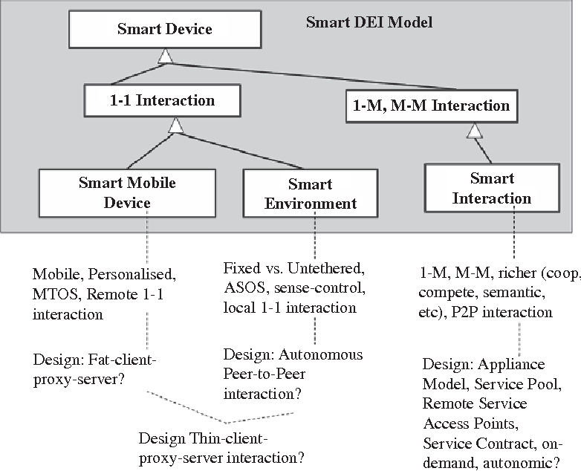
 | b | List the Characteristics of service access used by smart devices.  Answer:
Q3 | a | List and Discuss characteristics of sensors.  Answer:Range – is the maximum and minimum value range over which a sensor works well. Often sensors will work well outside this range, but require special or additional calibration. e.g. salinity sensors deployed in salinity of a few PPT in an estuary which is below where the PSU scale is defined (2  PSU). However, generally if you try to operate a sensor outside its range, it will not work (give a constant output at the max, significantly change sensitivity or give erratic results) or be damaged e.g. a 130 m pressure sensor deployed at 200 m depth.  - Accuracy – how well the sensor measures the environment in an absolute sense. That is how good the data is when compared with a recognized standard. e.g. a temperature sensor accurate to 0.001o C is expected to agree within 0.001o C with a temperature standard such as a triple-point- of-water cell or the temperature measured by a PRT standardized in recognized calibration standards or by another sensor with the same accuracy calibrated properly.This is what you want to compare results with other observations.  3. Resolution – the ability of a sensor to see small differences in readings. e.g. a temperature sensor may have a resolution of 0.000,01o C, but only be accurate to 0.001o C. That is you can believe the size of relative small changes in temperature, which are smaller than the accuracy of the sensor. Resolution in often controlled by the quantization in digitizing the signal – e.g. one bit is equal to 0.0005o C. This is not a function of the sensor, but the sampling process.  4. Repeatability – This is the ability of a sensor to repeat a measurement when put back in the same environment. It is often directly related to accuracy, but a sensor can be inaccurate, yet be repeatable in making observations.  5. Drift – This is the low frequency change in a sensor with time. It is often associated with electronic aging of components or reference standards in the sensor. Drift generally decreases with the age of a sensor as the component parts mature. A smoothly drifting sensor can be corrected for drift.
 | b | What is RFID and What are two types of it?  Answer:Radio frequency identification (RFID) technology has become much more common across a  number of industries, but there are a variety of different types of RFID technology, tags, and readers —  each uniquely suited to different types of applications.  RFID tags can be classified by the radio frequency range they use to communicate (low, high, or  ultra-high), and the way the tag communicates with the reader (active or passive). Listed below are the  different types of RFID technology, their capabilities and limitations, and the types of applications for  which they are best suited.  Types:  1. Active RFID  Active RFID tags have their own transmitter and power source (usually a battery) onboard the tag.  These are mostly UHF solutions, and read ranges can extend up to 100 m in some instances. Active tags are usually larger and more expensive than their passive counterparts and are used to track large assets (like cargo containers, vehicles, and machines). Active RFID tags are also often equipped with sensors that measure and transmit temperature, humidity, light, and shock/vibration data for the objects they are  attached to.  There are two types of active tags. Transponders only “wake up” and transmit data when they receive  a radio signal from a reader. For example, a transponder attached to a vehicle in a toll payment or checkpoint control location would only be active when passing through a particular gate. This helps conserve battery life. Beacons, on the other hand, emit a signal at a pre-set interval. This type of active  tag is used in real-time location systems (RTLS) for tracking anything from wheelchairs at a hospital to large cargo containers at a shipping dock.  2. Passive RFID  In passive RFID solutions, the reader and reader antenna send a signal to the tag, and that signal is used to power on the tag and reflect energy back to the reader. There are passive LF, HF, and UHF systems. Read ranges are shorter than with active tags and are limited by the power of the radio signal reflected back to the reader (commonly referred to as tag backscatter).  Passive tags are usually smaller, less expensive, and more flexible than active tags. This means they can be attached or even embedded on a wider variety of objects. Passive UHF tags are commonly used for item-level tracking of consumer goods and pharmaceuticals, for example.  3. Battery-Assisted Passive (BAP) RFID  A third, hybrid type of RFID tag has also emerged. BAP systems, or semi-passive RFID systems, incorporate a power source into a passive tag configuration. The power source helps ensure that all of the captured energy from the reader can be used to reflect the signal, which improves read distance and data  transfer rates. Unlike active RFID transponders, BAP tags do not have their own transmitters.

