**Assignment 5**

**Name : Manvi Pandya**

**Roll NO :43233**

**Batch – R10**

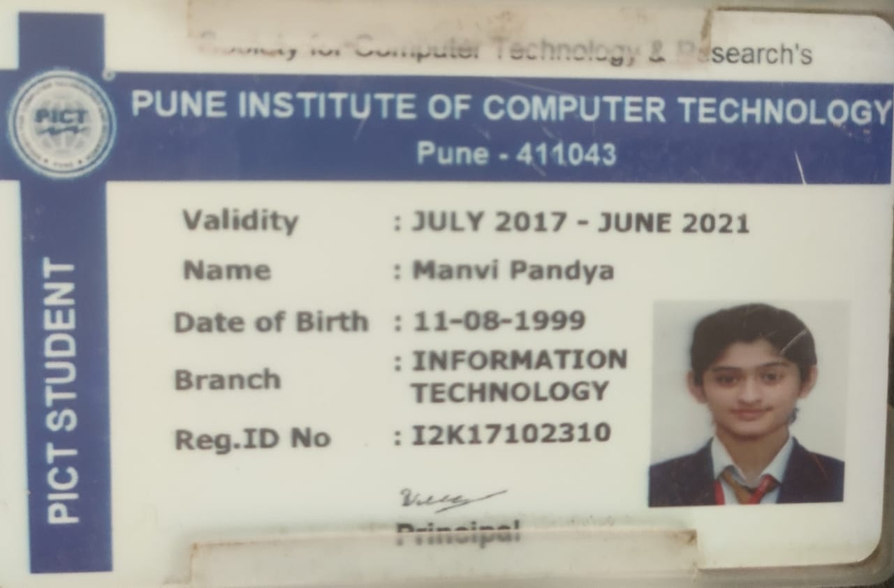

***Java RESTful web service with Jersey***

Implemented a java web service - RESTful service using Jersey and javascript to fetch data of phone specifications from database and send it to the client.

Output

http://localhost:8080/HelloREST/index.html

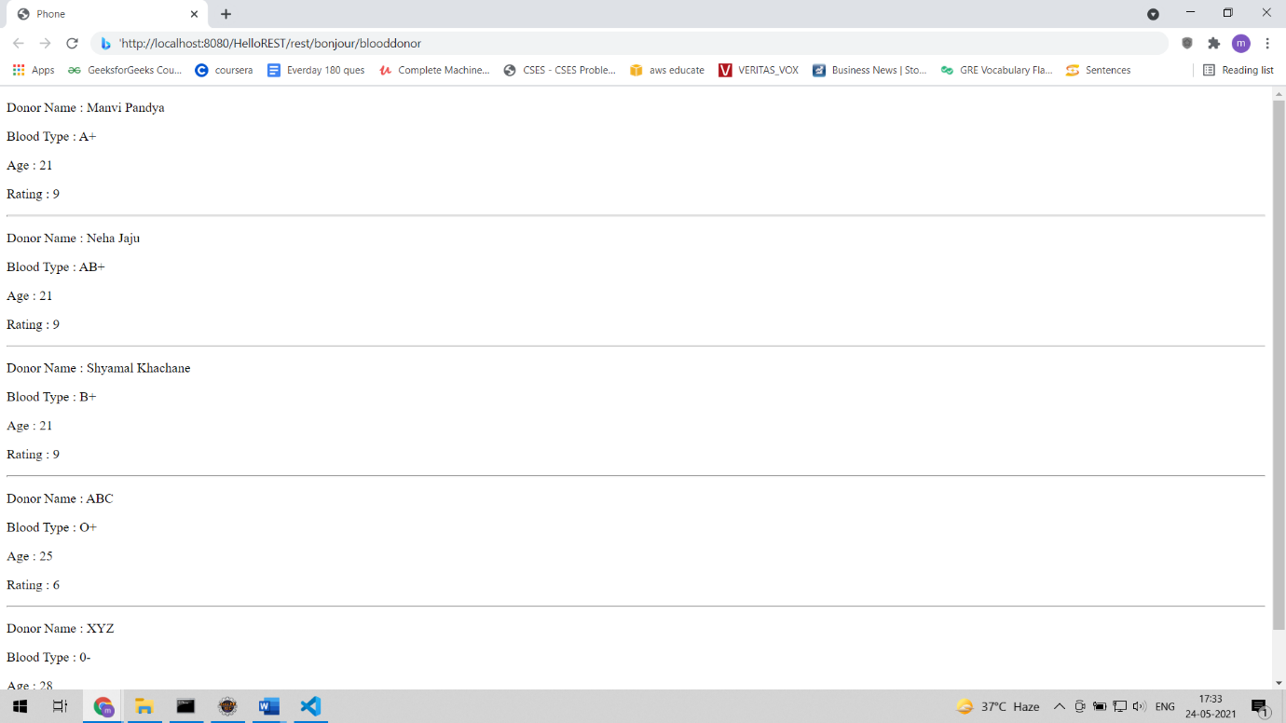

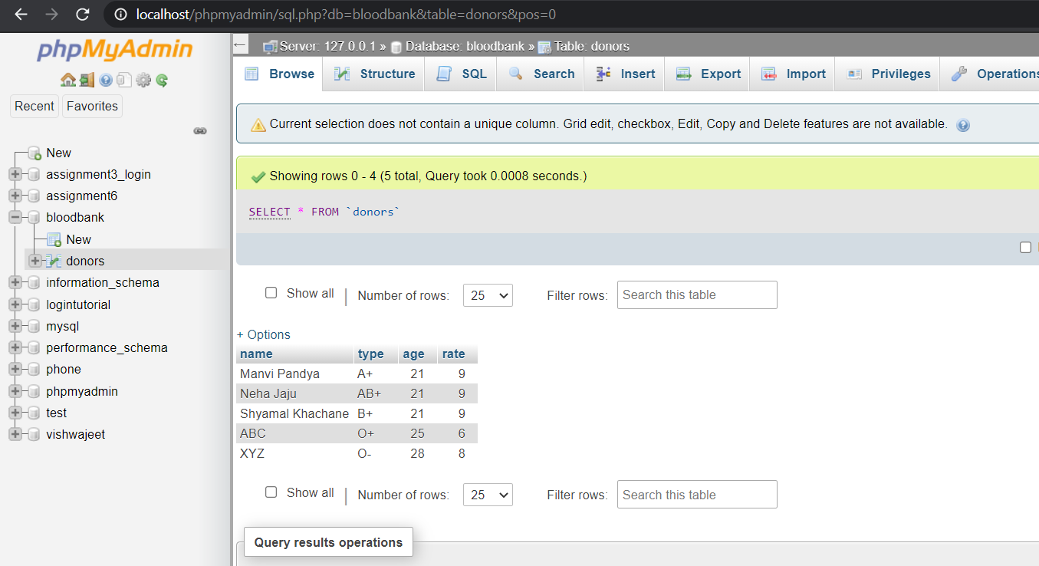

**Codes**

**Index.html**

<!DOCTYPE html>

<html lang="en">

<head>

  <meta charset="UTF-8">

  <meta name="viewport" content="width=device-width, initial-scale=1.0">

  <title>Blood Bank</title>

  <link href="style.css" rel="stylesheet">

</head>

<body>

  <div id="root"></div>

  <script src="scripts.js"></script>

</body>

</html>

**Scripts.js**

const app = document.getElementById('root');

const container = document.createElement('div');

container.setAttribute('class', 'container');

app.appendChild(container);

var request = new XMLHttpRequest();

request.open('GET', 'http://localhost:8080/HelloREST/rest/bonjour/blooddonor', true);

request.onload = function () {

  var data = JSON.parse(this.response);

  if (request.status >= 200 && request.status < 400) {

    data.forEach(blooddonors => {

      console.log(blooddonors.name,blooddonors.type,blooddonors.age,blooddonors.rate)

      const card = document.createElement('div')

      /*card.setAttribute('class', 'card')*/

      const h1 = document.createElement('h1')

      h1.textContent = blooddonors.name

      const p = document.createElement('p')

      p.textContent = `Manufacturer : ${blooddonors.type} `

    const q = document.createElement('p')

      q.textContent = `Price : ${blooddonors.age} `

    const r = document.createElement('p')

      r.textContent = `RAM : ${blooddonors.rate}`

      container.appendChild(card)

      card.appendChild(h1)

      card.appendChild(p)

      card.appendChild(q)

      card.appendChild(r)

    });

  } else {

    const errorMessage = document.createElement('marquee');

    errorMessage.textContent = `It's not working!`;

    app.appendChild(errorMessage);

  }

}

request.send();

**Web.xml**

<?xml version="1.0" encoding="UTF-8"?>

<web-app xmlns:xsi="http://www.w3.org/2001/XMLSchema-instance" xmlns="http://xmlns.jcp.org/xml/ns/javaee" xsi:schemaLocation="http://xmlns.jcp.org/xml/ns/javaee http://xmlns.jcp.org/xml/ns/javaee/web-app_3_1.xsd" id="WebApp_ID" version="3.1">

  <display-name>HelloREST</display-name>

  <welcome-file-list>

    <welcome-file>index.html</welcome-file>

    <welcome-file>index.htm</welcome-file>

    <welcome-file>index.jsp</welcome-file>

    <welcome-file>default.html</welcome-file>

    <welcome-file>default.htm</welcome-file>

    <welcome-file>default.jsp</welcome-file>

  </welcome-file-list>

<servlet>

    <servlet-name>Jersey REST Service</servlet-name>

    <servlet-class>org.glassfish.jersey.servlet.ServletContainer</servlet-class>

    <init-param>

        <param-name>jersey.config.server.provider.packages</param-name>

        <param-value>net.codejava.ws</param-value>

    </init-param>

    <load-on-startup>1</load-on-startup>

</servlet>

<servlet-mapping>

    <servlet-name>Jersey REST Service</servlet-name>

    <url-pattern>/rest/*</url-pattern>

</servlet-mapping>

</web-app>

**POM.xml**

<project xmlns="http://maven.apache.org/POM/4.0.0" xmlns:xsi="http://www.w3.org/2001/XMLSchema-instance" xsi:schemaLocation="http://maven.apache.org/POM/4.0.0 https://maven.apache.org/xsd/maven-4.0.0.xsd">

  <modelVersion>4.0.0</modelVersion>

  <groupId>net.codejava.ws</groupId>

  <artifactId>HelloREST</artifactId>

  <version>0.0.1-SNAPSHOT</version>

  <packaging>war</packaging>

 <dependencies>

        <dependency>

    <groupId>org.glassfish.jersey.containers</groupId>

    <artifactId>jersey-container-servlet</artifactId>

    <version>2.29.1</version>

</dependency>

<dependency>

    <groupId>org.glassfish.jersey.inject</groupId>

    <artifactId>jersey-hk2</artifactId>

    <version>2.29.1</version>

</dependency>

<dependency>

    <groupId>mysql</groupId>

    <artifactId>mysql-connector-java</artifactId>

    <version>5.1.39</version>

</dependency>

<dependency>

    <groupId>org.glassfish.jersey.media</groupId>

    <artifactId>jersey-media-json-jackson</artifactId>

    <version>2.29.1</version>

</dependency>

  </dependencies>

  <build>

    <sourceDirectory>src</sourceDirectory>

    <plugins>

      <plugin>

        <artifactId>maven-war-plugin</artifactId>

        <version>2.6</version>

        <configuration>

          <warSourceDirectory>WebContent</warSourceDirectory>

          <failOnMissingWebXml>false</failOnMissingWebXml>

        </configuration>

      </plugin>

      <plugin>

        <artifactId>maven-compiler-plugin</artifactId>

        <version>3.3</version>

        <configuration>

          <source>1.7</source>

          <target>1.7</target>

        </configuration>

      </plugin>

    </plugins>

  </build>

</project>